Customer Support Ticket Priority Prediction and Automated Assignment System Using Agentforce

Team leader : Niranjana Sri S(922223104032)
Team Member 1 : Srinathi G(922223104048
Team Member 2 : Sharmi R(922223104045)
Team Member 3 : Barani Selvi B(922223104007)

1. Aim of the Project
Support teams receive many tickets every day, and sorting them by hand delays the urgent ones. The aim of this project was to build a Salesforce solution that reads a ticket description, decides its priority, creates a task for urgent tickets, assigns them to a senior agent, and lets a user trigger all of this by chatting with an Agentforce agent.

2. Work Done, Step by Step

Part A: Creating the custom object

Step 1: Created the custom object
I opened Setup, went to Object Manager and clicked Create > Custom Object. I gave the label Support Ticket Intelligence, which produced the API name Support_Ticket_Intelligence__c. I set the record name as an Auto Number field with the format TKT-{0000} and saved the object.
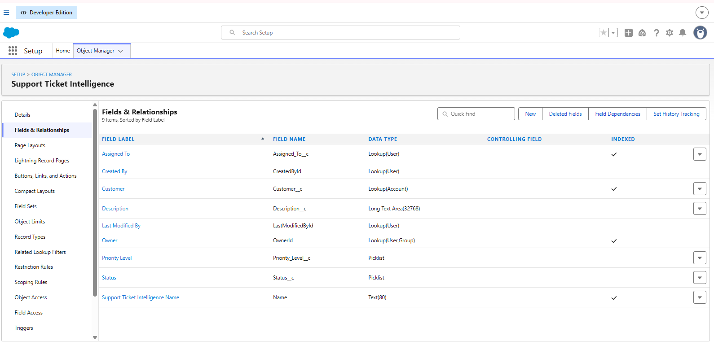

Step 2: Created the fields
Inside the object I opened Fields & Relationships and created the fields listed below.
Field Label | API Name | Data Type | Notes
Customer | Customer__c | Lookup (Account) | Related account
Contact | Contact__c | Lookup (Contact) | Customer contact
Issue Type | Issue_Type__c | Picklist | Technical, Billing,  General
Description | Description__c | Long Text Area | Issue details
Priority Level | Priority_Level__c | Picklist | Low, Medium, High
Status | Status__c | Picklist | New, In Progress,  Resolved
Created Date | Created_Date__c | Date | Ticket date
Assigned To | Assigned_To__c | Lookup (User) | Support agent
SLA Breach Risk | SLA_Breach_Risk__c | Checkbox | Risk flag
Resolution Time (hrs) | Resolution_Time__c | Number | Time taken

Step 3: Created sample data
To test the logic I created an Account (for example "ABC") and then a Support Ticket Intelligence record for it. In the Description I typed a sentence containing an urgency keyword such as "Urgent". The ticket was saved as TKT-0002.
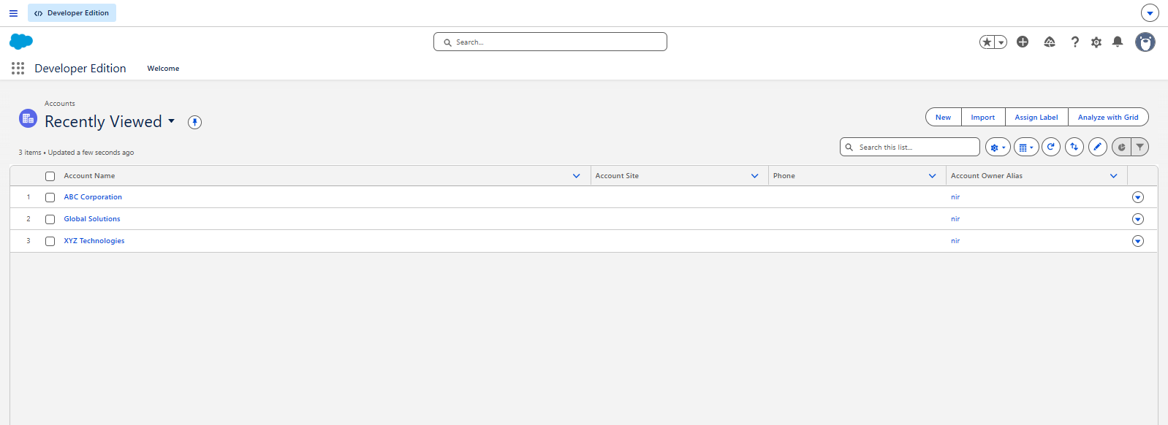

Part B: Building the auto-launched Flow

Step 4: Created the Flow and its variables
In Setup I opened Flows, clicked New Flow and selected Autolaunched Flow (No Trigger). I created one input variable and five output variables, all of type Text: varAccountName (input), and varAccountIdvarTicketId, varPriorityLevel, varAssignedTo, varActionMessage (output).
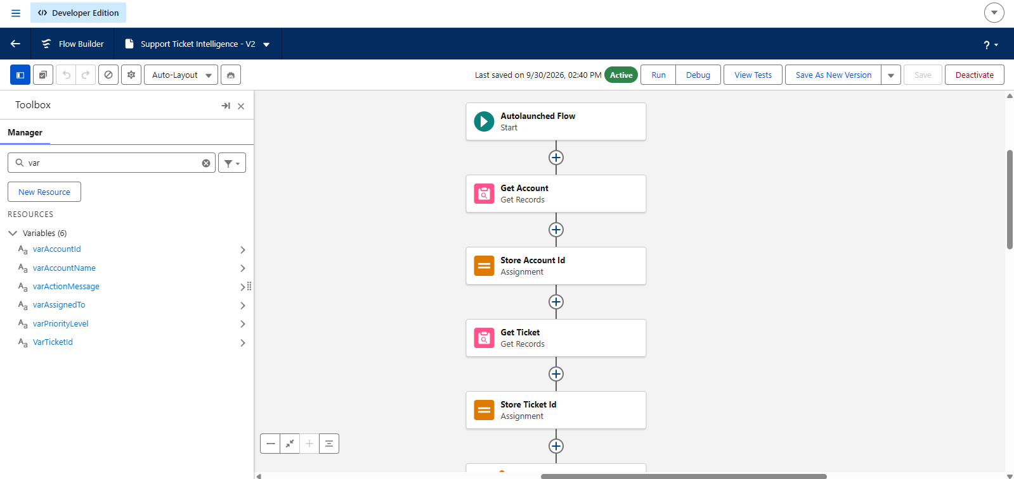

Step 5: Get Account
I added a Get Records element named Get Account on the Account object with the condition Name Equals {!varAccountName}. I sorted by CreatedDate descending and chose to store only the first record.
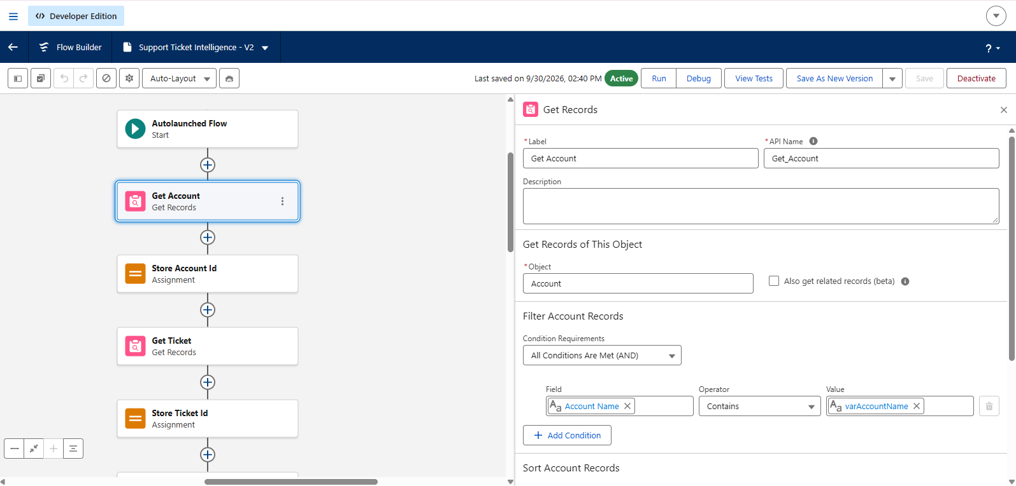
Step 6: Store Account Id
I added an Assignment element and set varAccountId equal to {!Get_Account.Id}.
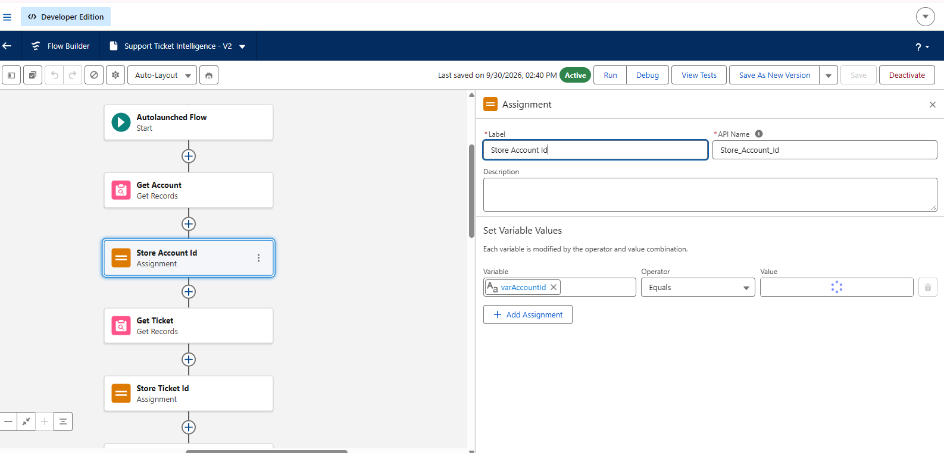

Step 7: Get Ticket
I added a second Get Records element named Get Ticket on Support_Ticket_Intelligence__c with the condition Customer__c Equals {!varAccountId}, sorted by CreatedDate descending, storing only the first record, so that the latest ticket is picked.
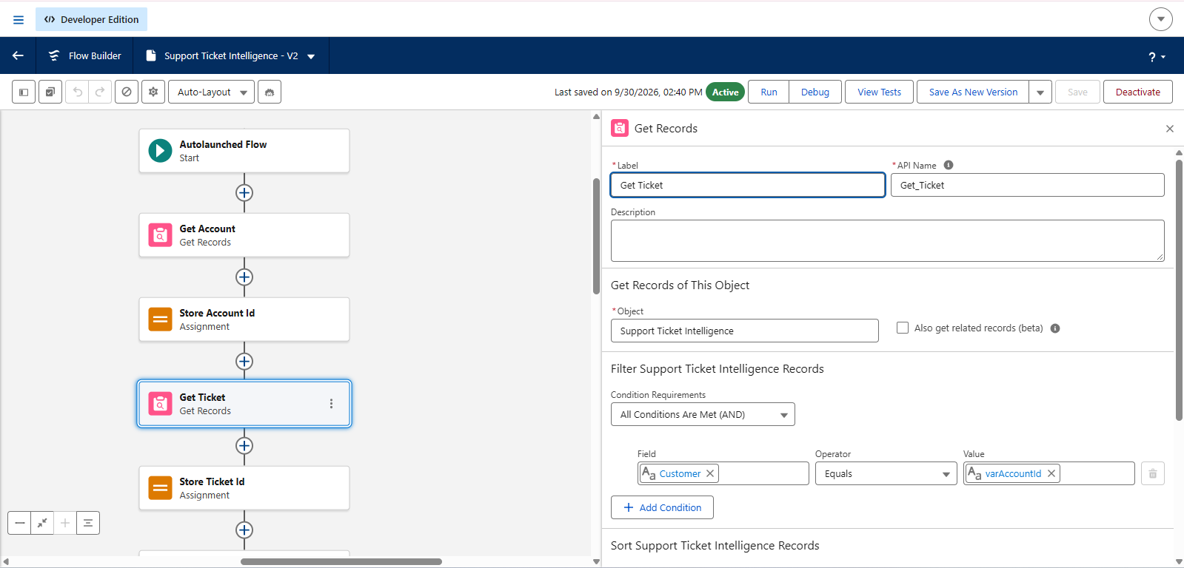Step 8: Store Ticket Id
Another Assignment element set varTicketId equal to {!Get_Ticket.Id}.
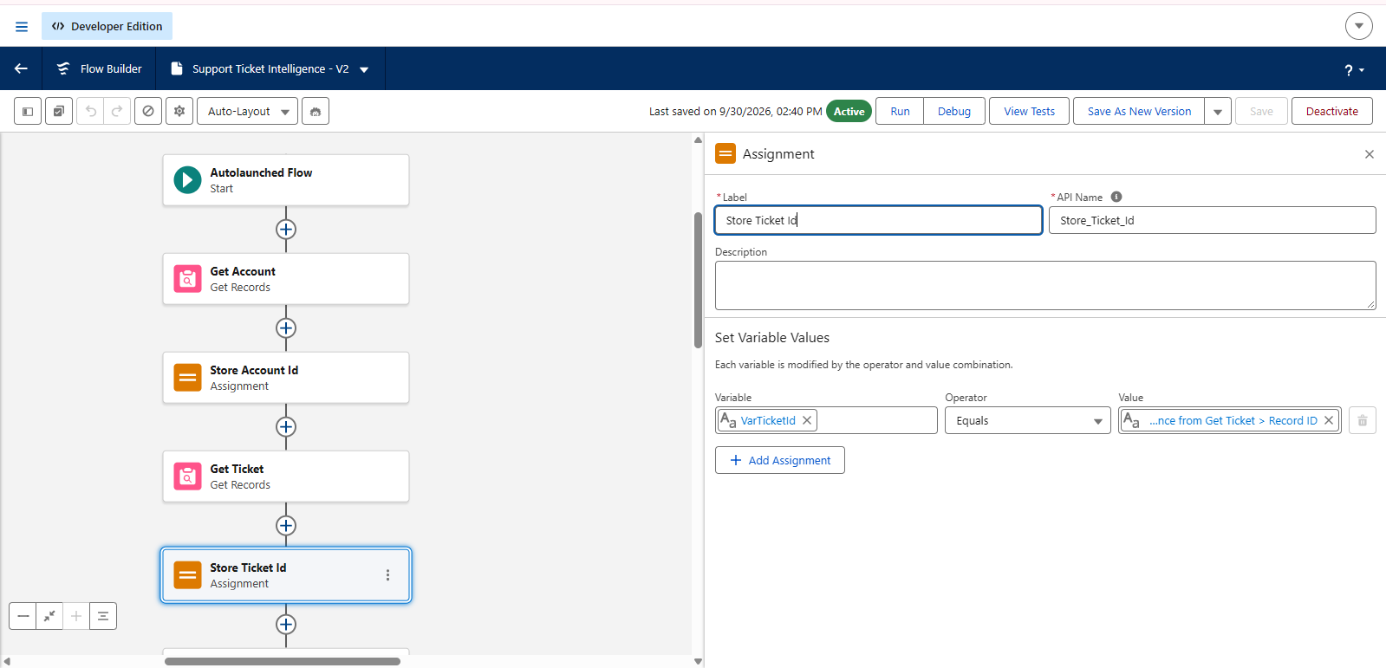

Step 9: Analyze Description (Decision)
I added a Decision element named Analyze Description with two outcomes. The High Priority outcome checks whether the ticket description contains "urgent", "not working" or "failure" (multiple CONTAINS conditions joined with OR). The Medium Priority outcome checks for "issue", "slow" or "delay". The default outcome was renamed Low Priority.
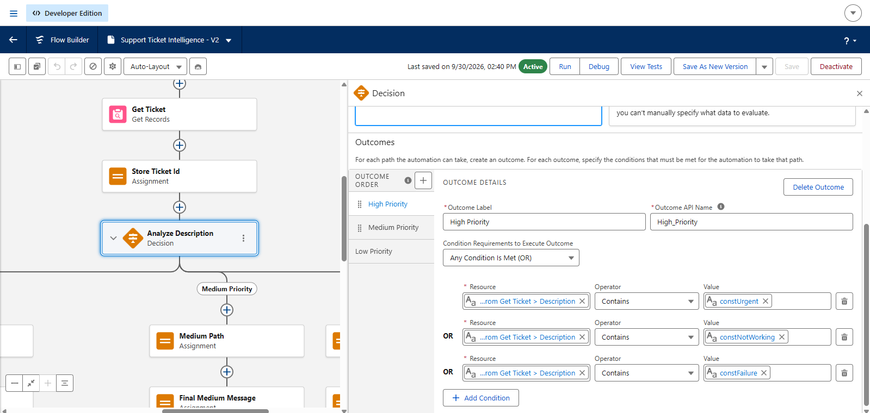
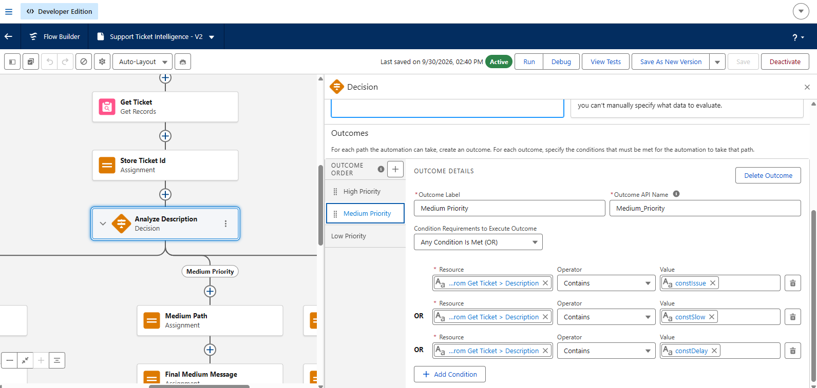

Step 10: Set Priority Level
On each path I added an Assignment: varPriorityLevel = "High" on the high path, "Medium" on the medium path and "Low" on the low path.
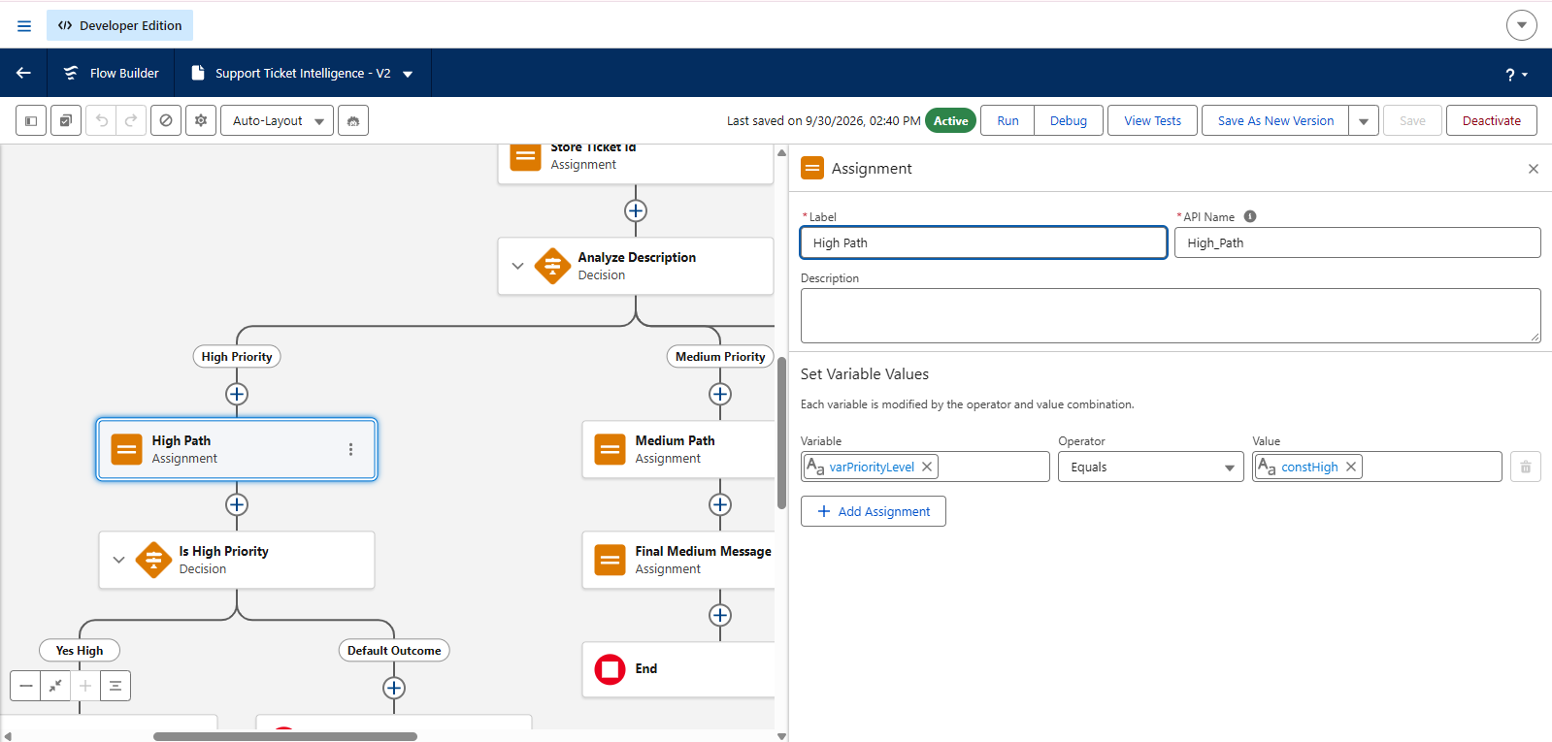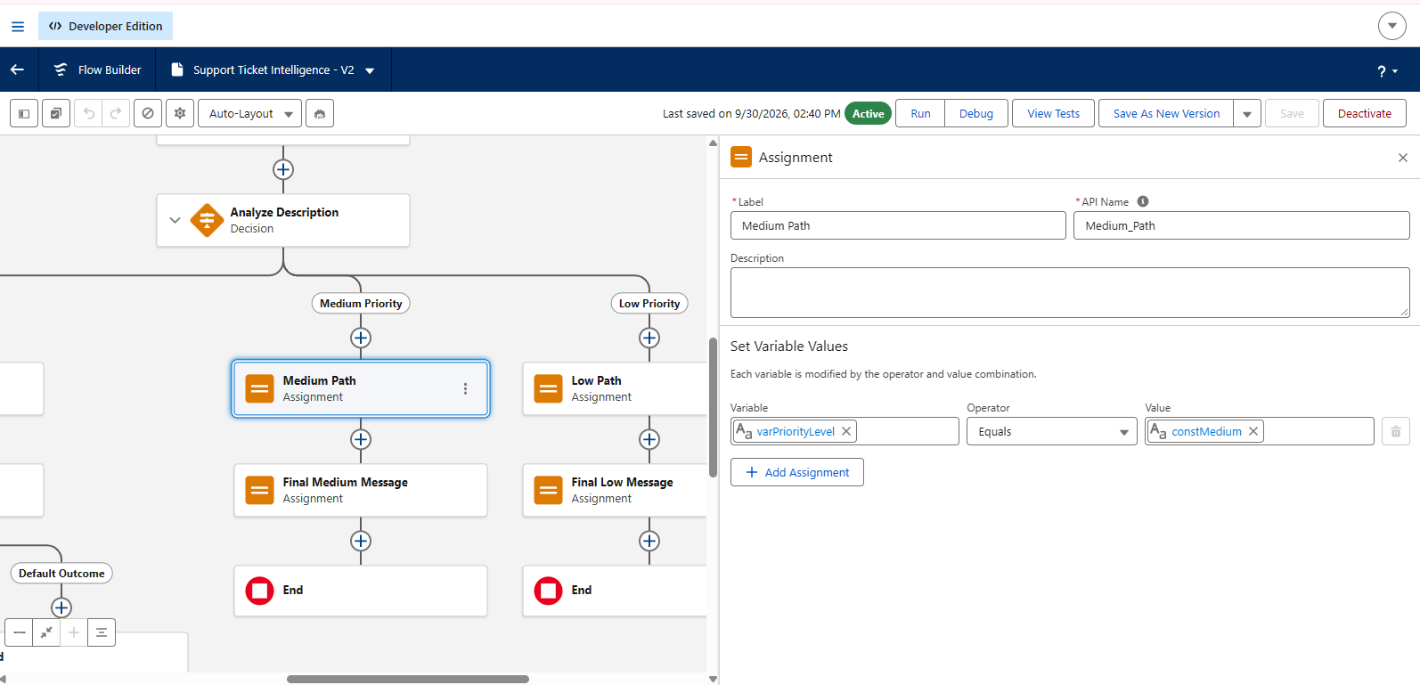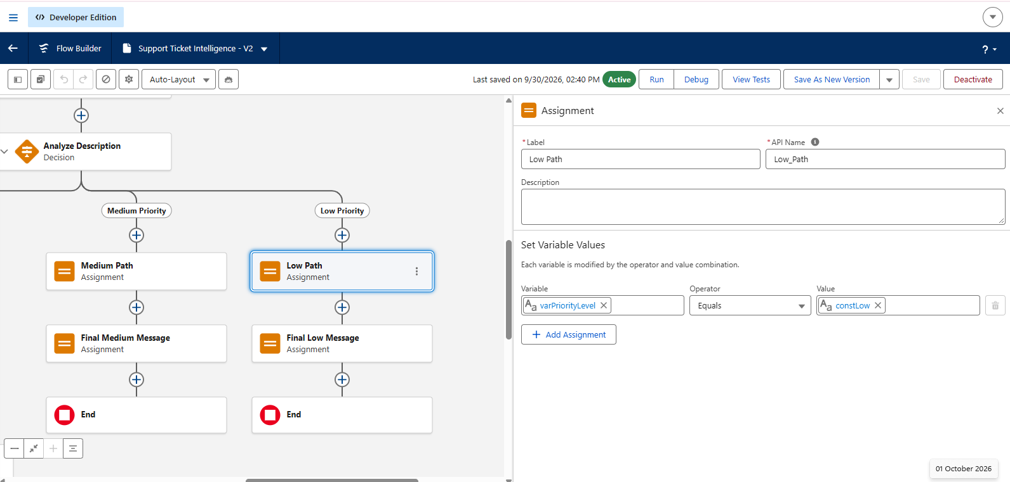

Step 11: Create Task for high-priority tickets
On the high path I added a Create Records element for the Task object with Subject "Urgent Ticket Handling", WhatId {!varTicketId}, Priority High and Status Not Started.
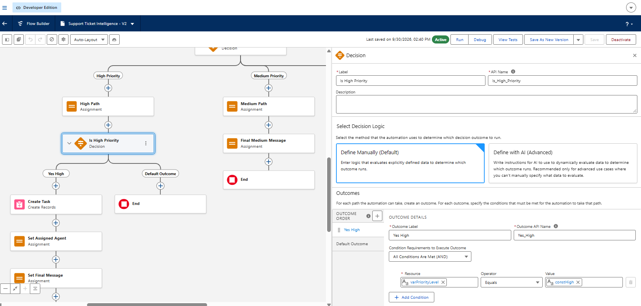
Step 12: Set Assigned Agent
After the task I added an Assignment that sets varAssignedTo to "Senior Support Agent".
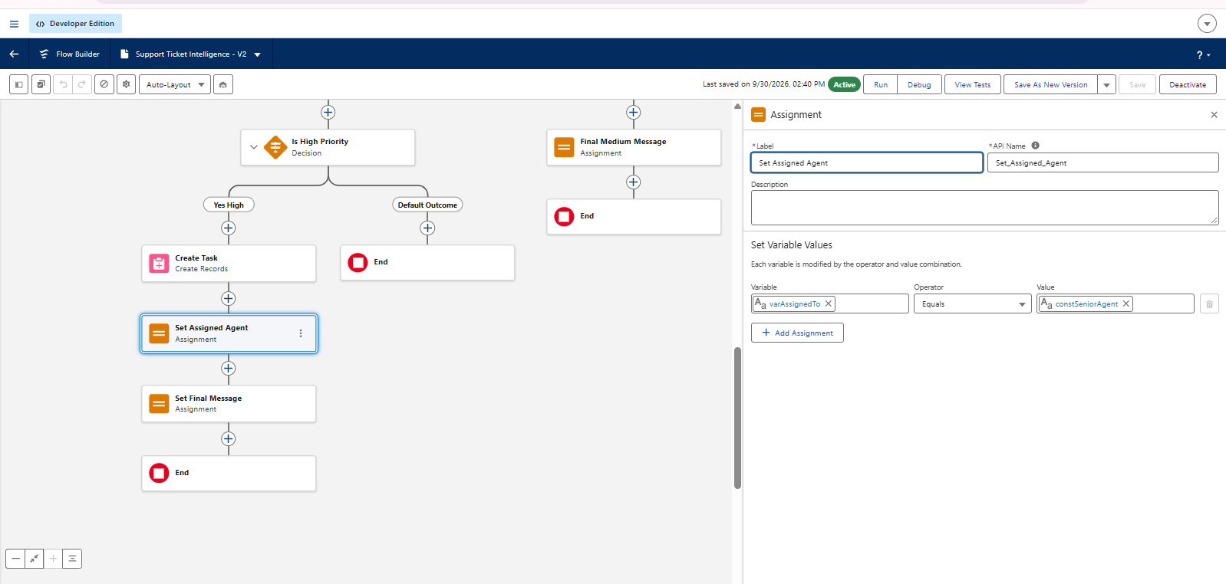

Step 13: Final messages
Each path ends with an Assignment that fills varActionMessage. High: "High priority ticket detected. Assigned to senior agent." Medium: "Ticket marked as medium priority. Will be handled shortly." Low: "Tickets are low priority and queued for processing."
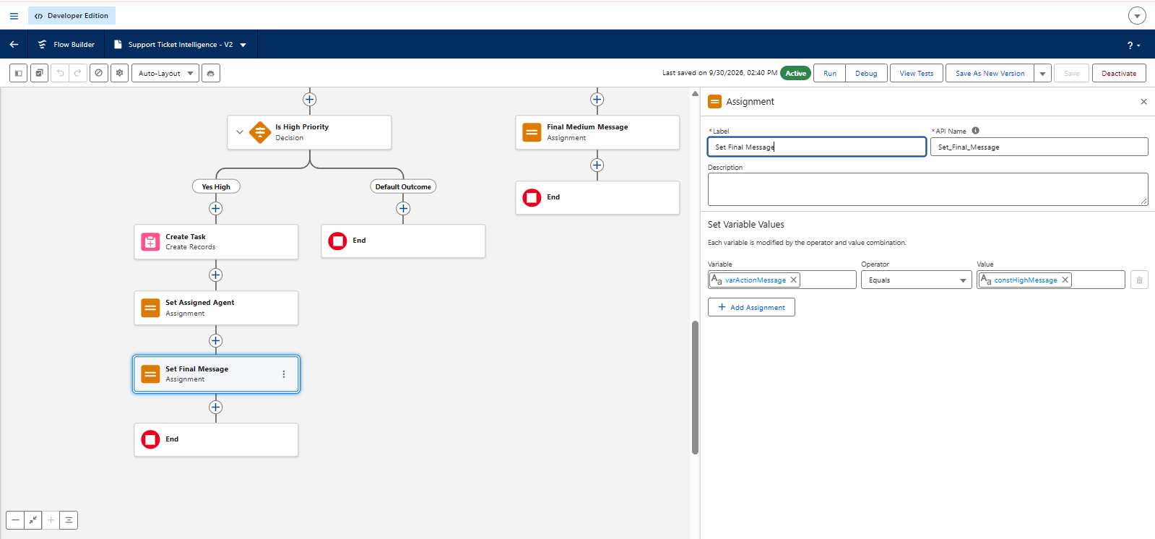

Step 14: Saved and activated the Flow
I saved the Flow with the label Support_Ticket_Intelligence and activated it.
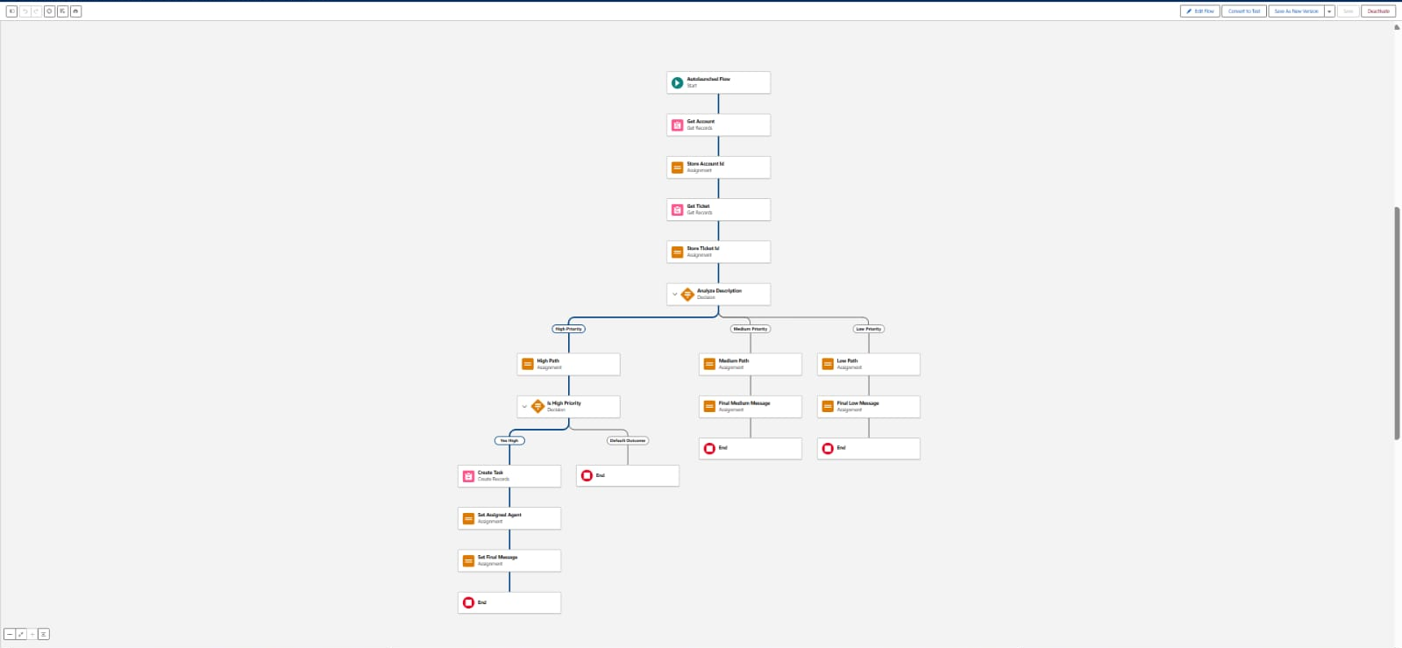

Final flow structure
Start > Get Account > Store Account Id > Get Ticket > Store Ticket Id > Analyze
Description High: Set Priority > Create Task > Set Assigned Agent > Final Message > End
Medium: Set Priority > Final Message > End
Low: Set Priority > Final Message > End

Part C: Configuring Agentforce

Step 15: Enabled Agentforce
I clicked the Setup gear icon and opened Salesforce Go. I searched for "default", selected Agentforce (Default), then clicked Get Started, Turn On and Confirm.
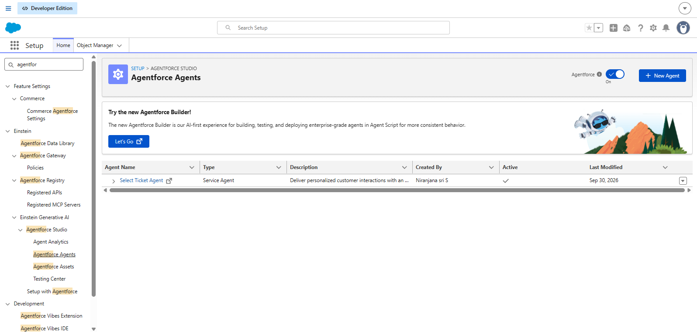

Step 16: Opened the default agent in the builder
In Setup I searched "Agents" in Quick Find, opened Agentforce Agents, made sure Agentforce was switched on, selected Agentforce (Default) and clicked Open in Builder.

Step 17: Created a new subagent (topic)
In the builder I clicked New > New Subagent and then Next. I entered the name Support Ticket Priority Analysis and API name Support_Ticket_Priority_Analysis. The classification description said that the topic analyses support tickets to decide priority from the issue description and urgency. The scope limited the agent to analysing ticket descriptions, deciding High/Medium/Low priority and triggering the automation, and told it not to handle billing, subscription or account update requests.
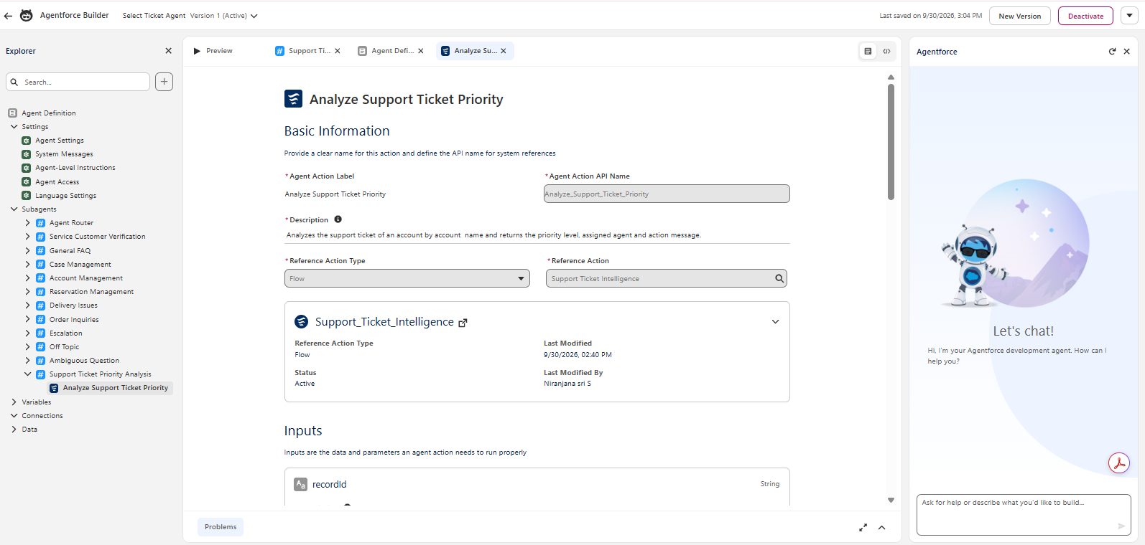

Step 18: Wrote the instructions
In the Instructions box I told the agent to: (1) ask for the Account Name if missing, (2) fetch the latest ticket for the account, (3) read the description, (4) decide priority by keywords (High: urgent, not working, failure; Medium: issue, slow, delay; otherwise Low), (5) set the priority, (6) run the Flow and create a task if High, (7) assign a senior agent for High, (8) reply with a clear message for each priority, and (9) never update records directly or send emails, using the Flow for all actions. I then clicked Next and Finish.
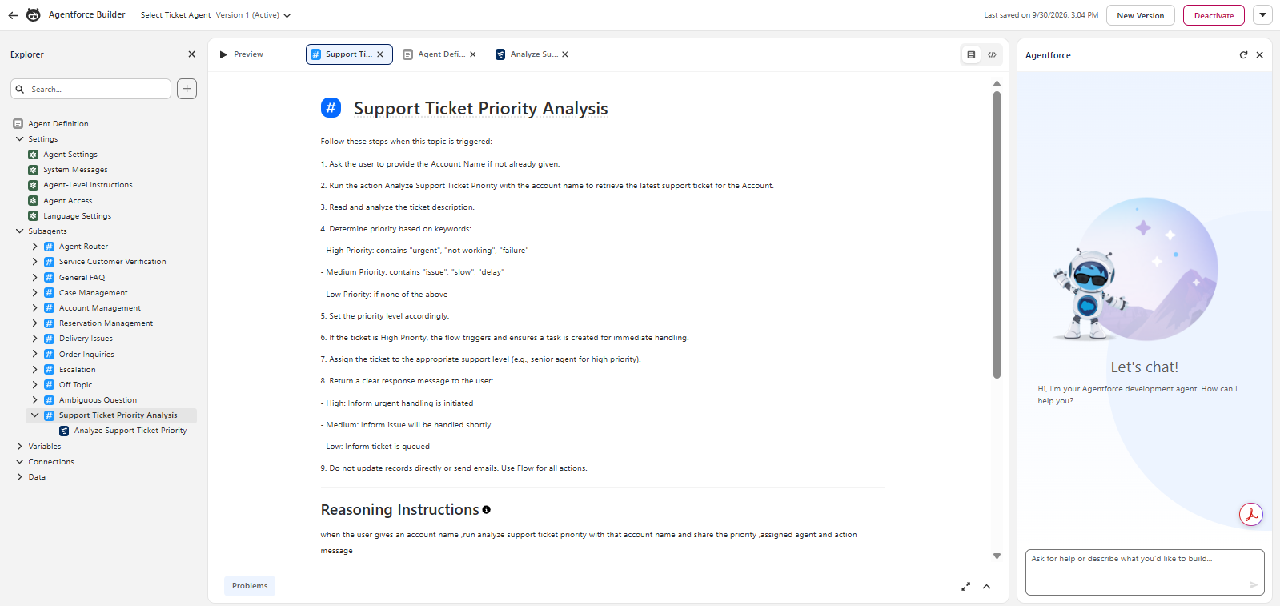

Step 19: Added the Flow as an agent action
I opened the new topic, went to This Topic’s Actions, clicked New > Create New Action, set the Reference Action Type to Flow and selected my Support Ticket Intelligence Flow. I wrote the action description (analyses tickets for the given account, decides the priority and triggers task assignment for high-priority cases) and the loading text "Analyzing ticket details and determining priority...".

Step 20: Configured input and outputs
For the input varAccountName I wrote a description, and turned on Require Input and Collect Data From User. For the outputs varAccountId, varTicketId, varPriorityLevel, varAssignedTo and varActionMessage I added descriptions, enabled Show in Conversation and set Output Rendering to Text. All variables use the lightning__textType data type. Then I clicked Finish.

Part D: Testing

Step 21: Tested in Conversation Preview
I opened the Conversation Preview and asked the agent to analyse a support ticket. The agent asked for the Account Name, I entered it, and the agent ran the Flow and returned the account details, ticket Id, priority, assigned agent and final message. I also checked the ticket record in Salesforce and confirmed that the task "Urgent Ticket Handling" had been created for a high-priority ticket.
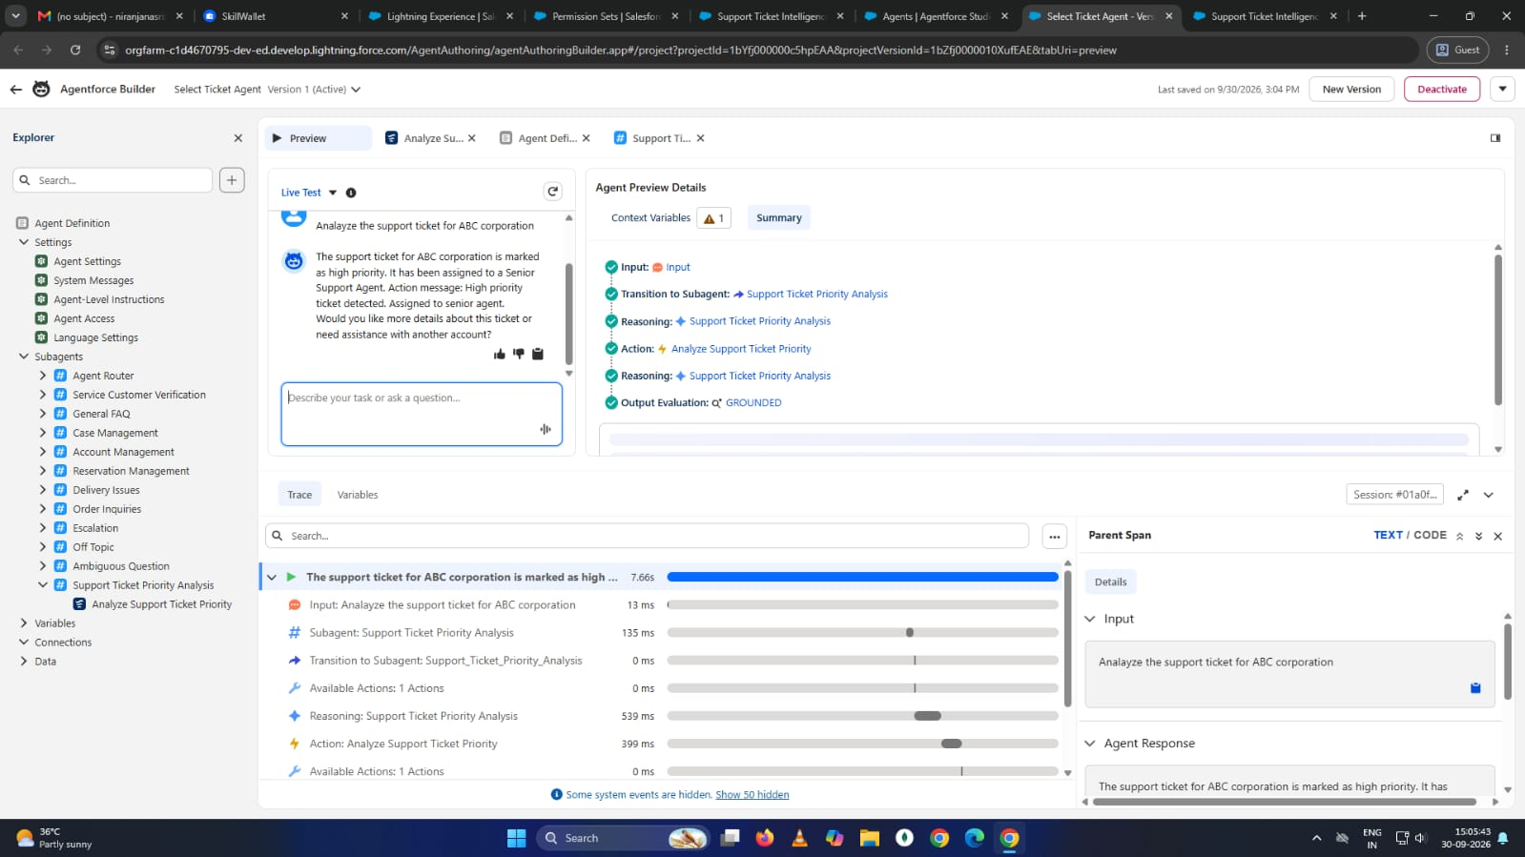

3. Result
- The system takes an Account Name as input.
- It fetches the latest support ticket of that account.
- It analyses the description with keywords and sets the priority.
- It creates a task for urgent tickets and assigns them to a senior agent.
- It returns the result to the user through Agentforce.

4. Conclusion
This project reduced the manual work of sorting and assigning tickets. The Flow handles the logic and Agentforce gives users a simple chat interface to run it. The solution can be extended by adding more Flow variables, updating the priority and SLA fields on the ticket directly, and using AI prompt templates instead of fixed keywords.

