NAME: NIRANJANEE B

ROLL NO: 727721EUCS093

DAY : 10

**SELENIUM-TESTNG**

1, 2, 3)

CODE:

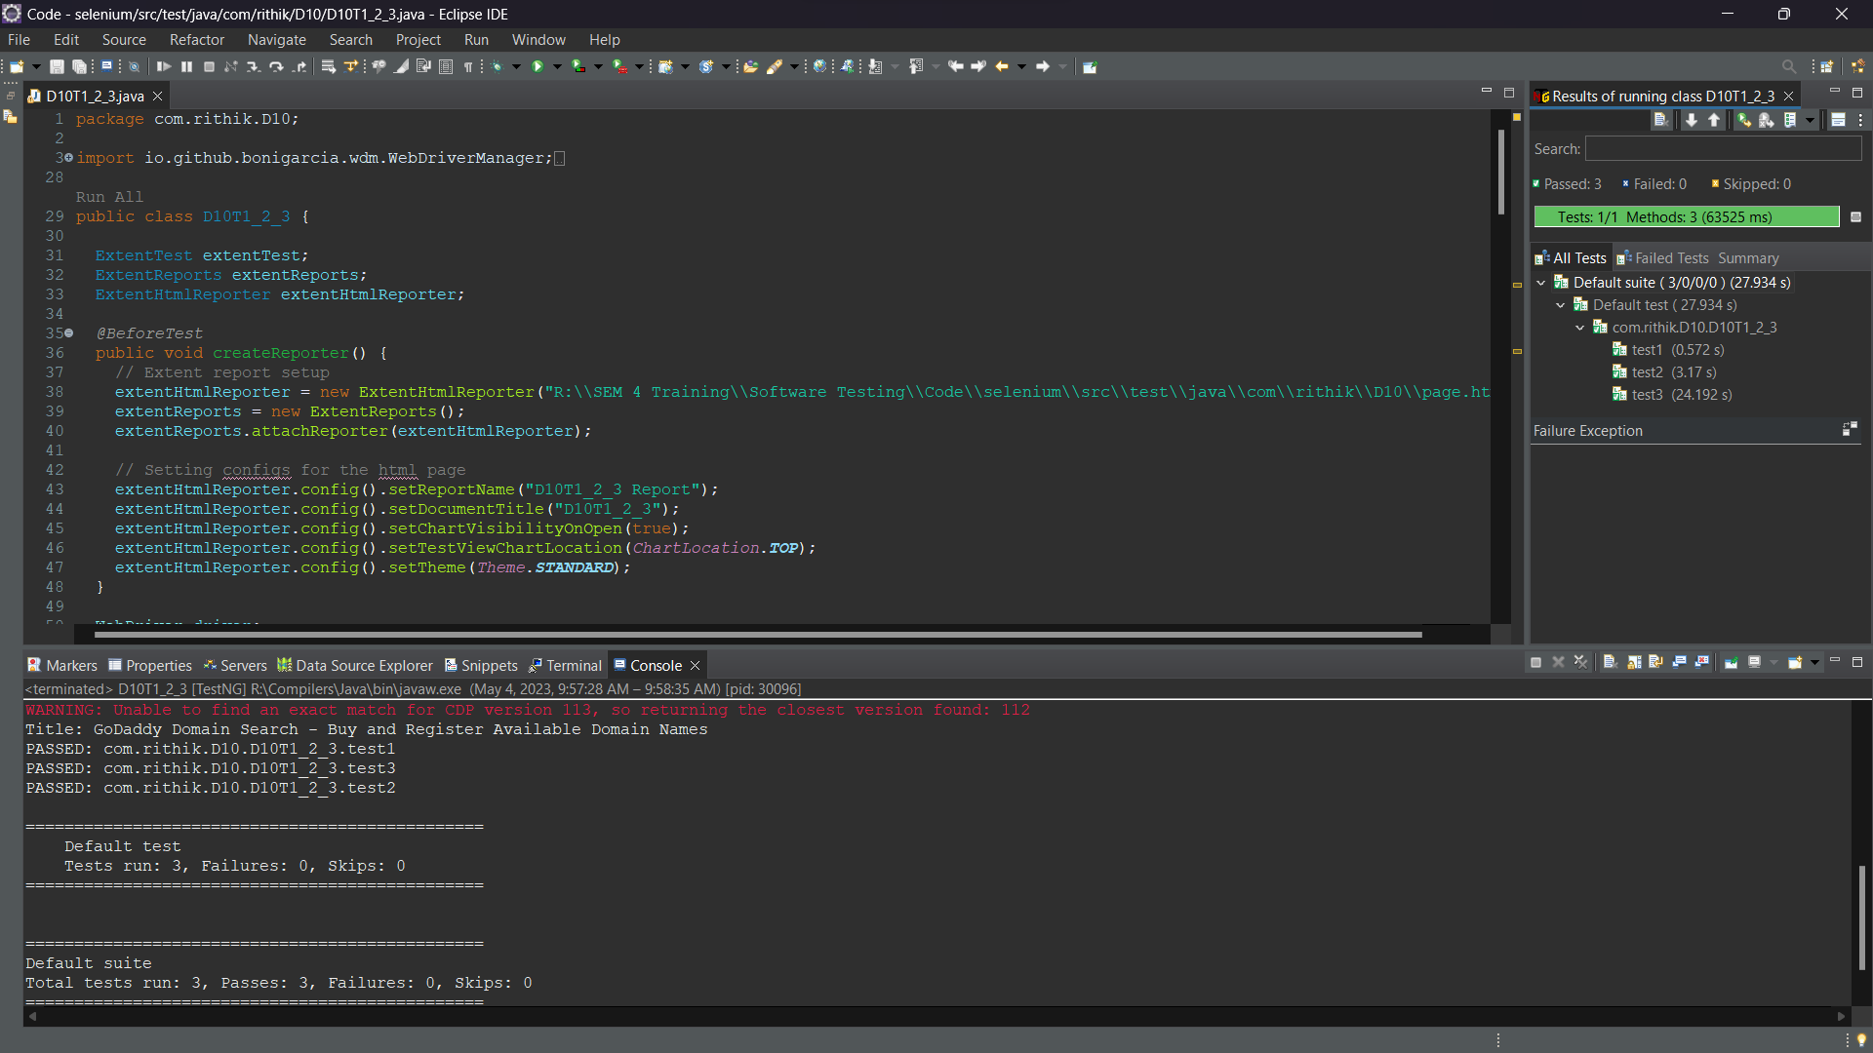

Extent Report :

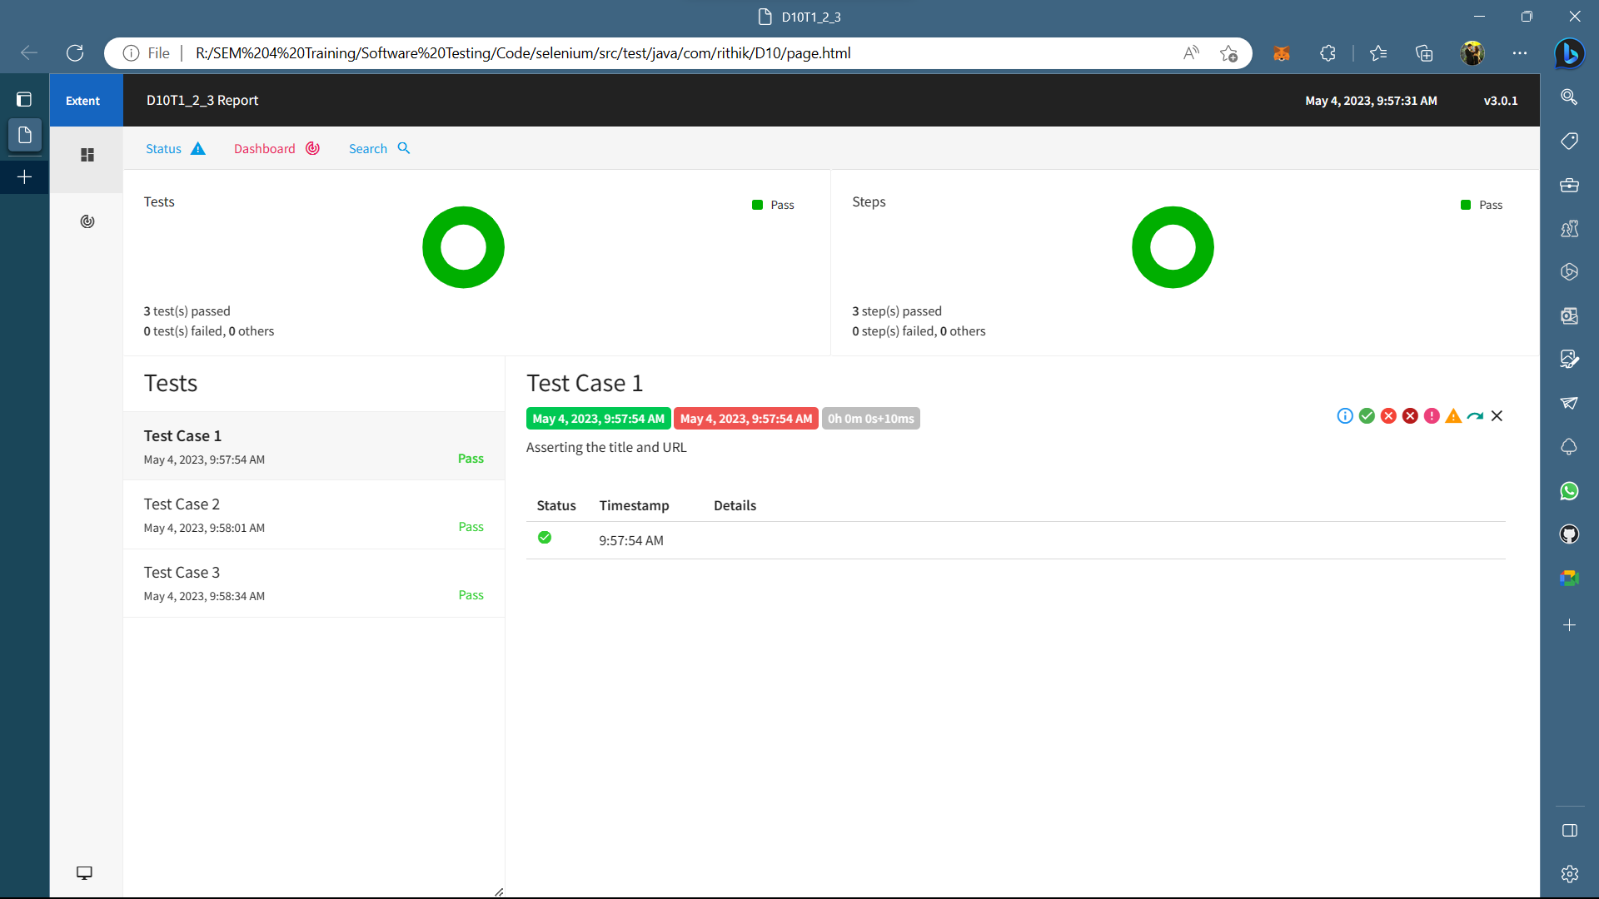

4)

CODE:

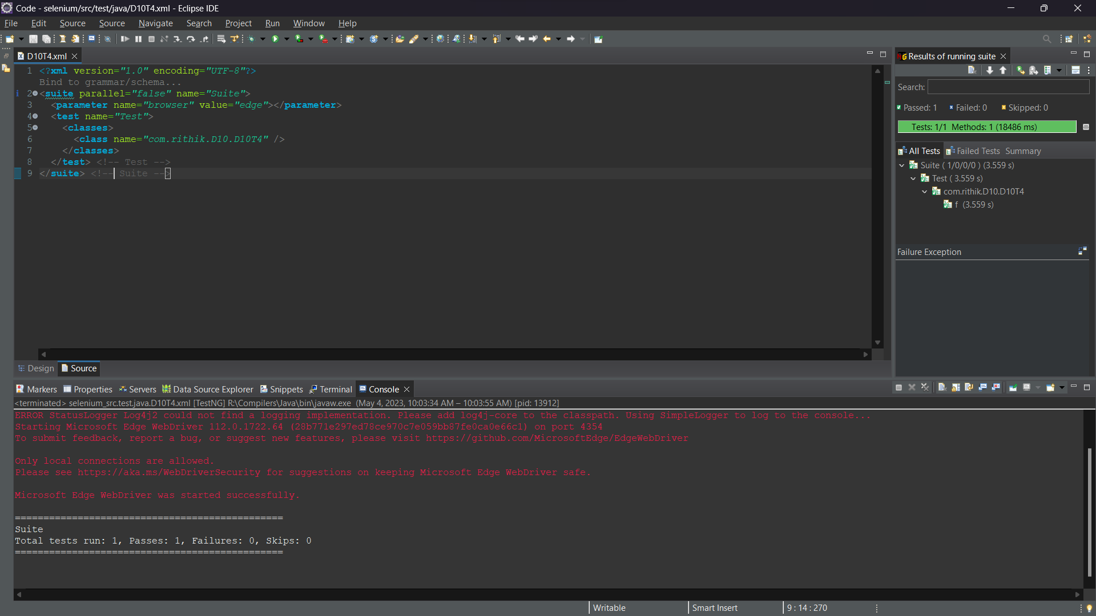

Extent Report:

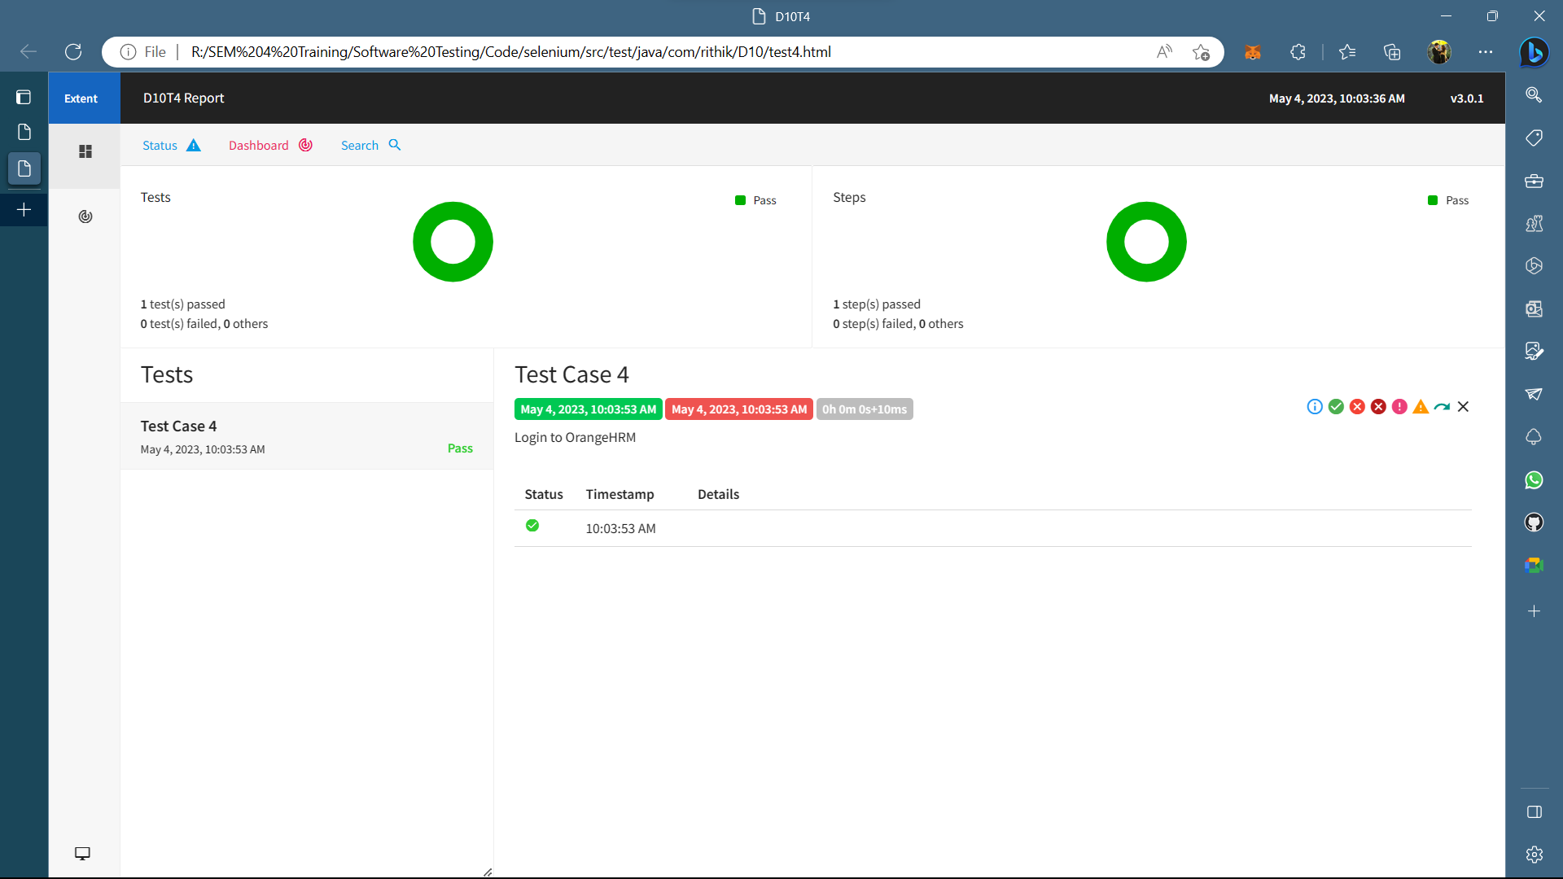

5)

CODE:

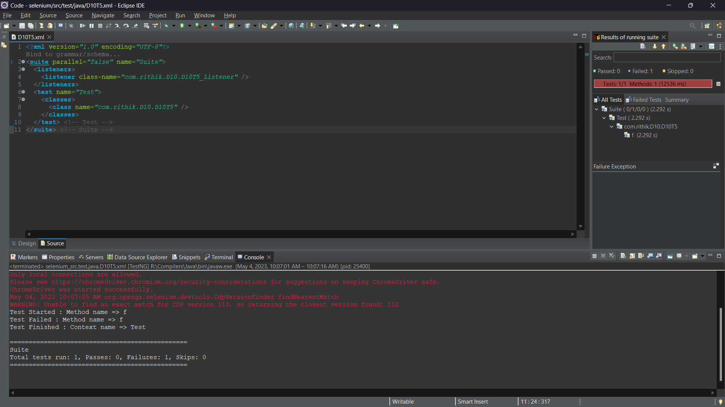

Extent Report:

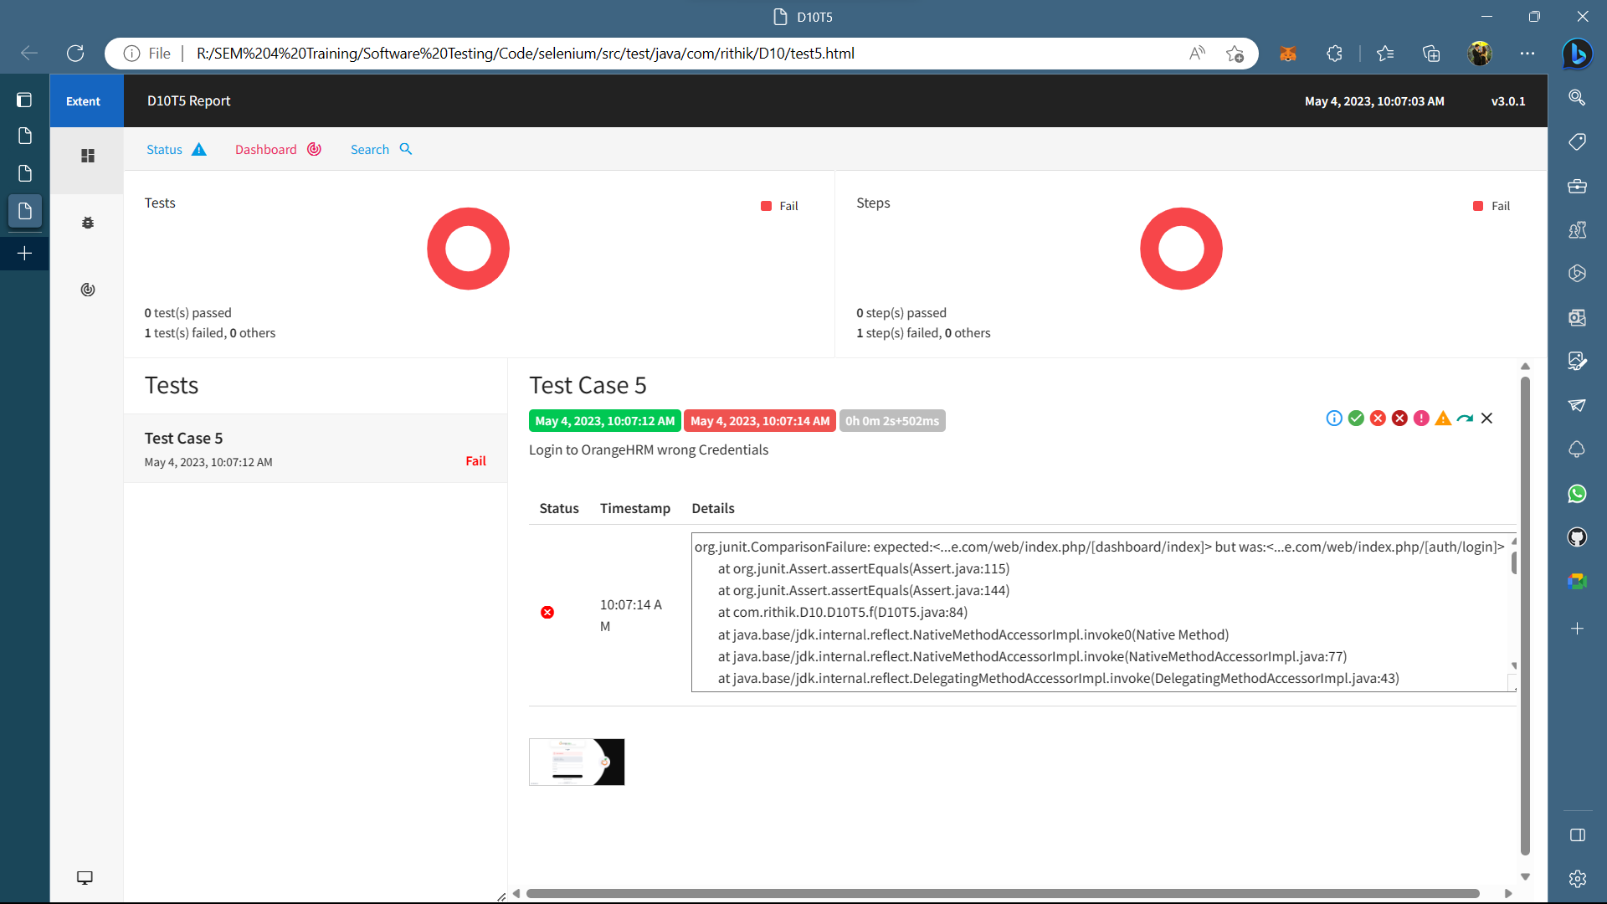

Screenshot of Error:

