NAME:NIRANJANEE B

REG NO.:727721EUCS093

SCHOOL ADMISSION PORTAL

DAY:1

1)USE CASE DIAGRAM:

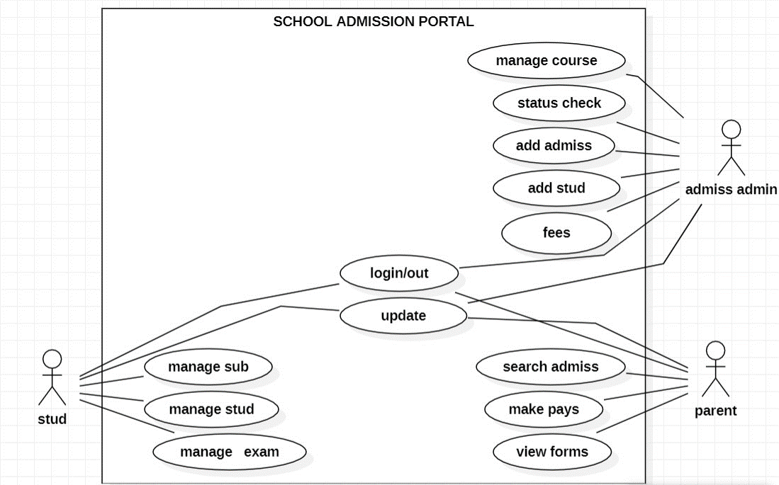

2)SEQUENCE DIAGRAM:

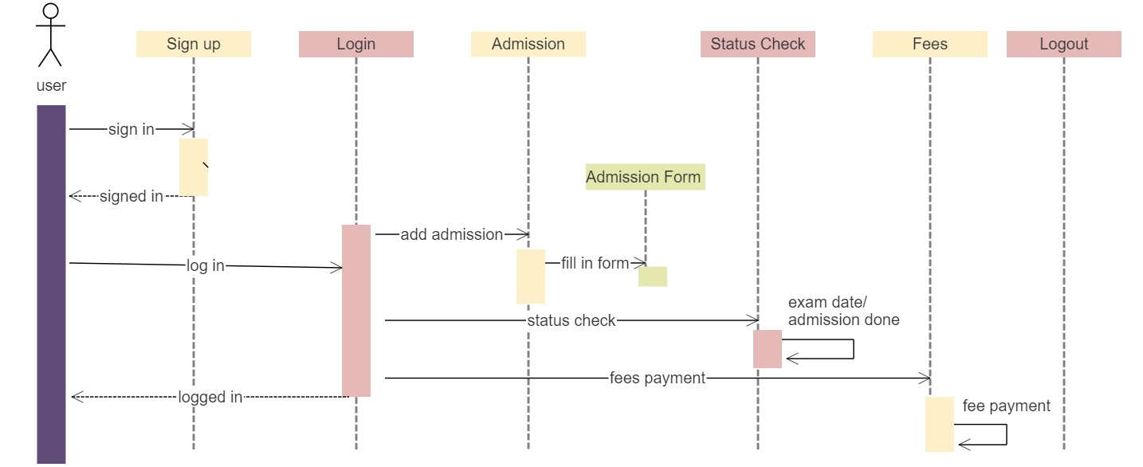

3)CLASS DIAGRAM:

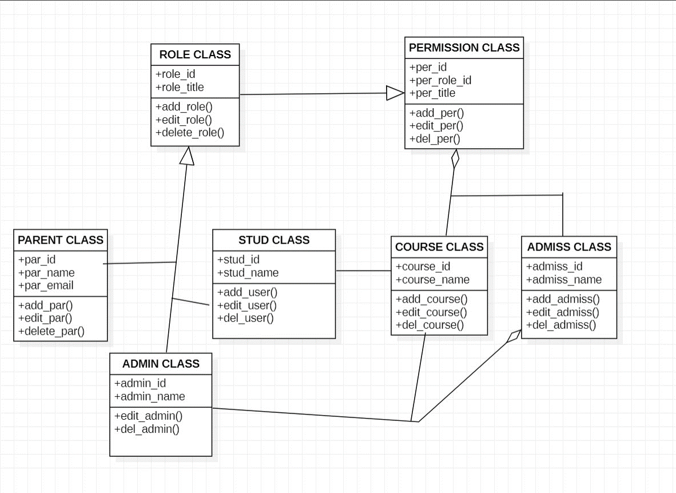

4)

