STQA Mini Project No. 2

**2.1 Title:**

Create a small web-based application by selecting relevant system environment/platform and programming languages. Narrate concise Test Plan consisting features to be tested and bug taxonomy. Narrate scripts in order to perform regression tests. Identify the bugs using Selenium Web Driver and IDE and generate test reports encompassing exploratory testing.

**2.2 Problem Definition:**

Perform Web testing and identify the bugs using Selenium WebDriver and IDE and generate test reports encompassing exploratory testing.

**2.3 Prerequisite:**

Knowledge of Core Java

**2.4 Software Requirements:**

Eclipse photon R latest Version, JAVA 1.8, selenium-server-standalone-3.13.0 Chromedriver.exe

**2.5 Hardware Requirement:**

PIV, 2GB RAM, 500 GB HDD, Lenovo A13-4089Model.

**2.6 Learning Objectives:**

We are going to learn how Identify the bugs using Selenium WebDriver and IDE and generate test reports encompassing exploratory testing.

**2.7 Outcomes:**

You are able to Web Testing using Automation Tool like Selenium Web driver and IDE

**2.8 Theory Concepts:**

**2.8.1 What is Selenium?**

Selenium is a free (open source) automated testing suite for web applications across different browsers and platforms.

Selenium is a suite of software tools to automate Web Browsers.

• It is an Open source suite of tools mainly used for Functional and Regression Test Automation.

Selenium is a free (open source) automated testing suite for web applications across different browsers and platforms.

Lab Practices-2 Fourth Year Computer Engineering

It is quite similar to HP Quick Test Pro (QTP now UFT) only that Selenium focuses on automating web- based applications. Testing done using Selenium tool is usually referred as Selenium Testing.

• Selenium supports various Operating environments.

✓ MS Windows

✓ Linux

✓ Macintosh etc…

• Selenium supports various Browsers.

✓ Mozilla Firefox

✓ IE

✓ Google Chrome

✓ Safari

✓ Opera etc…

Note: Selenium IDE supports Mozilla Firefox only.

• Selenium supports various programming environments to write programs (Test scripts)

✓ Java

✓ C#

✓ Python

✓ Perl

✓ Ruby

✓ PHP

2.8.2 History of the Selenium Project

Selenium first came to life in 2004.

• In 2006, Selenium WebDriver was launched at Google.

• In 2008, the whole Selenium team decided to merge Selenium WebDriver with Selenium RC in order to form more powerful tool called Selenium 2.0

✓ Selenium 1 (Selenium IDE + Selenium RC + Selenium Grid)

✓ Selenium 2 (Selenium IDE + Selenium RC + Selenium WebDriver + Selenium Grid)

**2.8.3 Selenium’s Tools Suite**

Selenium is not just a single tool but a suite of software's, each catering to different testing needs of an organization.

It has four components.

• Selenium Integrated Development Environment (IDE)

• Selenium Remote Control (RC)

• Web Driver

• Selenium Grid

**2.8.4 Brief Introduction Selenium IDE**

It is a Firefox browser plug in, used to create and execute Test cases.

1. Selenium IDE Features:

• Create Test Cases, Test suites (We can Record test cases or type Test steps using element locators and Selenese commands)

• Edit Test Cases

• Execute Test cases, Test suites

• Debug Test Cases.

• Enhance Test Cases

• Export Test cases to other formats (java, ruby etc…)

2. Drawbacks of Selenium IDE

• It supports Mozilla Firefox browser only.

• It doesn’t support Programming logic/features to enhance Test cases.

• It doesn’t support Data Driven Testing.

• It is not suitable for complex test case design.

• No centralized maintenance of Objects/Elements

3. Selenium RC (* Out dated) -Currently, Selenium RC is still being developed but only in maintenance mode.

4. Selenium Web Driver

✓ It is a Programming interface to create and execute Test cases. Selenium IDE has IDE but doesn’t have Programming interface

✓ Selenium Web Driver has Programming interface but doesn’t have IDE

✓ It communicates Directly to the browser.

✓ No need of Separate Server such as RC Server

✓ UFT/QTP has both IDE as well as Programming interface

✓ Faster Execution than IDE & RC

• Selenium WebDriver supports various programming environments to write programs.

✓ Java,

✓ C#

✓ Perl

✓ Python

✓ Ruby

✓ PHP

• Using Element/Object locators/properties and Web driver Methods we can create and execute Test cases.

• Selenium Web driver supports various browsers to create and execute test case/test script/test

• Selenium Web Driver supports various operating environments

✓ MS Windows

✓ Linux Macintosh etc…

Drawback of Selenium Web Driver

• It doesn’t generate detailed Test Reports.

• No centralized maintenance of Object/elements

• It require Programming Knowledge

• cannot support the readily new browser

• Installation is More Complicated than Selenium IDE

• No built-in mechanism for logging runtime message

5. Selenium Grid

• Selenium Grid is used to execute tests across multiple browsers, operating environments and machines in parallel.

• Selenium Grid 2 supports Selenium RC Tests as well as Selenium Web Driver Tests.

i) Selenium Web Driver to create Test cases using element locators and Web driver methods.

ii) Java Programming to enhance test cases.

iii) TestNG Framework to group test cases, execute test batches and generate detailed test reports. Features:

• Enables simultaneous running of tests in multiple browsers and environments.

• Saves time enormously.

• Utilizes the hub-and-nodes concept. The hub acts as a central source of Selenium commands to each node connected to it.

Note on Browser and Environment Support

• Because of their architectural differences, Selenium IDE, Selenium RC, and WebDriver support different sets of browsers and operating environments.

Selenium IDE Web Driver

Browser

Mozilla

Internet Explorer versions 6 to 11, both 32 and 64-bit

Support

Firefox

Microsoft Edge version 12.10240 & above (partial support some)

Firefox 3.0 and above Google Chrome 12.0 and above Opera 11.5 and above Android - 2.3 and above for phones and tablets (devices & emulators)

IOS 3+ for phones (devices & emulators) and 3.2+ for tablets (devices & emulators)

Html Unit 2.9 and above Operating Windows, Mac All operating systems where the browsers above can run. System OS X, Linux

2.8.5 How to Choose the Right Selenium Tool for Your Need

Tool Why Choose?

• To learn about concepts on automated testing and Selenium, including:

• Selenese commands such as type, open, click And Wait, assert, verify, etc.

• Locators such as id, name, xpath, css selector, etc.

• Executing customized JavaScript code using run Script Selenium IDE

• Exporting test cases in various formats.

• To create tests with little or no prior knowledge in programming.

• To create simple test cases and test suites that you can export later to RC or Web Driver.

• To test a web application against Firefox only.

• To design a test using a more expressive language than Selenese

• To run your test against different browsers (except Html Unit) on different Selenium RC operating systems.

• To deploy your tests across multiple environments using Selenium Grid.

Tool Why Choose?

• To test your application against a new browser that supports JavaScript.

• To test web applications with complex AJAX-based scenarios.

• To use a certain programming language in designing your test case.

• To test applications those are rich in AJAX-based functionalities. Web Driver

• To execute tests on the Html Unit browser.

• To create customized test results.

• To run your Selenium RC scripts in multiple browsers and operating systems Selenium Grid.

• To run a huge test suite, that needs to complete in the soonest time possible.

**2.8.6 Advantages of Selenium**

i) It is an Open source Software.

ii) It supports various Operating environments (Windows, Linux, Mac etc…)

iii) It supports various browsers (IE, Mozilla Firefox, Chrome, safari, Opera etc…)

iv) It supports various programming environments (Java, Perl, Python, Ruby and PHP)

v) It supports parallel Test execution.

vi) It uses less Hardware resources.

**2.8.7 Disadvantages of Selenium**

i) It supports Web based Applications only.

ii) No reliable support from anybody.

iii) No centralized maintenance of Elements/objects

iv) Difficult to setup environment.

v) Difficult to use.

vi) Limited support for Image based testing.

vii) New features may not work properly.

viii) No other tool integration for test management & No built in Reporting facility.

Lab Practices-2 Fourth Year Computer Engineering

**2.8.8 Selenium versus UFT**

Selenium UFT / QTP

1) Open Source Vendor tool, License is required.

2) Supports various OS Environments.MS Windows only.

3) Supports various programming Environments VBScript only.

4) No Object Repositories Local and Shared object Repositories.

5) No built-in Reporting feature. Built in reporting feature.

6) Selenium Web Driver has no IDE and Selenium UFT has both IDE and Programming IDE has no Programming Interface. Interface.

7) Uses less Hardware resources. Uses more Hardware resources

8) Difficult to setup environment and use. Easy to setup and use.

9) Limited support for Image Testing Rich support for Image Testing

10) No Reliable support from HP

11) No other tool integration for Test UFT can be integrated with ALM/QC for Test management.

12) New features may not work properly. New features will properly.

13) No Adding for supporting Application Adding are required for supporting Environments. Application environments.

14) Supports Web Applications only Supports Desktop and Web Applications.

15) No Authorized Certification Authorized Certification program.

**2.8.9 What is TestNG?**

TestNG is a powerful testing framework, an enhanced version of JUnit which was in use for a long time before TestNG came into existence. NG stands for 'Next Generation'.

TestNG framework provides the following features −

• Annotations help us organize the tests easily.

• Flexible test configuration.

• Test cases can be grouped more easily.

• Parallelization of tests can be achieved using TestNG.

• Support for data-driven testing.

• Inbuilt reporting.

**2.8.9 Step by Step Tutorial**

1. First of Download Latest Eclipse java photon-R version.

2. Download latest selenium-server-standalone-3.13.0 jar File from following link https://www.seleniumhq.org/download/ here on site 3.14.0 version is latest

3. Download and Extract geckodriver.exe for windows on any drive of computer. https://github.com/mozilla/geckodriver/releases here 2.42 is latest version

4. After Download Extract same on any Drive here I extract on C Drive and my path of that exe file is C:\geckodriver_win64 it will look as follows:

5. Now Open Eclipse IDE-----> Create Java Project- →

Right Click Project Name →

Properties

→

Java

Build Path

→

Libraries

→

Add External JAR →

add selenium-java-3.14.1 jar

→

Apply and Close.

6. Now Want Open the Firefox browser with index2.html page via Selenium Web driver Java Coding so here we need to write Java Code in Class file which we already created

7. Here in My Program

I Created Demo1 Java Project Folder name and Test.java is my class file so write java code in this class file:

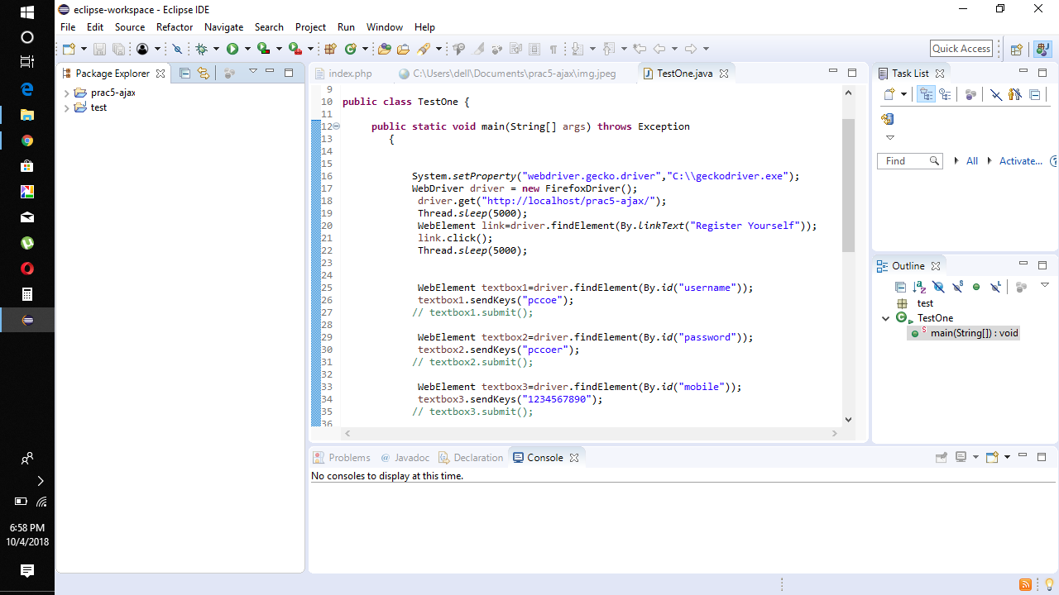

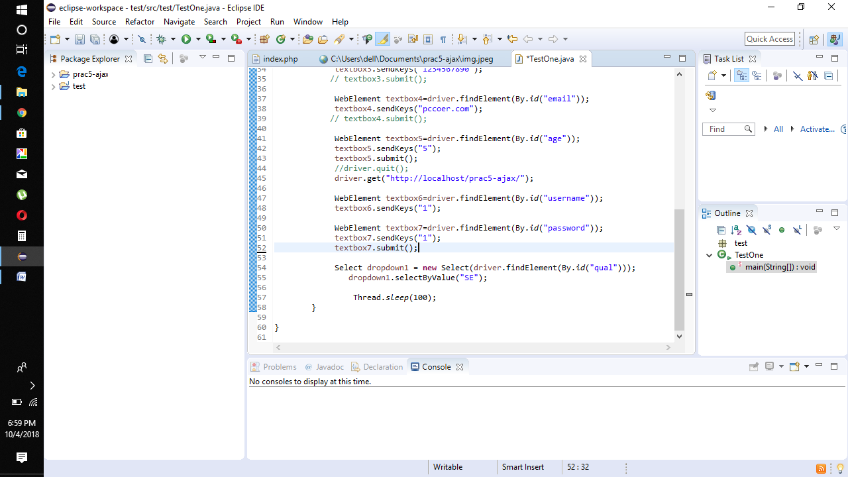

8. Right click on java program, select Run As and > "Java Application".

9. Now the Firefox browser will open and the first page i.e. the Home page will open:

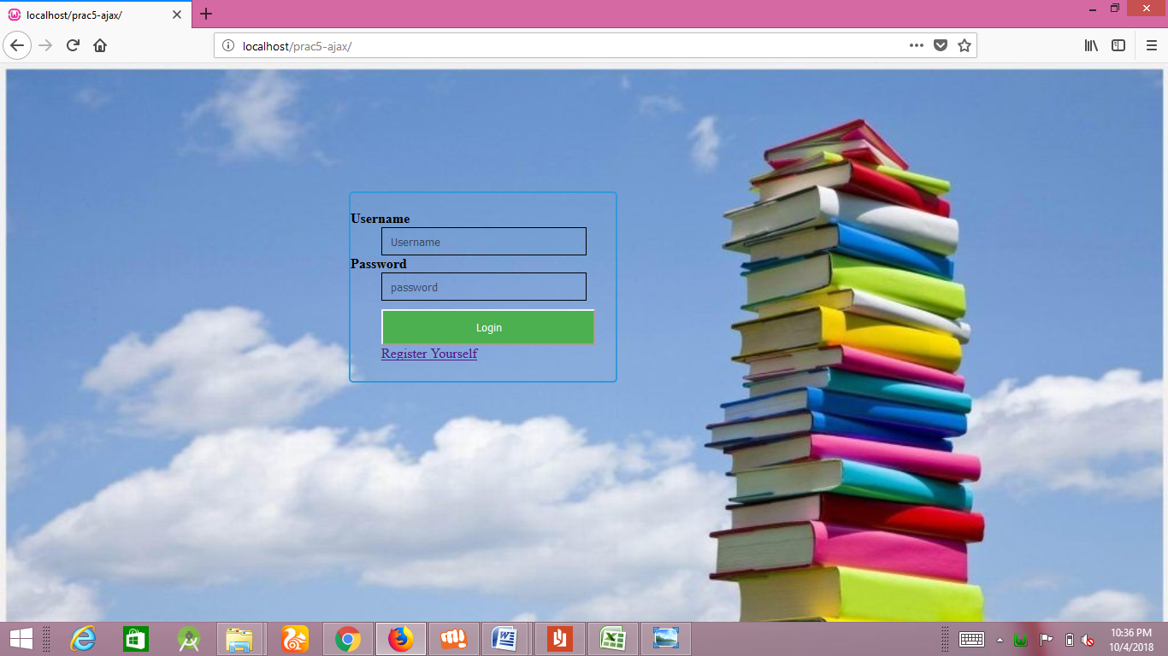

10. The next page that will open as follows:

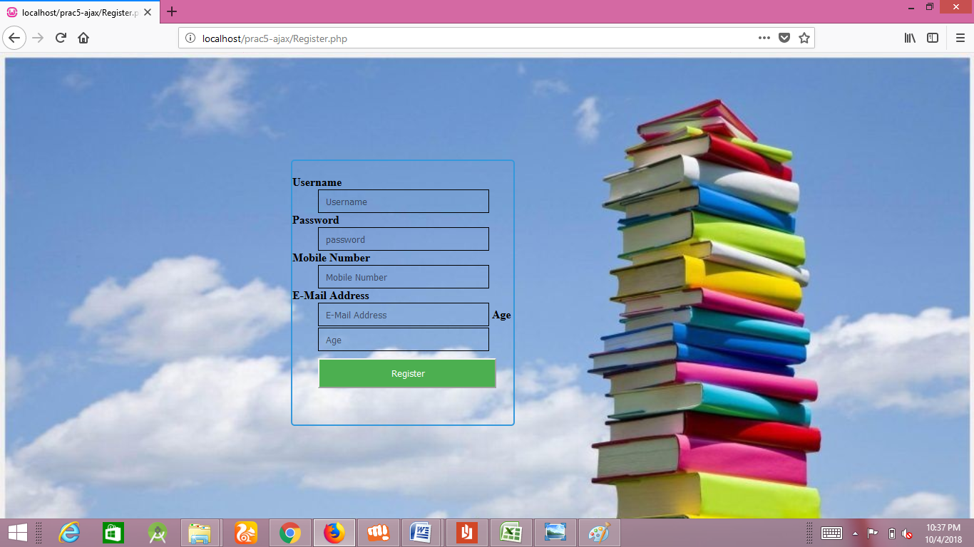

11. The next command is to open a link as follows:



**2.10 Conclusion**

In this way we have learned how to use Selenium Open Source Tool for perform Automation Testing on web based application.