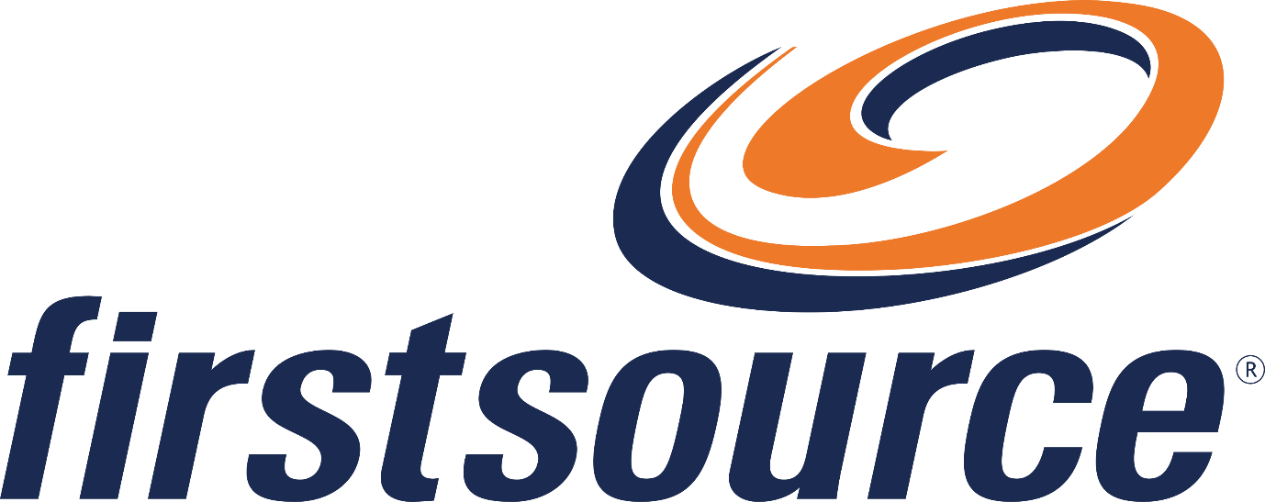

Acme Bank Analyst RFI Response
Firstsource response covering liability, model strategy and innovation footprint.
3 questions answered.

Source documents
- ClientRFI.docx
- Capabilities.pptx

32-38 | 8 | >99%
GenAI engagements | Innovation labs | Compliance accuracy
25+
Years domain depth

Overview
Three questions answered across two source documents.
- Kairos delivers Intelligence that Operates.
- Governed Autonomy throughout.
Key takeaway
Outcome accountability is underwritten.

Responses
Answers preserve the client's original numbering.

Q1. Describe your liability and indemnification model
Liability is capped at 12 months of service fees, direct damages only.
Firstsource carries E&O and cyber-liability insurance.

Q7. Do you build foundational models?
Firstsource does not build foundational LLMs. It builds domain-specific models.

3.2(a). What is your innovation lab footprint?
Eight labs and 95 FTE, with 12+ proprietary solutions in the past 12 months.

Capabilities
Portfolio detail.
Area | Detail
Generative AI | 32-38 engagements
Agentic AI | 16-22 engagements

Sources
What each uploaded document contributed.
- ClientRFI.docx - supplied the questions.
- Capabilities.pptx - supporting evidence.

