**KATHFORD INTERNATIONAL COLLEGE OF**

**ENGINEERING AND MANAGEMENT**

Balkumari, Lalitpur

A

Minor Project Proposal

On

**“CHARACTERS AND NUMBER RECOGNITION OF RESULT PAPER USING MACHINE LEARNING”**

[Subject Code: EX654]

**Project Members**

Bharat Karki (003/BEX/2074)

Niranjan Tamang (007/BEX/2074)

Sagar Shrestha (011/BEX/2074)

**DEPARTMENT OF COMPUTER AND ELECTRONICS &**

**COMMUNICATION ENGINEERING**

**LALITPUR, NEPAL**

**JANUARY 2020**

Abstract

In this world advancing with innovation, everybody likes to spare time and lessen dreary work. Also, the storage of proper information is crucial. So, to create an efficient way of managing text and numbers, we have used OCR using machine learning algorithm for text and number conversion. The aim of this project is to create numbers and Character Recognition that converts English letters and numbers into digital format and make mark sheet. The main focus of this project is to decrease the delay time that was required for making the mark sheet of student’s exam results which indirectly helps in the student’s academics. Unlike taking a photo, the symbol number, marks, subject name will be stored in database which will be then used to make the mark sheet. The main motive for working on this project is to create a value, save time and reduce repetitive work. Talking about the procedure the text and numbers is scanned which is further noise reduced, skew corrected, gray scaled and other filtering process that makes the scanning process fast and error free. A photo of mark sheet will be captured with the help of pi Camera and raspberry pi microcontroller. Then the scanned text and number is converted to digital format. So, the final converted format (i.e. Text (subject), number (symbol number, marks etc.) can be saved in the database and later the data stored in the database will be used to make mark sheet. This application allows academics section of Nepal to spend less amount of time to make the marks sheet instead of taking huge amount of time in making mark sheet. In terms of market use it can be used by all the academics section such as SLC board, NEB, University, colleges and many more.

**Keywords:** Number and Character Recognition, Pi Camera, Digitalization, Machine Learning algorithms, Optical Character Recognition

Table of Contents

Abstract i

Table of Contents ii

List of Figures iv

List of Tables v

List of Abbreviations vi

1 Introduction 1

1.1 Background 1

1.2 Problem Statement 1

1.3 Objectives 2

1.3.1 Main Objective 2

1.3.2 Specific Objectives 2

2 Literature Review 3

3 Feasibility Study 5

3.1 Technical Feasibility 5

3.2 Financial Feasibility 5

3.3 Schedule Feasibility 5

3.4 Operational Feasibility 6

4 Project Methodology 7

4.1 Block Diagram 7

4.2 Flow Chart 8

5 Implementation Plan 9

5.1 Schedule 9

5.2 Hardware and Software Requirements 10

5.2.1 Hardware Requirements 10

5.2.2 Software Requirements 10

6 Expected Outcomes 11

7 Cost Estimation 12

References 13

List of Figures

Figure 4.1 Block Diagram 7

Figure 4.2 Flow Chart 8

List of Tables

Table 5.1 Gantt Chart 9

Table 7.1 Cost Estimation Table 12

List of Abbreviations

JPEG Joint Photographic Experts Group

ML Machine Learning

OCR Optical Character Recognition

PNG Portable Network Graphics

SVM Support Vector Machine

# Introduction

## Background

OCR is a conversion of handwritten or any text into machine encoded text. It is a technology that enables us to convert different types of documents, such as scanned paper documents, PDF files or images captured by a digital camera or phone into editable and searchable data. It is able to recognize text in images and convert it into editable text by going through a simplified process. This conversion can be electronic or mechanical. It is used in data entry for paper documents like passport, business cards, receipt and so on which can be stored compactly in a digital format that can later be edited which helps in document management. This technology is very useful since it saves time without the need of retyping the document. It can perform the actions in a few minutes.

The modern English alphabet is a Latin alphabet consisting of 26 letters, each having an upper and lower-case form. A character is any mark or symbol that can appear in writing. A letter is a character that is part of an alphabet. Basically, a character that represents a sound in the language and that can be combined with other characters to form words. Number is a mathematical object used to count, measure, and label. Number can be used to calculate the marks in exam paper.

The main goal of this project is to convert mark sheets paper which consists of handwritten marks, symbol number, subject into text and number in a digital format which can be stored in database and can be used to create result paper.

## Problem Statement

Optical Character Recognition would be very much appropriate for the characters and number recognition of result paper with much faster and efficient outcome. As compared to the traditional methods of recording alphanumeric character, typing is done manually. Handwritten alphanumeric characters may be difficult to be recognized by recorder and multiple times checking of numbers is required which requires more time. So, OCR is more favorable for scanning marks and symbol numbers and storing it in database in mark sheet format which is more efficient and accurate compared to tradition methods. Besides that, there are also some problems seen in the OCR projects done earlier. OCR is still in the field of research area. Sometimes there may be delay in academic mark sheets of national level examinations which may result in many issues and problems such as students may not be able to get admission in school and colleges on time and there will be gap in their academic progression which will hamper students’ academic study and career.

## Objectives

### Main Objective

* To design and develop a system for characters and number recognition of result paper using machine learning.

### Specific Objectives

1. To capture the alphanumeric characters using pi camera
2. To implement Support Vector Machine (SVM) algorithm to recognize characters and numbers on the raspberry pi.
3. To train the system using various data sets.
4. To store the detected data (symbol number and marks) into database and create the mark sheet.

# Literature Review

Rachit Adhvaryu [1] described about the OCR. According to him OCR is the process of classification of optical pattern contained in a digital image corresponding to alphanumeric characters. OCR Technology allows us to convert scanned documents, pdf files and images from digital camera to editable and readable form. It is also described as the different technique used for speech recognition, optical mark reading, online character recognition and offline character recognition etc.

M. Jordan [2] described in this book about the concept on recognition system and machine learning helpful for the different type of modeling system. Richard O. Duda [3] described how to implement the modeling system on different type of design cycle to help for design algorithm.

Computer vision is the science and technology of machines that machine is capable to extract the information from the information such as numbers, text and many more to solve some task. Alphanumeric recognition system can recognize almost all the letters and numbers correctly and their respective locations as they appear in the image. In general, alphanumeric recognition is classified into two types as off-line and online handwriting recognition methods. In the off-line recognition takes the raster image from the scanner (scanned images), digital camera. The image is binarized based on for instance, color pattern (color or gray scale) so that the image pixel is either 1 or 0. But, in case of on-line character recognition, the current information is presented to the system and recognition is carried out at the same time. Basically, it accepts the string of (x, y) coordinate pairs from an electronic pen touching a pressure sensitive digital tablet. Adaptive Template matching and Feature Extraction using curvelet transform can be used to recognize the alphanumeric character [4].

Text characters are often in different scale in the documents to give an importance and also the character could also appear in different orientation other than the usual horizontal and vertical direction. Partha [5]used the convex Hull based approach for multi-oriented character recognition from the graphical documents. A Support Vector Machine (SVM) classifier has been used for recognition purpose.

Alphanumeric recognition results vary a bit from different types of classifiers. Classifier like Projection distance (PD), Subspace method (SM), Linear discriminant function (LDF), Support vector machines (SVM), Modified quadratic discriminant function (MQDF), Mirror image learning (MIL), Euclidean distance (ED), Nearest neighbor, k-Nearest neighbor (k-NN), Modified Projection distance (MPD), Compound projection distance (CPD), and Compound modified quadratic discriminant function (CMQDF) are there [6]. For recognition purpose, four sets of features are there(two are from binary and two are from gray-scale image). Most of the case we use the binary dataset, but our data set is grey scale, to get the feature on the binary images we convert the gray-scale image into binary using Otsu method.

Sometimes photo we click may be blurring artifacts, varying illuminations, changing background due to which some of recognition system may not work properly, so this above problem can be efficiently solve by using stroke width transform [7]. At first, pre-processing of the image is done to remove blurring artifacts. Then the significant edges in the image are detected and new image is formed by grouping the connecting rays.

# Feasibility Study

## Technical Feasibility

All the technical resources required for the project including hardware parts and software are easily available in the market. Also, most of the equipment that is required for the project is there within the reach of college’s Electronics Lab. And there must not be a problem for us to get those things that are required for the project. Evaluating the technical feasibility is the most intricate part of the feasibility study. Here, as we will be making an OCR using python and mat lab. For making an OCR application, the image preprocessing (Noise Reduction, Skew correction, Gray scaling, Thresholding) will be done by using OpenCV. The segmentation part (Page Segmentation, box segmentation and Character Segmentation) will also be done by OpenCV and the Character classification will be done by using Neural Networks and Machine Learning techniques We just need Rasp Bain OS. Since our project does not require many resources and technical requirements it can be operated easily.

## Financial Feasibility

The project we are going to work on is economically feasible and is within the range of affordable expenditure as most of the equipment and electronic devices are already available. Once the system setup is done and it starts functioning as it is supposed to, then all the expenses that are made during the project would look worth it. A simple financial analysis which gives the actual comparison of costs and benefits are much more meaningful in every project. This gives the top management economic justification for the new system. Since we do have to use few hardware components in our project so, the total cost for our project is very low which makes it financially feasible and easy to complete within deadline.

## Schedule Feasibility

The project is currently in the analysis and requirement gathering phase. So, in 9 months, the project is expected to be completed within the proposed schedule.

## Operational Feasibility

Our final project will need the computer and raspberry pi controller with internet connection to utilize it. The result will be in PDF form that contains the mark sheets of students.

# Project Methodology

## Block Diagram

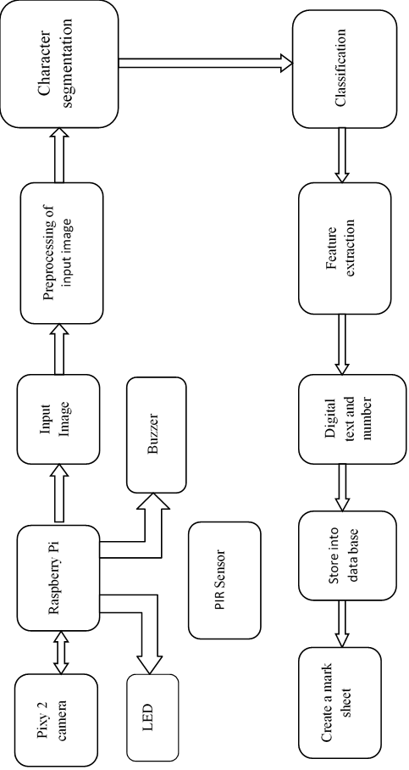

**Figure 4.1 Block Diagram**

## Flow Chart

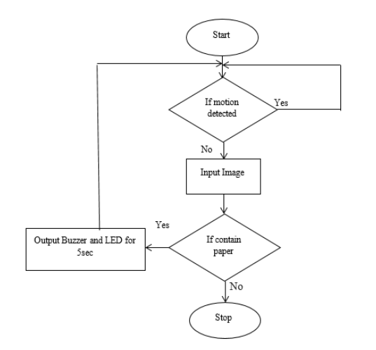

**Figure 4.2 Flow Chart**

# Implementation Plan

## Schedule

**Table 5.1 Gantt Chart**

|  |  |  |  |  |  |
| --- | --- | --- | --- | --- | --- |
| **S.N.** | **ACTIVITY** | **JAN-MAR** | **MAY-JUN** | **JUL-AUG** | **SEPT-OCT** |
| 1 | Feasibility Study |  |  |  |  |
| 2 | System specification |  |  |  |  |
| 3 | Requirement Analysis |  |  |  |  |
| 4 | Design  Hardware Interface with Microcontroller |  |  |  |  |
| Entire Hardware Assembling |  |  |  |  |
| 5 | Designing and Building Prototype |  |  |  |  |
| 6 | Documentation |  |  |  |  |
| 7 | Testing |  |  |  |  |
| 8 | Implementation |  |  |  |  |

## Hardware and Software Requirements

### Hardware Requirements

* + A computer with internet connection
  + Raspberry pi 4 with cable (USB-C), Case
  + Pi camera (8 megapixel)
  + Male to Male wire
  + Male to female wire
  + Female to female wire
  + SD Card (16 GB)
  + USB-C power supply for Raspberry Pi 4
  + Led, buzzer
  + PIR sensor
  + HDMI cable

### Software Requirements

* + Python
  + Flask
  + Mat lab
  + Putty
  + Raspbian OS
  + MYSQL DBMS
  + Win32 Disk Images
  + SQL

# Expected Outcomes

The following outcomes have been presumed for this project:

* + Extracting the handwritten symbol number, marks, subject into digital format and store in database
  + Using that data, we will create the mark sheet of each student.

# Cost Estimation

**Table 7.1 Cost Estimation Table**

|  |  |  |  |  |
| --- | --- | --- | --- | --- |
| **S.N.** | **Part of list** | | **Quantity** | **Price (Rs.)** |
| 1 | Raspberry pi with case(4GB) | | 1 | 12000 |
| 2 | Pi camera (8 megapixel) | | 2 | 7000 |
| 3 | Male to Male wire | | 15 | 150 |
| 4 | Female to Female wire | | 15 | 250 |
| 5 | SD Card (16GB) | | 2 | 1800 |
| 6 | Universal micro USB power supply | | 1 | 150 |
| 7 | PIR sensor | | 2 | 500 |
| 8 | Male to female wire | | 15 | 150 |
| 9 | Buzzer | | 2 | 100 |
| 10 | LED | | 5 | 25 |
| 11 | Ethernet cable | | 1 | 300 |
| 12 | Card Reader | | 1 | 120 |
| 13 | Glue Gun | | 1 | 300 |
| 14 | Glue stick | | 3 | 60 |
| 15 | HDMI cable | | 3 | 600 |
| 16 | | Miscellaneous | | 2000 |
| Total | | | | 25355 |

**Note:**

Except the above instrument in table, we require the following instruments:

• Keyboard

• Mouse

• Projector

References

|  |  |
| --- | --- |
| [1] | R. Adhvaryu, R. Parikh and K. Vora, "Design and Implementation of OCR to identify English Characters and Numbers," *International Journal of Scientific Research in Science, Engineering and Technology,* vol. 4, no. 2, pp. 57-62, 2018. |
| [2] | M. Jordan, J. Kleinberg and B. Scholkopf, PATTERN RECOGNITION AND MACHINE LEARNING, New York, 2006. |
| [3] | R. O.Duda, P. E.Hart and D. G.Stork, "Pattern Classification". |
| [4] | K. S.Machhale and P. Zode, "Implementation of Number Recognition using Adaptive Template Matching and Feature Extraction Method," 2012. |
| [5] | U. P. J. L. F. K. P. P. Roy, "Convex Hull based Approach for Multi-Oriented Character Recognition from Graphical Documents," IEEE, 2008. |
| [6] | T. W. and F. K. U. Pal, "Comparative Study of Devnagari Handwritten Character Recognition using Different Feature and Classifiers," 2009. |
| [7] | J. C. A. P. J. K.V, "Automatic Number Plate Recognition system," 2013. |