Test case:

1. Checked the totral number of cash spent with the total number of revenue

If the total number of cash spent equal to revenue then auction is successful

If it is not then there is a fault auction server.

1. Checked the total number of items sold + total number of items unsold is equal to total number of items up for bidding.
2. The seller is added to the blacklist if he voilates the rule and it is same as bidder.

Used lock on instance object.

**ANT:**

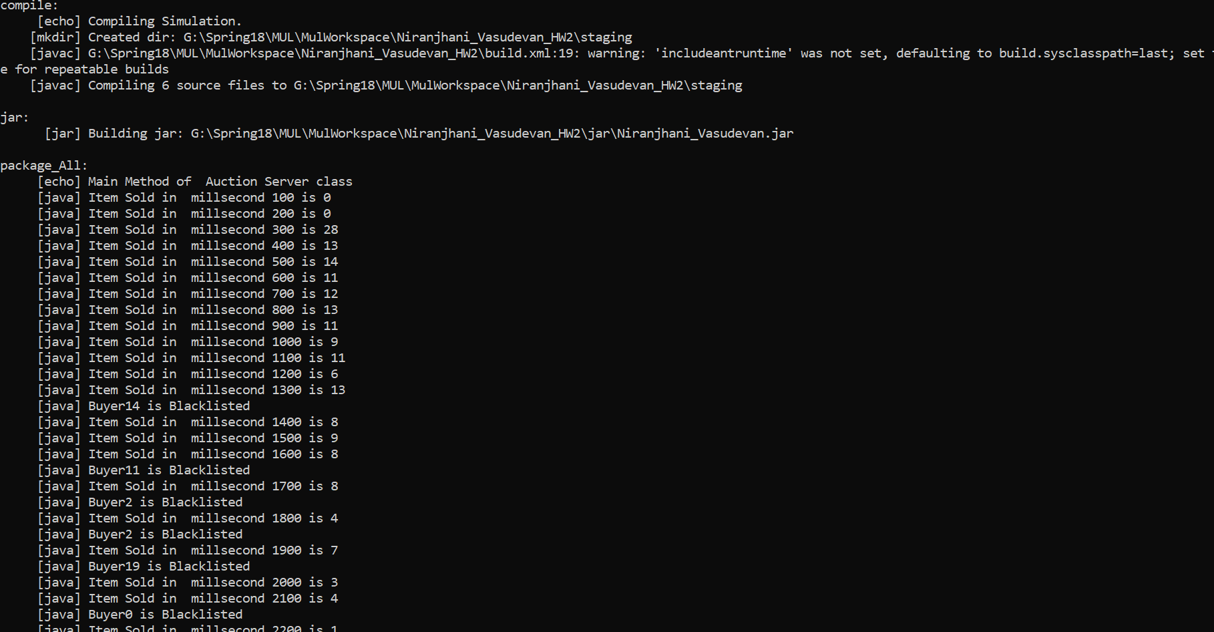

**OUTPUT:**