

XGEN – XML Generator

README Document

**Prerequisites**

1. The software needs to have the Java runtime Environment 1.6.0_1 or better.
2. The software needs Windows operating systems to run.

**Installing**

The software doesn’t need any specific installation. It can be directly run after extraction.

**Getting Started**

Please copy the Contents in the XGEN folder or extract the XGEN.rar file into the desired location in the computer. The folder has the following contents.

1. “lib” folder which contain the “AbsoluteLayout.jar” jar file.
2. “Additional Files” folder which contain the “Notepad++” software.
3. README.PDF
4. XGEN.exe

**Using the Software**

1. The initial Screen that is displayed will be as follows.

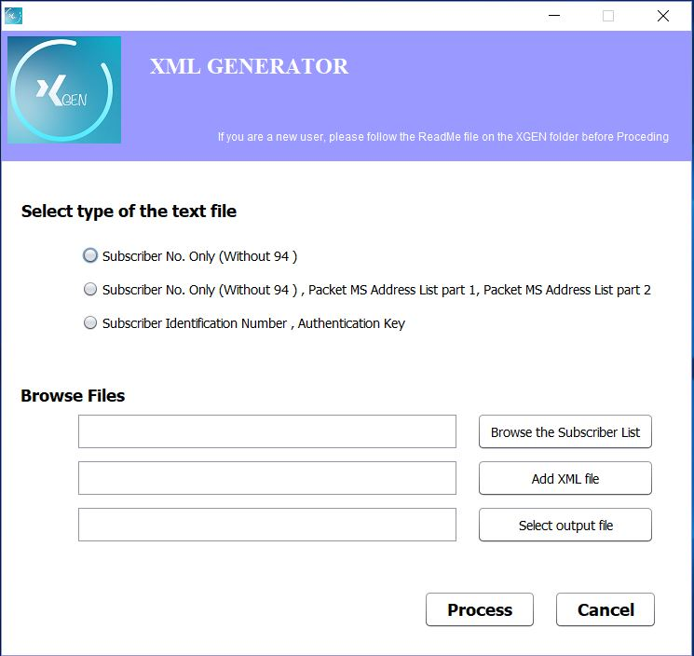

1. Select the type of the subscriber list provided in .txt format.

* TXT file with only the subscriber number (Should not contain the 94 part)

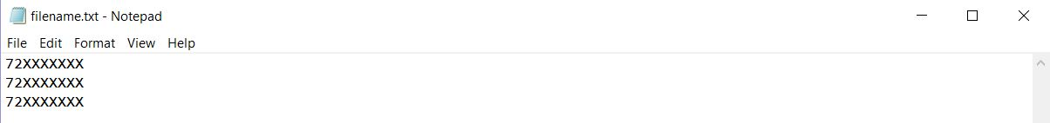

* TXT file with subscriber number, PacketMSAddress List part 1 and 2

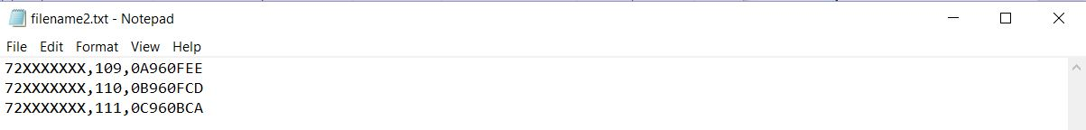

* TXT file with subscriber Identification number and Authentication Key

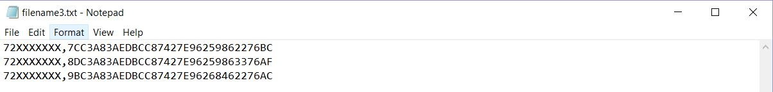

1. Browse and select the .txt file that contain the subscribers list.
2. Add the XML script to be run. (Note that the .xml script should not have more than 1 element tag in a single line. If the xml script is not in this way, please re-arrange the .xml file. An example is given below.)

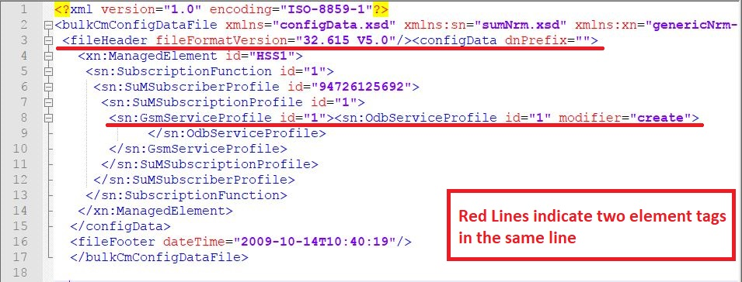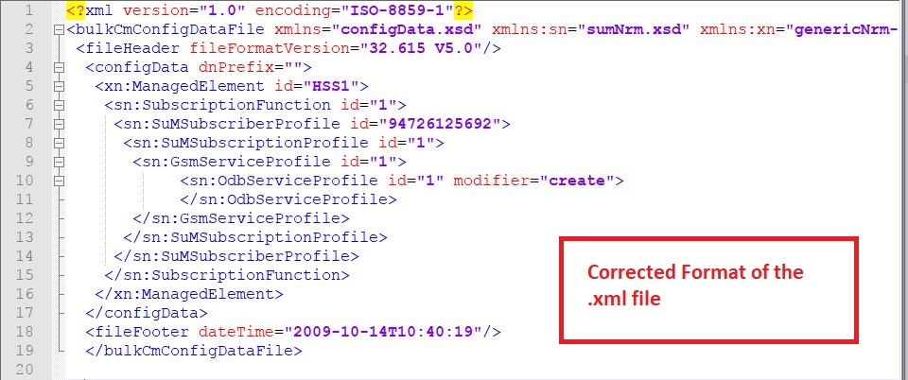

1. Select the folder for outputting the created xml file and type a desired filename along with the .xml tag.

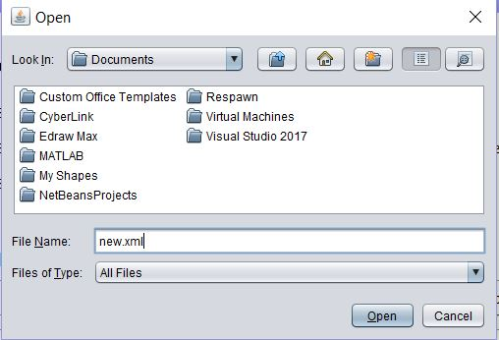

1. Press the process button to generate the XML file needed.

**NOTE – The batch size for the generated xml will depend on the size of the .txt file that is given to the system. So the txt file should contain the necessary amount of subscribers.**

**e.g.: If the .txt file contain 100,000 subscriber numbers the generated file will be a 100,000 batch file. If the batch size needed is 25,000, separate the .txt file into 4 .txt files with each having 25,000 subscribers.**

**The Notepad++ software is recommended for the editing of .xml and .txt files (Included here)**