Acme Specialty Chemicals Pvt. Ltd.

Sustainable Procurement Policy

DOCUMENT NO.  ASC-ENV-001 | EFFECTIVE DATE  2025-01-15
REVISION  01 | NEXT REVIEW  2027-01-14

Contents
01 Preface
02 Policy Declaration
03 Scope
04 Key Focus Areas
05 SDG Alignment
06 Roles & Responsibilities
07 Monitoring, Reporting & Transparency
08 Review Mechanism & Continuous Improvement

01 Preface
Sustainable Procurement Policy provides a consistent framework for Acme Specialty Chemicals Pvt. Ltd. to define responsibilities, make decisions, and review performance across its activities and locations.

02 Policy Declaration
Acme Specialty Chemicals affirms its commitment to implementing this Sustainable Procurement Policy in line with applicable requirements, proportionate controls, and regular management review.

03 Scope
This Sustainable Procurement Policy applies to the operations, workers, business relationships, and locations identified by Acme Specialty Chemicals Pvt. Ltd., including manufacturing, R&D, warehousing, logistics, and corporate functions.
Location / Unit | Address | Primary Function
Manesar Plant | Plot 14, Sector 4, IMT Manesar, Gurugram - 122051, Haryana, India | Manufacturing & R&D

04 Key Focus Areas
01 | Supplier Code of Conduct & Onboarding

05 SDG Alignment
This policy aligns with the following United Nations Sustainable Development Goals:
  Decent Work |   Industry & Innovation | 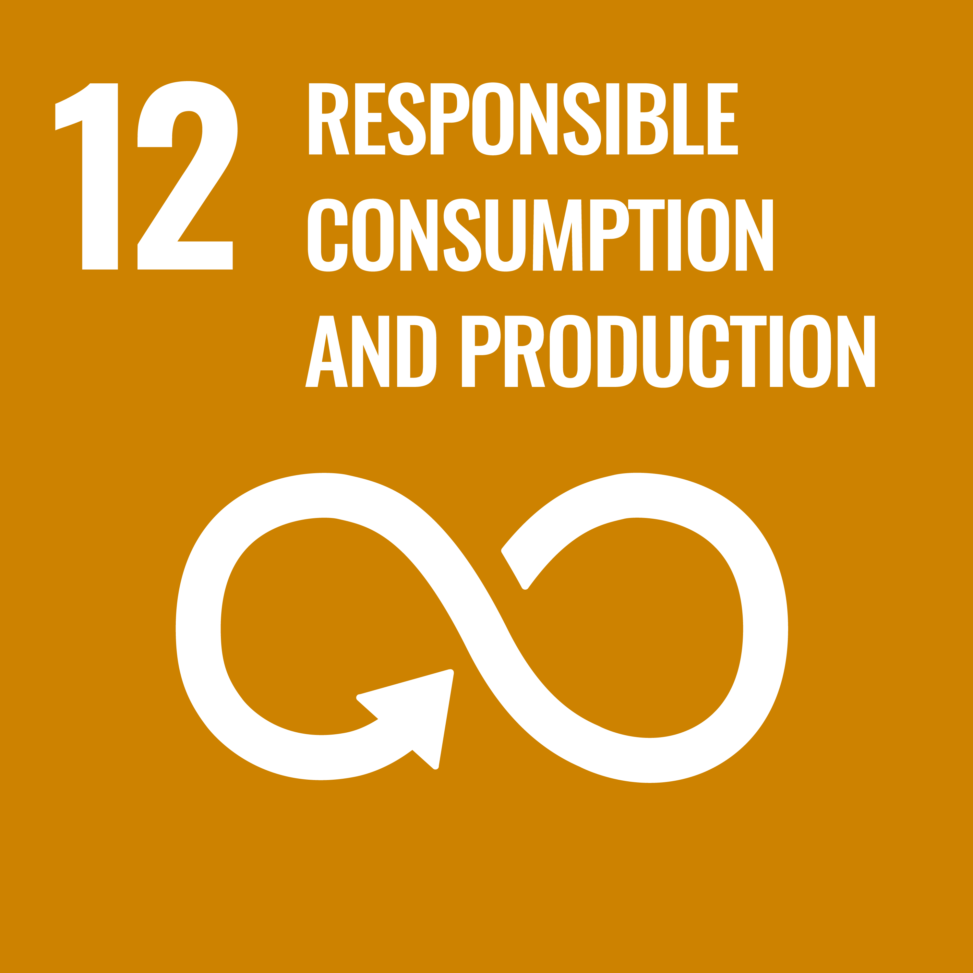  Responsible Consumption
  Peace & Justice |   Partnerships

06 Roles & Responsibilities
01 | Procurement Team  Integrate ESG and sustainability criteria into supplier selection, contracting, and ongoing performance management.

07 Monitoring, Reporting & Transparency
Environmental performance is monitored continuously through a centralized EHS dashboard, with KPIs reviewed monthly by site leadership and quarterly by the Executive Committee. Independent third-party audits are conducted annually for ISO 14001 and as required by customers. Findings, progress against targets, and incidents are reported in the annual Sustainability Report prepared in line with GRI Standards and BRSR.

08 Review Mechanism & Continuous Improvement
This Policy is reviewed every two years or earlier if there are significant changes in operations, regulations, or stakeholder expectations. The EHS team initiates the review, the Executive Committee approves revisions, and updated versions are communicated to all employees and relevant stakeholders. Feedback collected through employee engagement, customer audits and investor dialogues is incorporated into each revision.

Approved by: Managing Director

Employee Acknowledgement Form
I acknowledge that I have read and understood the Sustainable Procurement Policy of Acme Specialty Chemicals Pvt. Ltd. and agree to uphold its commitments in my work.
EMPLOYEE NAME | EMPLOYEE ID
DEPARTMENT | DATE
SIGNATURE

