Acme Specialty Chemicals Pvt. Ltd.

Environmental Policy

DOCUMENT NO.  ASC-ENV-001 | EFFECTIVE DATE  2025-01-15
REVISION  01 | NEXT REVIEW  2027-01-14

Contents
01 Preface
02 Policy Declaration
03 Scope
04 Key Focus Areas
05 Qualitative Objectives
06 Quantitative Targets
07 SDG Alignment
08 Roles & Responsibilities
09 Monitoring, Reporting & Transparency
10 Review Mechanism & Continuous Improvement

01 Preface
Acme Specialty Chemicals Pvt. Ltd. is committed to environmental stewardship across every facility, process and product. As a manufacturer of specialty intermediates, we recognize our responsibility to minimize ecological impact, conserve natural resources and operate in line with internationally recognized environmental standards. This Environmental Policy establishes the framework through which we set objectives, allocate resources and measure progress toward a more sustainable future.

02 Policy Declaration
Acme Specialty Chemicals affirms its unwavering commitment to protecting the environment, preventing pollution, and continually improving its environmental performance. The Company will comply with all applicable legal requirements, reduce its carbon and water intensity, manage waste responsibly, and integrate environmental considerations into every business decision.

03 Scope
This Environmental Policy applies to all operations, sites and activities of Acme Specialty Chemicals Pvt. Ltd., including manufacturing, R&D, warehousing, logistics, and corporate functions. It covers all employees, contractors, suppliers and visitors acting on behalf of the Company.
Location / Unit | Address | Primary Function
Manesar Plant | Plot 14, Sector 4, IMT Manesar, Gurugram - 122051, Haryana, India | Manufacturing & R&D

04 Key Focus Areas
01 Energy Consumption & GHG Emissions | 02 Air Emissions Control
03 Raw Materials & Resource Efficiency | 04 Waste Management & Circularity
05 Water Stewardship | 06 Biodiversity & Land Use
07 Climate Risk & Emergency Preparedness | 08 Product End-of-Life & Environmental Stewardship

05 Qualitative Objectives
01 Energy Consumption & GHG Emissions
- Improve energy efficiency across all manufacturing operations and reduce absolute Scope 1 and Scope 2 GHG emissions year-on-year.
- Increase the share of renewable electricity in our total energy mix and procure credible renewable energy certificates where feasible.
- Maintain an energy management system aligned with ISO 50001 and disclose progress in our annual sustainability report.

02 Air Emissions Control
- Operate and maintain air pollution control equipment to keep all stack emissions well below regulatory limits.
- Monitor fugitive emissions through periodic Leak Detection and Repair (LDAR) programs.
- Progressively replace high-global-warming-potential process gases with low-GWP alternatives.

03 Raw Materials & Resource Efficiency
- Optimize raw material use, increase process yields and reduce process losses through continuous improvement.
- Prefer bio-based, recycled and sustainably sourced inputs where technically and commercially viable.
- Collaborate with R&D and procurement to design products with reduced environmental footprint.

04 Waste Management & Circularity
- Apply the waste hierarchy - prevent, reduce, reuse, recycle, recover, dispose - across all operations.
- Achieve diversion of operational waste from landfill through segregation, recycling and co-processing.
- Engage with licensed third-party waste processors and maintain auditable manifests for all hazardous waste streams.

05 Water Stewardship
- Reduce freshwater withdrawal per unit of production and recycle treated wastewater in suitable applications.
- Maintain zero-liquid-discharge compliant treatment systems and conduct periodic third-party water-quality audits.
- Conduct site-level water risk assessments using tools such as WRI Aqueduct and respond to high-risk findings.

06 Biodiversity & Land Use
- Avoid operating in or near ecologically sensitive areas and conduct biodiversity impact assessments for new projects.
- Implement landscaping and habitat programs on owned land to support local flora and fauna.
- Engage with local communities and conservation groups on biodiversity stewardship initiatives.

07 Climate Risk & Emergency Preparedness
- Identify, assess and mitigate climate-related physical and transition risks as part of enterprise risk management.
- Maintain site-level emergency response plans for spills, releases and natural events, and conduct regular drills.
- Disclose climate-related risks and opportunities aligned with TCFD recommendations.

08 Product End-of-Life & Environmental Stewardship
- Apply life-cycle thinking to product design and provide customers with end-of-life and disposal guidance.
- Extend producer responsibility by participating in take-back and recycling programs where applicable.
- Continuously improve packaging to reduce material use and increase recycled content.

06 Quantitative Targets
Targets are tracked against a defined period or reported annually as ongoing commitments.
01 | Energy Consumption & GHG Emissions  Reduce specific energy consumption (kWh per tonne of product) by 15% Baseline FY 2022-23 · Due FY 2029-30
02 | Energy Consumption & GHG Emissions  Reduce absolute Scope 1 + Scope 2 GHG emissions by 30% Baseline FY 2022-23 · Due FY 2030-31
03 | Energy Consumption & GHG Emissions  Source 50% of electricity from renewables Baseline FY 2024-25 · Due FY 2028-29
04 | Water Stewardship  Reduce specific freshwater withdrawal by 25% Baseline FY 2022-23 · Due FY 2029-30
05 | Water Stewardship  Recycle / reuse 70% of process wastewater Baseline FY 2022-23 · Due FY 2028-29
06 | Waste Management & Circularity  Achieve 95% diversion of operational waste from landfill Baseline FY 2022-23 · Due FY 2028-29
07 | Waste Management & Circularity  Reduce hazardous waste generation per unit by 20% Baseline FY 2022-23 · Due FY 2029-30
08 | Air Emissions Control  Maintain zero exceedance of statutory air emission limits Baseline FY 2022-23 · Due FY 2027-28
09 | Air Emissions Control  Replace 100% of high-GWP refrigerants with low-GWP alternatives Baseline FY 2024-25 · Due FY 2028-29

07 SDG Alignment
This policy aligns with the following United Nations Sustainable Development Goals:
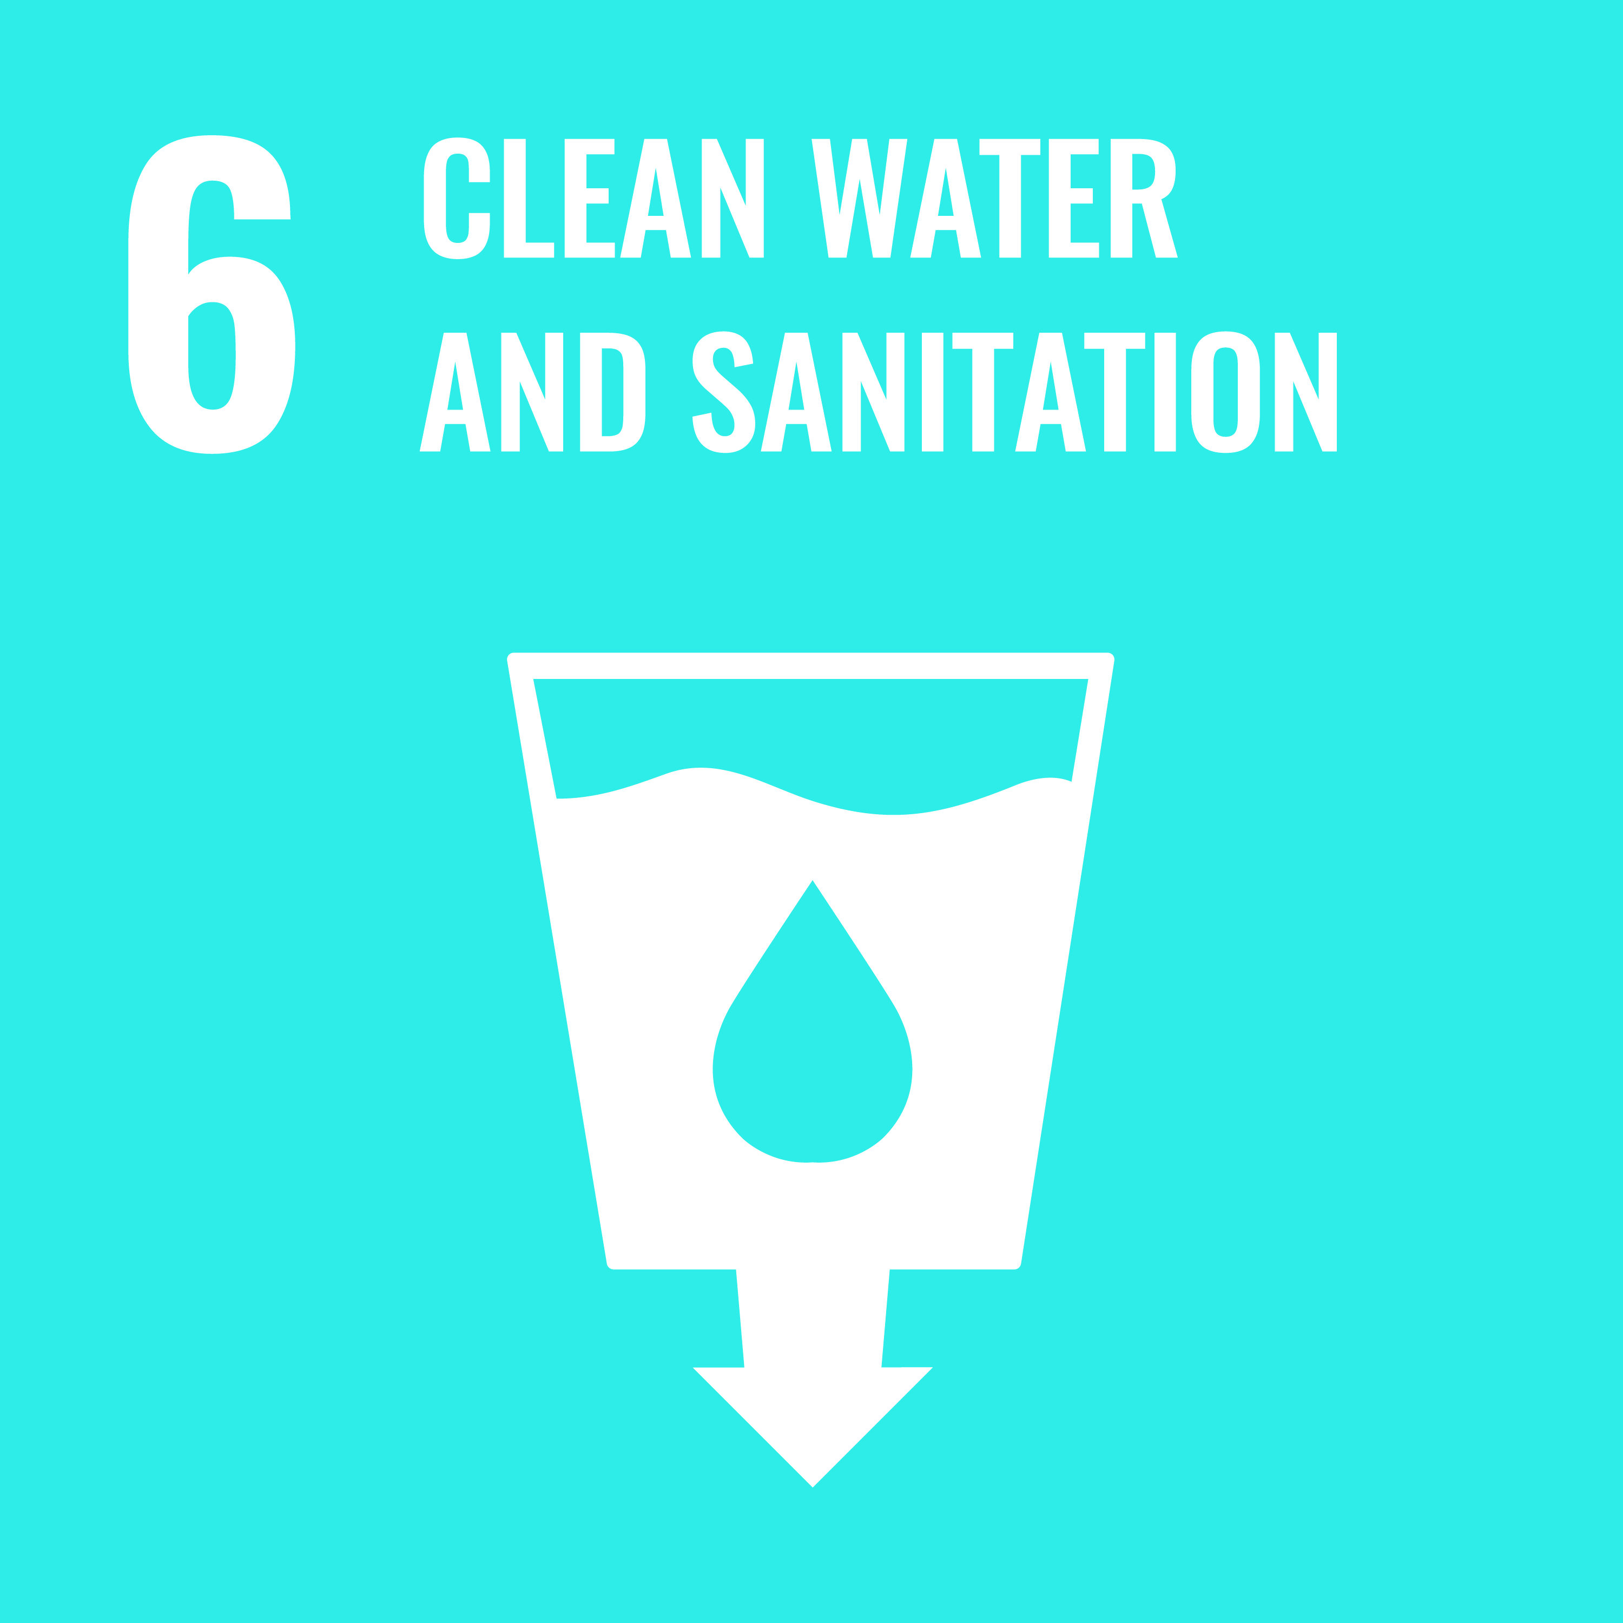  Clean Water | 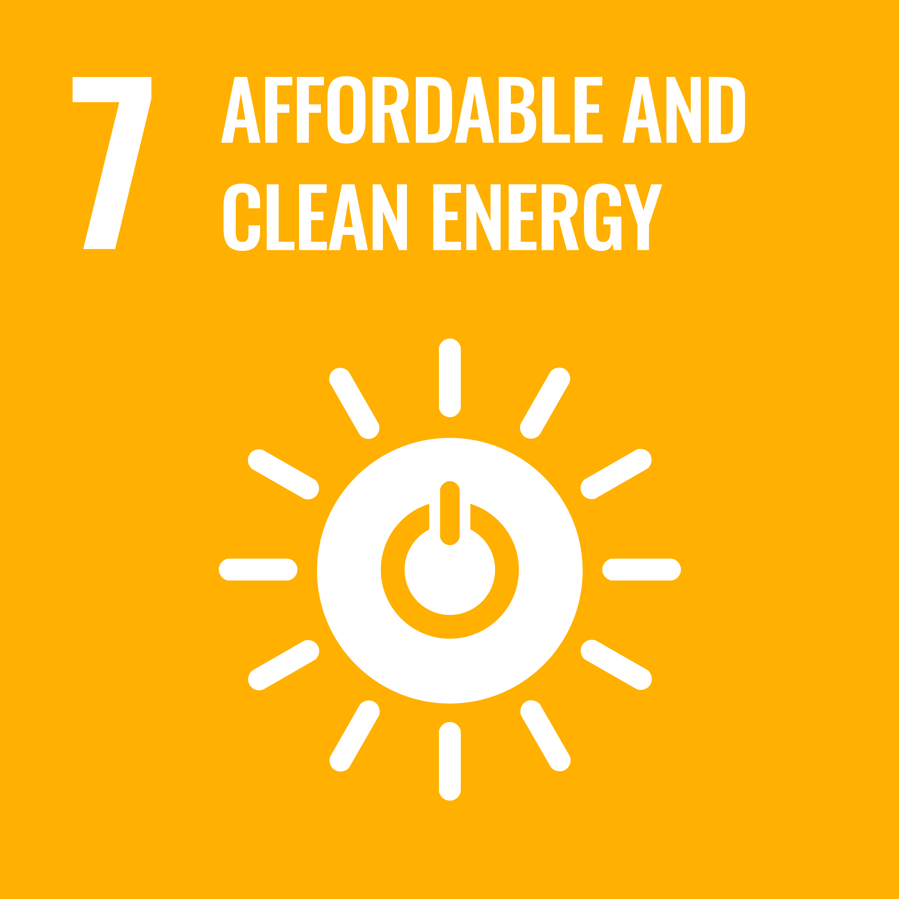  Clean Energy | 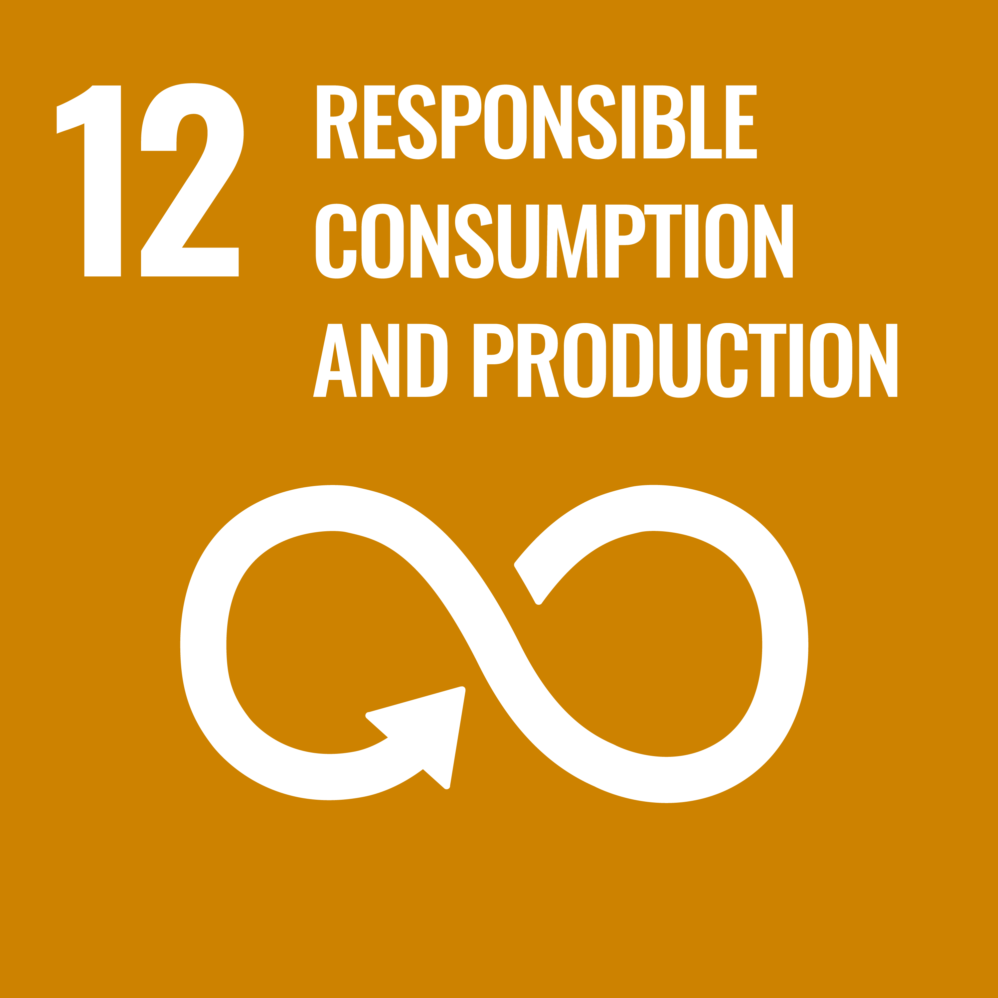  Responsible Consumption
  Climate Action | 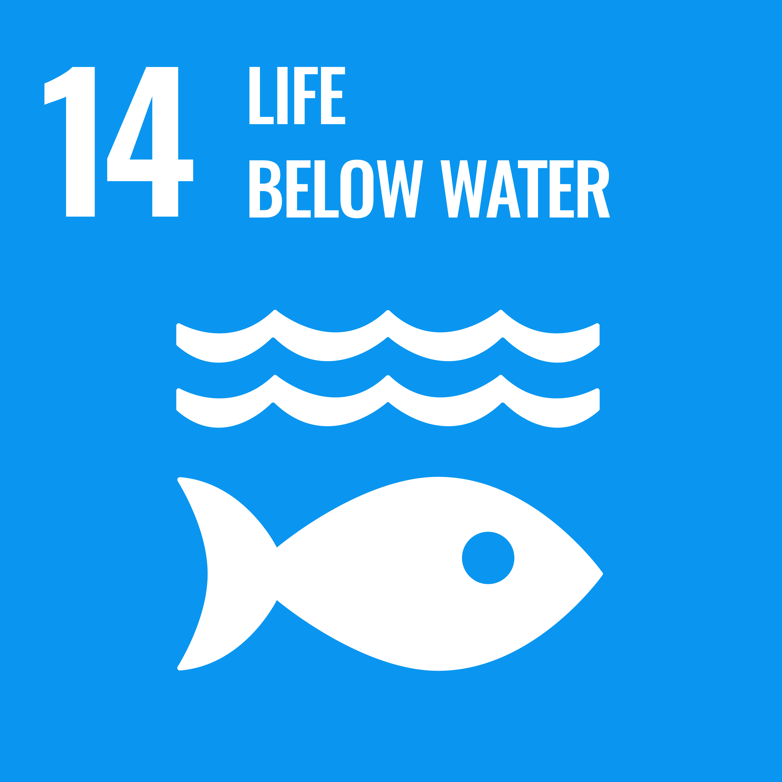  Life Below Water | 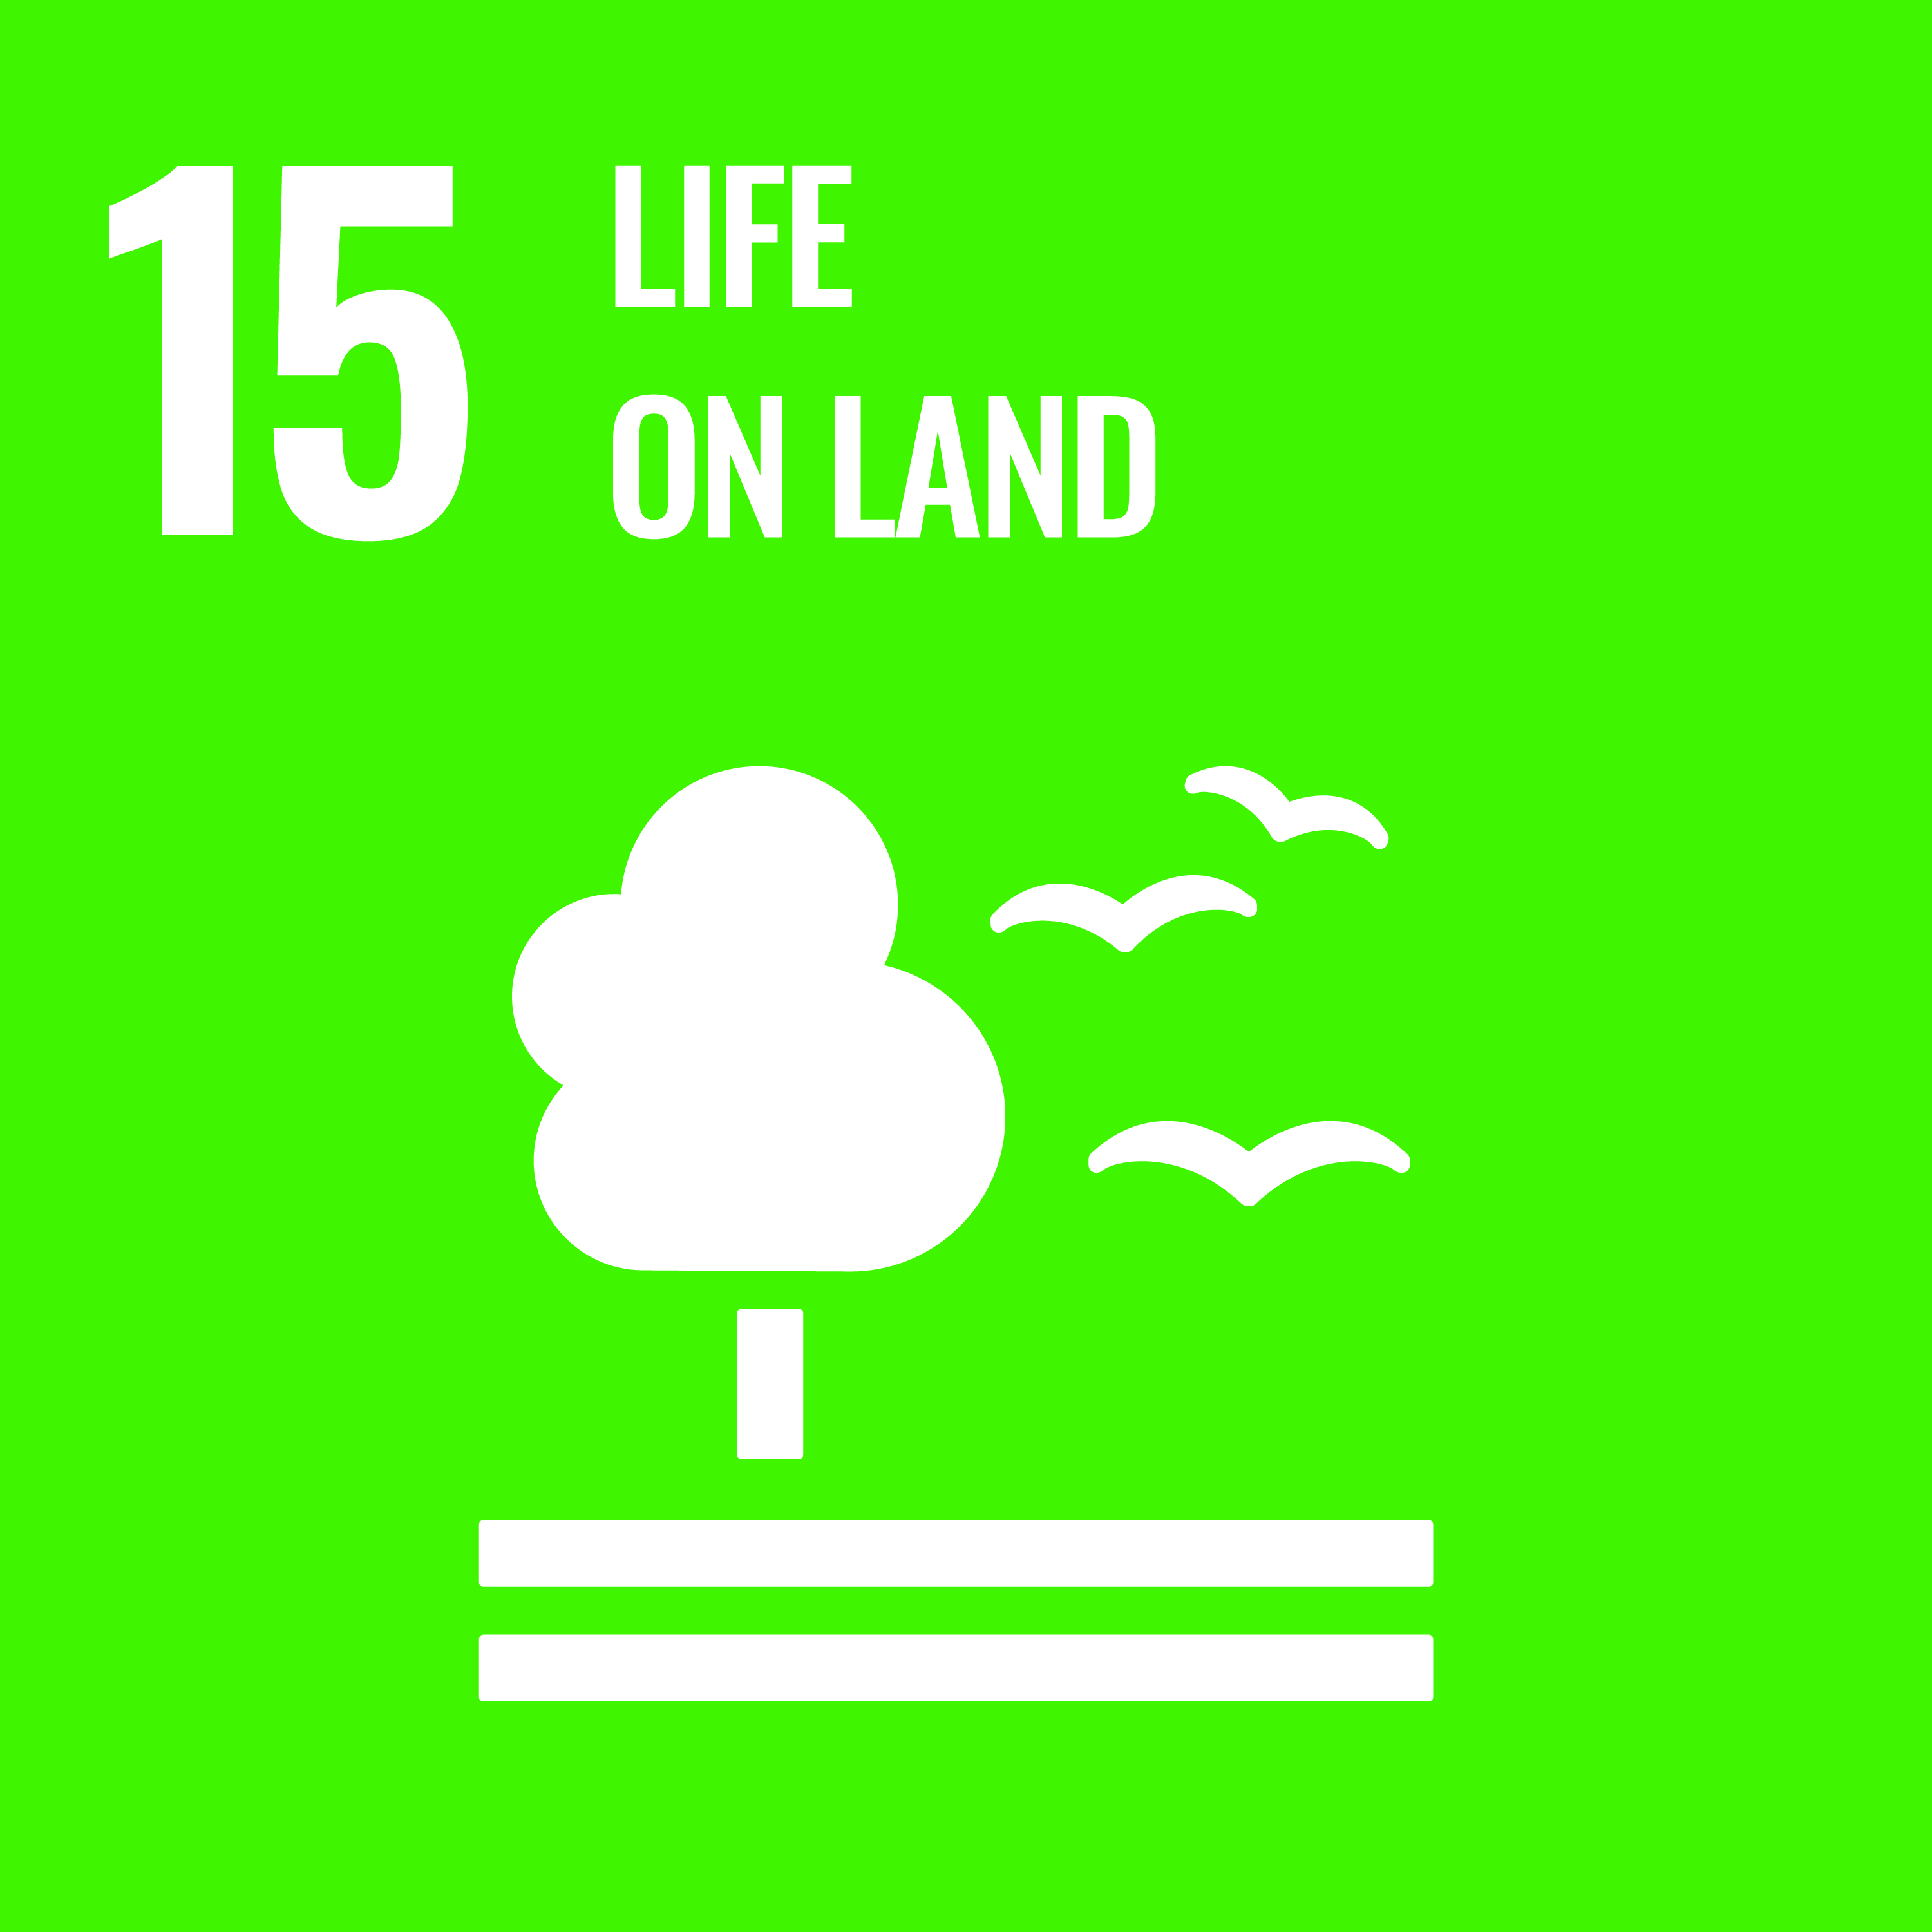  Life on Land

Partnerships

08 Roles & Responsibilities
01 Board & Senior Management  Provide strategic direction, approve the policy, allocate resources, and review environmental performance at the highest level. | 02 EHS / Sustainability Team  Maintain the environmental management system, ensure regulatory compliance, track KPIs, coordinate audits, and report progress to leadership.
03 Production & Operations  Implement energy, water and waste management initiatives on the shop floor, maintain pollution control equipment, and minimize process losses. | 04 Procurement & Supply Chain  Engage suppliers on sustainability criteria, source environmentally responsible materials, and integrate ESG clauses into contracts.
05 All Employees  Follow environmental procedures, identify improvement opportunities, participate in training, and report incidents or concerns. | 06 Contractors & Visitors  Comply with site environmental rules, follow safe handling and waste segregation practices, and report any observed non-conformities.

09 Monitoring, Reporting & Transparency
Environmental performance is monitored continuously through a centralized EHS dashboard, with KPIs reviewed monthly by site leadership and quarterly by the Executive Committee. Independent third-party audits are conducted annually for ISO 14001 and as required by customers. Findings, progress against targets, and incidents are reported in the annual Sustainability Report prepared in line with GRI Standards and BRSR.

10 Review Mechanism & Continuous Improvement
This Policy is reviewed every two years or earlier if there are significant changes in operations, regulations, or stakeholder expectations. The EHS team initiates the review, the Executive Committee approves revisions, and updated versions are communicated to all employees and relevant stakeholders. Feedback collected through employee engagement, customer audits and investor dialogues is incorporated into each revision.

Approved by: Managing Director

Employee Acknowledgement Form
I acknowledge that I have read and understood the Environmental Policy of Acme Specialty Chemicals Pvt. Ltd. and agree to uphold its commitments in my work.
EMPLOYEE NAME | EMPLOYEE ID
DEPARTMENT | DATE
SIGNATURE

