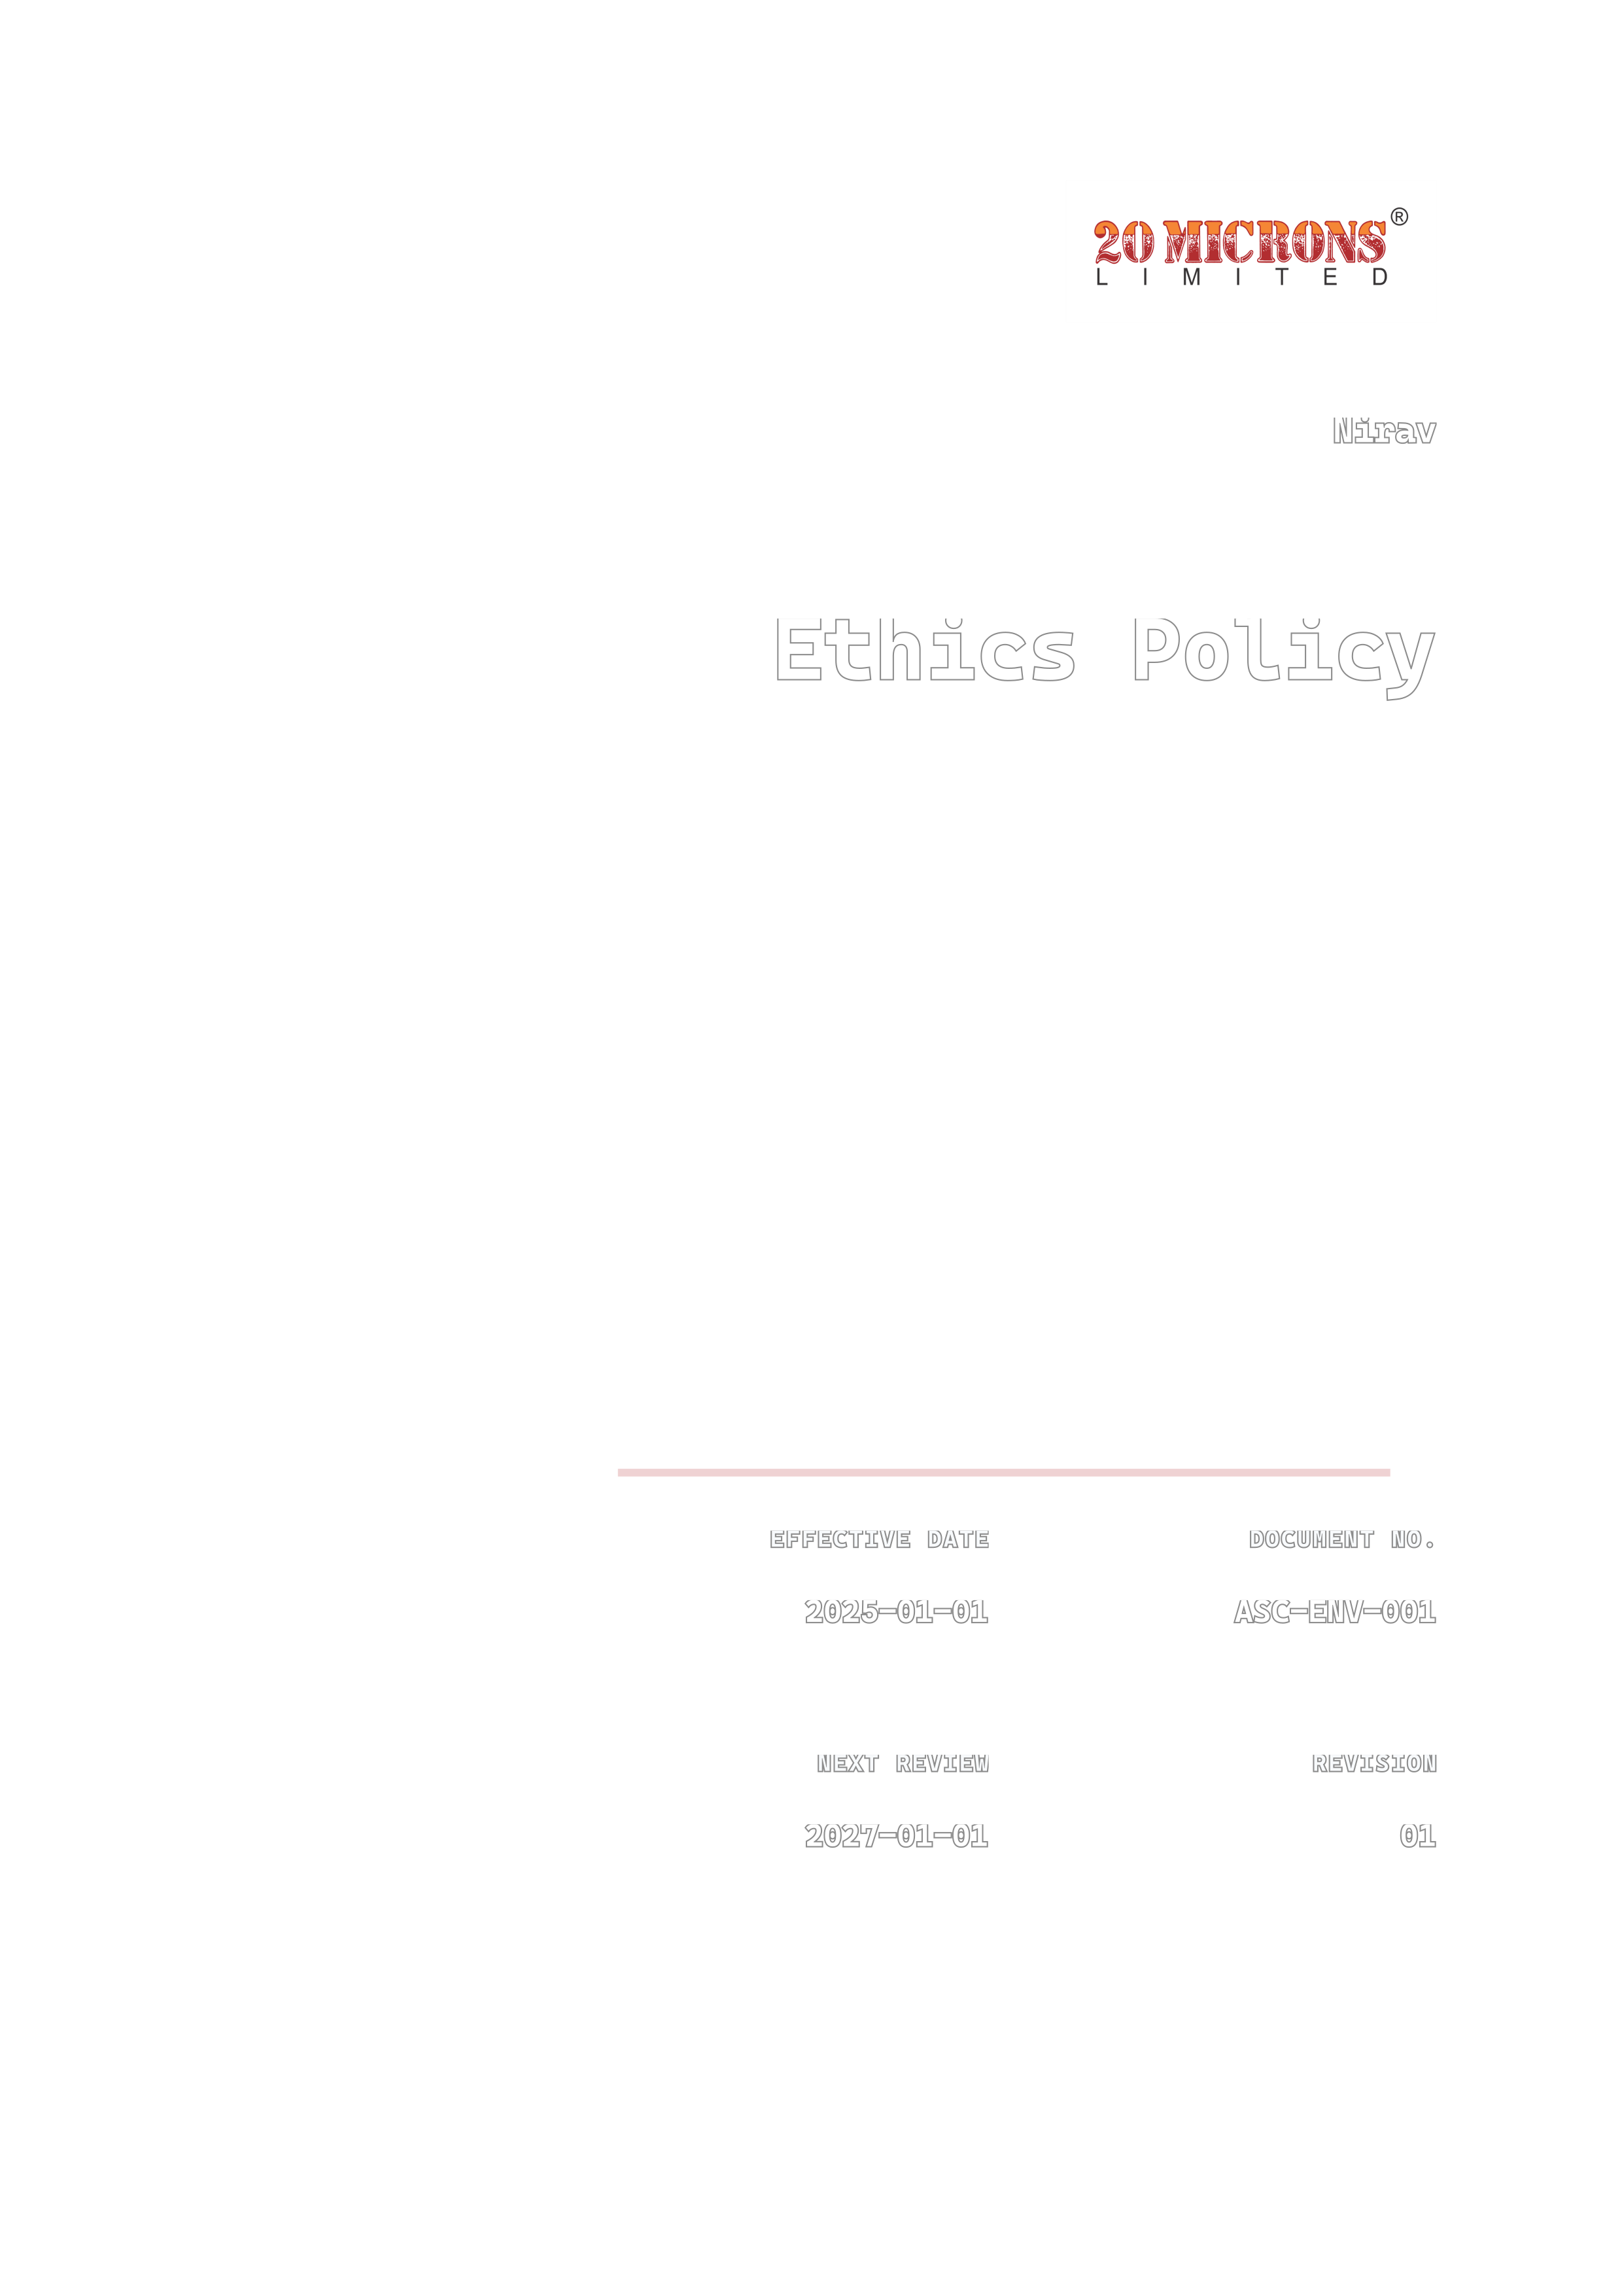
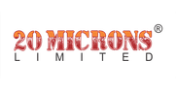
Ethics Policy
Nirav
DOCUMENT NO.
ASC-ENV-001
EFFECTIVE DATE
2025-01-01
REVISION
01
NEXT REVIEW
2027-01-01

Contents
01 Preface
02 Policy Declaration
03 Scope
04 Key Focus Areas
05 Qualitative Objectives
06 Quantitative Targets
07 SDG Alignment
08 Roles & Responsibilities
09 Monitoring, Reporting & Transparency
10 Review Mechanism & Continuous Improvement
11 Revision History

01 Preface
Nirav is committed to conducting its food and beverage business with the highest standards of integrity, ethics, transparency, and accountability. We recognize that responsible business conduct is fundamental to protecting consumer trust, supporting sustainable growth, and creating value for employees, customers, suppliers, business partners, shareholders, and the communities in which we operate. This Ethics Policy establishes the principles and standards that guide ethical behaviour and responsible decision-making across our operations and business relationships. Nirav maintains a zero-tolerance approach to bribery, corruption, fraud, conflicts of interest, money laundering, anti-competitive conduct, and other unlawful or unethical practices. The Policy is aligned with the principles of ISO 37001, the United Nations Global Compact, the Business Responsibility and Sustainability Reporting framework, and the Sustainable Development Goals, and is supported by effective governance, awareness, reporting, non-retaliation, accountability, and continual improvement.

02 Policy Declaration
At Nirav, we are committed to conducting our business with the highest standards of ethics, integrity, transparency, and accountability. We recognize that responsible business conduct and ethical decision-making are essential to maintaining trust with our employees, customers, suppliers, business partners, and communities. This Ethics Policy outlines our commitment to compliance with applicable laws and regulations, the prevention of bribery, corruption, fraud, conflicts of interest, and other unethical conduct, and the responsible use of company resources and information. We expect all employees, contractors, and business partners to uphold these principles and to report concerns in good faith, without fear of retaliation.

03 Scope
This Ethical Conduct Policy applies to all operations and business activities carried out by Nirav at its operational location in fdgbdbdbdfbd. It applies to all directors, employees, management, contract workers, trainees, consultants, contractors, suppliers, service providers, agents, and other business partners acting on behalf of or representing the Company. It covers all business activities, decisions, and interactions undertaken by or on behalf of Nirav and establishes the framework for ethical behaviour, responsible business conduct, regulatory compliance, and integrity across all operations and business relationships.
Location / Unit | Address | Primary Function
fgbdbdbv | fdgbdbdbdfbd | Head Quarter

04 Key Focus Areas
01 | Anti-Corruption & Anti-Bribery
02 | Conflicts of Interest
03 | Data Privacy & Confidentiality
04 | Gifts & Hospitality
05 | Whistleblowing & Speak-Up
06 | Regulatory Compliance
07 | Fair Competition & Antitrust
08 | Corporate Governance

05 Qualitative Objectives
01 Conflicts of Interest
- Establish clear requirements for identifying, disclosing, and managing actual, potential, or perceived conflicts of interest across Nirav’s operations.
- Promote transparent and impartial decision-making by ensuring that personal, financial, family, or external interests do not improperly influence business activities.
- Provide appropriate guidance and awareness to employees and relevant business partners on recognizing conflicts of interest and reporting them through established channels without fear of retaliation.

02 Anti-Corruption & Anti-Bribery
- Maintain zero tolerance for bribery, corruption, facilitation payments, kickbacks, and other improper business practices in all activities and relationships.
- Promote integrity, transparency, and accountability through appropriate anti-corruption controls, accurate record-keeping, and due diligence of third parties.
- Provide confidential reporting channels and ensure that suspected bribery or corruption is investigated promptly, with appropriate corrective and disciplinary action taken where necessary.

03 Data Privacy & Confidentiality
- Protect personal, commercial, operational, employee, customer, and supplier information from unauthorized access, use, disclosure, alteration, or loss.
- Handle, store, and share confidential information responsibly in accordance with applicable data protection laws, contractual obligations, and Nirav’s internal policies.
- Promote secure information practices through appropriate access controls, employee awareness, responsible technology use, and prompt reporting of suspected privacy or confidentiality breaches.

06 Quantitative Targets
# | Focus Area | Targets
01 | Anti-Corruption & Anti-Bribery | - Nirav will provide anti-corruption and anti-bribery training to 100% of employees and relevant contractors by FY 2029-30, measured against the FY 2024-25 baseline.  - Nirav will complete documented anti-corruption due diligence for 100% of high-risk third parties before engagement by FY 2030-31, measured against the FY 2024-25 baseline.  - Nirav will investigate and resolve 100% of substantiated bribery or corruption concerns within 30 calendar days by FY 2028-29, measured against the FY 2024-25 baseline.
02 | Conflicts of Interest | - Nirav will achieve 100% completion of annual conflict-of-interest declarations by all employees, directors, and relevant contractors by FY 2029-30, measured against the FY 2023-24 baseline.  - Nirav will review and resolve 100% of disclosed conflicts of interest within 30 calendar days by FY 2029-30, measured against the FY 2023-24 baseline.  - Nirav will provide conflict-of-interest training to 100% of employees and relevant decision-makers by FY 2028-29, measured against the FY 2023-24 baseline.
03 | Data Privacy & Confidentiality | - Ensure 100% compliance with applicable data protection and privacy requirements across Nirav’s operations by FY 2029-30, measured against the FY 2024-25 baseline.  - Ensure 100% of Nirav employees and contractors who handle confidential or personal data complete mandatory data privacy and confidentiality training by FY 2028-29, measured against the FY 2024-25 baseline.  - Maintain 0 confirmed major data breaches or unauthorized disclosures of confidential or personal data by FY 2030-31, measured against the FY 2024-25 baseline.

07 SDG Alignment
This policy aligns with the following United Nations Sustainable Development Goals:
 |  | 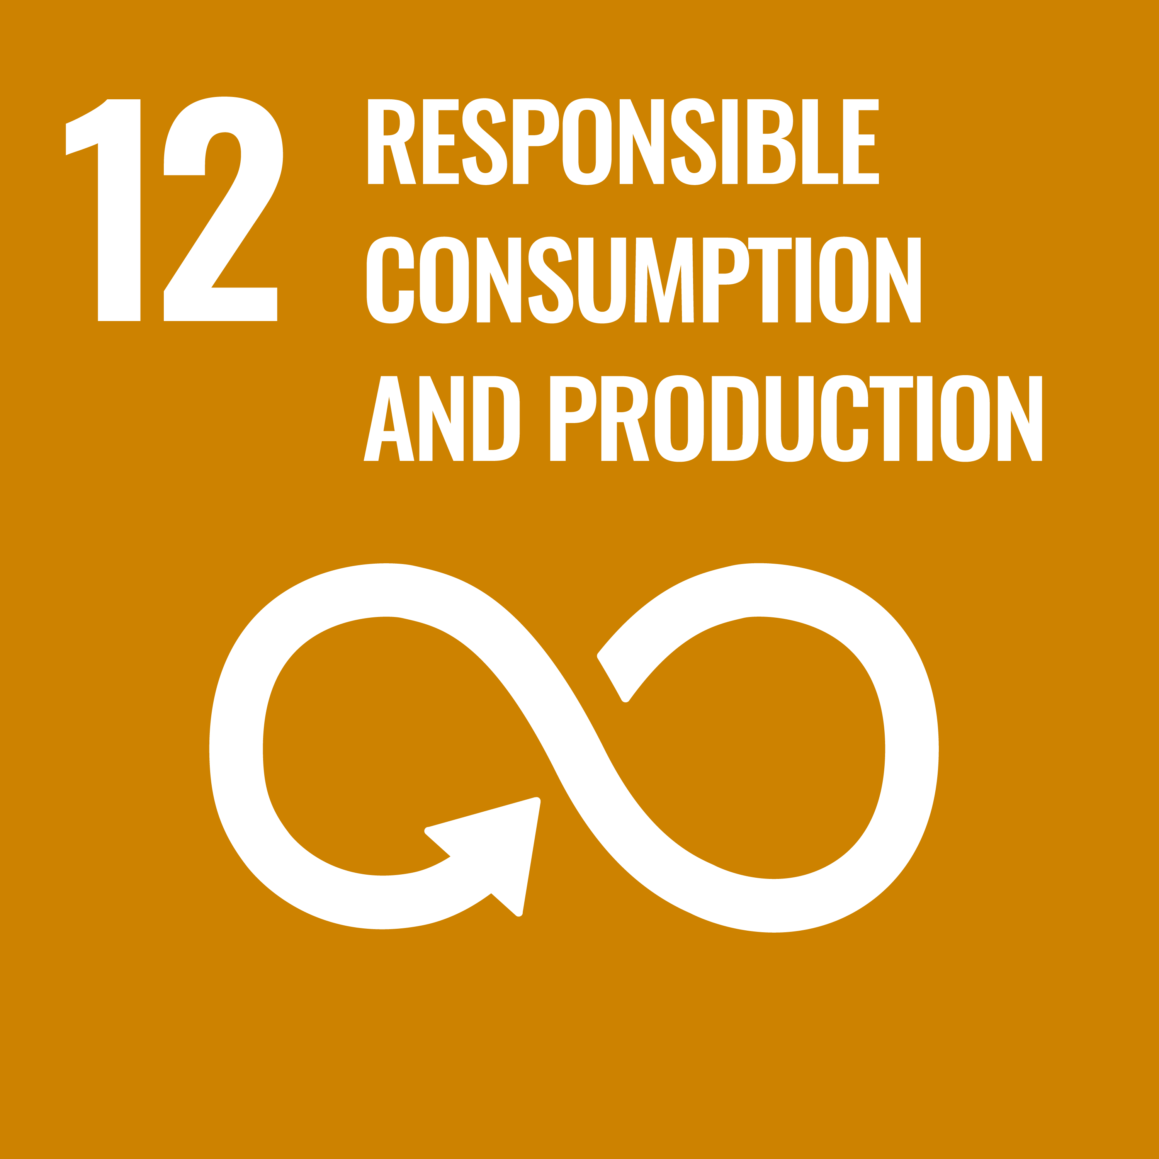 | 


08 Roles & Responsibilities
Role / Department | Responsibility
Compliance Officer | Oversee ethics program implementation, manage whistleblowing channels, and investigate reported violations.
HR Manager | Enforce code of conduct, coordinate ethics training, and address workforce compliance issues.
IT Manager | Maintain data privacy controls, safeguard confidential information, and ensure cybersecurity compliance.
Internal Audit Team | Conduct periodic compliance audits, assess anti-corruption controls, and report findings to management.
Senior Management | Promote an ethical culture, approve ethics policies, and ensure organizational accountability.
Employees | Uphold ethical standards, report misconduct or conflicts of interest, and complete mandatory training.

09 Monitoring, Reporting & Transparency
Nirav is committed to monitoring and continuously improving the effectiveness of this Ethics Policy and related controls. The Company conducts periodic compliance reviews, internal assessments, management evaluations, and, where appropriate, independent audits to assess adherence to ethical standards, applicable laws, and established procedures across its operations and business relationships. Relevant indicators may include training completion, reported concerns, investigation outcomes, corrective actions, and identified ethics-related risks.
Employees and relevant stakeholders are encouraged to report suspected misconduct, conflicts of interest, fraud, corruption, violations of this Policy, or other unethical conduct through the designated reporting channels. Reports will be handled promptly, confidentially, and impartially, subject to applicable legal requirements. Nirav prohibits retaliation against any person who raises a concern or participates in an investigation in good faith. Findings from monitoring activities, investigations, stakeholder feedback, and regulatory developments will be used to strengthen controls, update training and procedures, and support continual improvement. Material ethics risks, significant incidents, and progress against relevant objectives will be communicated to appropriate management and, where suitable, disclosed transparently to stakeholders.

10 Review Mechanism & Continuous Improvement
This Ethics Policy will be reviewed annually by the Sustainability Officer to assess its continued relevance, effectiveness, and alignment with applicable legal requirements and recognized ethical standards. An interim review will be initiated following significant regulatory changes, ethical incidents, substantiated grievances, audit findings, or material changes to Nirav’s operations or stakeholder expectations. The Sustainability Officer will evaluate compliance data, audit results, incident records, and feedback from employees and relevant stakeholders, and will recommend improvements for management approval. Approved revisions and resulting actions will be communicated to employees and relevant stakeholders, with implementation monitored as part of Nirav’s continuous improvement process.

11 Revision History
Revision No. | Date | Description of Change
0.0 | 01/01/2024 | Initial release of policy
1.0 | 01/01/2025 | Policy updated to strengthen compliance controls, risk management systems, and reporting structure
2.0 | 01/01/2026 | Policy revised to enhance monitoring mechanisms, performance tracking, and continuous improvement approach

Approved by: Managing Director

Employee Acknowledgement Form
I acknowledge that I have read and understood the Ethics Policy of Nirav and agree to uphold its commitments in my work.
EMPLOYEE NAME | EMPLOYEE ID
DEPARTMENT | DATE
SIGNATURE

