
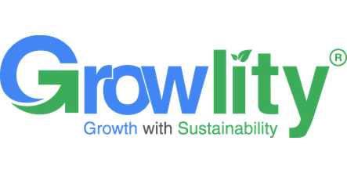
Sustainable
Procurement
Policy
2025-01-01
ASC-ENV-001
01

DOCUMENT NO.
EFFECTIVE DATE
REVISION
NEXT REVIEW

Contents
01 Preface
02 Policy Declaration
03 Scope
04 Key Focus Areas
05 Qualitative Objectives
06 Quantitative Targets
07 SDG Alignment
08 Roles & Responsibilities
09 Monitoring, Reporting & Transparency
10 Review Mechanism & Continuous Improvement
11 Revision History

01 Preface
Growlity_Realty is committed to integrating sustainability, ethical conduct, and responsible business practices across its procurement activities in the food and beverage sector. This Sustainable Procurement Policy establishes a framework for selecting, engaging, and managing suppliers in alignment with ISO 20400, the UN Global Compact Principles, EcoVadis sustainability expectations, the Business Responsibility and Sustainability Reporting (BRSR) framework, and the Sustainable Development Goals (SDGs). It aims to promote responsible sourcing, respect for human rights and labour standards, environmental stewardship, supply-chain transparency, and continuous improvement, while reducing environmental and social risks and creating shared value for stakeholders.

02 Policy Declaration
Growlity_Realty is committed to integrating sustainability into its procurement practices and supply chain management. We aim to consider environmental, social, ethical, and economic factors when selecting and managing suppliers, contractors, materials, and services. Through responsible sourcing, transparent procurement processes, supplier engagement, and continual improvement, we seek to reduce environmental impacts, promote fair labor and ethical business practices, and support resilient and sustainable real estate development.

03 Scope
This Sustainable Procurement Policy applies to all procurement and sourcing activities undertaken by Growlity_Realty at Luxuria Hub. It covers the procurement of construction materials, building systems, equipment, office supplies, maintenance services, facilities management, utilities, logistics, professional services, and other goods and services required for the Company's real estate operations. The policy applies to all employees, management, procurement personnel, contractors, consultants, suppliers, service providers, agents, and other business partners engaged in activities on behalf of Growlity_Realty. It establishes the framework for integrating environmental, social, ethical, and governance considerations into supplier selection, evaluation, contracting, and ongoing supplier relationships.
Location / Unit | Address | Primary Function
Growlity_Textile Site 1 - ESG data testing | Luxuria Hub | Head Quarter
testing_growlity | Surat Gujarat | Head Quarter

04 Key Focus Areas
01 Supplier Code of Conduct & Onboarding | 02 Supplier Due Diligence & Risk Assessment
03 Environmental Requirements for Suppliers | 04 Ethical Sourcing & Anti-Corruption
05 Labour & Human Rights in Supply Chain | 06 Supply Chain Transparency & Traceability
07 Supplier Capacity Building & Training | 08 Monitoring, Auditing & Continuous Improvement

05 Qualitative Objectives
01 Ethical Sourcing & Anti-Corruption
- To ensure that all procurement activities are conducted with integrity, transparency, accountability, and compliance with applicable anti-corruption laws and ethical business standards.
- Engage suppliers, contractors, and service providers that demonstrate responsible business conduct, fair labor practices, and zero tolerance for bribery, fraud, conflicts of interest, and other corrupt practices.
- Maintain appropriate supplier due diligence, reporting, and monitoring mechanisms to identify ethical sourcing risks, address non-compliance, and support continual improvement across the procurement supply chain.

02 Supplier Code of Conduct & Onboarding
- Establish and maintain a Supplier Code of Conduct that sets clear expectations for ethical business practices, environmental responsibility, human rights, labour standards, health and safety, and legal compliance.
- Integrate sustainability and integrity criteria into supplier onboarding, including appropriate screening, documentation, acknowledgment of the Code of Conduct, and assessment of risks relevant to construction, property development, facilities management, and other procurement activities.
- Promote transparent, accountable, and continually improving supplier relationships by communicating expectations, monitoring compliance, addressing identified gaps through corrective actions, and encouraging responsible practices throughout the supply chain.

03 Environmental Requirements for Suppliers
- Require suppliers and contractors to comply with applicable environmental laws, permits, and regulatory requirements, including those relating to construction activities, pollution prevention, waste management, and resource use.
- Encourage suppliers to reduce the environmental impacts of materials, products, and services provided to Growlity_Realty by adopting resource-efficient practices, using recycled or responsibly sourced materials, and minimizing energy consumption, emissions, water use, and waste.
- Prioritize and collaborate with suppliers that demonstrate effective environmental management practices, including pollution prevention, responsible handling of hazardous substances, sustainable packaging, and continual improvement aligned with ISO 14001 principles.

04 Supplier Due Diligence & Risk Assessment
- Conduct risk-based due diligence during supplier selection, onboarding, and periodic reviews, considering environmental, social, ethical, legal, and health and safety criteria relevant to real estate operations.
- Assess suppliers and contractors for compliance with applicable environmental regulations, labour and human rights standards, anti-bribery requirements, responsible sourcing expectations, and project-specific sustainability requirements.
- Maintain appropriate supplier risk records, address identified non-conformities through corrective action plans, and restrict or discontinue relationships where serious or repeated non-compliance is not adequately remedied.

06 Quantitative Targets
Targets are tracked against a defined period or reported annually as ongoing commitments.
01 | Supplier Code of Conduct & Onboarding  Screen 100% of new suppliers against defined environmental, social, ethical and compliance criteria before onboarding by FY 2028-29. Baseline FY 2026-27 · Due FY 2028-29
02 | Supplier Code of Conduct & Onboarding  Complete onboarding and Supplier Code of Conduct acknowledgement for 100% of newly onboarded suppliers by FY 2029-30. Baseline FY 2026-27 · Due FY 2029-30
03 | Supplier Code of Conduct & Onboarding  Conduct documented sustainability and compliance risk assessments for 100% of active high-risk suppliers by FY 2030-31. Baseline FY 2026-27 · Due FY 2030-31
04 | Supplier Due Diligence & Risk Assessment  Complete documented risk assessments for 100% of active tier-one suppliers providing construction materials, equipment, facilities services, or other critical goods and services by FY 2030-31. Baseline FY 2026-27 · Due FY 2030-31
05 | Supplier Due Diligence & Risk Assessment  Ensure that 100% of suppliers classified as high risk have documented mitigation or corrective action plans, with progress tracked to closure, by FY 2029-30. Baseline FY 2026-27 · Due FY 2029-30
06 | Supplier Due Diligence & Risk Assessment  Reassess 100% of high-risk suppliers and 100% of critical suppliers at least once every two years, with reassessment records maintained by FY 2030-31. Baseline FY 2026-27 · Due FY 2030-31
07 | Environmental Requirements for Suppliers  Evaluate 100% of high-impact suppliers against defined environmental criteria, including legal compliance, resource efficiency, waste management, pollution prevention, and environmental management practices. Baseline FY 2025-26 · Due FY 2030-31
08 | Environmental Requirements for Suppliers  Include environmental requirements in 90% of contracts and purchase orders for high-impact goods and services, including construction materials, facility operations, logistics, and waste management. Baseline FY 2025-26 · Due FY 2030-31
09 | Environmental Requirements for Suppliers  Ensure 50% of key suppliers adopt an ISO 14001-certified or equivalent environmental management system, or demonstrate a documented environmental improvement programme. Baseline FY 2025-26 · Due FY 2030-31
10 | Ethical Sourcing & Anti-Corruption  Ensure 100% of active suppliers, contractors, and service providers acknowledge and comply with Growlity_Realty’s Supplier Code of Conduct and anti-corruption requirements. Baseline FY 2024-25 · Due FY 2029-30
11 | Ethical Sourcing & Anti-Corruption  Complete ethical due diligence assessments for 100% of high-risk suppliers and contractors engaged across real estate development, construction, facilities management, and related procurement activities. Baseline FY 2024-25 · Due FY 2029-30
12 | Ethical Sourcing & Anti-Corruption  Provide annual anti-bribery, anti-corruption, conflict-of-interest, and ethical procurement training to 100% of procurement, project management, and vendor-management personnel. Reported annually

07 SDG Alignment
This policy aligns with the following United Nations Sustainable Development Goals:
 |  |  | 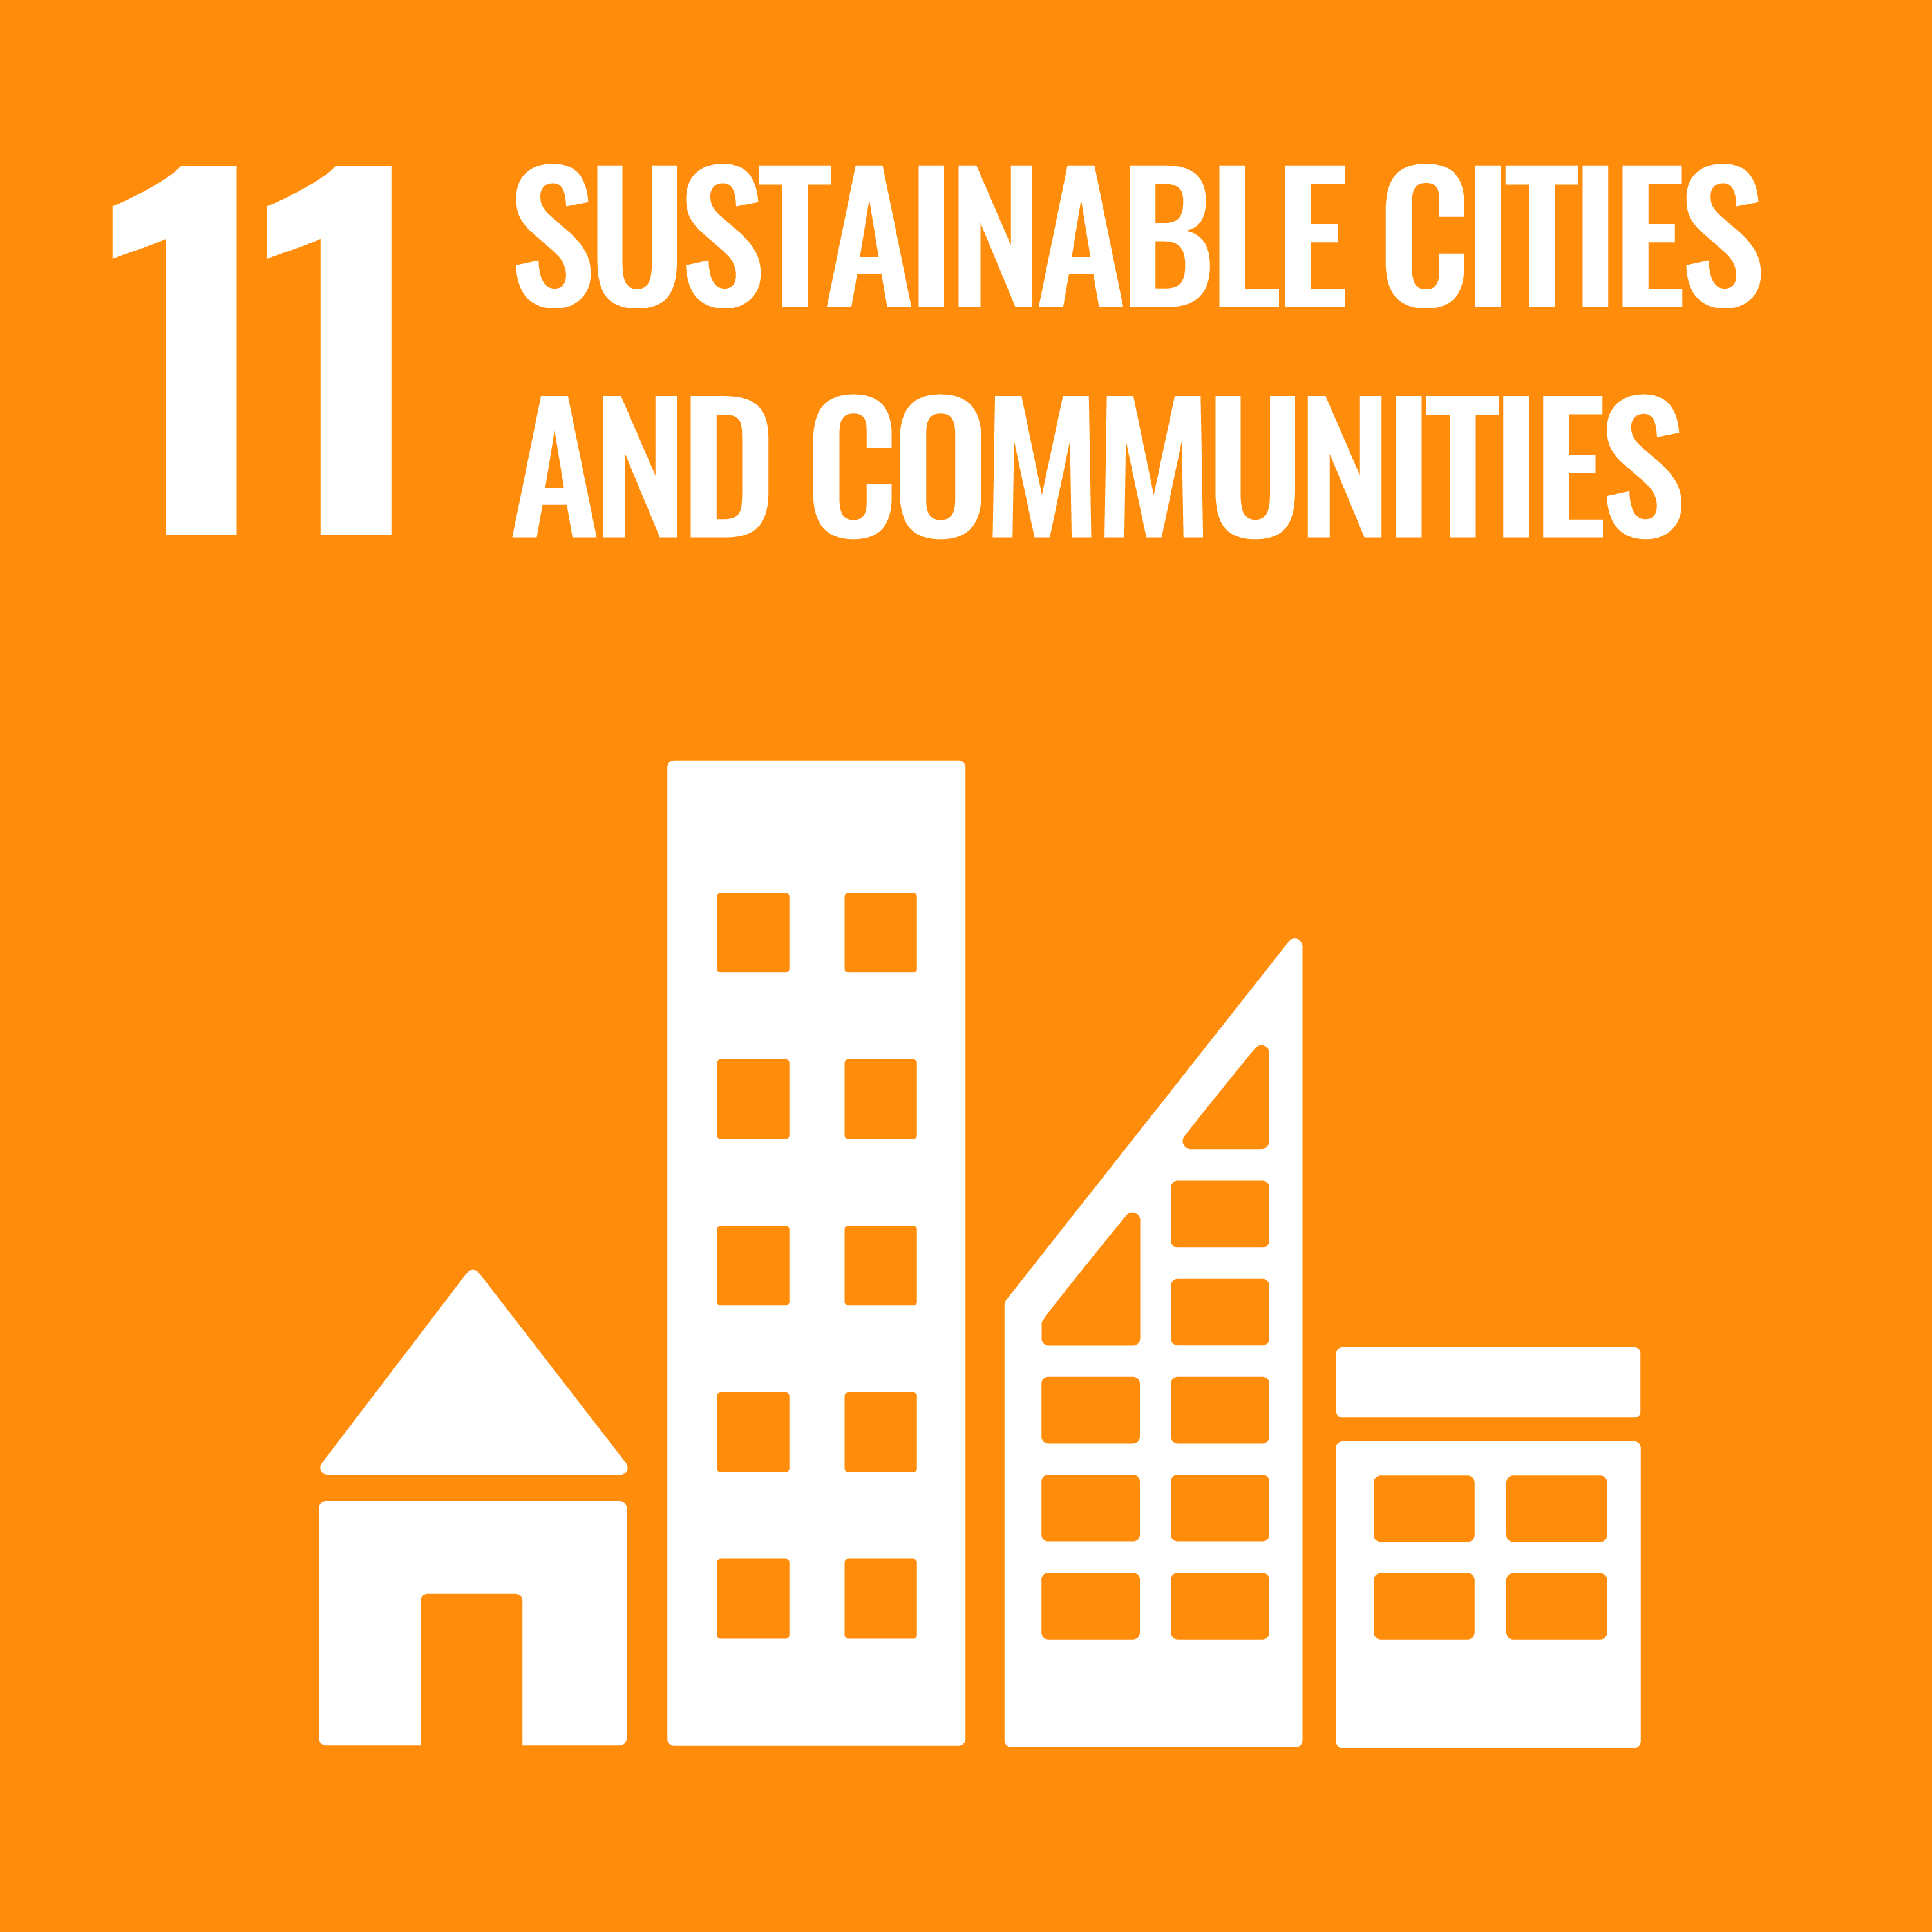
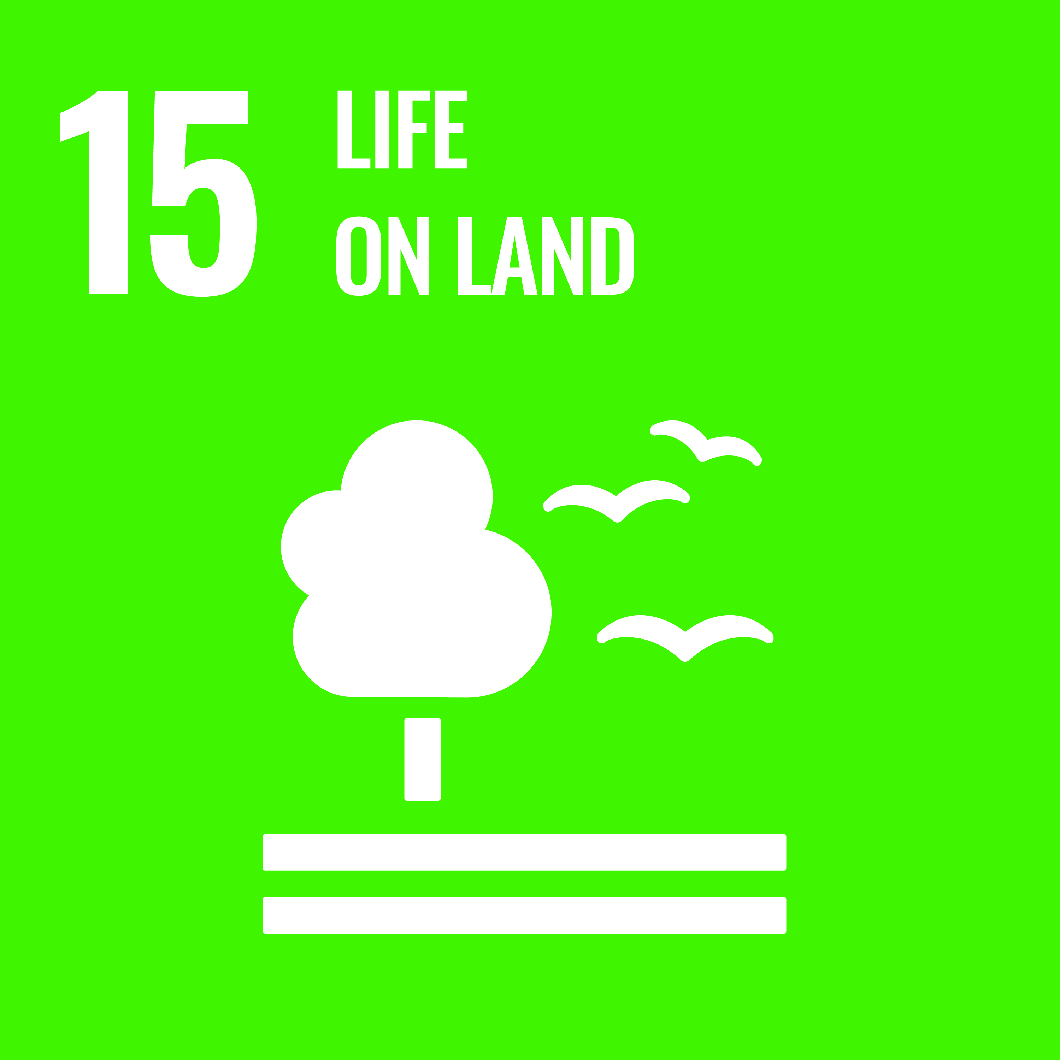 | 

08 Roles & Responsibilities
01 Procurement Team  Integrate ESG and sustainability criteria into supplier selection, contracting, and ongoing performance management. | 02 Sustainability Team  Develop sustainable procurement standards, assist with supplier ESG evaluations, and track supply-chain targets.
03 Suppliers  Comply with the Supplier Code of Conduct, provide requested disclosures, and participate in sustainability audits. | 04 Senior Management  Approve sustainable procurement commitments, allocate resources, and review supply chain risk reports.
05 All Employees
Adhere to responsible purchasing guidelines and support sustainable procurement practices.

09 Monitoring, Reporting & Transparency
Growlity_Realty is committed to monitoring, reporting, and continuously improving the implementation of this Sustainable Procurement Policy across its operations and supply chain. Procurement and relevant functional teams shall monitor key performance indicators, including supplier sustainability assessments, compliance with environmental and social requirements, sustainable material and service procurement, supplier corrective actions, and supplier engagement and training. Performance shall be reviewed periodically against established objectives, targets, applicable legal requirements, and ISO 14001 principles.
Accurate records shall be maintained for supplier evaluations, environmental and social due diligence, procurement decisions, contractual sustainability requirements, incidents, corrective actions, and supporting evidence. Internal audits, supplier assessments, and management reviews shall be conducted at appropriate intervals to verify conformity, identify risks and opportunities, and drive continual improvement. Suppliers and contractors may be required to provide relevant sustainability data and evidence of compliance, particularly for construction materials, waste management, energy-related services, and other significant procurement categories.
Growlity_Realty shall communicate relevant sustainable procurement performance and progress to management and appropriate stakeholders through periodic reports and management review processes. Material non-conformities, grievances, or breaches of procurement requirements shall be documented, investigated, and addressed through corrective and preventive actions. Where appropriate, sustainability expectations, performance outcomes, and improvement initiatives shall be shared with suppliers and stakeholders to promote transparency, accountability, and responsible procurement throughout the value chain.

10 Review Mechanism & Continuous Improvement
Growlity_Realty’s Sustainable Procurement Policy will be reviewed at least annually by the designated Procurement and Sustainability representatives, with input from relevant business functions and senior management. The review will assess supplier performance, environmental and social impacts, compliance with applicable legal and regulatory requirements, progress against procurement objectives, audit findings, and stakeholder feedback. Corrective actions and opportunities for improvement will be documented, assigned, and monitored to strengthen responsible sourcing practices and supply chain performance. The policy may also be updated outside the scheduled review cycle in response to significant changes in operations, supplier risks, regulatory requirements, or sustainability priorities, with approved changes communicated to relevant employees and suppliers.

11 Revision History
Revision No. | Date | Description of Change
0.0 | 01/01/2024 | Initial release of policy
1.0 | 01/01/2025 | Policy updated to strengthen compliance controls, risk management systems, and reporting structure
2.0 | 01/01/2026 | Policy revised to enhance monitoring mechanisms, performance tracking, and continuous improvement approach

Approved by: Managing Director

Employee Acknowledgement Form
I acknowledge that I have read and understood the Sustainable Procurement Policy of Growlity_Realty and agree to uphold its commitments in my work.
EMPLOYEE NAME | EMPLOYEE ID
DEPARTMENT | DATE
SIGNATURE

