# Architecture and Flow

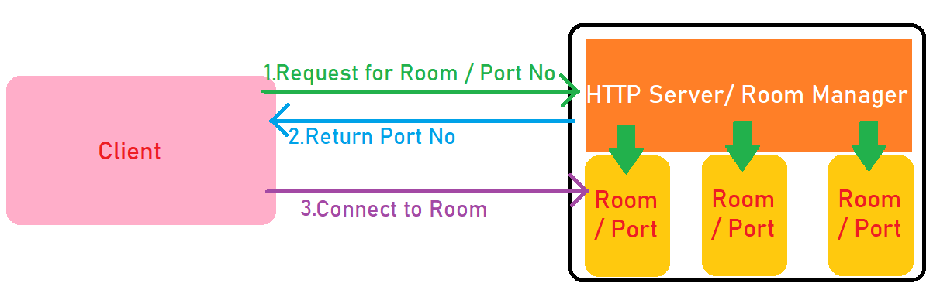

1. There is a Http server (Image) that manages all the **rooms.**
2. These rooms are nothing but running Instances of **Server Build** version of your game.
3. All the rooms / instances / process are managed by Http Server (Image) and are running on different ports.
4. The port for each instance / room is determined by Http server (Image).
5. The server build sends regular heartbeat to the http server (Image).
6. Http server (Image) maintains record of number of players connected to each instance / room / single port and starts new instance if required.

# Understanding the build process.

1. Navigate to Tanks Example in Mirror examples.
2. Build for Server Build and Client Build scenes separately at **different paths.**

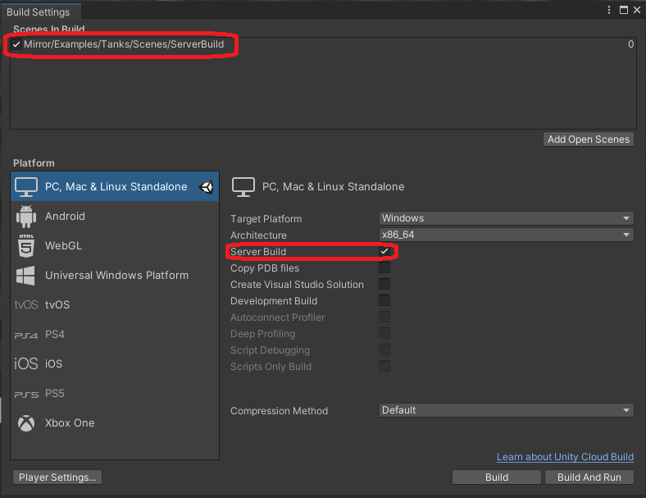

1. Go to Python folder, open config.py and set value for EXC_PATH  
   Example:

EXC_PATH = '../Builds/MultiplayerRoom.exe'

1. Now open python server folder in cmd and type python main.py
2. Http server (Image) is running, it will manage server builds so we don’t need to worry about it.
3. Now go to client build path and Run the client. It should look something like this:

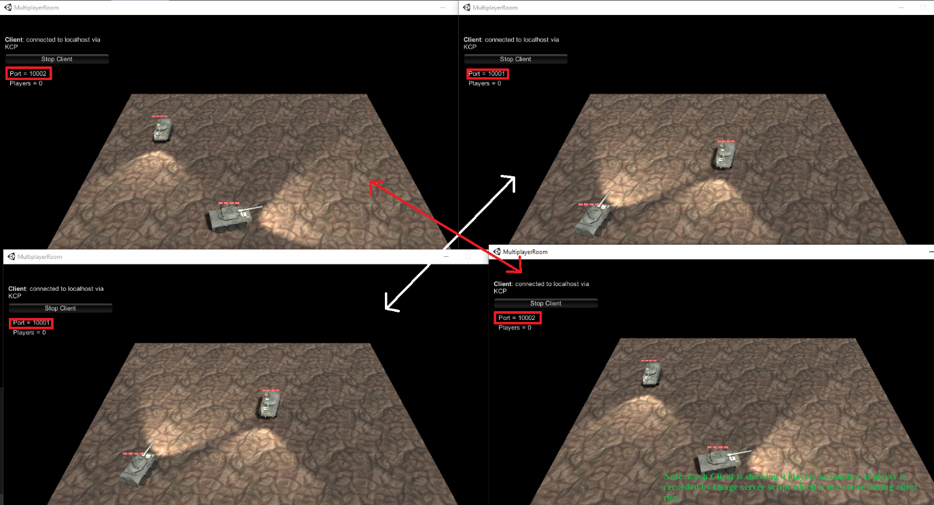

Server console images

# Configuration for deployment.

1. Simply copy the python folder and unity build to server.
2. Make sure the http port for Image (10000 by default) and TCP ports from *startPort to startPort + maxInstances* are exposed to outside network*.*
3. Make sure required python version is present and reconfigure the EXC_PATH if required.
4. Get the Ip address of the server and change that in ***ImageClient*** script as it will be calling the server to get appropriate room. (refer the first figure)

|  |  |
| --- | --- |
|  |  |
| Example build: |  |

Example deployment:

1. For ***ImageServer*** script you don’t need to make any changes as it already runs on same server as **Image**