ASSIGNMENT – 2

PROG3176- Programming: Distributed Applications Development Nirav Saxena (8979968)

API Gateway
The car rental platform MVC application has one entry point, API Gateway which is developed using YARP (Yet another Reverse Proxy). The MVC client does not make any direct calls to a backend Web API. Each request is passing through the gateway where it authenticates and checks the API key, route and removes the service prefix and then directs the request to the appropriate backend API.
The appsettings.json contains two sections in the gateway configuration:
- Routes - determine how the incoming requests are identified and a cluster to forward.
- Clusters -- specify the real backend service addresses.
This is appsettings.json
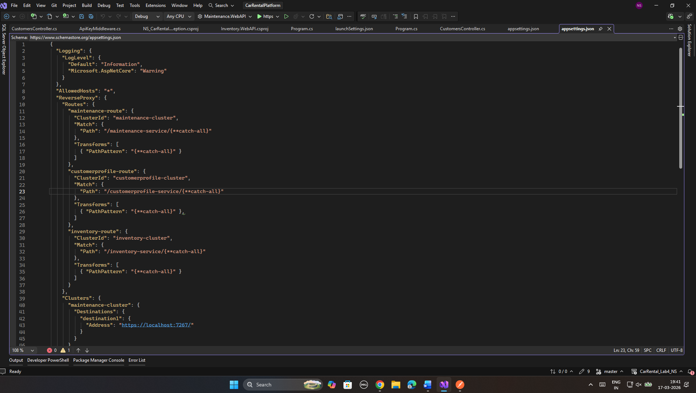

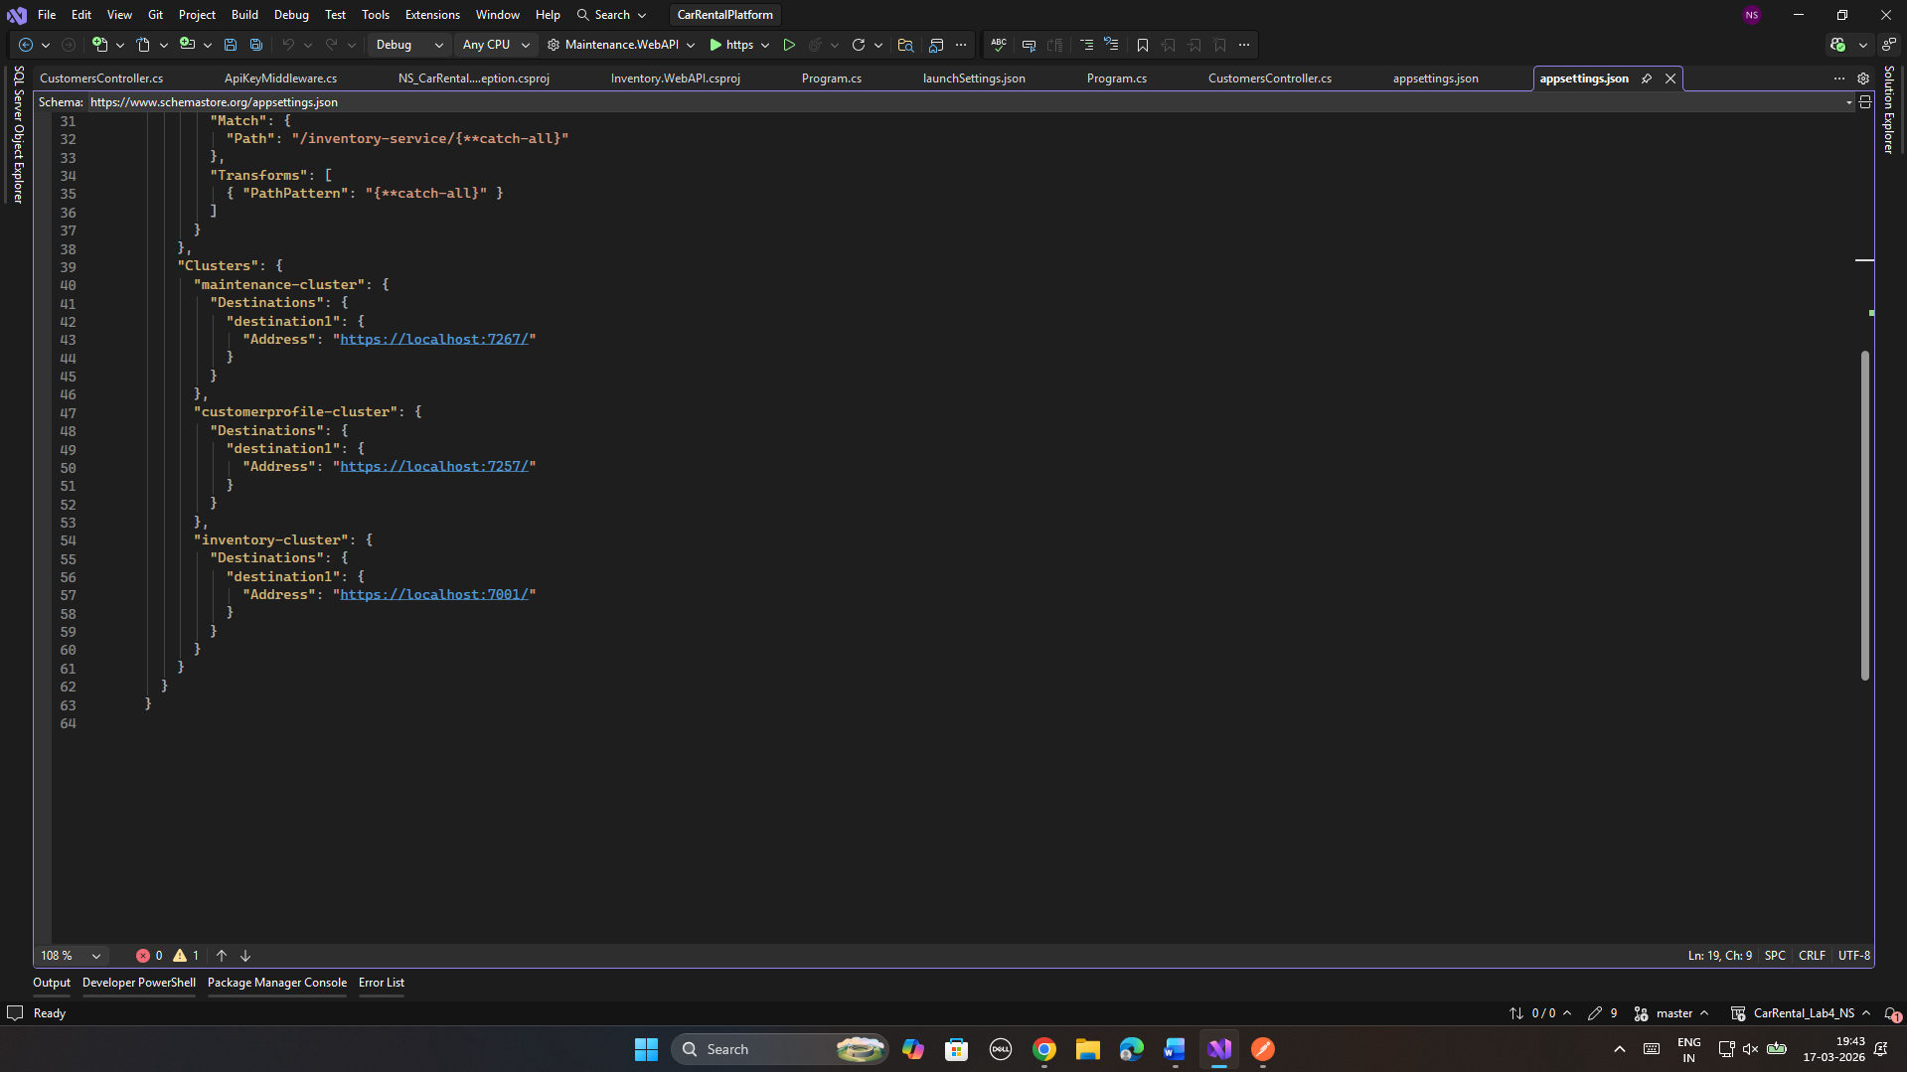
This is the cluster where I have given the Ports on which each service is running

API key Authentication Middleware
NS_ApiKeyAuthMiddleware is used to verify the X-Api-Key header on each request. In the case of the missing or incorrect key, the gateway will send an immediate 401 and stop sending a request to any backend. And The MVC application has one named HttpClient named ApiGateway. All calls to the backend pass via this client that will automatically add the API key header: 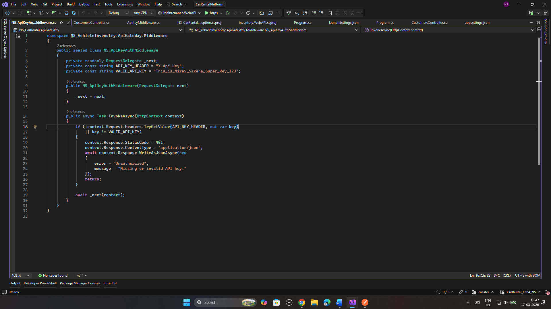
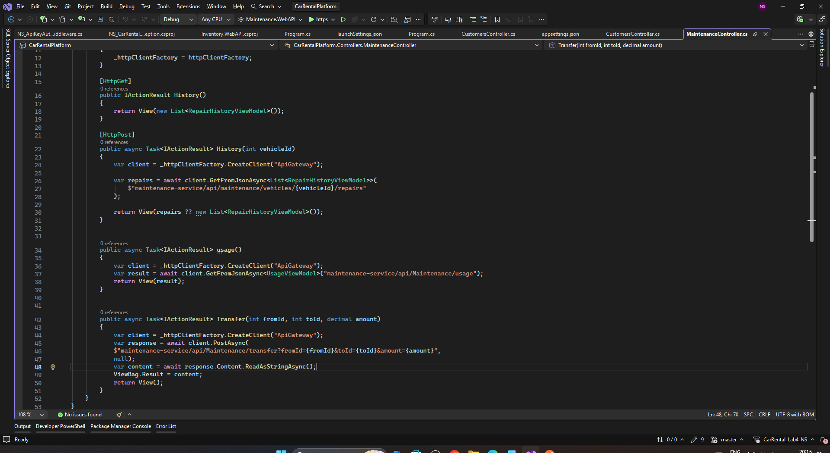

Test cases
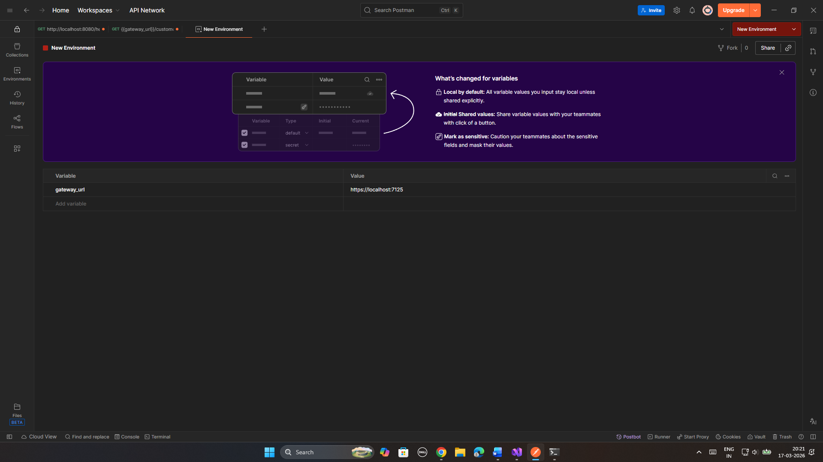
Note : All URLs use {{gateway_url}} – Which I have set up in the Environment
The gateway is running on https://localhost:7125 Which I got from Launchsettings.json under properties.

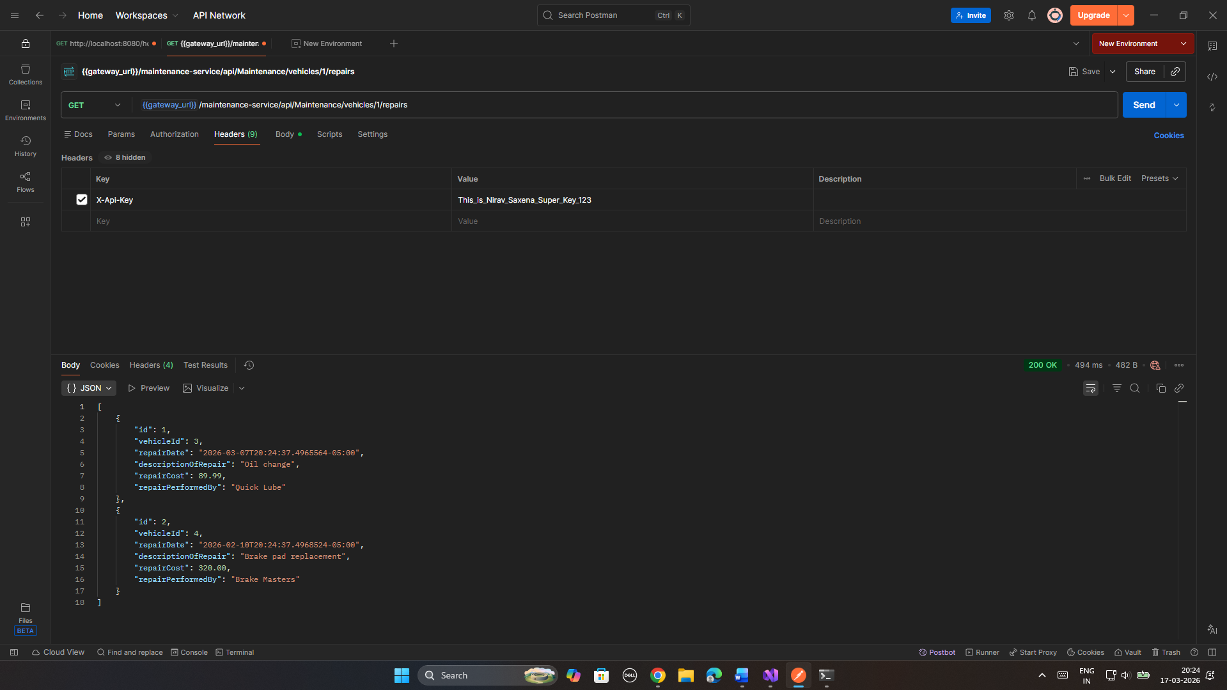
Valid Api key – Gateway will authenticate the API key and give access to maintenance

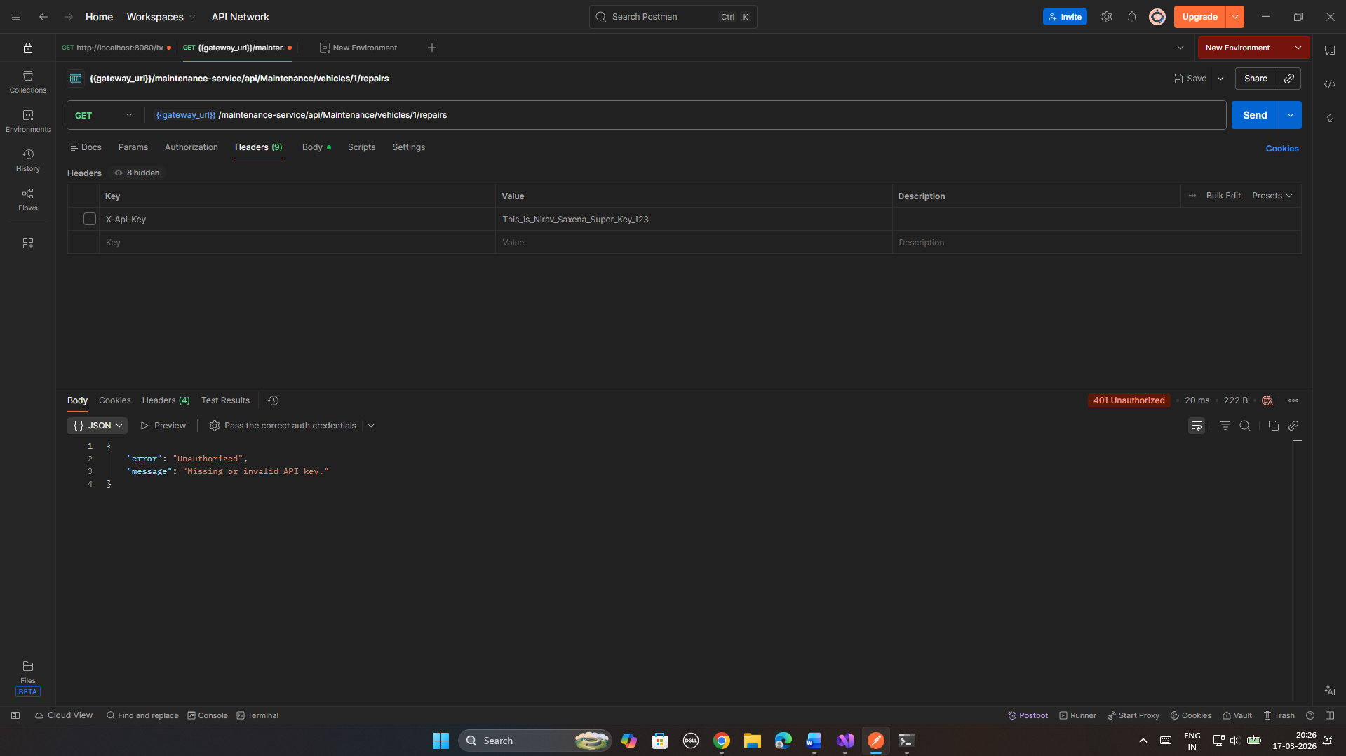
No Api Key – It will throw error of 401. If ApiKeyAuthMiddleware will not see the API it will throw the error

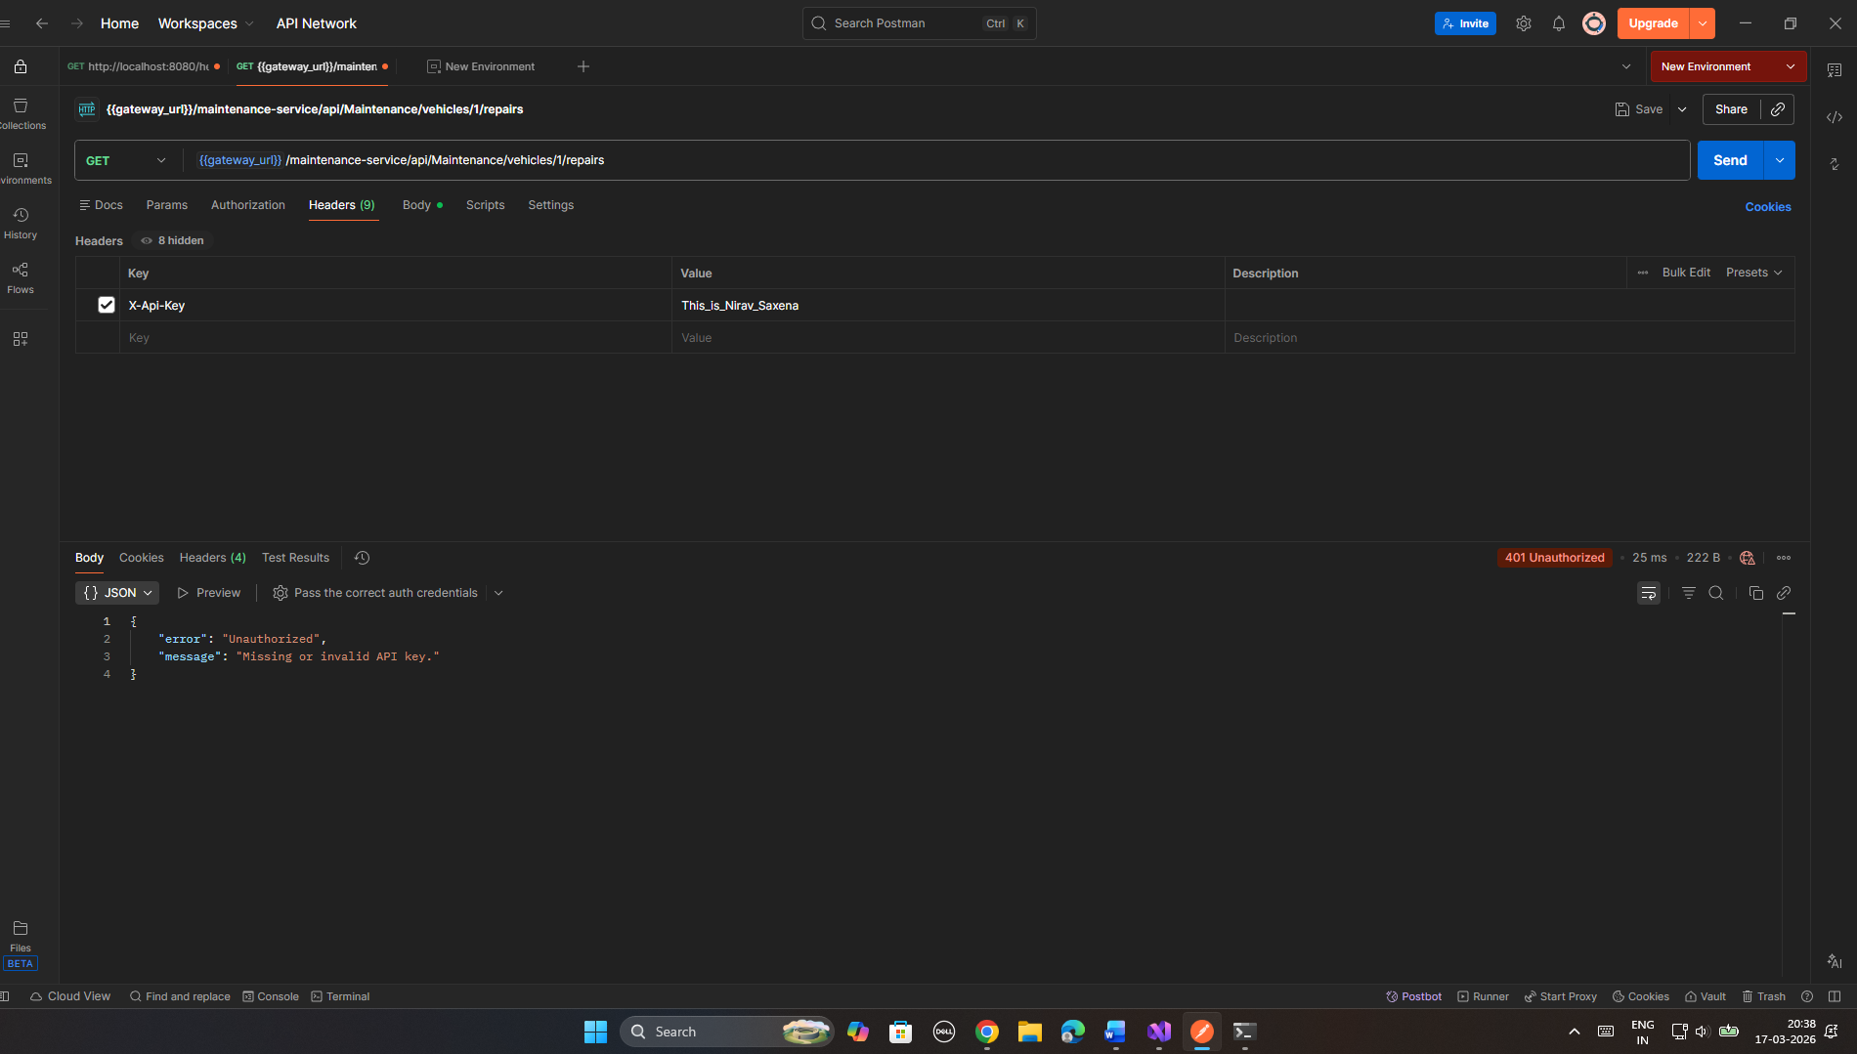
Wrong API key – It will show an error if the Api Key doesn’t match from the initialized in ApikeyAuthMiddleware

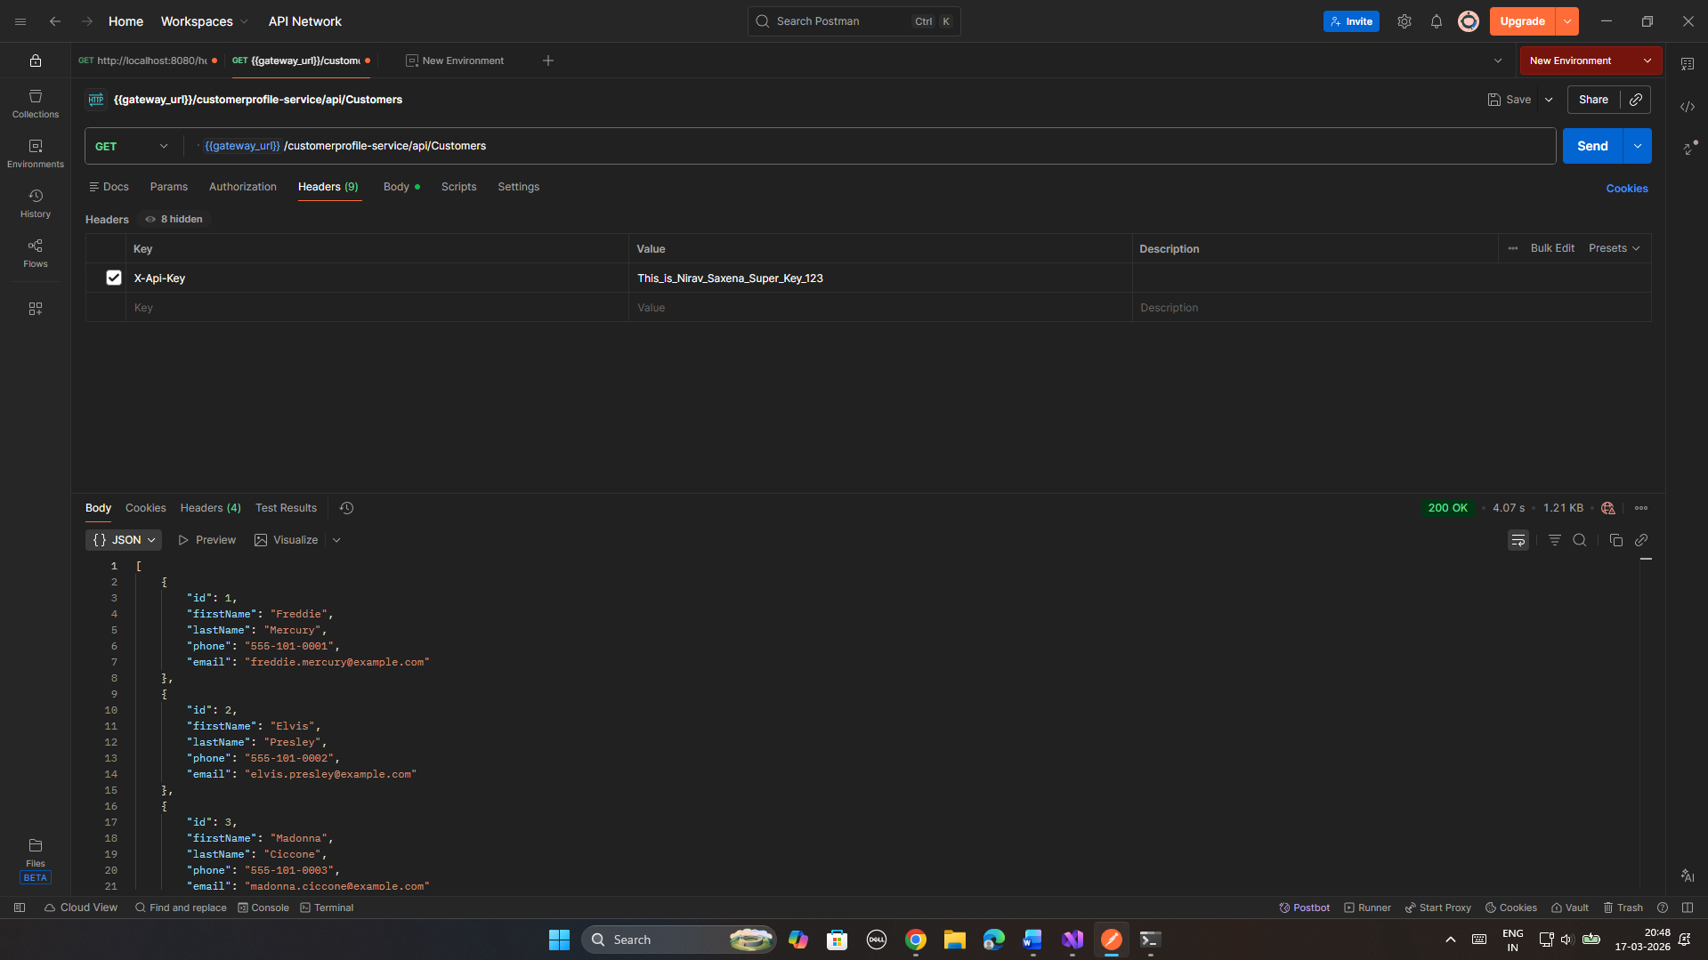
t is a test that customerprofile-route has been properly configured. The gateway defrauds /customerprofile-service and redirects to CustomerProfile.WebAPI. This is used to prove the gateway is running numerous backend services.

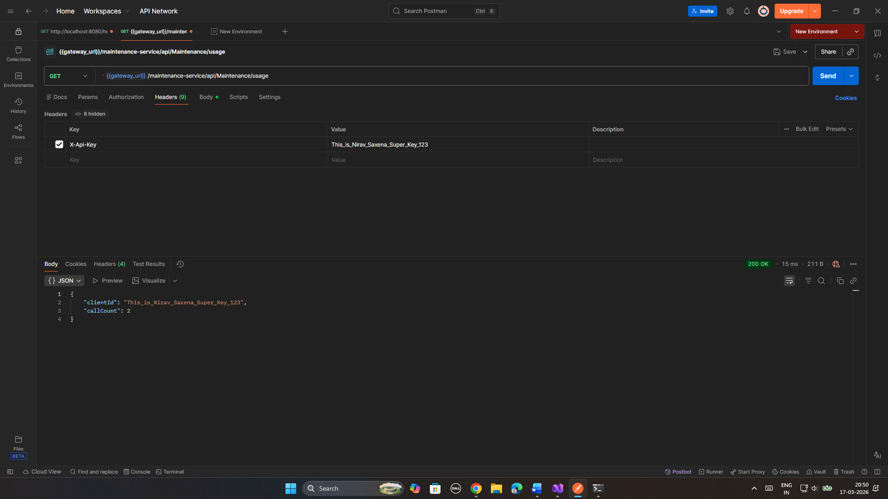
This test confirms the stateful behavior that is used in Maintenance.WebAPI. The usageCounts dictionary becomes a singleton and keeps a record of the number of times each API key has been calling the usage endpoint. The number is maintained within memory among requests.

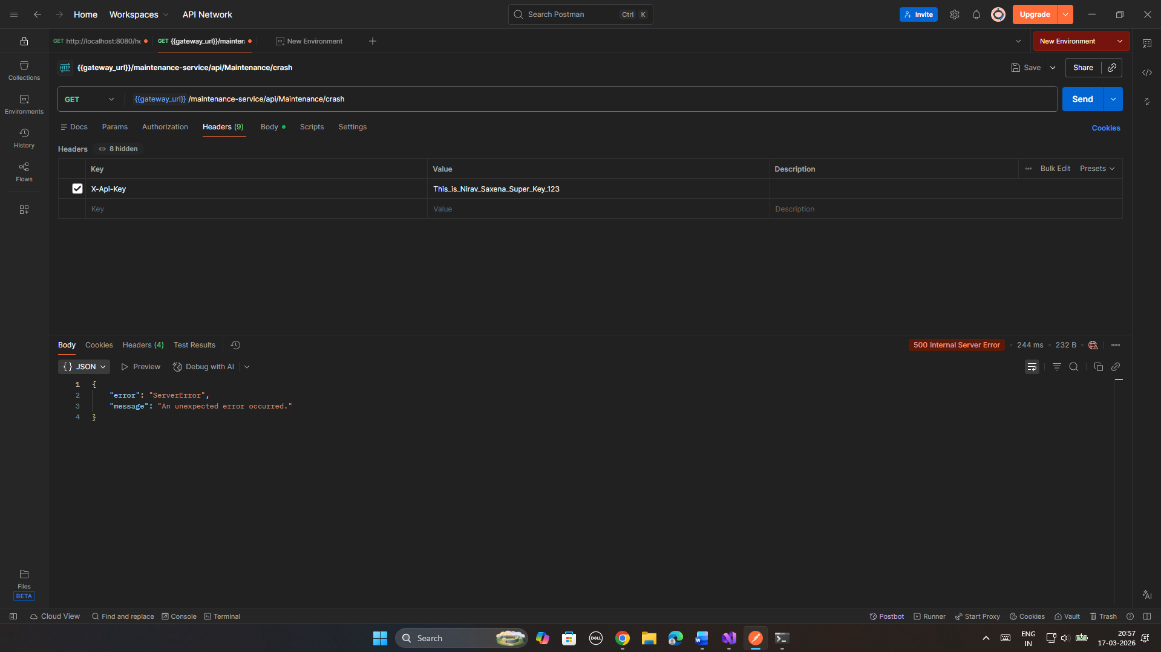
Global Exception Handling - The requirement on the assignment is use DRY principle. A class library was made with the name NS_CarRental.GlobalException. It includes one class, which is NSGlobalExceptionMiddleware. The three Web APIs all mention this library and identify the same class. The exception handling code is developed once and is shared - the DRY (Don't Repeat Yourself) principle.
Test Case - Crash endpoint returns HTTP 500- The endpoint of the crash divides on purpose by zero. In the absence of the middleware this would result in an unhandled 500 with no body. Using the middleware, it will give a clean structured response.

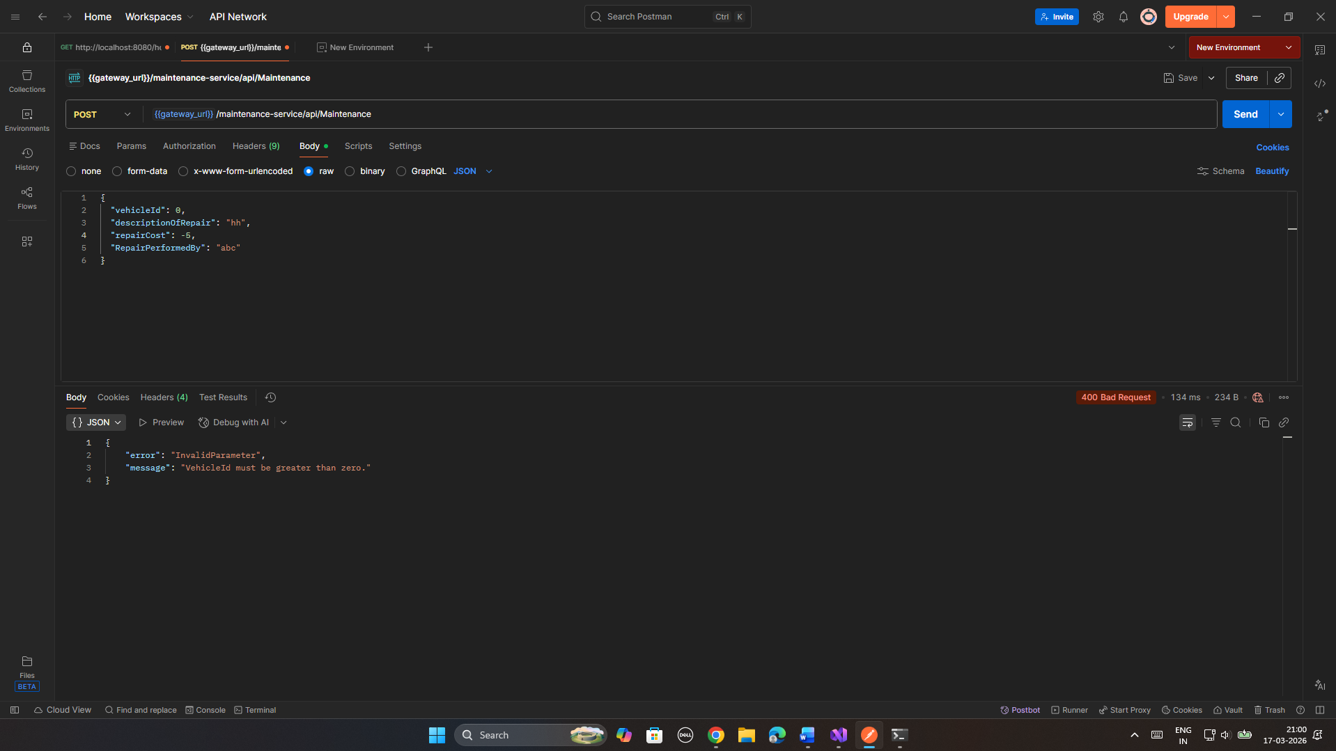
Validation error — VehicleId must be greater than zero - This is a test used to verify local validation in the controller. In the case of a 0 value in the VehicleId, the controller sends a 400 and then the request is sent to the service. The global middleware is also non-interfering, just like intentional 400 responses, it merely captures unhandled exceptions.

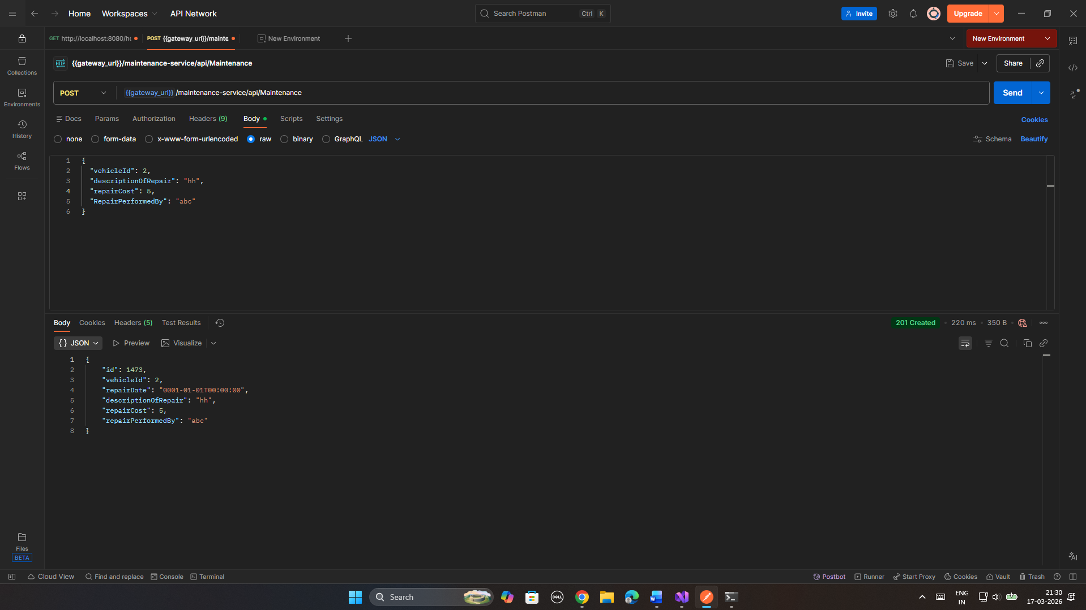
This test ensures that the exception middleware would not interfere with normal successful requests. An acceptable repair record is developed and it returns HTTP 201. The middleware is only triggered in case of unhandled exception.

DDD Fixes in Vehicle Inventory

Problem which I had in the assignment –
- VehicleCode was an unadorned string - not a Value Object. It was not encapsulated and not domain-level validated and equality was not value-based but reference-based.
- VehicleType was a homogenous string - like this. Vehicle type is a significant concept in a car rental domain, which ought to be validated and encapsulated.
- There was only one table all in one Vehicles table. DDD involves the domain model being duly represented on the database structure. The concept of a location is independent and should have a table.

Fixes –
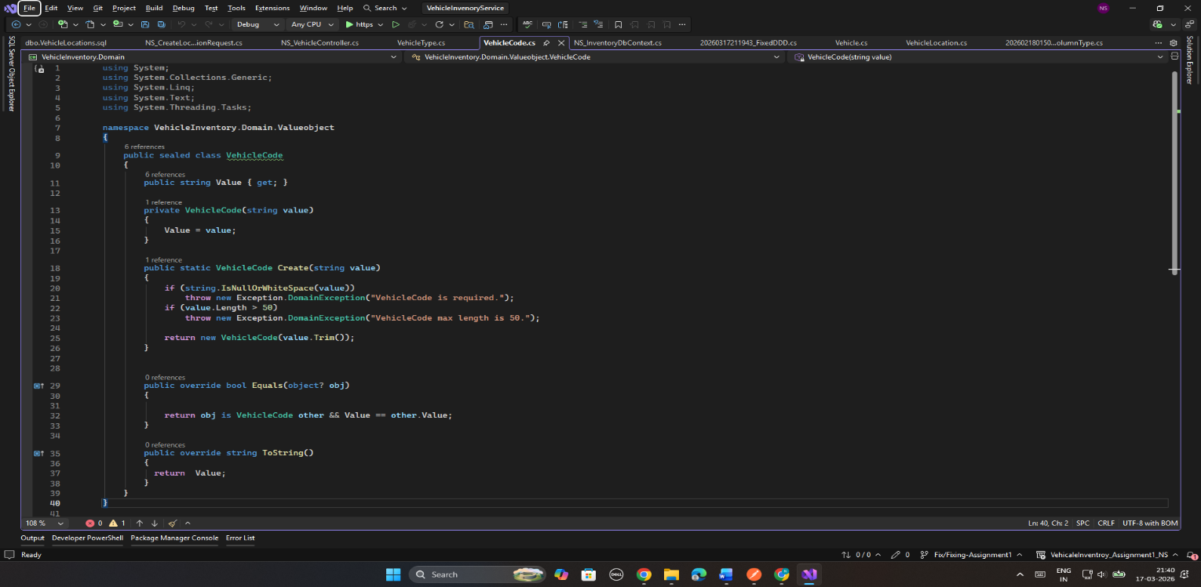
- Value Object –
VehicleCode has become a ValueObjects class. It is unchangeable - Value property is not settable. It is constructed by using the only method of Validate which is the static Create. Two objects of the VehicleCode are equal when they have strings with the same value.

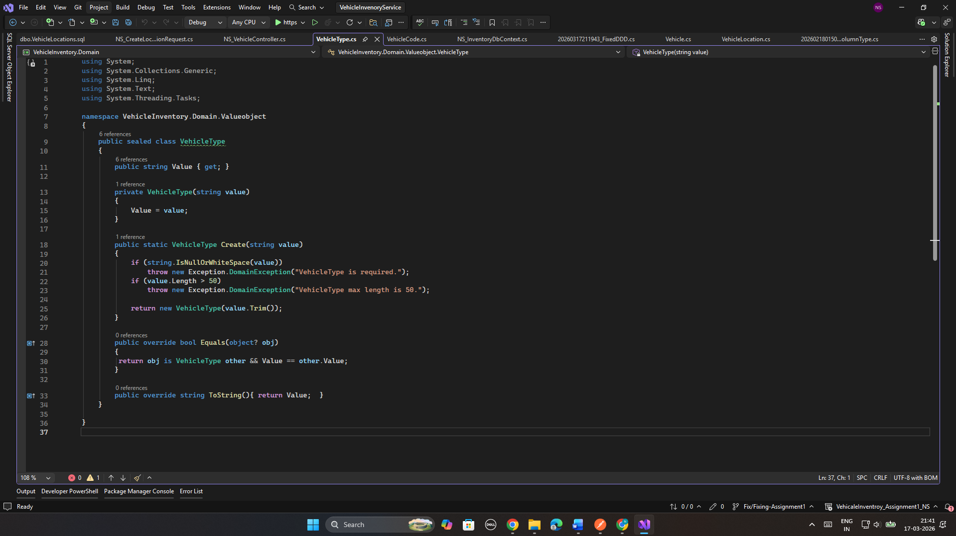
The same is true of VehicleType. It is unchanging, justified at the time of creation and equality is based on values. The Vehicle constructor now invokes VehicleType.Create as an alternative to being presented a raw string. It implies that there is no way to make a Vehicle of invalid type, nor is it possible to do so, the domain imposes it.

2. Two Tables: A new VehicleLocation entity was added to the domain. The database now has two tables — Vehicles and VehicleLocations. The LocationId on Vehicle is a foreign key pointing to VehicleLocations. This properly separates the two concepts in the database, reflecting the domain model. EF Core OwnsOne is used to store the Value Objects as columns within the Vehicles table

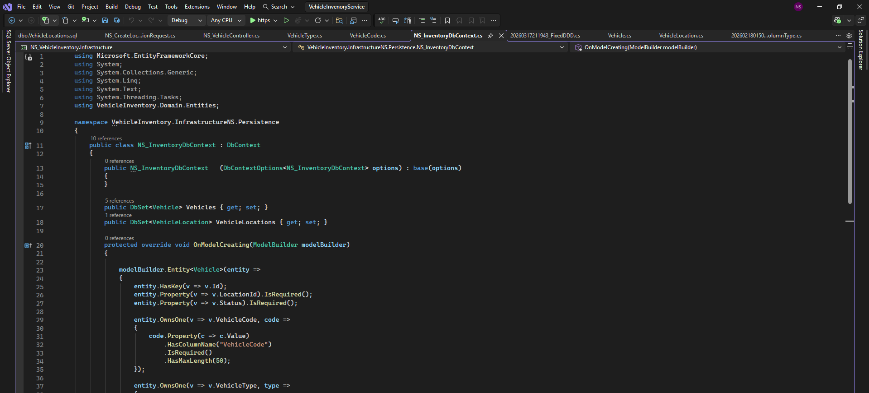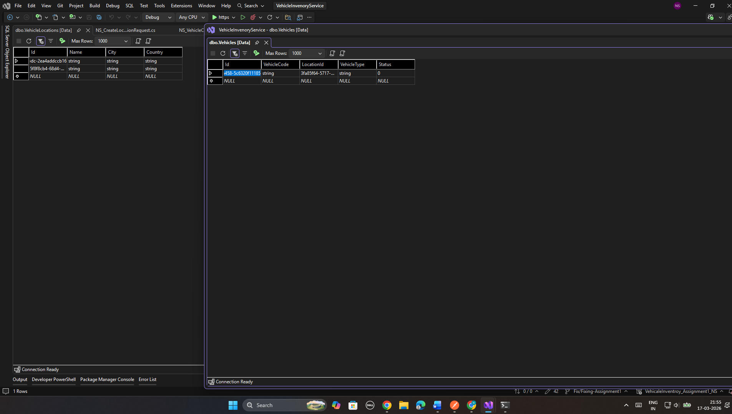

Test Cases

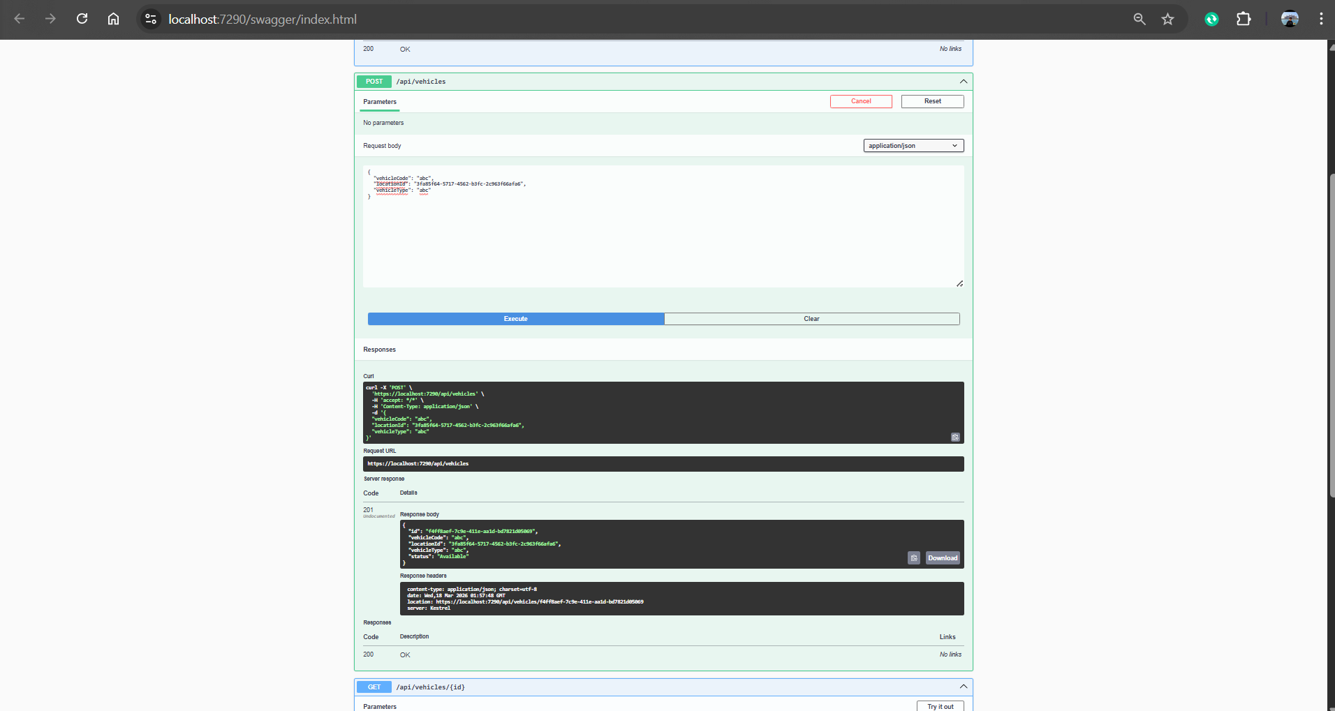
Creating vehicle: This Test cases verifies that it is creating the vehicle and adding it into Vehicle Table

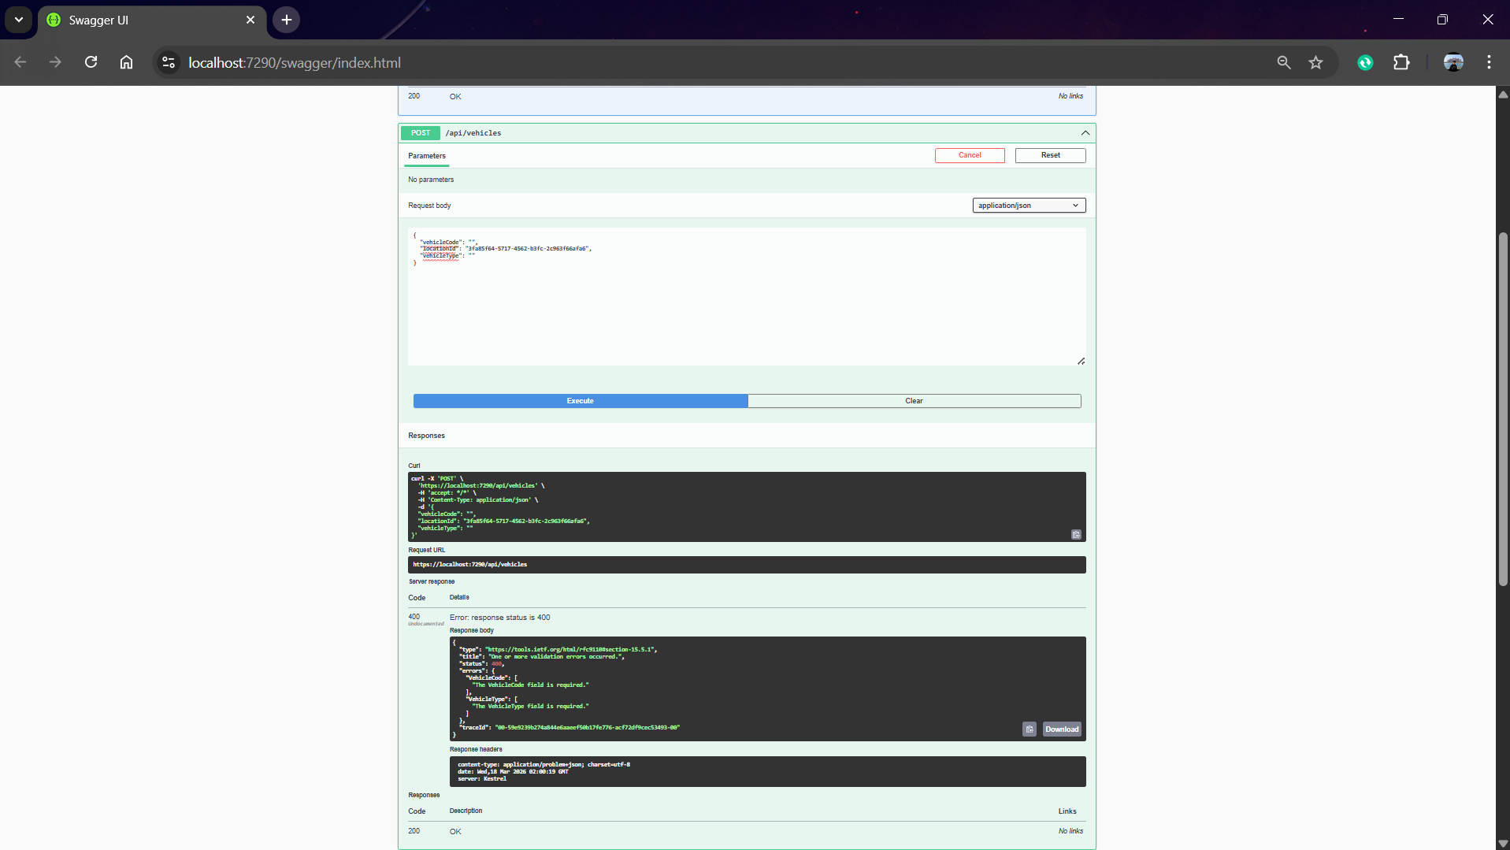
Empty VehicleCode Rejeted by domain: It shows domain level validation works when VehicleCode and ype are empty

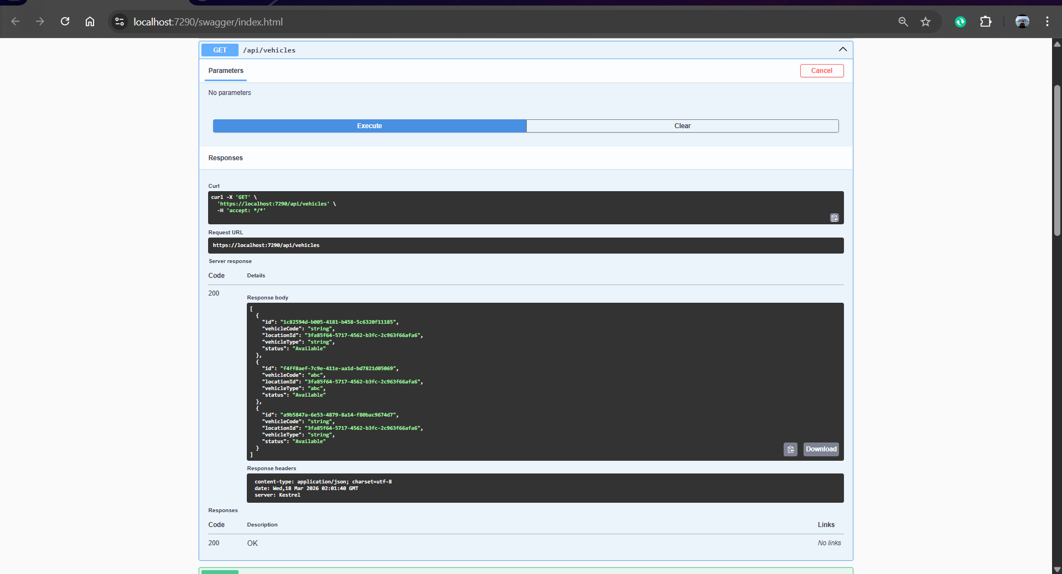
Getting All vehicles: ToDto mapping appropriately removes the.Value attribute of the VehicleCode and VehicleType Value Object. The answer contains simple string values of vehicleCode and vehicletype - the caller should not care about the structure of Value Object.

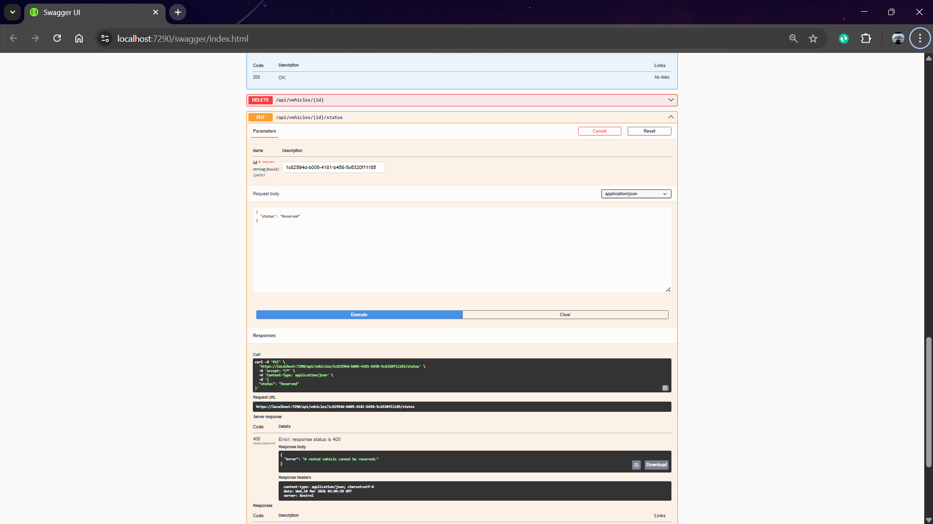
Domain rule — rented vehicle cannot be reserved: This test confirms that the aggregate root Vehicle is business rule compliant. The vehicle is initially changed to Rentedand then to Reserved. MarkReserved() of the Vehicle entity is a DomainException. It is caught by the controller and sent back (400).

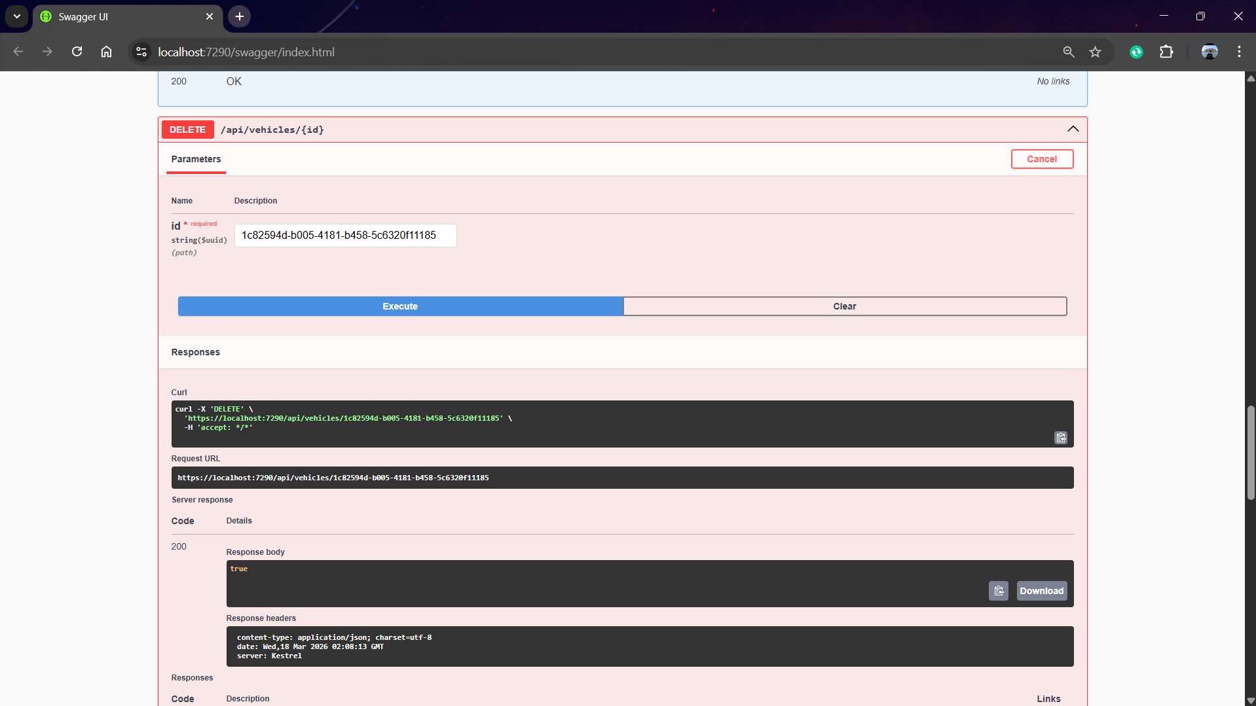
Deleting Vehicles: This is shows that it is deleting the vehicle from table and showing success.

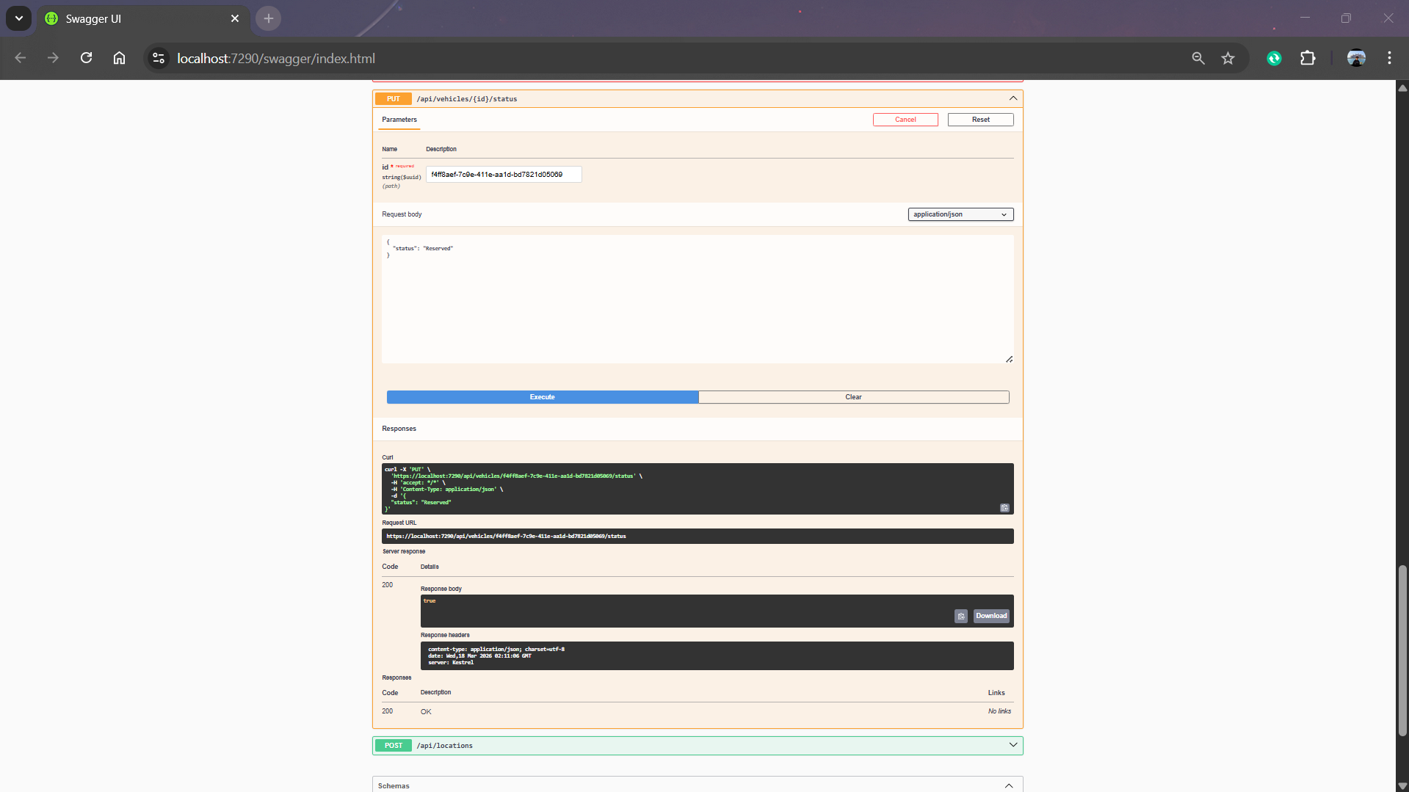
Updating the status: Updating the status of Vehicle From “Available ” to “Reserved” and returns 200 ok

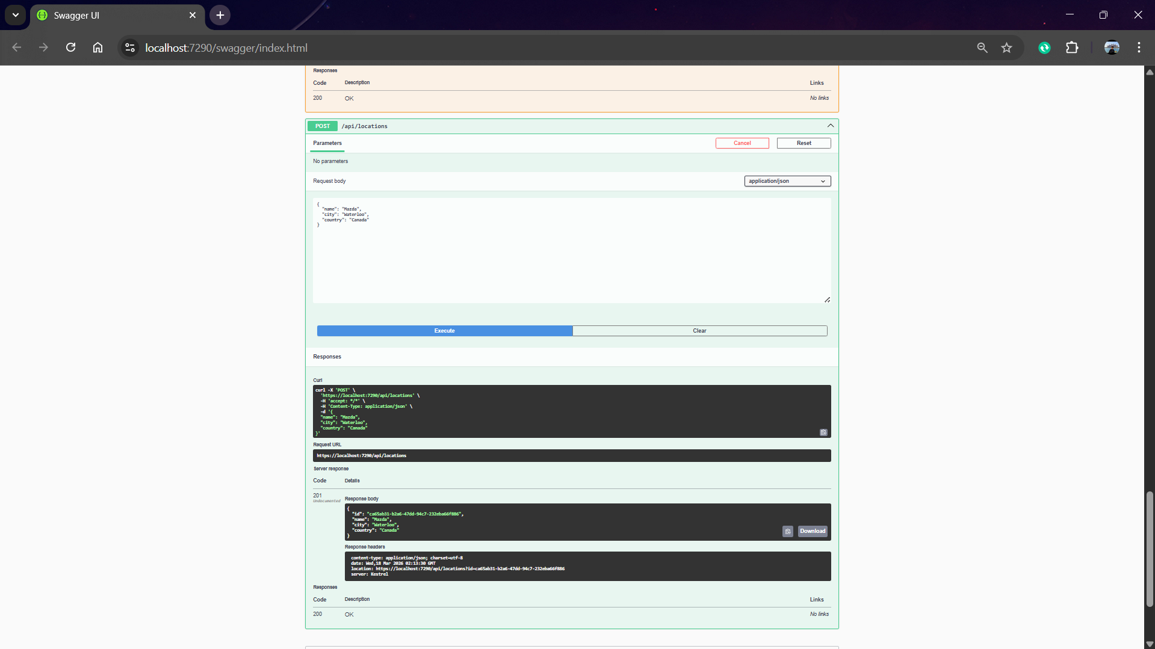
Adding location: Adding location to the New table VehicleLocation

