Questions;

1. What is the overall trend in sales revenue over the past year?
2. What are the peak sales periods and how do they correlate with holidays, promotions, or other events?
3. Which product categories contribute the overall sales revenue?
4. How do sales compare across different store locations?
5. What are the sales trends by location, and do certain locations have seasonal spikes or dips in sales?
6. What is the average transaction value and how does it vary by customer segment?
7. Which products are most frequently purchased together (market basket analysis)?
8. What is the sales uplift during promotional period compared to non- promotional period?
9. Which products benefit the most from promotions?
10. What impact do external factors (e.g., economic changes, competitor actions) have on sales trends?

Problem statement;

The Walmart Superstore wants to analyse its sales data to gain insights into its performance and identify opportunities for growth. The company has a vast amount of sales data, including information on products, customers, stores, and transactions. The main objective is to extract meaningful insights from this data to analyse the overall sales of Walmart superstore.

Analysis of sales;

1. Most sold items are chairs, phones, tables
2. California state has the biggest market for Walmart

Analysis of inventory;

1. Staples & clips are the most sold products
2. Office supplies is the most sold category

Analysis of customers;

1. More than 80% of the customers are from California & Washington state
2. Technology category has the least no of customers
3. Raymond Buch is the most valuable customer

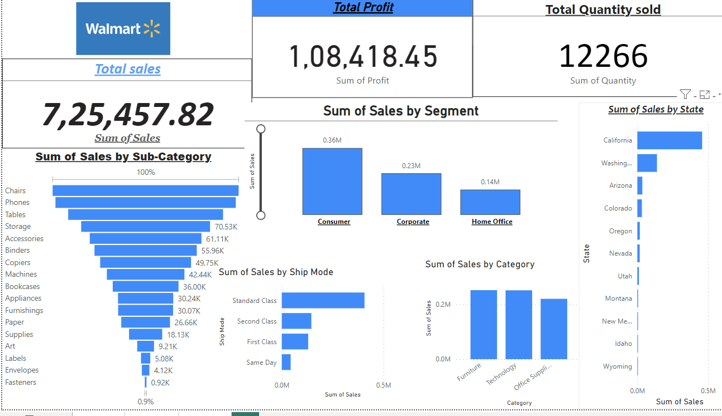

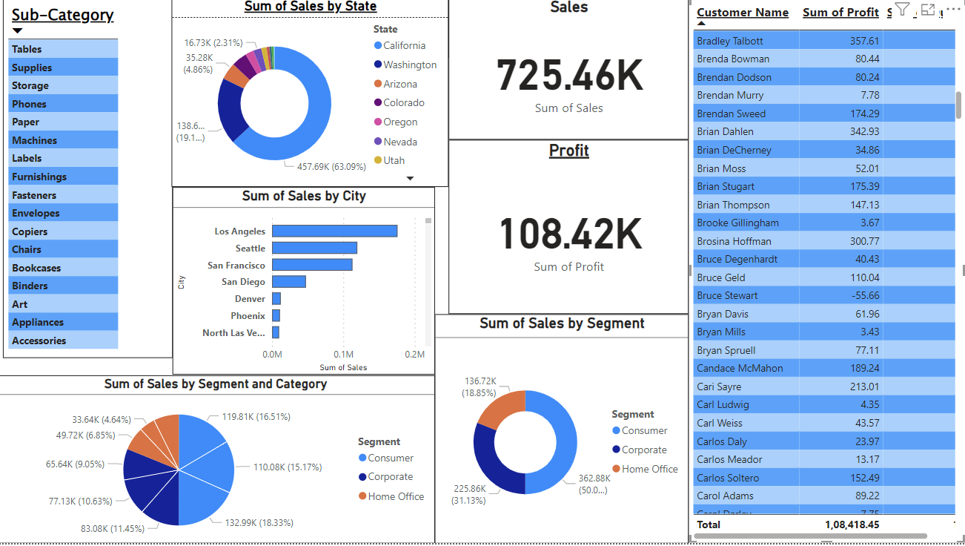

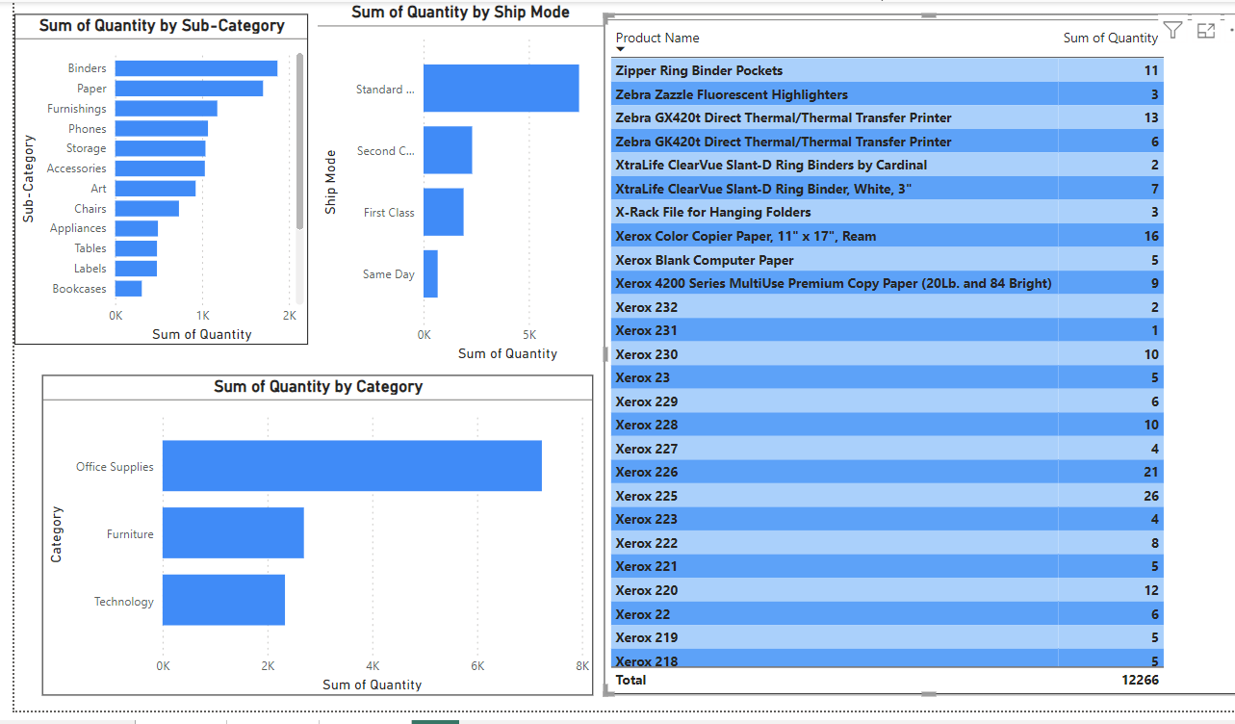

Recommendations: (to improve the performances)

1. Furniture segment is the most profitable category. So, this segment can be expanded.
2. Stores in Arizona, Colorado are facing losses. Steps has to be taken to prevent losses.