**Mintbean chat room**

**Nirav Sorathiya**

**Rajat Bareja**

**Case : 1 – Signup**

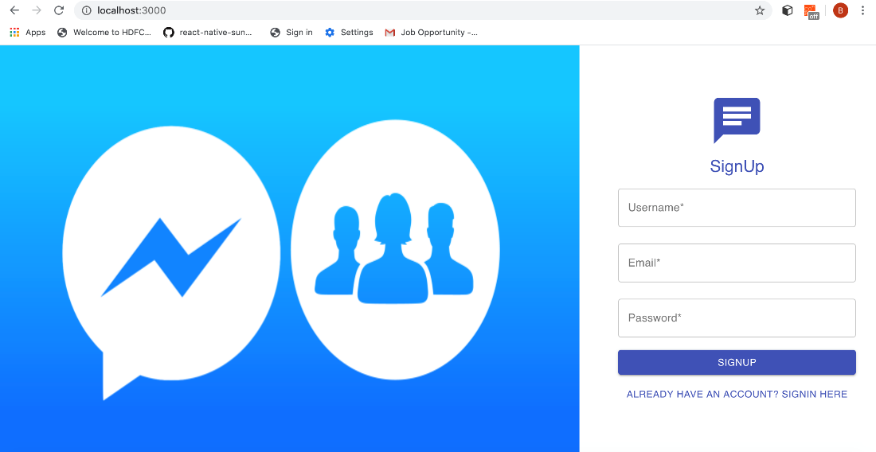

**Case : 2 - Signin**

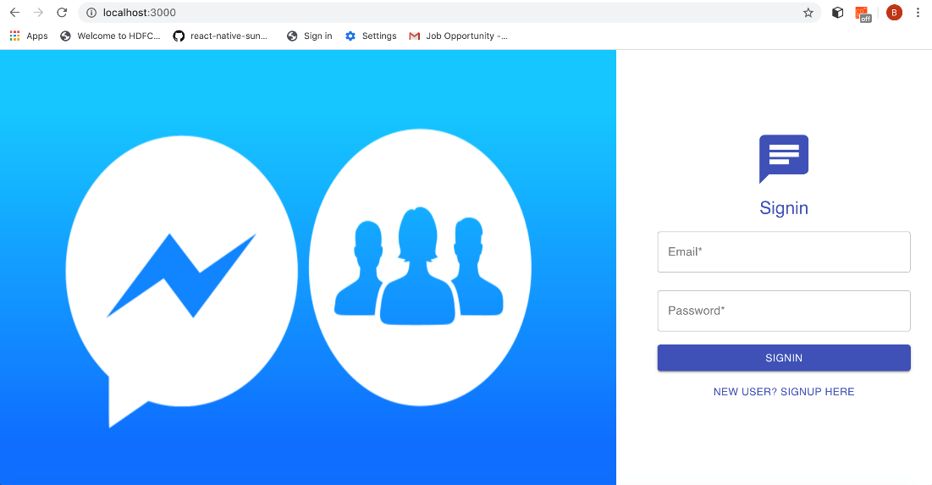

**Case : 3 – Chat room & Logout**

