A Multi-Factor Quantitative Equity Strategy for Large-Cap Indian Stocks

Abstract:

This project investigates whether systematic multifactor investment strategies can outstrip NIFTY 50 on a risk-adjusted basis with consideration of transaction costs. The strategy is tested on a fixed universe of 30 large-cap Indian equities and combines five factors: Momentum, Low Risk, Quality, Value and Size. Every stock is ranked on a monthly basis using percentile based factor score. The five factors are weighed equally to create a composite Factor Score. The 10 highest-ranked stocks are selected each month and tested under three portfolio-construction methods: Equal Weight, Factor-Score Weight and Sharpe-Optimized Weight. To minimise look ahead bias - error of using information from the future in a historical analysis or backtest - annual fundamental data is assumed to become available 90 days after the financial year-end, +and only information available at each rebalance date is used. The model was evaluated across a training period from 2020-2022, a validation period in 2023 and an out-of-sample test in 2024. Over the full sample, the Factor Score portfolio produced the strongest overall combination of return, Sharpe ratio, drawdown and turnover among the tested methods. It achieved a Compound Annual Growth Rate(CAGR) of approximately 25%, compared with around 15% for NIFTY 50, while simultaneously experiencing lower volatility and a smaller maximum drawdown.The strategy also stayed competitive during validation and out-of-sample periods and under several robustness tests. However, the results are subject to limitations including survivorship bias, simplified transaction-cost assumptions and the use of approximate fundamental-data availability dates.

Research Question and Motivation:
The main research question of this project is:
Which combination of quantitative factors provides the strongest risk-adjusted performance among a universe of large-cap Indian equities, and how robust is that relationship across different market conditions and portfolio-construction methods?
I chose this question because I was keen in learning whether investment decisions could be made using a system that is straightforward, transparent and repeatable. Rather than relying entirely on fluke, judgement or short-term market opinions. Multi-factor investing was something which I did not know about. I learned about it when understanding what all factors had significant impacts. It is particularly interesting because it combines several different explanations for stock performance rather than depending on one signal alone. For instance, Momentum rewards stocks that have performed strongly, Value looks for relatively inexpensive companies, Quality focuses on financial strength, Low Risk favours more stable stocks, and Size captures differences related to company scale.Instead of assuming the fact that one of these factors would always work best, the project tests whether combining them into one systematic ranking model produces stronger and more consistent results.Another objective was to compare simple portfolio construction with a more complex optimization approach. This allowed the project to test whether greater mathematical complexity actually improved portfolio performance or simply increased turnover and sensitivity to historical data.
The final goal was not to create a prediction model that guarantees future returns, but to build a research framework that could be tested, audited and improved over time.

Data and Stock Universe:
The strategy is tested on a fixed universe of 30 liquid large-cap Indian equities. The universe includes companies from several sectors including banking, information technology, energy, pharmaceuticals, consumer goods and industrials. A fixed universe was chosen so that the factor model could be tested consistently across the full sample period.However, that is not the limit.
Historical price data was collected at monthly intervals using the final trading day of each month. Adjusted prices were used for return calculations so that the stock splits and other corporate actions did not artificially distort historical performances.For valuation-related calculations, such as price-to-earnings(P/E) ratio and market capitalisation, raw month-end prices were used instead. While adjusted prices are appropriate for computing returns, valuation ratios should be computed using the actual stock price observed at that point in time.
Screener exports were used to obtain historical fundamental data. The main variables used in the analysis were net profit, equity share capital, reserves and shares outstanding. They were used to derive return on equity, earnings per share and market capitalisation
One of the main challenges faced was avoiding look-ahead bias. Annual financial statements are not available to investors on the final day of the financial year, so the model assumes that annual fundamental information becomes available 90 days after year-end. Until a newer financial statement becomes available, the latest known annual value is carried forward.This is still an approximation because the day different companies publish differs. However, using a fixed reporting lag is much more realistic than assuming that financial information was available immediately at year-end.
The benchmark used throughout the project is the NIFTY 50. The NIFTY 50 was selected as the benchmark because the strategy operates within a universe of liquid Indian large-cap equities. The index provides a widely recognized representation of the Indian large-cap equity market and therefore serves as an appropriate passive reference against which the strategy’s return and risk-adjusted performance can be evaluated.
The main backtest begins in 2020 because the Momentum and Low Risk factors require 12 months of historical price data. Price data therefore begins in 2019 so that these trailing indicators can be calculated before the strategy starts making selections.

Factor Construction:
The model comprises of five factors: Momentum, Low Risk, Quality, Value and Size. The aim was to combine signals that capture different characteristics of a company rather than relying on a single indicator.Each factor is calculated separately for every eligible stock at each monthly rebalance date. Stocks are then ranked cross-sectionally using percentile scores. This means that each company is scored relative to the other stocks in the universe at that point in time.
The percentile approach also makes it possible to combine factors that are measured in very different units.

Momentum:
Momentum measures a stock's trailing 12-month price performance.Stocks with stronger historical price performance score higher. The basic idea is that price trends can sometimes persist, meaning that stocks which have performed strongly over the recent past may continue to outperform for some period.
The Momentum factor is calculated using adjusted month-end prices:
Momentum = Percentage change in adjusted price over the previous 12 months
The stock with the strongest trailing return therefore receives one of the highest Momentum percentile scores.

Low Risk:
The Low Risk factor measures the volatility of a stock's monthly returns over the previous 12 months.Lower volatility receives a higher score. This reflects the idea that relatively stable stocks may deliver better risk-adjusted performance than more volatile stocks.
Volatility is calculated as the standard deviation of the previous 12 monthly returns.
Because lower volatility is preferred, the ranking direction is reversed when the percentile score is calculated.

Quality:
Quality is measured using return on equity.Return on equity compares a company's net profit with the amount of shareholder equity employed in the business:
ROE = Net Profit / Shareholder Equity
Shareholder equity is approximated as equity share capital plus reserves using the historical financial statements. Companies with higher ROE receive higher Quality scores because they are generating more profit relative to their equity base.
Only the most recent annual financial information that would have been available at each historical rebalance date is used.

Value:
Value is measured using the price-to-earnings ratio.Historical earnings per share is calculated from annual net profit and adjusted shares outstanding. The most recently available annual EPS is then combined with the current raw month-end stock price:
P/E = Month-End Share Price / Latest Available Annual EPS
Lower P/E values receive higher Value scores, since a lower price relative to earnings is treated as a stronger value characteristic.
Using the current month-end price means that the Value signal can change every month even when the latest annual earnings figure has not yet changed.

Size:
Size is measured using market capitalisation.Market capitalisation is calculated using the current raw month-end share price and the latest available number of shares outstanding:
Market Capitalisation = Month-End Share Price × Shares Outstanding
Within the large-cap universe, smaller companies receive higher Size scores.This does not mean that the strategy invests in genuinely small-cap companies. The Size factor only ranks companies relative to the other stocks within the predefined large-cap universe.

Composite Factor Score:
After the five factors are calculated, each is converted into a percentile score between 0 and 1. The five factor scores are equally weighted:
Factor Score = 20% Momentum + 20% Low Risk + 20% Quality + 20% Value + 20% Size
We choose equal weighting as our baseline specification because it does not impose additional assumptions about which factor should dominate.
Then, as part of the robustness analysis we tested alternative factor-weight combinations. The original equal-weight specification was kept as the main strategy to avoid selecting factor weights just because they worked best in hindsight.

Portfolio Construction and Backtesting Framework
After calculating the five-factor scores each month, the 10 highest-ranked stocks are selected for the portfolio.The number of holdings was fixed at 10 before the final robustness testing. This creates a concentrated enough portfolio for factor differences to matter, while still providing diversification across several companies and sectors.
A deterministic tie-breaking rule is also used so that if stocks have the same Factor Score, the ranking is resolved consistently rather than depending on row order in the dataset.

Portfolio Construction Methods

Three different portfolio construction methods are tested to see whether weighting methodology changes the final outcome.

Equal Weight:

The Equal-Weight portfolio assigns the same weight to each selected stock. Since the top 10 are selected, each stock initially receives a 10% weight . This approach is simple and avoids making additional assumptions about how strongly the factor score should influence position size.

Factor-Score Weight:
The Factor-Score portfolio gives more weight to stocks with higher composite Factor Scores. Next, the Top 10 stocks are selected and each stock’s portfolio weight is calculated as its Factor Score divided by the sum of the Factor Scores of all selected stocks.
This means that stronger ranked stocks receive slightly larger allocations, while the portfolio remains fully invested and long-only.

Sharpe-Optimized Weight:
The Sharpe-Optimized portfolio uses historical return data to estimate a set of portfolio weights that maximises the historical Sharpe ratio.Only the previous 12 months of monthly returns available at each rebalance date are used.This prevents the optimizer from using return information from the future.Portfolio weights are constrained to be non-negative and must sum to 100%, meaning short selling is not allowed.
The optimizer uses a time-varying short term Indian risk-free rate when calculating excess returns.

Rebalancing, Turnover and Transaction Costs

The portfolio is rebalanced on a monthly basis. A new Top 10 ranking is generated at each rebalance date and target portfolio weights are determined.
The portfolio weights are allowed to drift from the prior month based on the returns earned on each stock before the turnover is calculated. This makes the comparison between current portfolio and new target portfolio more realistic.

Turnover is the half sum of the absolute changes in portfolio weights:
Turnover = 0.5 × Σ |New Weight - Drifted Previous Weight|

The first portfolio formation has 100% turnover since the strategy starts from a blank portfolio.

The backtest assumes all-in transaction costs of 0.25% per unit of turnover to account for trading frictions. This is not an attempt to reproduce the exact historical broking, taxes, bid-ask spread and slippage of every trade, but rather a simplified modelling assumption.

Thus, net portfolio returns are computed as:
Net Return = Gross Portfolio Return - Transaction Cost

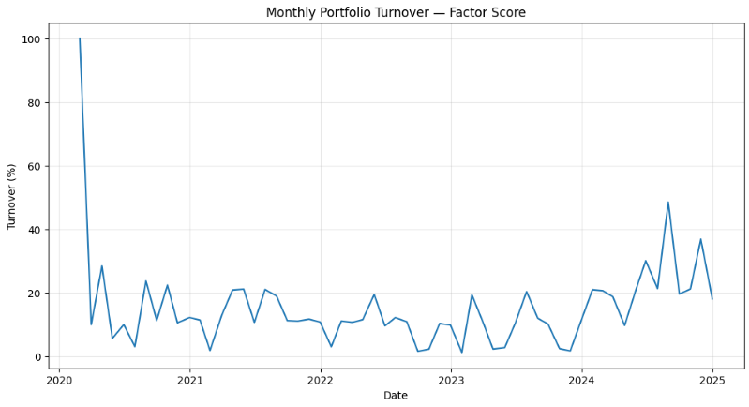

Benchmark & Risk-Free Rate

The NIFTY 50 is considered as the benchmark for the entire analysis.
Benchmark returns are calculated based on the last trading day of each month so that the benchmark is aligned with the monthly return periods of the strategy.

Monthly Indian short-term interest rate series is used as proxy for risk-free rate for risk adjusted performance in the model.Risk free observations are annualised, converted to monthly equivalents and matched to the appropriate month in the backtest.
Both the reported Sharpe ratios and the Sharpe-optimization process make use of the time-varying risk free rate.

Training, Validation and Out-of-Sample Testing

To limit the risk of drawing conclusions from one continuous historical sample, the backtest is divided into 3 periods.

- The training was done between 2020 and 2022. This is the key period to observe the strategy performance and to set up the initial research framework.
- The validation period is 2023. This gives a different time for determining whether the model continues to perform after the first training sample.
- The out-of-sample period is 2024. This is the most important test, as it evaluates the model on a period that is considered separately from the development stage before it.

The intent of this split is not to suggest that the strategy has been developed without exposure to the full historical dataset, but to provide a more disciplined framework for evaluating robustness and reducing overfitting.

Performance Measures

Each portfolio is evaluated utilising multiple measures, not just return.The arithmetic annualised return is calculated by multiplying the average monthly return by 12.

- CAGR is the compound annual growth rate over the entire analysis period.
- Annualised volatility is the standard deviation of monthly returns multiplied by the square root of 12.
- The Sharpe ratio calculates the average excess return relative to portfolio volatility using the time-varying monthly risk-free rate.
- Maximum Drawdown is the Largest peak-to-trough decline in portfolio value over the period.
- Average monthly turnover is a measure of the extent to which the portfolio is replaced or reweighted on an average month.

By looking at all these metrics together, it is possible to tell the difference between a strategy that simply produces a high return and one that produces a better overall risk-return trade-off.

Results
Full-Period Performance:

The first comparison looks at performance over the full backtest period from 2020 to 2024.
The Factor-Score portfolio delivered the best overall result among the three portfolio construction methods. It reported a CAGR of 25.03% as against NIFTY 50 benchmark of 14.87%.
It also generated lower annualised volatility than the benchmark, and a lower maximum drawdown. So its Sharpe ratio was significantly higher.

Portfolio | CAGR | Volatility | Sharpe Ratio | Max Drawdown | Avg. Monthly Turnover
Equal Weight | 24.17% | 16.82% | 1.08 | -15.42% | 16.23%
Factor Score | 25.03% | 16.55% | 1.14 | -14.67% | 15.29%
Sharpe Optimized | 18.32% | 16.43% | 0.80 | -15.07% | 34.83%
NIFTY 50 | 14.87% | 18.91% | 0.57 | -23.25% | –

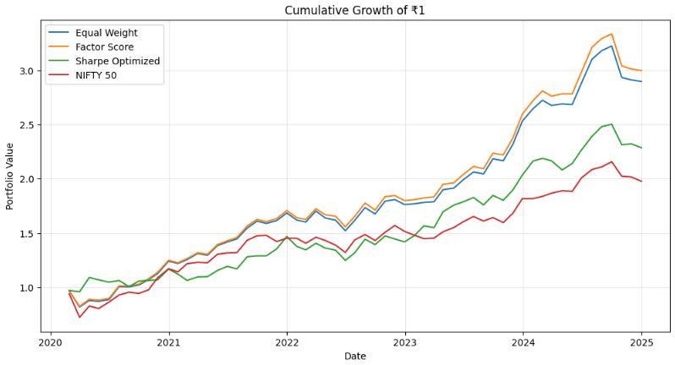

The Equal-Weight portfolio performed almost as well as the Factor-Score portfolio, indicating that the majority of the strategy’s performance came from the stock selection process rather than just the weighting scheme.However, Factor-Score weighting produced slightly higher returns and a higher Sharpe ratio while also having lower turnover than Equal Weight.

The Sharpe-Optimized portfolio was the most surprising result. Despite using a more mathematically complex weighting process, it produced a significantly lower CAGR and Sharpe ratio than the two simpler approaches. Its average monthly turnover was also more than twice that of the Factor-Score portfolio.

This suggests that optimization based on a relatively short historical return window may have reacted too strongly to recent relationships between stocks. In this test, greater complexity did not translate into better performance.

Training, Validation and Out-of-Sample Results
Full-period performance alone can be misleading because a model may perform well on the same historical data used during its development. For this reason, the sample was divided into training, validation and out-of-sample periods.
Training Period: 2020–2022
During the training period, the Factor-Score portfolio produced a CAGR of approximately 22.27% and achieved stronger risk-adjusted performance than the NIFTY 50.
The Equal-Weight portfolio also performed strongly, while the Sharpe-Optimized portfolio was weaker.This provided the initial evidence that the five-factor ranking approach was capable of identifying a group of stocks that performed differently from the benchmark.

Validation Period: 2023
The strategy remained strong during the separate 2023 validation period.The Factor-Score portfolio achieved a CAGR of approximately 44.50%. This was an unusually strong year, so the result should not be treated as a normal expectation for the strategy.
More importantly, strong performance continued even though 2023 was separated from the original training sample. This provided evidence that the model's historical result was not entirely dependent on the 2020–2022 period.
Out-of-Sample Period: 2024
The 2024 out-of-sample period was the most important part of the evaluation.The Factor-Score portfolio achieved a CAGR of approximately 15.49%, compared with roughly 8.8% for the NIFTY 50. Although the difference was smaller than in 2023, the strategy continued to outperform after the development and validation periods.
This result is more meaningful than the full-period backtest alone because the model's rules were evaluated on a later period rather than judged only by their historical fit.

Interpretation of Results
The comparison of the portfolios yields three primary findings.
- First, it seems that the stock selection was more important than the sophisticated portfolio optimisation. The Equal Weight and the Factor-Score Weight both beat the Sharpe-Optimized portfolio significantly.
- Second, the Factor-Score method produced the best overall trade-off between return, volatility, drawdowns and turnover. Its edge over Equal Weight was not enormous but was fairly persistent in the different testing periods.
- Thirdly, the benefit of the strategy over the benchmark was not constant. Some years the difference was large and some years it was very close. This is important because a realistic quantitative strategy cannot be expected to beat the market by the same amount every year.
The results are therefore supportive of the multi-factor approach, but do not suggest that the strategy has discovered a sure-fire source of excess return. The historical evidence is encouraging and the robustness and out-of-sample tests help to show that the result is not based on only one particular backtest period.

Robustness Tests
To ensure that the performance of the strategy was not overly sensitive to one particular set of assumptions, a number of robustness tests were performed.

Number of Holdings
The portfolio was tested using the Top 8, Top 10 and Top 12 stocks ranked.
Performance was relatively strong in all three specifications. This shows that the outcome was not based on the choice of the 10 stocks.

We did not select the one with the highest historical return. We selected the Top 10 specification prior to the robustness comparison, which is why it was retained as the main model.

Transaction Costs
The backtest was repeated using different transaction-cost assumptions. As expected, the strategy’s net return was lower due to higher transaction costs. But even using more conservative cost assumptions, the overall historical performance was still reasonably strong.
This is important because a strategy that only works if trading is practically free would be far less convincing.

Factor Weights
Alternative combinations of the five factor weights were also tested.
Some alternative specifications, particularly those placing greater weight on Quality and Value, produced stronger historical results than the original equal-weight model.

However, these alternatives were not adopted as the main strategy. Selecting the best-performing factor weights after observing the historical results would create a risk of overfitting.
The original 20% weight for each factor was therefore retained as the primary specification.

Year-by-Year Performance
Performance was also analysed separately for each calendar year from 2020 to 2024.
The benefit of the strategy varied considerably in the sample. 2022 was much weaker and much closer to the benchmark, with some years very strong outperformance.
This variation is useful as it demonstrates that the final outcome was not arrived at by assuming a steady rate of outperformance each year.

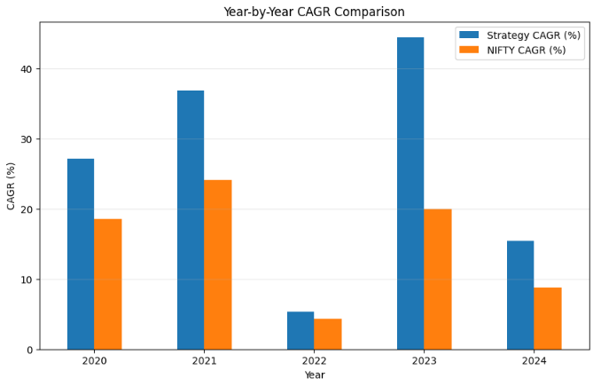

Discussion

The results raise an important question: why did the simpler Factor-Score portfolio perform better than the more complex Sharpe-Optimized portfolio?

One possible explanation is that the factor ranking process already had most of the useful information in the strategy. By selecting stocks with relatively strong Momentum, Quality, Value, Low Risk and Size characteristics, the model had already created a portfolio with a specific return profile before any optimization was applied.

The Factor-Score weighting method then made only moderate changes to position sizes. Stocks with stronger composite scores received somewhat larger weights, but no single stock was allowed to dominate the portfolio simply because of short-term historical return patterns.

The Sharpe-Optimized method showed a different behaviour. Its weights were based on only the previous 12 months of returns. Although this made the optimizer responsive to recent market conditions, it also made it more sensitive to short-term noise. Correlations and return patterns estimated from a relatively small sample can change quickly, which may explain why the optimized portfolio produced substantially higher turnover and weaker overall performance.

This result is useful because it shows that mathematical complexity is not automatically an advantage. A simpler rule can sometimes be more robust if it relies on economically meaningful signals rather than repeatedly fitting recent price behaviour.

Why Combining Factors May Have Helped

Each of the five factors captures a different characteristic of a stock.

Momentum measures recent market behaviour, while Value and Quality focus more on company fundamentals. Low Risk attempts to control exposure to unstable stocks, and Size introduces another dimension of cross-sectional variation.
Because these signals are not identical, combining them may reduce dependence on any single factor.

For example, a stock may have strong Momentum but appear expensive on a Value basis. Another may have a low valuation but weak Quality. The composite score forces the strategy to consider several dimensions simultaneously rather than selecting stocks because they look attractive according to only one measure.

This may help explain why the strategy remained relatively competitive across different years, even though the strength of individual market characteristics likely changed over time.

The Importance of Turnover

Turnover was another important difference between the portfolio-construction methods.

The Factor-Score portfolio had relatively moderate monthly turnover, while the Sharpe-Optimized portfolio changed its weights much more aggressively.
Higher turnover matters because it creates additional transaction costs and also makes a backtest more dependent on assumptions about execution.

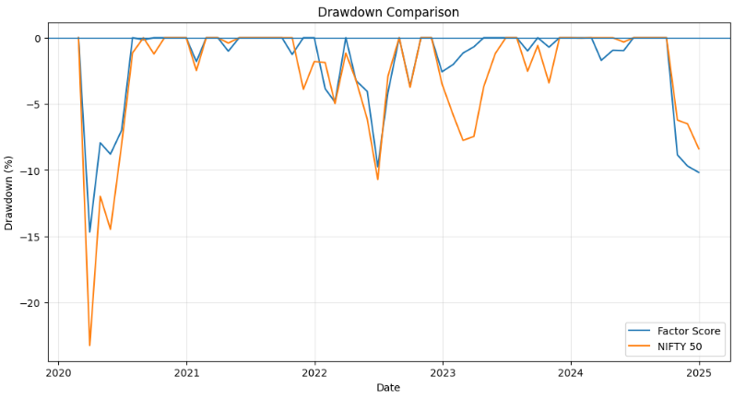

A strategy that appears slightly better before trading costs may become less attractive if it requires substantially more portfolio changes.
For this reason, the portfolio with the highest raw historical return is not necessarily the most attractive model. Return, risk and implementation costs need to be considered together.

What the Out-of-Sample Result Means

The 2024 out-of-sample performance is encouraging, but it should be interpreted carefully.
The model continued to outperform the NIFTY 50 during this period, suggesting that its historical performance was not entirely restricted to the earlier sample.
However, one year is still a relatively short out-of-sample period. It is possible for a strategy to perform well for a year because of market conditions that happen to favour its factor exposures.

A stronger test would involve continuing to run the model forward without changing its core rules and recording results as new data becomes available. This is therefore one of the natural next steps for the project.

Implications and future directions

The project proposes a lot of ways to improve or extend the model.

One improvement would be to reconstruct the historical investable universe, instead of a fixed universe of 30 present-day large-cap stocks. This would reduce survivorship bias, and make the historical simulation more realistic.
Further improvement would be to use exact company filing or result-announcement dates instead of the fixed 90-day availability lag. This will result in a more accurate point-in-time fundamental dataset.

Also could include Quarterly fundamentals. Currently the model is based on annual financials, so more frequent reporting may enable the Quality and Value factors to respond more quickly to changes in company performance.

The factor model could be extended as well. Other signals such as earnings growth, stability of profitability, leverage or cash-flow measures could be tested but any new factors would have to be added carefully to avoid overfitting.

One especially helpful extension would be to extend the strategy past 2024 using the same frozen methodology. The model may generate a new monthly portfolio signal with the latest available data, instead of rewriting rules every time performance degrades. This would create a real forward test of the performance of the strategy after development.

Final Conclusion

This project set out to test whether a transparent, rules-based multi-factor strategy could produce stronger risk-adjusted performance than the NIFTY 50 within a universe of large-cap Indian equities.

The results provide evidence in favour of that idea. Across the 2020–2024 backtest, the Factor-Score portfolio achieved a CAGR of approximately 25%, compared with around 15% for the benchmark, while also recording lower volatility and a smaller maximum drawdown.

The strategy also remained competitive across training, validation and out-of-sample periods, and its performance was reasonably stable under several robustness tests.
At the same time, the project also showed that greater complexity did not automatically improve results. The Sharpe-Optimized portfolio produced higher turnover and weaker overall performance than the simpler Factor-Score approach.

The most important conclusion is therefore not that the strategy is guaranteed to outperform in the future. Instead, the project demonstrates that a systematic combination of economically interpretable factors can be built, tested and evaluated using a disciplined quantitative framework.

The next stage of the project is to continue applying the frozen methodology to new data and observe whether the historical relationships remain useful outside the original backtest period.

References and Data Sources
Price Data
Historical stock-price and NIFTY 50 data were obtained using Yahoo Finance through the yfinance Python library.
Adjusted closing prices were used for return calculations, while raw closing prices were used for valuation-related calculations such as P/E and market capitalisation.
Fundamental Data
Historical annual financial data was obtained from Screener.in company exports.
The variables used included net profit, equity share capital, reserves and shares outstanding.
Risk-Free Rate
The risk-free rate was proxied using a monthly Indian short-term interest-rate series. Annualised observations were converted into monthly equivalents and aligned with the corresponding strategy months.
Benchmark
The NIFTY 50 index was used as the benchmark for comparing portfolio performance.
Yahoo Finance / yfinance — historical stock prices and NIFTY 50 prices
https://finance.yahoo.com/
https://ranaroussi.github.io/yfinance/
Screener.in — historical company fundamentals and Excel exports
https://www.screener.in/
https://www.screener.in/features/
FRED — India 3-month / 90-day short-term interest rate used as the risk-free-rate proxy
https://fred.stlouisfed.org/series/INDIR3TIB01STM
NIFTY Indices — official NIFTY 50 benchmark information
https://www.niftyindices.com/indices/equity/broad-based-indices/nifty--50
National Stock Exchange of India — transaction taxes, statutory charges and other trading levies used to justify the transaction-cost assumption
https://www.nseindia.com/static/invest/first-time-investor-sebi-turnover-fees-stt-other-levies
The 0.25% transaction-cost rate is a conservative modelling assumption intended to account for taxes, statutory charges and execution frictions. It is not an exact historical trading cost quoted by NSE.
The risk-free rate is proxied using the monthly Indian 3-month/90-day short-term interest-rate series available through FRED.

Appendix

Appendix A – Stock Universe
Full 30-stock list here:
- TCS
- Infosys
- Reliance Industries
- HDFC Bank
- ICICI Bank
- SBI
- Kotak Mahindra Bank
- Axis Bank
- Larsen & Toubro
- Bharti Airtel
- Hindustan Unilever
- ITC
- Asian Paints
- Maruti Suzuki
- Mahindra & Mahindra
- Sun Pharmaceutical Industries
- Dr. Reddy’s Laboratories
- Cipla
- NTPC
- Power Grid Corporation
- ONGC
- Coal India
- Titan Company
- Bajaj Finance
- Bajaj Finserv
- UltraTech Cement
- Nestlé India
- Wipro
- HCL Technologies
- Tech Mahindra

Appendix B – Factor Definitions
Factor | Definition | Preferred Direction
Momentum | 12-month adjusted-price return | Higher
Low Risk | 12-month monthly-return volatility | Lower
Quality | ROE | Higher
Value | P/E | Lower
Size | Market capitalisation | Lower

Appendix C –Primary Strategy Rules
Universe: 30 large-cap Indian equities
Rebalancing: Monthly
Selected holdings: Top 10
Factor weights: 20% each
Portfolio method: Factor-Score Weight
Reporting lag: 90 days
Transaction-cost assumption: 0.25% per unit of turnover
Benchmark: NIFTY 50
Training: 2020–2022
Validation: 2023
Out-of-sample: 2024

Appendix D – Robustness Tests
- Top 8 / 10 / 12
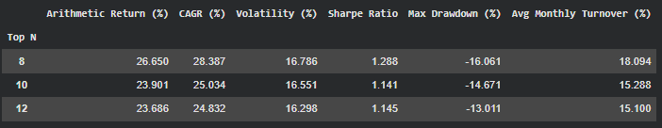
- transaction costs
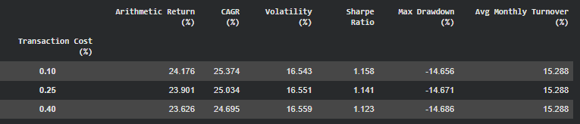
- alternative factor weights
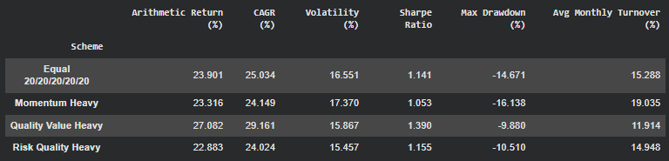
- year-by-year results
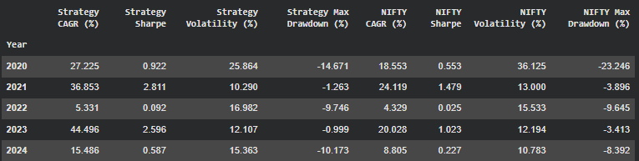

Appendix E –Technical Audit
The final model was audited for portfolio-weight consistency, missing data, duplicate observations, look-ahead bias, factor-score consistency, forward-return availability and point-in-time fundamental usage.
The final audit found no point-in-time violations in the fundamental-data pipeline and no missing selected forward returns.

