disparityrange = 320

SAD_window_size = 5

left_matcher = cv2.StereoSGBM_create(

minDisparity=0,

numDisparities=disparityrange,

blockSize=5,

P1=8 * 3 * SAD_window_size ** 2,

P2=32 * 3 * SAD_window_size ** 2,

disp12MaxDiff=-1,

uniquenessRatio=15,

speckleWindowSize=0,

speckleRange=2,

preFilterCap=15,

mode=False

)

right_matcher = cv2.ximgproc.createRightMatcher(left_matcher)

I have used upper code snipper for creating left_matcher & right_matcher object in opencv in python. Following are the details which I understand please correct me if I am wrong.

* minDisparity

As name suggestes,mindisparity allowed

* numdisparity

mindisparity+disparityrange

* blocksize

As you have explained,algorithm will try to find matching block,by evaluating cost on epipolar line of this much size block.

* P1 and P2 are penalty given to cost for block.
* Disp12MaxDiff

Pixels are matched from the left image to right image and from the right image back to left image. The disparities are only valid if the distance between the original left pixel and the back matched pixel is smaller then Disp12MaxDiff. Guess, It should create black dot where is larger than Disp12MaxDiff.

* uniquenessRatio= usually 5-15

Accepts the computed disparity only if SAD(d)>=SAD(d*)(1+uniquenessRatio/100).

In short, This much percentage variation is allowed for winning condition within search range.

* Speckle Noise

This type of noise is present while image is taken using RADAR or LASER so need of that so speckle window size is set to zero

* Mode

It is set to false because This is the default mode, the algorithm is single-pass, which means that you consider only 5 directions instead of 8.

displ = left_matcher.compute(imgL, imgR)#.astype(np.float32)/16

dispr = right_matcher.compute(imgR, imgL)

this code create two disparity map displ and dispr from left_matcher and right_matcher accordingly.

First image is of displ and second is of dispr and third is after applying wls filter.

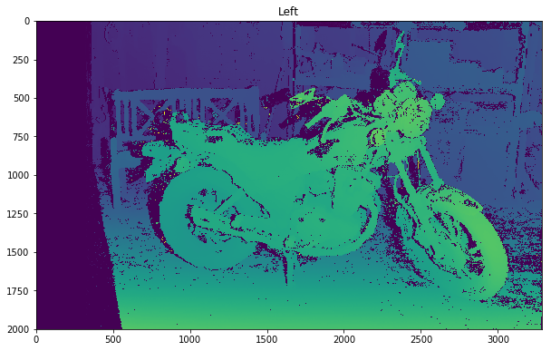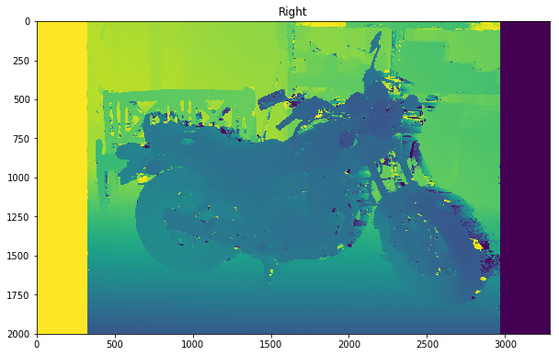

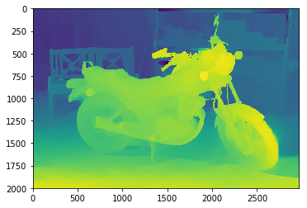

Here for wls filter(weighted least square) two parameter is used. Lambda and sigma.

|  |
| --- |
| Lambda is a parameter defining the amount of regularization during filtering. Larger values force filtered  Disparity map edges to adhere more to source image edges.  SigmaColor is a parameter defining how sensitive the filtering process is to source image edges.  Large values can lead to disparity leakage through low-contrast edges. Small values can make the filter too  sensitive to noise and textures in the source image. Typical values range from 0.8 to 2.0. |

So, usually lambda is 8000 and sigma is taken as 1.2