**Staff Management**

Staff Summary

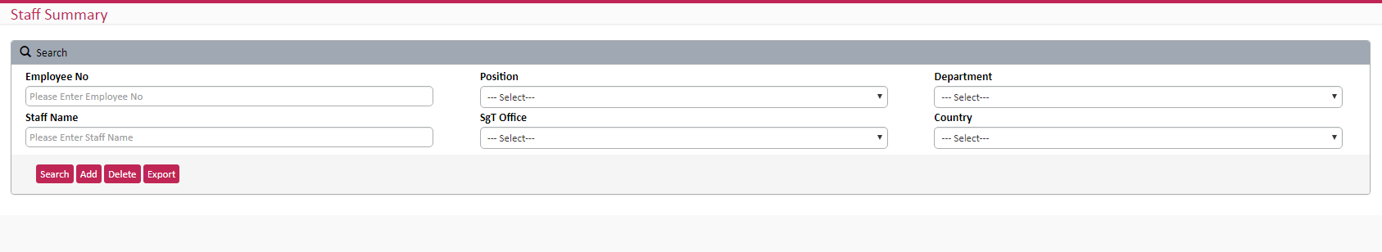

* All drop down list should be multiple select control.
* “Delete” button not common. It is based on employee. So we can keep delete button in each row. When click on delete button, one pop up will show with details.one validation (Need to check any expense claim pending for this user) process should be done in background.
* Can we have one more export option which download the employee summary (not in details).

Column name: - Employee No, employee name, country, position, company email, report head,

Employee type, location, operation country, profile, payroll currency.

* Add new field- one drop down with option active & Not Active. When user search with “Not active” option, need to show the employees details who are left from company. So we don’t want any separate page for “departure” details.
* Add new field – Employee type

New

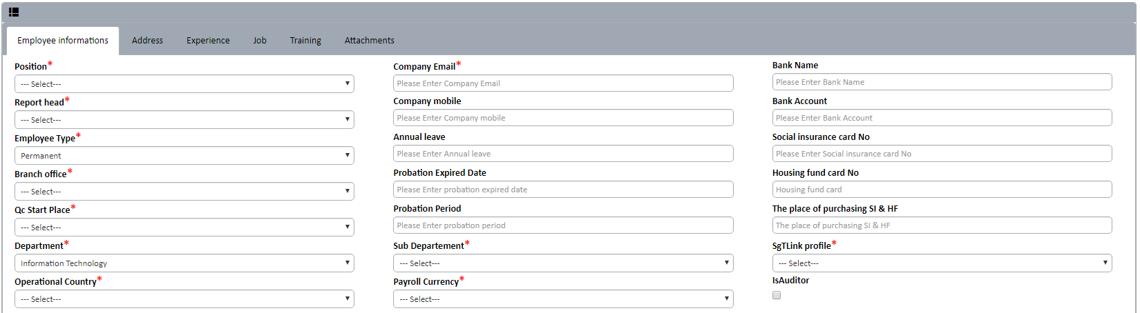

* Need one new field – Manager. (sometimes manager and report head will be different)
* Profile should be multiple selection. One user can be CS, QC, Auditor, Manager etc. In current system can select only one option.
* Operational country should be multiple. One employee may be work in multiple country like QC.

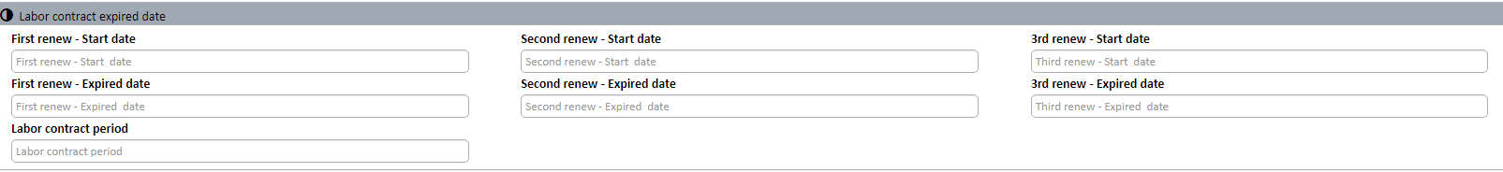

* Labor contract should be dynamic. User can able to add multiple contract. columns:- renew type(like first renew, second etc.) , start date, end date

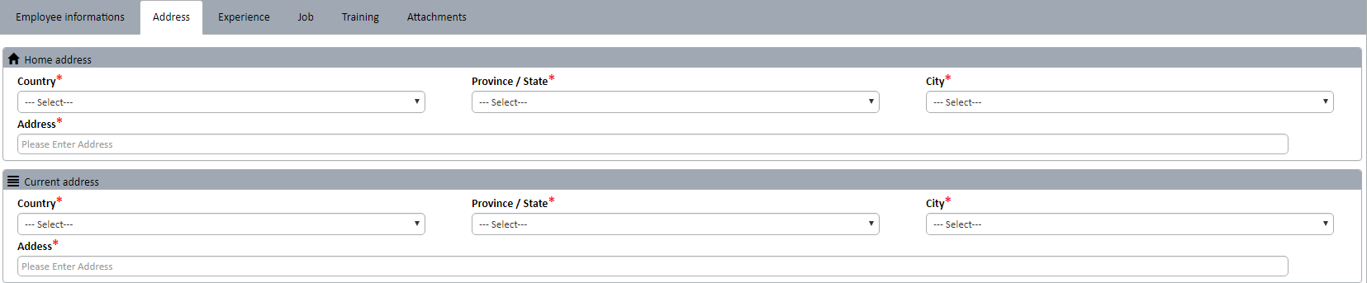

* We need one checkbox “Same as home Address” in current address. So user don’t want to enter two times if the information are same.

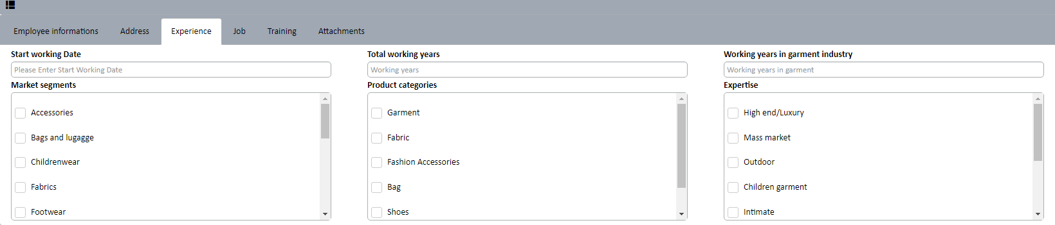

* If we can add experience year in each section, would be excellent.