**Supplier –Factory**

**Register**

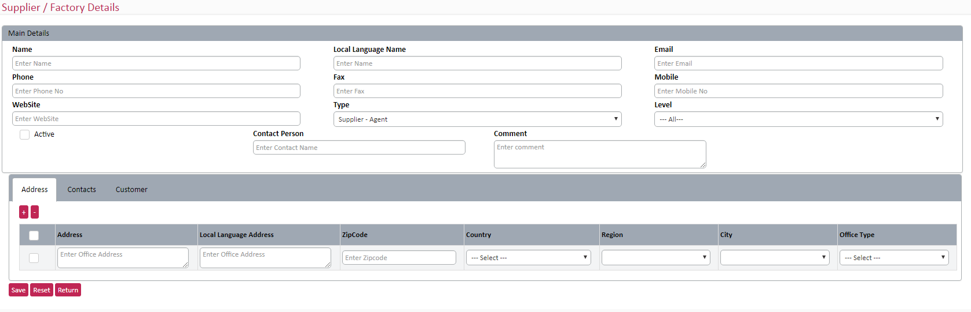

**New fields**

* Legal Name (using quotation module)
* GL code (unique code – input by user)
* GPS Coordinates
* Entity (No UI. We need to take this value from user profile.)

**Delete Fields**

* Active

New Features

We need to map contacts to customer. So the tab will show in below order

1. Address
2. Customer
3. Contacts 4) supplier (only for factory)

User will map the customer first. When add new contact, user will select the mapped customer in the dropdown list. Customer list should be multi –select. One contact may have multiple customer.

Screen show like this below

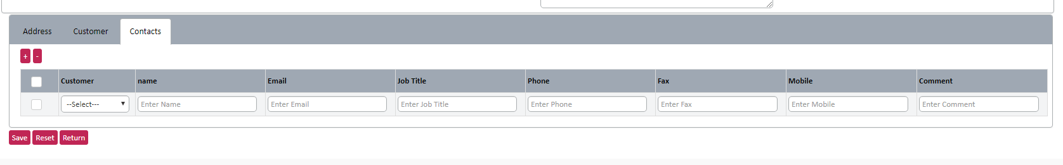

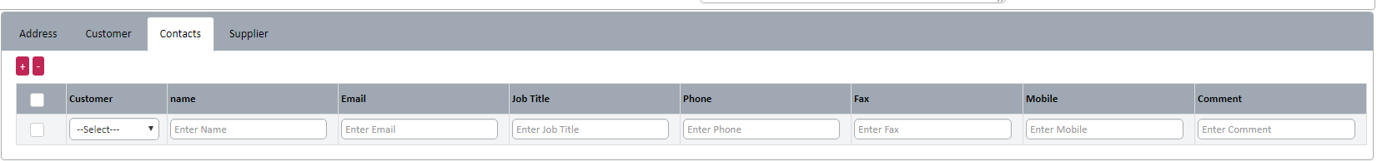

New feature - Factory

* When user create a new factory, show one checkbox “New supplier”. If user checked it, while save the factory details, ignore the supplier map validation (normally one supplier has to map) and save one new supplier with same factory information and map it automatically.
* One factory can have more than one supplier. One - many relation (Sgt have one-one relation in table structure).

**Summary**

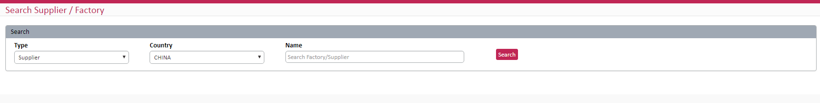

* Multi drop down list is ok. No need search text box

No change.