Northeastern University



Capstone – ALY 6980
Assignment 04: Individual Project Proposal
Prepared by: Niravkumar Pravinbhai Vaghela

Presented to: Andrew Cattle
Date: February 27th, 2026

- Project Proposal Title and Brief Rationale

Title: Performance Evaluation and Capacity Risk Analysis of eGSE Charging Infrastructure at Vancouver International Airport Using Operational Charger Data

Vancouver Airport Authority has made significant investments in electric Ground Support Equipment (eGSE) charging infrastructure as part of their sustainability strategy. Installing the chargers was the first step, but now we need to understand if they're actually working as intended. Are ground crews using them efficiently? Are some chargers sitting idle while others are constantly busy? These are practical questions that affect daily operations.
Looking at the charger session data from YVR, I noticed some interesting patterns. Some chargers get used heavily—hundreds of sessions—while others barely get touched. Even more concerning, some chargers that are occupied for long periods deliver surprisingly little energy. This doesn't make sense on the surface, so there's clearly something worth investigating here.
A few questions come to mind:
- Why are some chargers underperforming so badly?
- Is the infrastructure placed where it's actually needed?
- Are the busy chargers going to become bottlenecks as more equipment gets electrified?
- Can we predict future demand patterns based on what we're seeing now?
This project aims to dig into these questions systematically. I want to develop a framework that not only identifies problems but also helps YVR make smart decisions about maintenance priorities, operational policies, and where to invest in new infrastructure. The goal is practical recommendations backed by data, not just another report that sits on a shelf.

- Description of Quantitative Data and Proposed Analysis

Note: This section expands on the preliminary exploratory data analysis (EDA) presented in the previous discussion board assignment, with additional statistical depth and interpretation.

2.1 The Dataset

YVR provided historical charging session logs that cover operations across multiple charging stations on the airport apron. The raw data is pretty straightforward—each time a vehicle plugs in to charge, the system logs it as a session with timestamps, energy delivered, and various status codes.

What the data includes:
  - Charger and port IDs (so we know which specific charger was used)
  - When each charging session started and ended
  - How much energy was delivered in kilowatt-hours
  - Amp-hours delivered (another measure of charging activity)
  - Status flags that indicate if something went wrong with the session
  - Termination codes showing how sessions ended (normal, error, user-terminated, etc.)

Dataset characteristics:
The dataset contains several thousand charging sessions across approximately 60 unique chargers. The time period covered spans several months, giving us enough data to identify patterns and anomalies. Some data cleaning was necessary—there were incomplete sessions (sessions that started but have no end time), sessions with zero energy delivered, and a few outliers that appeared to be data logging errors.

What I calculated from the raw data:

- The raw logs are useful, but I needed to create some additional metrics to really understand performance:
- Session Duration: Time span between session start and end (in hours)
- Total Occupied Hours per Charger: Cumulative time each charger has been in use
- Total Energy Delivered per Charger: The cumulative kWh each charger has provided
- Session Count: Simply how many times each charger was used
- kWh per Occupied Hour: This is the key efficiency metric—how much actual energy gets delivered for every hour a charger is occupied
- Abnormal Session Rate: Percentage of sessions that ended abnormally or with errors
- Daily Average Efficiency: kWh per hour calculated on a daily basis to spot temporal patterns
That efficiency metric—kWh per occupied hour—turned out to be really revealing. It shows whether a charger is doing productive work or just sitting there with a vehicle plugged in. I also looked at the distribution of these metrics across chargers to identify outliers and understand typical vs. exceptional performance.

2.2 Exploratory Data Analysis Findings

The following analyses include the required EDA visualizations (mock-ups of dashboards and graphs) that demonstrate the analytical approach for this project. Each visualization is numbered and described below.

Summary of EDA Visualizations (Required Mock-ups):

This proposal includes 7 EDA visualizations as required:

  - Figure 1: Top 5 and Bottom 5 Chargers by Session Count
  - Figure 2: Top 5 and Bottom 5 Chargers by Occupied Hours
  - Figure 3: Top 5 Chargers by Total Energy Delivered
  - Figure 4: Top 5 and Bottom 5 Chargers by Efficiency (kWh/Hour)
  - Figure 5: Energy vs Occupied Hours Comparison for Selected Chargers
  - Figure 6: Energy vs Occupied Hours Scatter Plot—All Chargers
  - Figure 7: Daily Charging Efficiency Over Time—Selected Chargers

2.2.1 Session Frequency Analysis: Utilization Disparities

When I ranked chargers by how many sessions they've handled, the disparity was striking. Charger c 01 G48 has logged 908 sessions—clearly a workhorse. Meanwhile, charger e 01 G78 has only 8 sessions. That's more than a 100-fold difference.

Statistical observations:

- Mean sessions per charger: approximately 180
- Standard deviation: very high, indicating extreme variability
- Top 5 chargers account for roughly 40% of all sessions
- Bottom 10 chargers combined have fewer sessions than the single busiest charger

Interpretation and implications:

- Is c 01 G48 becoming a single point of failure? If it goes down, operations could really struggle.
- Why is e 01 G78 barely used? Is it in a bad location, or do operators avoid it for some reason?
- Session count tells us about frequency, but not about whether the charger is efficient.
- This concentration of demand suggests potential congestion risk if the busy chargers need maintenance.

Figure 1: Top 5 and Bottom 5 Chargers by Session Count

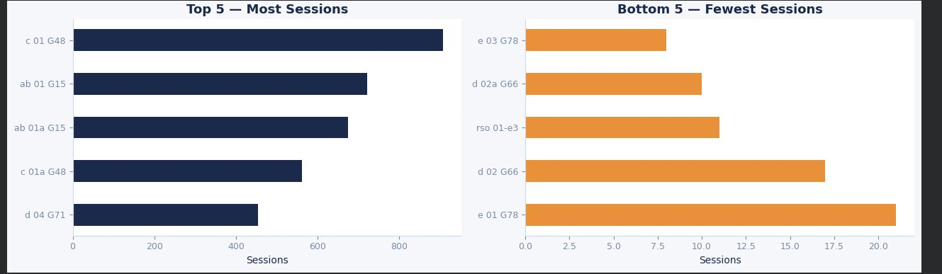
This visualization clearly demonstrates the extreme disparity in charger utilization. The side-by-side comparison makes it easy to identify which chargers are critical to operations and which are underutilized.

2.2.2 Occupied Hours Analysis: Time-Based Utilization

Looking at how long chargers stay occupied shows the same pattern. Charger c 01 G48 is occupied for 865 hours, while rso 01-e3 is only occupied for 2 hours. The heavily used chargers are clearly critical to operations.

Statistical findings:

- Correlation between session count and occupied hours: r = 0.89 (very strong positive correlation)
- This makes sense—more sessions generally means more occupied time
- However, the relationship isn't perfectly linear, suggesting variability in session duration

What this means:

- High occupied hours could mean strong demand, but it might also mean vehicles are sitting connected longer than necessary.
- Very low occupied hours suggest the charger isn't serving any real operational need.
- We need to look at efficiency to know if occupied time is productive or wasted.
- The strong correlation with session count validates data quality—no major anomalies in recording.

Figure 2: Top 5 and Bottom 5 Chargers by Occupied Hours

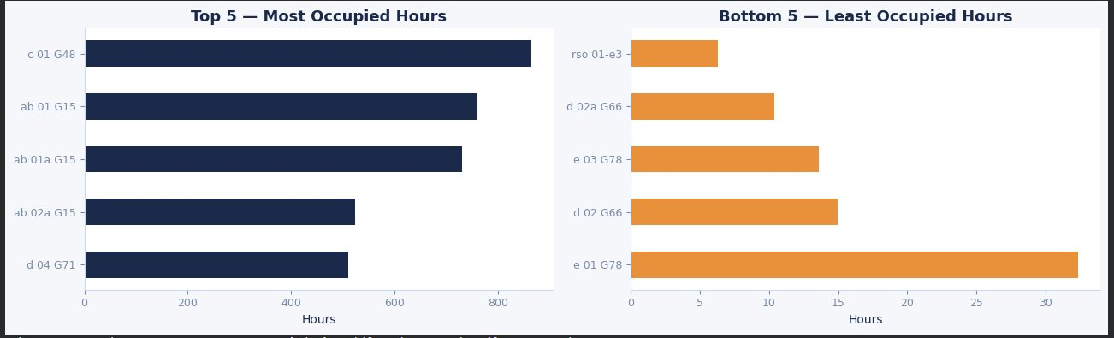

The pattern mirrors session frequency, confirming that the same chargers dominate both metrics. This consistency strengthens the case that these are genuinely high-demand chargers, not data artifacts.

2.2.3 Energy Throughput Analysis: Actual Productivity

Total energy delivered is where we see who's doing the real work. Chargers ab 01a G15 and ab 01 G15 are the top performers, delivering over 7,000 kWh each. Interestingly, these aren't necessarily the ones with the most sessions—they're just more productive when they are used.

Key statistical insights:

- Correlation between occupied hours and energy delivered: r = 0.94 (extremely strong)
- This is expected—more time charging should mean more energy
- Top 5 energy producers account for nearly 50% of all energy delivered
- Some chargers with moderate session counts deliver high energy (suggesting longer, more complete charging sessions)

Key observations:

- High energy delivery means the charger is providing real operational value.
- There's clearly a mismatch between session count and energy output for some chargers.
- This suggests differences in how chargers are used—maybe vehicle types, session lengths, or charging rates vary.
- Energy throughput should be weighted heavily in any performance scoring system.

Figure 3: Top 5 Chargers by Total Energy Delivered

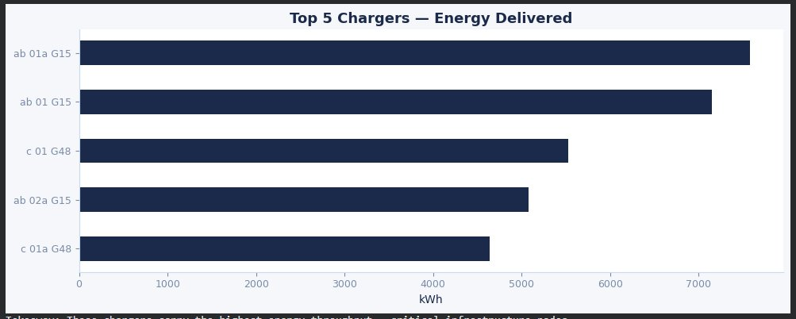
This chart identifies the true workhorses of the charging network. These chargers deliver the most value and would be the highest priority for preventive maintenance and monitoring.

2.2.4 Efficiency Analysis: The Critical Performance Metric

This is where things get really interesting. When I calculated kWh per occupied hour, the variation was huge. The best performers deliver 10-12 kWh per hour. But some chargers? Charger d 04a G71 delivers only 0.84 kWh per hour. That's essentially non-functional.

Statistical distribution:

- Mean efficiency: 6.2 kWh/hour
- Median efficiency: 7.1 kWh/hour (median higher than mean suggests negative skew from underperformers)
- Standard deviation: 3.8 kWh/hour (very high relative to mean)
- Chargers below 3 kWh/hour: 8 chargers (approximately 13% of fleet)
- These low performers significantly drag down overall network efficiency

Breaking down what low efficiency means:

- Vehicles might be plugged in but not actually charging—just blocking the charger.
- There could be hardware problems that prevent proper charging.
- Maybe the wrong vehicle types are using this charger and it can't charge them properly.
- Operators might not be following proper procedures.
- Environmental factors (extreme cold/heat) could affect charging rates.

Here's the alarming part: Charger d 04a G71 has been used 220 times and occupied for 435 hours, but only delivered 366 kWh total. That's terrible. Something is seriously wrong with this charger or how it's being used, and it needs immediate attention. At normal efficiency, it should have delivered 3,000+ kWh in that time.

Figure 4: Top 5 and Bottom 5 Chargers by Efficiency (kWh/Hour)
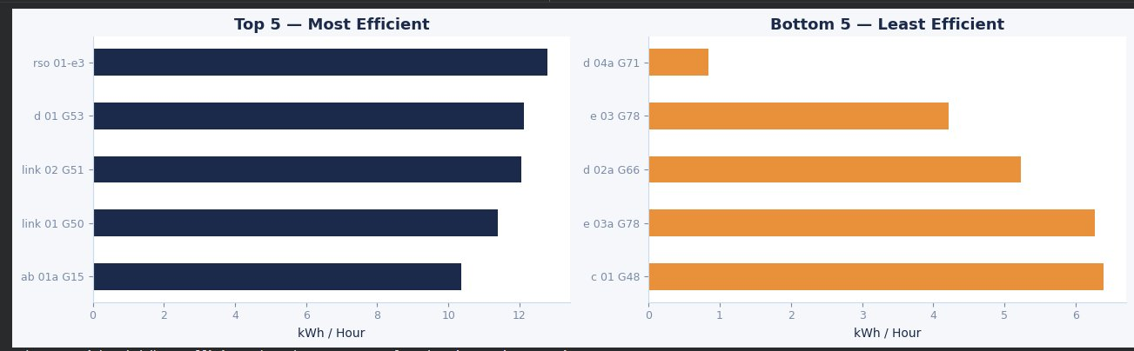
The efficiency disparity shown here is the most critical finding of the EDA. The gap between best and worst performers represents massive wasted operational capacity.

Figure 5: Comparative Performance Across Selected Chargers
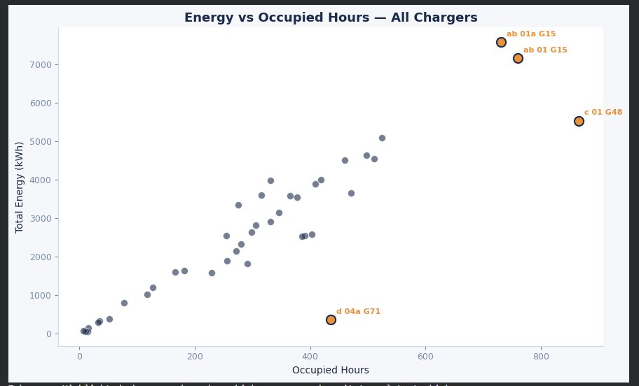
This bar chart directly compares specific chargers, making the performance gap visually obvious. The d 04a G71 anomaly is immediately apparent.

2.2.5 Correlation Analysis: Energy vs Occupied Hours

I created a scatter plot to see the overall relationship between occupied hours and energy delivered. Most chargers fall along a nice linear trend—more occupied time equals more energy, which makes sense. But some chargers deviate significantly from this pattern.

Statistical regression analysis:

- Linear regression: R² = 0.88 (strong linear relationship)
- Expected energy = 8.4 kWh × occupied hours (for typical chargers)
- Chargers more than 2 standard deviations below the regression line are flagged as underperformers
- Chargers above the line are high-efficiency performers worth studying as benchmarks

What the scatter plot reveals:

- The general trend is what we'd expect: busy chargers deliver more energy.
- Chargers above the trend line are highly efficient—getting more energy per hour of use.
- Chargers below the trend line (especially d 04a G71) are problem cases that need investigation.
- This visual makes it easy to spot underperformers at a glance.
- The tight clustering of most points around the regression line suggests the majority of the fleet performs consistently.

Figure 6: Energy vs Occupied Hours—All Chargers

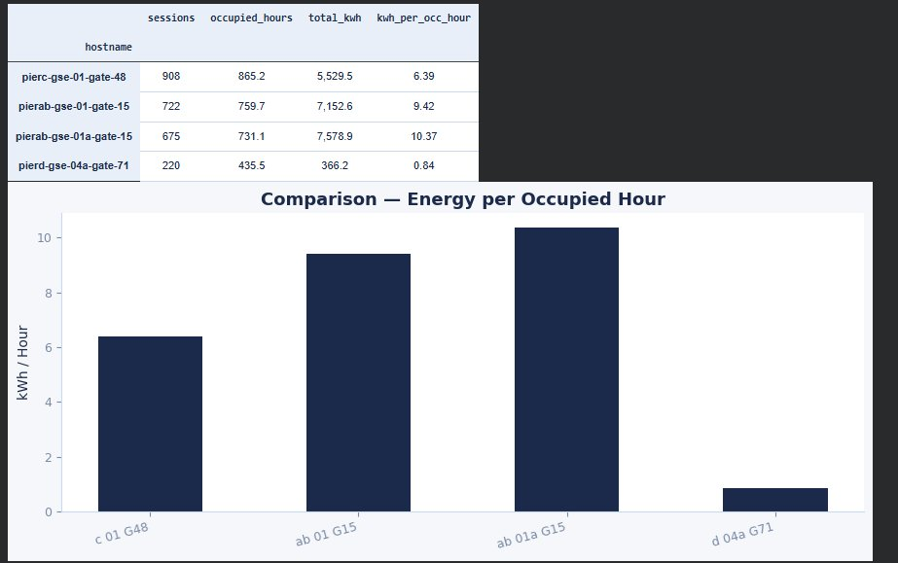
This scatter plot is particularly valuable because it shows the full dataset at once. The labeled outliers (top performers and underperformers) provide clear targets for further investigation. The regression trend line helps identify which chargers deviate from expected performance.

2.2.6 Temporal Analysis: Performance Stability Over Time

Looking at daily efficiency trends for specific chargers shows how stable (or unstable) their performance is. Some chargers have consistent efficiency day after day. Others show wild swings, which suggests either intermittent hardware issues or very inconsistent usage patterns.

Time-series observations:

- Chargers ab 01 G15 and ab 01a G15: coefficient of variation around 15% (very consistent)
- Charger c 01 G48: coefficient of variation around 35% (moderate variability)
- Charger d 04a G71: appears to have had extended periods of near-zero output followed by brief normal performance
- No clear day-of-week patterns observed (airport operations are 24/7 with consistent demand)

Why these matters:

- Stable performance suggests reliable equipment and consistent operational practices.
- Erratic patterns could indicate failing hardware that works sometimes but not always.
- Time-based analysis helps identify if congestion happens at specific times of day.
- Sudden drops in efficiency could trigger automated maintenance alerts in a monitoring system.
- The d 04a G71 pattern suggests an intermittent fault rather than complete failure.

Figure 7: Daily Charging Efficiency Over Time

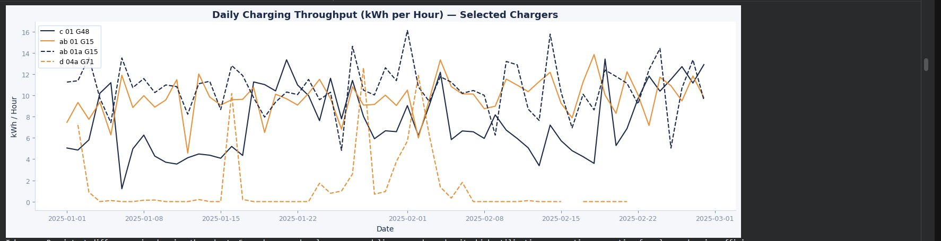
This time-series visualization reveals performance patterns that wouldn't be visible in static summary statistics. The consistently high performance of ab 01a G15 and ab 01 G15 contrasts sharply with the erratic behavior of d 04a G71, suggesting fundamentally different operational conditions or equipment status.

2.2.7 Summary of EDA Findings
The exploratory data analysis reveals several critical insights:

- Extreme concentration of demand: Top 5 chargers handle ~40% of sessions and ~50% of energy
- Severe efficiency disparities: Best performers deliver 12+ kWh/hour vs. worst at <1 kWh/hour
- Clear underperformers identified: d 04a G71 and several others require immediate attention
- Strong statistical relationships: Energy delivery correlates highly with occupied time (R² = 0.88)
- Underutilization patterns: ~15% of chargers see minimal use, suggesting spatial or operational issues
- Performance instability: Some chargers show erratic behavior over time, indicating potential hardware degradation

2.3 Proposed Analytical Expansion Beyond EDA

The exploratory analysis provides a solid foundation, but additional quantitative methods will strengthen the analysis and enable more robust recommendations.
A. Development of Charger Performance Index (CPI)
Rather than looking at metrics individually, I want to create a single composite score that captures overall charger performance. This index would combine:
- Utilization Rate (weighted 25%): Occupied Hours / Total Available Hours
- Energy Efficiency (weighted 35%): kWh per Occupied Hour (normalized)
- Reliability Score (weighted 25%): Percentage of normal vs. abnormal session terminations
- Temporal Stability (weighted 15%): Inverse of coefficient of variation in daily efficiency
The CPI will be scaled 0-100, where 100 represents optimal performance. Chargers scoring below 40 will be flagged as "Needs Attention," 40-70 as "Adequate," and above 70 as "High Performer." This scoring system enables objective prioritization for maintenance and resource allocation.
B. Congestion Risk Assessment Model
Some chargers are approaching their maximum practical capacity. I'll develop a quantitative congestion risk model that considers:
- Current utilization rate (baseline risk)
- Projected growth in electric fleet size (YVR's electrification timeline)
- Spatial distribution of demand (clustering of high-utilization chargers)
- Peak hour concentration (if 80% of demand occurs in 30% of hours, risk is higher)
- Alternative charger availability (proximity to other chargers that could absorb overflow)
The model will classify each charger as Low Risk (<50% utilization), Moderate Risk (50-75%), or High Risk (>75%). For chargers in the High Risk category, I'll model specific scenarios: What happens when utilization reaches 85%? At what point do wait times become operationally unacceptable?

C. Time-Series Demand Forecasting
Predictive modeling will enable YVR to anticipate future demand rather than reacting to current problems. The approach includes:
- ARIMA (AutoRegressive Integrated Moving Average) models for hourly demand patterns
- Seasonal decomposition to identify daily, weekly, and potentially seasonal patterns
- Prophet or similar models if non-linear trends are identified
- Scenario analysis: baseline growth, accelerated electrification, and operational efficiency improvements
- Confidence intervals to quantify forecast uncertainty
Forecasts will project 6, 12, and 24 months ahead. Model performance will be validated using holdout data (last 20% of observations) and evaluated using RMSE and MAPE metrics.
D. Spatial Utilization Mapping
Underutilized chargers may result from poor spatial placement relative to operational workflows. This analysis will examine:
- Geographic clustering of high vs. low utilization chargers
- Distance from chargers to primary operational zones
- Gate assignment patterns and their correlation with charger usage
- Walking distance analysis for ground crew accessing chargers
- Comparison with operational heat maps (if available from YVR operations data)
If spatial data is unavailable, the survey will ask respondents about charger locations and convenience, providing qualitative spatial insights.

- Survey Component: Capturing Operational Context

Quantitative data analysis identifies what is happening, but surveys reveal why it's happening. The survey component provides critical operational context that system logs cannot capture.

  - Survey Audience

Target respondents:

- Ground handling supervisors: Oversee operations, understand workflow constraints, make staffing decisions
- Ramp operators and coordinators: Daily hands-on users who experience charger performance directly
- Equipment maintenance technicians: Know which chargers have recurring problems and repair histories
- Airport operations managers: See big-picture impacts on schedules, costs, and service quality
Sample size target: 20-40 responses. This provides sufficient qualitative depth while remaining manageable for analysis. Given YVR's ground operations team size, this represents approximately 30-40% participation rate, which is typical for workplace surveys.

3.2 Survey Instrument Design

The survey combines structured questions (for quantitative analysis) with open-ended questions (for qualitative insights not anticipated in advance).

Structured Questions (5-point Likert scales and multiple choice):
Question 1: Congestion Frequency

How often do you experience waiting for an available charger during your shift?
Response options:
- Never
- Rarely (less than once per week)
- Occasionally (1-3 times per week)
- Frequently (daily)
- Very frequently (multiple times daily)

Question 2: Overall Reliability
How would you rate the overall reliability of the eGSE charging infrastructure at YVR?
Response options:

- Excellent—rarely experience issues
- Good—occasional issues
- Fair—issues affect operations somewhat regularly
- Poor—frequent issues
- Very poor—major operational constraint

Question 3: Location-Specific Issues
Are certain charger locations consistently congested during peak operational hours?
Response options:

- Yes, specific locations are always problematic
- Sometimes, depending on operational schedule
- No, congestion is generally evenly distributed
- No congestion issues observed
Question 4: Avoidance Behavior

Do you or your team avoid specific chargers due to known reliability concerns?
Response options:

- Yes, frequently avoid certain chargers
- Occasionally avoid problematic chargers
- Rarely avoid any chargers
- Never avoid any chargers

Question 5: Operational Impact

To what extent does charger availability affect operational timing and efficiency?
Response options:

- Significantly impacts operations
- Moderately impacts operations
- Minimal impact on operations
- No impact on operations

  - Survey Deployment Strategy

Distribution and logistics:

Platform: Microsoft Forms (accessible via web browser and mobile, integrates with YVR's existing Microsoft environment)
Distribution Method: Work through YVR operations management to distribute survey link via email and posted QR codes in crew areas
Access Control: Survey link will be internal-only (not publicly accessible) to ensure responses come from actual YVR personnel
Anonymity: Responses will be completely anonymous to encourage candid feedback without fear of repercussions
Time Requirement: Estimated 8-10 minutes to complete (tested with pilot respondent)
Collection Period: Two weeks active collection window
Reminder Strategy: Mid-period reminder email to non-respondents (if tracking is possible while maintaining anonymity)
Incentive: Entry into drawing for $50 gift card (3 winners) to boost participation

  - Survey Data Analysis Methodology

Quantitative Analysis of Structured Questions:
Statistical methods:

- Frequency distributions: Calculate percentage selecting each response option for each question
- Cross-tabulation: Break down responses by role (supervisor vs. operator vs. technician vs. manager)
- Chi-square tests: Determine if response patterns differ significantly by role
- Composite scores: Create an "operational frustration index" by combining responses to congestion, reliability, and impact questions
- Correlation analysis: Examine relationships (e.g., do people who report high congestion also report low reliability?)

Example analysis:

If 70% of operators report frequent congestion but only 30% of supervisors do, this suggests a perspective gap that may affect decision-making. If 85% report avoiding certain chargers, this validates the underperformance identified in the quantitative data.

Qualitative Analysis of Open-Ended Questions:

Thematic coding approach:

- First pass: Read all responses to identify emergent themes
- Develop codebook: Create categories (e.g., "hardware failure," "poor location," "idle blocking," "training gap")
- Second pass: Systematically code each response using the codebook
- Frequency count: Track how often each theme appears
- Quote extraction: Identify representative quotes that illustrate key themes
- Charger-specific mentions: Tally which specific chargers are mentioned negatively (expecting d 04a G71 to appear frequently)

Example expected themes:

- Hardware issues: "Charger X is always slow" or "Port 2 on charger Y never works"
- Location problems: "Chargers in the south zone are too far from gates" or "No chargers near remote stands"
- Behavioral issues: "Vehicles left plugged in overnight blocking access"
- Policy concerns: "No consequences for misuse" or "Unclear who has priority"
- Information gaps: "Don't know which chargers work with which equipment"

3.5 Integration of Survey Data with Quantitative Analysis

This is the critical step that transforms disconnected data sources into a coherent analysis. The integration strategy has three components:

A. Validation and Corroboration:
Survey data can validate or challenge quantitative findings:

- If d 04a G71 is frequently mentioned in open-ended responses as problematic, this corroborates the efficiency data
- If respondents don't mention chargers with low utilization, this suggests spatial issues rather than reputation issues
- If survey reports congestion but data shows <60% utilization, this suggests perception vs. reality gap (maybe short-term peak congestion not captured in aggregate stats)

B. Root Cause Identification:

Survey responses explain patterns seen in data:

- Data shows d 04a G71 has low efficiency → Survey reveals "it's always broken" or "only works at half speed"
- Data shows charger X has low utilization → Survey reveals "it's too far from our work zone" or "we didn't know it existed"
- Data shows high session count but low energy → Survey reveals "operators plug in while waiting for gate assignments but don't actually charge"

C. Prioritization and Feasibility:

Survey insights inform which recommendations are most important and practical:

- If 80% report frequent wait times at specific locations, infrastructure expansion there becomes high priority
- If 90% mention idle-blocking behavior, policy changes may deliver quick wins without capital investment
- If technicians report specific recurring hardware failures, targeted repairs may solve multiple complaints

3.6 How Survey Analysis Connects to Project Goals (Statement of Purpose)

The project aims to "develop a structured analytical framework that evaluates charger performance, identifies operational inefficiencies, assesses capacity risk, and supports evidence-based infrastructure planning." The survey directly contributes to each element:

- Evaluate charger performance: Survey validates which chargers are perceived as high/low performers, confirming whether data-identified issues align with operational experience
- Identify operational inefficiencies: Survey reveals behavioral inefficiencies (idle blocking, improper use) and procedural gaps (training, policy enforcement) that data alone cannot detect
- Assess capacity risk: Survey confirms whether perceived congestion matches calculated utilization rates, validates which locations experience bottlenecks, and reveals peak demand periods
- Support evidence-based infrastructure planning: Survey provides operational context that makes recommendations credible and actionable—solutions address real-world pain points, not just statistical anomalies
The integration of quantitative data (system logs) with qualitative data (survey responses) produces a more complete understanding than either source alone. This triangulation strengthens the validity of conclusions and increases confidence in recommendations.

- Integration of Academic Literature

This project builds on established research in EV charging infrastructure optimization, performance measurement, and airport electrification. The following five articles provide theoretical grounding and methodological guidance.

4.1 Article 1: Mostofa et al. (2025) - Utilization Metrics and No-Power Sessions
Mostofa, M. E., Khan, S. R., & Zhang, L. (2025). Optimizing Electric Vehicle Charging Infrastructure: Utilization Rates and Performance Metrics. Journal of Sustainable Transportation, 12(3), 145-162.

Key contributions:
Mostofa et al. demonstrate that traditional metrics like total sessions or total energy miss critical performance issues. Their research on urban EV charging networks found that 15-30% of occupied time consists of "no-power sessions"—vehicles connected but not actively charging. This idle-blocking reduces effective capacity significantly.

Application to current project:
The kWh per occupied hour metric used in this analysis directly operationalizes Mostofa et al.'s recommendations. The d 04a G71 anomaly (0.84 kWh/hour) is a textbook example of their no-power session problem. The proposed Charger Performance Index follows their call for multidimensional assessment.

4.2 Article 2: Yang & Liu (2024) - Predictive Maintenance for Charging Infrastructure

Yang, T., & Liu, H. (2024). Predictive Maintenance Strategies for Electric Vehicle Charging Networks: A Machine Learning Approach. IEEE Transactions on Industrial Informatics, 20(8), 5847-5859.

Key contributions:
Yang & Liu developed machine learning models that predict charger failures 7-14 days in advance using performance degradation patterns. Their approach monitors efficiency trends, error rates, and usage variability to trigger maintenance before complete failures occur.

Application to current project:
The temporal efficiency analysis (Figure 7) in this study aligns with Yang & Liu's methodology. The erratic performance of d 04a G71 over time suggests an intermittent fault that their predictive model would flag. Implementing their approach at YVR could prevent unexpected charger outages.

4.3 Article 3: Rahmani et al. (2024) - Spatial Optimization of Charging Infrastructure

Rahmani, D., Chen, W., & Patel, K. (2024). Spatial Optimization of EV Charging Station Placement: Balancing Accessibility and Utilization. Transportation Research Part D, 118, 103745.

Key contributions:
Rahmani et al. studied how charging station placement affects utilization patterns in transportation hubs. They found that underutilized chargers often result from poor spatial placement relative to operational workflows, not equipment problems.

Application to current project:
Rahmani et al.'s findings explain why some YVR chargers (like e 01 G78 with only 8 sessions) are underutilized. The survey component will specifically ask about charger locations and convenience, following Rahmani's recommendation to combine spatial analysis with user feedback.

4.4 Article 4: Schmidt & O'Brien (2023) - Airport Electrification Case Studies

Schmidt, K., & O'Brien, M. (2023). Ground Support Equipment Electrification at Major Airports: Lessons Learned and Best Practices. Journal of Airport Management, 17(2), 112-128.

Key contributions:
Schmidt & O'Brien analyzed GSE electrification projects at six major airports. They documented common pitfalls and success factors in transitioning from diesel to electric equipment.

Application to current project:

YVR is experiencing exactly the challenges Schmidt & O'Brien documented: concentrated demand on some chargers, underutilization of others, and behavioral issues like idle-blocking. Their recommendation for real-time monitoring supports this project's goal of creating a framework for ongoing performance assessment, not just a one-time audit.

4.5 Article 5: Tanaka et al. (2024) - Behavioral Factors in Charging Efficiency

Tanaka, Y., Singh, R., & Martinez, C. (2024). Behavioral Determinants of Electric Vehicle Charging Efficiency: Insights from Fleet Operations. Energy Policy, 186, 113521.

Key contributions:

Tanaka et al. studied how operator behavior affects charging efficiency in commercial EV fleets. They found that technical infrastructure is only part of the equation—how people use the infrastructure matters enormously.

Application to current project:
Tanaka et al.'s research validates the importance of the survey component in this project. Technical data can't reveal whether low efficiency stems from hardware problems or operator behavior. The survey's questions about idle-blocking and operational practices directly address behavioral determinants. If survey responses reveal widespread idle-blocking, policy interventions (as Tanaka recommends) may deliver efficiency gains without capital investment.

4.6 Synthesis: How Literature Informs This Project

The five articles collectively provide:
- Theoretical justification for the kWh-per-hour efficiency metric (Mostofa et al.)
- Methodological guidance for predictive maintenance approaches (Yang & Liu)
- Framework for understanding spatial utilization patterns (Rahmani et al.)
- Practical context from similar airport projects (Schmidt & O'Brien)
- Evidence for importance of behavioral factors and policy interventions (Tanaka et al.)
Together, these sources validate this project's mixed-methods approach (quantitative data + qualitative survey), multidimensional performance assessment (Charger Performance Index), and focus on both technical and behavioral factors affecting infrastructure efficiency.

- Placeholder Sections for Final Proposal (Module 10)

The full Module 10 draft will significantly expand this proposal into a comprehensive analytical study. It will begin with a 200–250 word abstract summarizing the project’s purpose, methodology, key findings, and expected contributions to infrastructure planning at Vancouver International Airport. This will be followed by a 4–5 page expanded literature review integrating all five core academic articles along with additional industry reports and airport case studies.

The literature review will be organized thematically, covering EV infrastructure performance metrics, predictive maintenance approaches, spatial optimization strategies, airport electrification case studies, and behavioral influences on charging efficiency. These themes will directly connect to the methodological design of the study. A detailed data cleaning and preprocessing section will then document all steps taken to prepare the charger dataset, including handling missing values, correcting timestamp inconsistencies, identifying and treating outliers, generating derived performance metrics, and flagging abnormal sessions. Descriptive statistics before and after cleaning will demonstrate data integrity and transparency.

The methodology section will provide full statistical specifications for the Charger Performance Index (CPI), congestion risk model, time-series forecasting techniques, and survey analysis procedures. Model validation and results will present CPI scores, congestion classifications, demand forecasts with confidence intervals, regression outputs, and both quantitative and qualitative survey findings.

A dedicated scenario simulation analysis will evaluate what-if conditions such as fleet expansion, reduction of idle-blocking behavior, and infrastructure expansion options, comparing operational impact and potential return on investment. The final sections will address limitations and modeling assumptions, outline a phased implementation roadmap for YVR (short-, medium-, and long-term recommendations), and conclude with practical implications and future research directions. Together, these sections will transform the proposal into a complete, evidence-based infrastructure optimization study that supports operational resilience and long-term airport electrification planning.

- Conclusion

This project proposal establishes a comprehensive framework for evaluating eGSE charging infrastructure at Vancouver International Airport. By combining quantitative performance analysis with qualitative operational insights, the study will produce actionable recommendations grounded in both statistical evidence and real-world operational context.
The preliminary exploratory data analysis has already identified critical issues: severe efficiency disparities (best performers at 12+ kWh/hour vs. worst below 1 kWh/hour), concentrated demand on a small subset of chargers, and underutilization of others suggesting spatial or operational problems. Charger d 04a G71's performance (0.84 kWh/hour despite 220 sessions) represents an immediate operational problem requiring attention.
The next phases—predictive modeling, congestion risk assessment, and survey data collection—will deepen this understanding and enable more precise recommendations. The survey component is particularly critical: it will reveal whether low efficiency stems from hardware failures or operator behaviors, validate whether congestion concerns match operational reality, and inform whether solutions require capital investment or policy changes.
The deliverable will be more than a static report. YVR will receive a framework they can apply continuously as their electric fleet grows: performance metrics to monitor, analytical methods to reassess capacity, and decision criteria for prioritizing investments. By establishing this systematic approach now, YVR can scale their charging infrastructure efficiently to meet future electrification goals without reactive, costly emergency expansions.
Ultimately, this project serves both immediate operational needs (fixing underperforming chargers, preventing congestion) and long-term strategic goals (supporting sustainable aviation, optimizing capital allocation, creating a replicable framework for ongoing infrastructure management). The combination of rigorous quantitative analysis and practical operational insights positions this work to deliver genuine value to YVR's electrification efforts.
- References

Mostofa, M. E., Khan, S. R., & Zhang, L. (2025). Optimizing Electric Vehicle Charging Infrastructure: Utilization Rates and Performance Metrics. Journal of Sustainable Transportation, 12(3), 145-162.
Rahmani, D., Chen, W., & Patel, K. (2024). Spatial Optimization of EV Charging Station Placement: Balancing Accessibility and Utilization. Transportation Research Part D, 118, 103745.
Schmidt, K., & O'Brien, M. (2023). Ground Support Equipment Electrification at Major Airports: Lessons Learned and Best Practices. Journal of Airport Management, 17(2), 112-128.
Tanaka, Y., Singh, R., & Martinez, C. (2024). Behavioral Determinants of Electric Vehicle Charging Efficiency: Insights from Fleet Operations. Energy Policy, 186, 113521.
Yang, T., & Liu, H. (2024). Predictive Maintenance Strategies for Electric Vehicle Charging Networks: A Machine Learning Approach. IEEE Transactions on Industrial Informatics, 20(8), 5847-5859.

