- Client Side Pages :-
REGISTRATION PAGE :-
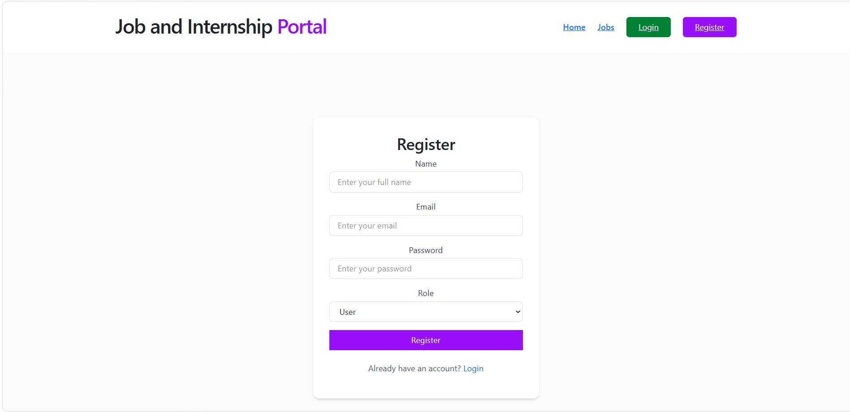

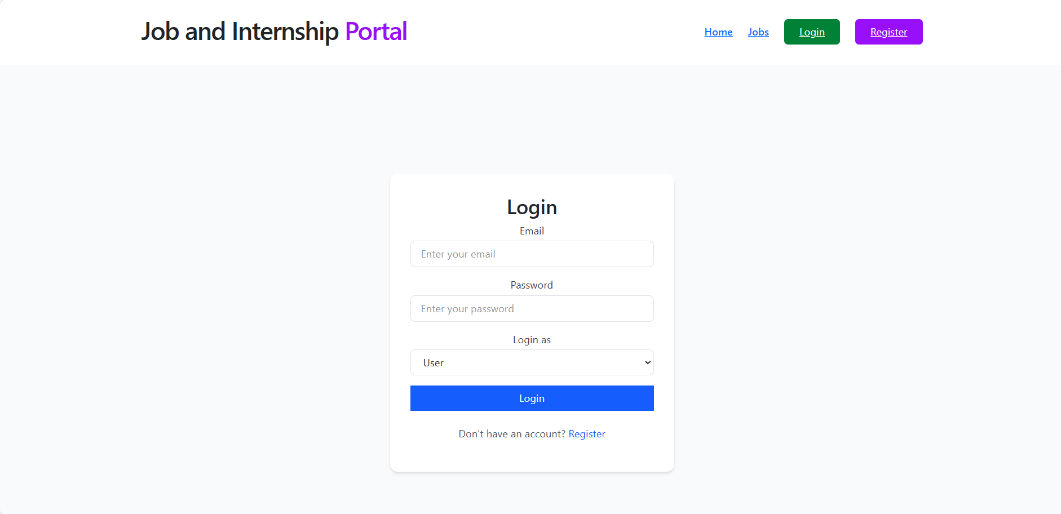
LOGIN PAGE:-

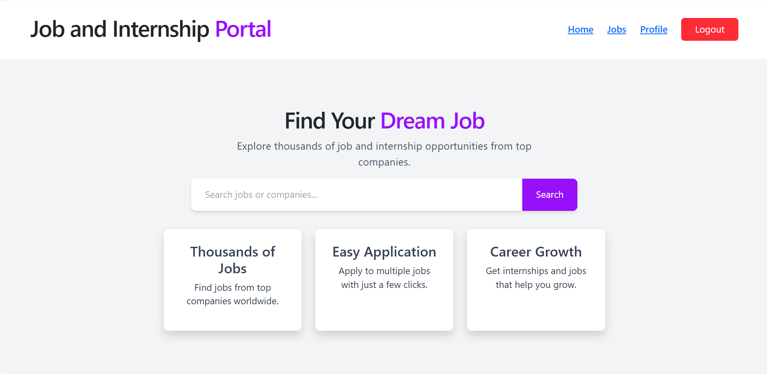
HOME PAGE :-

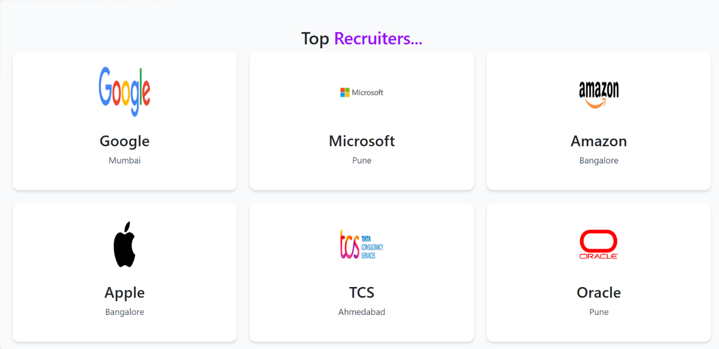
HOME PAGE (CONTINUE…) :-

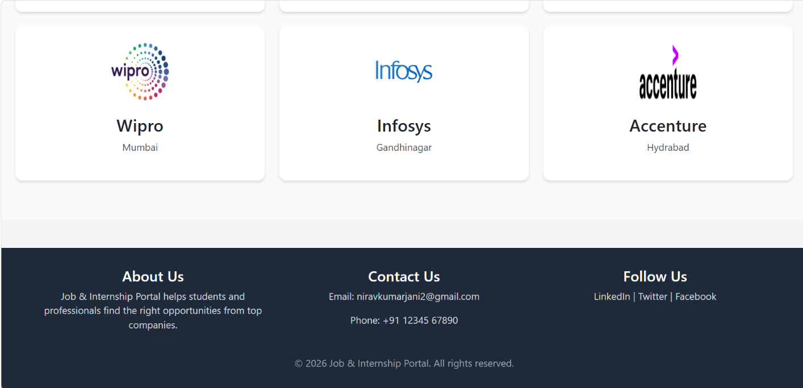
–HOME PAGE (CONTINUE) :-

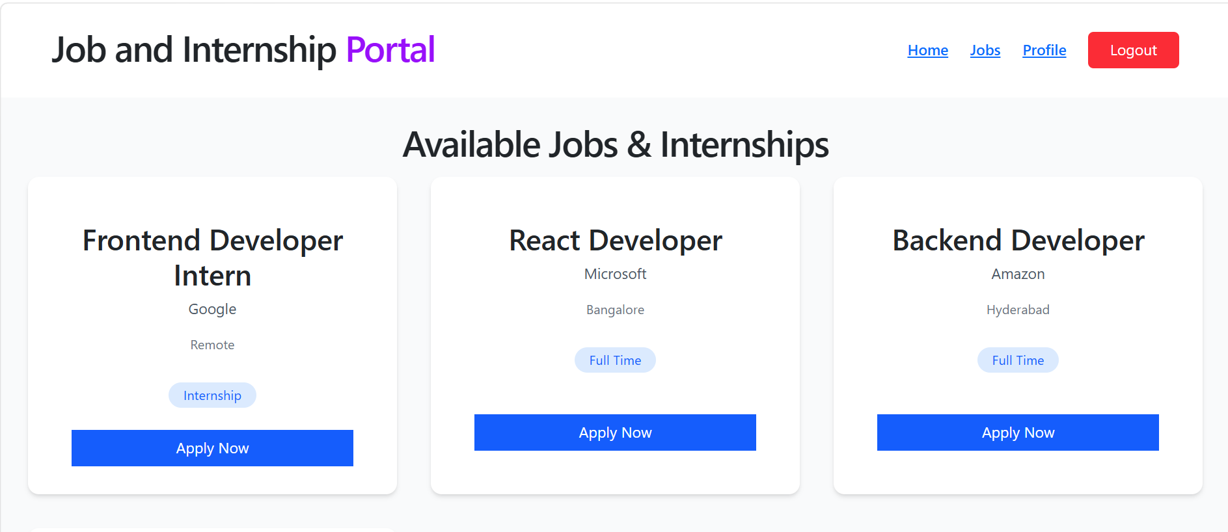
JOBS PAGE :-

JOBS PAGE (CONTINUE) :-
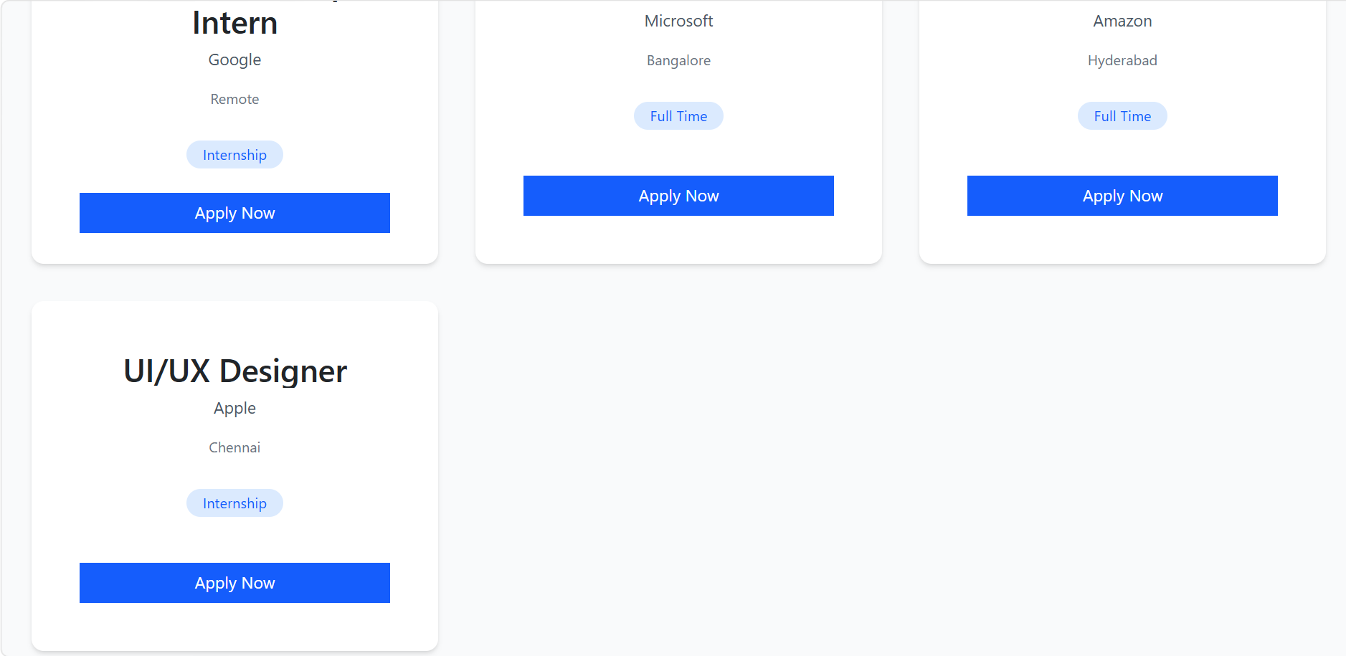

PROFILE PAGE:-
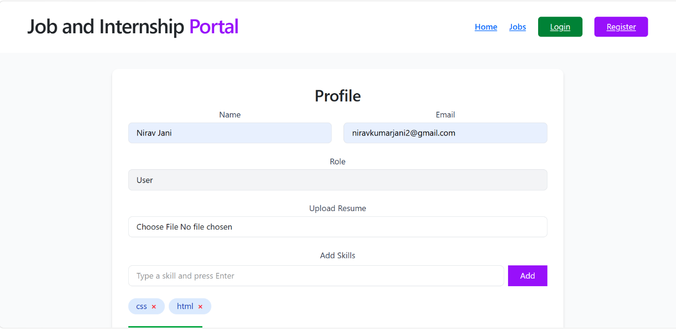

PROFILE PAGE (CONTINUE) :-
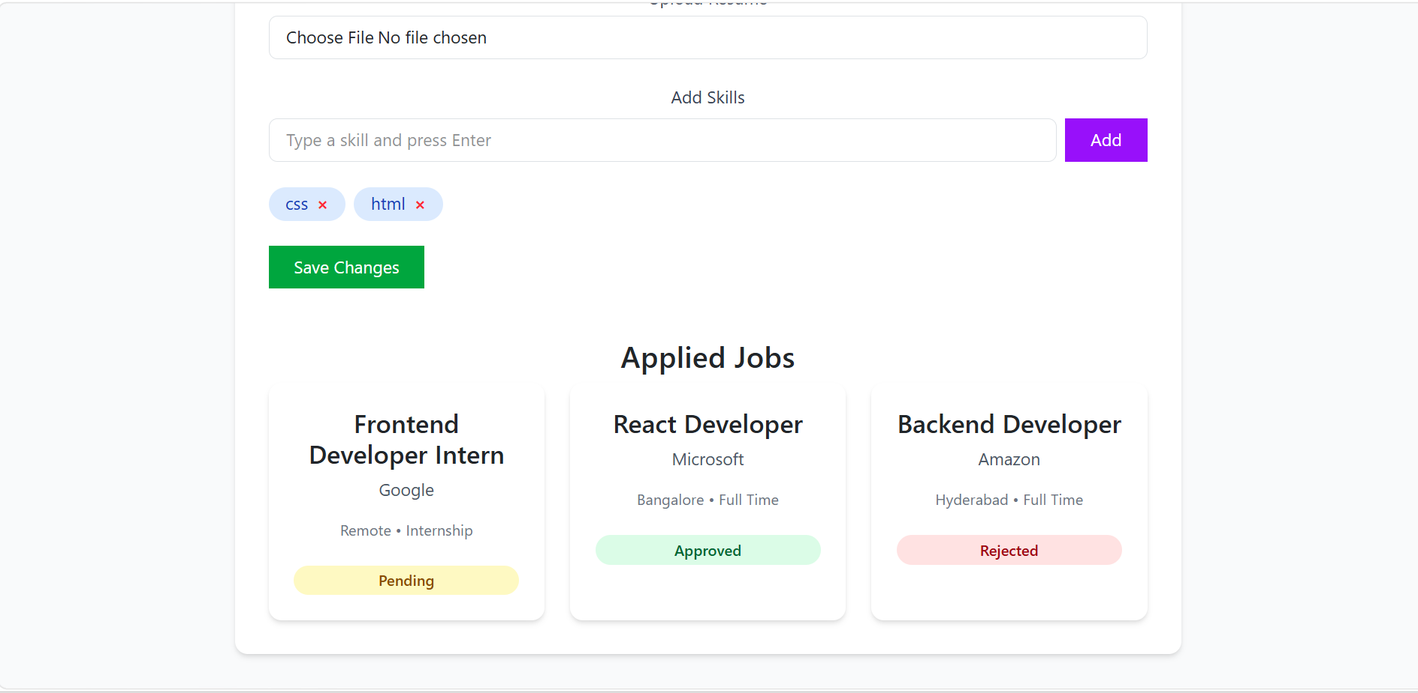

- Admin SidePages :-
RECRUITER DASHBOARD :- ADD JOBS PAGE:-
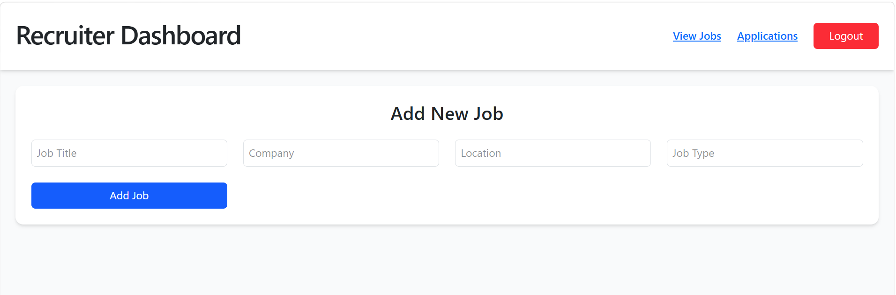

RECRUITER DASHBOARD :- VIEW JOBS PAGE:-
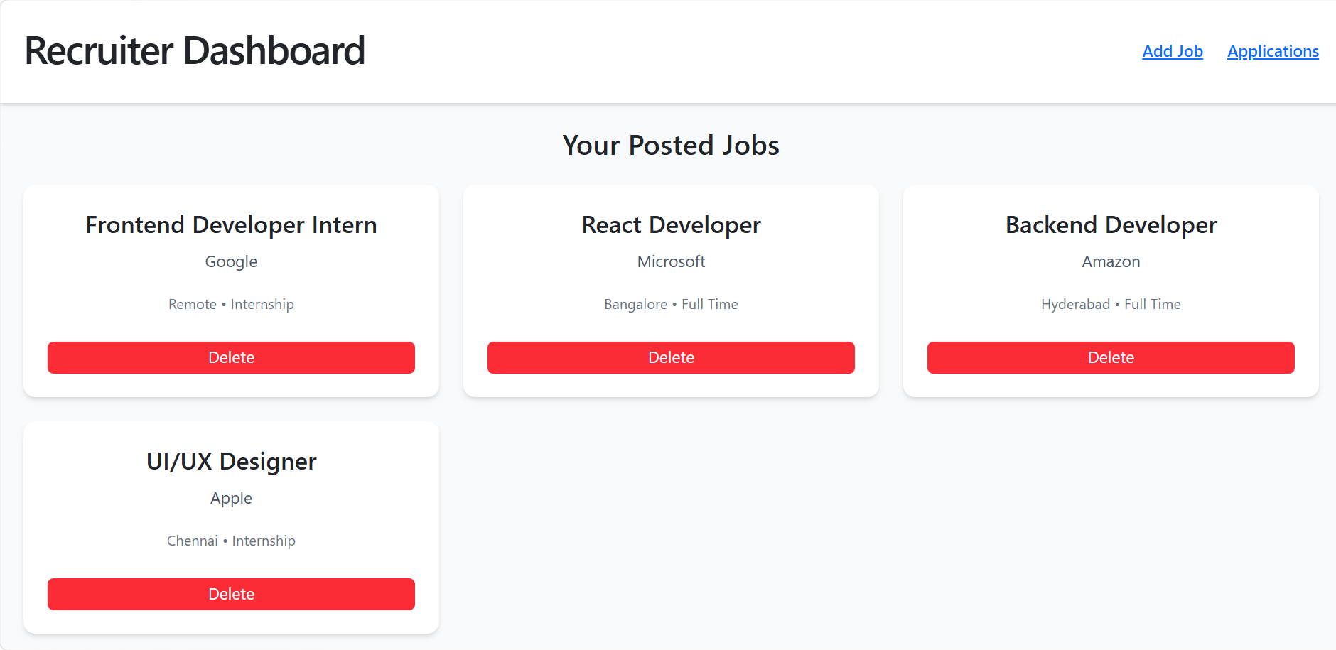
RECRUITER DASHBOARD :- VIEW APPLICATIONS PAGE:-
