- Client Side Pages :-
HOME PAGE :-
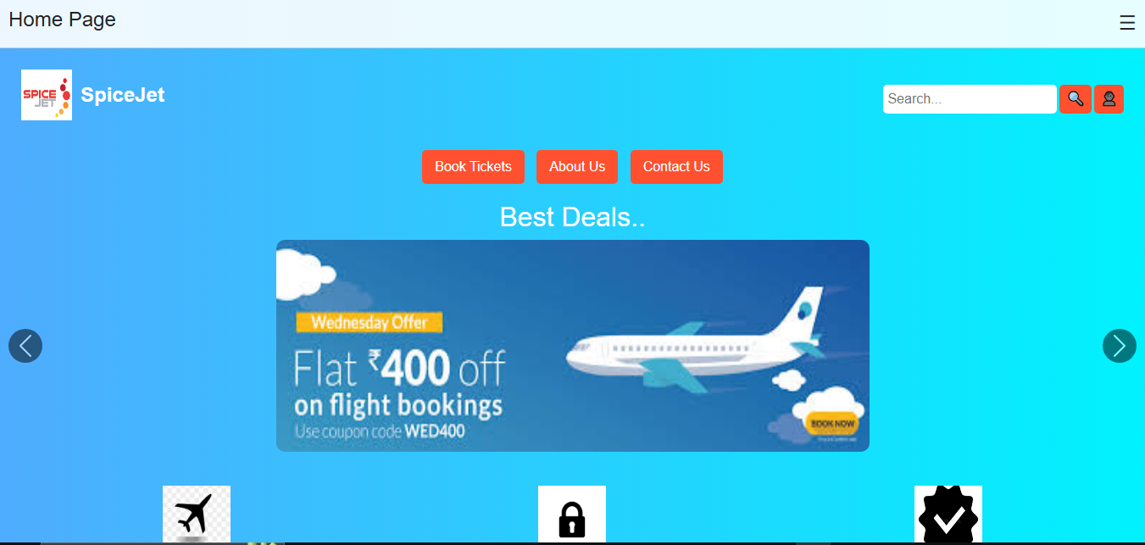

HOME PAGE (CONTINUE…) :-


REGISTRATION PAGE :-
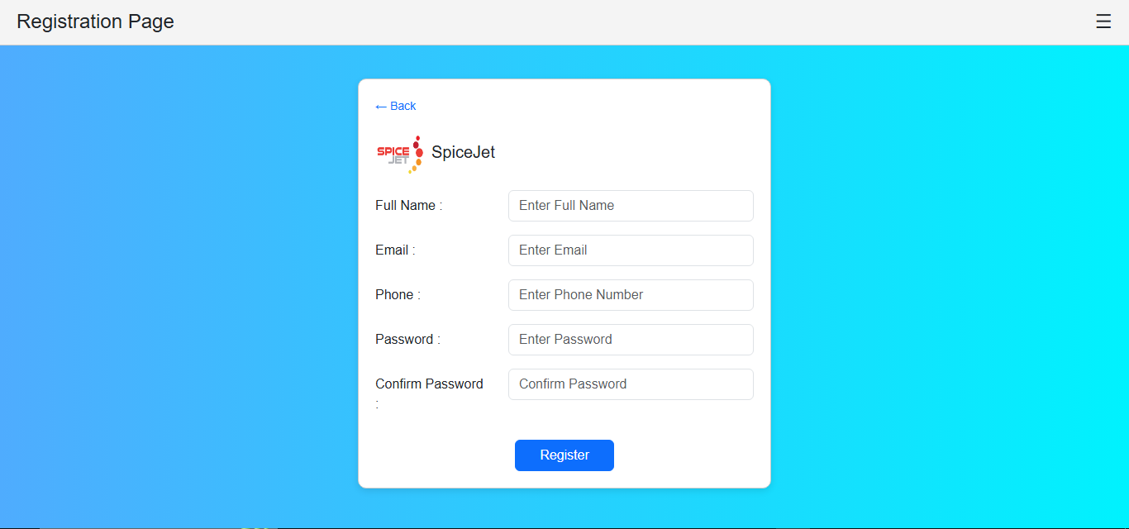

LOGIN PAGE :-
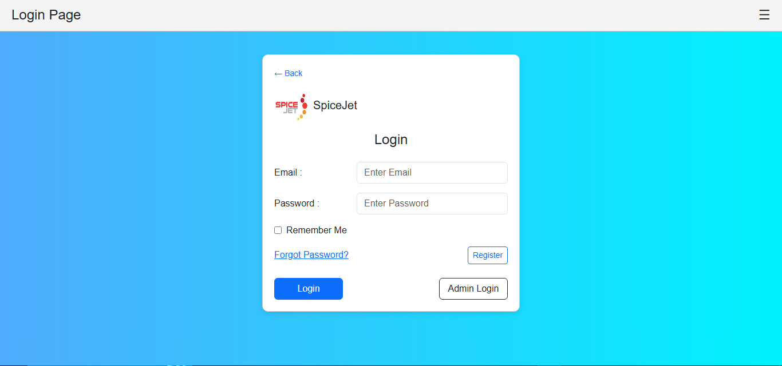

BOOKING PAGE :-
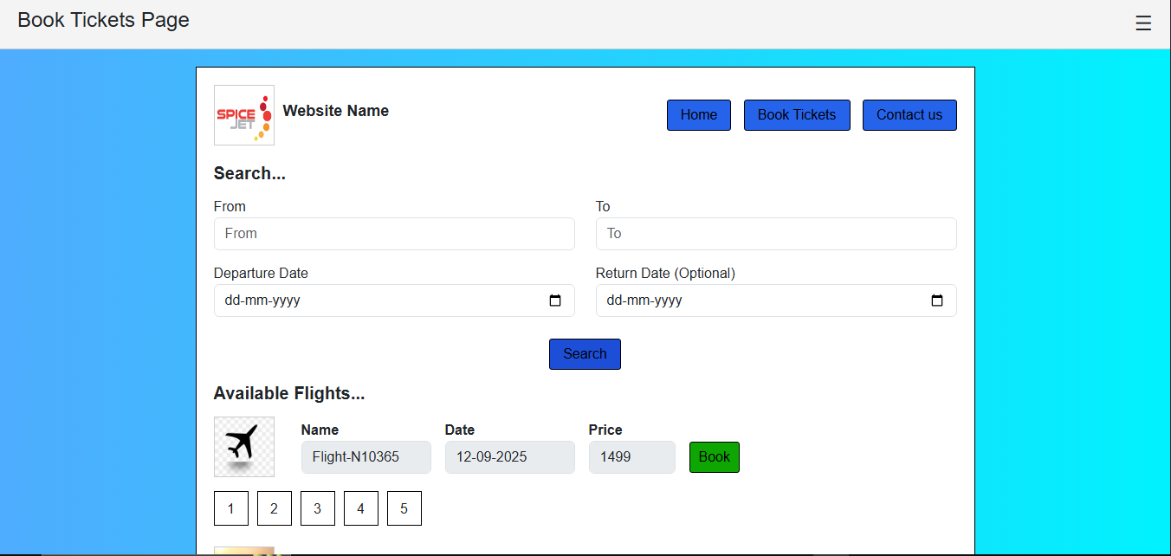

BOOKING PAGE (CONTINUE…) :-
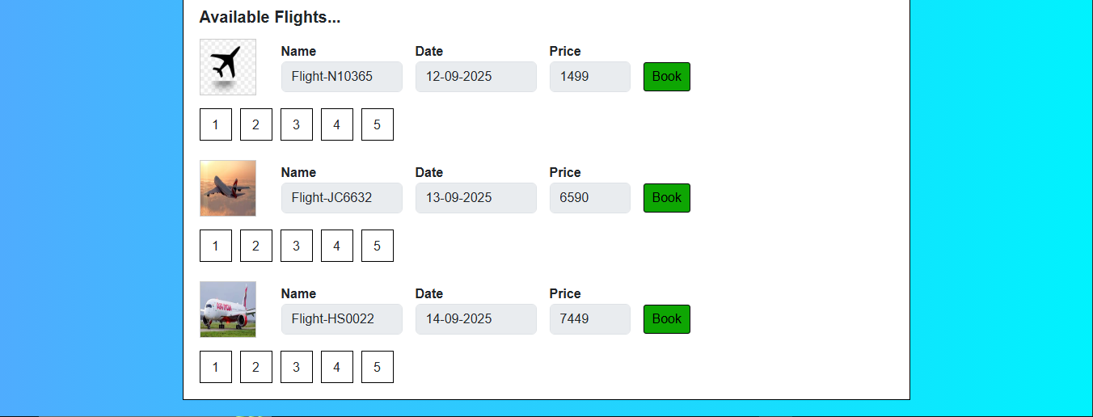

PROFILE PAGE :-
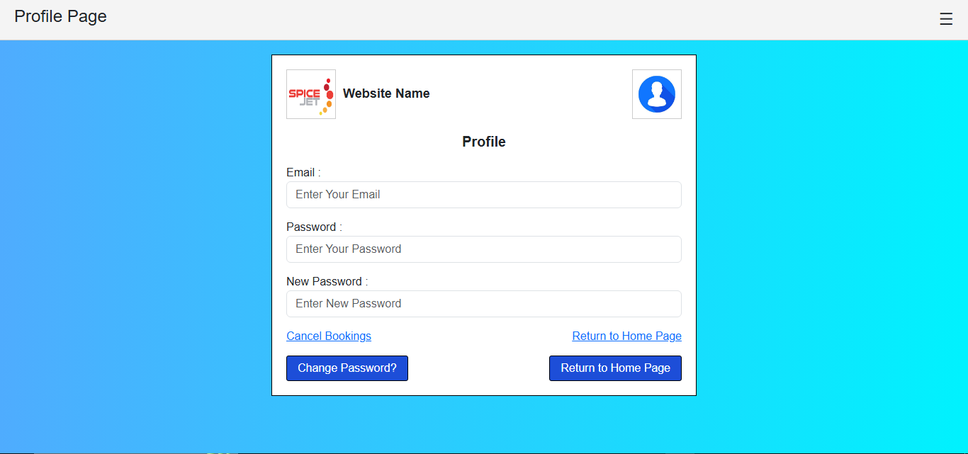

ABOUT US PAGE :-
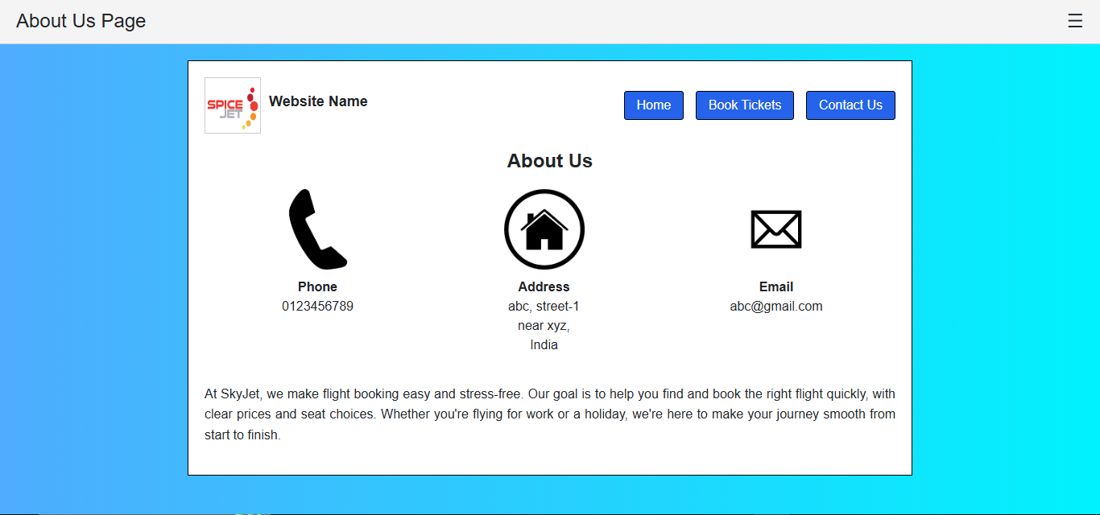

CONTACT US PAGE :-
