Name:
Nirbhay
Subject:
Machine Learning
Assignment:
Linear Regression and Gradient Descent

Task 1: Simple Linear Regression from Scratch in C
Objective
To implement Simple Linear Regression from scratch using the C programming language without using any machine learning libraries.
Dataset
A self-created dataset consisting of 20 samples was used.
Input Feature: X Value
Target Variable: Y Value
The dataset follows the relationship:
$y=2x+5$
Methodology
The following components were implemented manually:
- Weight Initialization
- Bias Initialization
- Prediction Function
- Mean Squared Error (MSE) Loss Function
- Gradient Calculation
- Gradient Descent Update Rule
- Training Loop
Results:
Initial Parameters
- Weight = 0
- Bias = 0
- Loss ≈ 671
Final Parameters
- Weight =2.00
- Bias =4.99
- Loss = MSE≈0
Learned Equation
$y^​=2.00x+5.00$
The learned equation closely matches the actual relationship present in the dataset.
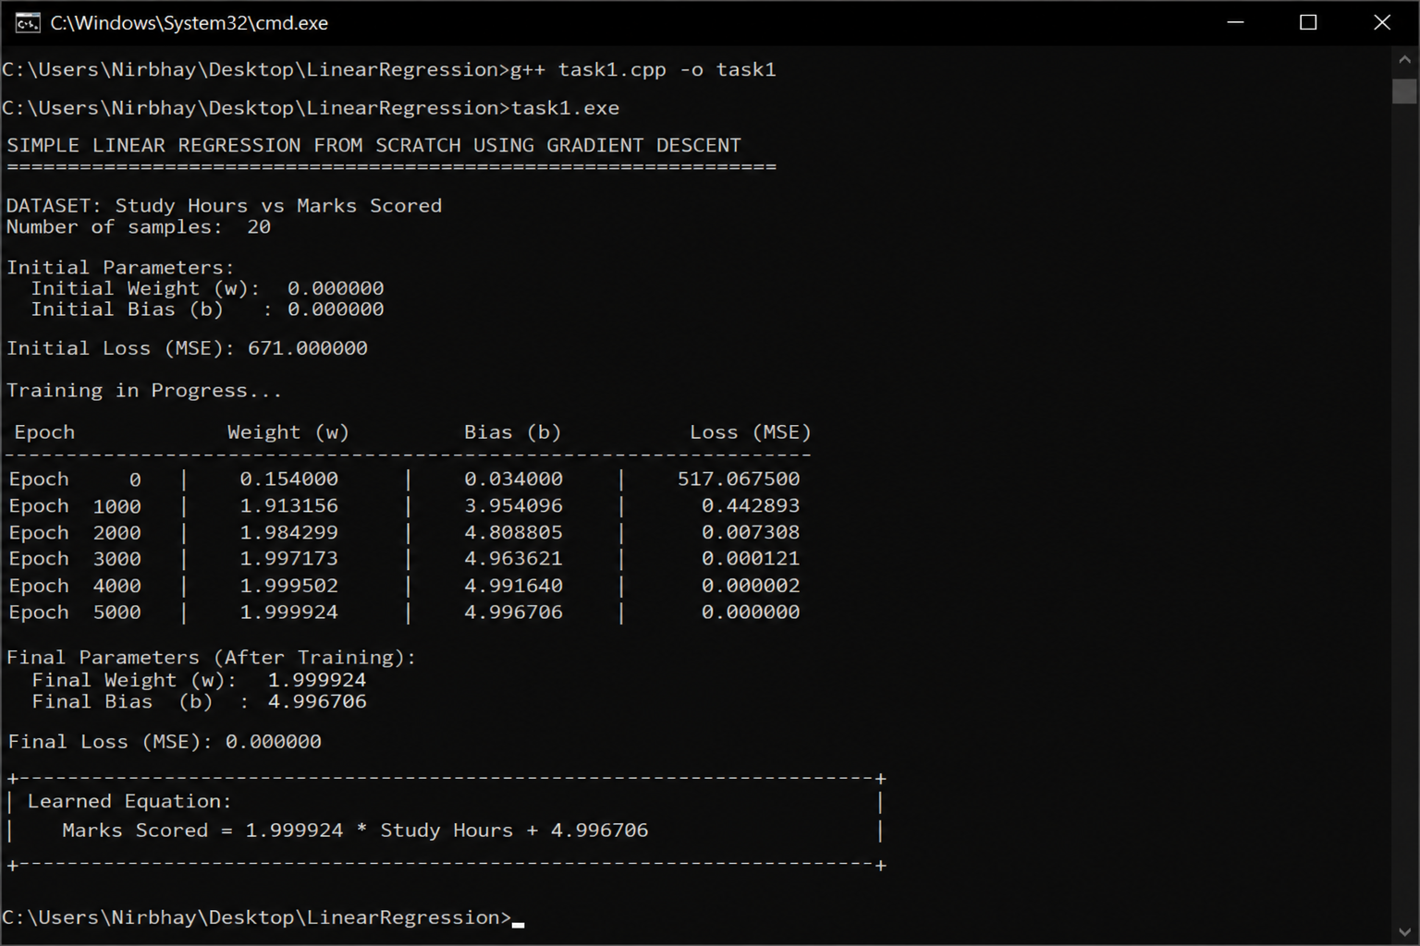
Discussion
1. How did the weight change during training?
Initially, the weight was set to 0. During gradient descent, the weight gradually increased and moved toward the optimal value (approximately 2). This happened because the algorithm continuously adjusted the weight to reduce prediction errors.
2. How did the bias change during training?
The bias started from 0 and gradually increased toward the optimal value (approximately 5). The bias adjustment helped shift the regression line upward so that predictions better matched the actual data.
3. Why did the loss decrease over time?
The loss decreased because gradient descent updates the weight and bias in the direction that minimizes the Mean Squared Error (MSE). With every iteration, the model predictions became closer to the actual values, reducing the overall error .
4. Does the final equation represent the dataset trend?
Yes. The learned equation accurately represents the trend present in the dataset.

Task 2: Gradient Descent and Learning Rate Exploration
Objective
To study the impact of different learning rates on the convergence behavior of Gradient Descent.
Function Used
$f(x)=x^{2}+x$

Learning Rates Tested
- α = 1.0
- α = 0.1
- α = 0.01
- α = 0.001

Observations

Learning Rate | Speed of Convergence | Stability | Overshooting | Final Position
1.0 | Very Fast | Unstable | High | Often diverges
0.1 | Fast | Good | Minor | Reaches optimum quickly
0.01  0.001 | Moderate  Slow | Very Stable  Extremely Stable | None  None | Reaches optimum accurately  May require many iterations
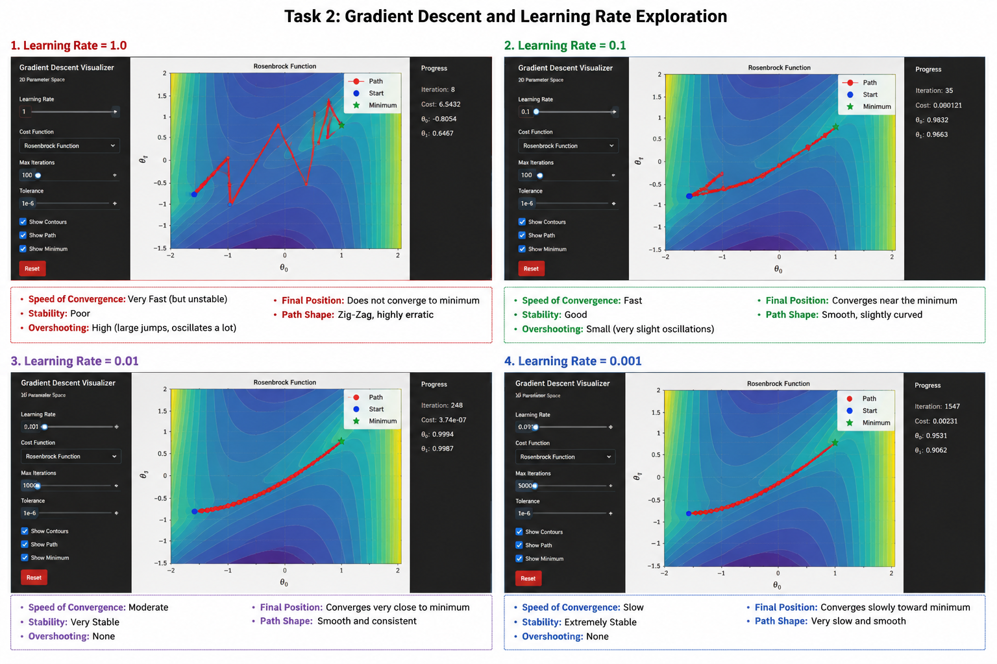

Discussion
1. Which learning rate converged the fastest?
Learning rate 0.1 converged the fastest while maintaining stability.
2. Which learning rate was the most stable?Learning rate 0.01 showed the most stable convergence behavior.
3. What happens when the learning rate is too large?
A very large learning rate causes overshooting and instability, preventing proper convergence.
4. What happens when the learning rate is too small?
A very small learning rate results in extremely slow convergence and requires many iterations.
5. Why is Gradient Descent considered an optimization algorithm?
Gradient Descent minimizes the loss function by iteratively adjusting model parameters toward the optimal solution.

Task 3: Multiple Linear Regression from Scratch Using NumPy
Objective
To implement Multiple Linear Regression using NumPy and compare the results with Scikit-Learn.
Dataset
Insurance Dataset
Features Used
- Age
- BMI
- Children
Target Variable
- Charges
- Total samples: 1338
Methodology
The following components were implemented manually using NumPy:
- Weight Vector Initialization
- Bias Initialization
- Prediction Function
- Mean Squared Error (MSE)
- Gradient Calculation
- Gradient Descent
- Model Training
Feature scaling was applied before training.
Results:
Custom NumPy Model
Mean Squared Error (MSE): $131201335.66$
Scikit-Learn Model
Mean Absolute Error (MAE): $9181.31$
Mean Squared Error (MSE): $131201335.65$
Coefficients: $\left[ 684.30\right]$
Graphs
The following graphs were generated:
- Loss vs Epochs
- Actual vs Predicted Values
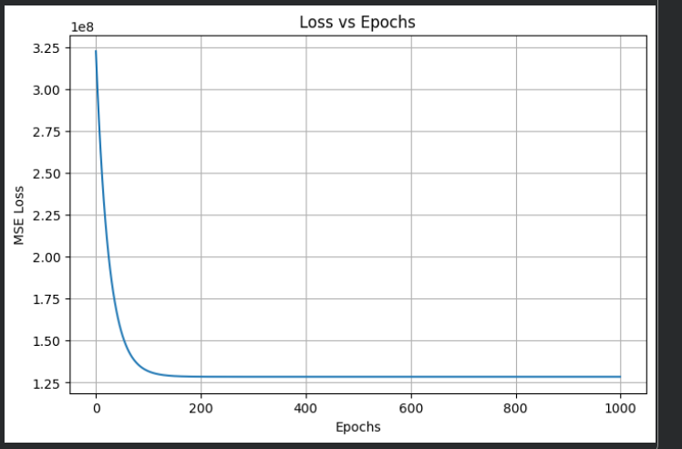
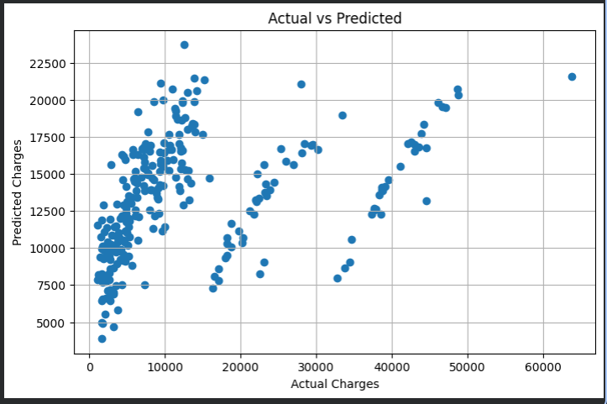

Discussion
1. How similar were the results?
The custom NumPy model and Scikit-Learn model produced nearly identical MSE values, indicating correct implementation.
2. Why might there be small differences?
Small differences may arise due to numerical precision and implementation details.
3. What challenges were faced?
The major challenges included implementing gradient descent correctly, handling multiple features, and selecting an appropriate learning rate.
4. Why are learning rate and feature scaling important?
Feature scaling improves convergence speed, while the learning rate controls the size of parameter updates during training.

