Module 1 –Overview of IT Industry

**1. What is a Program?**

* A program, in the context of computing, is a set of instructions that a computer follows to perform a specific task or solve a problem. Programs are written in programming languages, which provide the syntax and semantics for expressing the logic and operations that the computer should execute.

**2. Explain in your own words what a program is and how it functions?**

* A program is essentially a set of instructions that tells a computer what to do. Think of it like a recipe: just as a recipe outlines the steps needed to prepare a dish, a program outlines the steps needed to perform a specific task on a computer.

Here's how a program typically functions:

1. **Writing the Code**: A programmer writes the code using a programming language. This code includes various commands and logic that define how the program should behave.
2. **Compiling/Interpreting**: Depending on the language used, the code may need to be compiled (translated into machine language that the computer can understand) or interpreted (executed line by line). This step converts the human-readable code into a format that the computer can execute.
3. **Execution**: Once the code is ready, the computer runs the program. It follows the instructions step by step, performing calculations, manipulating data, or interacting with users as specified in the code.
4. **Output**: As the program runs, it may produce output, which could be anything from displaying information on the screen to saving data to a file or sending data over the internet.
5. **Feedback and Iteration**: Often, programs are tested and refined based on user feedback or performance. This may involve debugging (fixing errors) and updating the code to improve functionality or add new features.

**3.What is Programming?**

* Programming is the process of creating a set of instructions that a computer can follow to perform specific tasks or solve problems. It involves writing code in a programming language, which serves as a medium for expressing the logic and operations that the computer should execute.

**4. What are the key steps involved in the programming process?**

* The programming process typically involves several key steps that guide developers from the initial idea to a functioning software application. Here’s an overview of these steps:

1. **Problem Definition**:
   * Clearly identify and define the problem you want to solve. Understand the requirements and constraints of the project. This step often involves discussions with stakeholders to gather their needs and expectations.
2. **Planning**:
   * Outline the goals and objectives of the program. Determine the scope of the project, including what features will be included and what will be excluded. This may also involve creating a timeline and allocating resources.
3. **Design**:
   * Create a blueprint for the program. This includes:
     + **Architecture Design**: Defining the overall structure of the software, including how different components will interact.
     + **User Interface Design**: Planning how users will interact with the program, including layout and navigation.
     + **Algorithm Design**: Developing algorithms that will be used to process data and perform tasks.
4. **Implementation (Coding)**:
   * Write the actual code using a programming language. This step involves translating the design into a functional program. Programmers will often use integrated development environments (IDEs) and tools to assist in writing and organizing code.
5. **Testing**:
   * Test the program to identify and fix any errors or bugs. This can include:
     + **Unit Testing**: Testing individual components or functions for correctness.
     + **Integration Testing**: Ensuring that different parts of the program work together as intended.
     + **System Testing**: Testing the complete program in a real-world environment to verify that it meets the requirements.
6. **Debugging**:
   * Identify and resolve any issues or bugs found during testing. This may involve analyzing error messages, reviewing code, and making necessary corrections.
7. **Documentation**:
   * Create documentation that explains how the program works, including user manuals, technical specifications, and comments within the code. Good documentation helps users understand how to use the software and assists future developers in maintaining it.
8. **Deployment**:
   * Release the program to users. This may involve installing the software on user machines, deploying it to a server, or making it available for download.
9. **Maintenance**:
   * After deployment, the program will require ongoing maintenance. This includes fixing any new bugs that arise, updating the software to add new features, and ensuring compatibility with new hardware or software environments.

**10.Feedback and Iteration**:

* + Gather feedback from users to understand their experiences and identify areas for improvement. Based on this feedback, you may iterate on the design and implementation, making enhancements or adjustments as needed.

**5. Types of Programming Languages**

* Programming languages can be categorized in various ways based on their characteristics, paradigms, and intended use. Here are some of the main types of programming languages:

**1. High-Level vs. Low-Level Languages**

* **High-Level Languages**: These languages are closer to human languages and are designed to be easy to read and write. They abstract away most of the hardware details. Examples include:
  + Python
  + Java
  + C#
  + Ruby
  + JavaScript
* **Low-Level Languages**: These languages are closer to machine code and provide little abstraction from the hardware. They are more difficult to read and write but offer greater control over system resources. Examples include:
  + Assembly Language
  + Machine Code

**2. Compiled vs. Interpreted Languages**

* **Compiled Languages**: These languages are translated into machine code by a compiler before execution. This often results in faster execution times. Examples include:
  + C
  + C++
  + Rust
* **Interpreted Languages**: These languages are executed line by line by an interpreter at runtime, which can make them slower but more flexible. Examples include:
  + Python
  + Ruby
  + JavaScript

**6. What are the main differences between high-level and low-level programming languages?**

* Here are the main differences between high-level and low-level programming languages.

| **Feature** | **High-Level** | **Low-Level** |
| --- | --- | --- |
| Abstraction | High | Low |
| Ease | Easier | Complex |
| Control | Less | More |
| Portability | More | Less |
| Speed | Slower | Faster |
| Use Cases | Apps, web | Systems, embedded |

**7. Research and create a diagram of how data is transmitted from a client to a server over the internet.**

**8. Describe the roles of the client and server in web communication. Network Layers on Client and Server**

* In web communication, the roles of the client and server are fundamental to the functioning of the internet. Each plays a distinct role in the process of data exchange, and they operate across various network layers.

**Roles of the Client and Server**

**Client**

* **Definition**: The client is typically a device (such as a computer, smartphone, or tablet) that requests resources or services from a server. It initiates communication and interacts with the server to obtain data.
* **Functions**:
  + **Request Generation**: The client generates requests for resources, such as web pages, images, or data. This is often done through a web browser or application.
  + **User Interface**: The client provides a user interface for users to interact with the application, allowing them to input data and view results.
  + **Data Presentation**: Once the client receives data from the server, it processes and presents it to the user in a readable format (e.g., rendering HTML for web pages).
  + **Session Management**: The client may manage user sessions, maintaining state information (like login status) across multiple requests.

**Server**

* **Definition**: The server is a powerful computer or system that hosts resources, services, or applications and responds to requests from clients. It processes incoming requests and sends back the appropriate responses.
* **Functions**:
  + **Resource Hosting**: The server stores and manages resources such as web pages, databases, and files.
  + **Request Processing**: Upon receiving a request from a client, the server processes it, which may involve querying a database, performing calculations, or retrieving files.
  + **Response Generation**: The server generates a response based on the request, which may include HTML content, JSON data, or other formats.
  + **Security and Authentication**: The server often handles security measures, such as user authentication and data encryption, to protect sensitive information.

**Network Layers on Client and Server**

Both the client and server communicate through a series of network layers, typically modeled using the OSI (Open Systems Interconnection) model or the TCP/IP model. Here’s how these layers are structured:

**1. Application Layer**

* **Client**: The client application (e.g., web browser) generates requests using application protocols like HTTP or HTTPS.
* **Server**: The server runs web server software (e.g., Apache, Nginx) that listens for incoming requests and serves the appropriate content.

**2. Transport Layer**

* **Client**: The client uses transport protocols like TCP (Transmission Control Protocol) to ensure reliable communication. It establishes a connection to the server and manages data transmission.
* **Server**: The server also uses TCP to receive requests and send responses, ensuring that data is delivered accurately and in order.

**3. Internet Layer**

* **Client**: The client encapsulates data into packets with source and destination IP addresses, allowing it to route the request through the internet.
* **Server**: The server receives packets, extracts the data, and processes the request based on the information contained in the packets.

**4. Link Layer**

* **Client**: The client’s network interface (e.g., Ethernet, Wi-Fi) handles the physical transmission of packets over the local network.
* **Server**: The server’s network interface also manages the physical connection to the network, receiving packets from clients and sending responses back.

**9. Explain the function of the TCP/IP model and its layers?**

* **Functions of the TCP/IP Model**

1. **Standardization**: The TCP/IP model provides a standardized set of protocols that enable different devices and networks to communicate with each other, regardless of their underlying hardware or software.
2. **Interoperability**: It allows diverse systems and technologies to work together, facilitating communication between different types of devices, such as computers, smartphones, and servers.
3. **Modularity**: The model is structured in layers, which allows for modular design. Each layer has specific functions and can be developed or modified independently, making it easier to implement and troubleshoot.
4. **Data Transmission**: The TCP/IP model defines how data is packaged, addressed, transmitted, routed, and received, ensuring reliable communication across networks.
5. **Error Handling and Recovery**: The model includes mechanisms for error detection and correction, ensuring that data is transmitted accurately and reliably.

**Layers of the TCP/IP Model**

The TCP/IP model consists of four layers, each with specific functions:

1. **Application Layer**
   * **Function**: This layer provides network services directly to end-user applications. It is responsible for facilitating communication between software applications and the underlying network.
   * **Protocols**: Common protocols at this layer include:
     + **HTTP/HTTPS**: For web browsing.
     + **FTP**: For file transfer.
     + **SMTP**: For email transmission.
     + **DNS**: For domain name resolution.
2. **Transport Layer**
   * **Function**: This layer is responsible for end-to-end communication, ensuring that data is delivered reliably and in the correct order. It manages flow control, error detection, and retransmission of lost packets.
   * **Protocols**: The main protocols at this layer are:
     + **TCP (Transmission Control Protocol)**: Provides reliable, connection-oriented communication with error recovery and flow control.
     + **UDP (User Datagram Protocol)**: Provides connectionless communication with minimal overhead, suitable for applications that can tolerate some data loss (e.g., video streaming, online gaming).
3. **Internet Layer**
   * **Function**: This layer is responsible for addressing and routing packets across the network. It determines the best path for data to travel from the source to the destination.
   * **Protocols**: The primary protocol at this layer is:
     + **IP (Internet Protocol)**: Responsible for addressing and routing packets. It includes two versions:
       - **IPv4**: The most widely used version, which uses 32-bit addresses.
       - **IPv6**: A newer version that uses 128-bit addresses to accommodate the growing number of devices on the internet.
4. **Link Layer (Network Interface Layer)**
   * **Function**: This layer is responsible for the physical transmission of data over the network medium. It handles the details of the physical connection, including framing, addressing, and error detection at the hardware level.
   * **Protocols**: Protocols at this layer can vary based on the network technology used, including:
     + **Ethernet**: Commonly used in wired local area networks (LANs).
     + **Wi-Fi**: Used for wireless local area networks.
     + **PPP (Point-to-Point Protocol)**: Used for direct connections between two nodes

**10. Explain Client Server Communication**

Client-server communication is a model used in network architecture where a client requests services or resources from a server, which processes the request and returns the appropriate response.

1. **Client**:
   * The client is typically a device or application that initiates a request for resources or services. This can be a web browser, mobile app, or any software that communicates with a server.
   * Clients are often user-facing, meaning they provide an interface for users to interact with the application or service.
2. **Server**:
   * The server is a powerful computer or system that hosts resources, services, or applications. It listens for incoming requests from clients and processes them.
   * Servers can handle multiple client requests simultaneously and are designed to manage resources efficiently.

**Communication Process**

1. **Request Initiation**:
   * The client sends a request to the server. This request is typically formatted according to a specific protocol (e.g., HTTP for web requests).
   * The request may include information such as the type of resource being requested (e.g., a web page, image, or data), parameters, and authentication credentials.
2. **Request Transmission**:
   * The request is transmitted over the network using various protocols. The TCP/IP model is commonly used, where the request passes through different layers (application, transport, internet, and link layers).
   * The transport layer (e.g., TCP) ensures reliable delivery of the request, while the internet layer (e.g., IP) handles routing the request to the correct server.
3. **Request Processing**:
   * Upon receiving the request, the server processes it. This may involve querying a database, performing calculations, or retrieving files.
   * The server may also perform security checks, such as verifying user credentials or permissions.
4. **Response Generation**:
   * After processing the request, the server generates a response. This response may include the requested resource (e.g., HTML content, JSON data) or an error message if the request could not be fulfilled.
   * The response is formatted according to the same protocol used for the request.
5. **Response Transmission**:
   * The server sends the response back to the client over the network, again using the appropriate protocols.
   * The response travels through the same layers in reverse order, from the server’s application layer down to the link layer, and then back to the client.
6. **Response Handling**:
   * The client receives the response and processes it. This may involve rendering a web page, displaying data, or updating the user interface.
   * The client may also handle any errors or status codes returned by the server (e.g., 404 Not Found, 500 Internal Server Error).

**Advantages of Client-Server Communication**

* **Centralized Resources**: Servers can centralize resources and services, making them easier to manage and maintain.
* **Scalability**: The client-server model can scale to accommodate many clients, allowing for efficient resource allocation and load balancing.
* **Security**: Servers can implement security measures to protect sensitive data and manage user access.

**11. Types of Internet Connections**

| **Type** | **Speed Range** | **Advantages** | **Disadvantages** |
| --- | --- | --- | --- |
| Dial-Up | Up to 56 Kbps | Low cost | Very slow |
| DSL | Hundreds Kbps | Always-on | Distance limits |
| Cable | 10 Mbps to 1 Gbps | High speed | Peak slowdowns |
| Fiber | Up to 10 Gbps | Very fast | Limited access |
| Satellite | 12 Mbps to 100 Mbps | Remote use | High latency |
| Wireless | Varies | Convenient | Signal issues |
| Mobile | 4G: 100 Mbps; 5G: >1 Gbps | Portable | Data caps |
| Fixed Wireless | Few Mbps to 100+ Mbps | Rural access | Line of sight needed |

**12. Research different types of internet connections (e.g., broadband, fiber, satellite ) and list their pros and cons.**

**1. Broadband**

* **Pros**: High-speed, always-on, supports multiple devices.
* **Cons**: Variable speed and availability, potential data caps.

**2. Fiber Optic**

* **Pros**: Extremely fast (up to 10 Gbps), reliable, high bandwidth.
* **Cons**: Limited availability, higher installation costs.

**3. Cable**

* **Pros**: High speeds (up to 1 Gbps), widely available, supports multiple users.
* **Cons**: Slower during peak times, may require a cable subscription.

**4. DSL**

* **Pros**: Faster than dial-up, always-on, no dedicated phone line needed.
* **Cons**: Speed decreases with distance from the provider.

**5. Satellite**

* **Pros**: Available in remote areas, decent speeds (up to 100 Mbps).
* **Cons**: High latency, weather disruptions, potential data caps.

**6. Wireless (Wi-Fi)**

* **Pros**: Convenient, allows multiple devices, easy setup.
* **Cons**: Signal affected by distance and obstacles, security risks.

**7. Mobile Data (3G, 4G, 5G)**

* **Pros**: Portable, available almost anywhere, 5G offers high speeds.
* **Cons**: Data caps, variable speeds based on congestion.

**8. Fixed Wireless**

* **Pros**: Useful in rural areas, decent speeds.
* **Cons**: Requires line of sight, weather can affect performance.

**13. How does broadband differ from fiber-optic internet? Protocols**

* + **Broadband**: General term for high-speed internet that includes various technologies (DSL, cable, satellite, fiber).
  + **Fiber-Optic Internet**: A specific type of broadband that uses fiber-optic cables to transmit data as light.
* **Technology**:
  + **Broadband**: Can use DSL, cable, satellite, or fiber.
  + **Fiber-Optic**: Uses fiber-optic cables exclusively.
* **Speed**:
  + **Broadband**: Varies widely (e.g., DSL: 1-100 Mbps, Cable: 10 Mbps to 1 Gbps).
  + **Fiber-Optic**: Typically offers speeds exceeding 1 Gbps, with some up to 10 Gbps.
* **Reliability and Latency**:
  + **Broadband**: Reliability varies; can slow down during peak times.
  + **Fiber-Optic**: Generally more reliable with lower latency.
* **Availability**:
  + **Broadband**: More widely available, especially in urban areas.
  + **Fiber-Optic**: Limited availability, primarily in urban areas, with ongoing expansion.

**Relevant Protocols**

1. **TCP/IP**: Core protocols for internet communication.
2. **HTTP/HTTPS**: Protocols for transferring web pages and secure data.
3. **FTP**: Used for file transfers.
4. **DHCP**: Assigns IP addresses to devices on a network.
5. **DNS**: Translates domain names into IP addresses.

**14. Simulate HTTP and FTP requests using command line tools (e.g., curl)**

* **Basic HTTP GET Request**: To retrieve the content of a webpage:

curl <http://example.com>

**HTTP GET Request with Headers**: To include custom headers in the request: curl -H "User -Agent: MyBrowser" <http://example.com>

**HTTP POST Request**: To send data to a server (e.g., form data):

curl -X POST -d "param1=value1&param2=value2" <http://example.com/submit>

**Simulating FTP Requests with curl**

**Basic FTP GET Request**: To download a file from an FTP server:

curl <ftp://ftp.example.com/file.txt>

**FTP Upload Request**: To upload a file to an FTP server: curl -T localfile.txt ftp://ftp.example.com/ --user username:password

**List Files on FTP Server**: To list files in a directory on an FTP server:

curl ftp://ftp.example.com/ --user username:password

15. : What are the differences between HTTP and HTTPS protocols?

**HTTP (Hypertext Transfer Protocol)**

* **Security**: Not secure; data is transmitted in plain text.
* **Port**: Uses port 80 by default.
* **Encryption**: No encryption; vulnerable to eavesdropping and man-in-the-middle attacks.
* **Use Case**: Suitable for non-sensitive data and general web browsing.

**HTTPS (Hypertext Transfer Protocol Secure)**

* **Security**: Secure; data is encrypted using SSL/TLS.
* **Port**: Uses port 443 by default.
* **Encryption**: Provides encryption, ensuring data confidentiality and integrity.
* **Use Case**: Essential for sensitive transactions (e.g., online banking, e-commerce).

**16. Identify and explain three common application security vulnerabilities. Suggest possible solutions.**

* Here are three common application security vulnerabilities along with explanations and possible solutions:

**1. SQL Injection (SQLi)**

* **Description**: SQL injection occurs when an attacker inserts or "injects" malicious SQL queries into input fields, allowing them to manipulate the database. This can lead to unauthorized access, data leakage, or data manipulation.
* **Solutions**:
  + **Parameterized Queries**: Use prepared statements with parameterized queries to ensure that user input is treated as data, not executable code.
  + **Input Validation**: Validate and sanitize all user inputs to ensure they conform to expected formats.
  + **Least Privilege**: Limit database user permissions to only what is necessary for the application.

**2. Cross-Site Scripting (XSS)**

* **Description**: XSS vulnerabilities allow attackers to inject malicious scripts into web pages viewed by other users. This can lead to session hijacking, defacement, or redirection to malicious sites.
* **Solutions**:
  + **Output Encoding**: Encode data before rendering it in the browser to prevent execution of injected scripts (e.g., HTML encoding).
  + **Content Security Policy (CSP)**: Implement CSP headers to restrict the sources from which scripts can be loaded.
  + **Input Validation**: Validate and sanitize user inputs to prevent the injection of malicious scripts.

**3. Cross-Site Request Forgery (CSRF)**

* **Description**: CSRF attacks trick users into executing unwanted actions on a web application in which they are authenticated. This can lead to unauthorized transactions or changes in user settings.
* **Solutions**:
  + **Anti-CSRF Tokens**: Implement anti-CSRF tokens that are unique to each user session and must be included in state-changing requests.
  + **SameSite Cookies**: Use the **SameSite** attribute for cookies to prevent them from being sent with cross-origin requests.
  + **User Confirmation**: Require user confirmation for sensitive actions (e.g., password changes, fund transfers)

**17. What is the role of encryption in securing applications?**

* Encryption ensures no one can read communications or data except the intended recipient or data owner. This prevents attackers from intercepting and accessing sensitive data.

**18. Identify and classify 5 applications you use daily as either system software or application software**

* Here are five applications commonly used daily, classified as either system software or application software:

**1. Operating System (e.g., Windows, macOS, Linux)**

* **Type**: System Software
* **Description**: The operating system manages hardware resources and provides a platform for running application software.

**2. Web Browser (e.g., Google Chrome, Mozilla Firefox)**

* **Type**: Application Software
* **Description**: A web browser allows users to access and navigate the internet, view websites, and interact with web applications.

**3. Microsoft Office Suite (e.g., Word, Excel)**

* **Type**: Application Software
* **Description**: A collection of productivity applications used for document creation, data analysis, and presentations.

**4. Antivirus Software (e.g., Norton, McAfee)**

* **Type**: System Software
* **Description**: Antivirus software protects the computer from malware and other security threats, functioning at the system level.

**5. Media Player (e.g., VLC, Windows Media Player)**

* **Type**: Application Software
* **Description**: A media player allows users to play audio and video files, providing an interface for media consumption.

**19. What is the difference between system software and application software?**

| **Feature** | **System Software** | **Application Software** |
| --- | --- | --- |
| Definition | Manages hardware | Performs user tasks |
| Examples | OS (Windows, Linux) | Word processors, web browsers |
| Function | Resource management | Task execution |
| User Interaction | Minimal | Direct |
| Dependency | Essential for apps | Requires system software |

**20. Design a basic three-tier software architecture diagram for a web application**

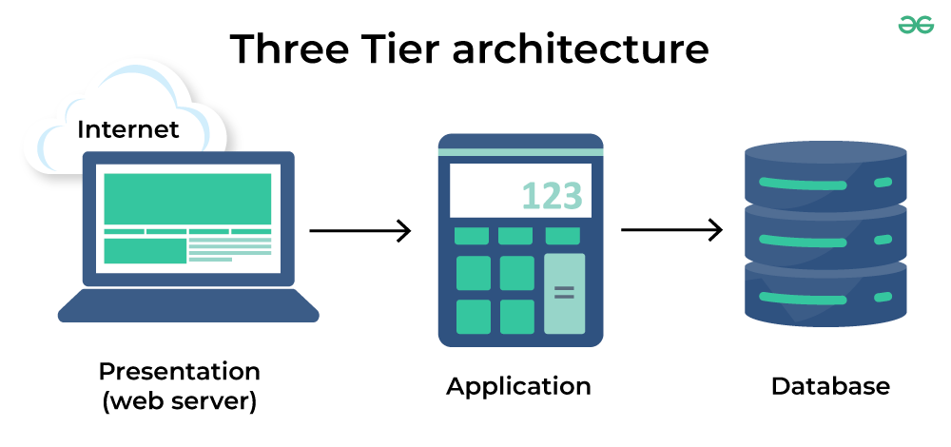

**21. What is the significance of modularity in software architecture?**

* **Significance of Modularity**

1. **Maintainability**: Easier to update and fix individual components without affecting the whole system.
2. **Reusability**: Modules can be reused in different projects, saving time and effort.
3. **Testing**: Simplifies testing by allowing independent testing of each module.
4. **Scalability**: Facilitates easier scaling by adding or modifying modules as needed.
5. **Collaboration**: Enables multiple teams to work on different modules simultaneously.

**22. Create a case study on the functionality of the presentation, business logic, and data access layers of a given software system**.

* **Case Study: Online Bookstore System**

**Overview**: This case study explores the functionality of the three layers—Presentation Layer, Business Logic Layer, and Data Access Layer—of an online bookstore system.



**1. Presentation Layer**

* **Functionality**: Provides the user interface for browsing, searching, and purchasing books.
* **Technologies**: HTML, CSS, JavaScript, front-end frameworks (e.g., React).
* **Example**: Users search for books and view results in a user-friendly format.

**2. Business Logic Layer**

* **Functionality**: Processes user requests, applies business rules, and manages core operations (e.g., authentication, order processing).
* **Example**: Validates stock availability and calculates total prices when a user adds a book to their cart.

**3. Data Access Layer**

* **Functionality**: Manages interactions with the database, including data retrieval and manipulation.
* **Technologies**: SQL, ORM frameworks (e.g., Entity Framework).
* **Example**: Executes queries to fetch book details based on user searches.

**23. Why are layers important in software architecture?**

**Layers are important in software architecture for the following reasons**

1. **Separation of Concerns**: Different aspects of the application are managed independently, making it easier to understand and maintain.
2. **Maintainability**: Changes in one layer can be made without affecting others, simplifying updates.
3. **Scalability**: Individual layers can be scaled independently based on demand.
4. **Reusability**: Components within layers can be reused across different projects, saving time.
5. **Testability**: Each layer can be tested independently, facilitating focused testing.
6. **Flexibility**: Different technologies can be used for different layers, allowing for easier integration of new tools.
7. **Collaboration**: Teams can work on separate layers simultaneously, improving development speed.

**24. Explore different types of software environments (development, testing, production).Set up a basic environment in a virtual machine.**

* **Types of Software Environments**

1. **Development Environment**:
   * **Purpose**: For writing and debugging code.
   * **Characteristics**: Local setup with IDEs, version control, and frequent changes.
2. **Testing Environment**:
   * **Purpose**: For testing the application before deployment.
   * **Characteristics**: Mimics production, stable configuration, includes testing tools.
3. **Production Environment**:
   * **Purpose**: Live environment for end-users.
   * **Characteristics**: Stable, secure, monitored, with cautious change management.

**Setting Up a Basic Environment in a Virtual Machine**

1. **Choose a Virtualization Tool**: Use VirtualBox or VMware.
2. **Create a New VM**: Allocate resources (CPU, RAM, disk space).
3. **Install an Operating System**: Attach an OS image (e.g., Ubuntu) and install it.
4. **Install Development Tools**: Set up IDEs, version control, and programming languages.
5. **Set Up Testing Tools**: Install testing frameworks and CI tools.
6. **Configure Production Environment**: Implement security measures and monitoring tools.
7. **Network Configuration**: Adjust network settings for communication.

**25. Explain the importance of a development environment in software production.**

* The development environment is important in software production for the following reasons:

1. **Code Development**: Provides a safe space for writing and editing code without impacting live systems.
2. **Testing and Debugging**: Enables thorough testing and debugging to identify and fix issues before deployment.
3. **Version Control**: Supports collaboration and change tracking through version control systems.
4. **Rapid Iteration**: Allows quick iterations and experimentation for new features.
5. **Isolation**: Keeps development separate from production, minimizing risks to live applications.
6. **Tool Integration**: Integrates essential development tools to enhance productivity.

**26. What is the difference between source code and machine code?**

| **Feature** | **Source Code** | **Machine Code** |
| --- | --- | --- |
| Definition | Human-readable code | Low-level binary code |
| Readability | Easily understandable | Not human-readable |
| Purpose | For software development | For CPU execution |
| Compilation | Needs compilation/interpreting | Generated from source code |
| Example | print("Hello, World!") | 10110000 01100001 |

**27. Why is version control important in software development?**

* Version control is important in software development for the following reasons:

1. **Collaboration**: Allows multiple developers to work together without conflicts.
2. **Change Tracking**: Maintains a history of code changes for review and rollback.
3. **Backup and Recovery**: Enables restoration of previous code versions in case of errors.
4. **Branching and Merging**: Supports feature development in isolated branches, which can be merged later.
5. **Accountability**: Tracks who made changes, aiding in issue identification.
6. **Continuous Integration**: Facilitates automated testing and deployment.

28. Create a list of software you use regularly and classify them into the following categories: system, application, and utility software.

Here’s a list of commonly used software classified into system, application, and utility software categories:

**System Software**

1. **Operating System**: Windows, macOS, Linux
2. **Device Drivers**: Printer drivers, graphics drivers

**Application Software**

1. **Office Suite**: Microsoft Office (Word, Excel, PowerPoint)
2. **Web Browser**: Google Chrome, Mozilla Firefox
3. **Email Client**: Microsoft Outlook, Thunderbird
4. **Graphic Design**: Adobe Photoshop, Canva
5. **Development Environment**: Visual Studio Code, IntelliJ IDEA

**Utility Software**

1. **Antivirus**: Norton, McAfee
2. **File Compression**: WinRAR, 7-Zip
3. **Backup Software**: Acronis True Image, Backblaze
4. **Disk Cleanup**: CCleaner

**29. What are the differences between open-source and proprietary software?**

| **Feature** | **Open-Source** | **Proprietary** |
| --- | --- | --- |
| Source Code | Publicly available | Closed access |
| Cost | Usually free | Paid license |
| Licensing | Flexible, modifiable | Restrictive |
| Support | Community-based | Vendor support |
| Customization | Highly customizable | Limited |
| Updates | Frequent community updates | Vendor-controlled updates |

**30. Write a report on the various types of application software and how they improve productivity.**

* **Introduction**

Application software enhances productivity by streamlining tasks and improving efficiency.

**Types of Application Software**

1. **Office Productivity**:
   * **Examples**: Microsoft Office, Google Workspace.
   * **Impact**: Facilitates document creation and data analysis.
2. **Communication**:
   * **Examples**: Microsoft Teams, Slack.
   * **Impact**: Enhances real-time collaboration.
3. **Project Management**:
   * **Examples**: Trello, Asana.
   * **Impact**: Aids in planning and tracking projects.
4. **Accounting**:
   * **Examples**: QuickBooks, Xero.
   * **Impact**: Automates financial tasks.
5. **CRM**:
   * **Examples**: Salesforce, HubSpot.
   * **Impact**: Streamlines customer interactions.
6. **Graphic Design**:
   * **Examples**: Adobe Photoshop, Canva.
   * **Impact**: Enables quick visual creation.
7. **Web Browsers**:
   * **Examples**: Google Chrome, Firefox.
   * **Impact**: Provides access to online resources.

**Conclusion**

Application software is vital for enhancing productivity through task automation and improved communication. Its importance continues to grow with technological advancements

**31. What is the role of application software in businesses?**

* **Role of Application Software in Businesses**

1. **Enhances Productivity**: Automates routine tasks, allowing focus on higher-value work.
2. **Facilitates Communication**: Improves collaboration through email, messaging, and video conferencing.
3. **Streamlines Operations**: Optimizes workflows with project management and accounting tools.
4. **Data Management**: Supports informed decision-making through effective data collection and analysis.
5. **Improves Customer Service**: Enhances customer satisfaction with CRM systems.
6. **Supports Marketing**: Aids in campaign management and performance tracking.
7. **Financial Management**: Simplifies budgeting and compliance with accounting software

**32. Create a flowchart representing the Software Development Life Cycle (SDLC)**

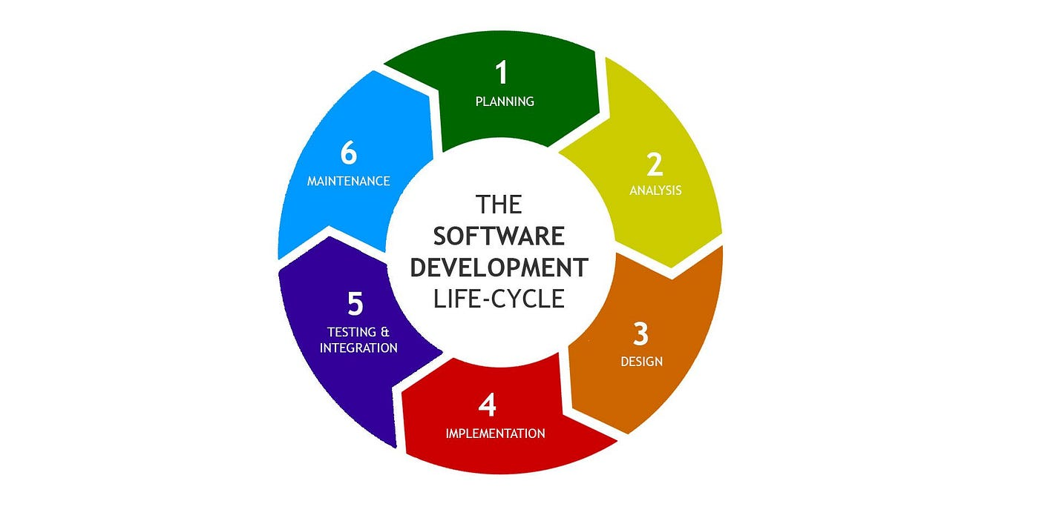

**33. What are the main stages of the software development process?**

1. **Requirements Gathering**: Identify and document the needs and expectations of stakeholders.
2. **System Design**: Create architectural and design specifications based on the gathered requirements.
3. **Implementation (Coding)**: Write the actual code to develop the software according to the design specifications.
4. **Testing**: Evaluate the software for defects and ensure it meets the specified requirements through various testing methods.
5. **Deployment**: Release the software to users or clients, making it operational in a live environment.
6. **Maintenance**: Provide ongoing support, updates, and bug fixes to ensure the software continues to function effectively over time.

**34. Write a requirement specification for a simple library management system**

* **Requirements Specification for a Library Management System**

**1. Introduction**

The Library Management System (LMS) will manage library operations, including book inventory, member management, and transactions.

**2. Functional Requirements**

**2.1 User Management**

* **Registration**: New members can register with personal details.
* **Login**: Members log in with a username and password.
* **Roles**: Define roles (Admin, Librarian, Member) with different access levels.

**2.2 Book Management**

* **Add Books**: Admins can add books with details (title, author, ISBN).
* **Update/Delete Books**: Modify or remove book entries.
* **Search Books**: Users can search by title, author, or genre.

**2.3 Transaction Management**

* **Borrow Books**: Members can borrow books with limits on quantity and duration.
* **Return Books**: Members can return books, updating their status.
* **View Borrowed Books**: Members can see their borrowed books and due dates.

**2.4 Reporting**

* **Generate Reports**: Admins can create reports on inventory and member activity.

**3. Non-Functional Requirements**

**3.1 Usability**

* User-friendly interface for easy navigation.

**3.2 Performance**

* Support up to 100 concurrent users.

**3.3 Security**

* Secure storage of user data.

**3.4 Compatibility**

* Compatible with major web browsers.

**35. Why is the requirement analysis phase critical in software development?**

* The requirement analysis phase is critical in software development because it:

1. **Clarifies User Needs**: Ensures the final product meets stakeholder expectations.
2. **Defines Scope**: Prevents scope creep by identifying necessary features early.
3. **Mitigates Risks**: Reduces potential issues and costly changes later.
4. **Guides Design**: Provides a clear foundation for subsequent design and development.
5. **Enhances Communication**: Aligns stakeholders and developers on project goals.
6. **Improves Efficiency**: Minimizes rework and delays, optimizing resource use.

**36. What is the role of software analysis in the development process?**

* The role of software analysis in the development process includes:

1. **Requirement Validation**: Ensures requirements are clear and feasible.
2. **Feasibility Study**: Assesses technical, operational, and economic viability.
3. **System Modeling**: Creates visual models to clarify functionality and interactions.
4. **Identifying Constraints**: Recognizes limitations that may impact development.
5. **Risk Assessment**: Evaluates potential risks and plans mitigation strategies.
6. **Guiding Design Decisions**: Informs architectural and design choices.
7. **Facilitating Communication**: Aligns stakeholders, developers, and project managers on goals

**37. Design a basic system architecture for a food delivery app**

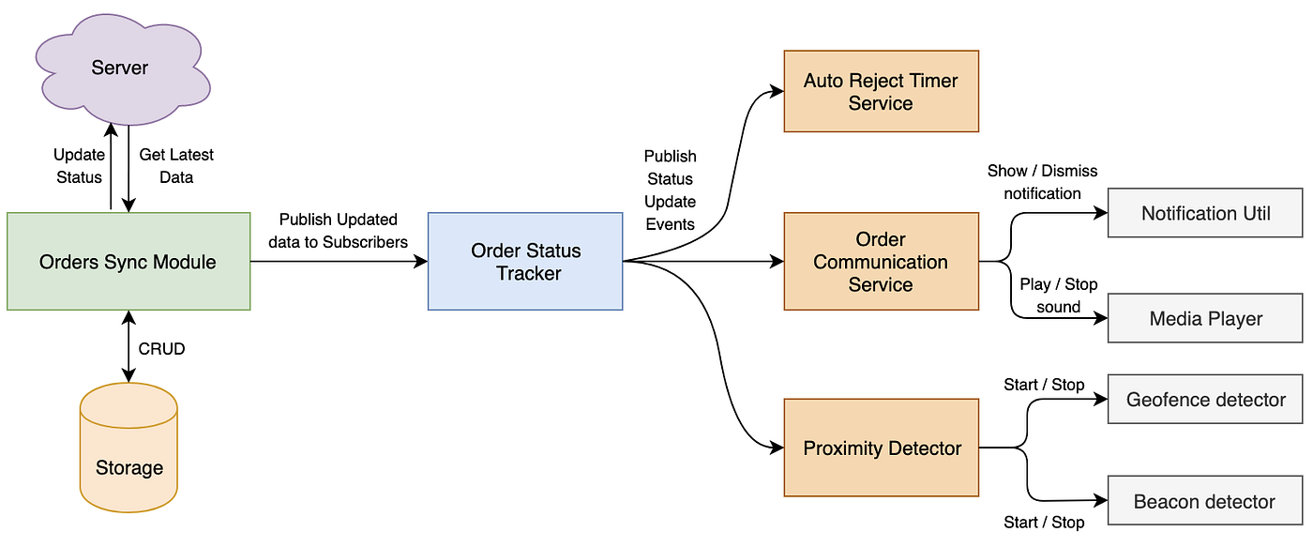

**38. What are the key elements of system design?**

* The key elements of system design are:

1. **Requirements Gathering**: Understanding functional and non-functional requirements, and constraints.
2. **Architecture Design**: Defining the system structure, components, and interactions.
3. **Data Design**: Organizing how data is stored, accessed, and flows within the system.
4. **Interface Design**: Designing APIs, user interfaces, and external integrations.
5. **Scalability and Performance**: Ensuring the system can handle growth, optimize performance, and manage load effectively.

**39. Why is software testing important?**

* Software testing is essential for maintaining a high standard of quality, reliability, and security in any application. Through testing, developers can detect issues early, improve functionality, and ensure that the software meets both user expectations and industry standards.

**40. Document a real-world case where a software application required critical maintenance.**

* Software Maintenance refers to the process of modifying and updating a software system after it has been delivered to the customer. This involves fixing bugs, adding new features, and adapting to new hardware or software environments. Effective maintenance is crucial for extending the software’s lifespan and aligning it with evolving user needs. It is an essential part of the software development life cycle (SDLC), involving planned and unplanned activities to keep the system reliable and up-to-date

**41. What types of software maintenance are there?**

* There are four types of software maintenance: corrective (issue resolution), adaptive (system updates), perfective (performance enhancements), and preventive (proactive problem prevention). Depending on the nature of your software, usage, and potential issues, the right type of maintenance should be chosen.

**42. What are the key differences between web and desktop applications?**

* Here’s an even more concise comparison of web and desktop applications:

1. **Platform**:
   * **Web**: Runs in browsers, platform-independent.
   * **Desktop**: Installed on specific OS, platform-dependent.
2. **Installation**:
   * **Web**: No installation; automatic updates.
   * **Desktop**: Requires installation; manual updates.
3. **Performance**:
   * **Web**: Dependent on internet speed.
   * **Desktop**: Generally faster, runs locally.
4. **User Interface**:
   * **Web**: Responsive but may have limitations.
   * **Desktop**: Richer, more complex interfaces.
5. **Connectivity**:
   * **Web**: Requires internet (some offline use).
   * **Desktop**: Fully functional offline.
6. **Security**:
   * **Web**: Centralized but internet-exposed.
   * **Desktop**: Local security, different vulnerabilities.
7. **Development**:
   * **Web**: Easier deployment with web technologies.
   * **Desktop**: More complex deployment, OS-specific languages.

**43. What are the advantages of using web applications over desktop applications?**

* Here are the key advantages of web applications over desktop applications in a very brief format:

1. **Accessibility**: Use from any device with a browser.
2. **No Installation**: No software installation needed.
3. **Automatic Updates**: Always up-to-date.
4. **Cross-Platform**: Works on any operating system.
5. **Lower Costs**: Cheaper to develop and deploy.
6. **Collaboration**: Supports real-time teamwork.
7. **Centralized Storage**: Easier data management.
8. **Scalability**: Easily accommodates more users.
9. **Integration**: Connects with other online services.
10. **Lightweight**: Runs on lower-spec devices.

**44. What role does UI/UX design play in application development?**

* UI/UX design is vital in application development for the following reasons:

1. **User Satisfaction**: Enhances overall user experience.
2. **Usability**: Ensures ease of navigation and use.
3. **Accessibility**: Makes apps usable for all users.
4. **Brand Identity**: Reflects and strengthens brand image.
5. **User Engagement**: Increases retention and interaction.
6. **Efficiency**: Streamlines user workflows.
7. **Feedback**: Incorporates user input for continuous improvement

**45. What are the differences between native and hybrid mobile apps?**

| **Feature** | **Native Apps** | **Hybrid Apps** |
| --- | --- | --- |
| Dev | Platform-specific | Web technologies |
| Performance | Faster | Slower |
| UX | Optimized | Varies |
| Access | Full access | Limited |
| Cost | Higher | Lower |
| Maintenance | Separate updates | Single codebase |
| Deploy | App stores | App/web stores |

**46. Create a DFD for a hospital management system.**

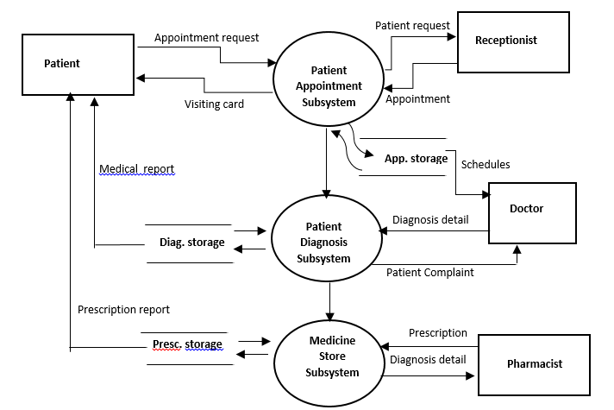

**47. What is the significance of DFDs in system analysis?**

* Here’s an even more concise summary of the significance of Data Flow Diagrams (DFDs) in system analysis:

1. **Visual Clarity**: Simplifies complex data flows.
2. **Process Insight**: Clarifies system processes and data handling.
3. **Stakeholder Communication**: Facilitates discussions among users and developers.
4. **Data Mapping**: Identifies sources and destinations of data.
5. **Requirements Validation**: Aids in gathering and confirming system needs.
6. **Efficiency Improvement**: Reveals redundancies and bottlenecks.
7. **Design Foundation**: Supports further design and analysis efforts.
8. **Documentation**: Provides a reference for system processes.
9. **Impact Assessment**: Evaluates effects of changes on data flows.

10.**Development Guidance**: Informs developers about data architecture

**48. What are the pros and cons of desktop applications compared to web applications?**

| **Feature** | **Desktop Apps** | **Web Apps** |
| --- | --- | --- |
| Pros |  |  |
| Performance | Faster | Accessible anywhere |
| Hardware Access | Full access | No installation needed |
| Offline Use | Works offline | Automatic updates |
| Rich UI | Feature-rich | Cross-platform |
| Security | Local data storage | Lower initial costs |
| Customization | Highly customizable | Easier collaboration |
| Cons |  |  |
| Installation | Requires installation | Needs internet |
| Platform Dependency | OS-specific | Limited hardware access |
| Updates | Manual updates | Performance may vary |
| Development Costs | Higher costs | Security risks |
| Accessibility | Device-limited | User experience varies |

**49. Draw a flowchart representing the logic of a basic online registration system.**

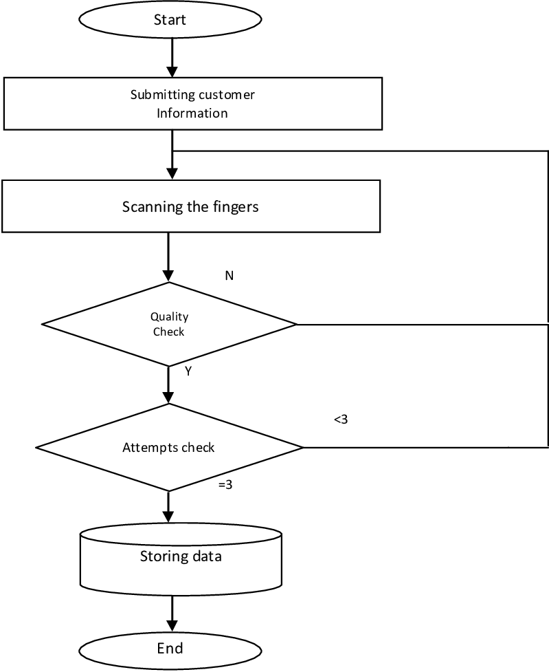

**50. How do flowcharts help in programming and system design?**

* Flowcharts help in programming and system design by visually representing the sequence of steps or processes in a system or program. They simplify complex logic, making it easier to understand, communicate, and debug. Flowcharts also assist in identifying potential issues early in the design phase and guide developers in writing more efficient code. They serve as a roadmap, ensuring that all aspects of the system are accounted for and properly structured