CSE 816 — Software Production Engineering · Mini-Project
End-to-End CI/CD Pipeline for a Calculator REST API
Name: <YOUR NAME> · Roll No.: <ROLL NO> · M.Tech (CSE), Term I 2026-27
GitHub: https://github.com/NirbhaySharma504/calculator-devops
Docker Hub: https://hub.docker.com/r/nirbhaysharma504/calculator-api

1. Objective and Technology Stack
The goal was to build a small, production-style Calculator REST API and wrap it in a fully automated DevOps pipeline. A single git push to GitHub builds, tests, containerises, publishes and redeploys the service with no manual steps. The application is deliberately simple; the work is in the pipeline around it.
Concern | Tool / choice
Application | Java 21, Spring Boot 4.1 (Spring Web, Actuator, Validation), Maven
Testing | JUnit 5 unit tests + Spring MockMvc integration tests (57 tests), Surefire XML reports
Version control | Git + GitHub: feature branches merged through pull requests
CI/CD | Jenkins LTS (declarative Jenkinsfile), GitHub webhook via ngrok, Poll SCM fallback, Email Extension
Containers | Docker multi-stage build; image published on Docker Hub
Deployment | Docker Compose: Nginx reverse proxy + API on a private bridge network

2. Pipeline Architecture
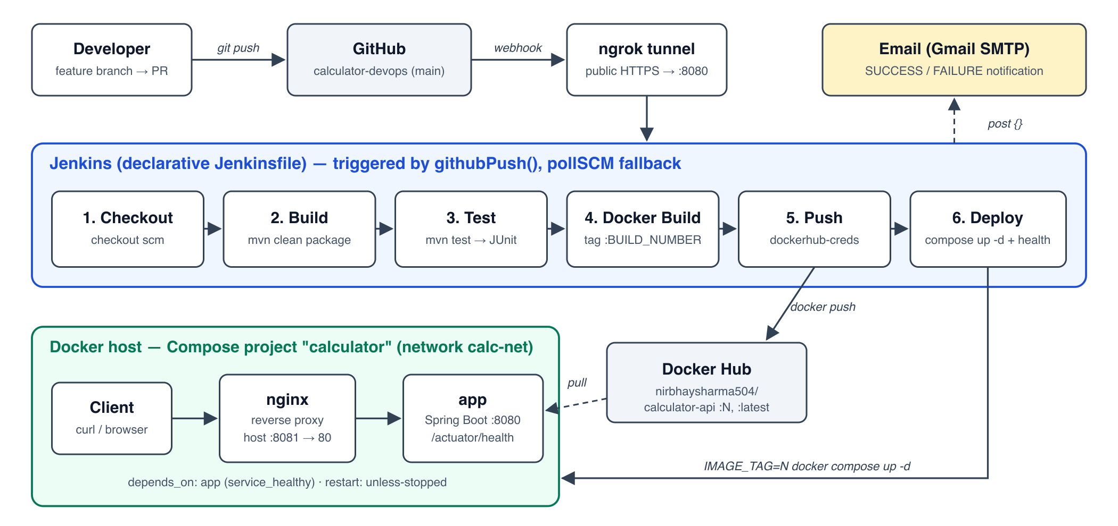
Figure 1: CI/CD pipeline. A push triggers Jenkins through a GitHub webhook; Jenkins builds, tests, publishes and deploys the stack.

3. Application and Tests
The service exposes GET /api/v1/{add|subtract|multiply|divide|modulo|power|sqrt}?a=&b= and returns JSON such as {"operation":"add","a":2.0,"b":3.0,"result":5.0}. Spring Boot Actuator provides /actuator/health, which the Docker, Compose and Jenkins health checks all use.
Validation lives in CalculatorService. A @RestControllerAdvice maps every invalid request to HTTP 400 with a structured body {timestamp, status, error, message, path}. That covers division or modulo by zero, square root of a negative number, missing or non-numeric parameters, NaN/Infinity inputs and overflowing results.
Unit tests (JUnit 5, parameterised) cover every operation and each edge case. Integration tests start the full Spring context and send real requests through MockMvc, checking successful responses, error bodies and the health endpoint. Maven Surefire writes JUnit XML, which Jenkins publishes on every build.

4. Jenkins Pipeline — Stage by Stage
The pipeline is a declarative Jenkinsfile in the repository. githubPush() starts it from the GitHub webhook, and pollSCM('H/5 * * * *') is a fallback. disableConcurrentBuilds() stops two pushes from deploying at once.
- Checkout: checkout scm fetches the exact commit that triggered the build and logs its hash, author and message.
- Build: mvn -B clean package -DskipTests compiles the code and produces the executable JAR.
- Test: mvn -B test runs all 57 tests. post { always { junit … } } publishes the results even on failure. A failing test fails the build, so nothing later runs and the live deployment is untouched.
- Docker Build: builds the image with two tags. :BUILD_NUMBER is immutable and traceable; :latest is convenient. An OCI label records the Git commit.
- Push: withCredentials injects the Docker Hub username and access token from the Jenkins Credentials store (ID dockerhub-creds). The token goes in via --password-stdin, is masked in the log and is never stored in Git.
- Deploy: IMAGE_TAG=<build> docker compose up -d --remove-orphans, then a loop polls /actuator/health through Nginx for up to 60 s. Smoke tests follow: add must return 5.0 and divide-by-zero must return 400. On failure the stage prints the container status and logs.
- Post actions: emailext sends a SUCCESS or FAILURE email (the failure email attaches the log), then old local images are pruned.
Idempotency: compose up -d reconciles the running stack to the desired state and only recreates containers whose image or configuration changed. The pipeline never runs down, so re-running a build leaves a healthy deployment in place.

5. Containerisation and Deployment
- Multi-stage Dockerfile: a maven:3.9-eclipse-temurin-21 stage builds the JAR. The runtime stage is eclipse-temurin:21-jre-alpine and receives only the JAR, so no JDK, Maven or source code ships.
- Best practices: pom.xml is copied and dependencies resolved before the sources, giving a cached dependency layer. The app runs as a non-root spring user, with an explicit EXPOSE 8080, a HEALTHCHECK on Actuator and JVM tuning through JAVA_TOOL_OPTIONS. A .dockerignore keeps target/, .git, IDE files and .env out of the build context.
- Compose stack: two services on the user-defined bridge network calc-net. app has no published port. nginx is the single entry point (host 8081, because Jenkins uses 8080). Both have health checks, restart: unless-stopped, environment variables and capped json-file logs. nginx starts only once app reports healthy (depends_on: condition: service_healthy).
- Redeploy-safe proxy: Nginx uses Docker's DNS (resolver 127.0.0.11) with a variable upstream, so it follows the new container IP after Jenkins recreates the app instead of returning 502.

6. Git Workflow
The work was developed in small commits on feature branches (feature/calculator-api, feature/docker, feature/compose-nginx, feature/jenkins-pipeline, docs/readme-report). Each branch was merged into main through a GitHub pull request, keeping merge commits so the history stays visible. The .gitignore excludes target/, IDE files, .env and key files. No credentials are in the repository: the Docker Hub token and the SMTP password exist only in the Jenkins Credentials store, and the notification address is a Jenkins global variable.

7. Challenges Faced and Solutions
Edit this list to match what actually happened during your setup.
Challenge | Solution
Jenkins (Homebrew service) could not find mvn or docker: "command not found" | launchd starts services with a minimal PATH, so the Jenkinsfile prepends /opt/homebrew/bin and /usr/local/bin.
docker login failed: docker-credential-desktop not found | Same PATH root cause: the Docker Desktop credential helper lives in /usr/local/bin.
GitHub webhooks cannot reach localhost:8080 | Exposed Jenkins with an ngrok static domain and pointed the webhook at /github-webhook/. Poll SCM is kept as a fallback.
Port conflict: Jenkins already uses 8080 | The API is not published at all; only Nginx is, on host port 8081.
Nginx returned 502 after a redeploy (stale container IP) | Used resolver 127.0.0.11 with a variable proxy_pass so the app name is re-resolved.
Gmail rejected SMTP authentication | Enabled 2-step verification and used a Google App Password over SSL on port 465.
Spring Boot 4 moved test annotations (AutoConfigureMockMvc) | Used the new spring-boot-starter-webmvc-test module and package.

8. Conclusion
Every push to main now goes from commit to a health-checked, running deployment automatically, with test results, a versioned image on Docker Hub and an email for every build. The capstone will extend the same repository with Ansible for configuration management, Kubernetes in place of Compose, and Prometheus and Grafana scraping the Actuator endpoints that already exist.

Appendix: Screenshots
[ Paste screenshot here: Insert → Pictures ]
Figure A1: Jenkins Stage View, all stages green (build started by GitHub push)
[ Paste screenshot here: Insert → Pictures ]
Figure A2: Jenkins Test Result: 57 tests, 0 failures
[ Paste screenshot here: Insert → Pictures ]
Figure A3: Build notification email (SUCCESS / FAILURE)
[ Paste screenshot here: Insert → Pictures ]
Figure A4: docker ps / docker compose ps showing both containers healthy
[ Paste screenshot here: Insert → Pictures ]
Figure A5: Sample API responses (curl), including HTTP 400 error bodies
[ Paste screenshot here: Insert → Pictures ]
Figure A6: Docker Hub tags for nirbhaysharma504/calculator-api
[ Paste screenshot here: Insert → Pictures ]
Figure A7: GitHub merged pull requests and commit history / network graph
[ Paste screenshot here: Insert → Pictures ]
Figure A8: GitHub webhook Recent Deliveries (HTTP 200)

