# Cognizant Digital Nurture 4.0 - Week 6

## ReactJS - HOL 1

**Name: NIRBHIK MANDAL**

**Roll No: 22053081**

## React Component Code

function App() {  
 return (  
 <div>  
 <h1>Welcome to the first session of React </h1>  
 <p>This is a Single Page Application built with React.</p>  
 </div>  
 );  
}  
  
export default App;

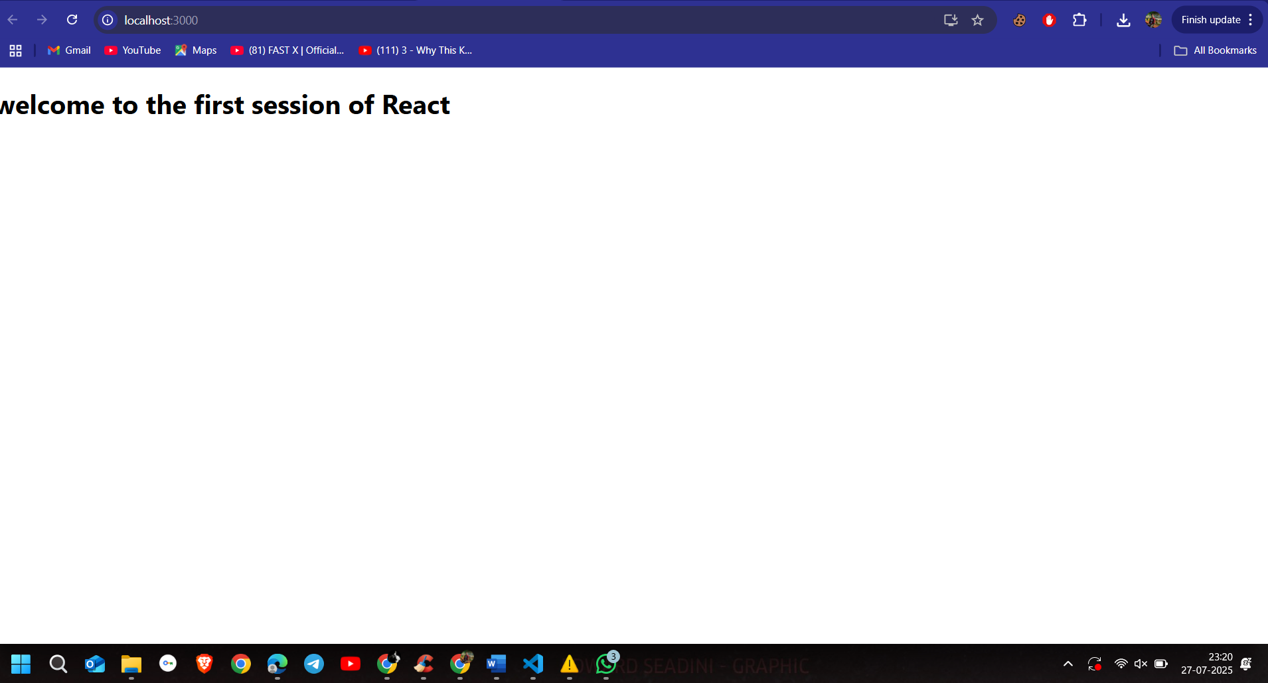

## ReactJS - HOL 2

## App.js Code

import React from "react";   
import Home from "./Components/Home";  
import About from "./Components/About";  
import Contact from "./Components/Contact";  
  
function App() {  
 return (  
 <div>  
 <h1>Student Management Portal</h1>  
 <Home />  
 <About />  
 <Contact />  
 </div>  
 );  
}  
  
export default App;

## Application Output Screenshot

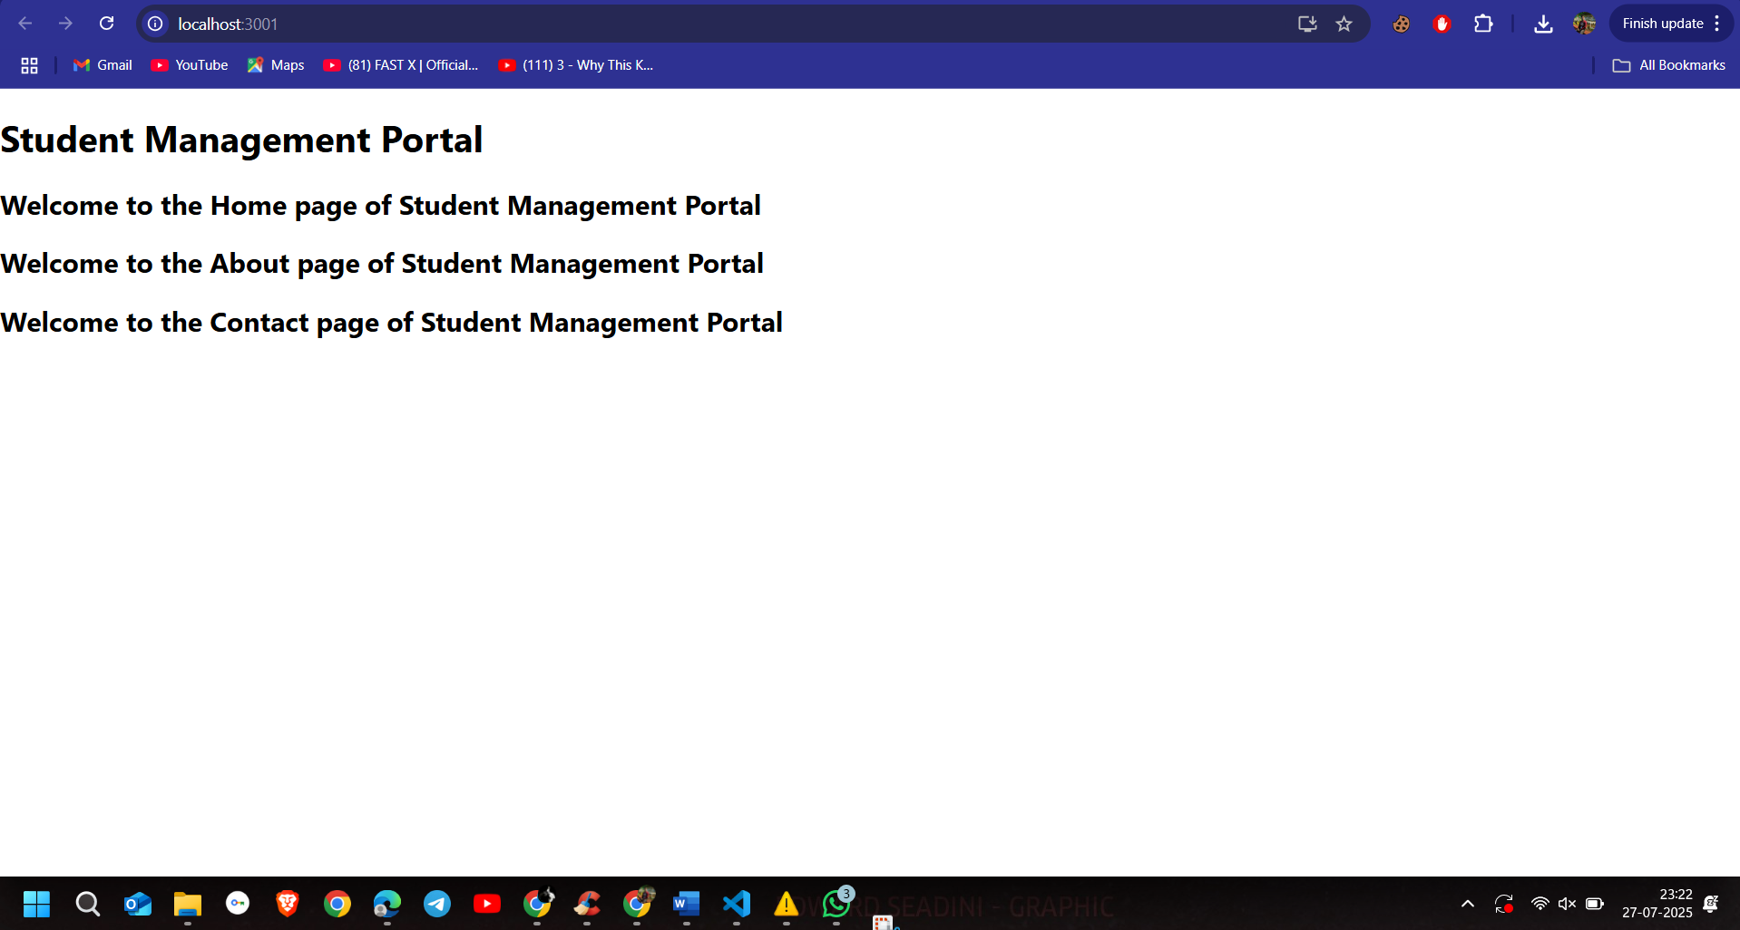

# Lab 3 – React Components & Constructor Demo

## App.js

import React from 'react';

import CalculateScore from './Components/CalculateScore';

function App() {

  return (

    <div>

      <CalculateScore name="Nirbhik Mandal" school="KENDRIYA VIDYALAYA IIT KGP" total={450} goal="Become an Engineer" />

    </div>

  );

}

export default App;

## Output Screenshot

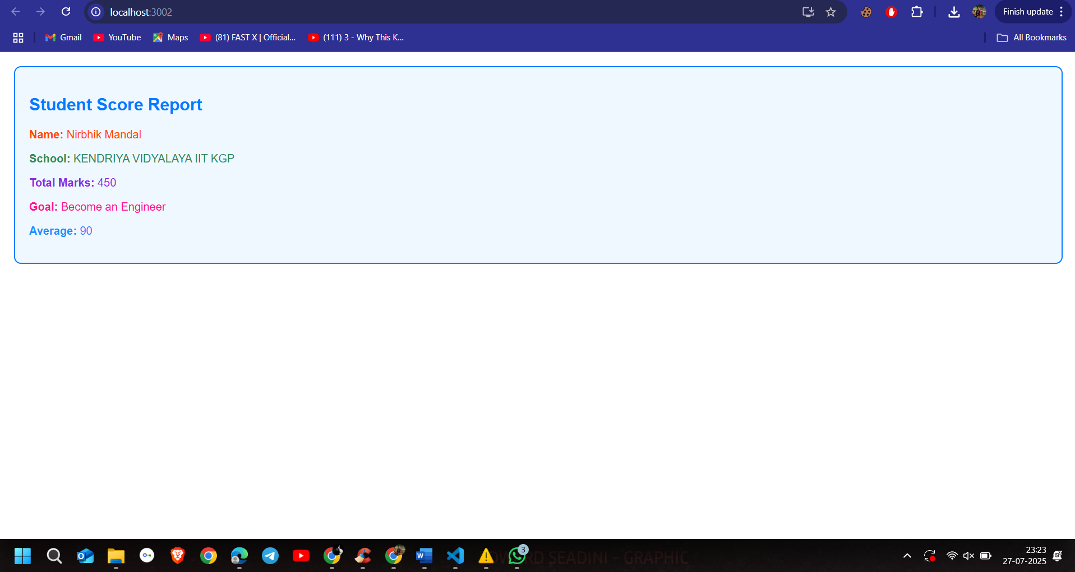

# Lab 4 – Blog App with React Lifecycle

## Posts.js

import React, { Component } from "react";  
import Post from "./Post";  
  
class Posts extends Component {  
 constructor(props) {  
 super(props);  
 this.state = {  
 posts: [],  
 error: null,  
 };  
 }  
  
 loadPosts = async () => {  
 try {  
 const response = await fetch("https://jsonplaceholder.typicode.com/posts");  
 if (!response.ok) throw new Error("Network response was not ok");  
 const data = await response.json();  
 this.setState({ posts: data });  
 } catch (error) {  
 this.setState({ error });  
 throw error;  
 }  
 };  
  
 componentDidMount() {  
 this.loadPosts();  
 }  
  
 componentDidCatch(error, info) {  
 alert("Error: " + error.message);  
 this.setState({ error });  
 }  
  
 render() {  
 if (this.state.error) {  
 return <div style={{ color: "red" }}>Something went wrong: {this.state.error.message}</div>;  
 }  
  
 return (  
 <div>  
 <h2>Blog Posts</h2>  
 {this.state.posts.slice(0, 10).map(post => (  
 <Post key={post.id} title={post.title} body={post.body} />  
 ))}  
 </div>  
 );  
 }  
}  
  
export default Posts;

## Output Screenshot

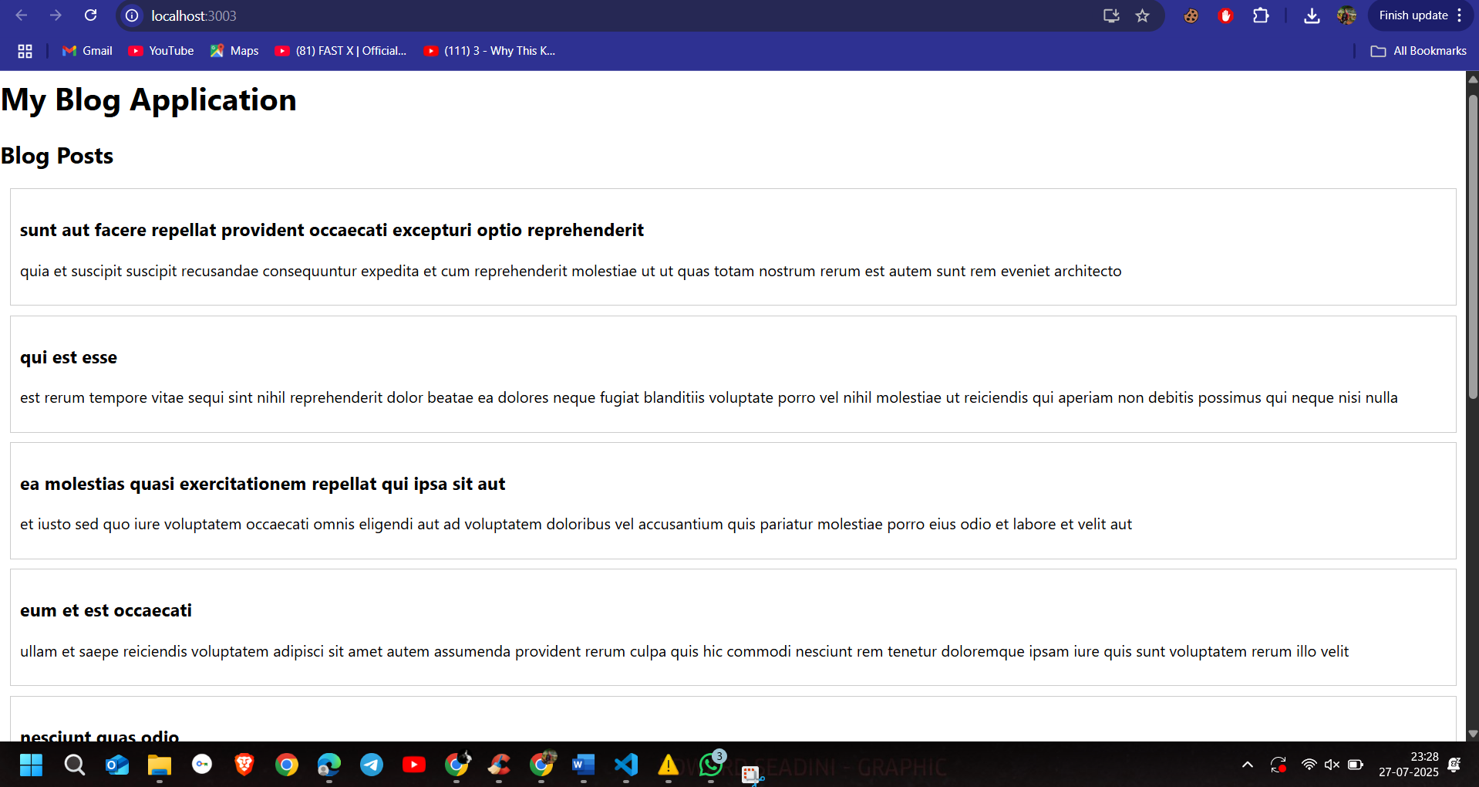

**Lab 5 – Cohort Dashboard with Conditional Styling**

**CohortDetails.js**

import React from 'react';

import styles from './CohortDetails.module.css';

function CohortDetails(props) {

  const { name, status, startDate, endDate, Trainer } = props;

  return (

    <div className={styles.box}>

      <h3 style={{ color: status === 'ongoing' ? 'green' : 'blue' }}>

        {name}

      </h3>

      <dl>

        <dt>Status:</dt>

        <dd>{status}</dd>

        <dt>Start Date:</dt>

        <dd>{startDate}</dd>

        <dt>End Date:</dt>

        <dd>{endDate}</dd>

        <dt>Trainer:</dt>

        <dd>{Trainer}</dd>

      </dl>

    </div>

  );

}

export default CohortDetails;

