**Virtual Mouse (A.I)**

**Project Report**

Project (IAI-851)

**BACHELOR OF TECHNOLOGY (CSE) A.I (i-Nurture)**

|  |  |
| --- | --- |
| PROJECT GUIDE:  **Mr.Sudhanshu Kumar** | SUBMITTED BY:  **Siddharth Singh (TCA1960007)**  **Nirdesh Kumar (TCA1960008)**  **Mohd.Suhel (TCA1960004)**  **Shruti Sharma (TCA1960005)** |

February, 2023



**FACULTY OF ENGINEERING & COMPUTING SCIENCES**

**TEERTHANKER MAHAVEER UNIVERSITY, MORADABAD**

**DECLARATION**

We hereby declare that this Project Report titled **Virtal Mouse (A.I)** submitted by us and approved by our project guide, Faculty of Engineering & Computing Sciences. Teerthanker Mahaveer University, Moradabad, is a bonafide work undertaken by us and it is not submitted to any other University or Institution for the award of any degree diploma / certificate or published any time before.

|  |  |  |
| --- | --- | --- |
| **Project Name :** | Virtual Mouse (A.I) | |
| **Student Name:** | Siddharth Singh |  |
| **Student Name:** | Nirdesh Kumar |  |
| **Student Name:**  **Student Name:** | Mohd.Suhel  Shruti Sharma |  |
|  |  |  |
| **Project Guide :** | Mr.Sudhanshu Kumar |  |

Table of Contents

[1 Project Title 4](#_Toc31392321)

[2 Problem Statement 4](#_Toc31392322)

[3 Project Description 4](#_Toc31392323)

[3.1 Scope of the Work 4](#_Toc31392324)

[3.2 Project Modules 4](#_Toc31392325)

[3.3 Context Diagram (High Level) 4](#_Toc31392326)

[4 Implementation Methodology 4](#_Toc31392327)

[5 Technologies to be used 4](#_Toc31392328)

[5.1 Software Platform 4](#_Toc31392329)

[5.2 Hardware Platform 5](#_Toc31392330)

[5.3 Tools, if any 5](#_Toc31392331)

[6 Advantages of this Project 5](#_Toc31392332)

[7 Assumptions, if any 5](#_Toc31392333)

[8 Future Scope and further enhancement of the Project 5](#_Toc31392334)

[9 Project Repository Location 5](#_Toc31392335)

[10 Definitions, Acronyms, and Abbreviations 6](#_Toc31392336)

[11 Conclusion 6](#_Toc31392337)

[12 References 7](#_Toc31392338)

**Appendix**

**A: Entity Relationship Diagram (ERD)**

**B: Use Case Diagram (UCD)**

**C: Screen Shots**

# Project Title

**Virtual Mouse (A.I)**

# Problem Statement

The proposed AI virtual mouse system can be used to overcome problems in the real world such as situations where there is no space to use a physical mouse and also for the persons who have problems in their hands and are not able to control a physical mouse.

Also, amidst of the COVID-19 situation, it is not safe to use the devices by touching them because it may result in a possible situation of spread of the virus by touching the devices, so the proposed AI virtual mouse can be used to overcome these problems since hand gesture and hand Tip detection is used to control the PC mouse functions by using a webcam or a built-in camera.

The main objective of the proposed AI virtual mouse system is to develop an alternative to the regular and traditional mouse system to perform and control the mouse functions, and this can be achieved with the help of a web camera that captures the hand gestures and hand tip and then processes these frames to perform the particular mouse function such as left click, right click, and scrolling function.

# Project Description

The main objective of the proposed AI virtual mouse system is to develop an alternative to the regular and traditional mouse system to perform and control the mouse functions, and this can be achieved with the help of a web camera that captures the hand gestures and hand tip and then processes these frames to perform the particular mouse function such as left click, right click, and scrolling function.

## Scope of the Work

Motion Tracker Application is the application software where after clicking on TRACK option which is given after just opening of application, instead of using physical mouse user can use their finger as a mouse & whatever the direction we give to our finger according to that cursor on the system move & user can do their work.

There are some related works carried out on virtual mouse using hand gesture detection by wearing a glove in the hand and also using color tips in the hands for gesture recognition, but they are no more accurate in mouse functions. The recognition is not so accurate because of wearing gloves; also, the gloves are also not suited for some users, and in some cases, the recognition is not so accurate because of the failure of detection of color tips. Some efforts have been made for camera-based detection of the hand gesture interface.

## Context Diagram (High Level)

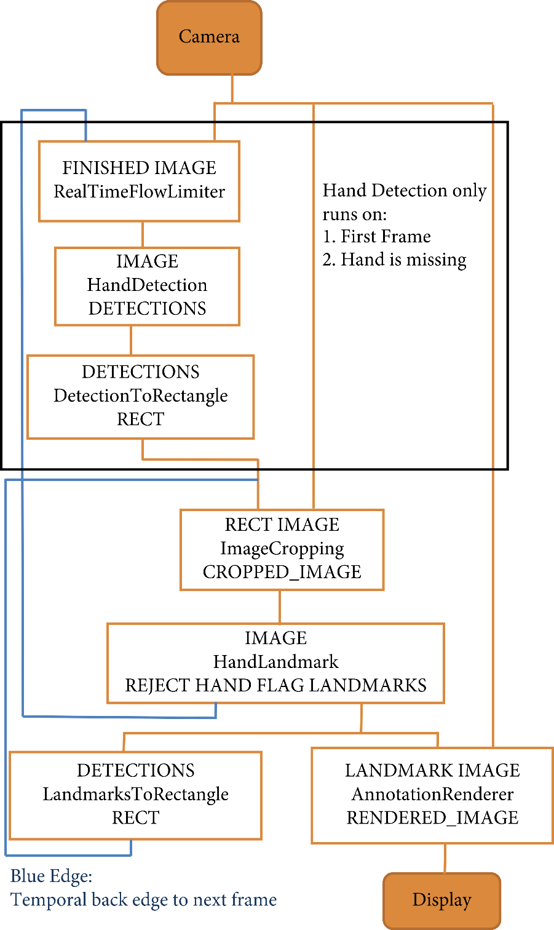

# 

# Implementation Methodology

The various functions and conditions used in the system are explained in the flowchart of the real-time AI virtual mouse system.

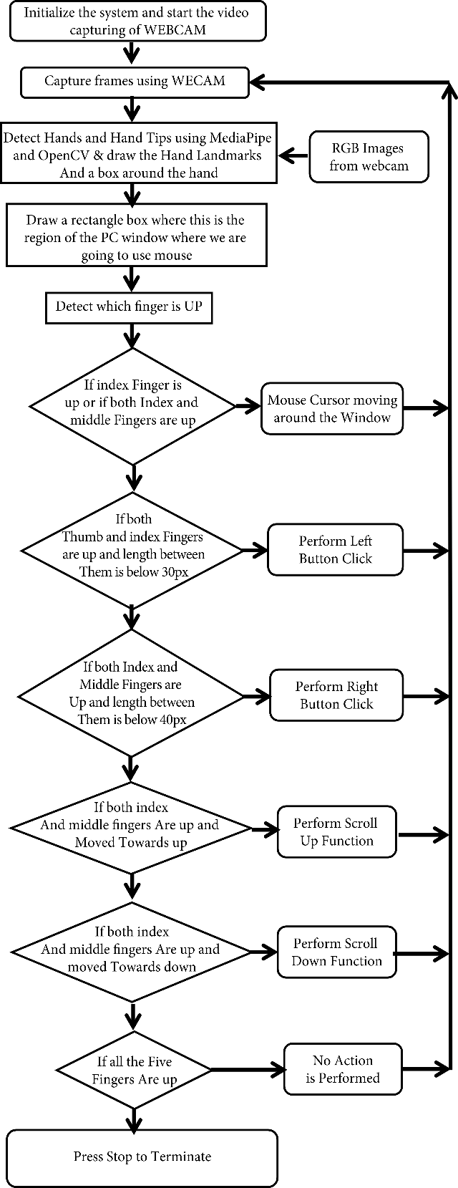

## The Camera Used in the AI Virtual Mouse System

The proposed AI virtual mouse system is based on the frames that have been captured by the webcam in a laptop or PC. By using the Python computer vision library OpenCV, the video capture object is created and the web camera will start capturing video. The web camera captures and passes the frames to the AI virtual system.

**[[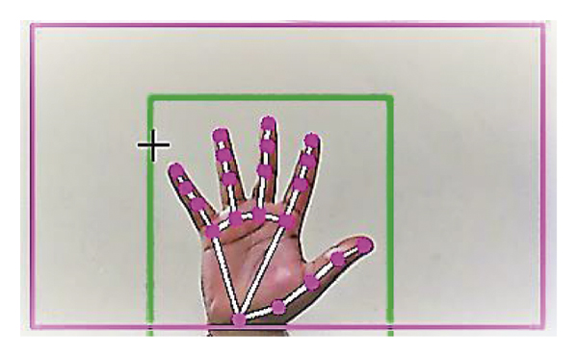](https://www.hindawi.com/journals/jhe/2021/8133076/fig4/)](https://www.hindawi.com/journals/jhe/2021/8133076/fig4/" \t "_blank)**

##### **4.2. Capturing the Video and Processing**

The AI virtual mouse system uses the webcam where each frame is captured till the termination of the program. The video frames are processed from BGR to RGB color space to find the hands in the video frame by frame as shown in the following code:

def findHands(self, img, draw = True):

imgRGB = cv2.cvtColor(img, cv2.COLOR\_BGR2RGB)

self.results = self.hands.process(imgRGB)

##### **4.3. (Virtual Screen Matching) Rectangular Region for Moving through the Window**

The AI virtual mouse system makes use of the transformational algorithm, and it converts the co-ordinates of fingertip from the webcam screen to the computer window full screen for controlling the mouse. When the hands are detected and when we find which finger is up for performing the specific mouse function, a rectangular box is drawn with respect to the computer window in the webcam region where we move throughout the window using the mouse cursor.

[[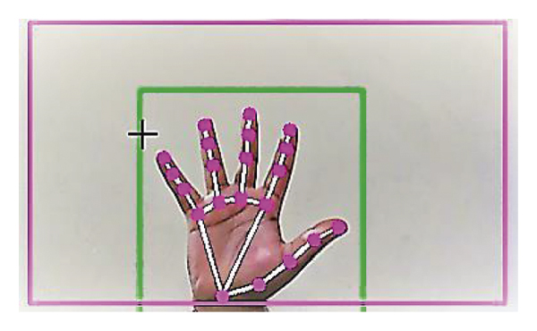](https://www.hindawi.com/journals/jhe/2021/8133076/fig5/)](https://www.hindawi.com/journals/jhe/2021/8133076/fig5/" \t "_blank)

##### **4.4. Detecting Which Finger Is Up and Performing the Particular Mouse Function**

In this stage, we are detecting which finger is up using the tip Id of the respective finger that we found using the MediaPipe and the respective co-ordinates of the fingers that are up, and according to that, the particular mouse function is performed.

[[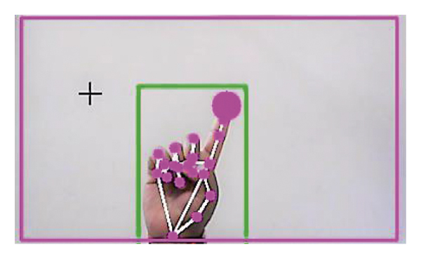](https://www.hindawi.com/journals/jhe/2021/8133076/fig6/)](https://www.hindawi.com/journals/jhe/2021/8133076/fig6/" \t "_blank)

##### **4.5. Mouse Functions Depending on the Hand Gestures and Hand Tip Detection Using Computer** **Vision**

###### **4.5.1. For the Mouse Cursor Moving around the Computer Window**

If the index finger is up with tip Id = 1 or both the index finger with tip Id = 1 and the middle finger with tip Id = 2 are up, the mouse cursor is made to move around the window of the computer using the AutoPy package of Python.

[[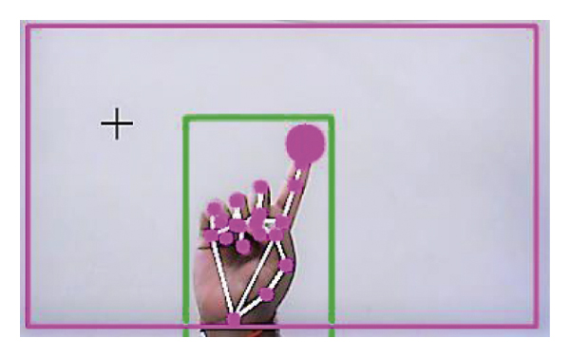](https://www.hindawi.com/journals/jhe/2021/8133076/fig7/)](https://www.hindawi.com/journals/jhe/2021/8133076/fig7/" \t "_blank)

###### **4.5.2 For the Mouse to Perform Left Button Click**

If both the index finger with tip Id = 1 and the thumb finger with tip Id = 0 are up and the distance between the two fingers is lesser than 30px, the computer is made to perform the left mouse button click using the pynput Python package.

[[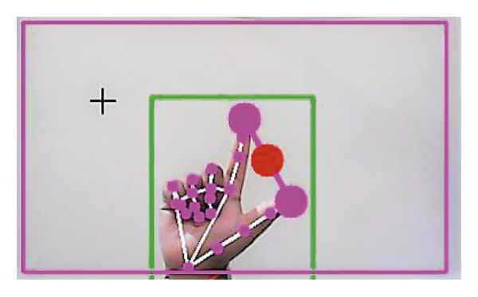](https://www.hindawi.com/journals/jhe/2021/8133076/fig8/)](https://www.hindawi.com/journals/jhe/2021/8133076/fig8/" \t "_blank)

[[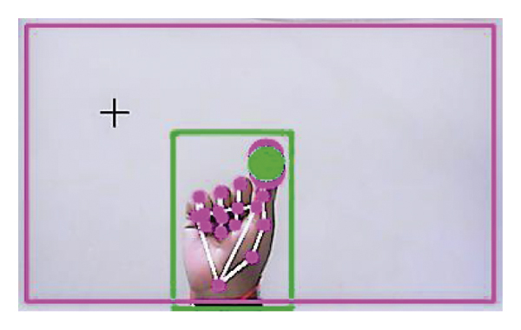](https://www.hindawi.com/journals/jhe/2021/8133076/fig9/)](https://www.hindawi.com/journals/jhe/2021/8133076/fig9/" \t "_blank)

###### **4.5.3. For the Mouse to Perform Right Button Click**

If both the index finger with tip Id = 1 and the middle finger with tip Id = 2 are up and the distance between the two fingers is lesser than 40 px, the computer is made to perform the right mouse button click using the pynput Python package.

[[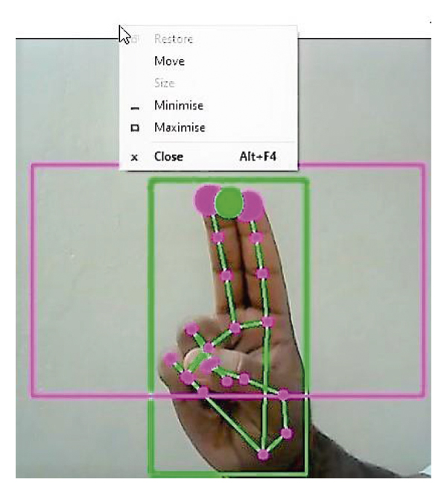](https://www.hindawi.com/journals/jhe/2021/8133076/fig10/)](https://www.hindawi.com/journals/jhe/2021/8133076/fig10/" \t "_blank)

###### **4.5.4. For the Mouse to Perform Scroll up Function**

If both the index finger with tip Id = 1 and the middle finger with tip Id = 2 are up and the distance between the two fingers is greater than 40 px and if the two fingers are moved up the page, the computer is made to perform the scroll up mouse function using the PyAutoGUI Python package.

[[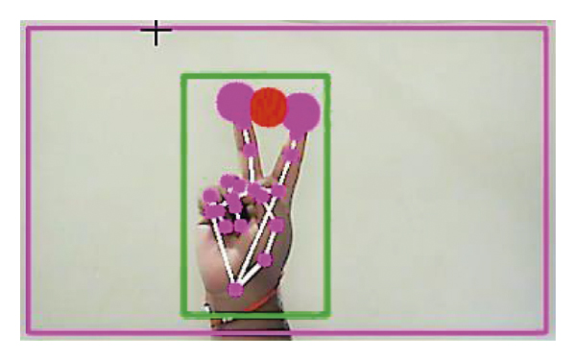](https://www.hindawi.com/journals/jhe/2021/8133076/fig11/)](https://www.hindawi.com/journals/jhe/2021/8133076/fig11/" \t "_blank)

###### **4.5.5. For the Mouse to Perform Scroll down Function**

If both the index finger with tip Id = 1 and the middle finger with tip Id = 2 are up and the distance between the two fingers is greater than 40px and if the two fingers are moved down the page, the computer is made to perform the scroll down mouse function using the PyAutoGUI Python package.

[[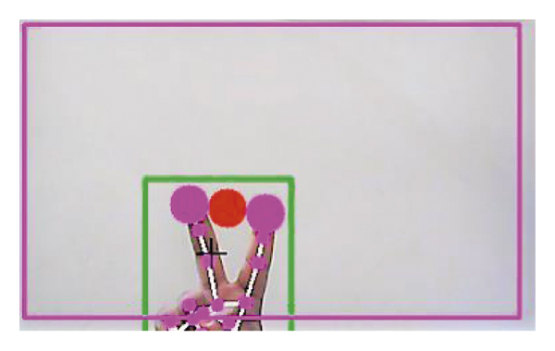](https://www.hindawi.com/journals/jhe/2021/8133076/fig12/)](https://www.hindawi.com/journals/jhe/2021/8133076/fig12/" \t "_blank)

###### **4.5.6. For No Action to be Performed on the Screen**

If all the fingers are up with tip Id = 0, 1, 2, 3, and 4, the computer is made to not perform any mouse events in the screen.

[[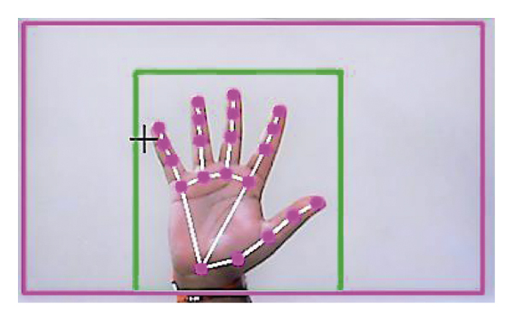](https://www.hindawi.com/journals/jhe/2021/8133076/fig13/)](https://www.hindawi.com/journals/jhe/2021/8133076/fig13/" \t "_blank)

# Technologies to be used

## 5.1 Software Platform

Python Version - 3.11.2.

Anaconda 3 (I.D.E).

Visual Code – 1.77.3.

Operating System Windows (7,8,10,11)

## 5.2 Hardware Platform

RAM - Minimum 4gb.

Hard Disk - Minimum 32gb.

Processor i-3, AMD 3 upwards.

## 5.3 Tools

Technical Process Following would be the languages I would use to develop my application within the stipulated period:

1) Media Pipe.

2) Open – CV.

3) Math.

4) Pyautogui.

5) Intenum.

6) Message to dict.

# 6 Future Scope and further enhancement of the Project

The proposed AI virtual mouse has some limitations such as small decrease in accuracy of the right click mouse function and also the model has some difficulties in executing clicking and dragging to select the text. These are some of the limitations of the proposed AI virtual mouse system, and these limitations will be overcome in our future work.

Furthermore, the proposed method can be developed to handle the keyboard functionalities along with the mouse functionalities virtually which is another future scope of Human-Computer Interaction (HCI).

# Conclusion

The main objective of the AI virtual mouse system is to control the mouse cursor functions by using the hand gestures instead of using a physical mouse. The proposed system can be achieved by using a webcam or a built-in camera which detects the hand gestures and hand tip and processes these frames to perform the particular mouse functions.

From the results of the model, we can come to a conclusion that the proposed AI virtual mouse system has performed very well and has a greater accuracy compared to the existing models and also the model overcomes most of the limitations of the existing systems. Since the proposed model has greater accuracy, the AI virtual mouse can be used for real-world applications, and also, it can be used to reduce the spread of COVID-19, since the proposed mouse system can be used virtually using hand gestures without using the traditional physical mouse.

The model has some limitations such as small decrease in accuracy in right click mouse function and some difficulties in clicking and dragging to select the text. Hence, we will work next to overcome these limitations by improving the finger tip detection algorithm to produce more accurate results.

# References

1. J. Katona, “A review of human–computer interaction and virtual reality research fields in cognitive InfoCommunications,” *Applied Sciences*, vol. 11, no. 6, p. 2646, 2021.

View at: [Publisher Site](https://doi.org/10.3390/app11062646) | [Google Scholar](https://scholar.google.com/scholar_lookup?title=A%20review%20of%20human%E2%80%93computer%20interaction%20and%20virtual%20reality%20research%20fields%20in%20cognitive%20InfoCommunications&author=J.%20Katona&publication_year=2021)

1. D. L. Quam, “Gesture recognition with a DataGlove,” *IEEE Conference on Aerospace and Electronics*, vol. 2, pp. 755–760, 1990.

View at: [Publisher Site](https://doi.org/10.1109/NAECON.1990.112862) | [Google Scholar](https://scholar.google.com/scholar_lookup?title=Gesture%20recognition%20with%20a%20DataGlove&author=D.%20L.%20Quam&publication_year=1990)

1. D.-H. Liou, D. Lee, and C.-C. Hsieh, “A real time hand gesture recognition system using motion history image,” in *Proceedings of the 2010 2nd International Conference on Signal Processing Systems*, IEEE, Dalian, China, July 2010.

View at: [Publisher Site](https://doi.org/10.1109/ICSPS.2010.5555462) | [Google Scholar](https://scholar.google.com/scholar_lookup?title=A%20real%20time%20hand%20gesture%20recognition%20system%20using%20motion%20history%20image&author=D.-H.%20Liou&author=D.%20Lee&author=C.-C.%20Hsieh)

1. S. U. Dudhane, “Cursor control system using hand gesture recognition,” *IJARCCE*, vol. 2, no. 5, 2013.

View at: [Google Scholar](https://scholar.google.com/scholar_lookup?title=Cursor%20control%20system%20using%20hand%20gesture%20recognition&author=S.%20U.%20Dudhane&publication_year=2013)

1. K. P. Vinay, “Cursor control using hand gestures,” *International Journal of Critical Accounting*, vol. 0975–8887, 2016.

View at: [Google Scholar](https://scholar.google.com/scholar_lookup?title=Cursor%20control%20using%20hand%20gestures&author=K.%20P.%20Vinay&publication_year=2016)

1. L. Thomas, “Virtual mouse using hand gesture,” *International Research Journal of Engineering and Technology (IRJET*, vol. 5, no. 4, 2018.

View at: [Google Scholar](https://scholar.google.com/scholar_lookup?title=Virtual%20mouse%20using%20hand%20gesture&author=L.%20Thomas&publication_year=2018)

1. P. Nandhini, J. Jaya, and J. George, “Computer vision system for food quality evaluation—a review,” in *Proceedings of the 2013 International Conference on Current Trends in Engineering and Technology (ICCTET)*, pp. 85–87, Coimbatore, India, July 2013.

View at: [Publisher Site](https://doi.org/10.1109/ICCTET.2013.6675916) | [Google Scholar](https://scholar.google.com/scholar_lookup?title=Computer%20vision%20system%20for%20food%20quality%20evaluation%E2%80%94a%20review&author=P.%20Nandhini&author=J.%20Jaya&author=J.%20George)

1. J. Jaya and K. Thanushkodi, “Implementation of certain system for medical image diagnosis,” *European Journal of Scientific Research*, vol. 53, no. 4, pp. 561–567, 2011.

View at: [Google Scholar](https://scholar.google.com/scholar_lookup?title=Implementation%20of%20certain%20system%20for%20medical%20image%20diagnosis&author=J.%20Jaya&author=K.%20Thanushkodi&publication_year=2011)

1. P. Nandhini and J. Jaya, “Image segmentation for food quality evaluation using computer vision system,” *International Journal of Engineering Research and Applications*, vol. 4, no. 2, pp. 1–3, 2014.

View at: [Google Scholar](https://scholar.google.com/scholar_lookup?title=Image%20segmentation%20for%20food%20quality%20evaluation%20using%20computer%20vision%20system&author=P.%20Nandhini&author=J.%20Jaya&publication_year=2014)

1. J. Jaya and K. Thanushkodi, “Implementation of classification system for medical images,” *European Journal of Scientific Research*, vol. 53, no. 4, pp. 561–569, 2011.

View at: [Google Scholar](https://scholar.google.com/scholar_lookup?title=Implementation%20of%20classification%20system%20for%20medical%20images&author=J.%20Jaya&author=K.%20Thanushkodi&publication_year=2011)

1. J. T. Camillo Lugaresi, “MediaPipe: A Framework for Building Perception Pipelines,” 2019, <https://arxiv.org/abs/1906.08172>.

View at: [Google Scholar](https://scholar.google.com/scholar_lookup?title=MediaPipe%3A%20A%20Framework%20for%20Building%20Perception%20Pipelines&author=J.%20T.%20Camillo%20Lugaresi&publication_year=2019)

1. Google, MP, <https://ai.googleblog.com/2019/08/on-device-real-time-hand-tracking-with.html>.
2. V. Bazarevsky and G. R. Fan Zhang. On-Device, MediaPipe for Real-Time Hand Tracking.
3. K. Pulli, A. Baksheev, K. Kornyakov, and V. Eruhimov, “Realtime computer vision with openCV,” *Queue*, vol. 10, no. 4, pp. 40–56, 2012.

View at: [Publisher Site](https://doi.org/10.1145/2181796.2206309) | [Google Scholar](https://scholar.google.com/scholar_lookup?title=Realtime%20computer%20vision%20with%20openCV&author=K.%20Pulli&author=A.%20Baksheev&author=K.%20Kornyakov&author=V.%20Eruhimov&publication_year=2012)

1. [https://www.tutorialspoint.com](https://www.tutorialspoint.com/)› opencv.
2. D.-S. Tran, N.-H. Ho, H.-J. Yang, S.-H. Kim, and G. S. Lee, “Real-time virtual mouse system using RGB-D images and fingertip detection,” *Multimedia Tools and ApplicationsMultimedia Tools and Applications*, vol. 80, no. 7, pp. 10473–10490, 2021.

View at: [Publisher Site](https://doi.org/10.1007/s11042-020-10156-5) | [Google Scholar](https://scholar.google.com/scholar_lookup?title=Real-time%20virtual%20mouse%20system%20using%20RGB-D%20images%20and%20fingertip%20detection&author=D.-S.%20Tran&author=N.-H.%20Ho&author=H.-J.%20Yang&author=S.-H.%20Kim&author=G.%20S.%20Lee&publication_year=2021)

1. A. Haria, A. Subramanian, N. Asokkumar, S. Poddar, and J. S. Nayak, “Hand gesture recognition for human computer interaction,” *Procedia Computer Science*, vol. 115, pp. 367–374, 2017.

View at: [Publisher Site](https://doi.org/10.1016/j.procs.2017.09.092) | [Google Scholar](https://scholar.google.com/scholar_lookup?title=Hand%20gesture%20recognition%20for%20human%20computer%20interaction&author=A.%20Haria&author=A.%20Subramanian&author=N.%20Asokkumar&author=S.%20Poddar&author=J.%20S.%20Nayak&publication_year=2017)

1. K. H. Shibly, S. Kumar Dey, M. A. Islam, and S. Iftekhar Showrav, “Design and development of hand gesture based virtual mouse,” in *Proceedings of the 2019 1st International Conference on Advances in Science, Engineering and Robotics Technology (ICASERT)*, pp. 1–5, Dhaka, Bangladesh, May 2019.

View at: [Publisher Site](https://doi.org/10.1109/ICASERT.2019.8934612) | [Google Scholar](https://scholar.google.com/scholar_lookup?title=Design%20and%20development%20of%20hand%20gesture%20based%20virtual%20mouse&author=K.%20H.%20Shibly&author=S.%20Kumar%20Dey&author=M.%20A.%20Islam&author=S.%20Iftekhar%20Showrav)

**Annexure B**

**Entity-Relationship Diagram (ERD)**

**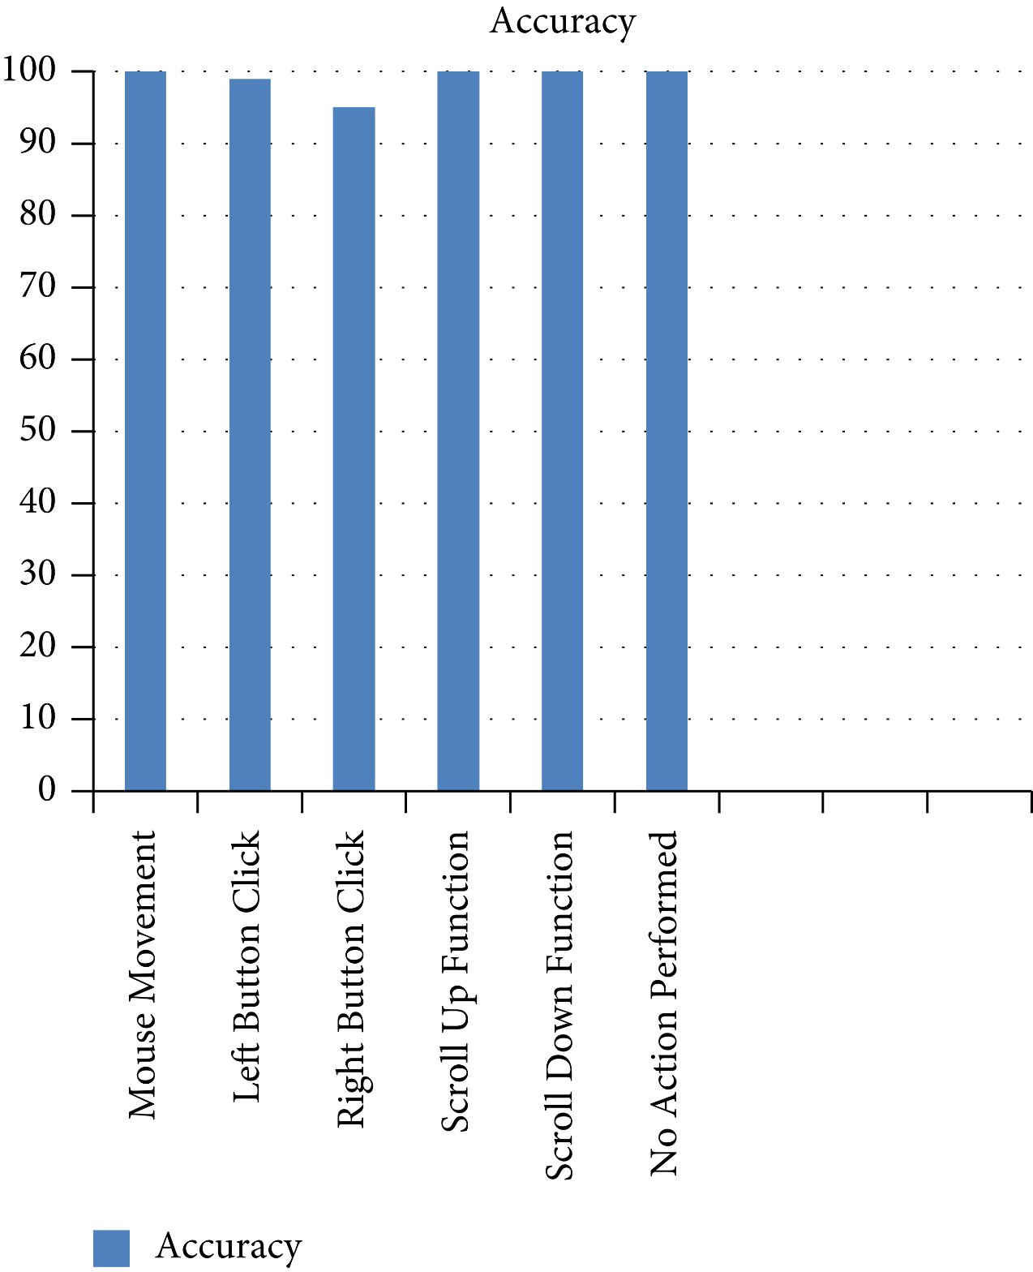**

**Annexure C**

**Use-Case Diagram (UCD)**

**