High Level Design Java 17, Springboot3, Gradle

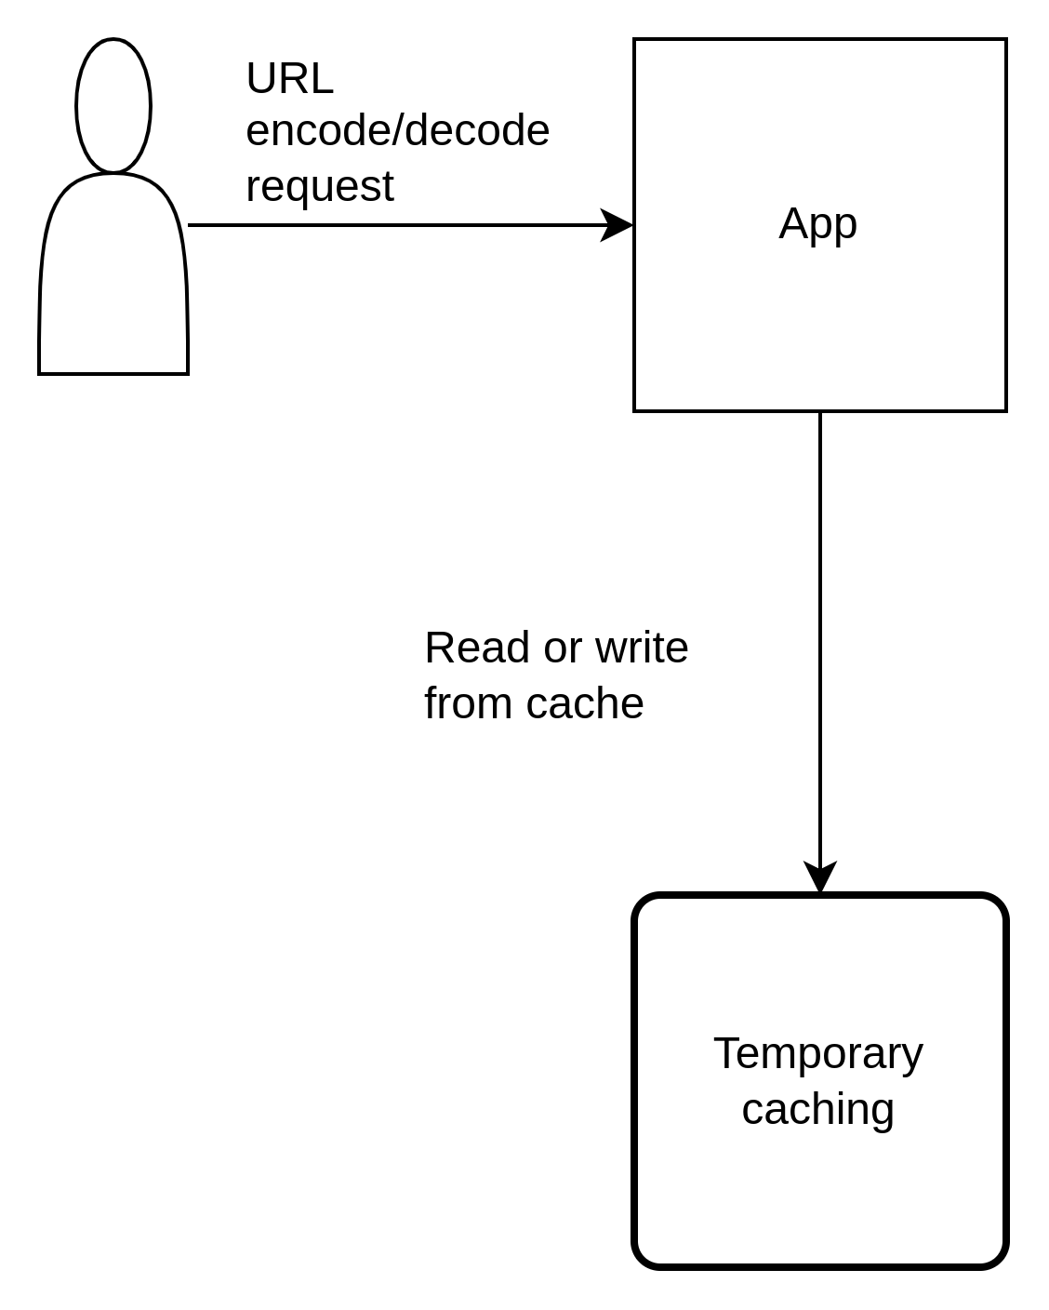
Assumptions:
Max characters for the short URL is 7 to 8.
I considered different approaches B10(10^7), B26, B52, B62 and MD5 hashing, due to size limitation I debated Base62 VS MD5
- MD5 give very long string and 7 to 8 characters will run into many hash collisions.
- B62 (62^7) we get more than 3 Trillion combination
Run:
there are 2 endpoints
- localhost:9000/api/v1/encode POST
Input JSON
{ "originalUrl": "http://www.google.com/1245/5897"}
Output JSON
{
"originalUrl": "http://www.google.com/1245/5897",
"shortUrl": "http://short3murl.com/VCDRwL"
}
- localhost:9000/api/v1/decode GET
Input JSON
{ "originalUrl": "http://short3murl.com/VCDRwL"}
Output JSON
{
"originalUrl": "http://www.google.com/1245/5897",
"shortUrl": "http://short3murl.com/VCDRwL"
}

