Online Retail Purchase Patterns
Market Basket Analysis using the Apriori Algorithm
24 March 2026

Executive Summary
This report presents findings from a Market Basket Analysis of an online retail transaction dataset using the Apriori algorithm. The goal was to identify frequent product combinations and extract actionable insights for cross-selling, bundling, and recommendation strategies. The analysis produced 20 association rules organized into five distinct product clusters, evaluated using Support, Confidence, and Lift.

Dataset & Methodology
The dataset contains online retail transactions with attributes including Transaction ID, Product Name, Quantity, Date, Unit Price, Customer ID, and Country. Preprocessing removed missing values, cancelled orders (invoices prefixed 'C'), duplicate records, and non-positive quantities. Transactions were grouped by InvoiceNo and converted into a sparse binary matrix for use with R's arules package.

Parameter | Value | Purpose
Minimum Support | 0.01 (1%) | Item pair must appear in ≥1% of all transactions
Minimum Confidence | 0.50 (50%) | Consequent bought in ≥50% of antecedent purchases
Minimum Rule Length | 2 | Rules must involve at least two distinct products

Rules were sorted by Lift — the ratio of observed to expected co-occurrence — to surface the strongest associations. Lift > 1 indicates a positive association; higher values signal more statistically meaningful pairings.

Exploratory Data Analysis
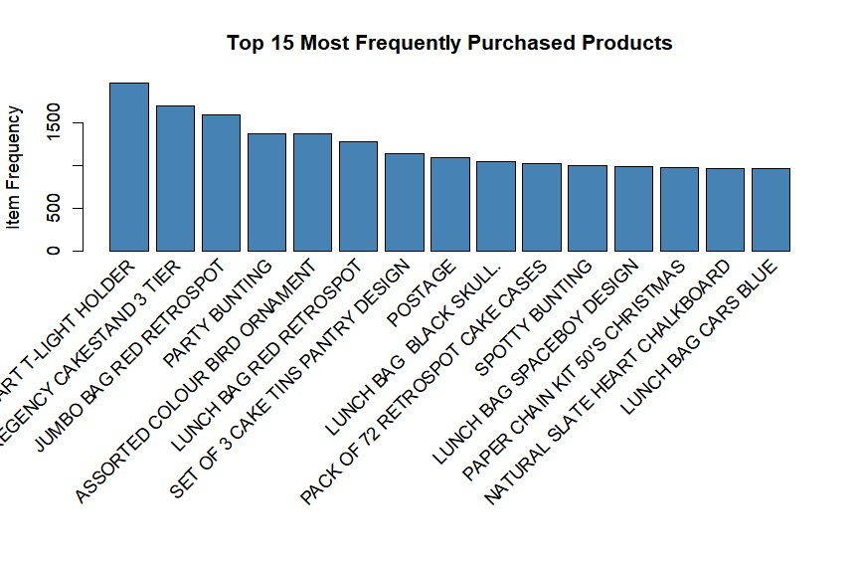
Figure 1: Top 15 Most Frequently Purchased Products (Absolute Frequency)
The top 15 chart reveals three dominant product clusters: home décor (HEART T-LIGHT HOLDER leading at ~1,800 transactions), kitchenware and storage (REGENCY CAKESTAND, JUMBO BAG RED RETROSPOT), and accessories (multiple lunch bag variants). The narrow frequency range across the top 15 (~900–1,800) suggests broad purchasing distribution rather than extreme concentration. Note: POSTAGE appears in the list, indicating shipping charges were recorded as product line items — these should be excluded in future preprocessing passes.

Association Rule Network Graph Analysis
The Apriori algorithm generated 20 association rules visualized as five network graphs. Blue rectangles represent products; pink circles represent rules. Deeper red colouring indicates higher Lift. All five clusters exhibit bidirectional rules — meaning neither product in a pair consistently leads the other — confirming that both items deserve equal prominence in recommendations and placement.

4.1 Regency Tea Plate Cluster (Rules 1, 2, 7, 8, 10, 11)
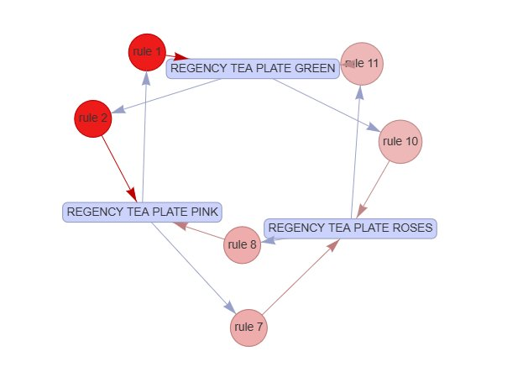
Figure 2: Regency Tea Plate Cluster — GREEN, PINK, ROSES
The strongest cluster in the dataset. Rules 1 & 2 (darkest red, highest Lift) capture a bidirectional association between REGENCY TEA PLATE GREEN and PINK. Rules 7–11 extend this to ROSES, forming a triangular relationship across all three variants — a clear set-buying pattern.

Business Insight
Bundle all three Regency Tea Plate variants as a 'Collection Set'. Surface all three whenever any one is added to cart. Highest-priority cluster for recommendation engine implementation.

4.2 Regency Kitchenware Cluster (Rules 4, 5)
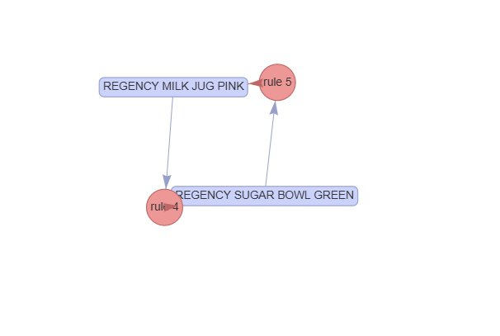
Figure 3: Regency Milk Jug Pink & Sugar Bowl Green
REGENCY MILK JUG PINK and REGENCY SUGAR BOWL GREEN are linked bidirectionally. Combined with the Tea Plate cluster, these five Regency products form the basis of a 'Complete Regency Afternoon Tea Collection' cross-range bundle opportunity.

Business Insight
Offer a 'Regency Tea Set Starter' (Milk Jug + Sugar Bowl) and combine with the Tea Plate cluster for a full Afternoon Tea bundle.

4.3 Poppy's Playhouse Cluster (Rules 3, 6, 9, 12, 13, 16, 17, 20)
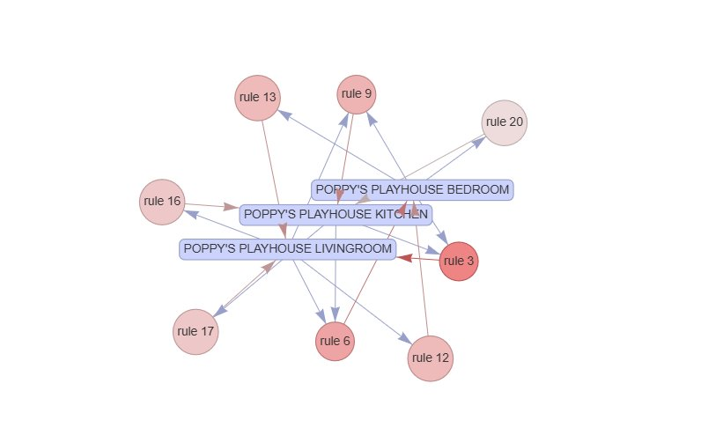
Figure 4: Poppy's Playhouse — BEDROOM, KITCHEN, LIVINGROOM
The most rule-dense cluster (8 rules), linking POPPY'S PLAYHOUSE BEDROOM, KITCHEN, and LIVINGROOM. Rule 3 has the highest Lift in this group. The density of connections confirms strong 'collect-the-set' behaviour. Rule 20 (lightest pink) is the weakest association and should be treated as a secondary recommendation.

Business Insight
Greatest basket-size uplift potential. Show 'Complete the Set' prompts linking all three room products on each product page. A pre-packaged full playhouse bundle would likely perform strongly.

4.4 Red Spotty Party Supplies Cluster (Rules 14, 15)
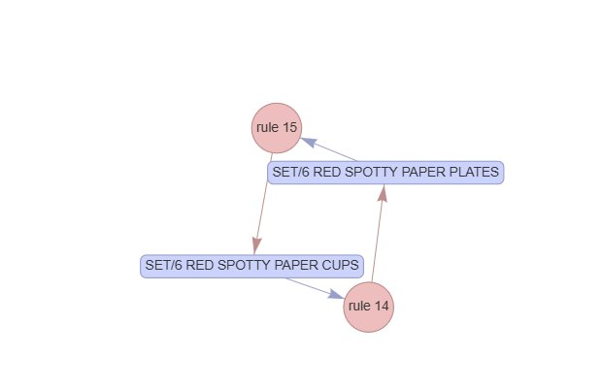
Figure 5: SET/6 Red Spotty Paper Plates & Cups
SET/6 RED SPOTTY PAPER PLATES and SET/6 RED SPOTTY PAPER CUPS are linked bidirectionally — a classic occasion-driven companion purchase driven by matching design and complementary function.

Business Insight
Create a 'Red Spotty Party Pack' bundle. Lower support to 0.005 in a follow-up run to find additional SET/6 Red Spotty items (napkins, bowls) that may form a larger party set cluster.

4.5 Children's Cutlery Cluster (Rules 18, 19)
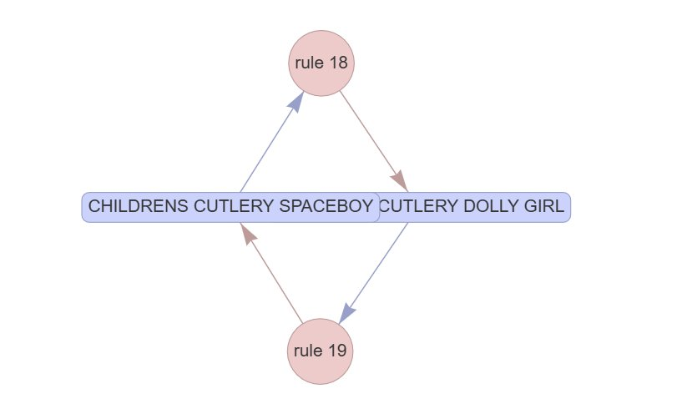
Figure 6: CHILDRENS CUTLERY SPACEBOY & DOLLY GIRL
CHILDRENS CUTLERY SPACEBOY and CHILDRENS CUTLERY DOLLY GIRL are linked bidirectionally, suggesting parents buying for multiple children or purchasing gender-paired gifts simultaneously.

Business Insight
Offer a 'Kids' Cutlery Duo Gift Set'. Expand the analysis to other Spaceboy/Dolly Girl branded products (bags, lunch boxes) to surface a broader brand-family cluster.

Recommendations Summary
Action | Products | Priority
Bundle: Regency Afternoon Tea Collection | Tea Plates (3) + Milk Jug + Sugar Bowl | High
Bundle: Complete Poppy's Playhouse | Bedroom + Kitchen + Livingroom | High
Recommendation Engine: Tea Plates | Surface all 3 variants on any plate PDP | High
Bundle: Red Spotty Party Pack | Paper Plates + Cups (+ explore others) | Medium
Bundle: Kids' Cutlery Duo Gift Set | Spaceboy + Dolly Girl | Medium
Data Quality: Remove POSTAGE entries | Preprocessing pipeline update | Low

Conclusion
The Apriori algorithm successfully identified 20 association rules across five coherent product clusters, all exhibiting consistent 'collect-the-set' and companion purchasing behaviour. The Regency Tea Plate range holds the highest Lift values and should be the first target for recommendation engine implementation. The methodology is reusable and scalable — future runs at lower support thresholds, combined with customer segmentation, will surface additional actionable patterns.
Market Basket Analysis • Apriori Algorithm • Online Retail Dataset

