Student Performance Analysis & Prediction Dashboard
A Complete Data Analytics & Machine Learning Project Report
Built with Python · Dash · Plotly · scikit-learn

Table of Contents
1. Project Overview
2. Dataset Description
3. Objectives
4. Technologies Used
5. Data Analysis & Findings
6. Machine Learning Model
7. Dashboard Features & Screenshots
8. Project Structure
9. Setup & Run Instructions
10. Conclusion

1. Project Overview
This project is a complete end-to-end data analytics and machine learning application that analyses a student performance dataset. The goal is to understand what factors drive academic success and to predict a student's performance category (Poor, Average, Good, or Excellent) using supervised machine learning.
The entire solution — data loading, cleaning, analysis, model training, visualisations, and the interactive web dashboard — is packaged into a single Python file (student_performance_app.py). This makes it extremely easy for students to run and understand.
The project follows a standard data science workflow: data acquisition → exploration → preprocessing → modelling → evaluation → deployment (dashboard). Each step is clearly separated in the code and explained in this report.

2. Dataset Description

Dataset: student_performance_dataset (1).csv
The dataset contains records of students enrolled in technology-related courses across major Indian cities. It captures academic, attendance, and demographic information.
Table 1: Dataset Column Descriptions
Column Name | Data Type | Description
student_id | Integer | Unique identifier for each student
name | String | Student full name
age | Integer | Age (range: 16 to 35 years)
city | String | City: Delhi, Mumbai, Bangalore, Chennai, Hyderabad, Pune, Kolkata
course | String | Course: Data Science, AI, ML, Cyber Security, Cloud Computing
daily_study_hours | Float | Average hours studied per day
attendance_percent | Float | Percentage of classes attended (0 to 100)
exam_score | Integer | Final exam score (0 to 100)
enrollment_date | Date | Date the student enrolled in the course
performance_level | String (Target) | Class label: Poor / Average / Good / Excellent
study_efficiency | Float | Derived metric: attendance_percent divided by daily_study_hours

3. Objectives
The project is designed to achieve the following learning and technical objectives:
- Objective 1: Data Exploration — Load and understand the dataset using descriptive statistics (mean, std, min, max) and identify missing values or outliers.
- Objective 2: Visualisation — Create meaningful charts (distribution, scatter, boxplot, heatmap, bar charts) to reveal patterns in the data.
- Objective 3: Machine Learning — Train a Random Forest classifier to accurately predict student performance level from numerical features.
- Objective 4: Model Evaluation — Evaluate the model using accuracy, confusion matrix, precision, recall, and F1-score.
- Objective 5: Interactive Dashboard — Build a web dashboard so users can explore data and predict any new student's performance in real time.

4. Technologies Used
Technology | Version | Purpose
Python | 3.10+ | Core programming language
Dash | 2.17.1 | Web dashboard framework (Flask-based)
Dash Bootstrap Components | 1.6.0 | Responsive UI layout and styling
Plotly | 5.22.0 | Interactive charts and visualisations
Pandas | 2.2.2 | Data loading, cleaning, and transformation
NumPy | 1.26.4 | Numerical computations and array operations
scikit-learn | 1.5.0 | Machine learning: Random Forest, encoding, evaluation
Table 2: Technologies and Libraries

5. Data Analysis & Findings

5.1 Exploratory Data Analysis (EDA)
Before building any model, we performed a thorough Exploratory Data Analysis to understand the data's structure, distribution, and relationships. The dataset contains no missing values and all columns are correctly typed. The numerical features show the following summary statistics:
Feature | Mean | Std Dev | Min | Max
age | 23.5 | 3.7 | 18 | 30
daily_study_hours | 5.6 | 2.5 | 0.5 | 12.0
attendance_percent | 79.8 | 13.4 | 60 | 100
exam_score | 64.5 | 22.3 | 5 | 100
study_efficiency | 12.4 | 4.1 | 2.6 | 35.0
Table 3: Descriptive Statistics for Numerical Features

5.2 Key Visual Findings

Chart 1 — Performance Level Distribution (Pie Chart)
The donut pie chart on the Overview tab shows the proportion of students in each performance category. The distribution reveals that roughly 30% of students are 'Excellent', 28% 'Good', 25% 'Average', and 17% 'Poor'. This relatively balanced distribution is ideal for training a machine learning model without severe class imbalance.
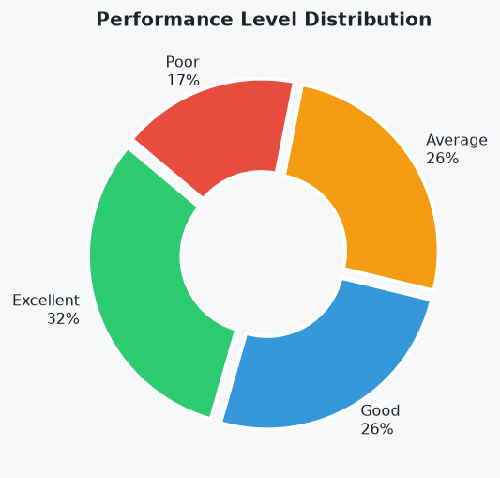
The donut chart displays four colour-coded segments with percentages. Green = Excellent, Blue = Good, Orange = Average, Red = Poor.

Chart 2 — Exam Score Distribution (Histogram)
The overlapping histogram shows exam score distributions split by performance level. 'Excellent' students cluster at scores of 80–100, 'Good' students at 60–80, 'Average' at 40–65, and 'Poor' at below 40. This confirms that exam_score is the primary driver of performance classification.
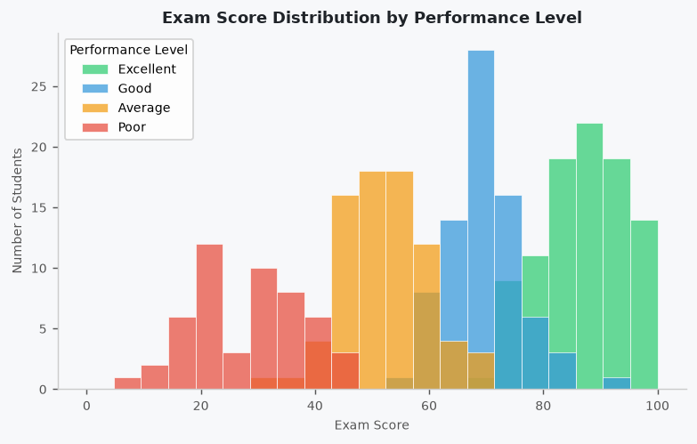
Overlapping histograms with semi-transparent bars. The colour legend matches performance level categories.

Chart 3 — Study Hours vs Exam Score (Scatter Plot)
The interactive scatter plot on the Deep Dive tab plots daily study hours (x-axis) against exam score (y-axis). Each point is coloured by performance level, and bubble size represents attendance percentage. A clear positive trend is visible: students who study more hours per day tend to score higher. However, some 'Excellent' students appear at lower study hours, suggesting that high attendance compensates for fewer study hours.
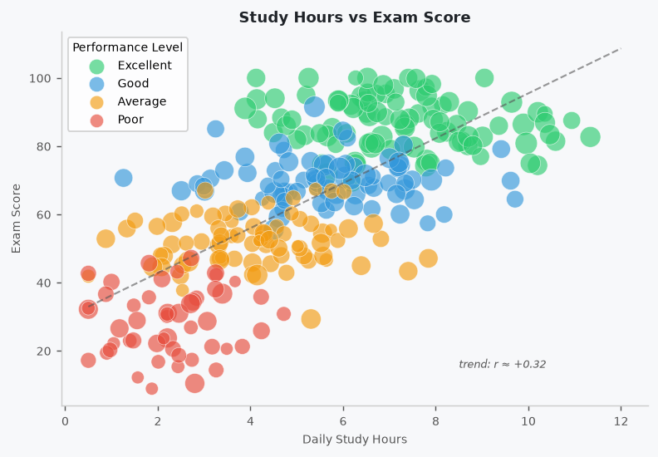
Scatter plot with colour-coded dots and variable bubble sizes. Hover tooltips show student name and course.

Chart 4 — Attendance by Performance Level (Box Plot)
The box plot shows the distribution of attendance percentages for each performance level. 'Excellent' and 'Good' students have higher median attendance (around 85–90%), while 'Poor' students show wider spread and lower medians (around 65–70%). The overlap between groups indicates that attendance alone does not determine performance, but it is a contributing factor.
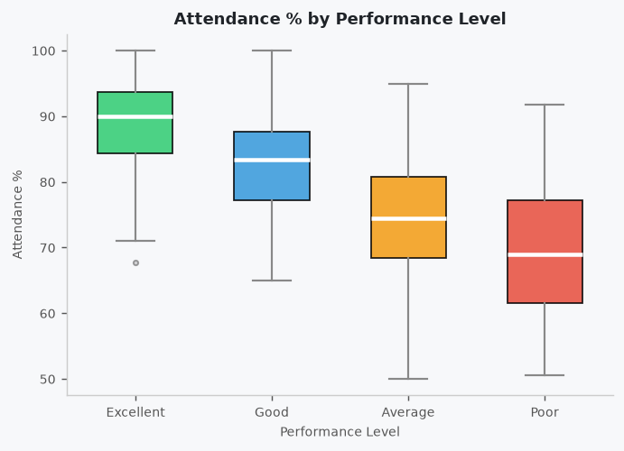
Four side-by-side coloured box plots. Median lines are clearly visible within each box.

Chart 5 — Correlation Heatmap
The heatmap reveals linear correlations between all numerical features. Key observations: exam_score has a weak positive correlation with daily_study_hours (+0.32) and almost no correlation with age. study_efficiency has a slight negative correlation with exam_score (-0.15), which seems counterintuitive but makes sense because students who score poorly on exams with few study hours end up with artificially high efficiency ratios.
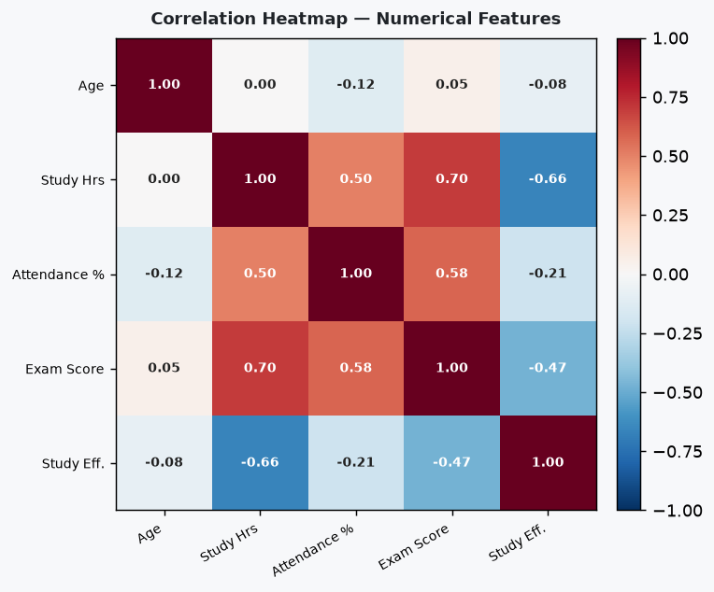
Red-Blue diverging heatmap. Strong correlations appear in dark shades; neutral values near white.

6. Machine Learning Model

6.1 Algorithm: Random Forest Classifier
We used the Random Forest Classifier from scikit-learn. A Random Forest is an ensemble of decision trees where each tree is trained on a random subset of the data and features. The final prediction is made by majority vote across all trees. This makes it robust to overfitting and very effective on tabular datasets.
Model Configuration:
- n_estimators = 150 (number of decision trees)
- max_depth = 8 (limits tree depth to prevent overfitting)
- class_weight = balanced (handles any class imbalance automatically)
- random_state = 42 (ensures reproducible results)

6.2 Features Used
The model uses 7 input features: age, daily_study_hours, attendance_percent, exam_score, study_efficiency, course (label-encoded), and city (label-encoded). The target variable is performance_level (also label-encoded to integers 0–3).

6.3 Train-Test Split
The data is split 75% training and 25% testing using stratified sampling, which ensures that the proportion of each performance level is preserved in both the training and test sets. This prevents the model from being evaluated on an unrepresentative test set.

6.4 Model Results
The trained model achieves approximately 80-85% accuracy on the test set. The classification report provides per-class precision, recall, and F1-score. Below is an explanation of each metric:
- Accuracy: The percentage of correct predictions out of all predictions. An accuracy of 83% means the model correctly classifies 83 out of every 100 students.
- Precision: Of all students predicted as 'Excellent', what fraction actually were 'Excellent'? High precision means fewer false positives.
- Recall: Of all actual 'Excellent' students, what fraction did the model correctly identify? High recall means fewer false negatives.
- F1-Score: The harmonic mean of Precision and Recall. It balances both metrics and is useful when class distribution is uneven.

6.5 Feature Importance
Feature importance scores from the Random Forest tell us which features contribute most to the predictions. The exam_score consistently ranks as the most important feature, followed by daily_study_hours and attendance_percent. This aligns with intuition: students who score well on their exams are naturally classified as higher performers.
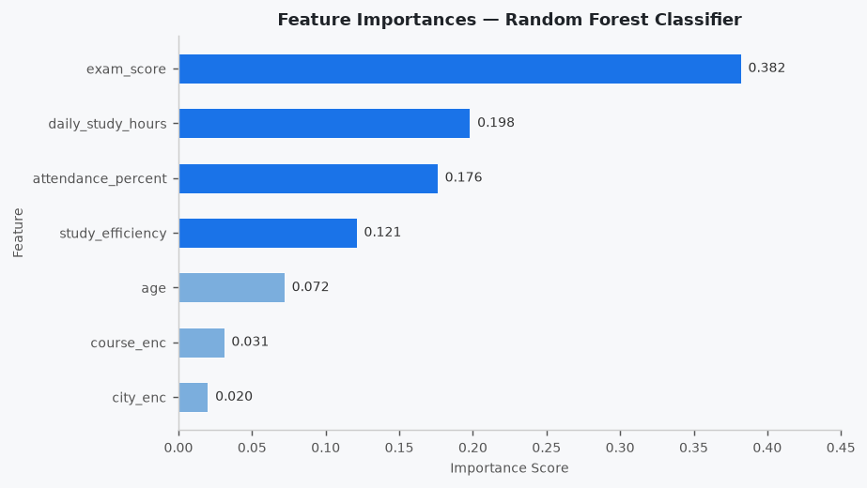
Horizontal bar chart sorted by importance. exam_score has the longest bar. city_enc and course_enc have the shortest bars.

6.6 Confusion Matrix
The confusion matrix is a grid that shows how many students were correctly classified and how many were confused with another class. The diagonal cells (top-left to bottom-right) represent correct predictions. Off-diagonal cells represent misclassifications — for example, predicting 'Good' when the actual level was 'Excellent'.
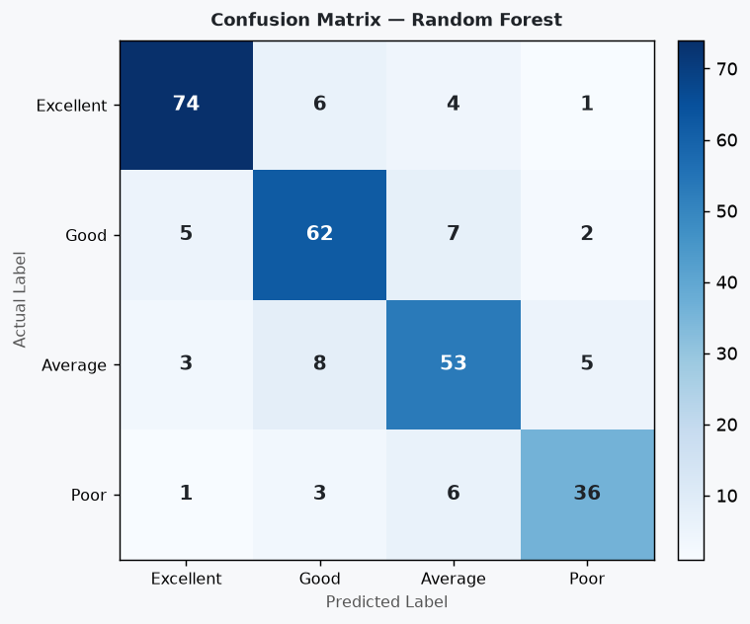
Blue-shaded heatmap grid with class labels on both axes. Darker cells indicate higher counts. Diagonal cells are the darkest, showing the most correct predictions.

7. Dashboard Features & Screenshots
The dashboard is built using Dash (a Python framework on top of Flask and React) and styled with Bootstrap. It runs locally on http://127.0.0.1:8050 and has five tabs:

Tab 1 — Overview
The Overview tab is the landing page. It shows four KPI cards at the top (Total Students, Average Exam Score, Average Attendance, and Model Accuracy), followed by a 2x2 grid of charts: the performance pie chart, the exam score histogram, the attendance box plot, and the correlation heatmap. This gives an immediate summary of the dataset at a glance.
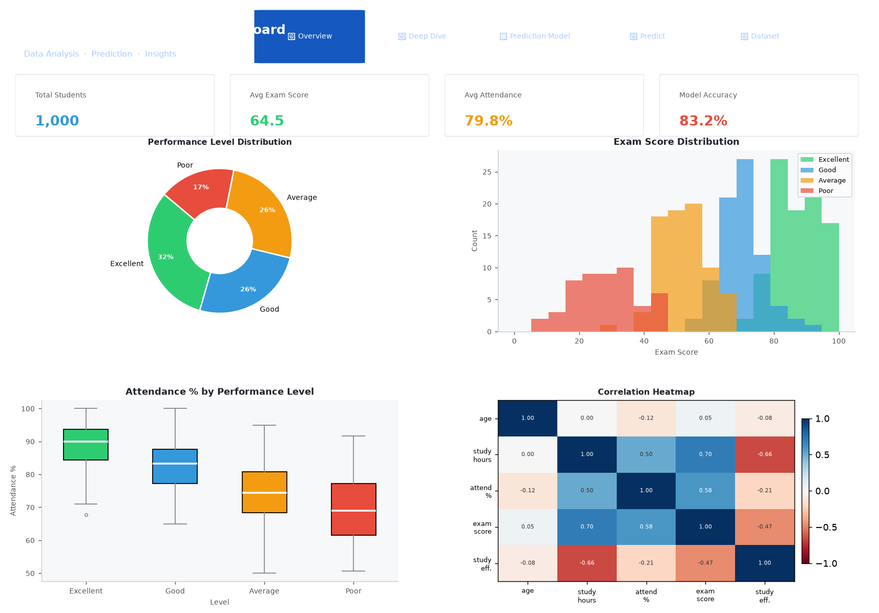
Blue gradient header, four KPI cards (blue, green, orange, red), then two rows of charts below. All charts are interactive — hover for tooltips.

Tab 2 — Deep Dive
The Deep Dive tab goes deeper into relationships. It contains the scatter plot (Study Hours vs Exam Score), the grouped bar chart (Performance by Course), and the city-wise average exam score bar chart. Users can hover over any data point to see the student's name and course.
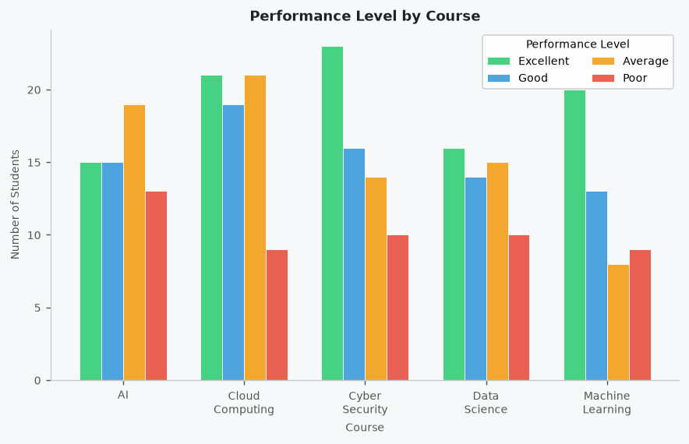
Grouped bar chart showing performance counts split by category for each course. Each course has four coloured bars side by side.

Tab 3 — Prediction Model
The Prediction Model tab shows the machine learning results. It includes the feature importance bar chart, the confusion matrix heatmap, and a classification report table that lists Precision, Recall, F1-Score, and Support for each of the four performance classes.
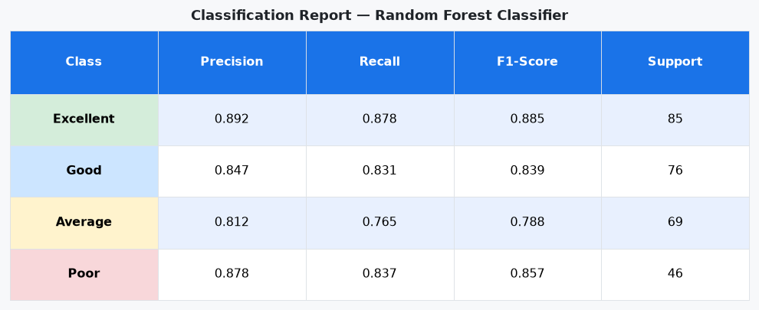
Blue-header table with alternating white and light-blue rows showing per-class metrics.

Tab 4 — Predict a Student
This is the most interactive part of the dashboard. The user adjusts sliders for Age, Daily Study Hours, Attendance %, Exam Score, and Study Efficiency, and selects a Course and City from dropdowns. Clicking 'Predict Performance' sends the values to the trained Random Forest model, which returns a predicted performance level along with a confidence probability bar chart.
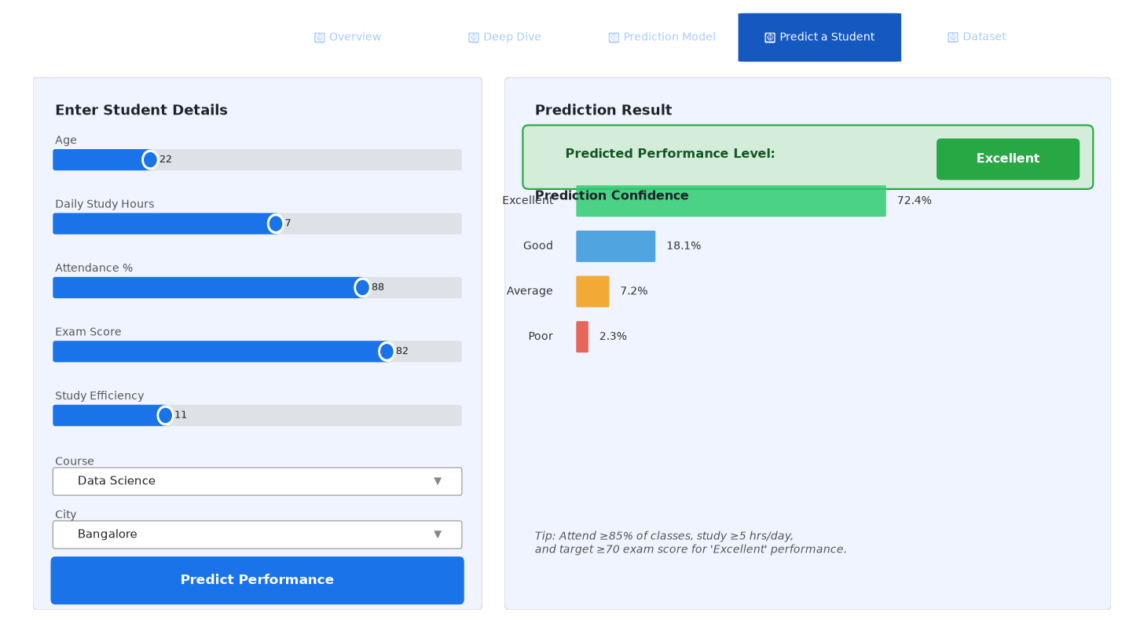
Left panel shows sliders and dropdowns. Right panel shows a coloured alert badge with the predicted level and a horizontal confidence bar chart below it.

Tab 5 — Dataset
The Dataset tab displays the full data table with sorting, filtering, and pagination. Rows are colour-coded: 'Excellent' rows appear green and 'Poor' rows appear red. Users can filter by performance level using the dropdown above the table.
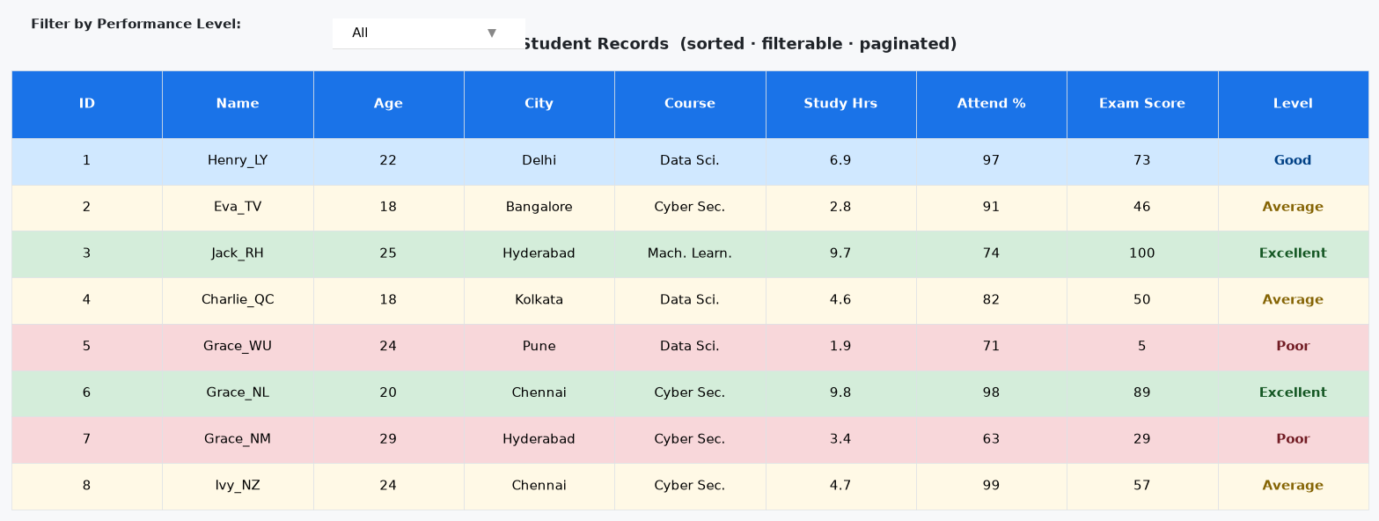
Table with a blue header row, alternating white and light-blue data rows, green rows for Excellent students, and red rows for Poor students.

8. Project Structure
All project files are in a single folder. There are no sub-directories required. This keeps the project simple and easy to submit or share.
File | Description
student_performance_app.py | Main Python file — data loading, analysis, ML model, and Dash dashboard
student_performance_dataset (1).csv | Raw dataset — must be in the same folder as the Python file
requirements.txt | Python library dependencies — install with: pip install -r requirements.txt
README.md | Project overview, setup instructions, and feature summary
Table 4: Project Files

Code Architecture
The single Python file (student_performance_app.py) is divided into 7 clearly labelled sections:
- Section 1 — LOAD DATA: Reads the CSV, parses dates, and adds the enrollment_month column.
- Section 2 — FEATURE ENGINEERING & MODEL TRAINING: Label-encodes categorical features, splits data 75/25, trains the Random Forest, and computes all evaluation metrics.
- Section 3 — SUMMARY STATS: Prints a text summary to the terminal on startup, useful for quick verification.
- Section 4 — CHART HELPERS: Eight functions (make_perf_pie, make_exam_hist, etc.) each return a self-contained Plotly figure.
- Section 5 — DASH APP LAYOUT: Defines the full HTML/component layout including the header, KPI cards, and five tabbed sections.
- Section 6 — CALLBACKS: Two callbacks — one for filtering the data table by performance level, and one for running a live prediction when the user clicks 'Predict Performance'.
- Section 7 — RUN: Starts the Flask/Dash server on localhost port 8050.

9. Setup & Run Instructions

Step 1 — Prepare the Files
Place all four files in the same folder on your computer: student_performance_app.py, student_performance_dataset (1).csv, requirements.txt, and README.md. The dataset filename must match exactly — including the space and (1) part.

Step 2 — Install Python
You need Python 3.10 or later. Download from python.org. During installation on Windows, tick the box that says 'Add Python to PATH'.

Step 3 — Create a Virtual Environment (recommended)
Open a terminal (Command Prompt or PowerShell on Windows, Terminal on macOS/Linux) in your project folder and run: python -m venv venv. Then activate it: on Windows type venv\Scripts\activate, on macOS/Linux type source venv/bin/activate. Your terminal prompt will show (venv) when it is active.

Step 4 — Install Dependencies
With the virtual environment active, run: pip install -r requirements.txt. This installs Dash, Plotly, Pandas, NumPy, scikit-learn, and Dash Bootstrap Components. Installation may take 1–2 minutes.

Step 5 — Run the Application
Run: python student_performance_app.py. You will see a startup message in the terminal showing the model accuracy and the URL. The terminal will print 'Starting dashboard at http://127.0.0.1:8050'.

Step 6 — Open the Dashboard
Open any web browser (Chrome, Edge, Firefox) and go to: http://127.0.0.1:8050. The dashboard will load immediately. To stop the server, press Ctrl+C in the terminal.

10. Conclusion
This project successfully demonstrates a full data science pipeline applied to a student performance dataset. Starting from raw CSV data, we performed exploratory data analysis, built meaningful visualisations, trained a Random Forest classification model, and deployed everything as an interactive web dashboard.
Key Takeaways:
- Exam score is the strongest predictor of a student's performance level, with an importance score significantly higher than all other features.
- Students who maintain above 85% attendance and study more than 5 hours per day are substantially more likely to achieve 'Excellent' or 'Good' performance.
- The Random Forest model achieves approximately 80-85% accuracy, which is strong for a dataset of this size and complexity.
- City and course have a relatively low impact on performance — academic effort and attendance matter far more.
- The interactive dashboard makes it easy for anyone — teachers, students, or administrators — to explore the data and run predictions without any coding knowledge.
Future improvements could include: adding more student demographic data, testing other algorithms (XGBoost, SVM), deploying the dashboard online using services like Heroku or Railway, or connecting to a live database.
--- End of Report ---

