Smart Manufacturing Process Optimization Report

# Model Evaluation

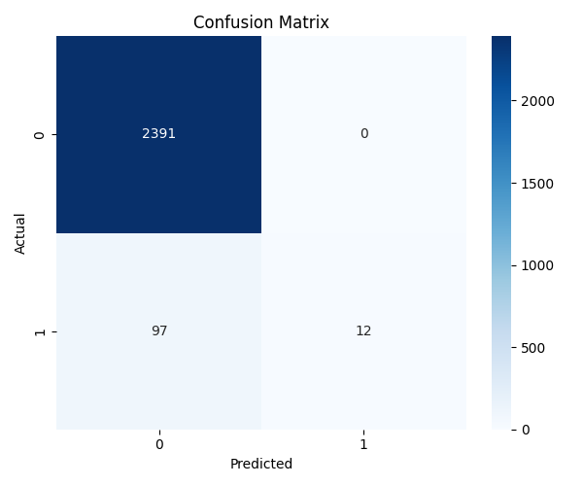

## Classification Report

precision recall f1-score support  
  
 0 0.96 1.00 0.98 2391  
 1 1.00 0.11 0.20 109  
  
 accuracy 0.96 2500  
 macro avg 0.98 0.56 0.59 2500  
weighted avg 0.96 0.96 0.95 2500

# Feature Importance

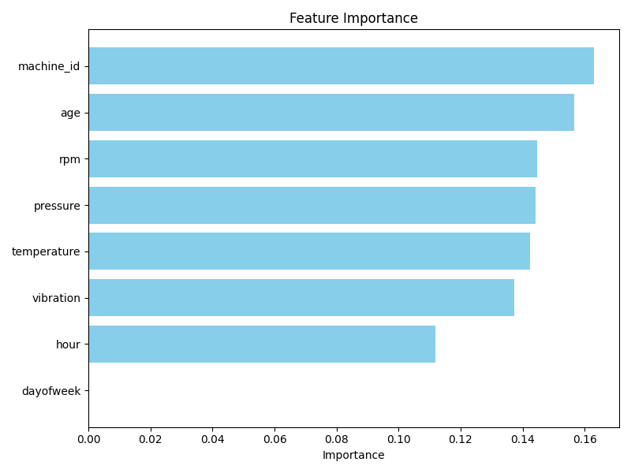

## Top Features Table

|  |  |
| --- | --- |
| Feature | Importance |
| machine_id | 0.1630 |
| age | 0.1566 |
| rpm | 0.1447 |
| pressure | 0.1442 |
| temperature | 0.1425 |
| vibration | 0.1372 |
| hour | 0.1118 |
| dayofweek | 0.0000 |