Assignment 1:

TASK1:

1.Start Hadoop single node on AcadGild VM (The command is start-all.sh):

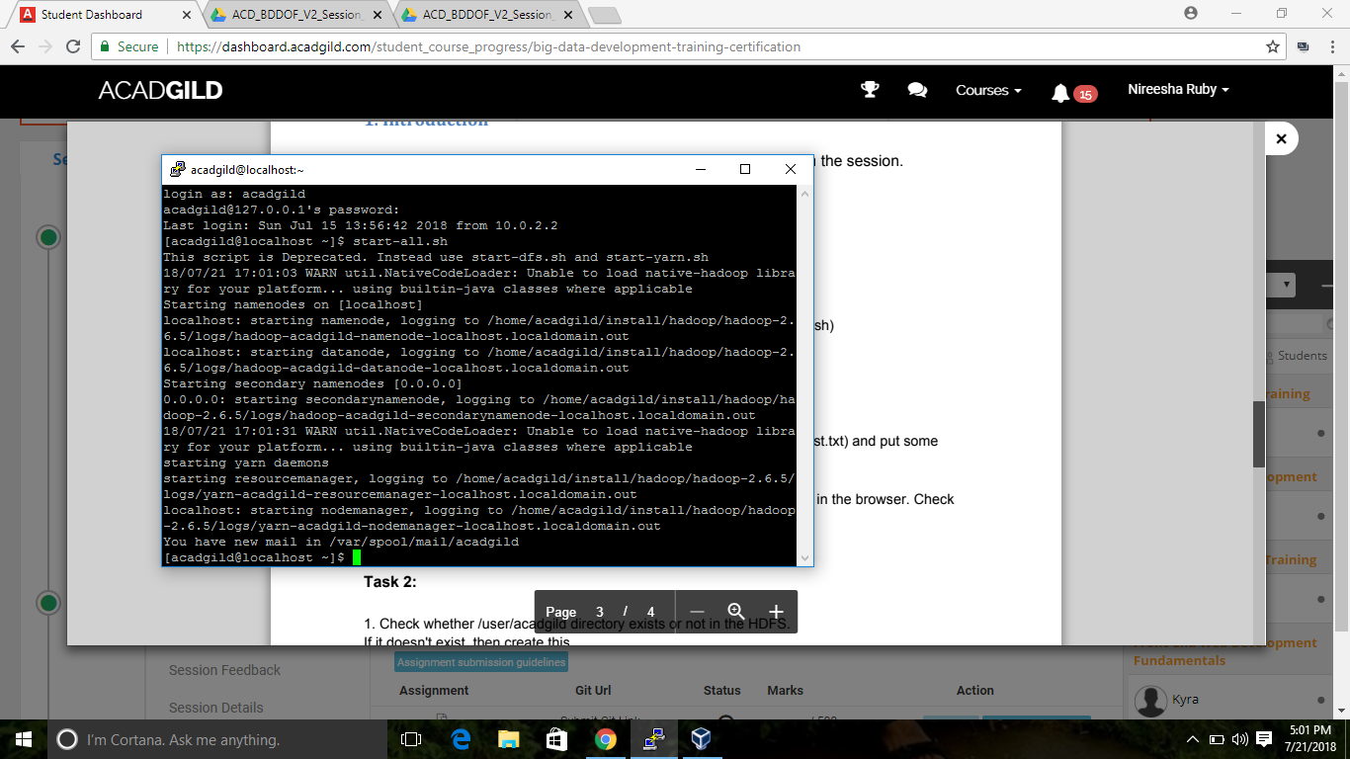

2. Run a JPS command to see if all the Hadoop daemons are running.

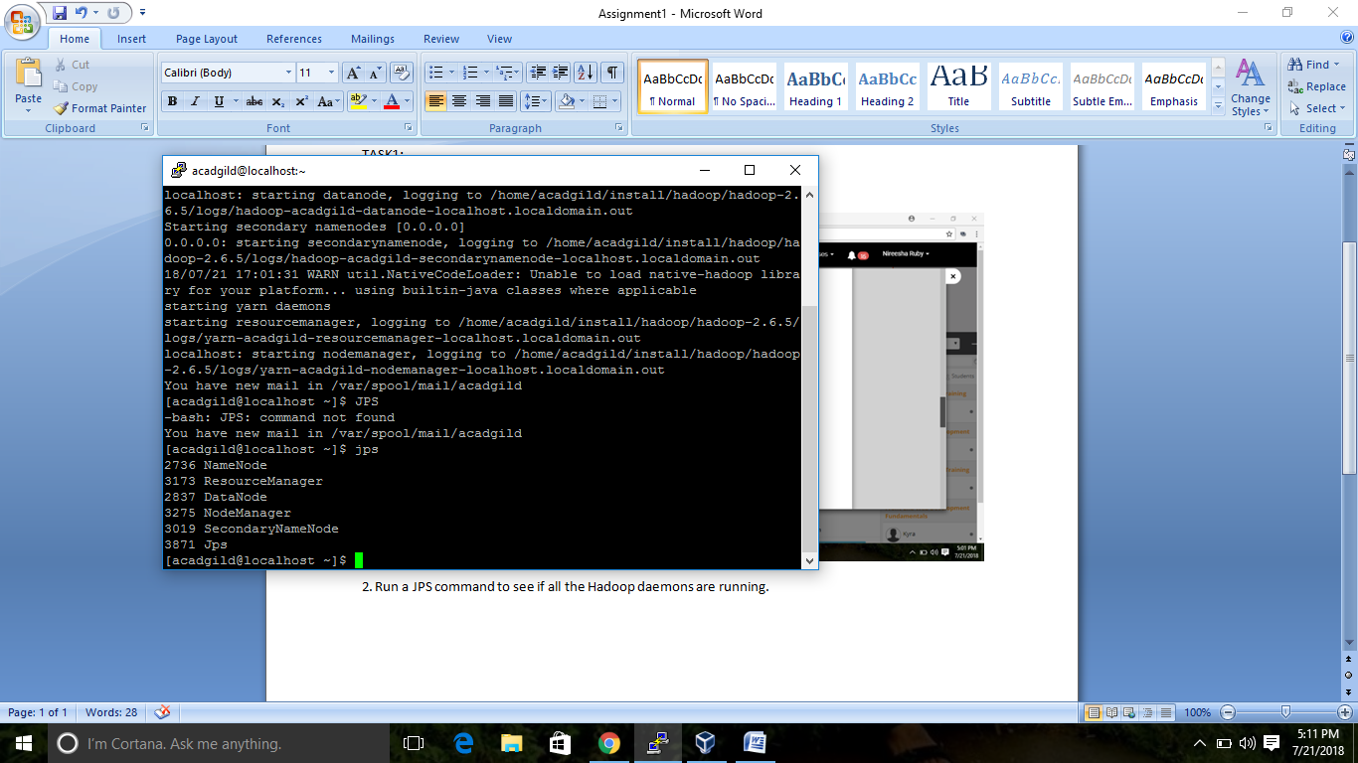

3. Run a couple of UNIX commands like pwd, ls -ls etc.

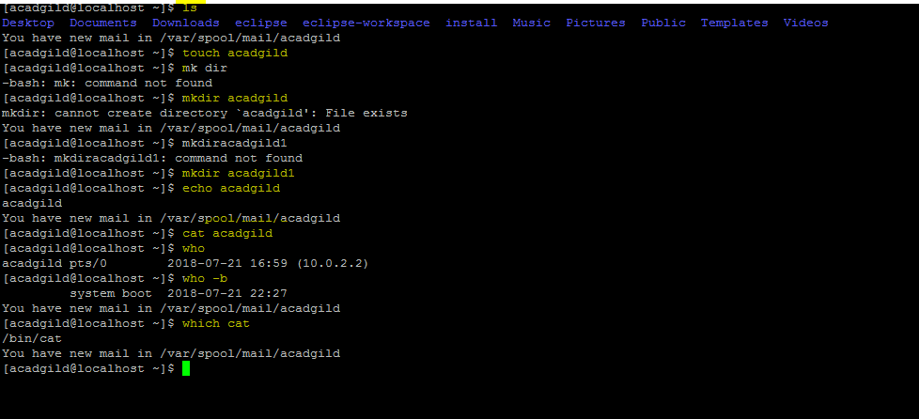

4. Create a file from the terminal using nano editor (for example nano test.txt) and put some

Content in it. Cat it to see if the content is saved

🡪Opening nano editor & creating a file.

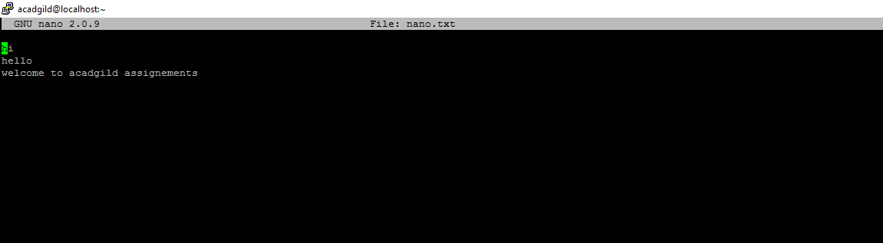

🡪Cat Operation on the file created nano.txt.

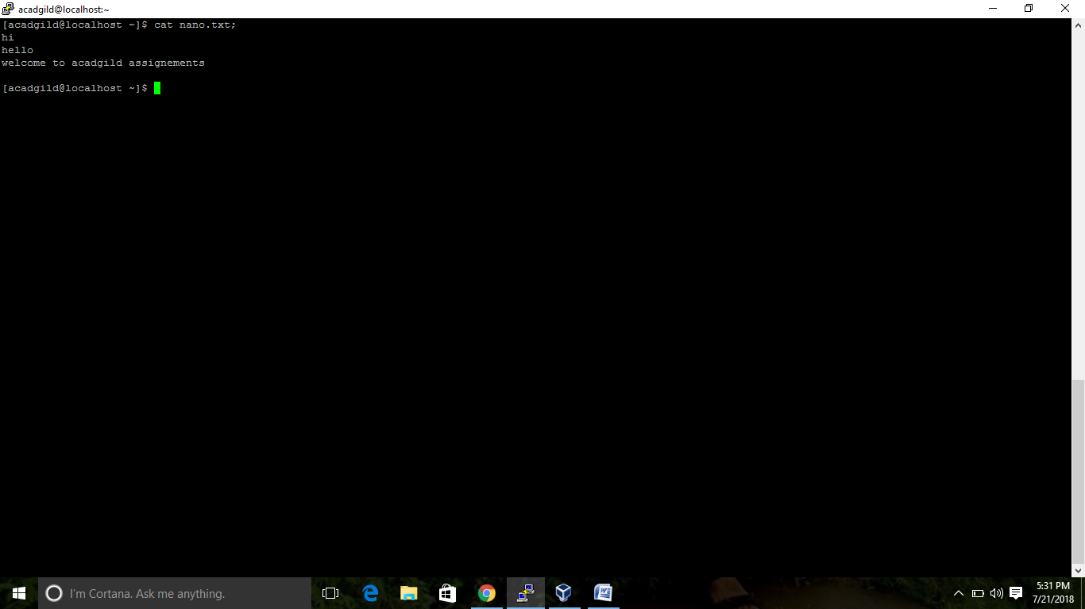

5. Open the hdfs web page from the browser by typing localhost:50070 in the browser. Check all the details of the HDFS.

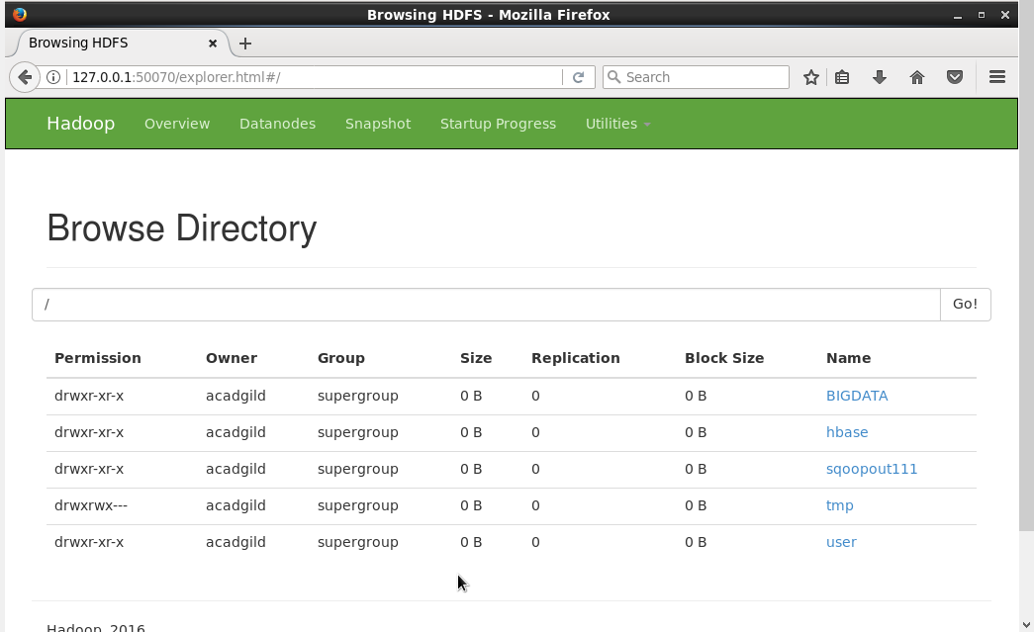

TASK 2

1. Check whether /user/acadgild directory exists or not in the HDFS.

If it doesn't exist, then create this.

Create a directory /user/acadgild/hadoop.

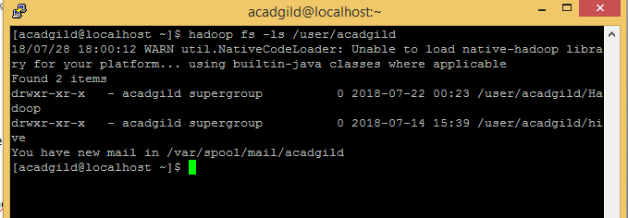

2. **2. Create a file in HDFS under directory /user/acadgild/hadoop, with name word-count.txt.**

**Whatever we type on screen should get appended to the file. Try to type (on screen) few lines from any online article or textbook.**

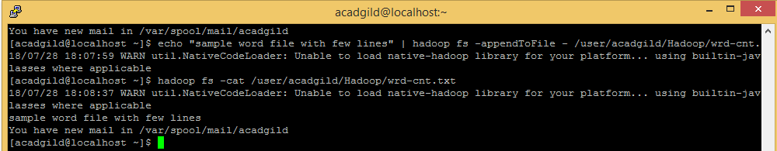

**3. Create a file max-temp.txt in local FS. Put some 10-15 records of date and temperature**

**example: dd-mm-yyyy,temperature**

**Example:10-01-1990,10**

**10-02-1991,20**

**Move this file to HDFS at /user/acadgild/hadoop.**

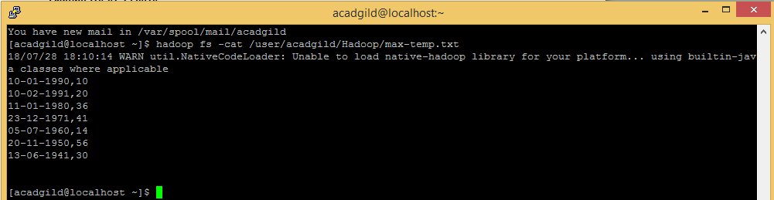

**4. Change the permission of the file /user/acadgild/hadoop/max-temp.txt, such that only the**

**owner and the group members have full control over the file.**

**Others do not have any control over it.**

Command: **chmod**

This command is user to add or remove permissions

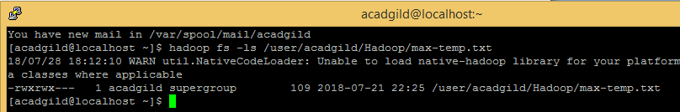

**Task 3:**

**1. Execute WordMedian​, WordMean,​ WordStandardDeviation​ programs using**

**hadoop-mapreduce-examples-2.9.0.jar file present in your AcadGild VM.**

**WordMedian**

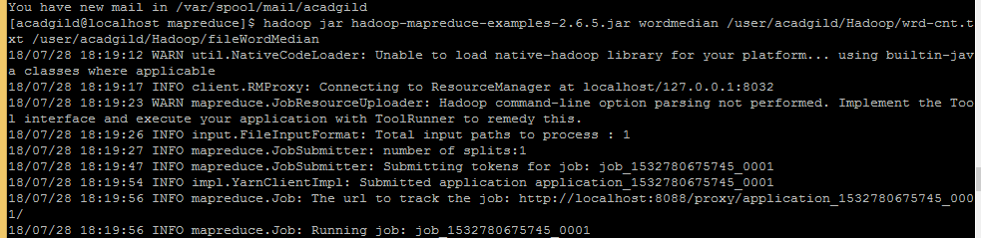

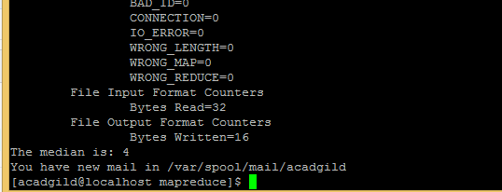

**WordMean**

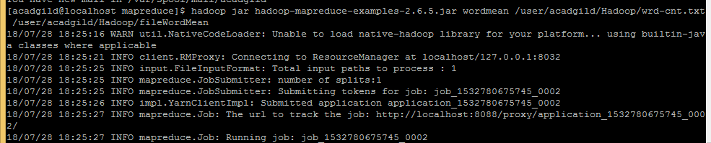

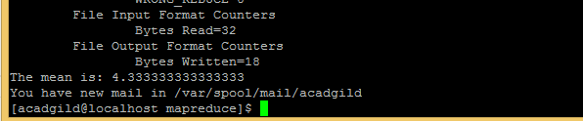

**WordStandardDeviation**

