Results From Push-Sum and Gossip Network Algorithms

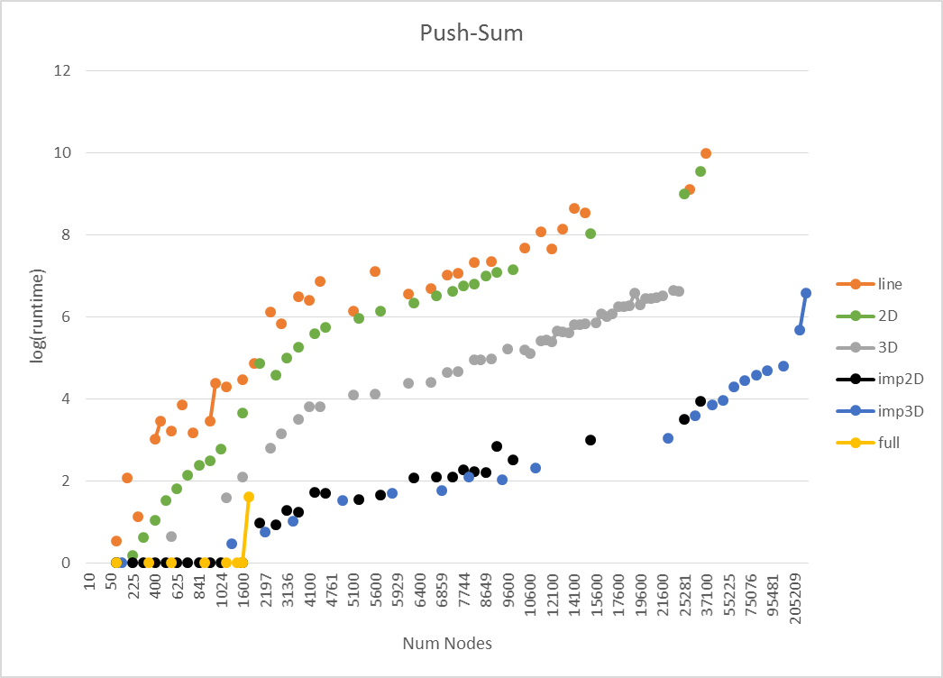

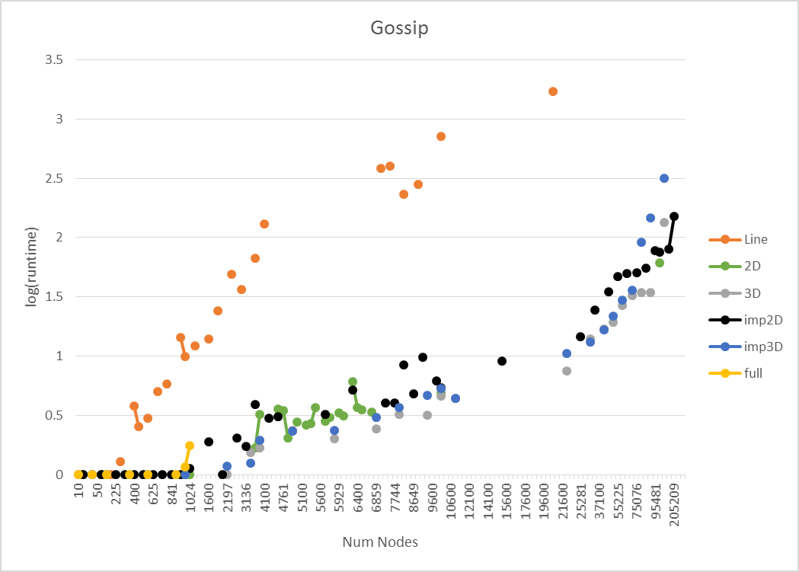

The topologies used for both the push-sum and gossip algorithms included:

- Line

- 2D (4 neighbors)

- 3D (6 neighbors)

- Imperfect 2D (5 neighbors)

- Imperfect 3D (7 neighbors)

- Full

Plots were created to map, for each algorithm, the run time for each topology versus the number of nodes in the network. A logarithmic scale was used for the run time to provide a more readable plot. Runtime values below 0 seconds were omitted so as to not include negative log values on the plot.

The line topology clearly showed the worst runtime performance with it being slower to converge between both algorithms for every size of network as well as a roughly exponential increase in runtime with respect to the number of nodes. Close behind was the 2D topology which maintained close performance along a similar trend for the gossip algorithm. However, the 2D topology performed at a much better rate with the gossip algorithm.

The remaining results for the gossip protocol seemed to all group together in third place. The push-sum algorithm showed a clear difference between 3D, which came in third after 2D, followed by imperfect 2D and imperfect 3D basically tied for fourth.

What was blatantly similar in both algorithms and even across both systems for each algorithm was tested on was the inability of the full topology to run with more than 1000 nodes in the system before the system during setup failed due to running out of heap space. For the couple of runs that did provide runtimes greater than 1 second, the performance of the algorithms was still worse than the imperfect 2D and 3D topologies. This shows a clear indication of the tradeoff between having a more links in a network versus having a just enough to facilitate efficient setup and running performance.