Spotter Machine Learning Assessment
Freight Rate Prediction
Machine Learning Engineer Take-Home Assessment

1. Executive Summary
This project develops a machine learning system for predicting posted freight rates from historical load information. The development dataset contains 48,000 historical loads from January through October 2025, while the assessment validation dataset contains 12,000 loads from November through December 2025.
The workflow covers data auditing, cleaning, exploratory data analysis, feature engineering, temporal validation, model comparison, hyperparameter tuning, error analysis, final model training, validation prediction generation, and December scenario prediction.
The final selected model is Ridge Regression trained on the log-transformed target using alpha = 0.01. On the temporal validation split covering September and October 2025, it achieved an MAE of approximately $108.61, RMSE of $633.26, and R² of 0.8278.

2. Dataset
Dataset | Rows | Purpose
train-test.csv | 48,000 | Labeled development/training data
validation.csv | 12,000 | Final assessment prediction data
validation-predictions-template.csv | 12,000 | Required prediction format
december-chart-inputs.csv | 31 | Fixed December scenario
The training data contains 14 columns including the target posted_rate. The assessment validation data contains 13 input columns because the target is not provided.

3. Data Audit
- Training rows: 48,000
- Training columns: 14
- Validation rows: 12,000
- Exact duplicate training rows: 0
- Exact duplicate validation rows: 0
- Duplicate training load IDs: 0
- Duplicate validation load IDs: 0
- Training missing weight values: 300
- Training negative weight values: 292
- Training missing market_index values: 374
- Validation missing weight values: 165
- Validation negative weight values: 145
- Validation missing market_index values: 249
The target posted_rate ranges from approximately $57 to $25,533. The target distribution is right-skewed, motivating the use of a log-transformed target for the Ridge model.

4. Data Cleaning
Cleaning statistics were fitted using training data only to reduce the risk of validation leakage.
- Missing and invalid weight values were identified using explicit diagnostic flags.
- Missing weight values were imputed using the training-set median.
- Weight-related derived features were created while preserving raw-weight information.
- Missing market_index values were first handled using date-specific training statistics and then a training global fallback.
- Distance values were checked for validity before feature generation.

5. Exploratory Data Analysis
Exploratory analysis examined the target distribution, rate per mile, distance, weight, equipment type, market index, quote signal, temporal patterns, and relationships between the variables.
- Distance has a very strong relationship with posted_rate; the Spearman correlation was approximately 0.976.
- Rate per mile generally decreases as shipment distance increases.
- Median rate per mile differs by equipment type, with Reefer and Flatbed generally above Dry Van.
- Market index and quote signal provide additional information beyond distance.
- A small number of extreme target values create substantial RMSE impact.

6. Feature Engineering
The final modeling pipeline generates 43 model features.
- Date-derived features such as day of week, day of month, and day of year
- Log-transformed distance and weight-related features
- Weight-distance interaction features
- Latitude and longitude differences
- Absolute geographic differences
- Haversine distance
- Distance-to-geographic-distance relationships
- Market-index and distance interactions
- Equipment indicator variables
- Equipment-specific distance and market interactions
Identifiers such as load_id were excluded from model features. Target-derived variables such as posted_rate and rate_per_mile were also excluded.

7. Validation Strategy
Because freight rates can change over time, a temporal validation strategy was used instead of a random split.
- Training period: January 1 through August 31, 2025
- Validation period: September 1 through October 31, 2025
- Temporal training rows: 38,477
- Temporal validation rows: 9,523
This design evaluates whether the model can generalize from earlier market conditions to later unseen dates.

8. Model Experiments
Model | MAE | RMSE | R²
Ridge Log Target | 108.61 | 633.26 | 0.8278
HistGradientBoosting | 135.44 | 635.92 | 0.8264
Extra Trees | 141.79 | 644.40 | 0.8217
Random Forest | 158.65 | 648.79 | 0.8193
Equipment Rate/Mile | 229.10 | 670.66 | 0.8069
Global Rate/Mile | 256.95 | 684.25 | 0.7990
Global Median | 1148.92 | 1569.42 | -0.0577
Ridge Regression with a log-transformed target achieved the lowest MAE among the evaluated approaches and was selected for further tuning.

9. Hyperparameter Tuning
The Ridge regularization parameter alpha was evaluated across multiple values.
- Best alpha: 0.01
- Validation MAE: $108.61
- Validation RMSE: $633.26
- Validation R²: 0.8278
The difference between alpha = 0.01 and alpha = 0.1 was very small, while larger regularization values progressively degraded validation performance.

10. Error Analysis
The tuned Ridge model achieved an overall temporal-validation MAPE of approximately 4.81%.
Equipment | Rows | MAE
Dry Van | 5,360 | $103.54
Flatbed | 1,770 | $111.01
Reefer | 2,393 | $118.19
Distance-based error analysis showed:
- ≤200 miles: MAE approximately $18.99
- 201–500 miles: MAE approximately $51.57
- 501–1,000 miles: MAE approximately $72.28
- 1,001–1,500 miles: MAE approximately $124.35
- 1,501–2,000 miles: MAE approximately $180.24
- >2,000 miles: MAE approximately $191.38
The largest errors were associated with extreme posted-rate observations. These observations strongly influence RMSE even when the majority of predictions have substantially smaller absolute errors.

11. Final Model
After model selection and tuning, the final Ridge model with alpha = 0.01 was retrained on all 48,000 development rows.
- Model: Ridge Regression
- Target transformation: log1p(posted_rate)
- Alpha: 0.01
- Model features: 43
- Training rows: 48,000
- Artifact: artifacts/ridge_model.joblib

12. Assessment Predictions
The final model generated predictions for all 12,000 rows in validation.csv.
- Output file: validation_predictions.csv
- Rows: 12,000
- Required columns: load_id, predicted_rate
- IDs match TE-000001 through TE-012000
- All predicted rates are finite and positive

13. Fixed December Scenario
Predictions were also generated for all 31 December scenario rows. The supplied December input does not contain market_index or quote_signal, so the current implementation uses training-set median fallback values for these fields.
- December rows: 31
- Scenario: Lexington to Fort Wayne
- Distance: 360 miles
- Equipment: Dry Van
- Weight: 32,000
- Market index fallback: training median
- Quote signal fallback: training median
December prediction chart:
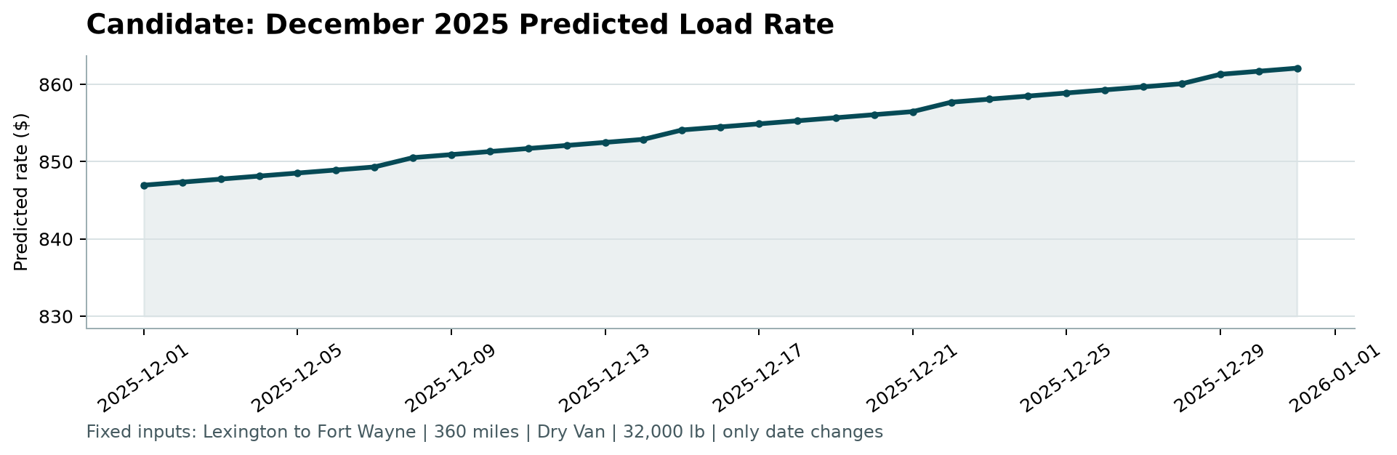

14. Official Scorer Verification
The provided assessment scorer was executed using the generated validation and December predictions.
Result: PASSED
- Validated 12,000 final predictions.
- Validated 31 fixed December predictions.
- Created scorer_results/candidate_december.png.
The hidden final Spotter evaluation metric is not calculated by the provided local scorer and will be determined by Spotter after submission.

15. Limitations and Future Improvements
- The temporal validation split does not contain the new-city cases present in the final assessment validation set.
- Extreme freight-rate outliers remain difficult for the current linear model.
- The December input lacks some features available in the historical development data.
- Additional location-based features, robust regression, gradient boosting, and carefully designed target-encoding strategies could be investigated.
- Rolling-origin validation across multiple time windows could provide a more robust estimate of temporal generalization.

16. Conclusion
The completed pipeline provides a reproducible end-to-end solution for freight rate prediction. The workflow separates training-time preprocessing from inference, uses a time-aware validation strategy, compares multiple modeling approaches, tunes the selected model, analyzes prediction errors, generates the required assessment predictions, and successfully passes the provided scorer.
The selected Ridge model provides the strongest validation MAE among the tested approaches and was retrained on the complete development dataset before producing the final assessment predictions.

