The "Traffic Controller" (App.jsx)
In HTML, you would have index.html, about.html, and contact.html. If you wanted a Navbar on all of them, you’d have to copy-paste the code into every file.

How it works in your React code:

The Wrapper: Notice <Navbar /> is outside the <Routes>. This is why the Navbar stays at the top even when you click "Login" or "About"—it never reloads.

The Switcher: The <Routes> block acts like a "lookup table". When the URL changes to /signup, React hides Home and shows Signup instantly.

Dynamic Paths: The line <Route path="/product/:productId" ... /> is something HTML can't do easily. The :productId is a variable, meaning this one file (Product.jsx) can display 1,000 different tyres just by changing the ID in the URL.

Since you are coming from an HTML background, the jump to React can feel like moving from a static map to a GPS system. In HTML, every page is a separate file; in React, the entire website is a single, living application.

Here are the notes to help you master the logic behind the files you’ve built.

1. The "Traffic Controller" (App.jsx)
In HTML, you would have index.html, about.html, and contact.html. If you wanted a Navbar on all of them, you’d have to copy-paste the code into every file.

How it works in your React code:

The Wrapper: Notice <Navbar /> is outside the <Routes>. This is why the Navbar stays at the top even when you click "Login" or "About"—it never reloads.

The Switcher: The <Routes> block acts like a "lookup table". When the URL changes to /signup, React hides Home and shows Signup instantly.

Dynamic Paths: The line <Route path="/product/:productId" ... /> is something HTML can't do easily. The :productId is a variable, meaning this one file (Product.jsx) can display 1,000 different tyres just by changing the ID in the URL.

2. The "Bridge" Between Frontend and Backend
You have two different "servers" running: the Frontend (Vite - Port 5173) and the Backend (Node - Port 5000).

The Connection Logic:

The Request: In Login.jsx and Signup.jsx, you use axios.post(). This is like sending a letter from Port 5173 to Port 5000 asking, "Can this user enter?".

The Middleware (CORS): In your server.js, you have app.use(cors()). Without this, the browser would see Port 5173 talking to Port 5000 and block it for security.

The Database Handshake: server.js talks to db.js, which holds the "keys" to your MySQL database. It runs the SQL command and sends the answer back to React.

3. The "Memory" (localStorage)
HTML is "forgetful." If you refresh an HTML page, all variables are gone. React is also forgetful, so we use localStorage to give it a "permanent memory."

Saving the Session: In Login.jsx, after a successful match, we run localStorage.setItem('user', ...). This stores the user's name and ID in the browser's physical storage.

Conditional UI: In Navbar.jsx, we use useState initialized with that storage data. This is why the Navbar knows to hide the "Login" button and show your profile_icon.png instead.
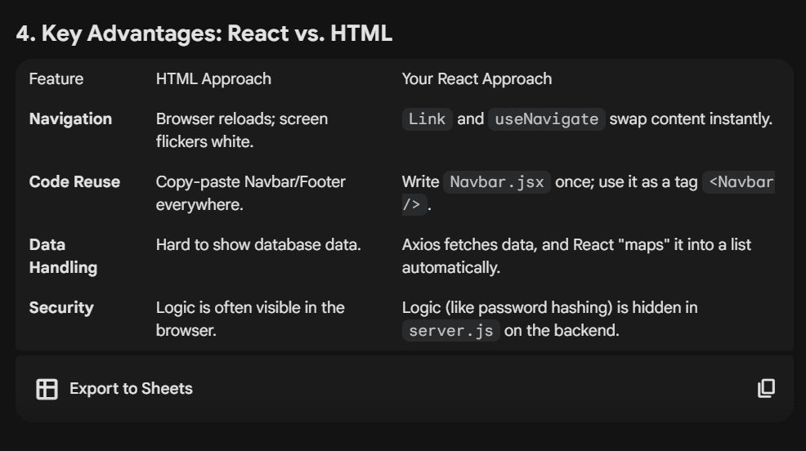

5. Summary of Functional Connections
- Connecting to MySQL: Happens in db.js using a "Connection Pool".
- Security: bcryptjs in server.js ensures that if someone steals your database, they only see scrambled text, not real passwords.
- Redirecting: window.location.replace() is used during logout to wipe the "back-button" memory so users can't go back into a private account after logging out.

