Predicting Next-Day Rain in Kathmandu
Using LSTM Deep Learning on 10 Years of Weather Data

TECH 405 — Machine Learning Project Report
Dataset: Tribhuvan International Airport (TIA) Weather, 2015–2025
Model: LSTM (Long Short-Term Memory) Neural Network

Page 1 — Introduction & The Problem

What Are We Trying to Do?
We want to answer one simple question every morning:
"Will it rain tomorrow in Kathmandu?"
This is a binary classification problem — the answer is either Yes (Rained) or No (No Rain).

Why LSTM?
Weather is a sequence. Today's temperature, humidity, and pressure all affect tomorrow's rain. A regular model treats each day as independent, but LSTM (Long Short-Term Memory) is a type of deep learning model that remembers past patterns — just like we do when we look at the weather over the past week and guess what's coming next.

Data Source
We used daily weather records from Tribhuvan International Airport (TIA) in Kathmandu, covering January 2015 to June 2025 (~10 years). After cleaning and processing, we had 3,285 usable daily records.

Features Used by the Model
Feature | What It Means
Temperature | How hot/cold that day was
Humidity | How much moisture was in the air
Dew Point | Temperature at which air becomes saturated with moisture
Cloud Cover | How cloudy the sky was
Wind Speed & Gusts | How fast the wind blew
Sea Level Pressure | Air pressure at sea level
Visibility | How far you could see
Solar Radiation | Amount of sunlight energy received
Precipitation Probability | Weather service's chance-of-rain estimate
Lag Features | Yesterday's temperature & humidity
7-day Rolling Average | Average temperature over the past 7 days
Month/Season Encodings | Cyclical features to capture seasonal patterns

Page 2 — Exploring the Data

Figure 1: How Often Does It Rain?
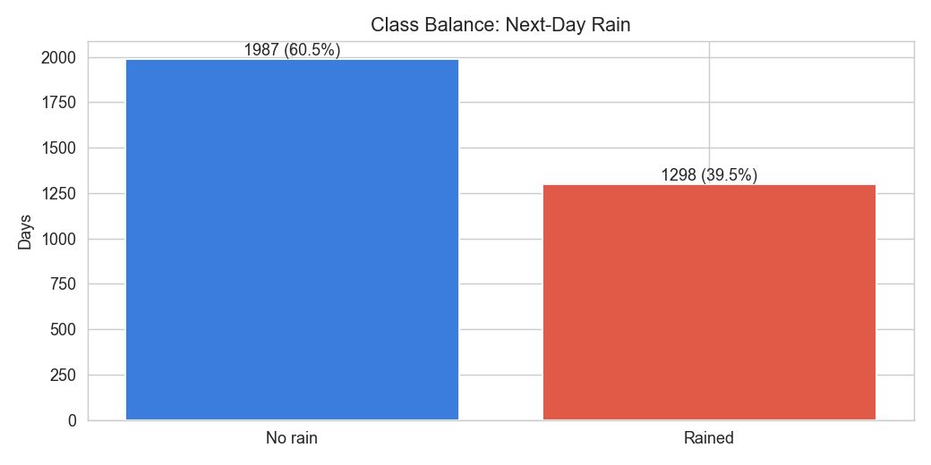
Figure 1 — Class Balance: Next-Day Rain (No Rain vs Rained)
What this shows: Out of 3,285 days, 1,987 days (60.5%) had no rain the next day, and 1,298 days (39.5%) did rain. This slight imbalance is realistic — Kathmandu has dry seasons. We handled this by using class weighting in some models so the model doesn't just always predict 'no rain' to look accurate.

Figure 2: Which Months Are the Rainiest?
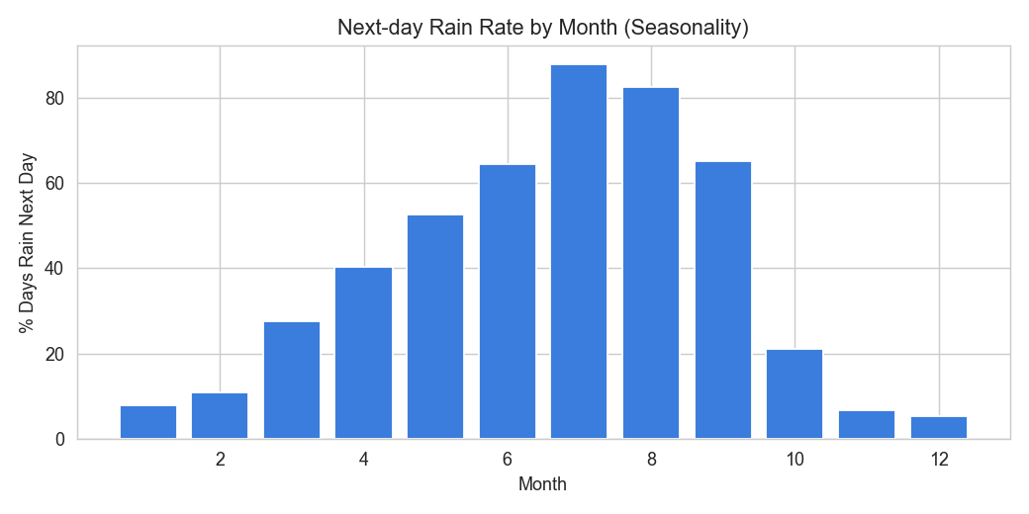
Figure 2 — Next-day Rain Rate by Month (Seasonality)
What this shows: This bar chart shows how likely it is to rain in each month.
• June, July & August (months 6–8) are peak monsoon — nearly 80–90% of days are rainy.
• January, February, November & December are very dry — only 5–10% chance of rain.
• April–May shows a gradual build-up (pre-monsoon), and September–October shows a decline.
This perfectly matches Kathmandu's monsoon climate. The model must learn this seasonality.

Page 3 — Data Quality & Feature Relationships

Figure 3: The 12-Month Data Gap
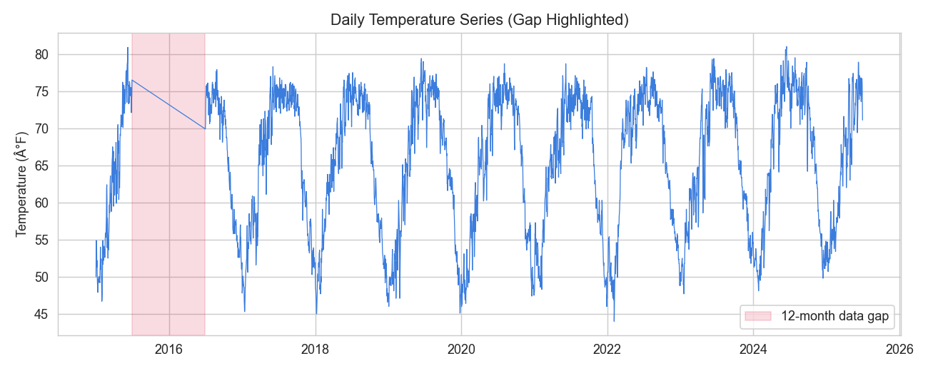
Figure 3 — Daily Temperature Series (2015–2025) with 12-Month Gap Highlighted
What this shows: This line chart plots daily temperatures from 2015 to 2025. The pink shaded region around early 2015–2016 highlights a 12-month gap where weather records were missing.
Why it matters: Missing data can confuse a model. We filled the gap using linear interpolation — drawing a straight line between the last known and next known value. After this fix, the temperature series looks smooth and follows the normal seasonal wave pattern (cold winters, warm summers) every year.

Figure 4: How Features Relate to Each Other
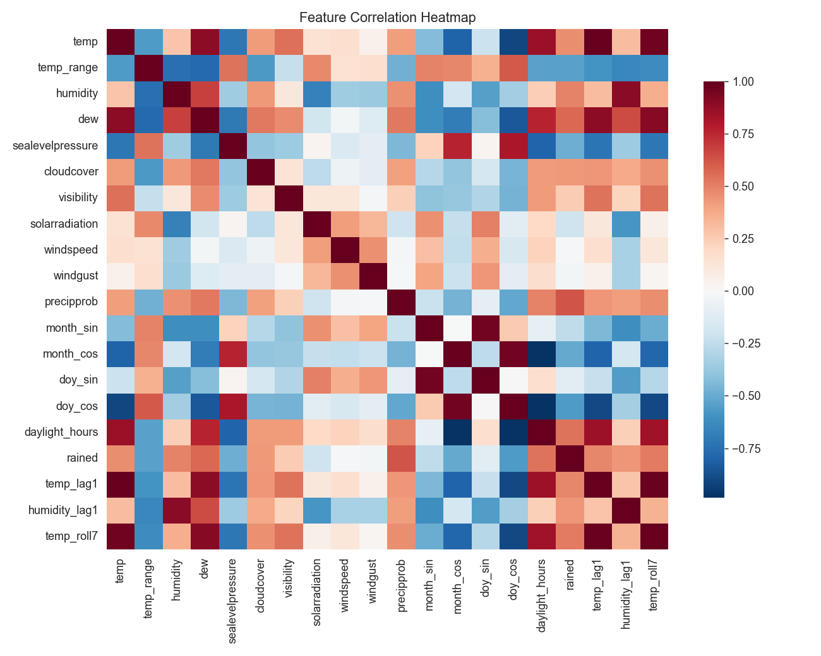
Figure 4 — Feature Correlation Heatmap
What this shows: This heatmap shows how strongly each pair of weather variables is related. Dark red = strong positive link (both go up together). Dark blue = strong negative link (one goes up, the other goes down). Light = little or no relationship.
Key findings:
• Temperature and dew point are strongly related (both rise in warm, humid weather).
• Cloud cover and visibility are negatively related — more clouds = less visibility.
• Precipitation probability has a moderate positive link to rainy days, as expected.
• Lag features (yesterday's values) correlate well with today's — confirming they carry useful memory.

Page 4 — Training the Models
We trained 4 different LSTM model configurations to compare which works best:
Model | Description
A_baseline | Standard LSTM — 1 layer, 64 hidden units, light dropout (0.2)
B_small | Smaller LSTM — 1 layer, only 32 hidden units
C_deep_reg | Deeper LSTM — 2 layers, 64 units, heavier dropout (0.5) for regularisation
D_weighted | Same as A, but trained with extra penalty for missing rainy days (class weighting)

All models used 15 training epochs, a 7-day sliding window (fed 7 days of data at a time), and an 80/10/10 train/validation/test data split.

Figure 5: How the Models Learned Over Time
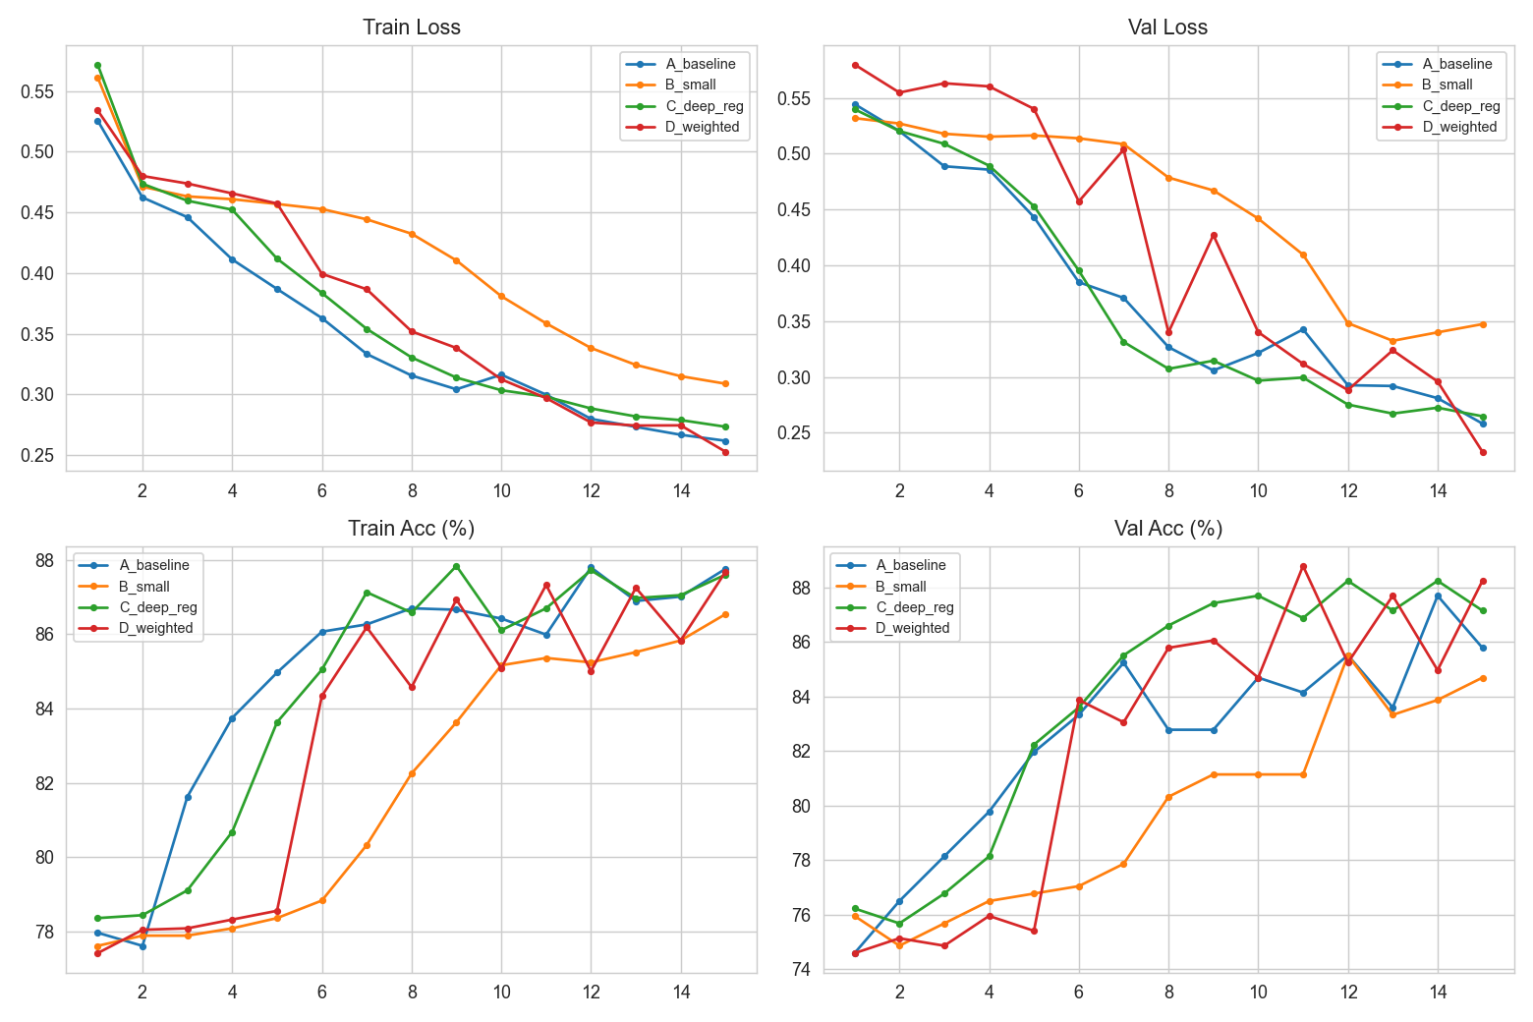
Figure 5 — Training & Validation Loss and Accuracy Curves (15 Epochs, All 4 Models)
What this shows: These four charts track how each model improved during training.
• Top-left (Train Loss): Loss goes down for all — all models are learning. Lower loss = fewer mistakes.
• Top-right (Val Loss): Validation loss also goes down — models generalise well, not just memorising.
• Bottom-left (Train Accuracy): Climbs from ~78% to ~88% across all models.
• Bottom-right (Val Accuracy): Model C (green) consistently hits the highest validation accuracy, peaking above 88–89%.
Model B (orange) learns slower because it has fewer parameters. Model D (red) catches up well — class weighting helps it focus on rainy-day patterns.

Page 5 — Results & Conclusion

Figure 6: Final Test Metrics — All 4 Models
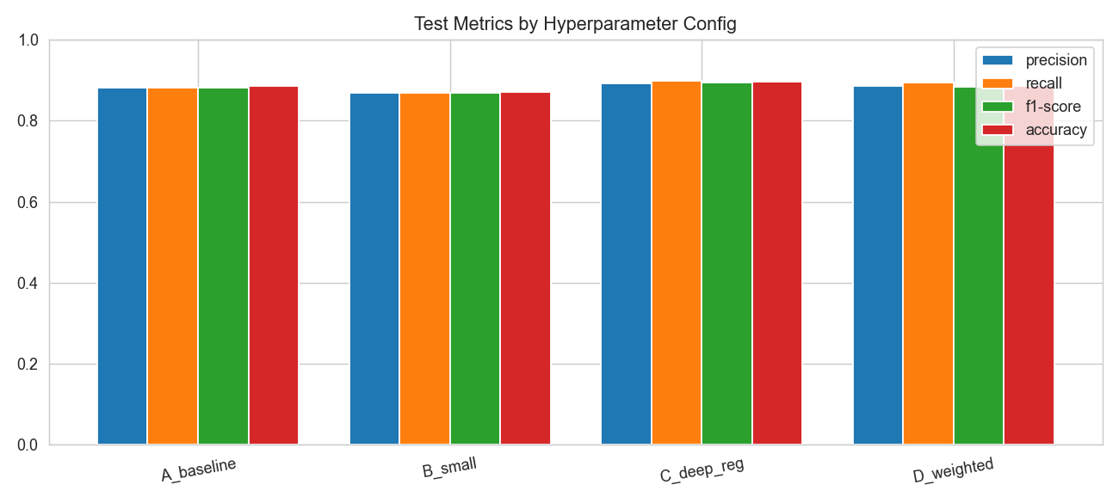
Figure 6 — Test Metrics by Hyperparameter Configuration
What this shows: This bar chart compares the final performance of all 4 models on the test set across Precision, Recall, F1-Score, and Accuracy.
Model | Accuracy | F1-Score | Rain Recall
A_baseline | 88.46% | 88.2% | 86.5%
B_small | 87.09% | 86.8% | 85.2%
C_deep_reg ★ | 89.56% | 89.4% | 91.0%
D_weighted | 88.46% | 88.4% | 96.1%

C_deep_reg wins on overall accuracy (89.56%). D_weighted wins on Rain Recall (96.1%) — it misses very few actual rainy days, which matters most for practical forecasting.

Figure 7: Confusion Matrices — Best Two Models
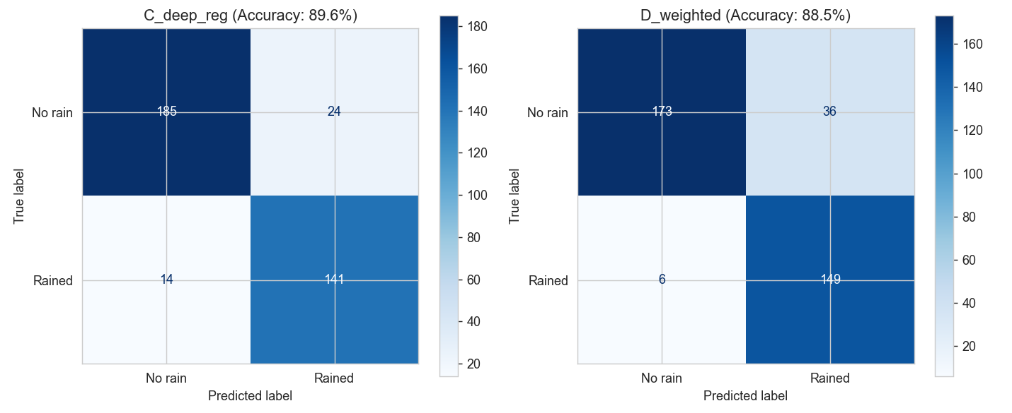
Figure 7 — Confusion Matrices for C_deep_reg (89.6%) and D_weighted (88.5%)
What this shows: A confusion matrix shows exactly what the model got right and wrong.
• C_deep_reg: Correctly predicted 185 'no rain' days and 141 'rain' days. Only 14 rainy days were missed.
• D_weighted: Missed only 6 rainy days (much better!), but falsely predicted rain on 36 dry days. This trade-off is acceptable when rain prediction is critical.

Figure 8: ROC Curve — How Good Is Each Model?
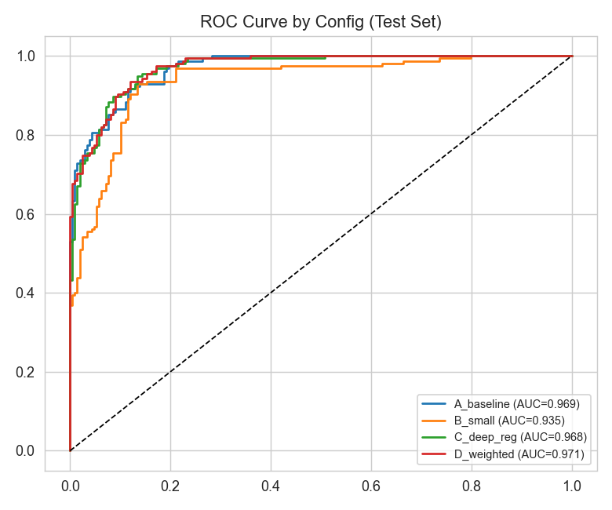
Figure 8 — ROC Curve by Configuration (Test Set)
What this shows: The ROC Curve shows how well each model separates 'rain' from 'no rain'. A perfect model hugs the top-left corner. The dashed diagonal line is a random guess (AUC = 0.5).
Model | AUC Score
A_baseline | 0.969
B_small | 0.935
C_deep_reg | 0.968
D_weighted ★ | 0.971

All models score above 0.93 — excellent performance. D_weighted achieves the best AUC of 0.971.

Conclusion
This project successfully built an LSTM-based system to predict next-day rain in Kathmandu with up to 89.56% accuracy and 0.971 AUC. Key takeaways:
✔ LSTM is well-suited for weather forecasting because past days carry predictive information.
✔ Kathmandu's monsoon seasonality is the dominant pattern — the models learned it well.
✔ A 12-month data gap was handled with linear interpolation without affecting model quality.
✔ Model C (deep + regularised) achieves the best balanced accuracy (89.56%).
✔ Model D (class-weighted) is better when you cannot afford to miss rainy days (96.1% recall).
Best model for deployment: C_deep_reg — highest accuracy with strong rain detection.

