**Lab Activity 5**

**Name: Nirja Upendrabhai Patel**

**Stdent ID: 100965379**

**1.resource created on GCP with terraform.**

**GCP-VOC.tf**

**provider "google" {**

**project = "dynamic-moment-441416-m2"**

**region = "us-east1"**

**credentials=("dynamic-moment-441416-m2-9aa348fdd5bc.json")**

**}**

**resource "google_compute_network" "patel_vpc" {**

**name = "patel-vpc-gcp"**

**auto_create_subnetworks = true**

**description = "VPC created for patel project"**

**}**

**Output:**

**VPC**

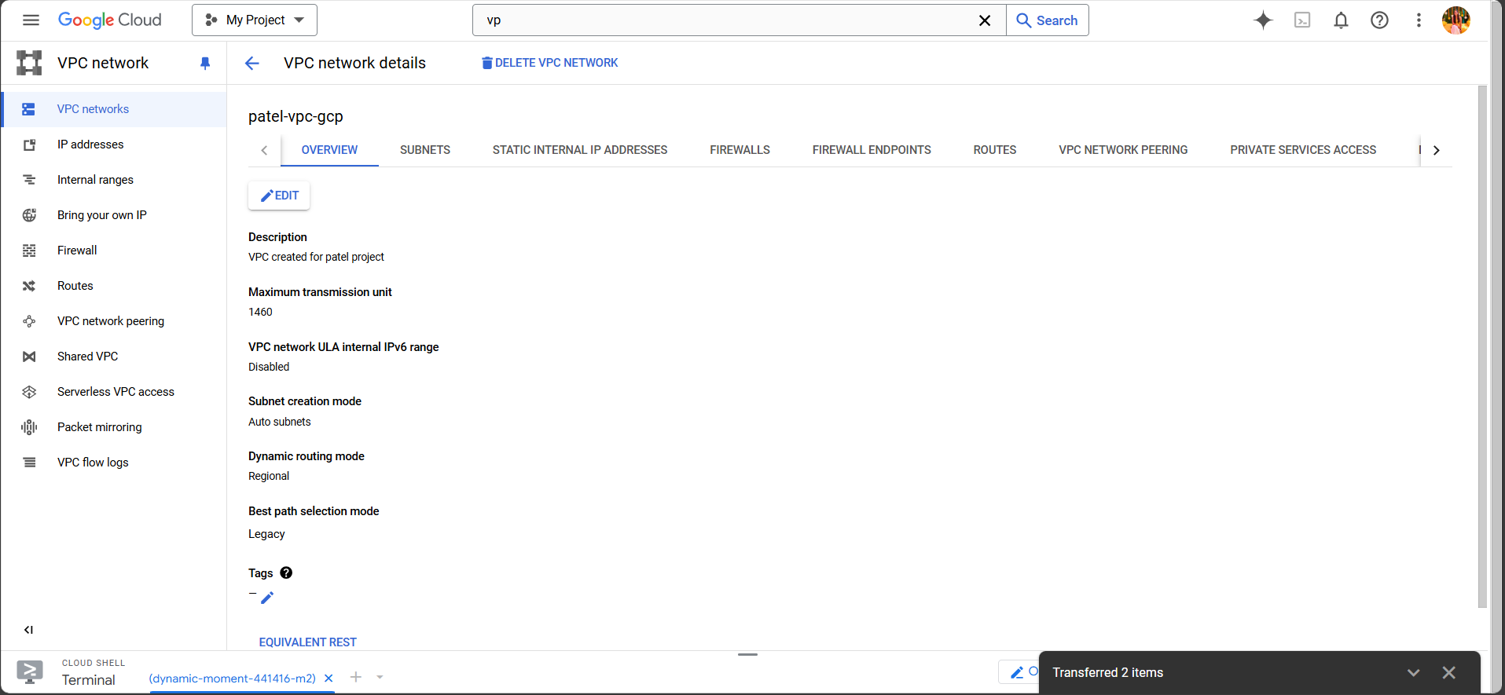

**Subnet**

**2.resource created on AWS with terraform. Aws-vpc.tf**

**provider "aws" {**

**region = "us-east-1"**

**}**

**resource "aws_vpc" "patel_vpc" {**

**cidr_block = "10.0.0.0/16"**

**tags = {**

**Name = "patel-vpc-aws"**

**}**

**}**

**VPC:**

**3. resource created on Azure with terraform**

**Azure-Vnet.tf**

**provider "azurerm" {**

**features {}**

**subscription_id = "f1dfb7e3-f606-4c89-a299-1286ae7c6052"**

**}**

**resource "azurerm_resource_group" "patel_rg" {**

**name = "patel-resource-group"**

**location = "East US"**

**}**

**resource "azurerm_virtual_network" "patel_vnet" {**

**name = "patel-vnet-azure"**

**address_space = ["10.0.0.0/16"]**

**location = azurerm_resource_group.patel_rg.location**

**resource_group_name = azurerm_resource_group.patel_rg.name**

**}**

**Vnet:**

**6. Completed terraform script**

**terraform {**

**required_providers {**

**aws = {**

**source = "hashicorp/aws"**

**version = "~> 4.16"**

**}**

**}**

**required_version = ">= 1.2.0"**

**}**

**provider "aws" {**

**region = "ca-central-1"**

**}**

**resource "aws_s3_bucket" "mybucket" {**

**bucket = "patel-lab5-bucket"**

**}**

**resource "aws_s3_bucket_public_access_block" "mybucket_access_block" {**

**bucket = aws_s3_bucket.mybucket.id**

**block_public_acls = false**

**block_public_policy = false**

**ignore_public_acls = false**

**restrict_public_buckets = false**

**}**

**resource "aws_s3_bucket_website_configuration" "mybucket_website" {**

**bucket = aws_s3_bucket.mybucket.id**

**index_document {**

**suffix = "index.html"**

**}**

**error_document {**

**key = "error.html"**

**}**

**}**

**resource "aws_s3_bucket_ownership_controls" "mybucket_ownership" {**

**bucket = aws_s3_bucket.mybucket.id**

**rule {**

**object_ownership = "BucketOwnerPreferred"**

**}**

**}**

**resource "aws_s3_bucket_acl" "mybucket_acl" {**

**bucket = aws_s3_bucket.mybucket.id**

**acl = "public-read"**

**depends_on = [**

**aws_s3_bucket_ownership_controls.mybucket_ownership,**

**aws_s3_bucket_public_access_block.mybucket_access_block**

**]**

**}**

**resource "aws_s3_bucket_policy" "mybucket_policy" {**

**bucket = aws_s3_bucket.mybucket.id**

**policy = jsonencode({**

**Version = "2012-10-17"**

**Statement = [**

**{**

**Sid = "PublicReadGetObject"**

**Effect = "Allow"**

**Principal = "*"**

**Action = "s3:GetObject"**

**Resource = [**

**aws_s3_bucket.mybucket.arn,**

**"${aws_s3_bucket.mybucket.arn}/*",**

**]**

**},**

**]**

**})**

**depends_on = [**

**aws_s3_bucket_public_access_block.mybucket_access_block**

**]**

**}**

**resource "aws_cloudfront_distribution" "mycdn" {**

**origin {**

**domain_name = "${aws_s3_bucket.mybucket.bucket_regional_domain_name}"**

**origin_id = "S3-${aws_s3_bucket.mybucket.id}"**

**}**

**default_cache_behavior {**

**target_origin_id = "S3-${aws_s3_bucket.mybucket.id}"**

**viewer_protocol_policy = "redirect-to-https"**

**allowed_methods = ["GET", "HEAD"]**

**cached_methods = ["GET", "HEAD"]**

**default_ttl = 3600**

**max_ttl = 86400**

**min_ttl = 0**

**forwarded_values {**

**query_string = false**

**cookies {**

**forward = "none"**

**}**

**}**

**}**

**restrictions {**

**geo_restriction {**

**restriction_type = "none"**

**}**

**}**

**viewer_certificate {**

**cloudfront_default_certificate = true**

**}**

**enabled = true**

**}**

**7. S3 section of the script is functional**

**8. CDN Section of the script is working**

**9. An index.html webpage successfully loads from your CDN when the instructor executes the script and adds an index.html to the created S3 bucket.**

