**FbBuy+1**

1. 3 Types of Authentications:
   1. Admin [ 0 roles ] :
      1. dashboard
   2. Vendors.
      1. dashboard
   3. Customers.
2. Tables:
   1. Auth_table:
      1. Admin
      2. Vendors
      3. Customers
   2. Products table
   3. Facebook pages
   4. Messages

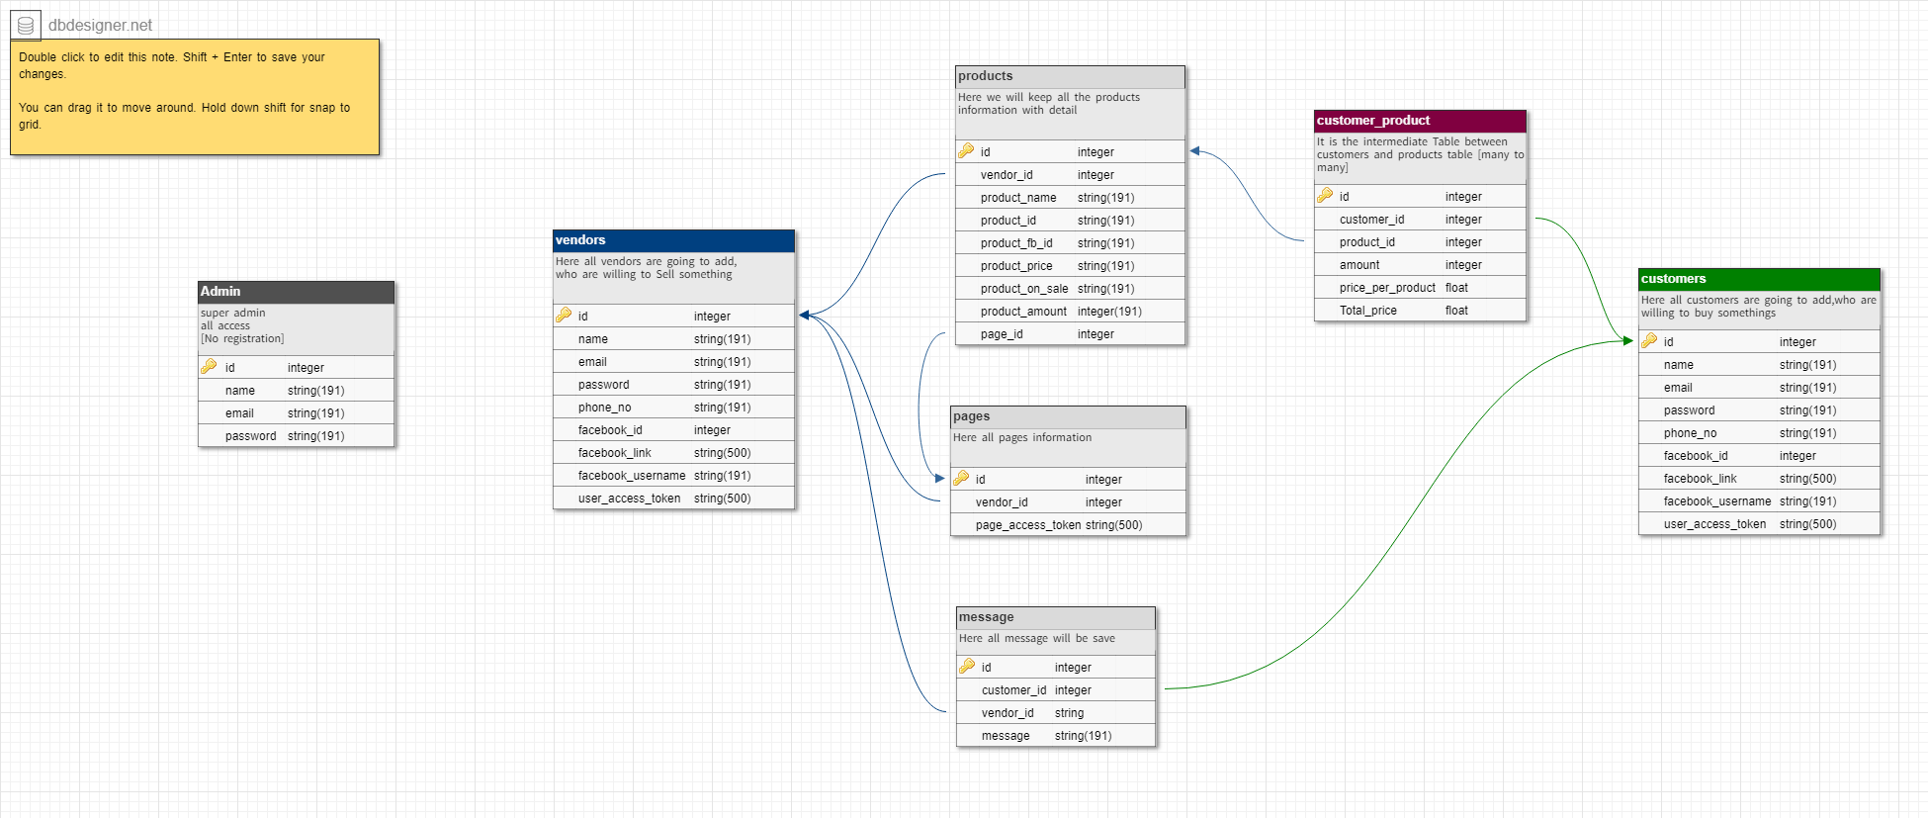

1. Pages: [ ]
   1. Customers :
      1. My profile
      2. Cart [after comments into any product post]
      3. Purchase History [ previously Buying ]
   2. Admin:
      1. Vendor list
         1. Edit
         2. Delete
      2. .
   3. Vendors:
      1. My profile
      2. My pages
         1. Product lists/Post Lists
            1. Total Comments list per post
            2. +1 comments list per post.
      3. Previous Customer list
         1. .
   4. Messenger Bot:

**How will it be done?**

1. Front-end [web Page] :
   1. Html, CSS, Bootstrap, JS, Ajax, JQuery.
   2. .
2. Back-end [web page]:
   1. PHP framework [ Laravel 5.5] & MySQL.
   2. .
3. Facebook integration:
   1. Graph API.
      1. Facebook login
      2. Messenger
      3. Webhook
   2. Facebook SDK
   3. User Access token
   4. Page Access token
   5. Post ID