

INDIAN SPACE RESEARCH ORGANISATION (ISRO)

ISRO TELEMETRY, TRACKING AND COMMAND NETWORK (ISTRAC)

INTERNSHIP REPORT ON

“HARDWARE-ACCELERATED MVDR ADAPTIVE BEAMFORMING

FOR 64-ELEMENT URA ON VERSAL FPGA”

Submitted to
Human Resource Development Division
ISRO Telemetry, Tracking and Command Network (ISTRAC)
Indian Space Research Organisation (ISRO)
Department of Space, Government of India

Internship Duration: 11/06/2026 – 24/07/2026

Submitted by
NIRJJALAA C R
B.E. Electronics and Communication Engineering
Government College of Engineering, Tirunelveli

Under the guidance of
Mr./Ms./Dr. __________________________
Designation: _________________________
Division/Group: _______________________
ISTRAC, ISRO

CERTIFICATE

This is to certify that Ms. NIRJJALAA C R, student of B.E. Electronics and Communication Engineering, Government College of Engineering, Tirunelveli, has successfully completed her internship work titled “Hardware-Accelerated MVDR Adaptive Beamforming for 64-Element URA on Versal FPGA” at ISRO Telemetry, Tracking and Command Network (ISTRAC), Indian Space Research Organisation (ISRO), Department of Space, Government of India.

The internship work was carried out during the period from 11/06/2026 to 24/07/2026. The work involved MATLAB-based MVDR algorithm development, Vitis HLS implementation, Vivado hardware integration, Versal FPGA execution, and MATLAB-versus-FPGA result verification.

This report is submitted as a record of the internship work carried out by her during the above-mentioned period.

Place: Peenya, Bengaluru
Date: 24/07/2026

Technical Guide

_________________________

_________________________

________________________

ISTRAC, ISRO

ACKNOWLEDGMENT

ABSTRACT

Adaptive beamforming is an important array signal processing technique used in radar, satellite communication, and wireless systems to improve the reception of a desired signal while suppressing interference from unwanted directions. In this internship project, Minimum Variance Distortionless Response (MVDR) adaptive beamforming is implemented for a 64-element Uniform Rectangular Array (URA) using MATLAB, Vitis HLS, Vivado, Vitis, and Versal FPGA. The antenna array is considered as an 8×8 URA with half-wavelength element spacing.
MATLAB was used as the golden reference model for developing and validating the MVDR algorithm. The received training data of size 64×5000 was used to compute the covariance matrix of the signal environment. Diagonal loading was applied to improve numerical stability. Instead of direct matrix inversion, the MVDR solution was obtained using Givens QR decomposition, back substitution, and normalization. This approach is more suitable for FPGA implementation because it converts the matrix solving process into a structured hardware-friendly form.
The verified algorithm was implemented in Vitis HLS as an AXI-based hardware accelerator. The generated IP was integrated in Vivado with Versal CIPS, AXI SmartConnect, AXI NoC, and DDR memory. A Vitis standalone C application running on the ARM processor was used to control the accelerator, transfer data through DDR, start the computation, and read back the final complex beamforming coefficients.
The design successfully completed HLS simulation, HLS synthesis, Vivado implementation, timing verification, XSA export, and board-level execution. The FPGA-generated coefficients were compared with MATLAB golden reference values and matched with a maximum printed error of 0.000000. The measured computation latency for one complete MVDR run was 1404.6 ms from ap_start to ap_done. This project demonstrates a complete MATLAB-to-FPGA workflow for MVDR adaptive beamforming on a Versal FPGA platform.

Keywords
MVDR Beamforming, Adaptive Beamforming, Uniform Rectangular Array, Vitis HLS, Vivado, Versal FPGA, QR Decomposition, AXI NoC, Hardware Acceleration, MATLAB Verification

TABLE OF CONTENTS

Chapter No. | Title | Page No.
— | Certificate
— | Acknowledgement
— | Abstract
— | List of Figures
— | List of Tables
1 | Introduction
2 | Background and Literature Review
3 | System Specification
4 | MVDR Adaptive Beamforming Algorithm
5 | MATLAB Golden Reference Model
6 | Vitis HLS Implementation
7 | Vivado Hardware Integration
8 | Vitis Software and Board Testing
9 | FPGA Verification and Result Analysis
10 | Performance Analysis
11 | Conclusion and Future Scope
— | References

LIST OF FIGURES

Figure No. | Figure Title | Page No.
1.1 | Basic concept of adaptive beamforming
3.1 | 8×8 Uniform Rectangular Array structure
4.1 | MVDR adaptive beamforming algorithm flow
4.2 | QR decomposition and back substitution flow
5.1 | MATLAB verification output showing QR accuracy and MVDR gain results
5.2 | MATLAB spatial heat map of MVDR beam pattern
5.3 | Target and interference direction representation used in MATLAB simulation
6.1 | Vitis HLS top function interface
6.2 | Vitis HLS C simulation result
6.3 | Vitis HLS C synthesis performance analysis report
7.1 | Vivado block design of MVDR accelerator system
7.2 | AXI NoC and DDR memory connection
7.3 | Vivado timing, utilization, and power summary
8.1 | Python data conversion output
8.2 | Vitis application build successful output
8.3 | PuTTY output showing FPGA board execution

LIST OF TABLES

Table No. | Table Title | Page No.
3.1 | System specifications of the proposed MVDR beamforming implementation
3.2 | Target and interference signal direction parameters
3.3 | Input and Output Data format
3.4 | Hardware and software tools used for implementation
4.1 | Major mathematical operations involved in MVDR beamforming
5.1 | MATLAB simulation parameters
6.1 | Vitis HLS top function input and output interface details
6.2 | HLS implementation modules and their functions
7.1 | Vivado block design components and their purpose
9.1 | MATLAB versus FPGA verification result
10.1 | Vivado implementation performance summary
10.2 | FPGA computation latency

CHAPTER 1

INTRODUCTION

1.1 Background
Modern radar, satellite communication, wireless communication, and defence systems require accurate reception of signals from desired directions while reducing the effect of unwanted interference. In practical signal environments, the received signal is often affected by noise, multipath components, and intentional or unintentional interference sources. When a single antenna is used, it receives signals from many directions without the ability to spatially separate the desired signal from the interference. To overcome this limitation, antenna array systems are widely used.
An antenna array consists of multiple antenna elements arranged in a specific geometry. The signals received by these antenna elements are combined in such a way that the overall array response becomes stronger in the desired direction and weaker in unwanted directions. This process is known as beamforming. Beamforming improves the quality of received signals by controlling the phase and amplitude of the signals received from each antenna element.
In conventional beamforming, the beam is usually steered towards a fixed direction. However, in real-time environments, interference sources may appear from different directions. Therefore, a more intelligent technique is required to adapt the antenna response according to the signal environment. This type of technique is called adaptive beamforming. Adaptive beamforming automatically adjusts the complex coefficients applied to each antenna element based on the received signal characteristics.
Among various adaptive beamforming techniques, the Minimum Variance Distortionless Response (MVDR) algorithm is widely used because it minimizes the output power due to interference and noise while maintaining a distortionless response in the desired signal direction. This means that the desired signal direction is preserved, while interference from other directions is suppressed. MVDR is highly useful in radar, satellite tracking, wireless communication, and array signal processing applications.
In this project, MVDR adaptive beamforming is implemented for a 64-element Uniform Rectangular Array (URA). The array is arranged as an 8×8 antenna structure with half-wavelength spacing between elements. The desired signal direction is considered at an azimuth angle of 40° and elevation angle of 0°.
Two interference sources are considered at different azimuth and elevation angles. The objective is to compute the adaptive beamforming coefficients required to preserve the target direction and reduce the interference directions.
The MVDR algorithm involves complex mathematical operations such as steering vector generation, covariance matrix computation, diagonal loading, QR decomposition, back substitution, and normalization. These operations are computationally intensive, especially for a 64-element antenna array with large training data. Therefore, implementing the algorithm only in software may not be suitable for real-time or low-latency applications. To address this, the algorithm is implemented using hardware acceleration on a Versal FPGA platform.
In this project, MATLAB is used as the golden reference model to validate the algorithm. The verified algorithm is then implemented using Vitis HLS and converted into an AXI-based hardware IP. The generated IP is integrated in Vivado with Versal CIPS, AXI SmartConnect, AXI NoC, and DDR memory. Finally, a Vitis C application is used to execute the design on the FPGA board and compare the hardware output with the MATLAB golden reference.

1.2 Need for Adaptive Beamforming
In practical radar and communication systems, the received signal environment is not ideal. The antenna array may receive the desired signal from one direction, while interference signals, jammers, noise, and multipath signals may arrive from other directions. If all these signals are received together without proper spatial filtering, the quality of the desired signal becomes poor. This affects the accuracy, reliability, and performance of the overall system.
A single antenna cannot separate signals based on their direction of arrival. It receives energy from many directions at the same time. To overcome this limitation, antenna arrays are used. By combining the signals received from multiple antenna elements with suitable complex coefficients, the array can be made more sensitive in the desired direction and less sensitive in interference directions. This process is known as beamforming.
In fixed or conventional beamforming, the beam is usually directed towards a predefined angle. However, this method may not perform well when interference sources change their position or when the signal environment varies with time. In real-world radar and satellite communication applications, the direction and strength of interference may not be constant.

Therefore, the beamforming system should be able to adjust its response according to the received signal condition.
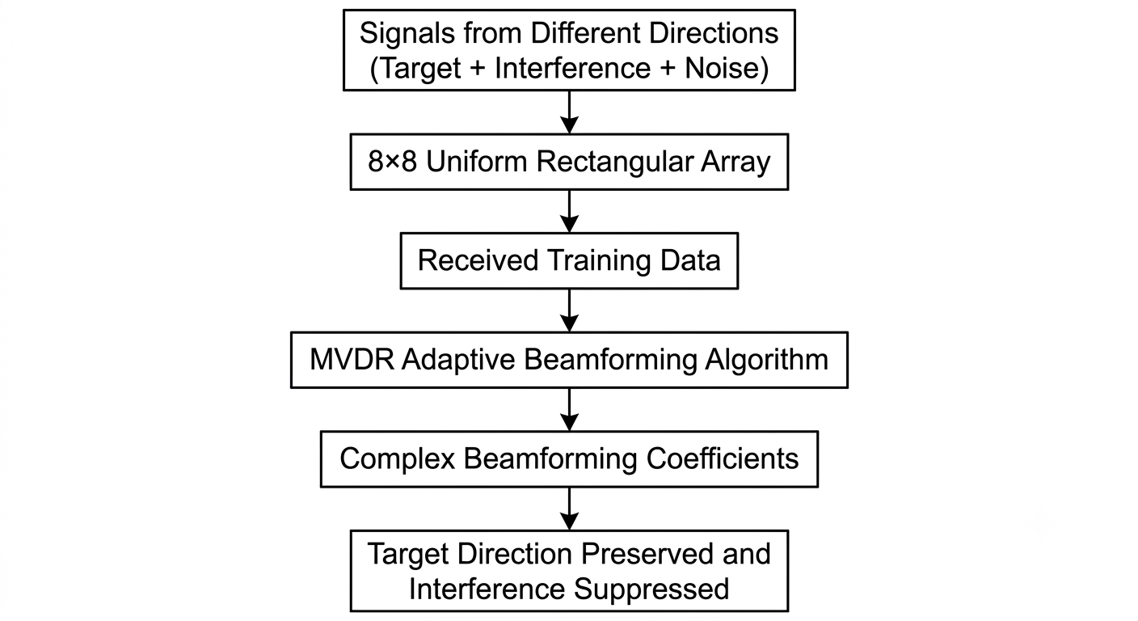
Figure 1.1 Basic concept of MVDR adaptive beamforming
Adaptive beamforming solves this problem by automatically updating the complex coefficients applied to the antenna elements. These coefficients are calculated based on the signal statistics obtained from the received data. As a result, the antenna array can preserve the desired signal direction while reducing the response towards unwanted interference directions. This makes adaptive beamforming more effective than fixed beamforming in dynamic and noisy environments.
The Minimum Variance Distortionless Response algorithm is one of the important adaptive beamforming techniques. It is designed to minimize the total output power caused by interference and noise while maintaining unity gain in the desired signal direction. This means that the desired signal is received without distortion, and the unwanted signals are suppressed as much as possible. Because of this property, MVDR is widely used in radar signal processing, direction-sensitive communication systems, satellite tracking, and defence applications.
In this project, adaptive beamforming is required because the system considers one desired signal and two interference sources arriving from different spatial directions. The 8×8 Uniform Rectangular Array provides spatial information about these signals. The MVDR algorithm uses this information to calculate the beamforming coefficients required to form a strong response towards the target direction and deep nulls towards interference directions.
Thus, the need for adaptive beamforming in this project arises from the requirement to improve desired signal reception, suppress interference, and demonstrate a practical FPGA-based implementation of a computationally intensive array signal processing algorithm.

1.3 Problem Statement
In modern radar, satellite communication, and wireless array systems, the received signal may contain the desired signal along with interference and noise. When multiple signals arrive from different spatial directions, it becomes necessary to separate the desired signal from unwanted signal components. A simple antenna system cannot perform this spatial separation effectively because it receives signals from all directions without directional control.
The problem considered in this project is the implementation of an adaptive beamforming system for a 64-element Uniform Rectangular Array. The array is arranged as an 8×8 antenna structure with half-wavelength spacing between adjacent elements. The system receives training data from all 64 antenna elements and uses this data to estimate the signal environment. Based on the target direction and received data, the MVDR algorithm is used to compute suitable complex beamforming coefficients.
The desired signal is considered to arrive from an azimuth angle of 40° and an elevation angle of 0°. Two interference sources are considered from different spatial directions. The first interference source is located at an azimuth angle of 30° and elevation angle of 10°, while the second interference source is located at an azimuth angle of -60° and elevation angle of -25°. The main requirement is to preserve the desired signal direction while reducing the array response towards the interference directions.
The received training data matrix can be represented as:
X_{train} ∈ C^(64 × 5000)
where 64 represents the number of antenna elements and 5000 represents the number of snapshots used for covariance estimation. The covariance matrix is computed from the training data as:
R = (X_{Train} × X_{train}ᴴ) / K
where R is the covariance matrix, X_{train}ᴴ is the conjugate transpose of the training data matrix, and K is the number of snapshots.
The MVDR beamforming problem is based on finding a complex coefficient vector that minimizes the output interference and noise power while maintaining a distortionless response in the target direction. This can be represented by the standard MVDR expression:
w = R⁻¹a / (aᴴR⁻¹a)
where w is the complex beamforming coefficient vector, R is the covariance matrix, and a is the steering vector corresponding to the desired direction.
However, direct matrix inversion is computationally expensive and difficult to implement efficiently in hardware. Therefore, this project avoids direct inversion and uses Givens QR decomposition, back substitution, and normalization to obtain the MVDR solution. The challenge is to implement this complete mathematical flow on a Versal FPGA platform and verify that the hardware output matches the MATLAB golden reference output.
Thus, the problem addressed in this project is to design, implement, integrate, and verify an FPGA-based MVDR adaptive beamforming system for a 64-element URA using MATLAB, Vitis HLS, Vivado, and Vitis.

1.4 Objectives of the Project
The main objective of this project is to implement and verify an MVDR adaptive beamforming system for a 64-element Uniform Rectangular Array using MATLAB, Vitis HLS, Vivado, Vitis, and Versal FPGA. The project focuses on developing a complete flow from algorithm simulation to FPGA-based hardware execution.
The specific objectives of the project are listed below:
- To study the concept of antenna arrays, beamforming, adaptive beamforming, and MVDR algorithm.
- To model an 8×8 Uniform Rectangular Array with 64 antenna elements and half-wavelength element spacing.
- To generate the steering vector for the desired target direction using azimuth and elevation angle information.
- To generate and process training data for the antenna array with interference and noise components.
- To compute the covariance matrix from the received training data and apply diagonal loading for numerical stability.
- To implement the MVDR mathematical solution using QR decomposition and back substitution instead of direct matrix inversion.
- To develop a MATLAB golden reference model for verifying the correctness of the MVDR algorithm.
- To implement the verified MVDR algorithm in Vitis HLS as an AXI-based hardware accelerator.
- To integrate the HLS-generated IP in Vivado with Versal CIPS, AXI SmartConnect, AXI NoC, and DDR memory.
- To create a Vitis standalone C application for controlling the FPGA accelerator and reading the computed output.
- To compare the FPGA-generated complex beamforming coefficients with the MATLAB golden reference values.
- To analyze the implementation results such as timing, utilization, power estimation, and computation latency.
Through these objectives, the project demonstrates a complete MATLAB-to-FPGA implementation flow for MVDR adaptive beamforming and provides practical exposure to algorithm development, hardware acceleration, FPGA integration, and board-level verification.

1.5 Scope of the Project
The scope of this project is limited to the design, implementation, and verification of MVDR adaptive beamforming for a 64-element Uniform Rectangular Array on a Versal FPGA platform. The project focuses on the complete development flow starting from MATLAB-based algorithm modelling to FPGA board-level execution and verification.
The antenna array considered in this project is an 8×8 Uniform Rectangular Array with half-wavelength spacing between adjacent elements. The system considers one desired signal direction and two interference directions. The desired signal is located at an azimuth angle of 40° and an elevation angle of 0°. The interference sources are located at different azimuth and elevation angles. The MVDR algorithm is used to preserve the desired direction and suppress the interference directions.

The input training data used in this project has a size of 64×5000, where 64 represents the number of antenna elements and 5000 represents the number of snapshots. The training data is used to compute the covariance matrix of the received signal environment. Diagonal loading is added to improve numerical stability during computation. The MVDR solution is obtained using QR decomposition and back substitution instead of direct matrix inversion.
The project includes MATLAB simulation, Vitis HLS implementation, Vivado block design integration, XSA export, Vitis software development, and board-level execution. The HLS-generated IP is connected with the Versal processing system using AXI interfaces. The ARM processor controls the hardware accelerator through AXI-Lite, while the input and output data are transferred through DDR memory using AXI master and AXI NoC.
The verification scope of the project includes comparison between FPGA-generated complex beamforming coefficients and MATLAB golden reference values. The output is verified by calculating the maximum error between MATLAB and FPGA results. Timing, utilization, power estimation, and latency are also considered for performance analysis.
The project does not include real-time antenna hardware data acquisition. The input signal data is generated and verified using MATLAB, then exported for FPGA testing. The current design focuses on functional correctness and complete FPGA implementation. Further optimization such as fixed-point conversion, single-precision implementation, deeper pipelining, and fully streaming real-time architecture can be considered as future improvements.
Thus, the scope of the project is to demonstrate a complete MATLAB-to-FPGA workflow for MVDR adaptive beamforming and to verify the correctness of the FPGA implementation using MATLAB golden reference results.

1.6 Organization of the Report
This report is organized into twelve chapters. Chapter 1 introduces the project background, need for adaptive beamforming, problem statement, objectives, and scope of the work. Chapter 2 presents the background and literature review related to antenna arrays, MVDR beamforming, QR decomposition, and FPGA-based signal processing.
Chapter 3 explains the system specification, including the 8×8 Uniform Rectangular Array, signal parameters, input data size, target and interference directions, and tools used. Chapter 4 describes the mathematical flow of the MVDR adaptive beamforming algorithm, including steering vector generation, covariance matrix computation, diagonal loading, QR decomposition, back substitution, and normalization.
Chapter 5 presents the MATLAB golden reference model and simulation results. Chapter 6 explains the Vitis HLS implementation of the MVDR algorithm. Chapter 7 describes the Vivado hardware integration of the HLS IP with Versal CIPS, AXI SmartConnect, AXI NoC, and DDR memory. Chapter 8 explains the Vitis software application and board-level execution.
Chapter 9 presents the FPGA verification by comparing the hardware output with MATLAB golden reference values. Chapter 10 discusses performance analysis, including timing, utilization, power estimation, and latency. Chapter 11 presents the beam pattern and spatial response analysis. Chapter 12 concludes the report and suggests future improvements.

CHAPTER 2

BACKGROUND AND LITERATURE REVIEW

2.1 Introduction
Array signal processing is an important area in modern radar, satellite communication, wireless communication, sonar, and defence systems. In many practical applications, signals are received from multiple directions at the same time. These signals may include the desired signal, interference, noise, and multipath components. The main aim of array signal processing is to use multiple antenna elements to improve the reception of the desired signal and reduce the influence of unwanted signals.
Beamforming is one of the major techniques used in array signal processing. It controls the directional response of an antenna array by applying suitable complex coefficients to the signals received from each antenna element. By adjusting these coefficients, the antenna array can form a beam in the desired direction and reduce the response in unwanted directions. This makes beamforming highly useful in systems where spatial selectivity is required.
Adaptive beamforming is an advanced form of beamforming in which the coefficients are calculated based on the received signal environment. Unlike fixed beamforming, adaptive beamforming can modify its response depending on the interference and noise conditions. This is especially useful in radar and satellite communication systems, where interference sources may change with time and direction.
The Minimum Variance Distortionless Response algorithm is one of the widely used adaptive beamforming methods. MVDR minimizes the output power due to interference and noise while maintaining a distortionless response in the desired direction. Due to this property, MVDR is suitable for applications requiring interference suppression and accurate target signal reception.
This chapter presents the background concepts required for understanding the project. It discusses antenna arrays, beamforming, adaptive beamforming, MVDR algorithm, QR decomposition, and FPGA-based hardware acceleration. It also provides a brief literature review of the existing methods and explains the need for implementing MVDR beamforming on FPGA hardware.

2.2 Antenna Array Systems
An antenna array is a group of antenna elements arranged in a specific pattern. Instead of using a single antenna, multiple antenna elements are used together to receive or transmit signals. The signals received by these elements are combined to form a directional response. This directional response allows the system to focus on signals coming from a desired direction and reduce signals arriving from unwanted directions.
The main advantage of an antenna array is that it provides spatial information. When a signal reaches different antenna elements, it arrives with small phase differences depending on the direction of arrival. These phase differences can be used to identify and control the direction in which the antenna array is most sensitive. This is the basic principle behind beamforming.
Antenna arrays can be arranged in different geometries. Some common array structures are linear arrays, circular arrays, planar arrays, and rectangular arrays. A Uniform Linear Array has elements arranged in a straight line. A Uniform Rectangular Array has elements arranged in rows and columns. In this project, an 8×8 Uniform Rectangular Array is considered. Therefore, the total number of antenna elements is 64.
The Uniform Rectangular Array is suitable for two-dimensional beamforming because it can process both azimuth and elevation angle information. Azimuth represents the horizontal direction, while elevation represents the vertical direction. Since the array has elements in both horizontal and vertical directions, it can form beams and nulls in a two-dimensional spatial region.
In this project, the spacing between adjacent antenna elements is considered as half wavelength. Half-wavelength spacing is commonly used in antenna array processing because it helps reduce spatial aliasing and supports effective beam steering. The 64-element URA provides enough spatial samples to form a beam towards the desired signal direction and suppress interference from other directions.
For an antenna array, the received signal from all elements can be represented as a vector. If there are 64 antenna elements, the received signal vector at a particular snapshot can be represented as:
$$x\left(k\right)∈ C^{64×1}$$
Here, $x\left(k\right)$represents the received complex signal vector at the $k^{th}$snapshot. Each element of this vector corresponds to the received signal at one antenna element. For multiple snapshots, the received data can be arranged as a matrix. In this project, 5000 snapshots are used, so the training data matrix size is:
X_{train} ∈ C^(64×5000)
The antenna array uses this received data to estimate the signal environment and compute the required adaptive beamforming coefficients. These coefficients are then used to combine the received signals in a way that improves the desired signal response and suppresses interference.

2.3 Beamforming Concept
Beamforming is a signal processing technique used to control the directional response of an antenna array. In an antenna array, each antenna element receives a version of the incoming signal with a different phase depending on the direction from which the signal arrives. By applying suitable complex coefficients to the received signal from each antenna element and adding them together, the antenna array can be made more sensitive in a selected direction.
The main idea of beamforming is to combine the signals from multiple antenna elements in such a way that signals from the desired direction add constructively, while signals from unwanted directions cancel or reduce. This helps improve the signal quality and increases the ability of the system to receive the desired signal even in the presence of interference and noise.
For an antenna array with 64 elements, the received signal vector at a particular snapshot can be represented as $x\left(k\right)$. A complex coefficient vector $w$is applied to the received signal vector. The beamformer output can be represented as:
y(k) = wᴴx(k)
where $y\left(k\right)$is the beamformer output, $w^{H}$is the conjugate transpose of the beamforming coefficient vector, and $x\left(k\right)$is the received signal vector from the antenna array.
The beamforming coefficient vector controls the direction in which the antenna array receives signals strongly. If the coefficients are selected properly, the array forms a main beam towards the desired direction. At the same time, the array response can be reduced in unwanted directions. The reduced response in an interference direction is called a null.
In conventional beamforming, the coefficients are usually calculated based only on the desired direction. This method is simple, but it may not perform well when strong interference is present. If the interference direction is close to the desired direction or changes with time, fixed beamforming may not be sufficient.
Adaptive beamforming improves this by calculating the coefficients based on the received signal environment. It uses the statistical properties of the received data to determine the best coefficient values. As a result, adaptive beamforming can preserve the desired direction and suppress interference more effectively than fixed beamforming.
In this project, the MVDR adaptive beamforming technique is used. The MVDR method calculates the complex coefficients in such a way that the desired signal direction is maintained without distortion while the total output power due to interference and noise is minimized. Therefore, beamforming is the basic concept behind the project, and MVDR is the adaptive method used to achieve better interference suppression.

2.4 Adaptive Beamforming
Adaptive beamforming is an advanced form of beamforming in which the beamforming coefficients are calculated according to the received signal environment. In practical systems, interference and noise are not always fixed. Their direction, strength, and characteristics may change with time. Therefore, a fixed beamforming method may not always provide good performance. Adaptive beamforming overcomes this limitation by changing the coefficients based on the input data.
In an adaptive beamformer, the antenna array receives signal samples from all antenna elements. These samples are used to estimate the statistical properties of the received signal environment. One important statistical quantity used in adaptive beamforming is the covariance matrix. The covariance matrix shows how the signals received by different antenna elements are related to each other. This information helps the algorithm identify the presence of interference and noise in the received data.
The general output of a beamformer is given by:
y(k) = wᴴx(k)
where $y\left(k\right)$is the beamformer output, $w$is the complex beamforming coefficient vector, and $x\left(k\right)$is the received signal vector at the $k^{th}$snapshot. The purpose of adaptive beamforming is to choose the coefficient vector $w$in such a way that the desired signal is preserved and the unwanted signal components are reduced.
The main advantage of adaptive beamforming is its ability to form nulls automatically in the direction of interference. A null is a direction where the array response becomes very low. By placing nulls near interference directions, the system reduces the effect of unwanted signals. At the same time, the main beam is maintained in the desired direction so that the target signal can be received properly.
Adaptive beamforming techniques are widely used in radar systems, sonar systems, satellite communication, wireless base stations, and defence applications. In radar and satellite systems, the desired signal may be weak compared to interference or noise. Adaptive beamforming improves the signal-to-interference-plus-noise ratio by controlling the spatial response of the antenna array.
In this project, adaptive beamforming is implemented using the Minimum Variance Distortionless Response method. The MVDR method uses the covariance matrix of the received training data and the steering vector of the desired direction to calculate the required complex coefficients. These coefficients are then used to preserve the target direction and suppress interference directions.
For a 64-element antenna array, the adaptive beamforming coefficient vector contains 64 complex values. Each value corresponds to one antenna element. The coefficient vector can be represented as:
w = [w₁, w₂, w₃, ..., w₆₄]ᵀ
Each coefficient controls the amplitude and phase contribution of the corresponding antenna element. When all 64 weighted signals are combined, the final array response is formed. Therefore, adaptive beamforming provides spatial filtering by using the antenna array structure and the received signal statistics.

2.5 Minimum Variance Distortionless Response Algorithm
The Minimum Variance Distortionless Response algorithm is an adaptive beamforming method used to improve the reception of a desired signal in the presence of interference and noise. The main aim of MVDR is to minimize the output power of the beamformer while maintaining the desired signal without distortion. This means that the array response is kept equal to unity in the desired direction, while the response in interference directions is reduced.
The word minimum variance means that the algorithm tries to reduce the total output power caused by interference and noise. The word distortionless response means that the desired signal direction is preserved without attenuation. Therefore, MVDR is useful when the system must receive a target signal from a known direction while suppressing signals arriving from other directions.
The output of an antenna array beamformer is given by:
y(k) = w^H x(k)
where $y\left(k\right)$is the beamformer output, $w$is the complex beamforming coefficient vector, $w^{H}$is the conjugate transpose of $w$, and $x\left(k\right)$is the received signal vector at the $k^{th}$snapshot.
The output power of the beamformer depends on the covariance matrix of the received signal. The covariance matrix is represented as $R$. The MVDR algorithm tries to minimize the output power:
w^H R w
At the same time, it must satisfy the distortionless constraint:
a^H w = 1
where $a$is the steering vector corresponding to the desired signal direction. This condition ensures that the desired direction is preserved with unity gain.
Therefore, the MVDR optimization problem can be written as:
minimize w^H R w
subject to a^H w = 1
The solution of this optimization problem gives the standard MVDR expression:
w = R^-1 a / (a^H R^-1 a)
In this expression, $R^{-1}$represents the inverse of the covariance matrix. However, directly calculating the inverse of a 64×64 complex matrix is computationally expensive and not suitable for efficient FPGA implementation. Direct inversion requires many arithmetic operations and may also cause numerical stability issues.
To avoid direct matrix inversion, this project solves the MVDR equation using QR decomposition and back substitution. Instead of calculating $R^{-1}a$directly, the system solves the linear equation:
R w_unnorm = a
The solution obtained from this equation is then normalized using:
w = w_unnorm / (a^H w_unnorm)
This produces the final MVDR beamforming coefficient vector. The normalization step ensures that the distortionless condition is satisfied.
In this project, the MVDR algorithm is applied to a 64-element Uniform Rectangular Array. The covariance matrix is computed from 64×5000 training samples. The steering vector is generated using the target azimuth and elevation angles. The final output of the algorithm is a 64-element complex coefficient vector, which is used to form the adaptive spatial response of the antenna array.
The MVDR algorithm is suitable for this project because it provides both target preservation and interference suppression. It also gives a clear mathematical structure that can be implemented and verified using MATLAB, Vitis HLS, Vivado, and FPGA hardware.
In practical implementation, direct matrix inversion is computationally complex, especially for a 64×64 complex covariance matrix. Therefore, hardware-oriented implementations often use matrix decomposition methods such as QR decomposition to solve the MVDR equation more efficiently. In this project, QR decomposition and back substitution are used in the implementation stage to avoid direct matrix inversion.

2.6 FPGA-Based Signal Processing
Digital signal processing algorithms are widely used in radar, communication, image processing, control systems, and embedded applications. Many of these algorithms involve repeated arithmetic operations such as multiplication, addition, matrix computation, filtering, and complex number processing. When these operations are executed only on a general-purpose processor, the execution time may become high for large data sizes or real-time applications.
A Field Programmable Gate Array is a reconfigurable hardware device that can be programmed to implement digital circuits. Unlike a processor, which executes instructions sequentially, an FPGA can perform many operations in parallel using dedicated hardware resources. This makes FPGA suitable for computationally intensive signal processing applications.
In adaptive beamforming, operations such as covariance matrix computation, complex arithmetic, matrix decomposition, and triangular system solving require a large number of mathematical calculations. For a 64-element antenna array, the covariance matrix size becomes 64×64, and the training data may contain thousands of snapshots. Therefore, implementing such an algorithm on FPGA provides a practical way to study hardware acceleration of array signal processing.
Vitis HLS allows C/C++ algorithms to be converted into hardware IP blocks. This reduces the need to write the complete design manually in hardware description languages such as Verilog or VHDL. The generated HLS IP can be connected with other system blocks in Vivado using standard AXI interfaces. In this project, the MVDR algorithm is implemented as an AXI-based HLS IP and integrated with the Versal processing system, AXI SmartConnect, AXI NoC, and DDR memory.
The main advantage of FPGA-based implementation is that the computational part of the algorithm can be moved from software to hardware. The processor is used mainly for control, while the programmable logic performs the major mathematical operations. This approach is known as hardware acceleration.
In this project, the FPGA implementation focuses on functional correctness and MATLAB-based verification. The hardware output is compared with the MATLAB golden reference to confirm that the FPGA implementation produces correct results. Further optimization such as single-precision arithmetic, fixed-point conversion, pipelining, and parallel architecture design can be considered in future work to reduce latency and improve performance.

2.7 Summary
This chapter presented the basic background required for understanding the project. It explained antenna arrays, beamforming, adaptive beamforming, and the MVDR algorithm. The chapter also discussed the need for FPGA-based signal processing for computationally intensive algorithms. These concepts form the foundation for the detailed MVDR algorithm and hardware implementation explained in the upcoming chapters.

CHAPTER 3

SYSTEM SPECIFICATION

3.1 Introduction
This chapter describes the system specification of the proposed MVDR adaptive beamforming implementation. The project is based on a 64-element Uniform Rectangular Array arranged in an 8×8 structure. The system considers one desired signal direction and two interference signal directions. The received training data is used to estimate the signal environment and compute the adaptive beamforming coefficients using the MVDR algorithm.
The implementation flow consists of MATLAB algorithm modelling, Vitis HLS hardware design, Vivado block design integration, Vitis software development, and Versal FPGA board-level execution. MATLAB is used as the golden reference model, while the FPGA implementation is verified by comparing the hardware-generated output with MATLAB reference values.
The system uses complex-valued input training data. Since FPGA implementation handles real and imaginary values separately, the training data is divided into real and imaginary arrays. The final output is also represented as separate real and imaginary arrays. This chapter explains the array configuration, signal parameters, input-output data format, and tools used for implementation.

3.2 Array Configuration
The antenna array used in this project is a Uniform Rectangular Array. A Uniform Rectangular Array contains antenna elements arranged in rows and columns with uniform spacing between adjacent elements. In this project, the array consists of 8 elements along one direction and 8 elements along the other direction. Therefore, the total number of antenna elements is 64.
The element spacing is considered as half wavelength. Half-wavelength spacing is commonly used in antenna array processing because it helps in effective beam steering and reduces spatial aliasing. Since the array is rectangular, it can process both azimuth and elevation angle information. This makes the array suitable for two-dimensional beamforming applications.
The 8×8 Uniform Rectangular Array structure used in this project is shown in Figure 3.1.

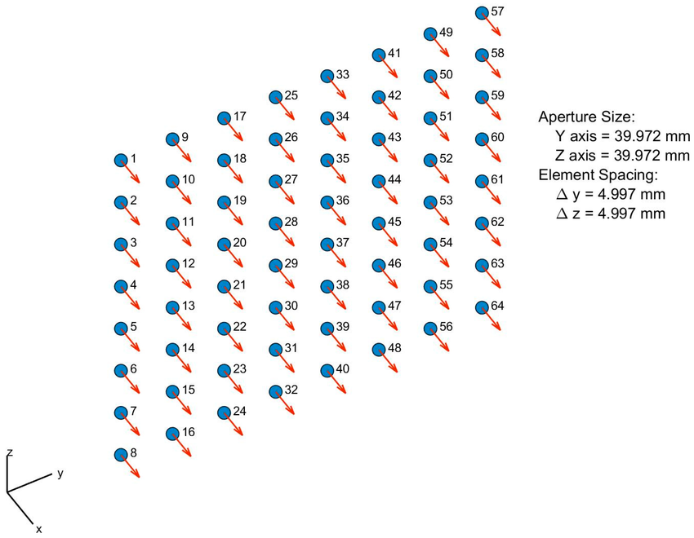
Figure 3.1 8×8 Uniform Rectangular Array structure
The array configuration used in this project is shown in Table 3.1.
Table 3.1 System specifications of the proposed MVDR implementation
Parameter | Value
Array type | Uniform Rectangular Array
Array size | 8 × 8
Total number of elements | 64
Element spacing | 0.5 wavelength
Number of snapshots | 5000
Training data size | 64 × 5000
Algorithm used | MVDR adaptive beamforming
Matrix solving method | QR decomposition and back substitution
FPGA platform | Versal FPGA
Development tools | MATLAB, Vitis HLS, Vivado, Vitis

3.3 Target and Interference Signal Parameters
The proposed system considers one desired signal and two interference signals. The desired signal represents the target direction that must be preserved by the adaptive beamformer. The interference signals represent unwanted signal sources that must be suppressed by the MVDR algorithm.
In this project, the desired signal is assumed to arrive from an azimuth angle of 40° and an elevation angle of 0°. The first interference signal is assumed to arrive from an azimuth angle of 30° and an elevation angle of 10°. The second interference signal is assumed to arrive from an azimuth angle of -60° and an elevation angle of -25°. These directions are used to generate the steering vectors for MATLAB simulation and FPGA verification.
The target and interference direction parameters are listed in Table 3.2.
Table 3.2 Target and interference signal direction parameters
Signal Type | Azimuth Angle | Elevation Angle | Purpose
Desired signal / Target | 40° | 0° | Direction to be preserved
Interference signal 1 | 30° | 10° | Direction to be suppressed
Interference signal 2 | -60° | -25° | Direction to be suppressed

The MVDR algorithm uses the target steering vector to maintain unity response in the desired direction. The interference and noise information is captured through the training data and covariance matrix. Based on this information, the adaptive beamformer forms a strong response in the target direction and reduced response in the interference directions.

3.4 Input and Output Data Format
The input data used in this project is the received training data from the 64 antenna elements. Since the system uses 5000 snapshots, the complete training data matrix has a size of 64×5000. Each row represents one antenna element, and each column represents one snapshot. Therefore, the training data contains the received signal information from all antenna elements over multiple time samples.
The received antenna signals are complex-valued because both magnitude and phase information are required for beamforming. In MATLAB, complex values can be directly represented using real and imaginary parts. However, for FPGA implementation and AXI memory transfer, the complex data is separated into two arrays: one array for the real part and another array for the imaginary part.
The training data is exported from MATLAB as two CSV files. The real part of the training data is stored in Xtrain_real.csv, and the imaginary part is stored in Xtrain_imag.csv. These files are then converted into a C header file for use in the Vitis application. The flattened memory order used in this project is sensor-major order, where the data index is calculated as:
index = sensor_index × K + snapshot_index
Here, K represents the number of snapshots. This memory order ensures that the FPGA hardware reads the data in the same arrangement as the MATLAB reference model.
The final output of the FPGA implementation is the complex MVDR beamforming coefficient vector. Since the array contains 64 antenna elements, the output contains 64 complex coefficients. Similar to the input data, the output coefficients are represented using separate real and imaginary arrays. Therefore, the FPGA writes the final output into w_real[64] and w_imag[64].
The input and output data format used in the implementation is shown in Table 3.3.
Table 3.3 Input and output data format
Data Name | Size | Type | Purpose
Xtrain_real | 320000 | Double | Real part of training data
Xtrain_imag | 320000 | Double | Imaginary part of training data
az_deg | 1 | Double | Target azimuth angle
el_deg | 1 | Double | Target elevation angle
d | 1 | Double | Antenna element spacing
w_real | 64 | Double | Real part of output coefficients
w_imag | 64 | Double | Imaginary part of output coefficients

The separation of real and imaginary values simplifies the hardware interface and makes the data suitable for AXI-based memory transfer. The input arrays are read from DDR memory by the HLS IP, and the output coefficient arrays are written back to DDR after the computation is completed.
3.5 Hardware and Software Tools Used
The implementation of the MVDR adaptive beamforming system requires both software tools and hardware platforms. MATLAB is used for algorithm modelling and golden reference verification. Vitis HLS is used to convert the C/C++ implementation of the algorithm into an AXI-based hardware IP. Vivado is used for hardware integration, synthesis, implementation, timing analysis, and XSA export. Vitis is used for creating the standalone application that runs on the ARM processor of the Versal device.
The hardware platform used in this project is a Versal FPGA board. The HLS-generated MVDR accelerator is integrated with the Versal processing system, AXI SmartConnect, AXI NoC, and DDR memory. The ARM processor controls the accelerator, while the programmable logic performs the major mathematical computation.
The tools and platforms used in this project are listed in Table 3.4.
Table 3.4 Hardware and software tools used for implementation
Tool / Platform | Purpose
MATLAB | Algorithm development, simulation, golden reference generation, and beam pattern verification
Python | Conversion of MATLAB CSV data into C header format for Vitis testing
Vitis HLS | C/C++ to hardware IP generation and HLS simulation/synthesis
Vivado | IP integration, block design creation, synthesis, implementation, timing, utilization, and power analysis
Vitis | Standalone C application development and FPGA board-level testing
PuTTY / Serial Terminal | Viewing FPGA board execution output
Versal FPGA Platform | Hardware execution of the MVDR accelerator
DDR Memory | Storage of input training data and output complex coefficients
AXI SmartConnect | Connection between processor and HLS IP control interface
AXI NoC | Data path between HLS IP and DDR memory

The use of these tools provides a complete development flow from algorithm modelling to FPGA verification. MATLAB provides the reference result, Vitis HLS converts the algorithm into hardware, Vivado integrates the generated IP with the Versal system, and Vitis executes the final design on the FPGA platform.

3.6 Summary
This chapter described the system specification of the proposed MVDR adaptive beamforming implementation. The 64-element antenna array was considered as an 8×8 Uniform Rectangular Array with half-wavelength element spacing. The target and interference signal directions were defined using azimuth and elevation angles.
The chapter also explained the input and output data format used for FPGA implementation. The training data was represented as separate real and imaginary arrays, and the final output was represented as 64 complex beamforming coefficients. The major hardware and software tools used in the project, including MATLAB, Python, Vitis HLS, Vivado, Vitis, AXI NoC, DDR memory, and Versal FPGA, were also listed.
Overall, this chapter provided the basic system details required for understanding the MVDR algorithm implementation and hardware design flow discussed in the following chapters.

CHAPTER 4

MVDR ADAPTIVE BEAMFORMING ALGORITHM

4.1 Introduction
This chapter explains the mathematical and logical flow of the Minimum Variance Distortionless Response adaptive beamforming algorithm used in this project. MVDR is an adaptive spatial filtering technique that calculates complex beamforming coefficients for an antenna array. These coefficients are used to preserve the desired signal direction while reducing the response towards interference and noise.
In this project, MVDR beamforming is applied to a 64-element Uniform Rectangular Array. The array is arranged as an 8×8 structure. The desired signal direction is represented using azimuth and elevation angles. The training data from the antenna array is used to estimate the covariance matrix of the received signal environment. This covariance matrix contains information about interference and noise present in the received data.
The standard MVDR solution requires the inverse of the covariance matrix. However, direct matrix inversion is computationally expensive and difficult to implement efficiently in FPGA hardware. Therefore, this project avoids direct inverse computation. Instead, the MVDR equation is solved using QR decomposition and back substitution. Finally, normalization is performed to satisfy the distortionless response condition.
The major stages of the MVDR algorithm used in this project are steering vector generation, training data formation, covariance matrix computation, diagonal loading, QR decomposition, back substitution, and normalization. The final output is a set of 64 complex beamforming coefficients.
The overall MVDR adaptive beamforming algorithm flow used in this project is shown in Figure 4.1.

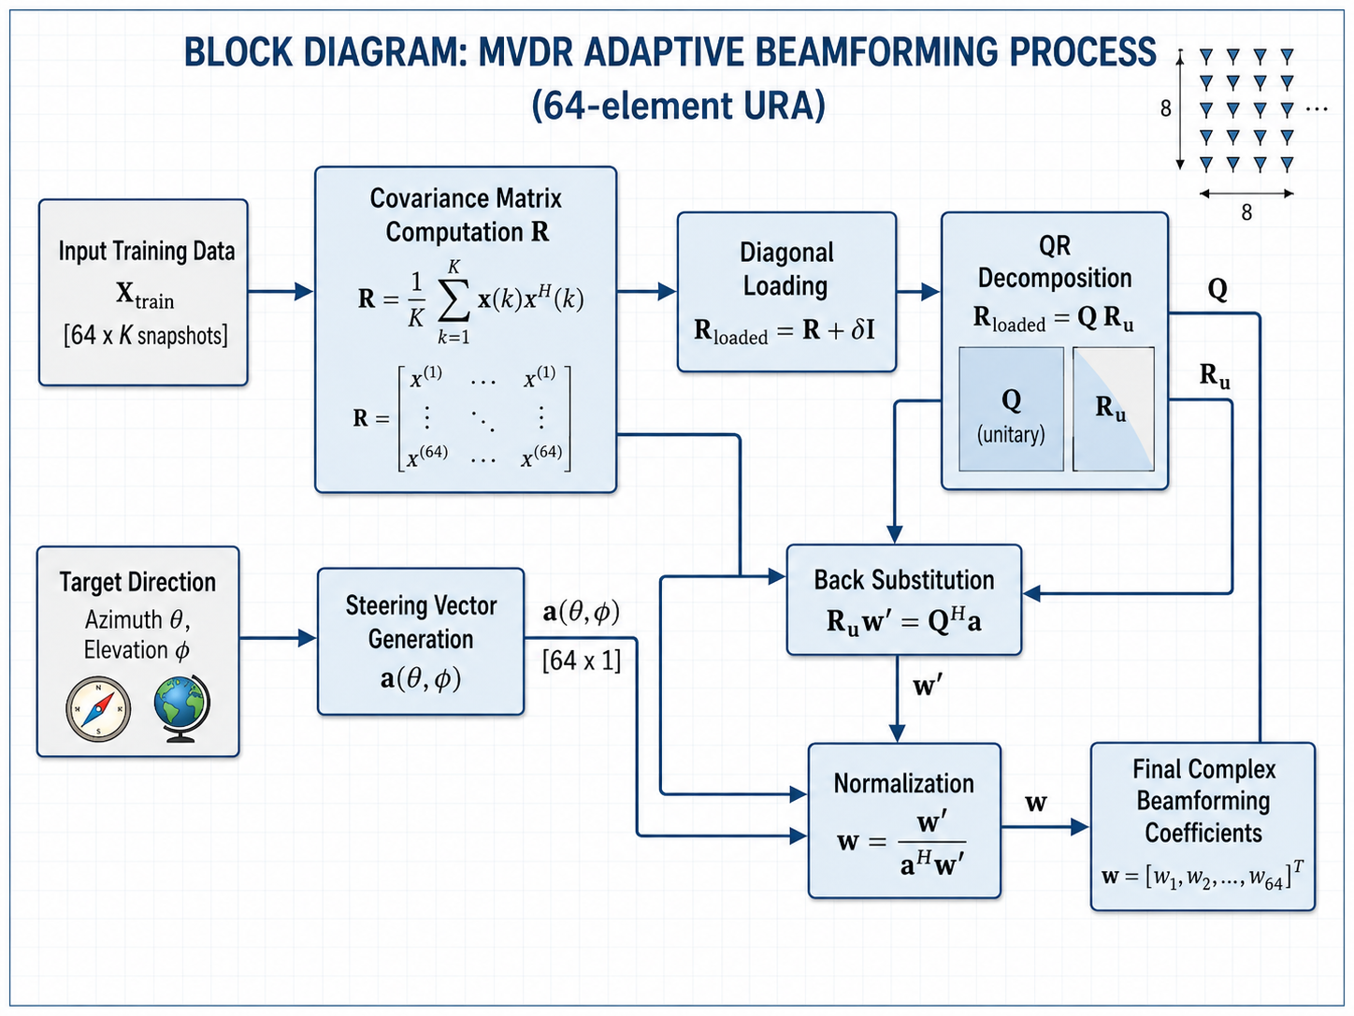
Figure 4.1 MVDR adaptive beamforming algorithm flow

4.2 Steering Vector Generation
The steering vector represents the phase response of the antenna array for a signal arriving from a particular direction. In an antenna array, the same incoming signal reaches different antenna elements with different phase shifts. These phase shifts depend on the direction of arrival and the physical position of each antenna element. Therefore, the steering vector acts as the spatial signature of a signal direction.
In this project, the antenna array is an 8×8 Uniform Rectangular Array. Since the array has elements in both horizontal and vertical directions, both azimuth and elevation angles are used for steering vector generation. The desired signal direction is given by azimuth angle $θ$and elevation angle $ϕ$. For the target direction used in this project, the azimuth angle is 40° and the elevation angle is 0°.
For a Uniform Rectangular Array, each antenna element has a position represented by its row and column index. If $x$represents the horizontal element position and $y$represents the vertical element position, the phase shift at each antenna element can be calculated using the direction information. The directional components are given as:

u = sin(θ) cos(φ)
v = sin(φ)
The phase value for each antenna element is calculated as:
phase = 2πd(xu + yv)
where $d$is the antenna element spacing. In this project, the spacing is considered as $d=0.5$, which represents half-wavelength spacing.
The complex steering vector element is then computed as:
a = e^(j phase)
Using Euler’s formula, this can be written as:
a = cos(phase) + j sin(phase)
In the implementation, the steering vector is normalized by dividing each element by $\sqrt{N}$, where $N=64$. This normalization keeps the steering vector power controlled and consistent during MVDR computation.
For the 64-element array, the steering vector has the size:
a(θ, φ) ∈ C^(64×1)
Each element of this vector corresponds to one antenna element in the 8×8 array. The generated steering vector is later used in the MVDR algorithm to preserve the desired direction during coefficient calculation.
In simple terms, the steering vector tells the algorithm how the target signal appears across all 64 antenna elements. MVDR uses this vector to make sure that the target direction is not suppressed while reducing the response towards interference directions.
4.3 Covariance Matrix Computation
The covariance matrix is an important part of the MVDR adaptive beamforming algorithm. It represents the statistical relationship between the signals received by different antenna elements. In an antenna array, each antenna element receives a signal that may contain interference and noise. By calculating the covariance matrix, the algorithm can understand how the received signals are correlated across the array.
In this project, the training data matrix is represented as $X_{train}$. The size of this matrix is 64×5000, where 64 represents the number of antenna elements and 5000 represents the number of snapshots. Each row of the matrix corresponds to one antenna element, and each column corresponds to one time snapshot.
The covariance matrix is calculated using the training data as:
R = (X_train X_train^H) / K
where $R$is the covariance matrix, $X_{train}$is the training data matrix, $X_{train}^{H}$is the conjugate transpose of the training data matrix, and $K$is the number of snapshots.
For each element of the covariance matrix, the computation can be understood as:
R(i,j) = (1/K) Σ X(i,k) X*(j,k)
Here, $X\left(i , k\right)$represents the signal received by the $i^{th}$antenna element at the $k^{th}$snapshot, and $X^{*}\left(j , k\right)$represents the complex conjugate of the signal received by the $j^{th}$antenna element at the same snapshot.
Since the array has 64 antenna elements, the covariance matrix size becomes:
R ∈ C^(64×64)
This matrix contains information about the interference and noise environment. The MVDR algorithm uses this matrix to reduce the output power caused by interference and noise while preserving the desired signal direction.
In the Vitis HLS implementation, the complex covariance matrix is computed using separate real and imaginary arrays. This is done because the input training data is stored as Xtrain_real and Xtrain_imag. The hardware reads these values from DDR memory and performs complex multiplication and accumulation to form the covariance matrix.
The covariance matrix computation is one of the most computationally intensive stages of the project because it uses 64 antenna elements and 5000 snapshots. For every pair of antenna elements, the algorithm accumulates signal products over all snapshots. Therefore, this step requires a large number of multiplication and addition operations.
In simple terms, the covariance matrix tells the MVDR algorithm where the interference and noise energy is present in the received signal environment. This information is later used to calculate the adaptive beamforming coefficients that suppress the interference directions.

4.4 Diagonal Loading
Diagonal loading is used to improve the numerical stability of the covariance matrix before solving the MVDR equation. In practical signal processing, the covariance matrix may become ill-conditioned due to limited snapshots, noise, or strong interference. An ill-conditioned matrix can produce unstable results during matrix solving. To reduce this problem, a small value is added to the diagonal elements of the covariance matrix.
The loaded covariance matrix is represented as:
R_loaded = R + δI
where $R$is the original covariance matrix, $δ$is the diagonal loading value, and $I$is the identity matrix.
In this project, the diagonal loading value is calculated using the trace of the covariance matrix. The trace is the sum of the diagonal elements of the matrix. The value of $δ$is calculated as:
δ = 0.01 × trace(R) / N
where $N$is the number of antenna elements. Since this project uses a 64-element array,
$N=64$.
Diagonal loading does not change the main purpose of the MVDR algorithm. It only makes the covariance matrix more stable for computation. This is important because the next stage uses QR decomposition and back substitution to solve the MVDR equation. A stable covariance matrix helps produce reliable beamforming coefficients.
In simple terms, diagonal loading acts like a small safety correction added to the covariance matrix. It prevents numerical instability and improves the robustness of the MVDR computation.

4.5 QR Decomposition
QR decomposition is used in this project to avoid direct matrix inversion in the MVDR algorithm. The standard MVDR equation contains the inverse of the covariance matrix, but direct inverse calculation is not suitable for efficient FPGA implementation. Therefore, the loaded covariance matrix is decomposed into two matrices.
The loaded covariance matrix is written as:
R_loaded = Q Rᵤ
where $Q$is a unitary matrix and $R_{u}$is an upper triangular matrix. The subscript $u$is used to represent the upper triangular matrix and to avoid confusion with the covariance matrix $R$.
Instead of directly calculating:
w = R⁻¹a
the system solves:
R_loaded w' = a
Using QR decomposition:
Q Rᵤ w' = a
Multiplying both sides by $Q^{H}$:
Rᵤ w' = Qᴴa
Now the problem becomes easier because $R_{u}$is an upper triangular matrix. This triangular system can be solved using back substitution.
In this project, Givens rotation is used for QR decomposition. Givens rotation eliminates the lower triangular elements of the matrix step by step and converts the covariance matrix into upper triangular form. This method is suitable for hardware implementation because it follows a structured sequence of arithmetic operations.

4.6 Back Substitution
After QR decomposition, the MVDR equation is converted into an upper triangular system. The equation to be solved is:
Rᵤw' = Qᴴa
For simplicity, the right-hand side can be written as:
y = Qᴴa
Therefore, the equation becomes:
Rᵤw' = y
Here, $R_{u}$is an upper triangular matrix, $y$is the transformed steering vector, and $w^{'}$is the unnormalized MVDR coefficient vector.
Since $R_{u}$is upper triangular, the unknown values can be calculated starting from the last row and moving upward. This process is called back substitution. It is simpler than direct matrix inversion and is more suitable for FPGA implementation.
The result obtained from back substitution is not the final MVDR coefficient vector. It is only the unnormalized solution. The final coefficient vector is obtained after applying the MVDR normalization condition.
The QR decomposition and back substitution process used for solving the MVDR equation is shown in Figure 4.2.
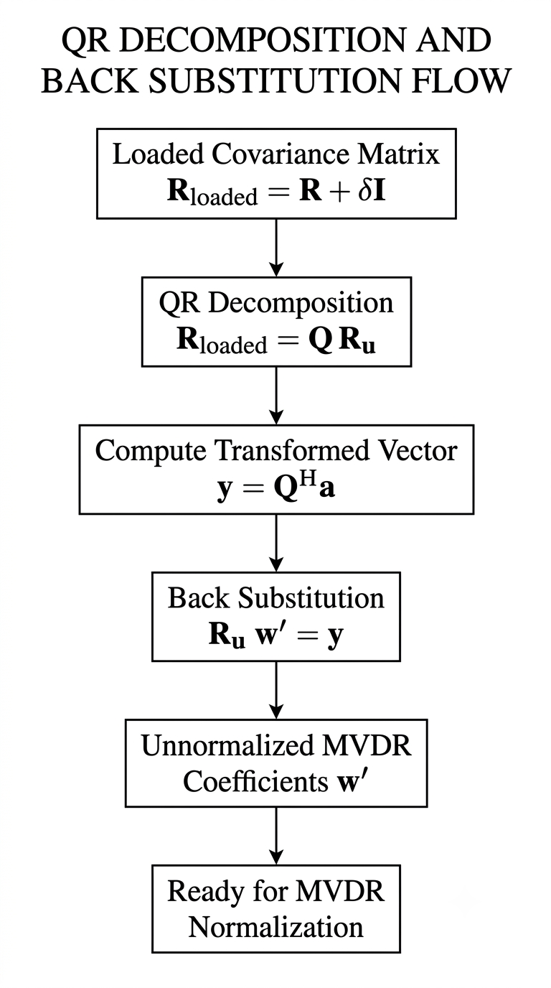
Figure 4.2 QR decomposition and back substitution flow

4.7 Normalization of MVDR Coefficients
The output obtained from back substitution is the unnormalized coefficient vector $w^{'}$. This vector solves the matrix equation, but it does not yet satisfy the main MVDR condition. In MVDR beamforming, the response in the desired target direction must be equal to one. This condition is known as the distortionless response condition.
The distortionless condition is written as:
aᴴw = 1
where $a$is the steering vector of the desired direction and $w$is the final MVDR coefficient vector.
To satisfy this condition, the unnormalized coefficient vector is normalized as:
w = w' / (aᴴw')
After normalization, the beamformer preserves the desired signal direction while suppressing interference and noise. The final output contains 64 complex coefficients, one for each antenna element in the 8×8 URA. These coefficients are stored separately as real and imaginary arrays in the FPGA implementation.
w_real[64] and w_imag[64]
In simple terms, normalization makes sure that the target direction is not reduced or distorted by the adaptive beamforming process.
The major mathematical operations involved in the MVDR beamforming algorithm are summarized in Table 4.1.
Table 4.1 Major mathematical operations involved in MVDR beamforming
Operation | Expression | Purpose
Steering vector generation | (a(θ, φ)) | Represents the desired signal direction
Covariance computation | (R = X_{train}X_{train}^{H}/K) | Estimates interference and noise environment
Diagonal loading | (R_{loaded} = R + δI) | Improves numerical stability
QR decomposition | (R_{loaded} = QRᵤ) | Avoids direct matrix inversion
Transformed vector | (y = Qᴴa) | Converts the equation for triangular solving
Back substitution | (Rᵤw' = y) | Computes unnormalized coefficients
Normalization | (w = w'/(aᴴw')) | Maintains unity response in target direction

4.8 Summary
This chapter explained the MVDR adaptive beamforming algorithm used in the project. The process begins with steering vector generation for the desired target direction. The training data from the 64-element URA is then used to compute the covariance matrix, which represents the interference and noise environment.
Diagonal loading is applied to improve numerical stability before solving the MVDR equation. Instead of using direct matrix inversion, QR decomposition and back substitution are used to obtain the unnormalized beamforming coefficients. Finally, normalization is performed to satisfy the distortionless response condition.
The final output of the algorithm is a set of 64 complex MVDR coefficients. These coefficients are later implemented in Vitis HLS and verified on the Versal FPGA platform. The MATLAB modelling and golden reference verification are explained in the next chapter.

CHAPTER 5

MATLAB GOLDEN REFERENCE MODEL

5.1 Introduction
MATLAB was used as the golden reference model for the MVDR adaptive beamforming algorithm. A golden reference model is a verified software model used to check whether the hardware implementation produces the correct output. In this project, the MATLAB result is considered as the reference output, and the FPGA-generated output is compared with it during final verification.
The MATLAB model was developed for a 64-element Uniform Rectangular Array arranged in an 8×8 structure. The system uses one desired target direction and two interference directions. The target direction is preserved by the MVDR algorithm, while the interference directions are suppressed based on the covariance information obtained from the training data.
The MATLAB implementation includes steering vector generation, training data formation, covariance matrix computation, diagonal loading, QR decomposition, back substitution, normalization, and final coefficient generation. The final MATLAB output consists of 64 complex MVDR beamforming coefficients. These coefficients are later used as golden reference values for comparison with the output generated by the Versal FPGA.
The MATLAB model also helps in visualizing the beamforming performance using beam pattern plots. These plots show whether the target direction is maintained and whether the interference directions are suppressed properly.

5.2 MATLAB Simulation Parameters
The MATLAB simulation was developed using fixed array and signal parameters. These parameters were kept constant so that the MATLAB output could be used as a reliable golden reference for FPGA verification. The antenna array was considered as a 64-element Uniform Rectangular Array with 8 elements along each dimension.
The training data used for covariance matrix computation contains 5000 snapshots. The desired target direction was set at an azimuth angle of 40° and an elevation angle of 0°. Two interference directions were also considered to test the adaptive suppression ability of the MVDR algorithm.
The main MATLAB simulation parameters are shown in Table 5.1.
Table 5.1 MATLAB simulation parameters
Parameter | Value
Array type | Uniform Rectangular Array
Array size | 8 × 8
Total antenna elements | 64
Element spacing | 0.5 wavelength
Number of snapshots | 5000
Target azimuth angle | 40°
Target elevation angle | 0°
Interference 1 direction | 30°, 10°
Interference 2 direction | -60°, -25°
Training data size | 64 × 5000
Covariance matrix size | 64 × 64
Diagonal loading factor | 0.01 × trace(R) / N
Reference tool | MATLAB

These parameters were used throughout the MATLAB simulation and later maintained during FPGA verification. Keeping the same input data and signal directions in both MATLAB and FPGA implementation ensures fair comparison between the software golden reference and hardware output.

5.3 MATLAB Algorithm Flow
The MATLAB implementation was developed to verify the complete MVDR adaptive beamforming process before hardware implementation. The same mathematical steps explained in Chapter 4 were implemented in MATLAB and used as the golden reference model.
First, the 8×8 Uniform Rectangular Array was defined with 64 antenna elements and half-wavelength spacing. The target and interference directions were then assigned using azimuth and elevation angles. Based on the target direction, the steering vector was generated.
The training data matrix $X_{train}$was used to compute the covariance matrix. After covariance computation, diagonal loading was applied to improve numerical stability. The loaded covariance matrix was then solved using QR decomposition and back substitution instead of direct matrix inversion. Finally, MVDR normalization was performed to obtain the final 64 complex beamforming coefficients.
The MATLAB implementation followed the sequence given below:
Define 8×8 URA parameters
↓
Set target and interference directions
↓
Generate steering vectors
↓
Generate / load training data
↓
Compute covariance matrix
↓
Apply diagonal loading
↓
Perform QR decomposition
↓
Apply back substitution
↓
Normalize MVDR coefficients
↓
Generate MATLAB golden output
The MATLAB output was saved and later used for comparison with the FPGA output. This helped to confirm whether the Vitis HLS and Versal FPGA implementation produced the same beamforming coefficients as the verified MATLAB model.

5.4 MATLAB Verification Output
The MATLAB command window output was used to verify the numerical correctness of the MVDR algorithm. The verification includes QR decomposition accuracy, normalization checking, target gain, interference gain, and suppression values. These results confirm whether the mathematical operations used in the MATLAB golden reference model are working correctly.
The QR verification result shows very small error values. This indicates that the QR decomposition was performed correctly. The normalization check also confirms that the final MVDR coefficient vector satisfies the distortionless response condition. The target gain is approximately equal to 1, while the interference gains are very small. This shows that the desired signal direction is preserved and the interference directions are suppressed.
The MATLAB command window verification output is shown in Figure 5.1.

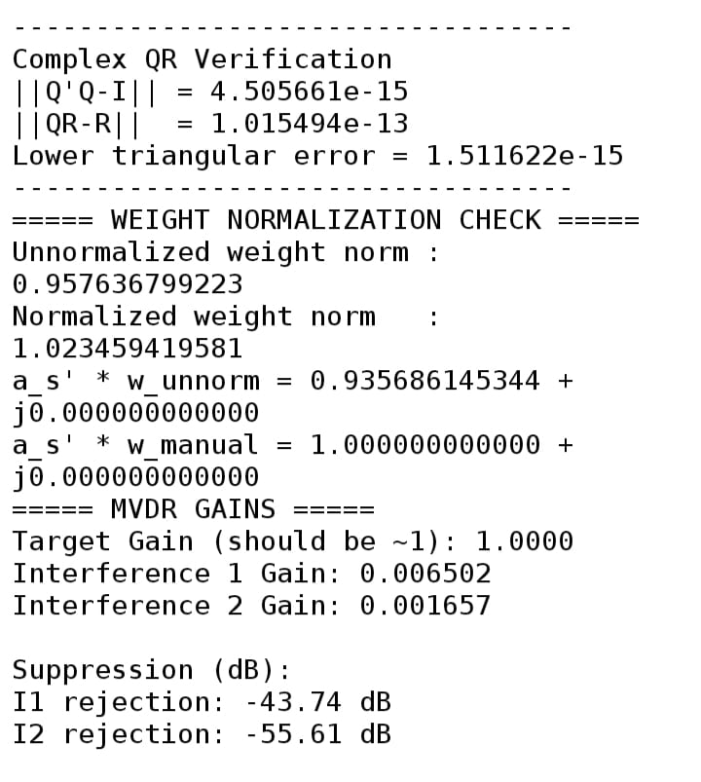
Figure 5.1 MATLAB verification output showing QR decomposition accuracy and MVDR gain results

From Figure 5.1, the target gain is approximately 1.0000, which confirms that the desired direction is preserved. The interference gains are 0.006502 and 0.001657, which are much smaller than the target gain. The corresponding interference suppression values are -43.74 dB and -55.61 dB. These values show that the MATLAB MVDR model successfully suppresses the interference directions while maintaining the target response.

5.5 MATLAB Beam Pattern Heat Map
The MATLAB heat map was used to visualize the spatial response of the MVDR beamformer. The heat map shows how the beamformer gain changes with respect to azimuth and elevation angles. This helps in understanding the direction where the beamformer provides strong response and the directions where the response is reduced.
In MVDR beamforming, the desired target direction should have a strong response. The interference directions should have reduced response or null formation. Therefore, the heat map is useful for visually confirming the adaptive beamforming behavior.
The MATLAB spatial heat map of the MVDR beam pattern is shown in Figure 5.2.
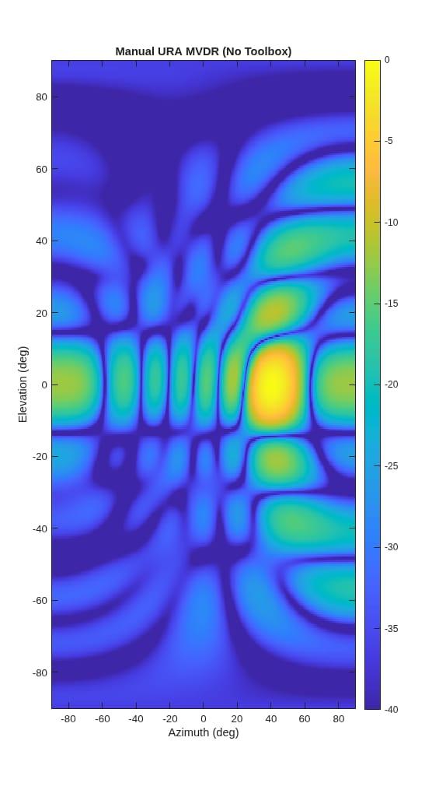
Figure 5.2 MATLAB spatial heat map of the MVDR beam pattern

From Figure 5.2, it can be observed that the MVDR beamformer produces a strong response near the desired target direction and reduced response in unwanted directions. This verifies the directional selectivity of the MVDR algorithm for the selected 64-element URA configuration.

5.6 Target and Interference Direction Representation
The target and interference direction plot was used to show the angular configuration considered in the MATLAB simulation. The desired signal was placed at the target direction, while two interference signals were placed at different azimuth and elevation angles. This setup was used to test whether the MVDR beamformer can preserve the target direction and suppress the interference directions.
The target and interference direction representation used in MATLAB simulation is shown in Figure 5.3.
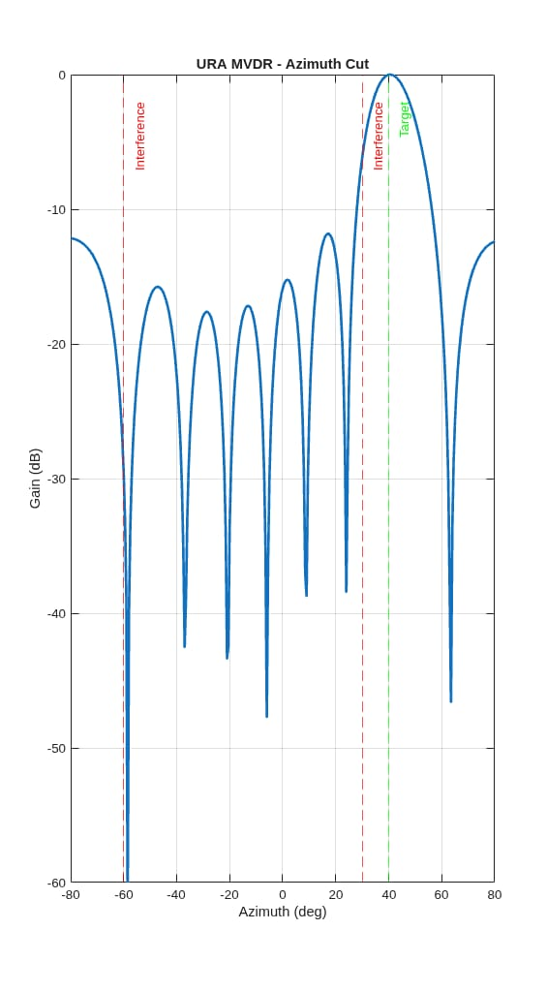
Figure 5.3 Target and interference direction representation used in MATLAB simulation
Figure 5.3 shows the target and interference locations used for testing the MVDR algorithm. The target direction is selected as the desired look direction, while the two interference directions represent unwanted signal sources. This angular arrangement is used throughout the MATLAB and FPGA verification process.

5.7 MATLAB Golden Data Export
After verifying the MVDR algorithm in MATLAB, the required input and reference output data were exported for FPGA verification. The training data matrix was separated into real and imaginary parts because the FPGA implementation handles complex values using separate arrays.
The real part of the training data was saved as Xtrain_real.csv, and the imaginary part was saved as Xtrain_imag.csv. The final MATLAB MVDR coefficients were also stored as golden reference values. These values were later compared with the coefficients generated by the Versal FPGA.
The complex data representation used during export is given as:
Xtrain = Xtrain_real + jXtrain_imag
w = w_real + jw_imag
The exported MATLAB data helped maintain the same input conditions for both software and hardware implementation. This ensured that the FPGA output could be directly compared with the MATLAB golden reference result.

5.8 Summary
This chapter explained the MATLAB golden reference model used for MVDR adaptive beamforming verification. The MATLAB model was developed for a 64-element URA with one desired target direction and two interference directions. The simulation parameters, algorithm flow, QR verification, normalization check, gain results, and beam pattern outputs were presented.
The MATLAB results confirmed that the target direction was preserved with approximately unity gain, while the interference directions were strongly suppressed. The verified MATLAB coefficients and input training data were exported for FPGA verification. These MATLAB outputs were later used as the golden reference for comparing the results generated by the Versal FPGA implementation.

CHAPTER 6

VITIS HLS IMPLEMENTATION

6.1 Introduction
Vitis HLS was used to convert the verified MVDR algorithm into a hardware accelerator suitable for FPGA implementation. The MATLAB model was first used to confirm the correctness of the algorithm. After verification, the same algorithmic flow was rewritten in C/C++ for Vitis HLS.
The main purpose of the HLS implementation was to generate a reusable hardware IP for MVDR coefficient computation. The HLS module receives the training data, target azimuth angle, target elevation angle, and antenna spacing as inputs. It then performs steering vector generation, covariance matrix computation, diagonal loading, QR decomposition, back substitution, and normalization.
The final output of the HLS module is a set of 64 complex MVDR beamforming coefficients. Since complex numbers are handled separately in the hardware interface, the output coefficients are stored as two arrays: w_real[64] and w_imag[64].
The HLS-generated IP was later exported and integrated in Vivado with the Versal processing system, AXI interconnect, AXI NoC, and DDR memory. This chapter explains the HLS top function, input-output interface, major internal modules, and HLS simulation and synthesis results.
6.2 HLS Top Function and Interface
The HLS implementation was developed using a top function named mvdr_top_axi. This function acts as the main hardware entry point for the MVDR accelerator. It receives the input training data, target direction, and antenna spacing, and returns the final MVDR beamforming coefficients.
The top function used in this project is shown below:
void mvdr_top_axi(
const double Xtrain_real[320000],
const double Xtrain_imag[320000],
double az_deg,
double el_deg,
double d,
double w_real[64],
double w_imag[64]
);
The arrays Xtrain_real and Xtrain_imag contain the real and imaginary parts of the training data. Since the training data size is 64×5000, each array contains 320000 values. The scalar inputs az_deg, el_deg, and d represent the target azimuth angle, target elevation angle, and antenna spacing. The output arrays w_real and w_imag store the real and imaginary parts of the 64 complex MVDR coefficients.
The input and output interface of the HLS top function is shown in Table 6.1.
Table 6.1 HLS top function input and output interface
Port Name | Size | Direction | Purpose
Xtrain_real | 320000 | Input | Real part of training data
Xtrain_imag | 320000 | Input | Imaginary part of training data
az_deg | 1 | Input | Target azimuth angle
el_deg | 1 | Input | Target elevation angle
d | 1 | Input | Antenna spacing
w_real | 64 | Output | Real part of MVDR coefficients
w_imag | 64 | Output | Imaginary part of MVDR coefficients

The HLS top function uses AXI interfaces for communication with the processor and DDR memory. The large input and output arrays are transferred through AXI master interfaces, while scalar values and control signals are handled through AXI-Lite.
The Vitis HLS top function interface used for the MVDR accelerator is shown in Figure 6.1.

Figure 6.1 Vitis HLS mvdr_top_axi top function interface

6.3 Internal Modules of HLS Implementation
The Vitis HLS implementation was divided into separate internal functional blocks to make the design easier to understand and verify. Each block performs one major operation of the MVDR algorithm. The complete HLS top function calls these internal blocks in sequence to generate the final beamforming coefficients.
The implementation starts with steering vector generation using the target azimuth and elevation angles. The covariance matrix is then computed from the input training data. Diagonal loading is applied to improve numerical stability. After this, QR decomposition converts the loaded covariance matrix into triangular form. Back substitution is used to solve the triangular equation, and normalization is applied to obtain the final MVDR coefficients.
The major internal modules used in the HLS implementation are shown in Table 6.2.

Table 6.2 HLS implementation modules and their functions
Module / Function | Purpose
Steering vector generation | Generates the target direction response for the 8×8 URA
Covariance computation | Computes the 64×64 covariance matrix from training data
Diagonal loading | Adds a small value to diagonal elements for stability
QR decomposition | Converts the loaded covariance matrix into upper triangular form
Back substitution | Solves the triangular system to obtain unnormalized coefficients
Normalization | Applies MVDR distortionless response condition
Output storage | Stores final coefficients in w_real[64] and w_imag[64]

This modular structure helped in developing and verifying the HLS design step by step. It also made the implementation easier to compare with the MATLAB golden reference model. Each internal operation follows the same mathematical flow used in MATLAB, ensuring consistency between software simulation and hardware implementation.

6.4 AXI Interface Implementation
The HLS top function was designed with AXI interfaces so that it could communicate with the Versal processing system and DDR memory after integration in Vivado. The input training data contains a large number of values, so it cannot be transferred efficiently through simple scalar ports. Therefore, AXI master interfaces were used for large input and output arrays.
The arrays Xtrain_real, Xtrain_imag, w_real, and w_imag were connected through AXI master interfaces. This allows the HLS IP to read training data from DDR memory and write the final MVDR coefficients back to DDR memory.
The scalar inputs such as az_deg, el_deg, and d were connected through AXI-Lite. The AXI-Lite interface is also used for control signals such as start, done, idle, and return. These signals allow the processor to start the MVDR accelerator and check when the computation is completed.
The AXI interface arrangement used in the HLS design is summarized below:
AXI Master Interface:
Xtrain_real, Xtrain_imag, w_real, w_imag
AXI-Lite Interface:
az_deg, el_deg, d, control signals
This interface structure makes the MVDR accelerator suitable for integration with the Versal system. The processor controls the accelerator through AXI-Lite, while the bulk data transfer takes place through DDR memory using AXI master communication.

6.5 HLS Simulation and Synthesis
Vitis HLS simulation was performed to verify the functional correctness of the C/C++ implementation before hardware generation. During simulation, the input training data, target azimuth angle, target elevation angle, and antenna spacing were provided to the mvdr_top_axi function. The function generated the real and imaginary parts of the MVDR coefficient vector.
The Vitis HLS C simulation output is shown in Figure 6.2.

Figure 6.2 Vitis HLS C simulation result
Figure 6.2 shows the successful completion of C simulation in Vitis HLS. This confirms that the HLS C/C++ implementation executes correctly and produces the expected output before hardware synthesis.
After successful C simulation, HLS synthesis was performed. The synthesis process converted the C/C++ MVDR implementation into RTL hardware. The generated design includes AXI interfaces for communication with the processor and DDR memory. The synthesis report provides details such as latency, resource usage, and interface information.
The Vitis HLS C synthesis performance analysis report is shown in Figure 6.3.

Figure 6.3 Vitis HLS C synthesis performance analysis report
Figure 6.3 shows the synthesis result of the MVDR accelerator in Vitis HLS. The successful synthesis confirms that the verified C/C++ algorithm was converted into a hardware IP suitable for Vivado integration.

6.6 Summary
This chapter explained the Vitis HLS implementation of the MVDR adaptive beamforming algorithm. The HLS top function, input-output interface, internal modules, AXI interface structure, simulation, and synthesis process were described.
The HLS design generated a hardware accelerator that reads training data from DDR memory, performs MVDR coefficient computation, and writes the final complex coefficients back to memory. The successful C simulation and synthesis results confirmed that the design was ready for Vivado hardware integration.

CHAPTER 7

VIVADO HARDWARE INTEGRATION

7.1 Introduction
Vivado was used to integrate the MVDR HLS IP with the Versal FPGA system. The IP generated from Vitis HLS was added to the Vivado block design and connected with the required processing system, AXI interconnect, AXI NoC, reset, clock, and DDR memory interfaces.
The main purpose of the Vivado stage was to convert the exported HLS IP into a complete hardware system that can run on the Versal FPGA board. The processor controls the MVDR accelerator through AXI-Lite, while the large input and output data arrays are transferred through DDR memory using AXI master communication.

7.2 Vivado Block Design
The Vivado block design consists of the Versal processing system, MVDR HLS IP, AXI SmartConnect, AXI NoC, reset block, and DDR memory interface. The processor sends control signals to the MVDR accelerator and starts the computation. After completion, the output coefficients are written back to memory.
The major components used in the Vivado block design are listed in Table 7.1.
Table 7.1 Vivado block design components and their purpose
Block / Component | Purpose
Versal CIPS | Provides the processing system used to control the MVDR accelerator
MVDR HLS IP | Performs MVDR coefficient computation in programmable logic
AXI SmartConnect | Connects the processor control interface to the HLS IP
AXI NoC | Provides memory access path between the HLS IP and DDR memory
DDR Memory | Stores input training data and output MVDR coefficients
Processor Reset System | Provides reset signals for AXI and IP blocks
Clock Source | Provides clock signal required for hardware operation

The Vivado block design of the MVDR accelerator system is shown in Figure 7.1.
Figure 7.1 shows the integration of the MVDR HLS IP with the Versal system. The AXI-Lite interface is used for control communication, while the AXI master interface is used for data transfer between the accelerator and DDR memory.

Figure 7.1 Vivado block design of MVDR accelerator system

7.3 AXI NoC and DDR Memory Connection
The AXI NoC is used to connect the MVDR accelerator to DDR memory. Since the training data contains 320000 real values and 320000 imaginary values, DDR memory is required to store the complete input data. The output coefficient arrays are also stored in DDR memory after computation.
The AXI NoC provides the data path between the HLS IP and memory. This allows the accelerator to read Xtrain_real and Xtrain_imag from memory and write w_real and w_imag back to memory.
The AXI NoC and DDR memory connection used in the Vivado design is shown in Figure 7.2.

Figure 7.2 AXI NoC and DDR memory connection

Figure 7.2 shows the memory communication path used by the MVDR hardware accelerator. The AXI NoC enables the HLS IP to access DDR memory for large training data transfer and output coefficient storage.

7.4 Timing, Utilization, and Power Results
After completing the block design, synthesis and implementation were performed in Vivado. The implementation result was checked using timing, utilization, and power reports. Timing analysis confirms whether the design can operate correctly at the required clock frequency. Utilization analysis shows the FPGA resources used by the design, and power analysis estimates the power consumed by the implemented system.
The Vivado timing, utilization, and power summary is shown in Figure 7.3.

Figure 7.3 Vivado timing, utilization, and power summary

Figure 7.3 shows the final Vivado implementation reports. The timing result confirms that the design satisfies the required timing constraints. The utilization and power reports provide the hardware resource usage and estimated power consumption of the implemented MVDR accelerator system.

7.5 Summary
This chapter explained the Vivado hardware integration of the MVDR accelerator. The HLS-generated IP was connected with the Versal processing system, AXI SmartConnect, AXI NoC, and DDR memory. The Vivado block design provided the required control and data transfer paths for FPGA execution.
The timing, utilization, and power reports confirmed that the design was successfully implemented in Vivado. The generated hardware platform was later exported as an XSA file and used in Vitis for board-level software testing.

CHAPTER 8

VITIS SOFTWARE AND BOARD TESTING

8.1 Introduction
Vitis was used to develop the software application required for board-level testing of the MVDR accelerator. After Vivado implementation, the hardware platform was exported as an XSA file and imported into Vitis. A standalone C application was then created to control the HLS-generated MVDR IP from the processor side.
The software application loads the input training data, sets the required input parameters, starts the hardware accelerator, waits for completion, and reads the output MVDR coefficients. The output values are then compared with the MATLAB golden reference to verify the correctness of the FPGA implementation.

8.2 Input Data Preparation
The MATLAB training data was exported as CSV files and converted into C header format for use in the Vitis application. Since the FPGA program uses real and imaginary values separately, the MATLAB data was stored as separate arrays.
The input data used in the Vitis application includes:
Xtrain_real[320000]
Xtrain_imag[320000]
The output arrays used to store the FPGA-generated coefficients are:
w_real[64]
w_imag[64]
The Python data conversion output used for preparing Vitis input data is shown in Figure 8.1.

Figure 8.1 Python data conversion output
Figure 8.1 shows the conversion of MATLAB-generated data into a format suitable for the Vitis software application. This step ensures that the same input data used in MATLAB is also used during FPGA verification.

8.3 Vitis Application Build
After preparing the input data, the Vitis software application was created using the exported Vivado hardware platform. The application contains the processor-side code required to configure and start the MVDR hardware accelerator.
The software program performs the following operations:
Initialize the MVDR IP
Set input and output memory addresses
Pass target azimuth, elevation, and spacing values
Start the accelerator
Wait for ap_done
Read output coefficients
Compare FPGA output with MATLAB reference
The successful Vitis application build output is shown in Figure 8.2.

Figure 8.2 Vitis application build successful output
Figure 8.2 confirms that the Vitis software application was successfully compiled. This application was later executed on the Versal processing system to control the MVDR accelerator.

8.4 Board-Level Execution
After building the Vitis application, the program was executed on the Versal FPGA board. The processor started the MVDR hardware IP, waited until the computation was completed, and printed the output through the serial terminal.
The PuTTY terminal output was used to observe the FPGA execution status, calculated coefficients, error comparison, and measured latency.
The FPGA board-level execution output observed through the serial terminal is shown in Figure 8.3.

Figure 8.3 PuTTY output showing FPGA board execution
Figure 8.3 shows the successful execution of the MVDR accelerator on the Versal FPGA board. The output confirms that the hardware IP completed the computation and produced coefficient values for comparison with the MATLAB golden reference.
8.5 Summary
This chapter explained the Vitis software development and board-level testing process. The MATLAB data was converted into C header format, the Vitis application was built successfully, and the MVDR accelerator was executed on the Versal FPGA board.
The processor controlled the accelerator through the software application, while the hardware IP performed the MVDR computation. The FPGA output obtained during board execution was used for final verification against the MATLAB golden reference.

CHAPTER 9

FPGA VERIFICATION AND RESULT ANALYSIS

9.1 Introduction
The FPGA output was verified by comparing it with the MATLAB golden reference output. The same training data, target angle, elevation angle, and antenna spacing were used in both MATLAB and FPGA implementation. This ensured that the comparison was made under identical input conditions.
The main output of the MVDR accelerator is the complex beamforming coefficient vector. Since the 64-element URA contains 64 antenna elements, the FPGA generates 64 complex coefficients. These coefficients are stored as separate real and imaginary arrays and compared with the MATLAB reference values.

9.2 MATLAB and FPGA Output Comparison
The FPGA-generated coefficients were compared with the MATLAB golden coefficients element by element. The comparison was performed separately for the real and imaginary parts. The maximum error between the MATLAB output and FPGA output was calculated to verify the correctness of the hardware implementation.
The verification results are summarized in Table 9.1.
Table 9.1 MATLAB and FPGA verification result
Verification Parameter | Result
Input data size | 64 × 5000
Number of output coefficients | 64 complex coefficients
MATLAB output format | w_real[64], w_imag[64]
FPGA output format | w_real[64], w_imag[64]
Maximum real part error | 0.000000
Maximum imaginary part error | 0.000000
Maximum component error | 0.000000
MATLAB golden weight power | 1.047
Verification status | Matched with MATLAB golden reference

From Table 9.1, it can be observed that the maximum error between the MATLAB golden reference and FPGA output is 0.000000 within the printed precision. This confirms that the Versal FPGA implementation produced the same MVDR coefficient values as the MATLAB reference model.

9.3 Result Analysis
The verification result confirms that the MATLAB-to-FPGA implementation flow was successful. The MVDR algorithm was first verified in MATLAB and then implemented as a hardware accelerator using Vitis HLS. The generated IP was integrated in Vivado and executed on the Versal FPGA board using a Vitis application.
The FPGA output matched the MATLAB golden reference values with zero printed error. This shows that the hardware accelerator correctly performed steering vector generation, covariance matrix computation, diagonal loading, QR decomposition, back substitution, and normalization.
The result also confirms that the data transfer between processor, DDR memory, and HLS IP worked correctly. The input arrays were successfully read from memory, and the final coefficient arrays were written back to memory after computation.

9.4 Summary
This chapter presented the FPGA verification and result analysis of the MVDR accelerator. The FPGA-generated complex coefficients were compared with the MATLAB golden reference values. The maximum printed error was 0.000000, confirming that the FPGA implementation matched the MATLAB output.
The successful verification proves the correctness of the HLS implementation, Vivado integration, and Vitis board-level execution. The performance results of the implemented design are discussed in the next chapter.

CHAPTER 10

PERFORMANCE ANALYSIS

10.1 Introduction
Performance analysis was carried out to evaluate the implemented MVDR accelerator after Vivado implementation and board-level execution. The main performance aspects considered in this project are timing, hardware utilization, power estimation, and computation latency.
Timing, utilization, and power were observed from the Vivado implementation reports. The computation latency was measured during board-level execution from the start of the MVDR accelerator to the completion signal.

10.2 Vivado Implementation Performance
After synthesis and implementation in Vivado, the design reports were checked to confirm that the hardware design was successfully implemented. Timing analysis confirms whether the design meets the required clock constraints. Utilization analysis shows the amount of FPGA hardware resources used by the design. Power analysis provides the estimated power consumption of the implemented system.
The Vivado implementation performance is summarized in Table 10.1.
Table 10.1 Vivado implementation performance summary
Performance Parameter | Observation
Synthesis status | Completed successfully
Implementation status | Completed successfully
Timing status | Timing met
Total negative slack | 0
Worst negative slack | Positive
Utilization report | Generated successfully
Power report | Generated successfully
Hardware platform export | XSA exported successfully

The Vivado implementation results confirm that the MVDR accelerator system was successfully implemented on the Versal FPGA platform. The timing report showed that the design met timing constraints, and the generated utilization and power reports provided the required hardware performance details.

10.3 Board-Level Latency Measurement
The computation latency was measured during FPGA board execution. The latency was measured from the time the processor started the MVDR accelerator until the accelerator completed the computation.
The measured latency is shown in Table 10.2.
Table 10.2 FPGA computation latency
Parameter | Value
Operation measured | Complete MVDR coefficient computation
Input data size | 64 × 5000
Output size | 64 complex coefficients
Measurement point | From ap_start to ap_done
Measured latency | 1404.6 ms

The measured latency includes the complete MVDR computation on the FPGA accelerator. This includes covariance matrix computation, diagonal loading, QR decomposition, back substitution, and normalization. Since the implementation uses double-precision computation and a large 64×5000 training dataset, the measured latency represents the full hardware execution time for one complete MVDR run.

10.4 Summary
This chapter presented the performance analysis of the MVDR accelerator. The Vivado reports confirmed successful synthesis, implementation, timing closure, utilization reporting, and power estimation. The board-level execution measured a latency of 1404.6 ms for one complete MVDR coefficient computation.
The results show that the hardware design was successfully implemented and executed on the Versal FPGA platform. The next chapter presents the spatial response and beam pattern analysis of the MVDR beamformer.

CHAPTER 11

CONCLUSION AND FUTURE SCOPE

11.1 Conclusion
This internship project presented the implementation and verification of an MVDR adaptive beamforming accelerator for a 64-element Uniform Rectangular Array on a Versal FPGA platform. The antenna array was considered as an 8×8 URA with half-wavelength spacing. The system was designed to preserve the desired target direction and suppress interference signals arriving from unwanted directions.
The MVDR algorithm was first developed and verified in MATLAB. The MATLAB model included steering vector generation, covariance matrix computation, diagonal loading, QR decomposition, back substitution, and normalization. The MATLAB output was used as the golden reference for FPGA verification.
The verified algorithm was then implemented in Vitis HLS as an AXI-based hardware accelerator. The HLS-generated IP was integrated in Vivado with Versal CIPS, AXI SmartConnect, AXI NoC, and DDR memory. A Vitis standalone application was used to control the accelerator, transfer data, start computation, and read back the output coefficients.
The FPGA-generated MVDR coefficients were compared with the MATLAB golden reference coefficients. The maximum printed error was 0.000000, confirming that the FPGA output matched the MATLAB reference result. The board-level execution also confirmed successful hardware operation, with a measured computation latency of 1404.6 ms for one complete MVDR coefficient computation.
Thus, the project successfully demonstrated a complete MATLAB-to-FPGA workflow for MVDR adaptive beamforming using Vitis HLS, Vivado, Vitis, and Versal FPGA.

11.2 Future Scope
The present implementation verifies the correctness of the MVDR algorithm on FPGA. In future work, the design can be optimized further to improve execution speed and hardware efficiency. The covariance matrix computation, QR decomposition, and back substitution stages can be optimized using pipelining, parallel processing, and fixed-point arithmetic.
The current implementation uses double-precision data for verification accuracy. Future versions can use single-precision or fixed-point representation to reduce resource usage and latency. The design can also be extended for real-time antenna input data instead of pre-generated training data.
Additional improvements can include real-time beam pattern visualization, multiple target handling, dynamic interference tracking, and integration with radar or satellite communication front-end systems. These improvements can make the design more suitable for practical adaptive beamforming applications.

11.3 Final Summary
The project successfully achieved its objective of implementing and verifying an MVDR adaptive beamforming accelerator on a Versal FPGA platform. The MATLAB golden reference, HLS hardware design, Vivado integration, Vitis software execution, and FPGA verification were completed successfully.
The matching MATLAB and FPGA results confirm the correctness of the complete design flow. This work provides a strong foundation for future FPGA-based adaptive beamforming systems used in radar, satellite communication, and advanced antenna array processing applications.

REFERENCES

- H. L. Van Trees, Optimum Array Processing: Part IV of Detection, Estimation, and Modulation Theory, Wiley, 2002.
- Simon Haykin, Adaptive Filter Theory, Pearson Education.
- Monson H. Hayes, Statistical Digital Signal Processing and Modeling, Wiley.
- B. D. Van Veen and K. M. Buckley, “Beamforming: A Versatile Approach to Spatial Filtering,” IEEE ASSP Magazine, 1988.
- A. V. Oppenheim and R. W. Schafer, Discrete-Time Signal Processing, Pearson Education.
- Xilinx / AMD, Vitis High-Level Synthesis User Guide, AMD Xilinx Documentation.
- Xilinx / AMD, Vivado Design Suite User Guide, AMD Xilinx Documentation.
- Xilinx / AMD, Versal Adaptive SoC Technical Reference Manual, AMD Xilinx Documentation.
- Xilinx / AMD, AXI NoC Product Guide for Versal Adaptive SoCs, AMD Xilinx Documentation.
- MathWorks, MATLAB Documentation: Matrix Operations and Signal Processing Functions, MathWorks Documentation.
- MathWorks, MATLAB Documentation: QR Decomposition and Linear Algebra Functions, MathWorks Documentation.

