* Lec4) String (topic)
* String is a sequence of character that is used to represent the text.
* Jese objects k pas key ,value paired hoty hn usi tareky sa string ma bhi internally variables hoty hn jo uski properties ko define krty hn ,likewise length hogya ,str.length it return the total length of an string .
* Concate(newstring) eski help sa hum 2 strings ko concate krskty hn , string ko hum directly + lagaky bht concatenate krskty hn ,string ko concate krty hn to vo space ko bhi count krta ha ,length ma .
* **str.replace()** method is used to find and replace.
* substring within a string with another substring. This method is commonly used for manipulating strings, such as replacing certain characters, words, or patterns within a string.
* Syntax, str.replace(searchValue, replaceValue).
* Les 5:functions and method (apna college)
* 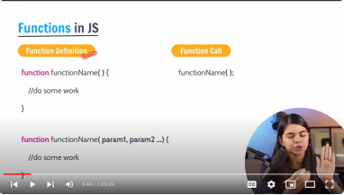
* Highere order funtions ya methods vo hoty hn ya to vo function ko as a parameter lrtr hn ya function/method ko return krty hn .
* Jaha bhi function callback mly to vo hmara highr order function bnjata ha .
* DOM
* The window object represents an open window in browser , it is a browsers objects (not js ) & is automatically created by browser .
* It is a global object with lots of properties and methods ,
* Console.log(“anything “) it just print out the thing , but console.dir is used to **console.dir()** is a JavaScript function used to display the properties and structure of an object in a detailed and interactive format in the browser's developer console. It helps developers inspect complex objects and understand their properties more easily during debugging and development.
* Getelementbyclassname ya ak collection return krta ha like an array esmy methods nhi hoty baki .
* While working with tree nodes , there are 3 types of ndes , 1,text node, commit node ,element node ,
* 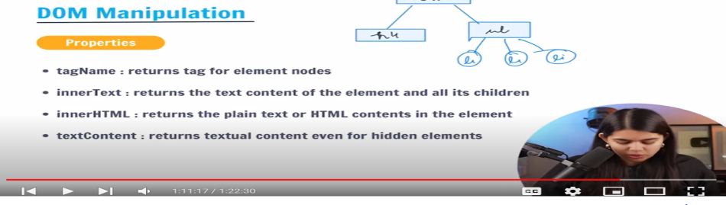
* Nodes ,+> firstNode , lastNode , DOM tree 1 text,commet,element .
* Lect 8> events in js. The change in the state of an object Is known as Event.
* Events ko hum generally use krty hn apny kam ko trigger krwany k lia,
* jaha humara constructor use hota ha , vaha hum objects instance bnaty hn new keyword say ? and jaha hum constructor nhi bnaty waha hme instance of the object new keyword sa bnany k zrorat nhi ?
* Ji haan, aapka bayan sahi hai. Constructor ka istemal karte hue, hum **new** keyword ka istemal karte hain taake naye objects ki instance bana sakein. Jab hum ek constructor function ka istemal karte hain, tou humein **new** keyword se ek naya object banane ki zaroorat hoti hai.