* Lec4) String (topic)
* String is a sequence of character that is used to represent the text.
* Jese objects k pas key ,value paired hoty hn usi tareky sa string ma bhi internally variables hoty hn jo uski properties ko define krty hn ,likewise length hogya ,str.length it return the total length of an string .
* Concate(newstring) eski help sa hum 2 strings ko concate krskty hn , string ko hum directly + lagaky bht concatenate krskty hn ,string ko concate krty hn to vo space ko bhi count krta ha ,length ma .
* **str.replace()** method is used to find and replace.
* substring within a string with another substring. This method is commonly used for manipulating strings, such as replacing certain characters, words, or patterns within a string.
* Syntax, str.replace(searchValue, replaceValue).
* Les 5:functions and method (apna college)
* 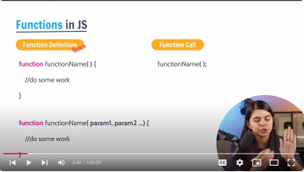
* Highere order funtions ya methods vo hoty hn ya to vo function ko as a parameter lrtr hn ya function/method ko return krty hn .
* Jaha bhi function callback mly to vo hmara highr order function bnjata ha .
* DOM
* The window object represents an open window in browser , it is a browsers objects (not js ) & is automatically created by browser .
* It is a global object with lots of properties and methods ,
* Console.log(“anything “) it just print out the thing , but console.dir is used to **console.dir()** is a JavaScript function used to display the properties and structure of an object in a detailed and interactive format in the browser's developer console. It helps developers inspect complex objects and understand their properties more easily during debugging and development.
* Getelementbyclassname ya ak collection return krta ha like an array esmy methods nhi hoty baki .
* While working with tree nodes , there are 3 types of ndes , 1,text node, commit node ,element node ,
* 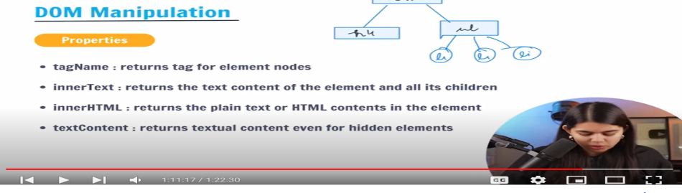
* Nodes ,+> firstNode , lastNode , DOM tree 1 text,commet,element .
* Lect 8> events in js. The change in the state of an object Is known as Event.
* Events ko hum generally use krty hn apny kam ko trigger krwany k lia,
* jaha humara constructor use hota ha , vaha hum objects instance bnaty hn new keyword say ? and jaha hum constructor nhi bnaty waha hme instance of the object new keyword sa bnany k zrorat nhi ?
* Ji haan, aapka bayan sahi hai. Constructor ka istemal karte hue, hum **new** keyword ka istemal karte hain taake naye objects ki instance bana sakein. Jab hum ek constructor function ka istemal karte hain, tou humein **new** keyword se ek naya object banane ki zaroorat hoti hai.
* API Integration
* *//fetch api provides an interface for sending and recieving data resources ,*
* *//it uses request/responce object , the fetch method is used to fetch resource data*
* *//let promice=fetch(url,[options]);*
* *//AJAX is the asyncroneous js and XML*
* *//phly jab hmara modern js nhi tha tab hmari network request ma jo data k formate hota tha vo xml ki sorat ma hota tha ,phly data k format xml formate ma hota tha ,*
* *//r aj ki date ma xml bht kam hota ha data k format generally json formate ma data ata ha ,*
* *//phly xml k formate ma data jata tha ab hme json format ma jatah adata r mlta ha*
* *//ajkl jo maximum apis jo hum use krrhy hoty hn ,conka json formate ma data ko return krti hn ,to un apis ko hum ajaj bhi khty hn*
* *//AJAJ means asyncroneous javascript and json ,*
* *//to hum enko ajaj bhi kehskty hn but ya ak popular term ni jabhi hum AJAX bolty hn ,*
* *// matlab vhi ha k data ko hum json formate ma recieve krrhy hn , generally yhi matlab hoa API ko request bhjrhy hn hum*
* *//AJAX simple yhi ha k api's ko call krwarhy hn ,network p humkuch request bhjrhy hn r kahi sa hmare pas response arha ha ,and thatis using ajax*
* *//sabsy phly humny api's ko jese hi request bheji to hmare pas respnnse atat ha r data ha vo json formate ma ata ha ,*
* *//to usko hum js object notataion ma convert krty hn , to usko convert krny k lia hum special method use krty hn which is json().*
* *//json is also an asyncroneous metod ,r ya bhi ak promise return krta hn , phla promise response na dea hmy , second promise hme json method na dea , to eslia hum yaha await lagaty hn ,*
* *//*
* *//vo request jo srf kuch data lany ka kaam krti ha kahi server sa data laky ajay kisi api sa data laky ajay to usy hum get request khty hn ,*