AIDD 30-Day Challenge — Task 2
Understanding AI-Driven Development: Nine Pillars & Specification-Driven Approach

October 2025 changed software development forever. AI is no longer just a helper; it’s a teammate that can reason, plan, and even take action on tasks. Developers now do more thinking, planning, and designing, while AI handles repetitive work.

1. Nine Pillars & Development Agents

Today, I explored how AI Development Agents, like Gemini CLI, can help me as a developer. Instead of setting up projects or running tests manually, I asked the agent to do it. This gave me more time to think about architecture, workflows, and design choices. It made me realize that using AI for repetitive tasks doesn’t make me lazy it actually trains me to grow into a system thinker, not just a coder.

The Nine Pillars show how to combine TDD, AI agents, specifications, and evaluation to function like an entire team. Following these pillars helps me develop multiple skills deeply — coding, testing, planning, evaluating making me closer to an M-Shaped Developer.

2. Vibe Coding vs Specification-Driven Development

Earlier, I tried Vibe Coding, just “coding by feel.” At first, it felt fast, but after a few days, my code was messy, buggy, and hard to maintain. Now, I understand Specification-Driven Development (SDD) is different: I write clear instructions for the AI before coding.

For example, I asked the AI CLI to generate a specification for an email validation function: it had to check the “@” symbol, a valid domain like .com or .org, and return clear error messages. The AI followed my instructions perfectly.

This made me realize: SDD keeps my code organized, predictable, and easy to maintain — problems that happen with Vibe Coding disappear.

3. Architecture Thinking

Thinking in layers and systems instead of raw code has been eye-opening. I now focus on how parts of a system connect rather than writing random lines of code. AI helps implement my design, but I’m the one deciding structure, workflow, and overall logic.

This shift makes me a system thinker I plan the building, the AI lays the bricks, and together we create something bigger than what I could do alone.

4. Practical Task

CLI Prompt:
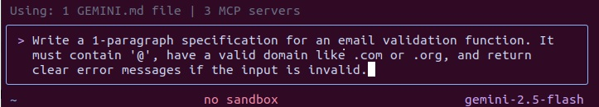
AI Output:
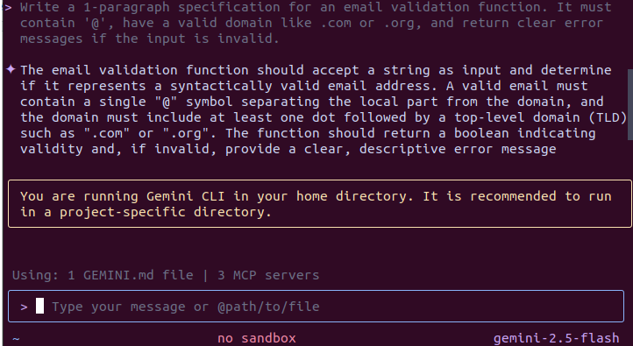

5. Self-Test (MCQs)

1. Main purpose of Spec-Driven Development?
B. Clear requirements before coding begins

2. Biggest mindset shift in AI-Driven Development?
B. Thinking in systems and clear instructions

3. Biggest failure of Vibe Coding?
B. Architecture becomes hard to extend

4. Main advantage of using AI CLI agents?
B. Handle repetitive tasks so dev focuses on design & problem-solving

5. What defines an M-Shaped Developer?
C. Deep skills in multiple related domains

