**Instruction to Run the Project.**

**1.First run the Backend part first**

**2.Next run the Frontend part with the command “npm start”.**

**3.Now the project will be working.**

**Todo Application Output**

**Home Page**

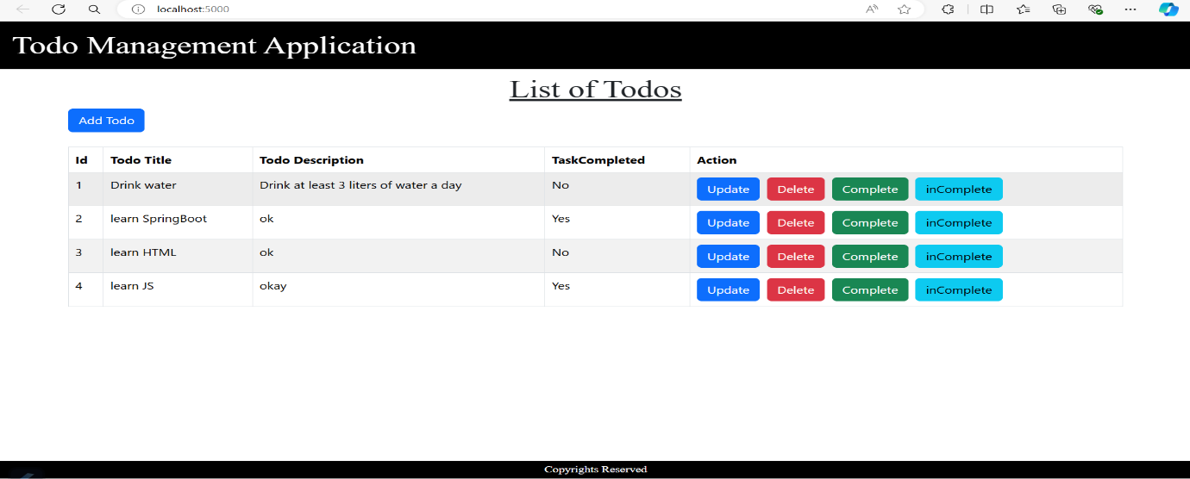

**Update Page:**

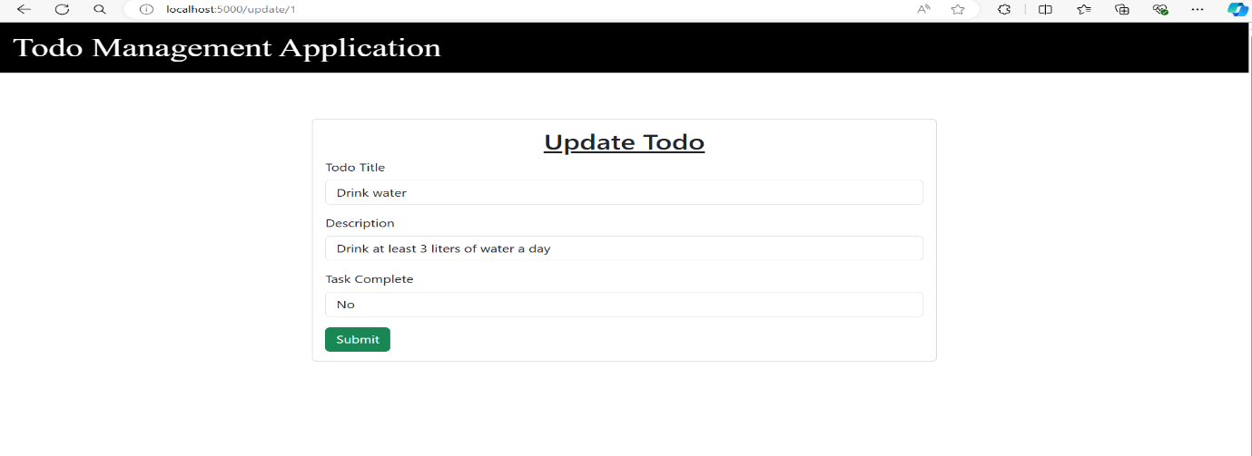

**Updated Home Page:**

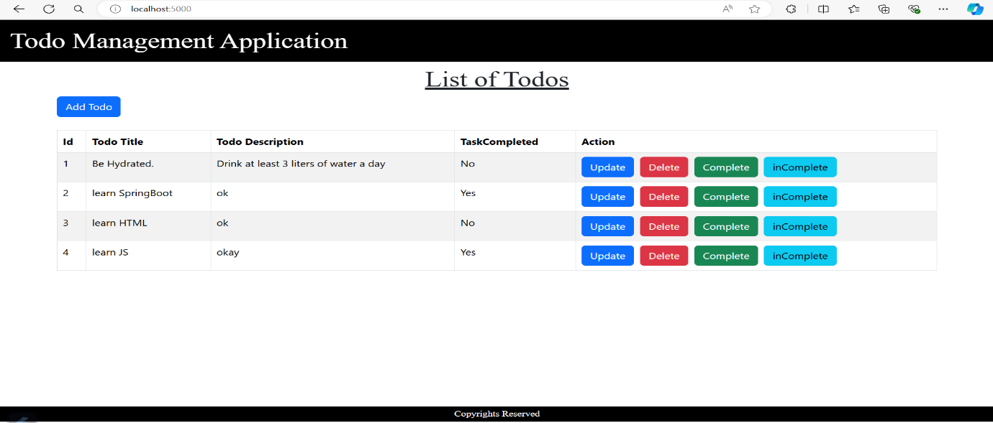

**After Clicking on completed button in 1st row column task completed updated with “Yes”**

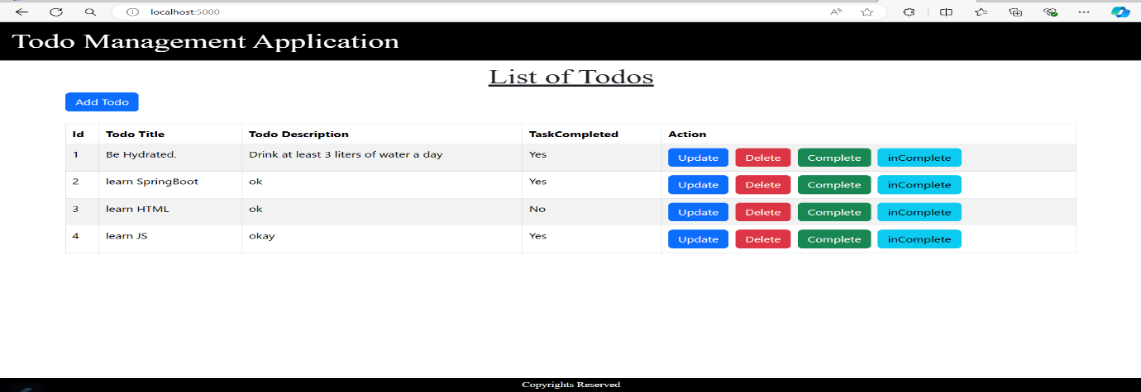

**After Clicking on incompleted button in 1st row column task completed updated with “No”**

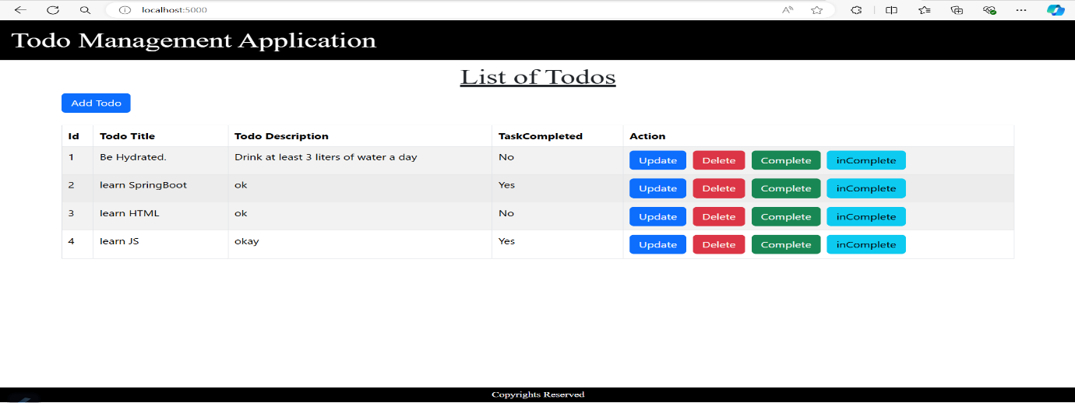

**Updated Home page after deletion of 4th column**

