Assignment 03

ME 670: Advanced Computational Fluid Dynamics

*Conjugate Gradient*

*and Preconditioned Conjugate Gradient*

*Nirmal S.*

*[234103107]*

*Computational Mechanics*

*MTech. Mechanical Engineering*

*IIT-Guwahati*

Table of Contents

Problem Statement: 2

Grid Details 3

Discretised Equations 4

Results 5

# Problem Statement:

1. Consider 2D conduction problem governed by equation

$$\frac{∂^{2}T}{∂x^{2}}+\frac{∂^{2}T}{∂y^{2}}=0$$

On a unit square domain with homogamous Dirichlet boundary conditions i.e. 𝑇=0 at the left, right and bottom boundaries. The top wall (non-dimensional) temperature is 1 unit. The analytical solution of the problem is:

$$T\left(x,y\right)=\frac{2}{π}\sum_{n=1}^{∞}{\frac{{\left(-1\right)}^{n+1}+1}{n}\sin\left(nπx\right)}\frac{sinh⁡(nπy)}{\sinh\left(nπ\right)}$$

Discretize the governing equation using finite volume method. The FV mesh is uniform in both the directions with 𝑁𝑖=𝑁𝑗=128 finite volumes in 𝑥- and 𝑦-directions, respectively. The FV cells are numbered in lexicographic ordering by lines of constant 𝑖. Show the final expression of the discrete set of equations in the form 𝐴𝑥=𝑏.

Solve the system of equations using conjugate gradient method, preconditioned conjugate gradient method with Jacobi, ILU and SIP preconditioners. Use residual 2-norm falling below ${10}^{-6}$ as convergence criteria.

1. Compare the iterations vs residual 2-norm plot for all four iterative methods.
2. Compare the temperature contours of the analytical and numerical solutions obtained from iterative methods.
3. Compare the temperature variation with *y* along mid-vertical plane *x* = 0.5 obtained from the analytical and numerical solutions.
4. Compare the temperature variation with *x* along mid-vertical plane *y* = 0.5 obtained from the analytical and numerical solutions.
5. For 𝑁𝑖=𝑁𝑗=4, tabulate the values of diagonals of 𝐿 and 𝑈 matrices coming from ILU and SIP factorization.

|  |  |  |  |  |  |
| --- | --- | --- | --- | --- | --- |
| n | $$L_{W}^{n}$$ | $$L_{S}^{n}$$ | $$L_{P}^{n}$$ | $$U_{N}^{n}$$ | $$U_{E}^{n}$$ |
| 1 |  |  |  |  |  |
| . |  |  |  |  |  |
| 16 |  |  |  |  |  |

# Grid Details

A 1D grid is considered using lexicographic ordering in the form from top left, along the top row, and down to the next line and so on, as shown in the figure below.

|  |  |  |  |  |
| --- | --- | --- | --- | --- |
| 1 | 2 | 3 | 4 | 5 |
| 6 | 7 | 8 | 9 | 10 |
| 11 | 12 | 13 | 14 | 15 |
| 16 | 17 | 18 | 19 | 20 |
| 21 | 22 | 23 | 24 | 25 |

Figure 1: A sample grid showcasing a 5x5 grid and its lexicographic ordering considered in the code.

# Discretised Equations

The 2D heat conduction problem:

$\frac{∂^{2}T}{∂x^{2}}+\frac{∂^{2}T}{∂y^{2}}=0$

Discretising it in Finite Volume Method:

$$β^{2}T_{i,j-1}+T_{i-1,j}-2\left(1+β^{2}\right)T_{i,j}+T_{i+1,j}+β^{2}T_{i,j+1}=0$$

Method solved in C.

Plotting in Excel and Python.

# Results

1. **Plotting residual norm against number of iterations:**

**a.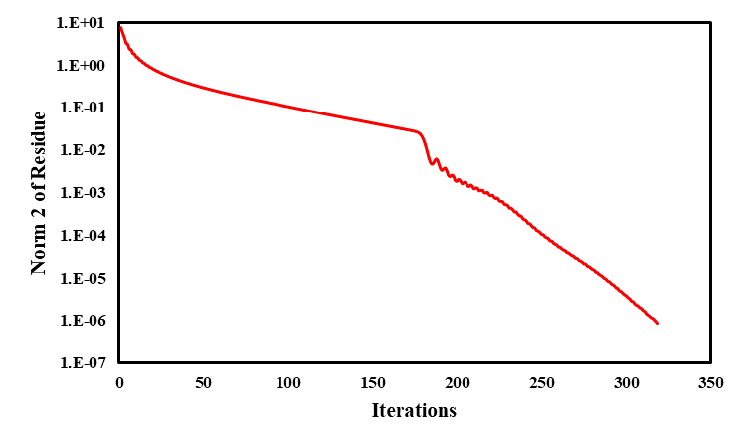b.**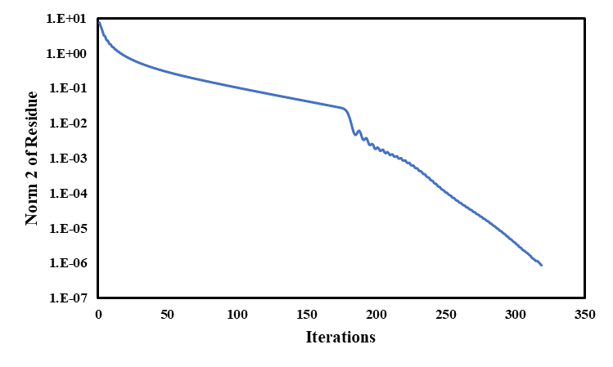

Figure 2: Norm2 of residual vs iteration of (a) Conjugate Gradient Method, (b) Preconditioned CG – Jacobi Method.

1. **Comparing Temperature Contours**

**a.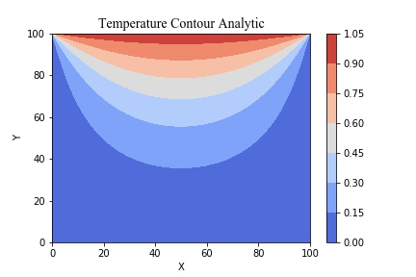b.** 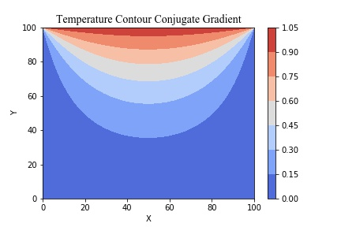

**c.**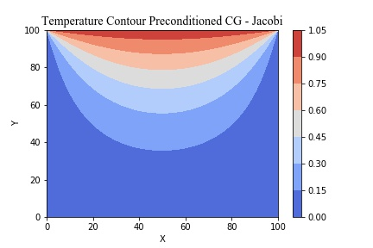

Figure 3: Temperature contours of (a) Analytic calculation of the solution, (b) Conjugate Gradient Method, (c) Preconditioned CG – Jacobi Method.

1. **Temperature variation along y-axis at horizontal midplane**

**a. 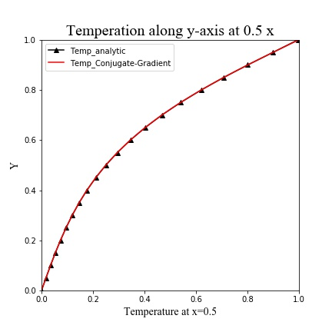 b.** 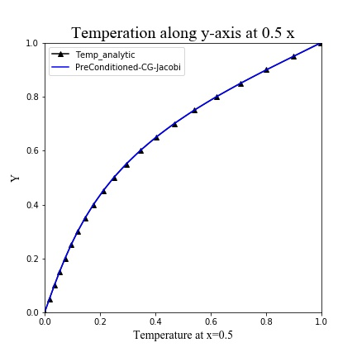

Figure 4: Temperature along y-axis at horizontal midplane of (a) Conjugate Gradient Method, (b) Preconditioned CG – Jacobi Method.

1. **Temperature variation along x-axis at vertical midplane**

**a. 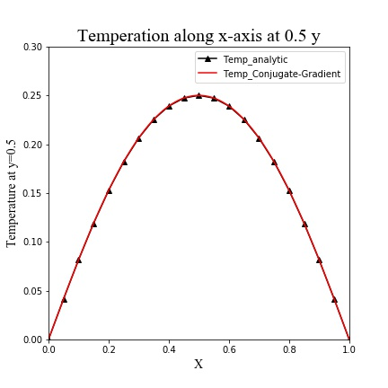 b.**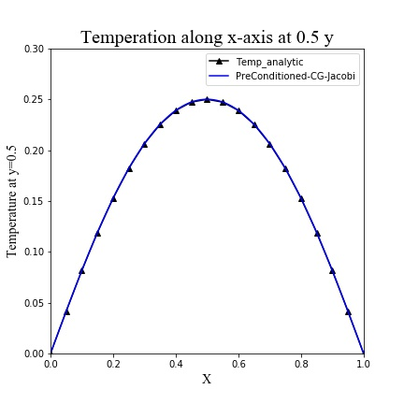

Figure 5: Temperature along x-axis at vertical midplane of (a) Conjugate Gradient Method, (b) Preconditioned CG – Jacobi Method.