Create a simple cloud software application for Car Booking Reservation System using
any Cloud Service Provider to demonstrate SaaS include the necessary fields such as
search for cabs, from, to, rental , out station, Package type, hours/Days etc.
Aim:
To create a cloud software application for Flight Reservation System
Procedure:
- Create a Zoho Account through one.zoho.in
- Head to Zoho Creator and Sign In
- Press “Create Solution” and “Create From Scratch”
- Click “Create a New Form” and In that Select “Cab Booking” Template
- Click “Done” And then Press “Access Development Live” for Trial
Implementation:
Fig 1. Form
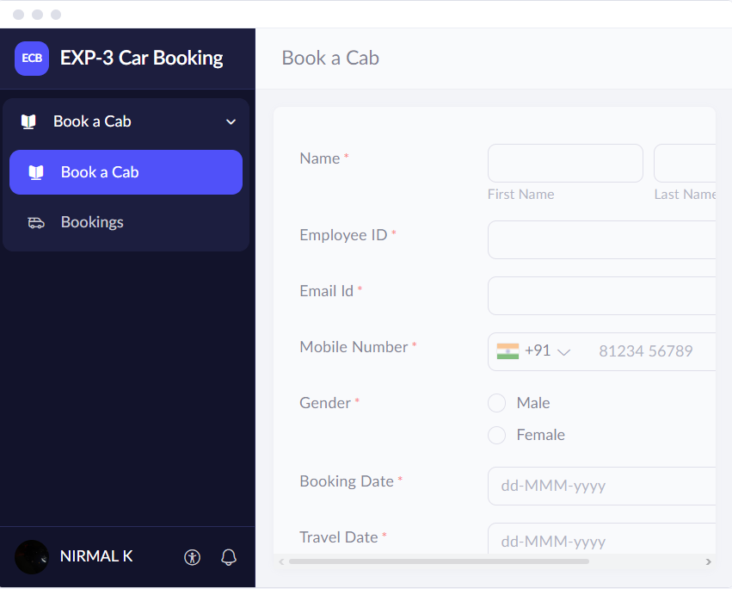
Fig 2. Form Building
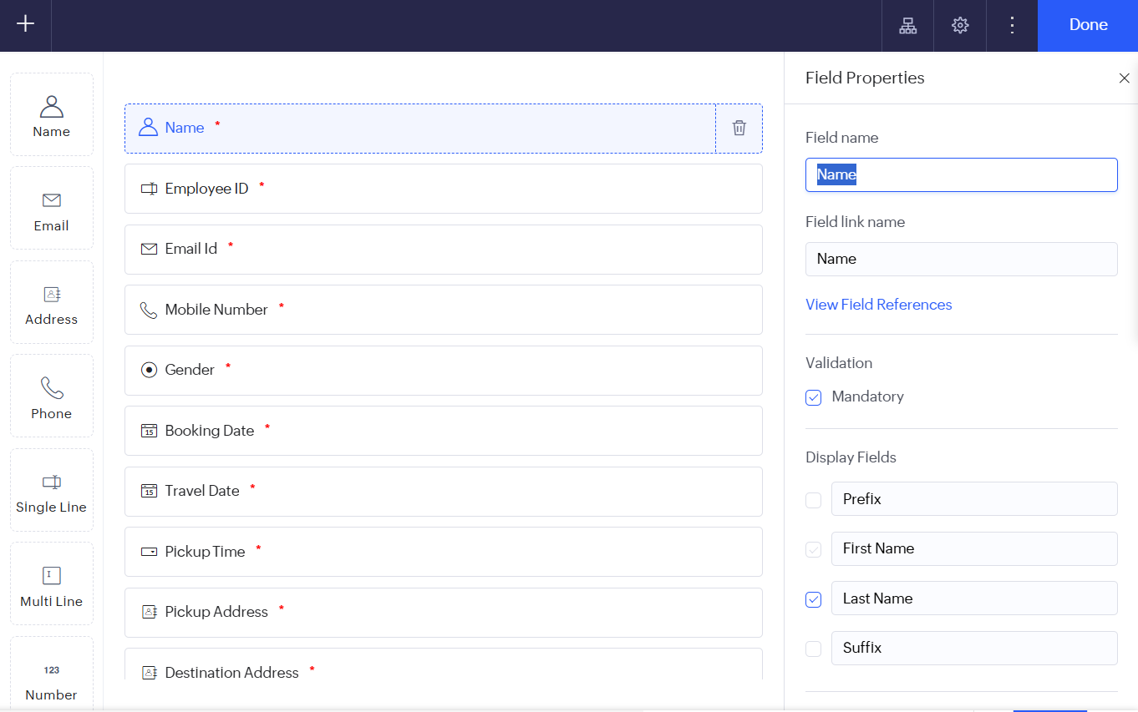

Output:
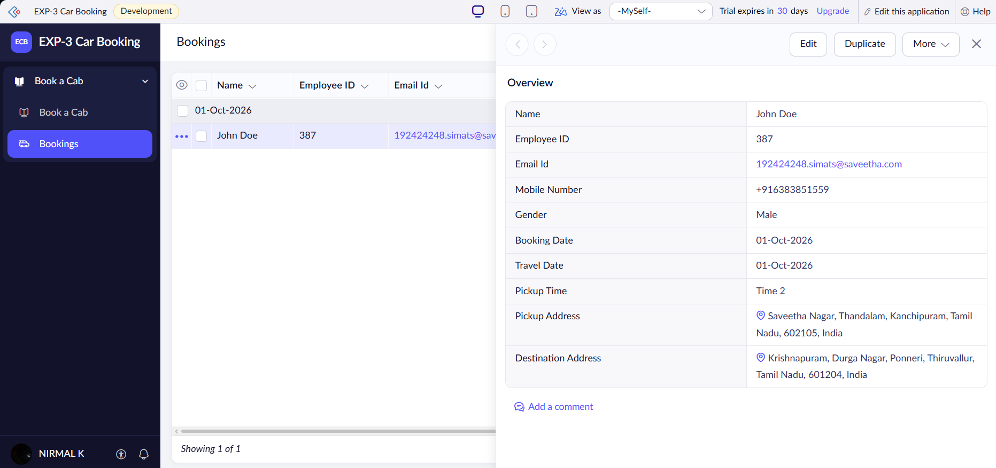
Result:
Cab Booking application is built successfully using Zoho Creator

