**Media Streaming with IBM Cloud Video Streaming**

**Phase 2: Innovation**

1. **Problem Definition:** Buffering problems streaming video occur when your internet speed or bandwidth is not enough to support the video quality that you are streaming. IBM cloud handles well in the case of the streaming problems.
2. **Cloud service selection:** In 2021, video streaming services are booming. Moreover, the global streaming market is expected to expand at a compound annual growth rate of 21.0% from 2021 to 2028.To ride that wave, entrepreneurs need to know how to create a video streaming service like Netflix that people will love to use. These services represent SaaS solutions that are very popular nowadays.
3. **Infrastructure Setup**: In 2021, video streaming services are booming. Moreover, the global streaming market is expected to expand at a compound annual growth rate of 21.0% from 2021 to 2028.

To ride that wave, entrepreneurs need to know how to create a video streaming service like Netflix that people will love to use. These services represent SaaS solutions that are very popular nowadays.

1. **Development:** IBM Watson Media’s adaptive HTTP chunk-based protocol can support HTML5 or Flash playback. For HTML5 desktop delivery, through HTML5 MSE, the service uses mp4 chunks and supports H.264 for video and AAC for audio delivery. For Flash on desktop, the service uses FLV container chunks and supports H.264, H.263 and VP6 for video, AAC, MP3 and Nellymoser for audio delivery. 
2. **Scaling and Optimization**: 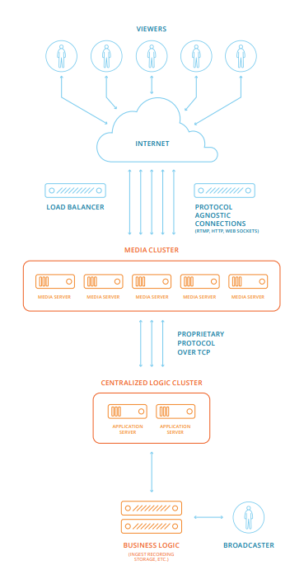

The IBM Watson Media Server is a proprietary server application developed for the purposes of large-scale live stream delivery with complex server-side business logic and access control. The IBM Watson Media Server maintains a bidirectional connection with each connected client. Content is typically ingested via RTMP while delivery supports HTTP streaming, HTTP live streaming (HLS) protocols, and legacy RTMP. The media server provides IBM with scale and flexibility, empowering enterprises to stream content without having to worry if their video content might go viral and attract huge audiences.