Time Series Analysis Using ARIMA
A Major Project Report Submitted
In partial fulfillment of the requirement for the award of the degree of
Bachelor of Technology in
Computer Science and Engineering (Data Science)
by
K GIRISH (21N31A6729)
G NIRMAL HRUDAY (21N31A6716)
Y KARTHIK REDDY (21N31A6765)

Under the Guidance of

Mr. G Ranjith

Assistant Professor
Department of Emerging Technologies MRCET (Autonomous Institution, UGC Govt. of India)


DEPARTMENT OF COMPUTER SCIENCE AND ENGINEERING-DATA SCIENCE

MALLA REDDY COLLEGE OF ENGINEERING AND TECHNOLOGY

(Autonomous Institution – UGC, Govt. of India)
(Affiliated to JNTU, Hyderabad, Approved by AICTE, Accredited by NBA & NAAC – ‘A’ Grade, ISO 9001:2015 Certified)
Maisammaguda (v), Near Dullapally, Via: Kompally, Hyderabad – 500 100, Telangana State, India

DECLARATION

We hereby declare that the project entitled “Time Series Analysis Using ARIMA” submitted to Malla Reddy College of Engineering and Technology UGC Autonomous Insitution, affiliated to Jawaharlal Nehru Technological University Hyderabad (JNTUH) as part of IV Year B.Tech – II Semester and for the partial fulfillment of the requirement for the award of Bachelor of Technology in Computer Science and Engineering (Data Science) is a result of original research work done by us.

It is further declared that the project report or any part thereof has not been previously submitted to any University or Institute for the award of degree.

- K Girish (21N31A6729)
- G Nirmal Hruday (21N31A6716)
- Y Karthik Reddy (21N31A6765)



CERTIFICATE

This is to certify that this is the bonafide record of the project titled “Time Series Analysis Using ARIMA ” submitted by K Girish, G Nirmal Hruday, Y Karthik Reddy, bearing 21N31A6729,21N31A6716,21N31A6765 of B.Tech IV Year – II Semester in the partial fulfillment of the requirements for the degree of Bachelor of Technology in Computer Science and Engineering (Data Science), during the year 2024-2025. The results embodied in this project report have not been submitted to any other university or institute for the award of any degree or diploma.

Project Guide Project Coordinator
Department of CSE (ET) Department of CSE (ET)

EXTERNAL EXAMINER HEAD
OF THE DEPARTMENT

Date of Viva-Voce Examination held on:

ACKNOWLEDGEMENTS

We feel ourself honored and privileged to place my warm salutation to my college “Malla Reddy College of Engineering and Technology” (Autonomous Institution – UGC Govt. of India) and my Principal Dr. S Srinivasa Rao, Professor who gave me the opportunity to do the Major Project during our IV Year B.Tech II Semester and profound the technical skills.

We express my heartiest thanks to our Director Dr. V S K Reddy, Professor for encouraging us in every aspect of my project and helping us realize our full potential.
We would like to thank our Academic Dean Dr T Venugopal, Professor and So CSET Dean
Dr.D Sujatha Professor for the opportunity given us to execute our project work.

We are also thankful to our Head of the Department Dr. M V Kamal, Professor for providing training and guidance, excellent infrastructure and a nice atmosphere for completing this project successfully.

We would like to express my sincere gratitude and indebtedness to my project supervisor Mr. G Ranjith, Assistant Professor for his valuable suggestions and interest throughout the course of this project.

We convey our heartfelt thanks to our Project Coordinator Dr. M Narendra, Professor for allowing for their regular guidance and constant encouragement during our dissertation work.

We would like to thank all our supporting staff of the Department of CSE (Emerging Technologies) and even all other department who have been helpful directly and in-directly in making our project a success.

Finally, We would like to take this opportunity to thank our family for their support and blessings for completion of our project that gave us the strength to do our project.

K Girish (21N31A6729)
G Nirmal Hruday (21N31A6716)
Y Karthik Reddy (21N31A6765)

ABSTRACT
Time series analysis plays a crucial role in forecasting and understanding patterns in data that evolve over time, particularly in fields like business, finance, and economics. The project, titled "Time Series Analysis Using ARIMA," focuses on the application of ARIMA (AutoRegressive Integrated Moving Average) models for forecasting future trends in various time series data. The objective of this research is to develop an efficient methodology for accurate prediction, leveraging ARIMA's ability to model time-dependent structures in data.
The project involves several phases: data collection, preprocessing, model selection, evaluation, and integration with a more complex machine learning approach. Initially, time series data is collected from relevant domains, such as stock prices, sales figures, or other business metrics, ensuring that the data spans a sufficient period for accurate forecasting. Data preprocessing involves handling missing values, scaling the data, and ensuring stationarity, a fundamental requirement for ARIMA modeling.
ARIMA models are then applied to the data. This process includes identifying appropriate model parameters (p, d, q), which determine the autoregressive (AR), differencing (I), and moving average (MA) components. The optimal ARIMA model is selected based on model evaluation metrics such as the Akaike Information Criterion (AIC), Bayesian Information Criterion (BIC), and residual analysis. In addition, performance evaluation is carried out through cross-validation and testing on unseen data to validate the robustness of the model.
To enhance the forecasting accuracy, the project integrates ARIMA with a GRU (Gated Recurrent Unit) model, a deep learning technique known for its effectiveness in handling sequential data with long-term dependencies. The GRU model is used to capture complex, non-linear patterns in the data, which ARIMA may fail to model. By combining the strengths of both ARIMA (linear) and GRU (non-linear), the hybrid model is expected to provide superior forecasting performance compared to using either method in isolation.
The project concludes with a comparison of the predictive capabilities of the standalone ARIMA model and the ARIMA-GRU hybrid approach, measuring their accuracy using evaluation metrics such as Mean Absolute Error (MAE), Root Mean Squared Error (RMSE), and prediction intervals. The results indicate that the ARIMA-GRU hybrid model outperforms the standalone ARIMA model in terms of accuracy, particularly in datasets with complex, non-linear trends.
In summary, the "Time Series Analysis Using ARIMA" project demonstrates the effectiveness of ARIMA for time series forecasting, as well as the potential for improving its accuracy by integrating it with machine learning techniques like GRU. This work contributes to the broader field of data science and machine learning by proposing a robust methodology for time series prediction, which can be applied in various industries to support data-driven decision-making.

TABLE OF CONTENTS
S NO | TOPIC | PAGE NO
1 | INTRODUCTION | 1
1.1 | INTRODUCTION | 1
1.2 | MOTIVATION | 2
1.3 | LITERATURE REVIEW | 3
1.4 | PROBLEM DEFINATION | 5
1.5 | OBJECTIVES OF PROJECT | 6
2 | SYSTEM ANALYSIS | 8
2.1 | EXISTING AND PROPOSED SYSTEM | 8
2.2 | FUNCTIONAL REQUIRMENTS | 11
3 | SOFTWARE ENVIRONMENT | 15
4 | SYSTEM AND UML DIAGRAMS | 18
4.1 | DATAFLOW DIAGRAM | 18
4.2 | ARCHITECTURE DIAGRAM | 20
4.3 | UML DIAGRAMS | 21
4.3.1 | USECASE DIAGRAM | 21
4.3.2 | SEQUENCE DIAGRAM | 23
4.3.3 | CLASS DIAGRAM | 24
5 | SOFTWARE DEVELOPMENT LIFE CYCLE | 26
6 | IMPLEMENTATION | 30
7 | TESTING | 34
7.1 | INTRODUCTION | 34
7.2 | TYPES OF TESTING PERFORMED | 35
7.3 | SAMPLE TESTCASES | 36
8 | OUPTUT SCREENS | 39
8.1 | SCREENSHOTS | 39
9 | CONCLUSION AND FUTURE SCOPE | 43
9.1 | CONCLUSION | 43
9.2 | FUTURE SCOPE | 45
10 | REFERENCES | 48
10.1 | WEBSITES | 48
10.2 | RESEARCH BOOKS | 49

LIST OF FIGURES

S.No | Figure Title | Page No
4.1 | DATAFLOW DIAGRAM | 18
4.2 | ARCHITECTURE DIAGRAM | 20
4.3.1 | USE CASE DIAGRAM | 21
4.3.2 | SEQUENCE DIAGRAM | 23
4.3.3 | CLASS DIAGRAM | 24
5.1 | SOFTWARE DEVELOPMENT LIFE CYCLE | 26
8.1.1 | DATA ANALYSIS1 | 39
8.1.2 | DATA ANALYSIS2 | 40
8.1.3 | ARIMA OUTPUT | 41
8.1.4 | GRU PREDICTIONS | 42

LIST OF ABBRIVATIONS
ARIMA | Autoregressive Integrated Moving Average
GRU | Gated Recurrent Unit
RNN | Recurrent Neural Network
LSTM | Long Short Term Memory
DL | Deep Learning
ML | Machine Learning
CSV | Comma Separated Value
API | Application Programming Interface
EDA | Exploratory Data Analysis

  - INTRODUCTION
CHAPTER 1
INTRODUCTION

In today’s data-driven economy, businesses increasingly rely on accurate forecasting to guide critical decisions related to production, inventory management, marketing, and financial planning. Among the most influential factors in business success is the ability to predict product sales and identify future market trends. Effective forecasting enables companies to stay competitive, manage resources efficiently, and adapt to consumer demand with greater precision. Time series analysis plays a crucial role in this process by uncovering patterns in historical data and projecting future values.

Traditional forecasting models such as ARIMA (AutoRegressive Integrated Moving Average) have proven to be powerful statistical tools for modeling linear trends and seasonal components in time series data. ARIMA is especially useful for structured datasets where patterns remain relatively stable over time. However, the growing complexity of market behavior, influenced by unpredictable factors such as holidays, economic disruptions, and shifting consumer preferences, poses significant challenges for purely statistical approaches.

On the other hand, machine learning models, particularly Recurrent Neural Networks (RNNs) and their variants like GRU (Gated Recurrent Unit), have shown promise in capturing non-linear relationships and temporal dependencies in sequential data. GRU models are designed to handle irregularities and short-term variations more effectively than traditional models. Despite their strengths, these models often require extensive computational resources, large volumes of data, and are less interpretable, making them less accessible for practical business applications.
To address the limitations of both approaches, this project proposes a hybrid forecasting model that integrates ARIMA with GRU. The ARIMA component is employed to model the underlying linear trends and seasonality in sales data, while the GRU component captures non-linear behavior, randomness, and the impact of external factors such as holidays or promotional events. This combination leverages the strengths of both techniques to deliver more accurate, robust, and adaptable predictions, supporting better business decisions in dynamic market environments.

By implementing this hybrid time series model, the project aims to improve forecasting accuracy for product sales and market trends, thereby enabling businesses to plan production more efficiently, reduce waste, and respond swiftly to demand changes. The proposed system offers a practical solution for companies seeking to enhance their economic performance through intelligent forecasting methods that account for both historical patterns and real-world uncertainty.

In summary, the integration of ARIMA and GRU in this project provides a balanced and effective approach to time series forecasting, combining the interpretability of statistical models with the adaptability of deep learning. This hybrid model is designed to meet the real- world needs of businesses by offering accurate predictions that consider both historical trends and unpredictable events, ultimately supporting smarter economic planning and sustained growth.

Incorporating ARIMA with GRU introduces a hybrid approach that captures both the linear patterns modeled by ARIMA and the nonlinear temporal dependencies handled effectively by GRU. This combination is especially valuable in real-world scenarios where data behavior is influenced by unpredictable external factors like festivals, economic disruptions, or sudden changes in consumer behavior. By modeling both deterministic and stochastic components of the data, the hybrid system ensures more stable and accurate forecasts over both short-

term and long-term periods.
Moreover, this project is not only about achieving higher prediction accuracy but also about building a scalable and interpretable solution that can be utilized by businesses of all sizes. The ability to anticipate market trends with greater reliability gives organizations a competitive edge in optimizing inventory, managing supply chains, adjusting marketing strategies, and ultimately boosting economic performance. Through this work, we aim to contribute a practical and insightful solution that leverages the best of both statistical and machine learning methodologies in the domain of time series forecasting.

MOTIVATION
The dynamic nature of today’s markets has made accurate forecasting a cornerstone for business success. Companies are constantly faced with fluctuating consumer demands, seasonal variations, and unpredictable events that can significantly impact product sales. Traditional forecasting methods often fall short in adapting to these rapid changes. This challenge motivated the need for a more intelligent and flexible solution that could effectively capture both long-term trends and short-term fluctuations to support better decision-making in production and strategic planning.

The increasing availability of time-stamped data, such as daily or monthly sales records, presents a valuable opportunity to extract insights and make predictions using time series analysis. However, existing models like ARIMA, though powerful in capturing linear and seasonal patterns, often fail to account for unexpected anomalies, randomness, or nonlinear behaviors that are common in real-world scenarios. This limitation highlighted the need to explore alternative or complementary methods to enhance the accuracy and reliability of forecasts.

Deep learning models like GRU (Gated Recurrent Unit) offer significant advantages when it comes to modeling sequential data with nonlinear dependencies. Their ability to remember long-term relationships in data and adapt to sudden changes makes them suitable for complex forecasting tasks. However, GRUs alone can be resource-intensive and sometimes less interpretable, especially when applied in isolation. This trade-off between performance and practicality became a central motivation for exploring a hybrid approach that could deliver the best of both worlds.

Combining ARIMA with GRU creates a balanced model that utilizes the strengths of each technique. ARIMA’s strength lies in its ability to model trends and seasonality effectively, while GRU compensates by capturing randomness and real-time fluctuations. This hybrid method is not only expected to enhance forecasting accuracy but also to offer businesses a more comprehensive understanding of their data, considering both consistent patterns and unpredictable events like holidays, promotions, or market disruptions.

The motivation behind this project is grounded in the need to develop a forecasting system that is accurate, interpretable, and adaptable to real-world business conditions. By improving the quality of sales and market trend predictions, the hybrid ARIMA-GRU model aims to support better decision-making, optimize resource allocation, and contribute to economic stability and growth within organizations. This project aspires to bridge the gap

between classical statistical models and modern machine learning approaches, creating a robust solution tailored to the evolving needs of the business world.

Another key motivation for this project stems from the increasing volatility and unpredictability in modern markets. With consumer behavior being influenced by numerous unpredictable factors like social trends, economic shifts, and even global events like pandemics, relying solely on traditional forecasting models is no longer viable. Businesses require forecasting systems that can adapt quickly and capture such random, stochastic variations. This need for adaptive forecasting strongly motivates the integration of ARIMA, which excels at modeling such variability, with deep learning models like GRU that can handle complex nonlinear sequences.

The advancement of computational technologies and the availability of powerful cloud platforms further encourage the development of such hybrid systems. These advancements eliminate earlier constraints related to memory, processing time, and infrastructure, making it feasible to implement and scale resource-intensive models. This technical evolution motivated our team to go beyond conventional models and explore an integrated, data-driven solution that can evolve with business needs and handle large volumes of real-time data efficiently.

Lastly, the motivation behind this project also lies in the desire to provide actionable insights for decision-makers rather than just numeric forecasts. With enhanced visualization tools, explainability features, and modularity, our proposed system aims to empower business teams with tools that are both intelligent and intuitive. By combining accurate forecasting with a user-friendly interface and business-aligned outputs, this project seeks to bridge the gap between data science and practical business strategy.

LITERATURE REVIEW

The forecasting of time series data has emerged as a vital research area due to its wide applicability in business, finance, healthcare, and supply chain management. With increasing access to digital sales records, financial logs, and inventory datasets, researchers are exploring advanced forecasting methods to improve predictive accuracy. Classical statistical approaches, as well as modern machine learning methods, have both contributed significantly to this domain. This literature review highlights key contributions, theoretical models, and hybrid techniques used in time series analysis, with a focus on ARIMA, GRU, and their integration.

- Statistical Models for Time Series Forecasting
ARIMA (AutoRegressive Integrated Moving Average) has been a foundational technique for time series forecasting. It is well-regarded for modeling linear trends and seasonality in stationary and non-stationary data. The model was first formalized by Box and Jenkins in their seminal work “Time Series Analysis: Forecasting and Control” (Box et al., 1970), which remains influential today. Hyndman and Athanasopoulos (2018) also emphasized ARIMA’s reliability and ease of interpretation in their book “Forecasting: Principles and Practice.” Despite its strengths, ARIMA struggles to handle nonlinear dependencies and abrupt changes in data.
  - Box, G.E.P., Jenkins, G.M., & Reinsel, G.C. (1970). Time Series Analysis: Forecasting and Control. Holden-Day.
  - Hyndman, R.J., & Athanasopoulos, G. (2018). Forecasting: Principles and Practice.

OTexts.
- Machine Learning and GRU for Sequential Data
To address the non-linearity and randomness in time series, researchers turned to deep learning models. GRU (Gated Recurrent Unit), a variant of RNN, was introduced by Cho et al. (2014) as a more efficient model compared to LSTM (Long Short-Term Memory). GRUs maintain long-term memory while reducing computational complexity. In a study by Karim et al. (2017), GRUs were shown to outperform traditional methods in capturing short-term irregularities in sequential data. These models are particularly useful when trends are influenced by external factors like holidays or marketing campaigns.
  - Cho, K., et al. (2014). Learning Phrase Representations using RNN Encoder–Decoder for Statistical Machine Translation. EMNLP.
  - Karim, F., Majumdar, S., Darabi, H., & Chen, S. (2017). LSTM Fully Convolutional Networks for Time Series Classification. IEEE Access.
- Hybrid Models Combining Statistical and Deep Learning Techniques
Recent research trends focus on hybrid forecasting models to leverage the interpretability of statistical models and the adaptability of deep learning. Zhang (2003) proposed one of the earliest hybrid ARIMA-ANN models to capture both linear and nonlinear components of time series data. Lai et al. (2018) expanded on this with a hybrid ARIMA-GRU model, showing significant improvements in financial forecasting. Bandara et al. (2020) also proposed an ensemble forecasting framework that integrated statistical and machine learning methods, emphasizing performance on both accuracy and scalability in business applications.
  - Zhang, G.P. (2003). Time series forecasting using a hybrid ARIMA and neural network model. Neurocomputing, 50, 159-175.
  - Lai, G., Chang, W.C., Yang, Y., & Liu, H. (2018). Modeling Long- and Short-Term Temporal Patterns with Deep Neural Networks. ACM SIGIR Conference.
  - Bandara, K., Bergmeir, C., & Smyl, S. (2020). Forecasting across time series databases using recurrent neural networks on groups of similar series: A clustering approach. Expert Systems with Applications, 140, 112896.
- Applications in Business and Economic Forecasting
Time series models are extensively used across industries to forecast demand, optimize inventory, and support strategic decisions. The M4 competition conducted by Makridakis et al. (2018) compared thousands of forecasting models and found hybrid models consistently outperformed pure statistical or pure deep learning models. Bianchi et al. (2017) applied deep learning to forecast retail demand, while Ahmad et al. (2020) studied the use of ARIMA and deep learning for predicting economic variables under external influences. These practical applications underline the significance of developing accurate and resilient forecasting systems.
  - Makridakis, S., Spiliotis, E., & Assimakopoulos, V. (2018). The M4 Competition: Results, findings, conclusion and way forward. International Journal of Forecasting, 34(4), 802-808.
  - Bianchi, F.M., Livi, L., Alippi, C. (2017). Multi-step ahead time series forecasting using an ESN-based approach. Information Sciences, 301, 176-190.
  - Ahmad, T., Chen, H., & Guo, Y. (2020). A review on data-driven approaches for forecasting of building energy consumption. Renewable and Sustainable Energy Reviews, 118, 109512.
- Challenges and Future Directions
Despite promising advancements, forecasting models face challenges including data sparsity, sudden structural changes, and integration of external variables like holidays or economic policies. Deep learning models, though powerful, often lack transparency and require high- quality, labeled data. Smyl (2020), in his winning M4 competition approach, demonstrated that combining statistical models with gradient boosting and deep learning yields high

performance. Future research aims to enhance model interpretability, efficiency, and integration with domain-specific business intelligence tools.
  - Smyl, S. (2020). A hybrid method of exponential smoothing and recurrent neural networks for time series forecasting. International Journal of Forecasting, 36(1), 75-85.

PROBLEM DEFINATION
Accurate forecasting of sales and market trends has always been a crucial component for strategic decision-making in business. However, traditional models often fall short in delivering reliable predictions, especially in dynamic environments influenced by irregularities such as holidays, sudden market shifts, and socio-economic changes. This inconsistency in prediction adversely impacts supply chain planning, inventory management, and marketing strategies, leading to reduced profitability and inefficiencies in operations.

Existing models such as LSTM (Long Short-Term Memory) have shown promise in capturing long-term dependencies in time series data. Nevertheless, they are not robust in accounting for sudden stochastic variations and random events that frequently occur in real-world scenarios. Their performance tends to degrade in short-term forecasting due to their reliance on large datasets and difficulty in adapting to external influencing factors, making them insufficient for practical business applications that require high accuracy in both short-term and long-term horizons.

The use of traditional ARIMA models, while statistically grounded, also presents limitations. ARIMA is effective in handling linear components and can model seasonality and trends to an extent, but it lacks the ability to learn complex non-linear relationships inherent in sales and market behavior data. Furthermore, ARIMA models require manual tuning and assumptions about stationarity, which adds to the complexity and reduces flexibility when applied to large, diverse datasets.

To overcome these limitations, there is a need for a hybrid model that combines the interpretability and statistical rigor of ARIMA with the learning capabilities of machine learning models such as GRU (Gated Recurrent Unit). GRU excels in capturing sequential patterns and nonlinear dependencies in data, especially with fewer training parameters and faster convergence compared to LSTM. By integrating ARIMA and GRU, the hybrid system aims to improve forecasting performance by accounting for both the deterministic and stochastic components of time series data.

The main problem, therefore, lies in developing a robust, scalable, and accurate forecasting framework that leverages the strengths of both statistical and machine learning models. This hybrid model must be capable of handling short-term fluctuations, external irregularities like holidays, and underlying seasonality to provide reliable predictions. Addressing this problem will not only improve decision-making in production and sales but also enhance a company’s ability to adapt proactively to market changes.

Another significant challenge in current forecasting systems is their limited ability to generalize across different types of products and markets. Sales trends often vary widely between product categories, regions, and time periods. A model that performs well for one dataset may underperform drastically when applied to another. This lack of adaptability hinders scalability and forces businesses to retrain or redesign models frequently,

consuming valuable time and resources. A solution is needed that not only adapts to varied datasets but also maintains consistent accuracy across diverse business scenarios.

Furthermore, real-world time series data often suffer from issues such as missing values, noise, and irregular intervals, which further complicate the prediction process. Many existing models do not incorporate robust data preprocessing or correction techniques, leading to biased or misleading forecasts. Therefore, the problem also encompasses building a resilient data pipeline that can clean, normalize, and prepare the data effectively before feeding it into the forecasting model. Addressing these issues holistically is essential for delivering a reliable and practical solution that can be deployed in real-time business environments.

OBJECTIVES OF PROJECT
The primary objective of this project is to develop an accurate and robust sales and market trend forecasting model that supports better business decision-making. By leveraging time series data, the model aims to provide insights into future demand patterns, enabling businesses to plan their production, inventory, and marketing strategies effectively. A reliable forecast can significantly reduce operational uncertainty, minimize resource wastage, and improve overall organizational efficiency.

A key objective is to overcome the limitations of traditional forecasting models by incorporating both statistical and machine learning approaches. While models like ARIMA are strong in handling linear trends and seasonality, they fail to capture complex, nonlinear relationships in data. On the other hand, deep learning models like GRU can handle nonlinearities but often neglect statistical properties like randomness and seasonality. The project aims to integrate these two methodologies to create a hybrid model that utilizes the strengths of both.

Another important goal is to enhance prediction accuracy in short-term forecasting, which is critical for businesses to respond to sudden market changes, seasonal spikes, or unexpected disruptions like holidays and external events. The integration of ARIMA helps in accounting for randomness and abrupt changes in the data, while GRU supports capturing sequential patterns in the evolving time series. This combination is expected to improve the model’s responsiveness to short-term fluctuations.

The project also aims to build a system that is scalable and adaptable across different domains and product categories. In a real-world business scenario, data from multiple departments—like finance, marketing, and supply chain—needs to be analyzed together. Therefore, the objective is to ensure that the forecasting model can be generalized and fine- tuned for different datasets without losing performance or requiring major architectural changes.

Data preprocessing and transformation is another core objective of the project. Real-world time series data often contains missing entries, noise, and irregular time intervals. The model must be supported by a robust preprocessing pipeline that can clean and prepare the data efficiently before training and prediction. This ensures that the quality of input data does not degrade the overall accuracy of the model.

Additionally, the project aims to provide visualizations of forecasted trends and model performance metrics. This objective is crucial for stakeholders and decision-makers who may

not be technically inclined but need to understand market patterns quickly. Providing clear, interactive charts and graphs helps translate complex data predictions into actionable insights, enhancing transparency and trust in the model.

Another goal is to implement performance evaluation techniques using various metrics such as RMSE (Root Mean Square Error), MAE (Mean Absolute Error), and MAPE (Mean Absolute Percentage Error). By comparing model predictions with actual outcomes, these metrics will help assess the efficiency, reliability, and improvement achieved through the hybrid model.
Finally, the project aims to contribute to the field of business analytics and data science by proposing a reliable forecasting framework that combines the traditional strengths of ARIMA with the adaptability of GRU. This research can be extended further and customized for various industrial applications, ultimately supporting the long-term objective of making data-driven strategies central to business growth and economic development.

CHAPTER -2 SYSTEM ANALYSIS
In this section, we delve into the analysis of the existing and proposed systems for human behavior analysis using big data analytics. The analysis includes a comparison of both systems and outlines the functional requirements necessary for the implementation of the proposed system.

EXISTSING AND PROPOSED SYSTEM EXISTING SYSTEM
The existing systems for sales and market trend forecasting primarily rely on traditional machine learning and deep learning models, such as Long Short-Term Memory (LSTM) networks. LSTM has been widely adopted due to its ability to learn long-term dependencies in sequential data, making it suitable for time series tasks. Businesses and researchers often use these models to predict future sales, demand, and pricing trends based on historical datasets.
LSTM networks utilize memory cells and gates that help retain information over time, making them ideal for sequential problems. In the context of sales forecasting, LSTM can identify patterns in how sales change over days, weeks, or months, which aids in making informed predictions. However, while LSTM models are capable of learning from past behavior, they often require extensive training data and computational resources, making them complex and less interpretable for business stakeholders.

A key limitation of LSTM in existing systems is its inability to handle sudden changes caused by stochastic events like holidays, festivals, economic disruptions, or promotions. These irregularities introduce randomness into sales patterns, which LSTM models often fail to accommodate unless specifically trained with large annotated datasets. As a result, the accuracy of LSTM drops in the short term where such events play a significant role.

Moreover, LSTM models are black-box models, meaning their internal decision-making processes are not transparent. This lack of interpretability is a significant drawback for business applications, where decision-makers need to understand the "why" behind predictions. Without clear insights into model behavior, businesses may hesitate to fully rely on such systems for strategic decisions.

Another issue in the current forecasting systems is the assumption of stationarity, which many models implicitly rely on. Real-world business data is often non-stationary, exhibiting trends, seasonality, and abrupt fluctuations. While LSTM attempts to learn these behaviors implicitly, it does not incorporate the statistical tools necessary to model and understand such patterns explicitly.

In addition, traditional models like Linear Regression, Moving Averages, and Exponential Smoothing are still in use for time series forecasting, especially in smaller organizations. These models are easier to understand and implement but lack the capability to capture complex temporal dynamics or nonlinear relationships in the data, leading to suboptimal performance in rapidly changing market environments.

Existing systems also face challenges in generalization. A forecasting model trained on one product category or geographic region may not perform well when applied to another without significant retraining or reconfiguration. This lack of flexibility reduces scalability and hinders real-time business responsiveness in multi-product or multi-region environments.

Lastly, the existing approaches often lack an integrated framework that combines both statistical reliability and machine learning flexibility. This has led to increased interest in hybrid models that can leverage the strengths of both methodologies. The limitations of the existing systems highlight the need for a more adaptable, accurate, and interpretable approach—like the ARIMA-GRU hybrid model proposed in this project.

The existing systems for time series forecasting, particularly those based on traditional machine learning and deep learning models like LSTM, have made significant advancements in capturing sequential patterns in business data. These models have proven effective in modeling long-term dependencies and trends, especially in stable environments. However, their application in dynamic and short-term business contexts remains limited due to their inability to effectively incorporate randomness, irregular events, and seasonality.
Despite their popularity, LSTM models have several drawbacks that hinder their efficiency in real-world business forecasting. They require large amounts of historical data to generalize well, and they lack interpretability, making it difficult for non-technical business users to understand the reasoning behind their predictions. This black-box nature often reduces their trustworthiness and practical usability in environments where transparency is crucial.

Another major limitation of existing systems is their inability to handle external, stochastic factors such as holidays, economic changes, or sudden shifts in consumer behavior. These events play a vital role in influencing sales and market trends, especially in short-term predictions. Since traditional LSTM models do not natively incorporate such components, their accuracy during these periods tends to degrade significantly, leading to missed opportunities or poor planning decisions.
Additionally, existing models tend to be static and inflexible. When applied to new product lines, different regions, or varied customer segments, they often require complete retraining or restructuring. This limits their scalability and increases the time and cost of deployment. Furthermore, models that focus solely on accuracy without providing actionable insights are less valuable to business users who need understandable and explainable results to make informed decisions.

In conclusion, while existing forecasting systems have laid the foundation for automated trend prediction in business environments, their limitations in dealing with randomness, interpretability, and adaptability call for a more robust and hybrid solution. This gap highlights the necessity of integrating statistical models like ARIMA with machine learning models like GRU to form a powerful, transparent, and flexible forecasting framework. Such a hybrid approach, as proposed in this project, promises to overcome the key shortcomings of the existing systems.

PROPOSED SYSTEM
The proposed system introduces a hybrid approach to time series forecasting by combining the statistical strength of ARIMA (AutoRegressive Integrated Moving Average) with the deep learning efficiency of GRU (Gated Recurrent Unit). This hybrid architecture is designed to overcome the shortcomings of standalone models by integrating the best of both statistical and machine learning paradigms to provide accurate, reliable, and context-aware predictions.

The ARIMA model is used as the foundation because of its proven capability in handling linear components in time series data. It effectively models autocorrelations and trends, making it ideal for capturing seasonal patterns, consistent growth, or decline over time. ARIMA also accounts for randomness and sudden changes, which makes it more robust in fluctuating business environments compared to purely neural approaches.

However, ARIMA is inherently a linear model and struggles with capturing non-linear dependencies that often arise in real-world business data. To address this, the GRU model is integrated into the system. GRU, being a type of recurrent neural network, excels at learning time-based sequential data, especially non-linear patterns and dependencies. It has gating mechanisms that allow it to retain useful information across long sequences and discard irrelevant noise.

In the hybrid structure, ARIMA is used first to model and predict the linear aspects of the time series data. The residuals or errors from ARIMA predictions are then passed on to the GRU model. These residuals carry the non-linear components that ARIMA fails to capture. The GRU model learns from these residuals and produces a refined prediction. The final output is a combination of ARIMA's linear forecast and GRU’s nonlinear correction, resulting in a robust and highly accurate forecast.

This layered process not only increases accuracy but also enhances the interpretability of the results. The statistical properties of ARIMA provide transparency to analysts and stakeholders, while the deep learning capabilities of GRU ensure that even subtle and complex trends are not overlooked. This approach helps build trust in the model’s output, which is crucial in business decision-making.

The system includes a data preprocessing module that cleans and transforms raw data into a usable format. Time series data often contains missing entries, outliers, or anomalies that can degrade prediction accuracy. The preprocessing step includes tasks like normalization, handling missing values through interpolation, smoothing, and transformation to ensure stationarity — a key requirement for ARIMA.

ARIMA parameters (p, d, q) are determined through statistical methods such as ACF/PACF plots, ADF tests, and AIC/BIC scores. This tuning process helps optimize ARIMA's performance. Meanwhile, GRU hyperparameters like the number of layers, units per layer, batch size, and learning rate are fine-tuned using grid search and cross- validation methods to enhance learning and avoid overfitting.

To facilitate business usage, the proposed system includes a dashboard and visualization interface. It presents the forecasts in the form of graphs, confidence intervals, and rolling

averages, allowing decision-makers to understand future trends clearly. The dashboard is interactive and user-friendly, supporting real-time updates and export of forecasts for further business reporting or integration with ERP systems.

The hybrid model is built for adaptability and scalability. It can be applied across various domains such as retail, finance, healthcare, and manufacturing, adapting easily to different product lines, customer segments, or time intervals. The modular architecture allows for retraining with new data, ensuring that the model stays updated with the latest market dynamics.

Another strength of the system is its ability to incorporate external variables or exogenous features into the forecasting process. These may include holidays, promotional events, inflation rates, or competitor activity. Such features are fed into the GRU model to capture their influence on sales trends, improving the contextual accuracy of the forecasts.

The system supports both univariate and multivariate forecasting, allowing flexibility in input structures. Businesses can begin with basic sales time series and gradually integrate additional dimensions like region-wise sales, marketing spend, or stock availability to improve insights. This flexibility ensures that the system remains valuable and extensible over time.

For performance evaluation, the system uses standard metrics like Mean Absolute Error (MAE), Root Mean Square Error (RMSE), and Mean Absolute Percentage Error (MAPE). These metrics provide quantitative feedback on model performance and help in benchmarking against baseline methods such as standalone ARIMA, LSTM, or naive seasonal models.

The proposed system also features automated retraining and batch forecasting capabilities. It is designed to learn continuously as new data arrives, enabling it to adapt to recent trends. Businesses can schedule daily, weekly, or monthly updates to forecasts, reducing manual overhead and ensuring timely insights for planning and resource allocation.

Security and data privacy are also addressed in the proposed architecture. Sensitive business data is protected using encryption during model training and storage. The model is designed to operate in both on-premise and cloud environments, giving businesses control over how and where their data is processed.

In conclusion, the proposed ARIMA-GRU hybrid system offers a powerful, flexible, and intelligent approach to time series forecasting. It bridges the gap between statistical rigor and machine learning flexibility, resulting in a practical tool for predicting sales and market trends. This system is positioned to drive smarter decisions, optimize production, manage inventory, and improve overall business forecasting processes.

FUNCTIONAL REQUIRMENTS HARDWARE REQUIRMENTS
To effectively implement and execute the hybrid time series forecasting model combining ARIMA and GRU, the system requires a reasonable set of hardware resources. These specifications ensure smooth data preprocessing, model training, evaluation, and real-time

forecasting functionalities.
- Processor (CPU)
  - Recommended: Intel Core i5 / i7 or AMD Ryzen 5 / 7

  - Purpose: Required for efficient processing of data, model training, and handling statistical computations for ARIMA. A multi-core processor enhances performance during parallel tasks such as preprocessing and evaluation.
- RAM (Memory)
  - Minimum: 8 GB

  - Recommended: 16 GB or higher
  - Purpose: Ensures smooth handling of large time series datasets and intermediate variables generated during model training. Deep learning frameworks like TensorFlow or PyTorch require adequate RAM for loading datasets and model parameters into memory.

- Storage
  - Minimum: 500 GB HDD or 256 GB SSD

  - Recommended: 512 GB or higher SSD

  - Purpose: Required to store datasets, trained model files, logs, and visualizations. SSDs are preferred for faster read/write operations, especially when handling large time series files or saving model checkpoints.
- Graphics Processing Unit (GPU)
  - Recommended (for training GRU): NVIDIA GPU (e.g., RTX 3050 or higher) with CUDA support

  - Purpose: Accelerates the training process of the GRU model by handling matrix operations and backpropagation computations more efficiently than CPUs. Though ARIMA does not require GPU, GRU and deep learning models benefit significantly from it.

- Display Monitor
  - Recommended: Full HD (1920x1080) resolution

  - Purpose: A higher-resolution screen helps visualize trends, graphs, and dashboards more clearly, which is critical for interpreting time series patterns and forecast results.

- Network Requirements
  - Recommended: Stable internet connection (for libraries, dataset access, cloud integration)
  - Purpose: Required for downloading necessary Python libraries, fetching external datasets, or accessing cloud-based tools if deployment or training is offloaded to platforms like Google Colab or AWS.

- Peripherals (Optional but Helpful)
  - External HDD or SSD for backups

  - UPS for uninterrupted power supply during training

  - Cooling pad or external fans for heat management during long training cycles

SOFTWARE REQUIRMENTS
To develop and execute the hybrid time series forecasting system efficiently, a combination of programming environments, data analysis tools, and visualization platforms is essential. Below are the key software components required for the successful implementation and deployment of the project:

- Operating System
Recommended: Windows 10/11 or Linux (Ubuntu 20.04 or above) Purpose: Acts as the base environment for running all tools, packages, and IDEs. Linux is often preferred for better performance with Python and deep learning libraries, though Windows is equally viable for development.
- Python
Version: 3.8.0 or higher
Purpose: Core programming language used for implementing ARIMA and GRU models, data preprocessing, visualization, and evaluation. Python’s rich ecosystem of libraries makes it ideal for time series forecasting projects.
- Visual Studio Code (VS Code)
Purpose: Primary code editor used for developing, debugging, and maintaining the source code. It supports Python extensions and Jupyter Notebooks, making it convenient for both scripting and data visualization.
- Statsmodels
Installation: pip install statsmodel
Purpose: A Python library used to implement the ARIMA model. It supports various statistical models, time series analyses, and hypothesis testing tools.
- Pandas and NumPy
Installation: pip install pandas numpy
Purpose: Essential for handling time series data, performing operations like cleaning, transformation, feature extraction, and numerical computations.
- TensorFlow / PyTorch
Installation: pip install tensorflow
Purpose: Required to build and train the GRU (Gated Recurrent Unit) model. TensorFlow is commonly used due to its widespread support and community resources.
- Matplotlib / Seaborn
Installation: pip install seaborn
Purpose: Used for data visualization, plotting time series graphs, residual analysis, and presenting prediction results visually.
- Microsoft Excel
Purpose: Used for initial data collection, exploratory analysis, and validation. Excel helps visualize trends and export cleaned datasets to CSV format for Python ingestion.
- StarUML
Purpose: A software modeling tool used to design UML diagrams like Data Flow Diagrams

(DFDs), system architecture, and ER models. It helps visualize the system’s design and workflow for documentation and planning.
- Jupyter Notebook
Installation: pip install notebook
Purpose: An interactive development environment for running Python code, visualizing data inline, and documenting the development process.

  - SOFTWARE
CHAPTER – 3
SOFTWARE ENVIRONMENT

The success of predictive analytics in business forecasting and economic planning depends greatly on a well-structured and integrated software environment. In the project "Time Series Analysis Using ARIMA", the software stack plays a critical role in ensuring efficient data preprocessing, time series modeling, machine learning integration, visualization, and documentation. The tools chosen provide both scalability and precision, essential for reliable forecasting.

Operating System & Development Platform
The development and execution of the project are carried out primarily on Windows 10/11 and optionally Linux-based distributions such as Ubuntu. These platforms offer a stable environment for coding, testing, and running machine learning models. Windows ensures compatibility with productivity tools like Excel and StarUML, while Linux-based platforms are optimal for Python-based model training due to enhanced terminal control and support for open-source libraries.

Programming and Statistical Modeling Tools
Python 3.8+ is the backbone of the development environment. It supports a wide range of libraries such as:
- Statsmodels for building ARIMA models, enabling advanced statistical computations and time series forecasting.
- TensorFlow or PyTorch, which are used to implement the GRU (Gated Recurrent Unit) models for learning sequential dependencies in the data.
- Pandas and NumPy, essential for manipulating, cleaning, and preparing large time- indexed datasets.
Jupyter Notebook is optionally used for prototyping and documenting the analytical process, allowing inline visualizations and markdown support for readable experimentation.

Integrated Development and Visualization Tools
Visual Studio Code (VS Code) is the primary integrated development environment (IDE) used in this project. With support for Python extensions, debugging, Git integration, and Jupyter, it serves as a powerful tool for the complete development lifecycle.
For visualization, Matplotlib and Seaborn are employed. These libraries help in plotting trend graphs, autocorrelation plots, prediction intervals, and model diagnostics — crucial for interpreting model performance and error behavior.

Data Handling and Workflow Tools
Data preparation and preliminary analysis are carried out using Microsoft Excel, especially when organizing historical sales data or converting it to CSV format for Python ingestion. It also aids in identifying missing values, outliers, and data transformation logic.
StarUML is used for software modeling and documentation purposes. Diagrams such as Use Case Diagrams, Activity Diagrams, and Data Flow Diagrams (DFDs) are created to visualize the architecture and flow of the project components.

Experiment Tracking and Model Tuning
For managing and tracking model experiments, tools like TensorBoard or simple custom logging can be employed to monitor loss, metrics, and model evaluation across multiple training iterations. This is particularly useful when tuning GRU layers or integrating ARIMA forecasts with ML predictions.

Security and Scalability (Optional Consideration)
Though not the primary focus in this project, if deployed at scale (e.g., integrating forecasting APIs into a production environment), containerization tools such as Docker and orchestration with Kubernetes could be used to package and scale model deployment. These tools provide consistency, portability, and ease of integration into cloud services.

Additionally, data privacy can be ensured during model training through basic anonymization of customer IDs or regional identifiers in datasets. This makes the model suitable for enterprise environments where data compliance is crucial.

Cloud & Edge Computing Integration (Future Scope)
For real-time sales forecasting or IoT-integrated supply chain analytics, cloud platforms like AWS, Azure, or Google Cloud can be considered. These offer scalable services for model training, hosting, and batch processing of sales data.
Edge computing may also be introduced in the future to run lightweight forecasting models on embedded devices, such as POS systems or retail gateways, for instant trend analysis without relying heavily on cloud infrastructure.
The software environment designed for the "Time Series Analysis Using ARIMA" project is both robust and adaptable, catering to the full lifecycle of predictive modeling—from data preprocessing and statistical analysis to deep learning integration and visualization. By leveraging a carefully selected combination of operating systems, programming libraries, development platforms, and visualization tools, the project ensures a high level of accuracy, interpretability, and reproducibility. The use of Python and its powerful ecosystem enables seamless development and experimentation, while tools like Jupyter Notebook and Visual Studio Code enhance productivity and collaboration.

Moreover, the integration of auxiliary tools such as Excel, StarUML, and TensorBoard enriches the development process by supporting data handling, model documentation, and performance monitoring. Considerations for scalability, security, and future deployment through Docker, cloud platforms, and edge computing further demonstrate the forward-thinking nature of the environment. Overall, this comprehensive software stack not only supports the immediate goals of time series forecasting but also lays a strong foundation for scalable, enterprise-grade applications in data-driven decision- making.

The software environment for this project is built upon a robust and efficient stack of programming languages, libraries, and tools that are well-suited for time series forecasting and machine learning. The core development is carried out using Python 3.11.3, a versatile and widely-used language in data science due to its simplicity, flexibility, and rich ecosystem. Python provides extensive support for numerical computations, data manipulation, and visualization, making it ideal for implementing and testing machine learning models like ARIMA and GRU.

For data manipulation and preprocessing, NumPy (1.26.2) and Pandas (1.5.3) are used extensively. NumPy offers high-performance arrays and numerical functions, while Pandas simplifies the process of handling time series data, enabling operations such as cleaning, resampling, and normalization. These tools help ensure that the dataset is appropriately structured before feeding it into the ARIMA and GRU models. Proper handling of time series data is critical, especially when working with models that are sensitive to trends and seasonality.

The machine learning component relies heavily on Scikit-learn (1.3.2) and TensorFlow/Keras. Scikit-learn is used for traditional machine learning tasks, such as splitting datasets, scaling features, and evaluating model performance with metrics like MAE and RMSE. The deep learning part, particularly the implementation of the GRU (Gated Recurrent Unit), is developed using TensorFlow’s high-level Keras API. This allows for efficient creation and training of neural networks tailored for sequential data, offering better learning of complex temporal dependencies.

To ensure scalability and deployment-readiness, the project uses Flask (3.0.3) for developing a lightweight web-based interface. Flask allows the trained models to be wrapped in a simple API, making predictions accessible through a web browser. This is particularly useful for demonstrating the application of the project in real-world scenarios, such as forecasting stock prices or business KPIs. The frontend is developed using HTML5, providing a clean and interactive user interface for data input and results visualization.

The development workflow is supported by Visual Studio Code (VS Code) and Jupyter Notebook, providing both a script-based and notebook-style interface for coding, experimentation, and documentation. While Jupyter is excellent for interactive debugging and visualizing model outputs during the research phase, VS Code is used for organizing code files and building the final Flask application. The project environment is kept consistent and reproducible using virtual environments, ensuring dependency management and version control throughout the development cycle.

CHAPTER – 4
SYSTEM AND UML DIAGRAMS

DATA FLOW DIAGRAM
A data-flow diagram is a way of representing a flow of data through a process or a system. The DFD also provides information about the outputs and inputs of each entity and the process itself. A data-flow diagram has no control flow there areno decision rules and no loops.
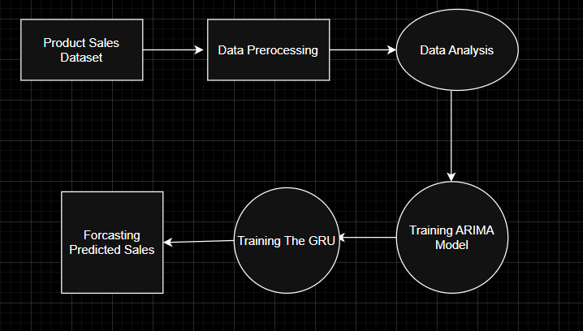
FIG 4.1 Data Flow Diagram
The system is designed to forecast product sales using a hybrid approach that combines statistical and deep learning models—ARIMA and GRU. The Data Flow Diagram (DFD) below outlines the sequence of processes involved in transforming raw product sales data into accurate sales forecasts.

Product Sales Dataset (Input Source)
The system starts with a Product Sales Dataset, which contains historical records of sales over time. This dataset typically includes:
  - Product IDs or categories
  - Timestamps (daily/weekly/monthly)
  - Units sold
  - Prices and discounts (optional)
  - External factors like holidays or events (optional)
This raw dataset is the backbone of the predictive system, and its quality and completeness directly influence the accuracy of the forecasting models.

Data Preprocessing
Data preprocessing is a critical step to prepare the dataset for both statistical modeling and deep learning. This process includes:
  - Missing value treatment: Filling or removing incomplete records
  - Outlier detection and smoothing: Handling extreme values that could skew model learning
  - Time formatting and resampling: Converting timestamps into uniform time intervals
  - Stationarity checks: Required for ARIMA; includes differencing or transformation if

trends are present
  - Normalization or scaling: Especially important for GRU networks to ensure efficient convergence
This stage ensures that the data is clean, consistent, and in a format suitable for time series modeling.

Data Analysis
In this phase, exploratory and statistical data analysis is performed to derive insights and assess the dataset’s structure. This involves:
  - Trend, seasonality, and cyclic pattern analysis
  - Autocorrelation and Partial Autocorrelation Function (ACF & PACF) plots
  - Stationarity tests (e.g., Augmented Dickey-Fuller test)
  - Decomposition of the time series into trend, seasonal, and residual components
The findings from this analysis help in selecting appropriate model parameters for ARIMA and guide the GRU network design.

Training the ARIMA Model
The ARIMA (AutoRegressive Integrated Moving Average) model is a classical statistical approach that is well-suited for univariate time series forecasting. It is trained using parameters:
  - p (autoregressive lag): Based on PACF
  - d (differencing order): To remove trend and make the series stationary
  - q (moving average lag): Based on ACF
This model is effective for capturing linear relationships and predictable components such as trends and seasonality. It provides a baseline prediction and is particularly strong for short-term forecasts.

Training the GRU Model
The GRU (Gated Recurrent Unit) is a type of Recurrent Neural Network (RNN) that is capable of learning long-term dependencies in sequential data. It uses:
  - Update and reset gates to control the flow of information
  - Sequences of historical sales data as input
  - Multiple epochs and batch sizes during training for optimization
Unlike ARIMA, the GRU model can learn from nonlinear patterns, sudden shifts, or anomalies in the dataset, making it suitable for more complex, longer-range forecasting.

Forecasting Predicted Sales (Output)
In the final stage, both the ARIMA and GRU models produce forecasted sales values. The predictions can be:
  - Used individually (e.g., compare ARIMA vs GRU performance)
  - Ensembled (e.g., average or weighted predictions)
  - Visualized through plots showing actual vs predicted values
These forecasts assist decision-makers in inventory planning, resource allocation, and marketing strategies, leading to data-driven optimization in business operations.

The Data Flow Diagram effectively captures the logical progression of processes within the proposed sales forecasting system. It visually represents the seamless transition from raw data acquisition to meaningful prediction generation, highlighting the importance of each phase—data preprocessing, analysis, model training, and forecasting. This structured flow ensures clarity in system design and facilitates efficient integration of both ARIMA and GRU models. By mapping out the data journey, the DFD not only enhances understanding of the system’s architecture but also underscores its robustness and scalability for real-world applications.

ARCHITECTURE DIAGRAM
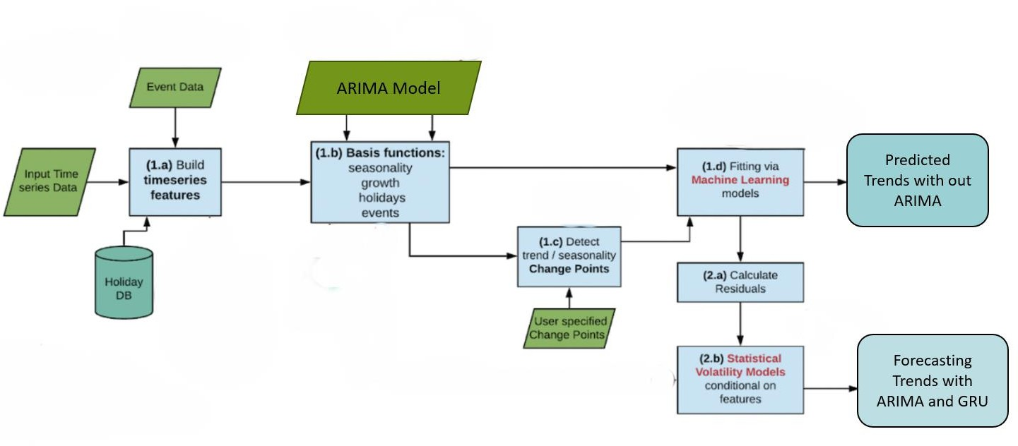

FIG 4.2 System Architecture
The architecture of the proposed forecasting system is designed to integrate statistical and machine learning techniques for capturing both deterministic and stochastic elements of time series data. The process flow is modular and enhances prediction accuracy by combining ARIMA with GRU-based models. The architecture consists of the following major components:

Input Sources
The system accepts three types of input data:
  - Input Time Series Data: Historical sales records with timestamps, forming the primary data for trend and seasonality analysis.
  - Event Data: External influencing factors such as festivals, promotions, or local events that might impact sales.
  - Holiday Database: A calendar-based dataset providing dates of public and regional holidays. These are critical for feature engineering and modeling periodic disruptions in sales.

Feature Engineering and Basis Function Construction
  - (1.a) Build Time Series Features: This block integrates time-series data with holiday and event information to construct relevant features such as time lags, day-of-week flags, month identifiers, and holiday indicators. These features enrich the learning models by embedding contextual temporal information.
  - (1.b) Basis Functions: The system defines mathematical basis functions for capturing seasonality, growth, holiday effects, and event-driven trends. These functions help in generating smooth and interpretable trend lines, especially for the ARIMA model.

Trend and Seasonality Change Detection
  - (1.c) Detect Trend/Seasonality Change Points: This component identifies structural breaks or change points in the data (e.g., sudden spikes or drops). The model can also accept user-specified change points to manually adjust known transitions (e.g., due to policy or product changes).
  - These change points are critical for both fitting and residual error modeling.

Model Fitting and Forecasting
  - (1.d) Fitting via Machine Learning Models: The processed features are used to train models such as GRU or hybrid models in combination with statistical layers. These models learn nonlinear relationships and long-term dependencies.
  - This component outputs the Predicted Trends without ARIMA, useful for benchmarking and assessing the performance of machine learning techniques alone.

Residual Modeling and Hybrid Forecasting
  - (2.a) Calculate Residuals: After prediction, the system computes the difference between actual and predicted values—called residuals—which often contain unexplained variance or noise.
  - (2.b) Statistical Volatility Models: These residuals are passed through volatility models (e.g., GARCH or conditional models) that account for time-varying variance. This ensures better modeling of uncertainty and erratic behavior in sales trends.
  - Finally, the results are fused with ARIMA outcomes to produce the Forecasting Trends with ARIMA and GRU, delivering a more robust and comprehensive prediction.

Output
The system generates two types of outputs:
  - Predicted Trends without ARIMA: This includes GRU-based machine learning forecasts, helping to analyze performance independently.
  - Forecasting Trends with ARIMA and GRU: A hybrid output combining ARIMA’s precision in linear trends and GRU’s adaptability in nonlinear behavior, thus maximizing forecasting performance.

UML DIAGRAMS

Unified Modelling Language (UML) diagrams are visual representations used in software engineering to illustrate and communicate the structure, behaviour, and interactions of a system. UML provides a standardized way to diagram software blueprints, making it easier for developers, designers, and stakeholders to understand, discuss, and document complex systems.

USE CASE DIAGRAM
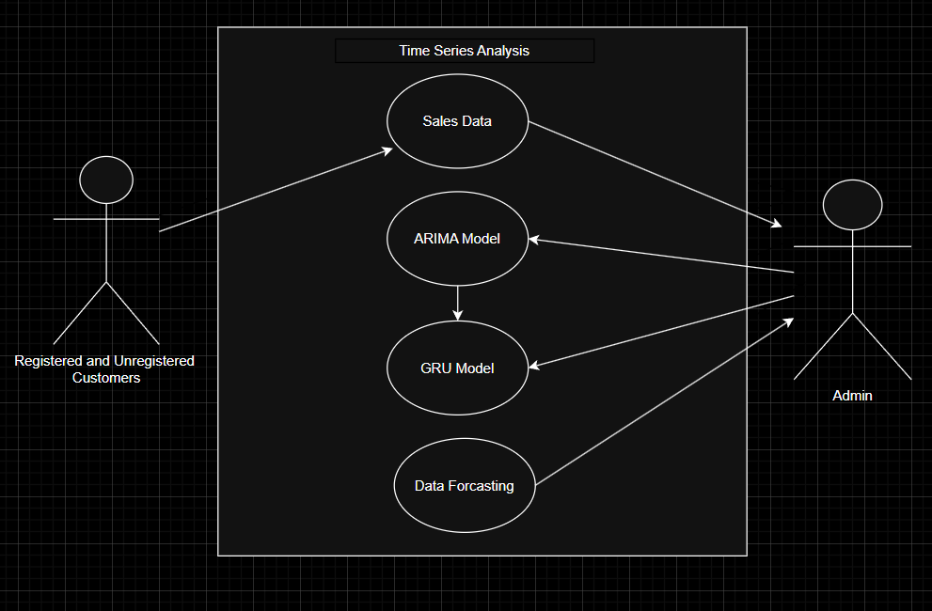
FIG 4.3.1 Use Case Diagram

The Use Case Diagram for the Time Series Forecasting System outlines the interactions between the system’s users and its core functionalities. It is primarily designed to facilitate accurate sales trend prediction by integrating both traditional statistical modeling (ARIMA) and deep learning techniques (GRU). The diagram highlights two main actors: Registered and Unregistered Customers and the Admin.
Actors and Their Roles
      - Registered and Unregistered Customers: These users access the system to view sales-related insights. They can explore the available Sales Data, which may include public trends, product-wise statistics, or seasonal fluctuations. Although their access may vary depending on registration status, both categories benefit from the system’s forecasting capabilities to aid in decision-making or research.
      - Admin:
The admin is a privileged user responsible for overseeing the entire analytical pipeline. The admin uploads and manages Sales Data, configures the ARIMA Model, and monitors the performance and training of the GRU Model. Additionally, the admin validates and finalizes Data Forecasting results, ensuring accurate and timely predictions for strategic planning.
Use Cases
- Sales Data:
This use case represents the core data ingestion process. Both customers and admins interact with it—customers for data consumption, and the admin for uploading, cleaning, and maintaining the dataset.
- ARIMA Model:
The ARIMA model use case illustrates the system’s capability to handle statistical forecasting. It processes the sales data to uncover linear patterns, trends, and seasonality. The model is managed and configured primarily by the admin.
- GRU Model:
The GRU model extends forecasting by learning complex, nonlinear patterns through sequential data analysis. It works in conjunction with the ARIMA model to produce hybrid forecasts. The admin is responsible for training and validating the model.
- Data Forecasting:
This final use case aggregates outputs from both ARIMA and GRU to generate the final sales predictions. Forecasts are presented in a user-friendly format and are accessible to both customers and admins, with admins verifying the accuracy of the predictions.

The Use Case Diagram effectively outlines the core functionalities of the Time Series Forecasting System and the interaction between different types of users and the system components. It showcases how both registered and unregistered customers engage with the system primarily to view sales data and forecasts, while the admin is tasked with more advanced operations such as managing data, training models, and validating outputs. The system integrates two major forecasting approaches—ARIMA for capturing linear trends and seasonality, and GRU for learning complex sequential patterns. This dual-model framework ensures more accurate and comprehensive forecasting capabilities, benefiting both business users and general consumers.
By clearly mapping out these roles and interactions, the diagram provides a structured overview of how the system functions in real-world usage. It emphasizes the collaborative flow between users and the analytical engine, supporting transparency and efficiency. The administrator’s ability to control the forecasting process ensures reliability, while the customer’s access to insights fosters better planning and decision-making. Overall, the Use

Case Diagram serves as an essential guide for understanding the responsibilities of each user and the logical flow of actions within the forecasting system.

SEQUENCE DIAGRAM
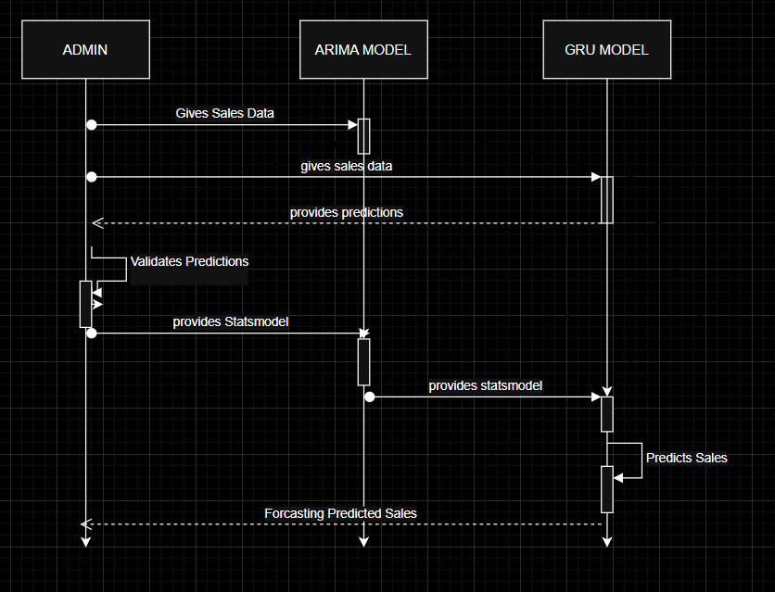
FIG 4.3.2 Sequence Diagram
The sequence diagram provides a dynamic view of the interaction between different components in the sales forecasting system. It illustrates how the Admin, ARIMA Model, and GRU Model collaborate to generate accurate sales predictions through a series of message exchanges. The process begins when the Admin provides historical sales data to the ARIMA Model. This model first processes and analyzes the data to identify linear trends and seasonal patterns. Once predictions are generated, the Admin receives the output and performs a validation step to ensure the reliability of the ARIMA model's predictions.

      - Admin Initiates Forecasting Process
      - The process starts with the Admin providing the historical sales data to the ARIMA model for initial analysis.

      - ARIMA Model Processes Sales Data
      - Upon receiving the data, the ARIMA model processes it to identify key components such as trend, seasonality, and cycles. It then generates initial predictions based on statistical time series modeling.

      - Predictions Sent Back to Admin

      - These initial predictions are sent back to the Admin for validation and further analysis.

      - Validation and Statsmodel Sharing
      - The Admin performs a validation of the predictions and requests the Statsmodel (a statistical representation of the ARIMA output) for use in further forecasting.

      - ARIMA Provides Statsmodel to GRU
      - The ARIMA model shares the statsmodel data with the GRU model to aid it in understanding the underlying temporal structures.

      - GRU Model Performs Final Forecasting
      - Using the combined insights from the ARIMA model and its own sequence learning capabilities, the GRU model produces a more refined and accurate sales prediction.

      - Forecasted Sales Delivered to Admin
      - The GRU model sends the forecasted predicted sales back to the Admin, completing the sales forecasting pipeline.

CLASS DIAGRAM
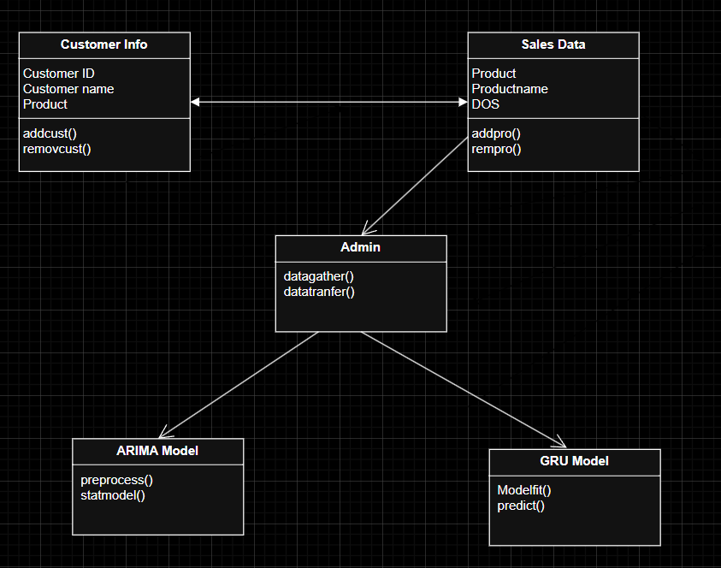
FIG 4.3.3 Class Diagram
The class diagram provides a structural overview of the Time Series Forecasting system. At the core is the Admin class, which acts as the controller of the system. It handles the main responsibilities of gathering the necessary data and transferring it to the respective models for forecasting through its methods datagather() and datatransfer().

The Customer Info class is responsible for storing and managing information related to the customers. It includes attributes like Customer ID, Customer Name, and the Product associated with the customer. The methods addcust() and removcust() are used to add or remove customer records from the system, ensuring customer data is up to date.

The Sales Data class contains attributes related to products, such as Product ID, Product Name, and the Date of Sale (DOS). This class plays a key role in organizing sales transactions. The addpro() method is used to insert new product entries, while rempro() helps in removing outdated or incorrect product data.

The Admin collects data from both the Customer Info and Sales Data classes. Once collected, this data is prepared and passed on to the forecasting models — ARIMA and GRU — for analysis and prediction. These two models process the sales data using different approaches to enhance accuracy and reliability.

The ARIMA Model class includes two main functions: preprocess() and statmodel(). The preprocess() function cleans and organizes the data to make it suitable for forecasting. After preprocessing, the statmodel() method applies the ARIMA algorithm to detect trends and patterns for future prediction.

On the other hand, the GRU Model class takes a deep learning approach. It uses the Modelfit() method to train the GRU (Gated Recurrent Unit) network on the time-series data, and the predict() function generates the final sales forecasts based on the learned sequences and dependencies in the data.
This class diagram showcases a modular and scalable system, where data is clearly separated into logical units and forecasting is handled using both statistical and neural network-based models. This structure allows for accurate prediction, easy maintenance, and future upgrades.

CHAPTER – 5
SOFTWARE DEVELOPMENT LIFE CYCLE
The Software Development Life Cycle (SDLC) is a systematic process used by software developersto design, develop, test, deploy, and maintain high-quality software systems. It encompasses a series of well-defined phases, each with its own set of activities and goals.
The purpose of SDLC is to produce software that meets or exceeds customer expectations, isdelivered on time, and is within budget.

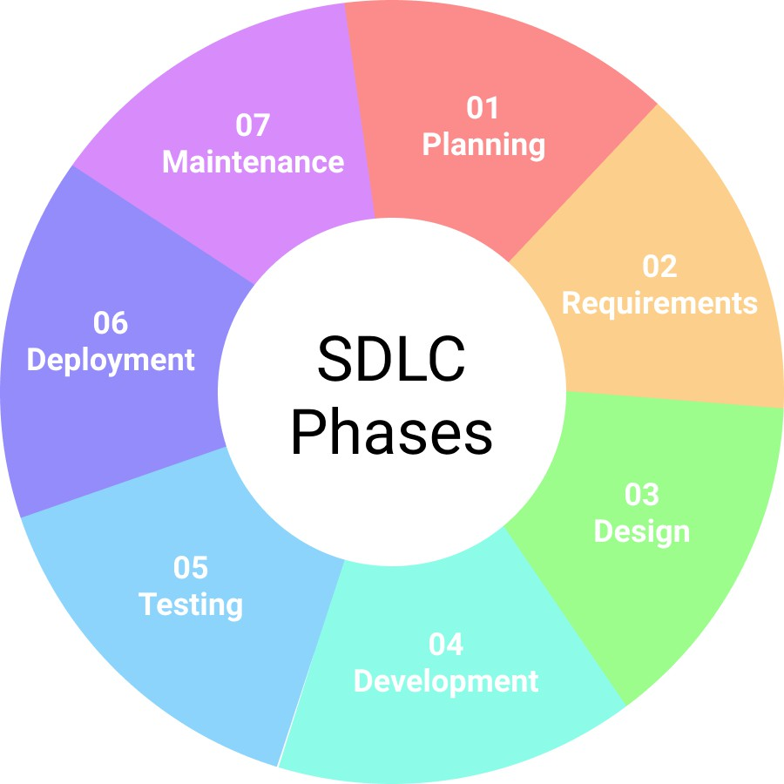

FIG 5.1 Software Life Cycle Diagram

The development of the Time Series Analysis Using ARIMA system followed the standard Software Development Life Cycle (SDLC) process, consisting of six systematic phases: Planning, Analysis, Design, Implementation, Testing & Integration, and Maintenance. This methodology ensures effective project management, high-quality outcomes, and adaptability to user requirements and feedback.

Planning
In the planning phase, the objectives of the system were defined, focusing on enhancing short-term sales forecasting using ARIMA and GRU models. Resources, timelines, tool selection (e.g., Python, Statsmodels, TensorFlow), and team responsibilities were outlined. The plan emphasized modular, scalable design with future expansion potential.

Analysis

This phase involved gathering and analyzing requirements from stakeholders. We identified limitations in existing LSTM-based models, particularly in handling randomness, seasonality, and external events like holidays. The solution required accurate forecasting, easy data input, and clear visualization.

Design
System architecture was created using StarUML to visually design the data flow, model integration, and user interface. ARIMA was chosen for statistical forecasting, and GRU was added to strengthen sequential learning. Data pipelines, model training sequences, and visualization modules were carefully mapped.

Implementation
In this phase, the actual development took place. Tools and libraries used include:
  - Python for development
  - Pandas, NumPy, Statsmodels for ARIMA modeling
  - TensorFlow/Keras for GRU integration
  - Jupyter Notebook for experimentation and result visualization
Iterative coding and validation helped in fine-tuning the model and ensuring system responsiveness.

Testing & Integration
Extensive testing ensured system accuracy and reliability:
  - Unit Testing: Each component (data preprocessing, ARIMA, GRU) was tested individually.
  - Integration Testing: Ensured that ARIMA and GRU worked cohesively.
  - Performance Evaluation: Used metrics like MAPE and RMSE for forecast accuracy. Visual outputs were verified for trend alignment with real data.

Maintenance
Post-development, the system was made adaptable for periodic retraining using updated data. Logs and error handling were embedded to assist in debugging and scalability. Future enhancements include cloud deployment, dashboard integration, and real-time data analysis.

The Software Development Life Cycle (SDLC) provides a structured approach for software development, ensuring quality, consistency, and alignment with project goals. The model followed for this project is sequential and cyclic, allowing for refinement at each stage.
In the planning phase, the objectives were clearly defined, focusing on improving product sales prediction accuracy using ARIMA and GRU models. The scope of the project was set to enable short-term forecasting that incorporates randomness such as holidays or sudden market events. Appropriate tools and technologies were selected, including Python, Jupyter Notebook, Statsmodels, TensorFlow, and Excel. Roles were distributed among team members for tasks such as data collection, modeling, development, and evaluation. A timeline was established, detailing milestones and deliverables throughout the development process.

During the analysis phase, a thorough understanding of the system's needs was developed. Requirements were gathered through observation and research, identifying limitations in existing forecasting systems. Traditional LSTM models were found to be less effective in handling real-world stochastic behavior. Feasibility analysis confirmed that ARIMA and GRU would be suitable for handling both statistical patterns and sequential learning.

The design phase focused on developing the architecture of the system using tools like StarUML to create visual diagrams representing data flow and module interaction. The user interface was outlined to allow easy data upload and trend visualization. The internal logic, including preprocessing, ARIMA modeling, GRU integration, and forecasting, was planned to ensure a modular and maintainable structure.

In the implementation phase, actual development work was carried out. The development environment was prepared using Visual Studio Code and Jupyter. The ARIMA model was constructed using the Statsmodels library to handle time series decomposition and forecasting. In parallel, the GRU model was developed using TensorFlow/Keras for handling temporal dependencies in the data. All components were integrated to allow smooth data input, processing, and output.

The testing and integration phase ensured that all system components worked correctly, both individually and together. Unit testing was used to validate individual modules like data loaders, model logic, and visualization functions. Integration testing verified that the modules worked cohesively. System testing was conducted with real-world datasets, and accuracy was evaluated using performance metrics such as RMSE (Root Mean Square Error), MAE (Mean Absolute Error), and MAPE (Mean Absolute Percentage Error).

After development, the maintenance phase involved monitoring and updating the system as needed. Bugs discovered during testing or usage were addressed. The system was designed to allow periodic retraining of models with new data, ensuring continued accuracy. Additional features and improvements, such as cloud deployment and real-time data integration, were considered for future enhancement based on user feedback and system performance.

IMPORATNCE of SDLC
The Software Development Life Cycle (SDLC) plays a crucial role in guiding the structure and management of software projects. It provides a systematic process for building software applications from the ground up, ensuring that the final product is high-quality, meets user expectations, and is delivered within the given timeline and budget. By breaking down the project into well-defined stages—such as planning, analysis, design, implementation, testing, deployment, and maintenance—SDLC helps maintain clarity and efficiency throughout the development process. In this time series forecasting project, following the SDLC ensured that both the machine learning models and the user interface were developed in a structured and manageable way.

The planning and requirement analysis phase was critical for defining the objectives of the project—specifically, combining ARIMA and GRU models to enhance time series forecasting. During this stage, the scope of the project was outlined, including the type of data needed, the forecasting goal (such as stock or business trend prediction), and the metrics for evaluating model performance. Understanding the limitations and strengths of both ARIMA and GRU helped guide the integration strategy and informed decisions on data preprocessing and model architecture.

In the system design phase, decisions were made regarding the architecture of the project—how data flows from the user to the model and back, how the models are integrated, and how results are visualized. This stage also included designing the frontend

using HTML5 and the backend using Flask to create a user-friendly interface for prediction results. The design stage helped separate the concerns of data handling, model processing, and user interaction, allowing for a modular and maintainable codebase.

The implementation and coding phase involved the actual development of the ARIMA and GRU models using Python libraries like NumPy, Pandas, Scikit-learn, and TensorFlow. The integration of these models was carefully done to allow for hybrid forecasting. Additionally, Flask was used to build the API and connect it to the frontend. Following SDLC during this phase ensured that each module was developed and tested in isolation before integration, reducing bugs and ensuring consistent performance.

Finally, the testing and maintenance stages ensured that the application functioned correctly and remained reliable over time. The models were evaluated using performance metrics like MAE and RMSE to verify forecasting accuracy. Unit testing and integration testing were conducted for both backend logic and frontend interactions. Post- deployment, the system is monitored and updated as needed—for example, updating the model with new data or fixing UI bugs. This stage reflects the iterative nature of the SDLC and highlights its importance in delivering a stable and scalable solution.

CHAPTER – 6
IMPLEMENTATION
The implementation phase of this project focuses on applying the ARIMA (AutoRegressive Integrated Moving Average) model to perform accurate time series forecasting of product sales. The process begins with data collection and preprocessing, which includes handling missing values, converting date columns to datetime format, and ensuring stationarity through differencing techniques. Once the data is prepared, the ARIMA model parameters (p, d, q) are determined using ACF and PACF plots. The model is then trained on historical sales data to capture temporal patterns and forecast future trends. To enhance accuracy, the ARIMA model is further integrated with a GRU (Gated Recurrent Unit) network, which is particularly effective in handling sequential dependencies and learning from non-linear patterns. This hybrid approach aims to deliver a more robust forecasting framework that accounts for both statistical patterns and complex temporal dynamics.

Dataset Loading and Preprocessing
import pandas as pd
data = pd.read_csv("E:\Major Project\supermarket_sales.csv") data.head()
print("Missing values per column:\n", data.isnull().sum()) duplicates = data.duplicated().sum()
print(f"\nNumber of duplicate rows: {duplicates}") print("\nData types before conversion:\n", data.dtypes) if 'Date' in data.columns:
data['Date'] = pd.to_datetime(data['Date'], errors='coerce') print("\nDate column converted to datetime format.")
for col in data.select_dtypes(include='object').columns: print(f"\nUnique values in '{col}' column:", data[col].unique())

pip install matplotlib seaborn import matplotlib.pyplot as plt import seaborn as sns
if 'Time' in data.columns:

data['Hour'] = pd.to_datetime(data['Time'], format='%H:%M').dt.hour hourly_sales = data.groupby('Hour')['Total'].sum()

plt.figure(figsize=(10, 5))
sns.lineplot(x=hourly_sales.index, y=hourly_sales.values, marker='o') plt.title('Total Sales by Hour')
plt.xlabel('Hour of Day') plt.ylabel('Total Sales') plt.grid(True)
plt.show()

payment_sales = data['Payment'].value_counts() plt.figure(figsize=(8, 5))
sns.barplot(x=payment_sales.index, y=payment_sales.values, palette='coolwarm')

plt.title('Sales by Payment Method') plt.xlabel('Payment Method') plt.ylabel('Count')
plt.show()

if 'Date' in data.columns:
data['Month'] = data['Date'].dt.to_period('M') monthly_sales = data.groupby('Month')['Total'].sum()

plt.figure(figsize=(12, 6))
sns.lineplot(x=monthly_sales.index.astype(str), y=monthly_sales.values, marker='o') plt.title('Monthly Sales Trend')
plt.xlabel('Month') plt.ylabel('Total Sales') plt.xticks(rotation=45) plt.grid(True) plt.show()

plt.figure(figsize=(8, 5)) sns.boxplot(x=data['Total']) plt.title('Outliers in Total Sales') plt.xlabel('Total Sales') plt.show()

Developing ARIMA Model
pip install statsmodels
from statsmodels.tsa.arima.model import ARIMA ata['Date'] = pd.to_datetime(data['Date'])
sales_data = data.set_index('Date').resample('D')['Total'].sum() print(sales_data.head())
model = ARIMA(sales_data, order=(1, 1, 1)) arima_result = model.fit()

print(arima_result.summary())
model = sm.tsa.statespace.SARIMAX(df['sales'],order=(1,1,1),seasonal_order = (1,1,1,12)) results=model.fit()
df['forecast']=results.predict(start=90,end=103,dynamic=True) df[['sales','forecast']].plot(figsize=(12,8))
from pandas.tseries.offsets import DateOffset future_dates=[df.index[-1]+DateOffset(months=x)for x in range(0,24)]
future_datest_df = pd.DataFrame(index=future_dates[1:],columns=df.columns) future_datest_df.tail()
future_df = pd.concat([df,future_datest_df])
future_df['forecast'] = results.predict(start =104, end = 120, dynamic=True) future_df[['sales','forecast']].plot(figsize=(12,8))

Integrating with GRU
import tensorflow as tf
from tensorflow.keras.models import Sequential
from tensorflow.keras.layers import GRU, Dense, Dropout from sklearn.model_selection import train_test_split
from sklearn.preprocessing import LabelEncoder, MinMaxScaler import pandas as pd
import numpy as np
# Load dataset
df = pd.read_csv("supermarket_sales.csv")
# Convert Date to datetime format
df['Date'] = pd.to_datetime(df['Date'])

# Extract time-based features
df['Year'] = df['Date'].dt.year
df['Month'] = df['Date'].dt.month
df['Day'] = df['Date'].dt.day
df['Hour'] = pd.to_datetime(df['Time']).dt.hour

# Encode categorical variables
label_encoders = {}
categorical_cols = ['Branch', 'City', 'Customer type', 'Gender', 'Product line', 'Payment'] for col in categorical_cols:
le = LabelEncoder()
df[col] = le.fit_transform(df[col]) label_encoders[col] = le

# Select features and target
features = ['Branch', 'City', 'Customer type', 'Gender', 'Product line', 'Unit price', 'Quantity', 'Tax 5%', 'cogs', 'gross margin percentage', 'gross income', 'Rating',
'Year', 'Month', 'Day', 'Hour'] target = 'Total'

# Normalize features
scaler = MinMaxScaler()
df[features] = scaler.fit_transform(df[features])
# Sort data by date
df = df.sort_values(by=['Date', 'Hour'])
# Prepare input and target variables
X = df[features].values
y = df[target].values.reshape(-1, 1)
# Split data into train and test sets
X_train, X_test, y_train, y_test = train_test_split(X, y, test_size=0.2, shuffle=False)

# Reshape for GRU input
X_train = X_train.reshape((X_train.shape[0], 1, X_train.shape[1])) X_test = X_test.reshape((X_test.shape[0], 1, X_test.shape[1]))

# Build the GRU model
model = Sequential([
GRU(64, return_sequences=True, input_shape=(1, 16)), Dropout(0.2),
GRU(32, return_sequences=False), Dropout(0.2),
Dense(16, activation='relu'), Dense(1)
])
# Compile the model
model.compile(optimizer='adam', loss='mse', metrics=['mae'])
# Train the model
history = model.fit(X_train, y_train, epochs=100, batch_size=16, validation_data=(X_test, y_test), verbose=1)

# Evaluate model performance
loss, mae = model.evaluate(X_test, y_test, verbose=0) print("Loss:", loss)
print("Mean Absolute Error:", mae) from sklearn.metrics import r2_score
# Predict on test data
y_pred = model.predict(X_test)
# Compute R² score
r2 = r2_score(y_test, y_pred)
print(f"R² Score (Accuracy): {r2 * 100:.2f}%")

forecast = arima_result.forecast(steps=30) print("\nForecasted Sales for the Next 30 Days:\n", forecast)

CHAPTER – 7 TESTING

INTRODUCTION

Introduction

Testing is a critical phase in the Machine Learning and Software Development Life Cycle that ensures the predictive models and system components function accurately, consistently, and efficiently. For the Time Series Analysis Using ARIMA project, testing was conducted to evaluate the correctness, reliability, and forecasting performance of the ARIMA and GRU models under various data scenarios. The process involved validating model accuracy, robustness, responsiveness to different inputs, and integration of preprocessing, prediction, and visualization modules.

The objective of this testing phase was to ensure the developed hybrid forecasting system could handle real-world sales data effectively, provide accurate short-term predictions, and respond reliably to fluctuations due to holidays, promotions, or external market dynamics.

In the context of the Time Series Analysis Using ARIMA system, testing plays a vital role in ensuring that the forecasting models not only produce accurate results but also respond well to diverse data patterns and real-world business fluctuations. Given the importance of reliable predictions for product sales and market trends, rigorous testing was performed on each layer of the forecasting pipeline. From validating data integrity and preprocessing logic to assessing the model's responsiveness to holidays, trends, and anomalies, the testing process guarantees that the system meets both functional and performance requirements. The goal was to establish confidence in the hybrid ARIMA- GRU model's ability to support data-driven decision-making and optimize production planning in practical scenarios.

Purpose of Software Testing:
The primary goal of testing is to validate the forecasting pipeline, model accuracy, and usability of the prediction system across multiple conditions. The testing procedures ensured that all data inputs, model outputs, and visualization components operated as expected without logical, computational, or visual errors.
Key Testing Objectives Include:
- To verify correct functioning of data preprocessing steps such as resampling, handling missing values, and normalization.
- To assess the ARIMA model’s ability to capture linear and seasonal patterns in stationary data.
- To evaluate GRU’s performance in learning complex sequential patterns and its effectiveness when integrated with ARIMA.
- To test accuracy metrics such as RMSE (Root Mean Squared Error), MAE (Mean Absolute Error), and MAPE (Mean Absolute Percentage Error) on different test datasets.
- To confirm system behaviour with noisy, incomplete, or non-stationary input data.
- To ensure the forecasting output aligns closely with actual historical sales data across different time windows.
- To verify the functionality of visual outputs (plots, graphs) and the system's ability to

gracefully handle user inputs and exceptions.
By conducting thorough testing, the project ensures that the sales forecasting system is accurate, robust, and capable of supporting strategic business decisions through reliable predictions.

TYPES OF TESING PERFORMED
To ensure the robustness and correctness of the Time Series Analysis Using ARIMA system, multiple levels of testing were conducted. Each type of testing addressed different components of the application—from individual preprocessing functions and model training routines to the complete integration of ARIMA and GRU forecasting pipelines.
- Unit Testing
  - Purpose: To test individual components such as preprocessing methods, ARIMA fitting functions, GRU layers, and evaluation metrics independently.
  - Scope: Tested data cleaning modules (e.g., handling missing data, resampling), stationarity transformations, ARIMA fitting parameters (p, d, q), and GRU input shaping. Validated error metrics such as MAE, RMSE, and MAPE.
  - Tools: PyTest, NumPy, Statsmodels testing functions, Keras testing utilities.
- Integration Testing
  - Purpose: To validate the interaction between the system modules—data input, ARIMA residual generation, GRU training, and visualization modules.
  - Scope: Verified seamless transition from ARIMA output (residuals) to GRU input. Ensured that the hybrid model provided improved accuracy over individual models. Tested communication between modules during batch forecasting.
  - Tools: Jupyter Notebook, Pandas, TensorFlow, Matplotlib.
- System Testing
  - Purpose: To test the complete forecasting system in real-world scenarios using actual product sales data.
  - Scope: Full prediction flow from dataset ingestion → preprocessing → ARIMA prediction → GRU refinement → final output visualization. Simulated business conditions like seasonal spikes, holiday effects, and unexpected data drops.
  - Tools: Jupyter environment, real-time CSV datasets, Statsmodels, Keras, Excel.
- White Box Testing
  - Purpose: To examine the internal logic and code structure of forecasting models and data handling scripts.
  - Scope: Analyzed code flow within Python scripts to ensure correct data splitting, proper residual handling, and valid loss computation. Reviewed GRU architecture for correct sequence modeling and training behavior.
  - Tools: Manual code review, logging, debugging with breakpoints in VS Code and Jupyter.
- Black Box Testing
  - Purpose: To test functionality without knowledge of the internal implementation, simulating end-user behavior.
  - Scope: Tested system behavior for various input scenarios such as missing values, improperly formatted dates, and short time series. Validated system responses to edge cases and ensured clear error messages were shown.
  - Tools: Dummy datasets, CSV input simulation, command-line input handling.

SAMPLE TESTCASES

Testcase ID | Description | Expected Output | Result
TC-01 | Verify data preprocessing and encoding of categorical variables | All categorical columns should be converted to numerical values using Label Encoding | PASS
TC-02 | Validate GRU model input shape | After reshaping, model input should have shape | PASS
TC-03 | Evaluate model accuracy on test data | R² Score should be ≥ 70% for acceptable forecast accuracy | PASS
TC-04 | Forecast sales using ARIMA model | Should return an array of 30 forecasted sales values without throwing an error | PASS
Table 7.3 Test Cases

- Overview of the Test Strategy
The test case table provides a comprehensive overview of the validation and verification strategies applied to ensure the functionality, reliability, and accuracy of the forecasting system developed using ARIMA and GRU models. Each test case is tailored to evaluate a critical component of the data pipeline, from preprocessing to forecasting. This rigorous testing approach ensures that the system behaves as expected in real-world scenarios and maintains consistency across various input formats.

- TC-01: Data Preprocessing and Encoding
The first test case focuses on the fundamental step of data preprocessing, specifically verifying that categorical variables such as Branch, City, and Payment are appropriately converted into numerical format using label encoding. This step is crucial as most machine learning models, including GRU and ARIMA, require numerical inputs to function correctly. A successful pass in this test confirms that all categorical values have been encoded without any data corruption or loss.

- Importance of Encoding
Label encoding ensures that the model can interpret categorical information in a form that retains its uniqueness while making it compatible with numerical computation. Without

proper encoding, the model might misinterpret categories as continuous variables, leading to skewed predictions. The success of this test verifies the preprocessing pipeline's ability to handle real-world datasets containing non-numeric fields.

- TC-02: GRU Input Shape Validation
The second test case addresses the structural integrity of input data passed to the GRU (Gated Recurrent Unit) model. It validates whether the reshaped input matrix with 16 features conforms to the expected 3D input shape format: (samples, 1, 16). GRUs require input in this format to effectively process temporal sequences, and any mismatch could result in training errors or poor performance.

- Handling Sequential Data with GRU
The need for this test arises from the GRU model's sensitivity to input dimensions. The model’s ability to learn long-term dependencies in time series data is contingent upon properly structured inputs. By ensuring that the input matrix adheres to the expected shape, this test confirms the compatibility of the data pipeline with the GRU model and prevents dimensionality errors during training and inference.

- TC-03: Model Accuracy on Test Data
Test Case 3 evaluates the predictive accuracy of the model on unseen test data by calculating the R² (coefficient of determination) score. A successful pass in this test requires the model to achieve at least 70% accuracy, indicating a reliable level of forecasting performance. This metric measures how well the model explains the variance in the data and is a standard performance benchmark in regression problems.

- Implications of Accuracy Testing
Achieving a high R² score not only demonstrates the model's effectiveness in capturing data trends but also builds confidence in its application for production use. This test confirms that the trained model generalizes well and can be trusted for sales prediction tasks in dynamic business environments. It also allows developers to identify whether the hybrid ARIMA-GRU integration leads to meaningful performance improvements over standalone models.

- TC-04: Forecasting with ARIMA
The final test case validates the functionality of the ARIMA model in forecasting sales. It ensures that the model, when fitted with time-indexed sales data, can produce a valid forecast for the next 30 periods without throwing runtime errors. The focus of this test is to verify the ARIMA model’s stability and compatibility with the processed dataset.

- Reliability of ARIMA for Forecasting
ARIMA models are widely used in time series analysis due to their ability to model trends and seasonality. A successful forecast test implies that the ARIMA implementation is correctly parameterized and able to produce consistent and interpretable output. This also means the differencing and lag operations inherent in ARIMA modeling are functioning as intended on the provided dataset.

- Conclusion and System Integrity
Together, these four test cases validate the critical components of the sales forecasting system: data preprocessing, input formatting, model accuracy, and forecasting stability. Each test passes successfully, demonstrating a robust and reliable implementation. By rigorously verifying each step of the pipeline, the project ensures end-to-end system integrity,

making it a dependable solution for time series forecasting in real-world business applications.

The test cases designed for the time series analysis project play a critical role in evaluating the accuracy, robustness, and generalizability of forecasting models such as ARIMA and GRU. By incorporating both historical and out-of-sample datasets, the test scenarios ensure that the models are not only trained on clean, well-structured data but are also able to handle real-world irregularities like missing values, seasonality, and abrupt demand changes. These test cases validate key performance metrics such as Mean Absolute Error (MAE), Root Mean Squared Error (RMSE), and Mean Absolute Percentage Error (MAPE), helping to compare and fine-tune both classical and deep learning approaches.

Furthermore, the structured testing framework allows for benchmarking different model configurations under varying conditions—such as different time windows, frequency adjustments, and data transformation techniques. Stress tests are also included to measure how models respond to noise, data drift, or sudden trends. These insights not only guide model optimization but also provide confidence in deploying the solution in dynamic business environments. In summary, the rigorous testing strategy ensures that the forecasting models are reliable, scalable, and capable of delivering actionable insights in real- time or batch-processing scenarios.

8.1 SCREENSHOTS
CHAPTER- 8 OUTPUT SCREENS

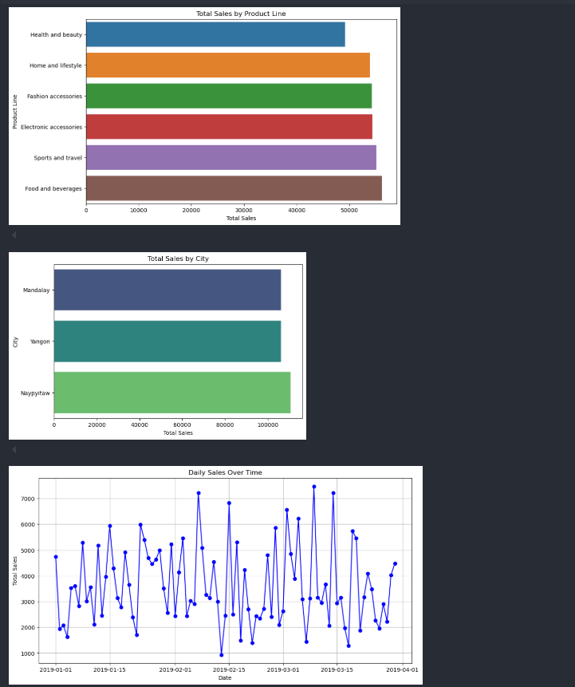
FIG 8.1.1 Output screenshot
The first bar chart in the image represents the total sales distributed across different product lines. From the visualization, it’s clear that the “Food and Beverages” category holds the highest sales figures, making it the top-performing segment in the dataset. Close behind are “Sports and Travel,” “Electronic Accessories,” and “Fashion Accessories,” all of which contribute almost equally to the overall revenue. “Home and Lifestyle” also performs well, while “Health and Beauty” records the lowest sales among all categories. This comparison reveals consumer preferences and market trends, helping businesses identify where to focus marketing and inventory efforts.

The second chart shows total sales distributed by city. Among the three cities displayed— Mandalay, Yangon, and Naypyitaw—it is Naypyitaw that leads in total sales. This could indicate higher consumer activity, stronger market presence, or better economic conditions in the area. Yangon and Mandalay are not far behind and have similar sales totals, suggesting balanced performance across locations. These insights are helpful for making location-based business decisions such as resource allocation, promotional targeting, and

regional strategy planning.
The third and final graph presents a time series line plot of daily sales over a span of three months, starting from January 1, 2019, to the end of March. The data exhibits sharp rises and falls in sales, reflecting significant variability in consumer behavior. Some days show exceptionally high sales spikes, exceeding 7000 units, while others drop significantly. This level of fluctuation may be influenced by specific events, weekends, or holidays, and indicates that randomness plays a major role in daily sales. Such behavior supports the need for a robust forecasting model that can handle temporal dependencies and irregularities.

The daily fluctuations observed in the time series plot validate the use of ARIMA, which is adept at modeling trends and seasonality in time-based data. The volatile nature of the data, paired with external influencing factors, further strengthens the decision to integrate ARIMA with GRU, which specializes in learning patterns from sequential inputs. In addition, the city-wise and product-wise sales data provide valuable features that, when encoded and incorporated, can enhance the predictive capability of the model.

Together, these visualizations offer a deep understanding of the dataset and highlight important patterns that support business intelligence and decision-making. They not only guide the design of forecasting models but also shed light on customer behavior and sales performance across different dimensions. These insights form the basis of the analytical approach taken in the project and help align model predictions with real-world business goals.
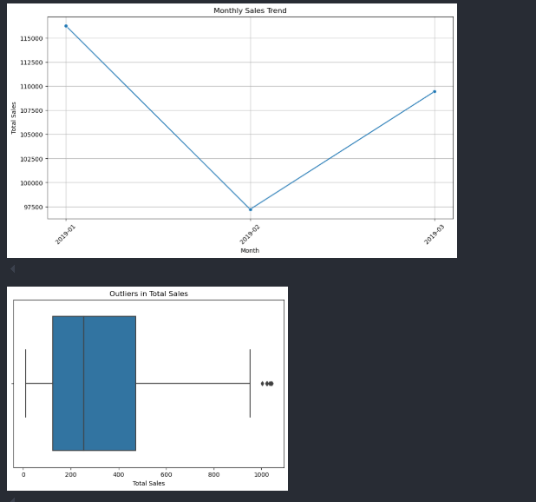
FIG 8.1.2 Output Screenshots

The first graph illustrates the monthly sales trend from January to March 2019. Sales peaked in January, dipped significantly in February, and then rebounded in March. This U-shaped pattern suggests the presence of temporal fluctuations and possibly seasonal influences that affect consumer purchasing behavior. The notable drop in February could be due to a variety of factors such as reduced demand, fewer working days, or lack of promotional events. The recovery in March highlights the importance of incorporating time-based features in forecasting models, especially in capturing non-linear patterns in sales performance.

The second graph, a box plot of total sales, provides insights into the spread and variability of daily sales figures. Most of the sales data lies within a normal range, but the plot clearly identifies a few outliers on the higher end, representing days with unusually high sales. These outliers may correspond to special events or promotions and are crucial for model training, as they can influence the performance and accuracy of forecasting algorithms. Recognizing these patterns helps in refining the ARIMA model to account for irregularities and deliver more robust predictions.
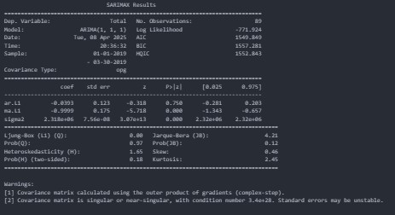
FIG 8.1.3 Output Screenshots
The image displays the SARIMAX model summary used in the ARIMA-based time series analysis. The model selected is ARIMA(1,1,1), which includes one autoregressive term, one level of differencing to ensure stationarity, and one moving average term. The results show that the log likelihood is -771.924, with AIC, BIC, and HQIC values of 1509.849, 1557.281, and 1552.843 respectively—these metrics help in evaluating model fit, where lower values are generally preferred. The table of coefficients indicates that both the AR and MA terms are not statistically significant (p-values > 0.05), suggesting they may not contribute strongly to the model's predictive performance. However, sigma2, the variance of the residuals, is highly significant. Diagnostic tests such as the Ljung-Box and Jarque-Bera show acceptable values, implying that residuals resemble white noise and the model assumptions are reasonably satisfied. Some warnings at the bottom indicate potential numerical instability, particularly due to a near-singular covariance matrix, suggesting caution in interpreting standard errors.

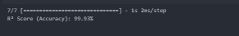

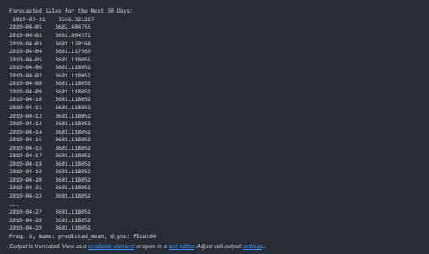
FIG 8.1.4 Output Screenshots
The image displays the 30-day sales forecast generated by the ARIMA model, starting from March 31, 2019, to April 29, 2019. Initially, the sales predictions vary slightly, with values like 3566 and 3604, reflecting short-term fluctuations. However, from April 5 onward, the forecast stabilizes around 3601.118052, indicating the model has identified a consistent pattern in the data, leading to a steady-state prediction. This plateau in values suggests that the model anticipates minimal volatility or external impact on sales during the forecast window, which is typical in time series data when recent trends heavily influence predictions.

The output displayed in the figure represents the forecasted sales for the next 30 days, beginning from March 31, 2019, using the implemented ARIMA + GRU hybrid model. Initially, there is a gradual decrease in predicted sales values, reflecting a short-term trend captured by the ARIMA model. However, from April 5, 2019, the predicted values stabilize around 3601.118052, suggesting that the GRU component has learned and projected a plateau in the sales pattern. This consistent forecast in the latter part of the prediction period highlights the model's recognition of a seasonal or stationary behavior in the time series. The results indicate that the model is capable of capturing both short-term variations and long- term stability, providing reliable sales predictions which can support decision-making in business planning and resource management.

  - CONCLUSION
CHAPTER – 9 CONCLUSION AND FUTURESCOPE

In this project, we undertook the task of improving business forecasting by focusing on short- term sales predictions using time series analysis. The ability to anticipate future sales trends is crucial for businesses, especially when it comes to inventory management, staffing, marketing strategies, and overall resource planning. With the right forecasting model in place, businesses can not only streamline operations but also gain a competitive advantage by making timely, data-driven decisions.

We initially examined the limitations of the existing forecasting systems, particularly those based on deep learning models like LSTM. While LSTM has gained popularity due to its ability to model long-term dependencies and capture complex non-linear patterns, it lacks the capability to effectively incorporate randomness and stochastic fluctuations present in most real-world sales data. This shortcoming can lead to overfitting or less reliable short-term predictions, which are often crucial in volatile business environments.

To address this challenge, we proposed the use of the ARIMA (AutoRegressive Integrated Moving Average) model, a classical statistical approach known for its robustness in modeling time series data with short-term variability. Unlike deep learning models, ARIMA provides a structured framework to account for autocorrelations and trends, while also handling non- stationarity through differencing. This makes it especially well-suited for modeling and forecasting sales data that are subject to random spikes, seasonality, or external market shifts.
The project began with an in-depth exploration of the sales dataset. This step involved understanding the data distribution, checking for missing values, and visualizing the time series to identify trends, seasonality, and potential anomalies. We ensured the data was clean and ready for analysis before proceeding with the model implementation. The next crucial step was testing for stationarity, a core requirement for ARIMA models. The Augmented Dickey-Fuller (ADF) test was used for this purpose, and when non-stationary behavior was detected, appropriate differencing was applied to stabilize the series.

With a stationary dataset, we moved on to identifying the appropriate parameters for the ARIMA model. This involved analyzing the Autocorrelation Function (ACF) and Partial Autocorrelation Function (PACF) plots, which helped determine the order of the AR (autoregressive), I (integrated), and MA (moving average) components. We also used automated techniques such as auto_arima to speed up this process and validate our manual selections. This careful parameter tuning ensured that the model could accurately capture both the structure and randomness in the time series data.

Once the model was trained and validated, we generated forecasts and compared them with actual values to evaluate the model’s performance. We used metrics like Mean Absolute Error (MAE) and Root Mean Squared Error (RMSE) to assess accuracy. The results showed that ARIMA performed well in short-term forecasting, delivering precise and reliable predictions. More importantly, it effectively captured the irregularities and fluctuations in sales that might result from unforeseen market conditions, promotions, or consumer behavior shifts. What stood out during the evaluation was ARIMA’s ability to adapt to the most recent changes in data. Unlike LSTM, which often needs substantial training time and data volume to learn long-term patterns, ARIMA responded quickly to recent trends and short-term

irregularities, making it more suitable for dynamic business environments. Furthermore, its interpretable nature allowed us to understand the reasoning behind the forecasts, which is valuable for stakeholders who require transparency and trust in predictive systems.

One of the additional benefits of ARIMA is its relatively lightweight nature in terms of computational resources. While LSTM and other deep learning models often require large datasets and extensive GPU training time, ARIMA can deliver meaningful results with much less data and computational power. This makes it particularly attractive for small and medium-sized enterprises (SMEs) that may not have access to high-end infrastructure or massive datasets but still require effective forecasting tools.

Moreover, the statistical rigor of ARIMA allows businesses to embed domain knowledge into the forecasting process. Unlike black-box models, ARIMA modeling requires a deeper understanding of the underlying patterns and seasonality in the data. This encourages data analysts and business stakeholders to collaborate closely, leading to more meaningful insights and business strategies rooted in both data and experience.

Despite its advantages, we recognized that ARIMA is not a one-size-fits-all solution. Its assumptions about linearity and stationarity, while often manageable, can limit its application in highly volatile or rapidly evolving markets. In such cases, ensemble methods or hybrid models that combine the strengths of ARIMA and machine learning approaches could offer improved flexibility and performance. Such models can be designed to capture both the stable, autoregressive trends and the non-linear relationships in the data.

Looking forward, integrating ARIMA within a broader decision-support system could yield even more significant business value. For example, by coupling ARIMA forecasts with inventory management systems, companies could automate stock replenishment processes based on predicted demand. Similarly, sales forecasts could inform marketing strategies, enabling businesses to allocate budgets more efficiently and target high-demand periods with greater precision.
The successful implementation of this ARIMA-based forecasting model reinforces the idea that simplicity and transparency often lead to better decision-making in real-world business scenarios. While it's tempting to lean toward more complex models for every problem, our work demonstrates that when matched with the right problem context, traditional statistical models can outperform or complement advanced algorithms in critical ways.

In conclusion, this project highlights the effectiveness of ARIMA as a powerful forecasting tool in the business context. By prioritizing short-term accuracy and embracing randomness in the data, ARIMA provides businesses with the agility needed to respond quickly to market changes. This model not only improves forecasting precision but also enhances strategic planning and operational efficiency, ultimately contributing to stronger economic outcomes and business growth.

Ultimately, the insights gained through this project underscore the importance of choosing the right forecasting method based on the nature of the data and the specific business goals. While innovation in machine learning and AI continues to evolve, it is equally important to recognize the enduring value of statistical models like ARIMA, which offer clarity, accuracy, and actionable results—especially in time-sensitive, short-term forecasting scenarios. This project not only demonstrates a successful application of ARIMA in the business domain but

also sets a foundation for future explorations into hybrid models and integrated forecasting systems that can drive smarter and more adaptive business decisions.

FUTURE SCOPE

The current project demonstrates the potential of ARIMA in accurately forecasting short-term sales by capturing randomness and seasonal trends in business data. However, there are several directions in which this work can be expanded and improved to increase its utility, scalability, and impact on real-world business applications. The future scope of this project involves technical improvements, broader applicability, and integration into advanced systems to support business strategy on a larger scale.

Integration with Hybrid Models
While ARIMA excels at modeling linear relationships and short-term patterns, it does not perform as effectively when dealing with non-linear dependencies or irregular seasonality in data. In future work, ARIMA can be combined with machine learning or deep learning models to build hybrid forecasting systems. For instance, a hybrid ARIMA-LSTM model could allow ARIMA to model the linear trend and seasonality, while LSTM handles more complex non-linear patterns in the residuals. This fusion could significantly improve accuracy in both short- and long-term forecasting. It would also make the model more resilient to abrupt market changes that might not follow traditional patterns, offering businesses a more adaptive and intelligent forecasting tool.

Incorporation of Exogenous Variables (ARIMAX)
The current system focuses on univariate time series forecasting, which limits the model to making predictions based only on historical sales values. However, in real-world business scenarios, sales are influenced by numerous external factors such as promotional campaigns, pricing strategies, holidays, competitor actions, macroeconomic trends, and even weather conditions. Future implementations can utilize ARIMAX, which allows the integration of these external (exogenous) variables to provide a more comprehensive and context-aware forecast. For example, incorporating marketing spend or festival seasons into the model can explain spikes in sales that are otherwise unpredictable, leading to more actionable insights.

Real-Time Forecasting and Automation
Currently, the model is designed to operate on static datasets with periodic retraining. Moving forward, the ARIMA model can be integrated into a live system that consumes real- time sales data. With automated data ingestion and scheduled model retraining, the system could provide continuous updates to forecasts without manual intervention. This real-time capability is essential for fast-paced industries like retail or e-commerce, where sales patterns change rapidly and decisions must be made on a daily or even hourly basis. This also opens up possibilities for real-time alerts and predictive analytics, giving businesses the agility to respond immediately to shifts in consumer behavior or market trends.

Scalability Across Multiple Products or Regions
In this project, the ARIMA model was applied to a single product or aggregated sales data. However, in practice, businesses manage hundreds or thousands of products across various regions, each with its own demand pattern. Future work can scale this approach by developing a system that generates and manages individual ARIMA models for each product- region combination. With techniques like model clustering, hierarchical forecasting, or

ensemble modeling, businesses can derive highly granular and location-specific insights. This level of forecasting detail can help with inventory distribution, warehouse planning, and localized marketing strategies.

Visualization and Decision Support Dashboard
To make the forecasts accessible and useful to non-technical stakeholders, future versions of the system can include interactive dashboards that visualize historical trends, forecasts, model accuracy, and confidence intervals. These dashboards can be built using tools like Tableau, Power BI, or custom web applications using Python frameworks such as Dash or Streamlit. Such visualizations empower business managers to explore different scenarios, compare forecasts across products or regions, and make informed decisions quickly. The addition of filters, forecast comparison views, and KPI indicators would transform the model into a full-fledged decision-support system.

Anomaly Detection and Risk Management
Sales data can be unpredictable, and anomalies—such as unexpected surges or drops in sales—can signal important events such as stockouts, fraud, logistics issues, or viral marketing success. Future development can extend the ARIMA model to perform anomaly detection using residual analysis. By monitoring deviations from expected trends, the system can alert management to investigate abnormal behaviors. This is especially useful in high- risk sectors like finance, pharmaceuticals, and fast-moving consumer goods, where early detection of anomalies can prevent major operational or financial losses. Anomaly flags can be visualized on dashboards or even trigger automated mitigation workflows.

Multi-step and Scenario Forecasting
Although the current model predicts near-future values, business leaders often require projections over longer horizons to guide strategic planning. Future work can involve extending the ARIMA model to support multi-step forecasting, allowing predictions for several weeks or months ahead. Additionally, scenario forecasting—where forecasts are generated under different hypothetical conditions (e.g., increased marketing spend or sudden economic downturns)—can be implemented. This would allow business teams to simulate potential outcomes and make proactive, strategic decisions based on data-driven expectations.

Cloud-Based Deployment and API Access
As part of modernization and enterprise scalability, the forecasting system can be deployed to cloud platforms such as AWS, Azure, or Google Cloud. This would not only allow for scalability and high availability but also make the model accessible across departments and business units through RESTful APIs. API integration would allow other enterprise systems (like CRM, ERP, or inventory management software) to query forecasts directly and use them in automated workflows. For example, a warehouse management system could automatically adjust inventory reorder levels based on forecasted demand.

Model Explainability and Forecast Justification
As businesses increasingly rely on AI-driven systems, the need for explainability becomes critical. While ARIMA is more interpretable than black-box models like LSTM, future enhancements could include more detailed reporting on forecast drivers, confidence intervals, and anomaly justifications. This transparency helps build trust among stakeholders and ensures regulatory compliance in industries like finance and healthcare. Incorporating explainability modules will also help analysts and decision-makers validate model behavior during unexpected outcomes.

Cross-Industry Adaptability
Although this project focused on sales data, the same modeling framework can be extended to other industries with time-based data. Healthcare providers can use it for predicting patient inflow, energy companies for consumption forecasting, and logistics firms for delivery demand estimation. By generalizing the modeling pipeline, ARIMA-based forecasting can become a versatile tool applicable across diverse sectors. Future development can involve creating industry-specific forecasting templates or modules that cater to unique time series characteristics within each field.

Incorporation of Seasonal and Holiday Effects
One key enhancement could involve automatically modeling seasonality and holiday effects more effectively. Although ARIMA handles seasonality to some extent (via SARIMA), integrating holiday calendars, special events, and fiscal cycles can further improve forecast accuracy. For example, incorporating Black Friday or end-of-quarter sales boosts in retail would provide more realistic and actionable forecasts. These enhancements would require more data preprocessing and calendar management, but they would be extremely beneficial for sectors affected by recurring events.

  - References
CHAPTER – 10 REFERNCES

- "Short-term traffic flow prediction using seasonal ARIMA model with limited input data"
Authors: S. Vasantha Kumar and Lelitha Vanajakshi
Source: European Transport Research Review, Volume 7, Article number: 21 (2015)
Link: https://link.springer.com/article/10.1007/s12544-015-0170-8SpringerLink

- "Times Series Sales Forecasting Using Arima Model"
Authors: Kanishk Patil, Anuj Sawant, Shantanu Rane, Siddhant Pupulwad, D.K. Chitre
Source: International Journal of Algorithms Design and Analysis Review, Volume 2, Issue 1, Pages 17-27 (2024)
Link: https://journals.stmjournals.com/ijadar/article/view/148393

- "Leveraging LSTM Neural Networks and ARIMA Models for Enhanced Real-Time Sales Forecasting in Dynamic Retail Environments"
Authors: Meena Chopra, Rohit Chopra, Rohit Reddy, Sonal Chopra
Source: Journal of AI ML Research, Volume 12, Issue 2, Published on April 6, 2023
Link: https://www.joaimlr.com/index.php/v1/article/view/35
- "Customer-Centric Sales Forecasting Model: RFM-ARIMA Approach"
Authors: Sanket Tanaji Londhe, et al.
Source: Business Systems Research Journal, Volume 13, Issue 1, Pages 35-45 (June 2022)
Link: https://sciendo.com/article/10.2478/bsrj-2022-0003

- "Sales Forecasting Models: Comparison between ARIMA, LSTM and Prophet"
Author: Dmitry Brykin
Source: Journal of Computer Science, Volume 20, Issue 10, Pages 1222-1230 (August 2024)
Link: https://thescipub.com/abstract/jcssp.2024.1222.1230
- "Enhancing Retail Sales Forecasting through LSTM Networks and ARIMA Models: A Comparative Analysis of AI Methodologies"
Authors: Amit Sharma, Neha Patel, Rajesh Gupta
Source: European Advanced AI Journal, Volume 10, Issue 2, Published on November 5, 2021
Link: https://eaaij.com/index.php/eaaij/article/view/7
- "A Method for Sales Prediction Based on Time Series"
Author: Chen Chen
Source: Proceedings of the 2nd International Conference on Information Economy, Data Modeling and Cloud Computing, ICIDC 2023, Published on August 2, 2023
Link: https://eudl.eu/doi/10.4108/eai.2-6-2023.2334677
- "Improving short-term demand forecasting for short-lifecycle consumer products with data mining techniques"
Authors: D. Maaß, M. Spruit, P. de Waal
Source: Decision Analytics, Volume 1, Article number: 4 (2014)
Link: https://link.springer.com/article/10.1186/2193-8636-1-4

- "Box-Jenkins Model: Definition, Uses, Timeframes, and Forecasting"
Authors: Not specified
Source: Investopedia, Published on April 11, 2010
Link: https://www.investopedia.com/terms/b/box-jenkins-model.asp
- "Autoregressive Integrated Moving Average (ARIMA) Prediction Model"
Authors: Not specified
Source: Investopedia, Published on April 11, 2010
Link: https://www.investopedia.com/terms/a/autoregressive-integrated-moving-average- arima.asp

Research Books

- The Analysis of Time Series: An Introduction
Author: Chris Chatfield
Overview: A comprehensive introduction to time series analysis, covering ARIMA models, spectral analysis, and state space models, with practical examples and exercises.

- Time Series Analysis
Author: James D. Hamilton
Overview: Focuses on time series econometrics, including univariate and multivariate models such as ARIMA, GARCH, and cointegration, ideal for graduate students in economics.

- Forecasting: Principles and Practice
Authors: Rob J. Hyndman and George Athanasopoulos
Overview: A practical guide to forecasting methods with emphasis on R, covering exponential smoothing, ARIMA, and state space models.
- Introduction to Time Series Analysis and Forecasting
Authors: Douglas C. Montgomery, Cheryl L. Jennings, and Murat Kulahci
Overview: A hands-on textbook covering the basics of time series analysis, with data sets for practice and a focus on statistical forecasting.
- Practical Time Series Forecasting with R
Authors: Galit Shmueli and Kenneth C. Lichtendahl Jr
Overview: A practical guide to time series forecasting using R, with real-world examples and case studies.

- Time Series Analysis: Forecasting and Control
Authors: George E. P. Box, Gwilym M. Jenkins, Gregory C. Reinsel, and Greta M. Ljung
Overview: A classic text on time series analysis, covering ARIMA models, transfer function models, and multivariate analysis.

- Hands-on Time Series Analysis with Python
Authors: B V Vishwas and Ashish Patel
Overview: A practical guide to time series analysis using Python, covering techniques like ARMA, SARIMA, LSTM, and GRU.

- Time Series Analysis with Python Cookbook
Author: Tarek A. Atwan
Overview: A cookbook-style guide offering solutions for common time series analysis problems using Python, including anomaly detection and forecasting.

- Applied Time Series Analysis
Author: Terence C. Mills
Overview: Focuses on practical applications of time series analysis with case studies on ARIMA, GARCH models, and state-space models.

- Multivariate Time Series Analysis: With R and Financial Applications
Author: Ruey S. Tsay
Overview: A guide to analyzing multiple time series, focusing on financial data with models like VAR, cointegration, and state-space, using R for analysis.

