**Agile Planning with Azure Boards**

**Overview**

In this lab, you will learn about the agile planning and portfolio management tools and processes provided by Azure Boards and how they can help you quickly plan, manage, and track work across your entire team. You will explore the product backlog, sprint backlog, and task boards which can be used to track the flow of work during the course of an iteration. We will also take a look at how the tools have been enhanced in this release to scale for larger teams and organizations.

**Pre-requisite**

In this demo, we are using **Parts Unlimited** Sample project.

**Note: if Parts Unlimited Project available in your Azure DevOps account skip this pre-requisite setup. Direct Start Exercises.**

Step 1: Open **Azure DevOps Demo Generator**

<https://azuredevopsdemogenerator.azurewebsites.net/>

Click on **Sign In** button.

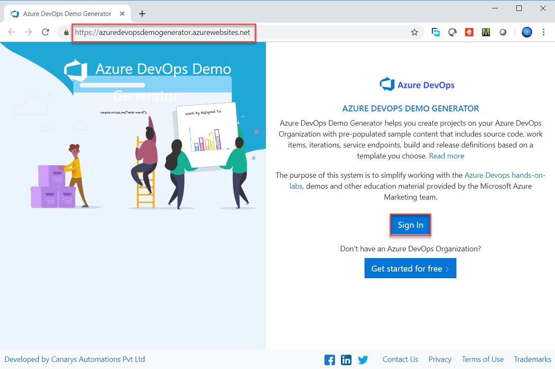

Step 2: Enter Azure DevOps credentials

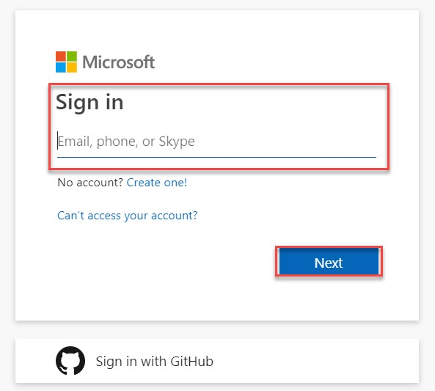

Step 3: Select **Organization**

Click on **Choose Template** option

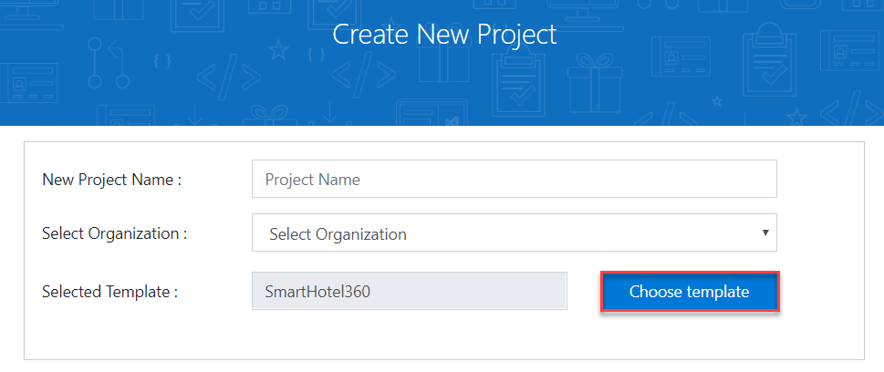

Step 4: Select **PartsUnlimited** template

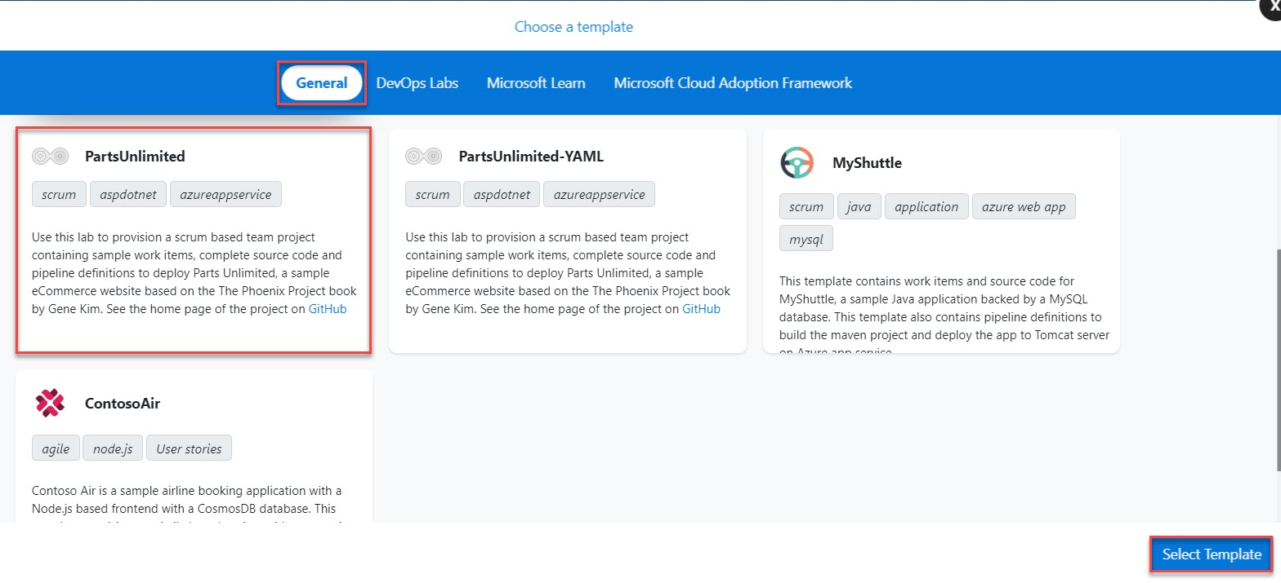

Step 5: Enter Project Name: **PartsUnlimited** and Click on **Create Project**.

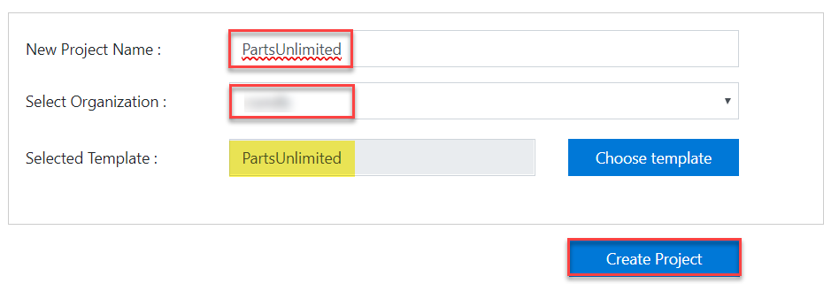

Step 6: Click on **Navigate to Project** button.

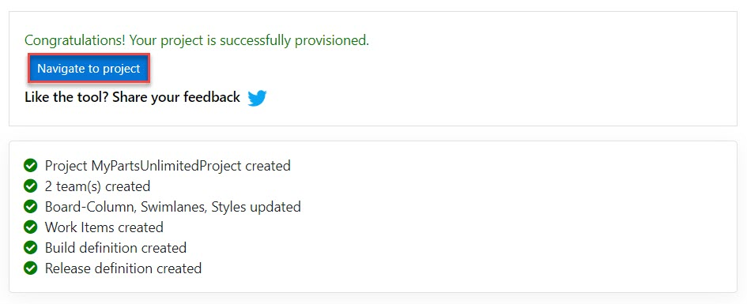

## Exercise 1: Agile Project Management

### ***Task 1: Defining dashboards***

1. Select **Overview** and click on **Dashboards**

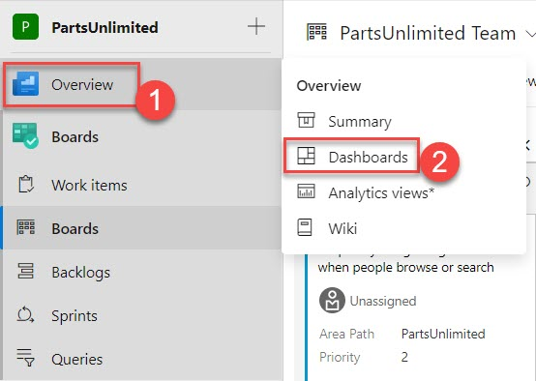

1. From the dashboard dropdown, select **Parts Unlimited Team Overview**. Dashboards allow teams to visualize status and monitor progress across the project. At a glance, you can make informed decisions without having to drill down into other parts of your team project site. The Overview page provides access to a default team dashboard which you can customize by adding, removing, or rearranging the tiles. Each tile corresponds to a widget that provides access to one or more features or functions.

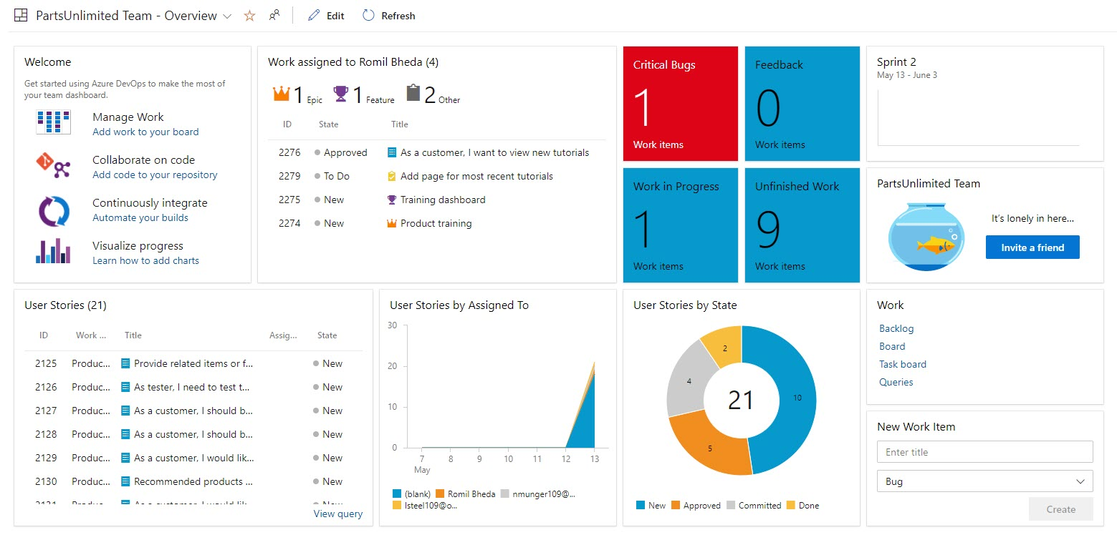

1. From the dashboard dropdown, select **New dashboard**.

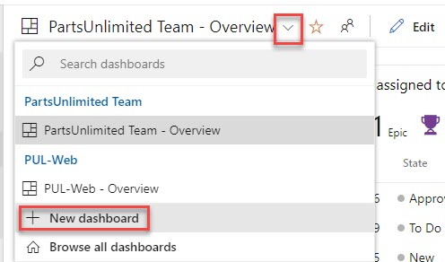

1. Set the **Name** to **“Product training”** and select the **PUL-Web** team. Click **Create**.

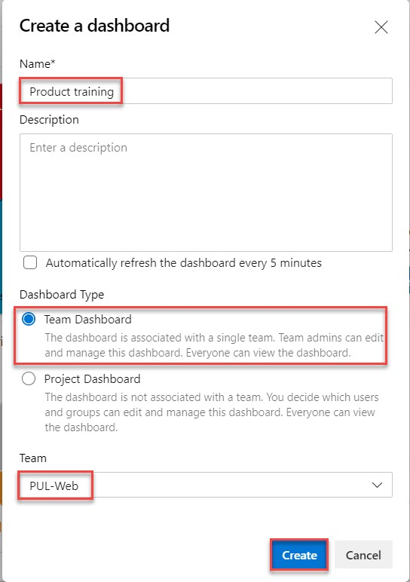

1. Click **Add a widget**.

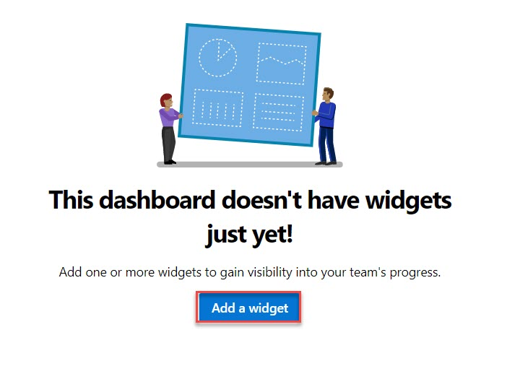

1. In the **Add Widget** panel, search for **“Sprint Overview”** to find existing widgets that focus on sprints. Select **Sprint Overview** and click **Add**.

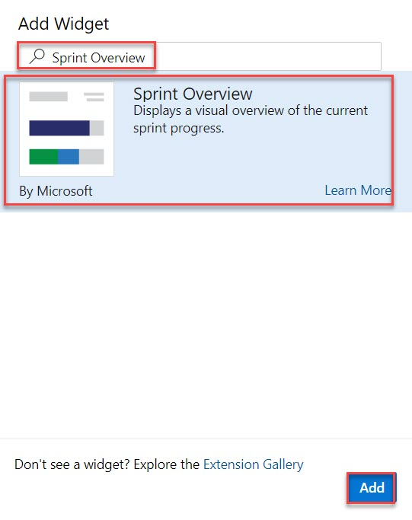

1. Many widgets have options you can configure. Click the **Settings** button.

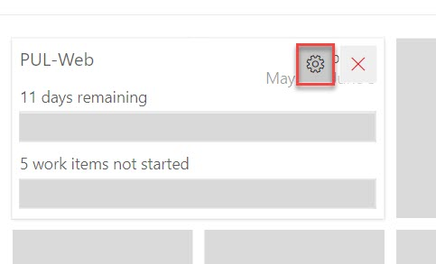

Team: **PUL-Web**

Values: **Count of Work Items**

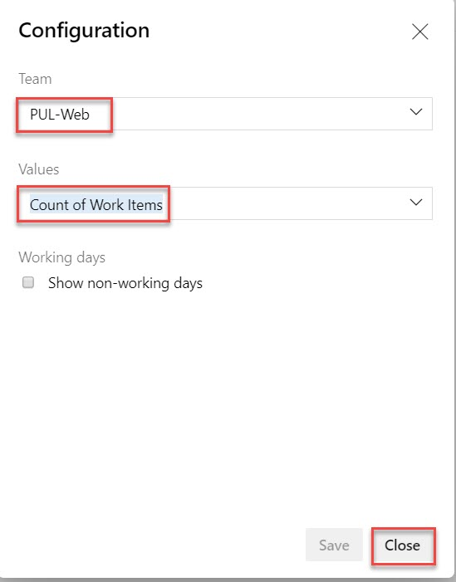

1. Search the widgets again for **“Sprint Capacity”** and add the **Sprint Capacity** widget.

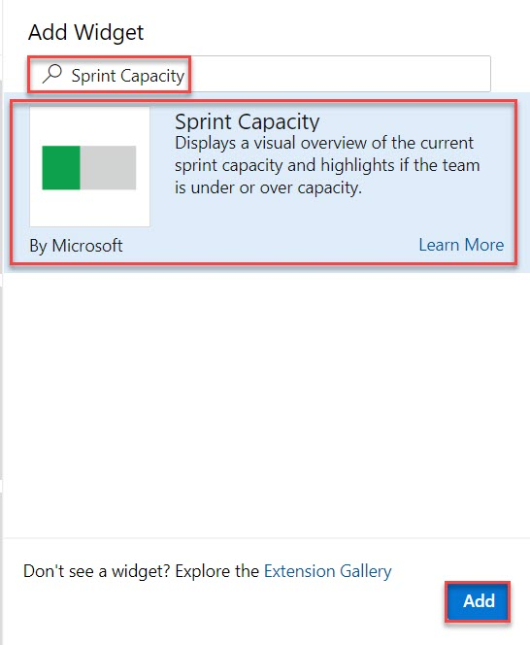

1. Click **Done Editing**.

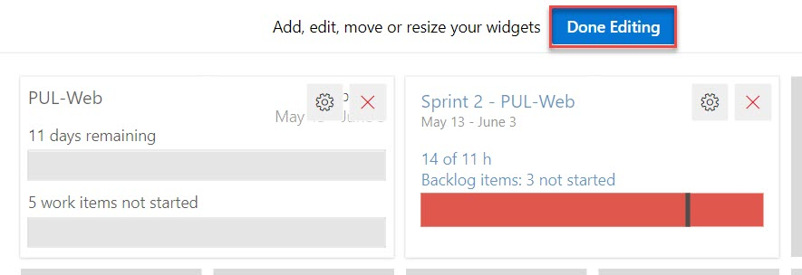

1. You can now review two important aspects of your current sprint on your custom dashboard.

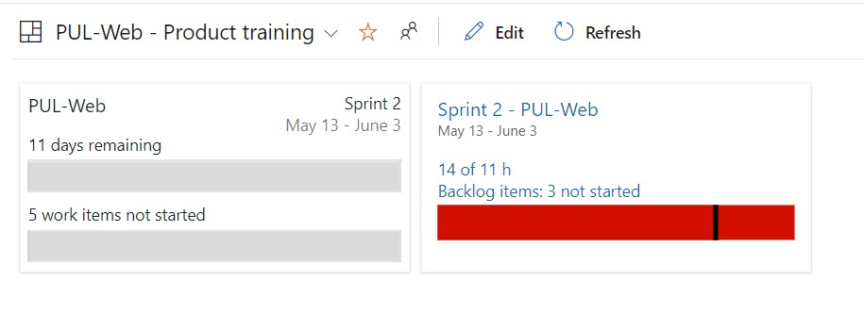

1. Another way of customizing dashboards is to generate charts based on work item queries, which you can share to a dashboard. Select **Boards -> Queries**

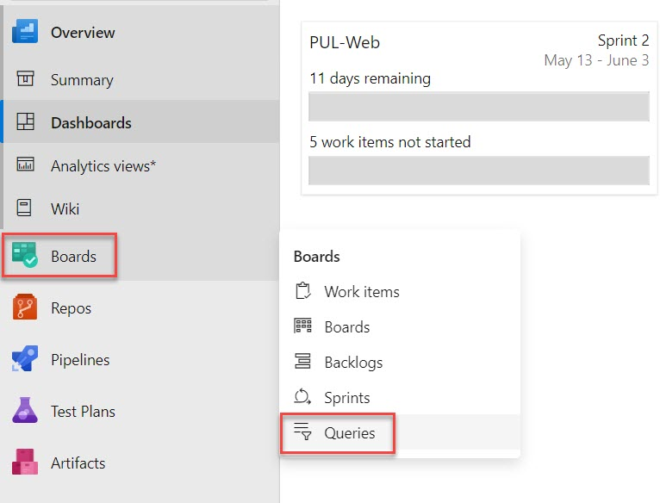

1. Click **New query**.

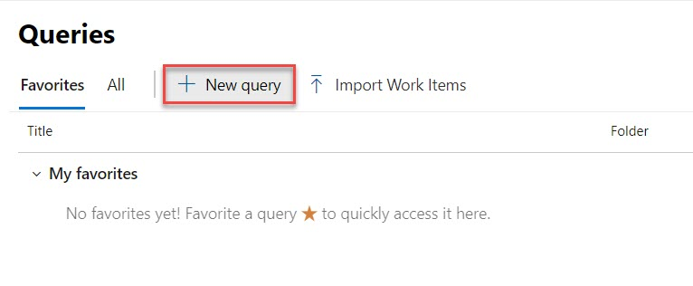

1. Set the first term to **Work Item Type = Task** and the second term to **Area Path = Parts Unlimited\PUL-Web**.

Click **Save query**.

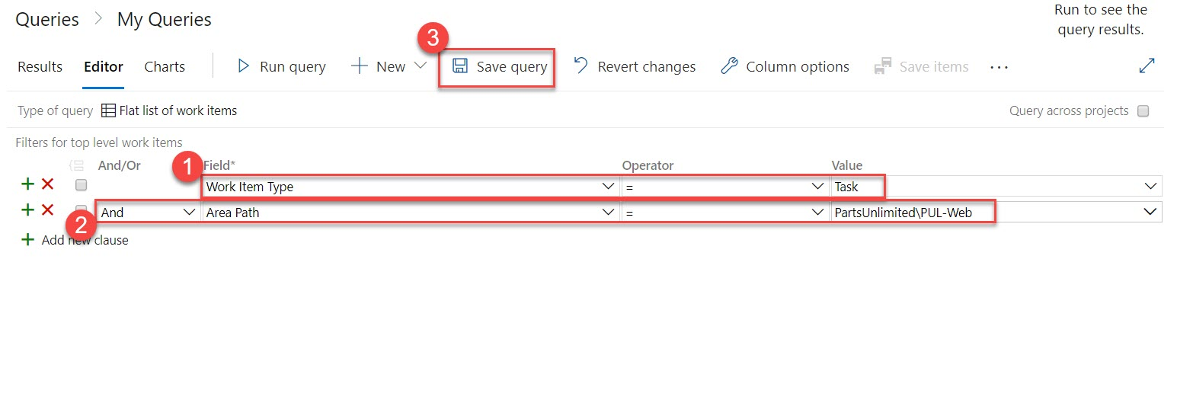

1. Set the **Name** to **“Web tasks”** and the **Folder** to **Shared Queries**. Click **OK**.

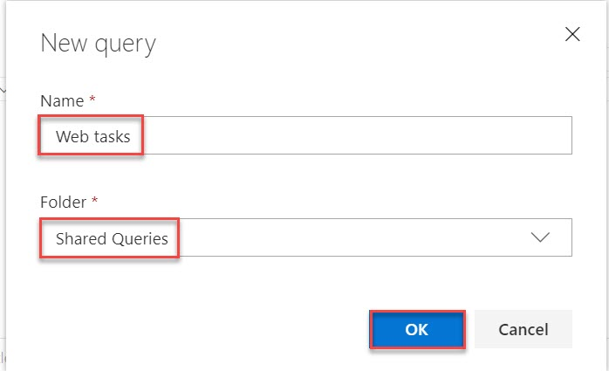

1. Select the **Charts** tab and click **New chart**.

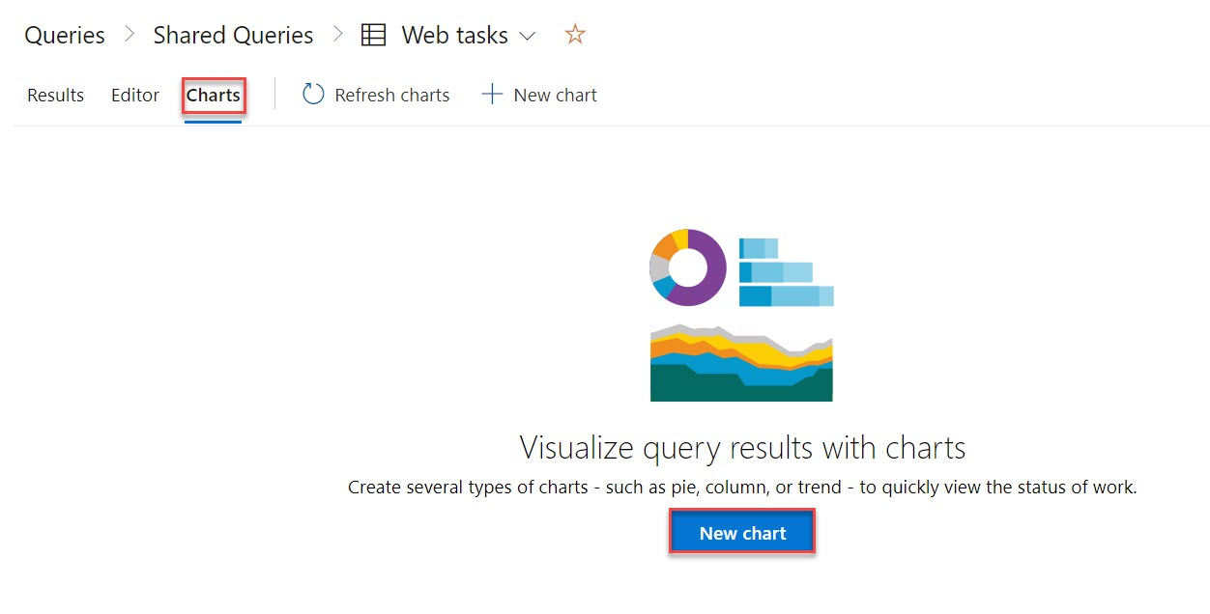

1. Set the **Name** of the chart to **“Web tasks - By assignment”** and **Group by** to **Assigned To**. Click **OK** to save.

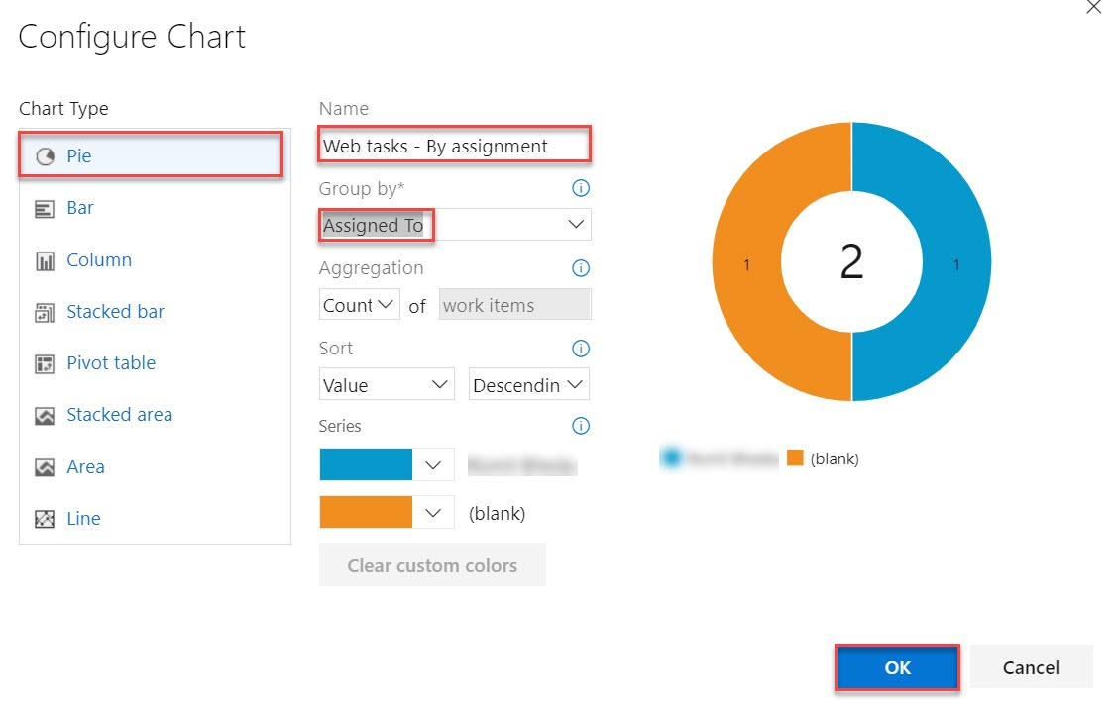

1. You can now add this chart to a dashboard.

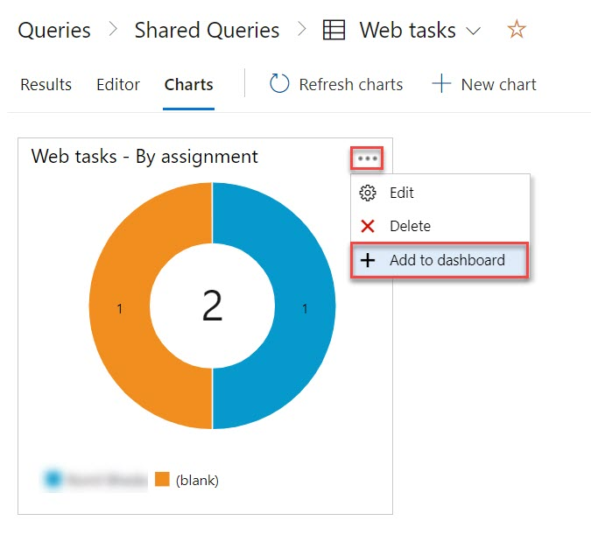

Select Dashboard: **Product training**

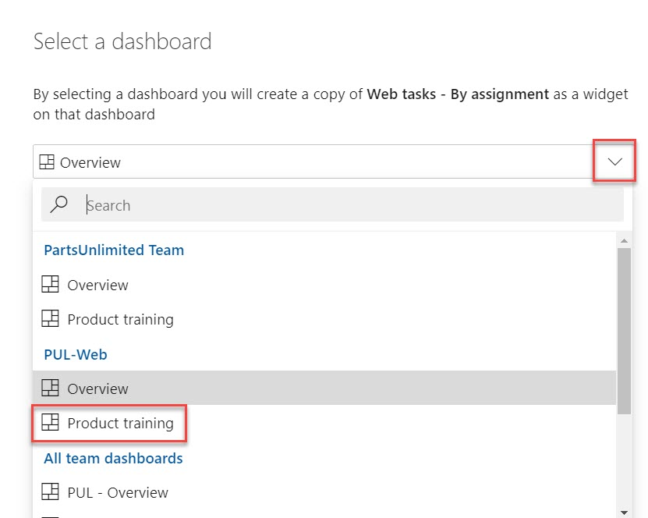

Navigate to **Overview** -> **Dashboards**

Select **PUL-Web – Product training**

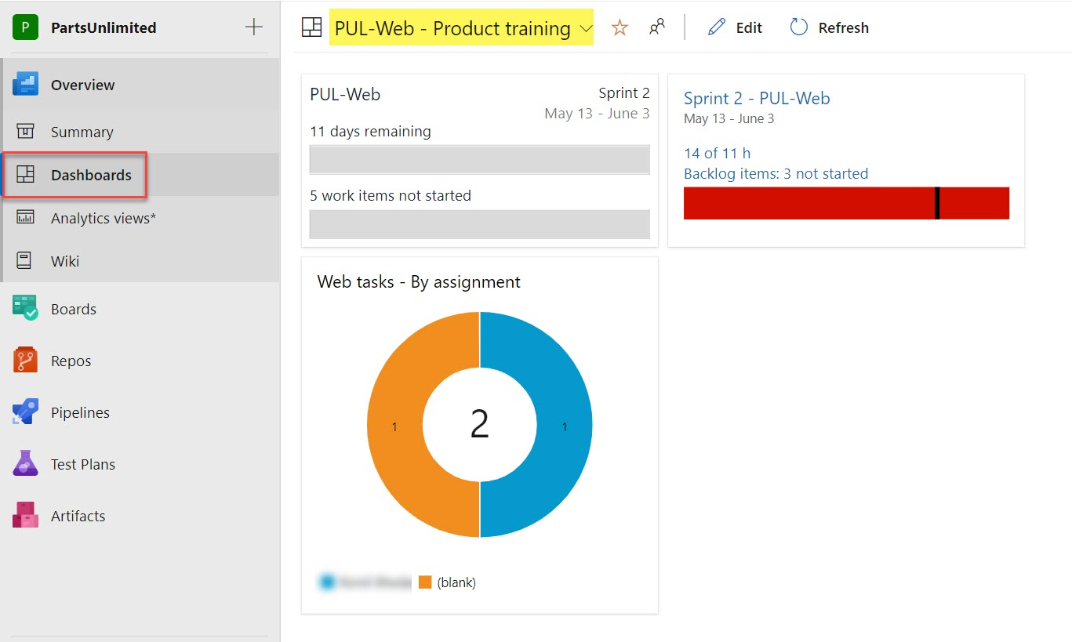

### ***Task 2: Customizing team process***

In Azure DevOps, you customize your work tracking experience through a process. A process defines the building blocks of the work item tracking system as well as other sub-systems you access through Azure DevOps. Whenever you create a team project, you select the process which contains the building blocks you want for your project.

Azure DevOps supports two process types. The first, the core system processes-Scrum, Agile, and CMMI system processes-are locked. You cannot customize these processes. The second type, inherited processes, you create from a core system process. These processes you can customize.

In addition, all processes are shared. That is, one or more team projects can reference a single process. Instead of customizing a single team project, you customize a process. Changes made to the process automatically update all team projects that reference that process.

Once you’ve created an inherited process, you can customize it, create team projects based on it, and migrate existing team projects to reference it. The Git team project can’t be customized until it’s migrated to an inherited process.

In this task we’ll create a new process that inherits from Scrum. The one change we’ll make is to add a backlog item field designed to track to a proprietary **PartsUnlimited** ticket ID.

1. Click the **Azure DevOps** logo in the **top left corner** to navigate to the account root.

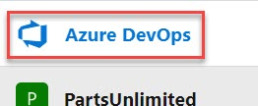

1. From the left bottom corner, click **Organization settings**.

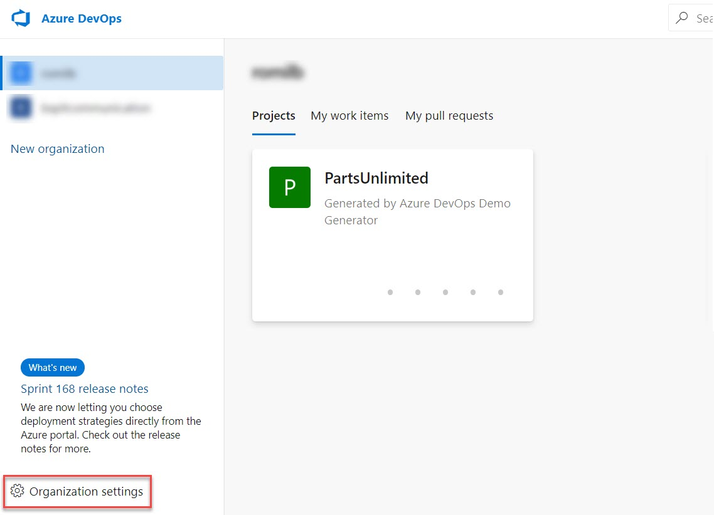

1. Select the **Process** tab under **Boards**.

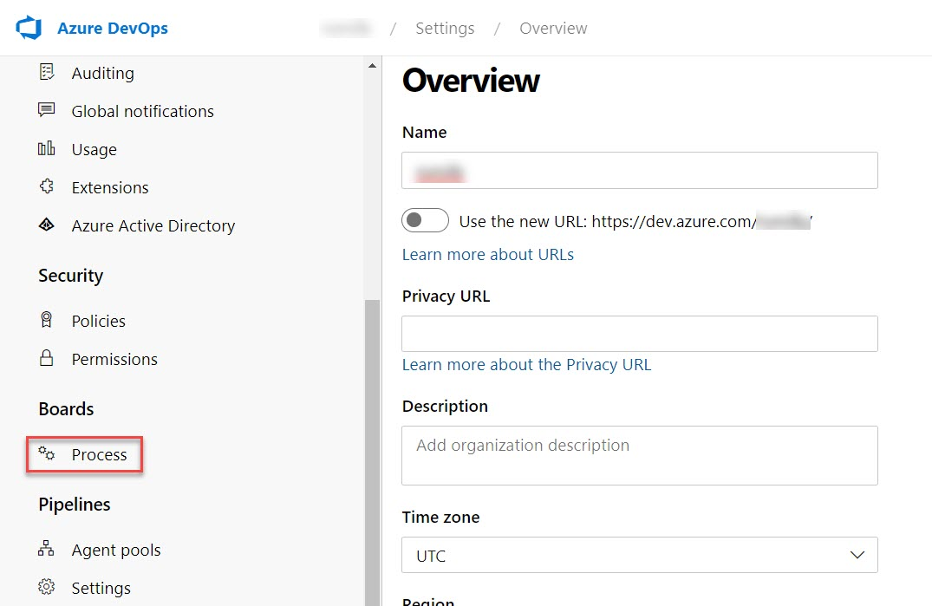

1. From the **Scrum** dropdown, select **Create inherited process**.

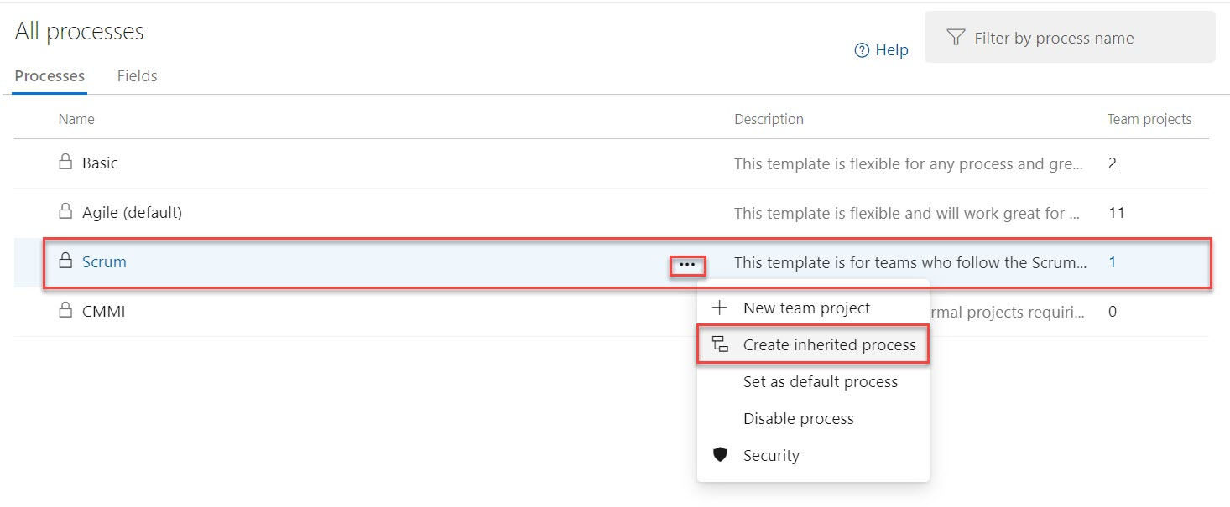

1. Set the name of the inherited process to **Customized Scrum** and click **Create process**.

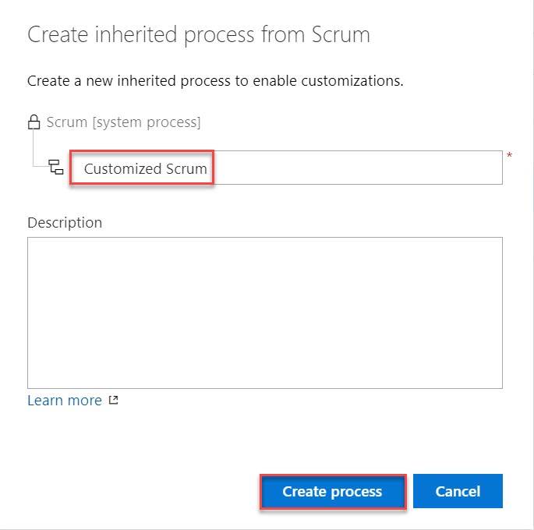

1. Open **Customized Scrum**. You may need to refresh the browser for this to become visible.

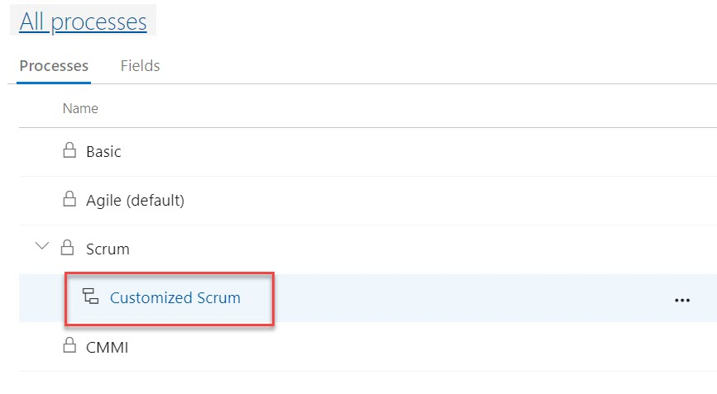

1. Select **Product Backlog Item**.

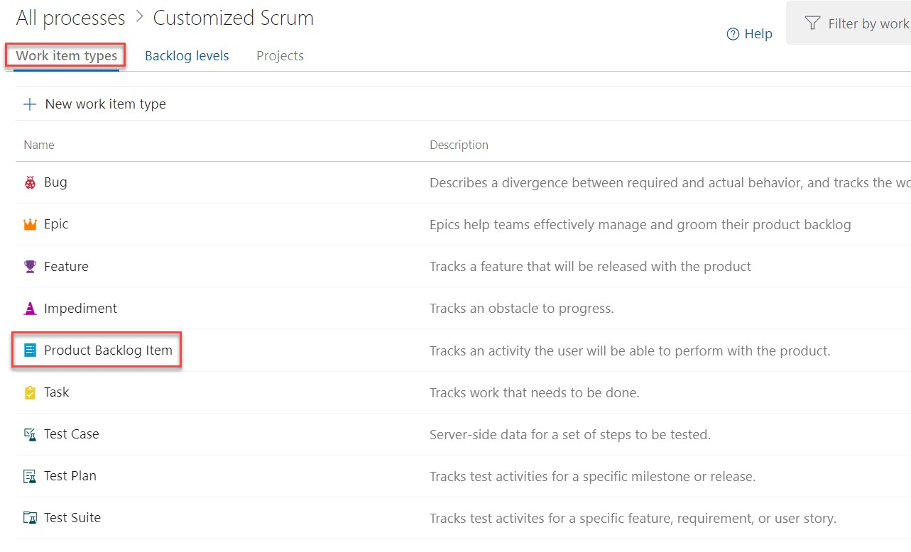

1. Click **New field**.

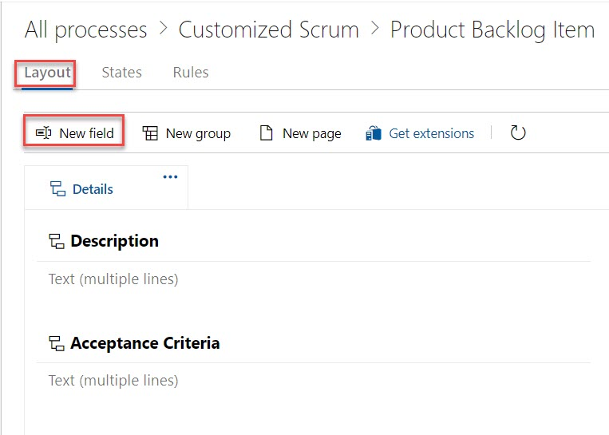

1. Set the **Name** of the new field to **“PUL Ticket ID”**.

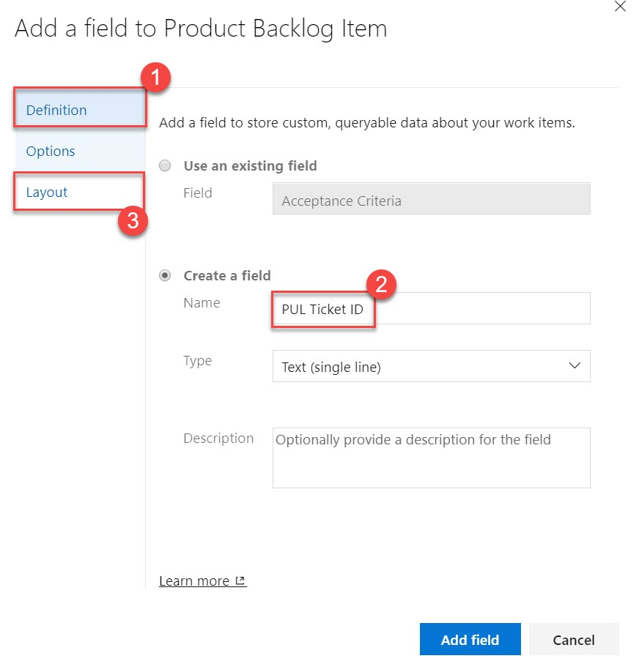

1. On the **Layout** tab, set the **Label** to **“Ticket ID”**. Also **Create a new group** for **“PartsUnlimited”**. Click **Add field**.

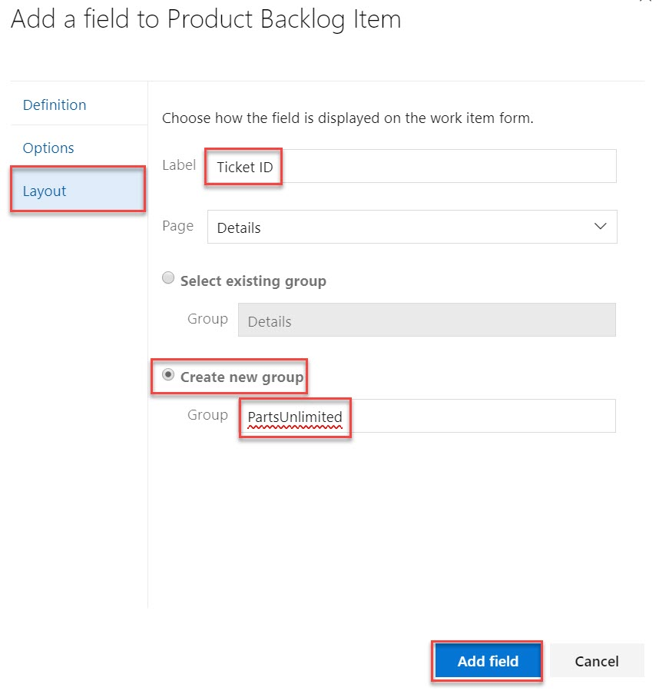

1. Now that the customized process has been configured, let’s switch the Parts Unlimited project to use it. Return to the **All processes** root using the breadcrumb.

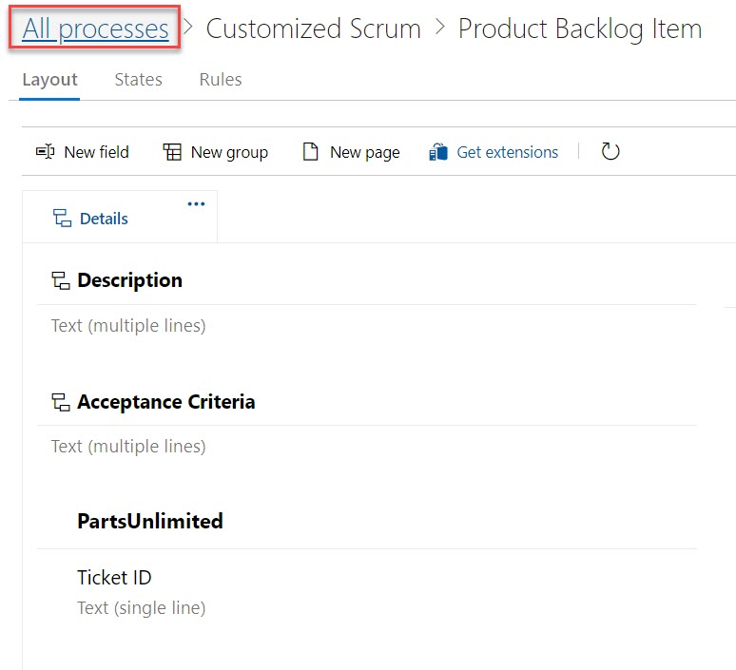

1. Our project currently uses **Scrum**, so select that process.

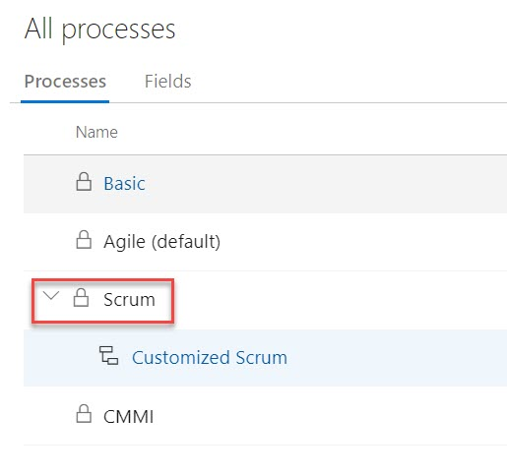

1. Switch to the **Projects** tab.

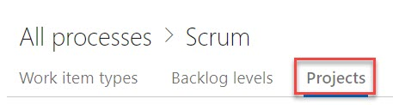

1. From the context menu for **Parts Unlimited**. Select **Change process**.

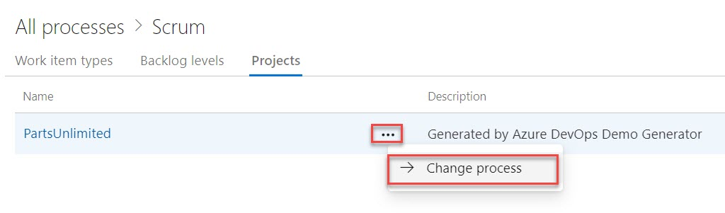

1. Select the **Customized Scrum** process and click **Save**.

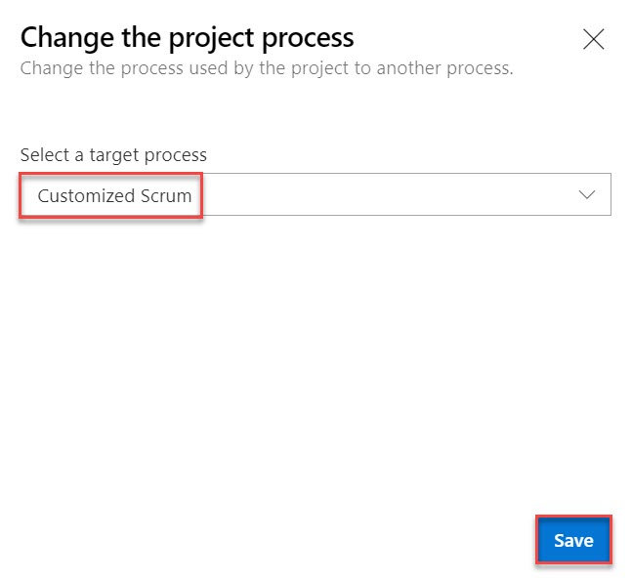

1. Return to the account dashboard using the logo link.

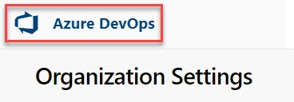

1. Open the **Parts Unlimited** portal.

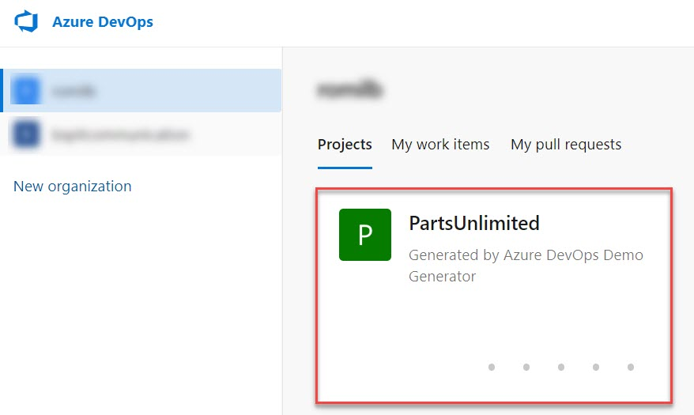

1. Select **Boards** -> **Work items**

Open the first backlog item.

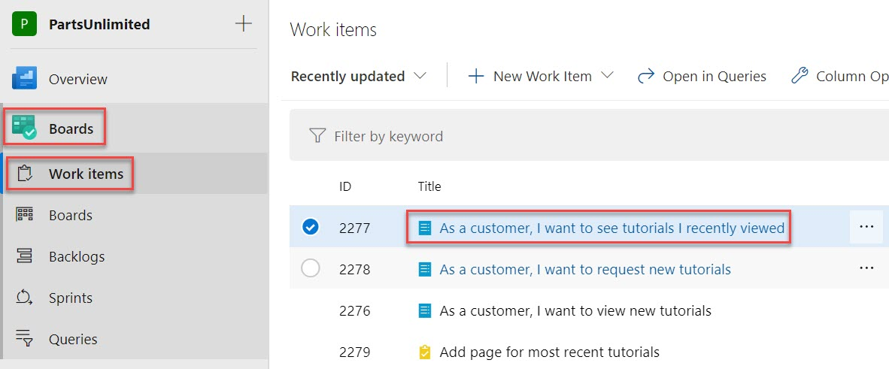

1. You will now see the **Ticket ID** field under the **PartsUnlimited** group defined during the process customization. You can treat this like any other text field.

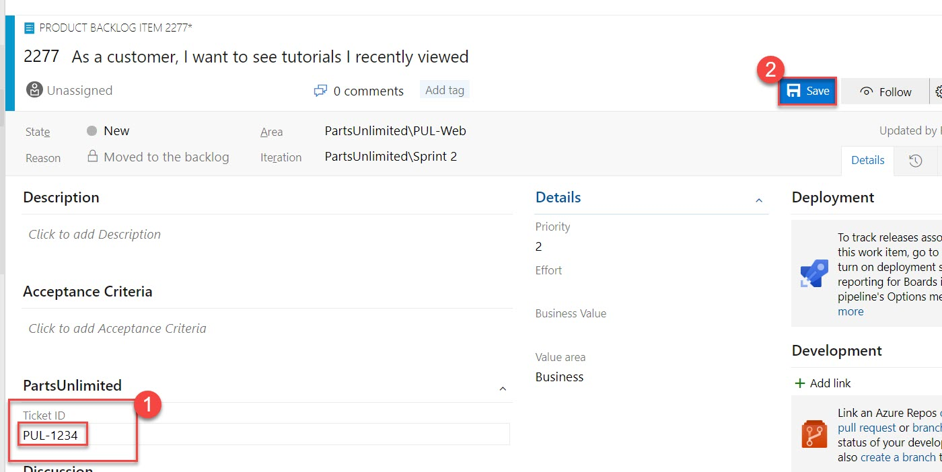

1. Once the work item is saved, Azure DevOps will also save the new custom information so that it will be available for queries and through the rest of Azure DevOps.