**Deploy Java App and Configure CI/CD**

**Step 1:** Open Azure DevOps Portal

[https://dev.azure.com](https://dev.azure.com/)

**Step 2:** Click on + **New** **Project**

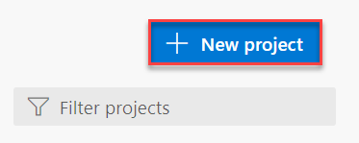

**Step 3:** Create New Project.

Project Name: **Name**-**JavaDevOpsProject (Update Name with your first or last or any other name)**

Click on **Create** button.

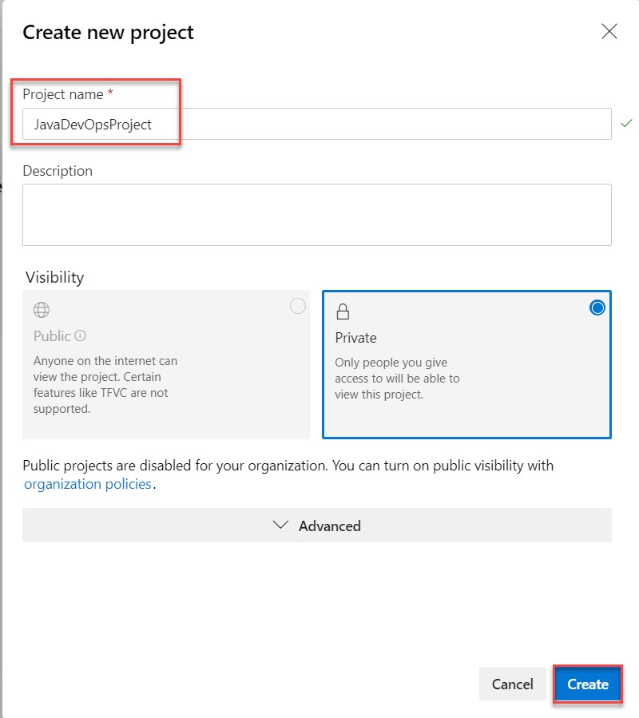

**Step 4:** Click on **Repos** and Import repository by click on **Import** button.

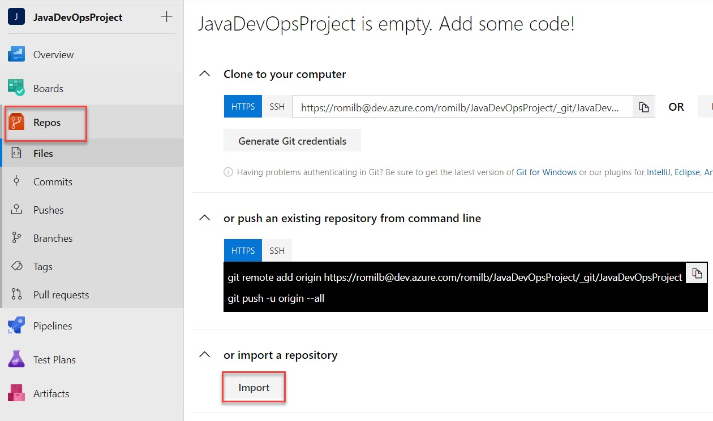

**Step 5:** Import Git Repo link:

<https://github.com/romilbheda/javawebappdemo.git>

Click on **Import** button.

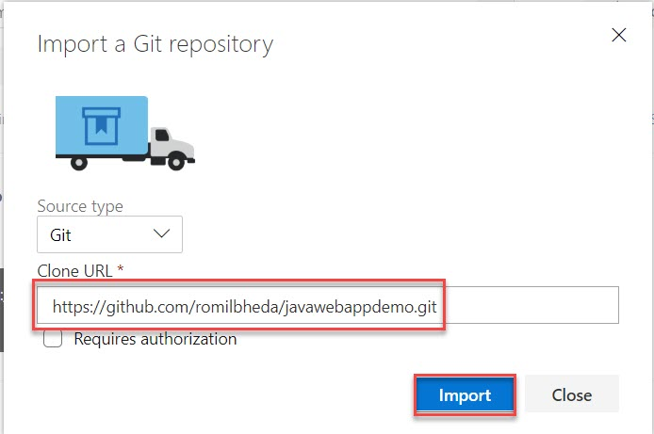

**Step 6:** Verify files

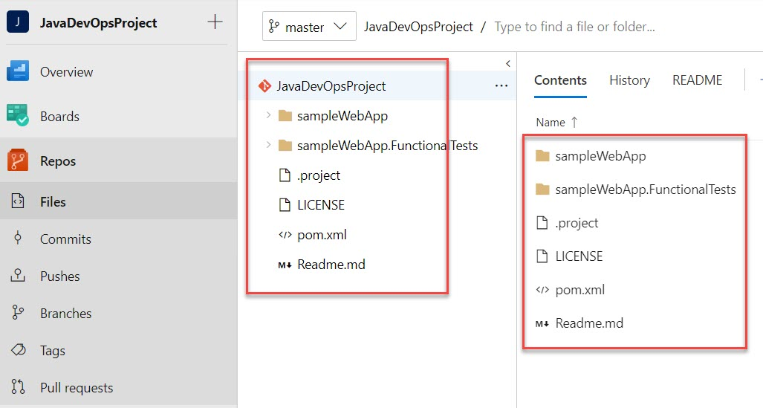

**Step 7:** Create Build Pipeline

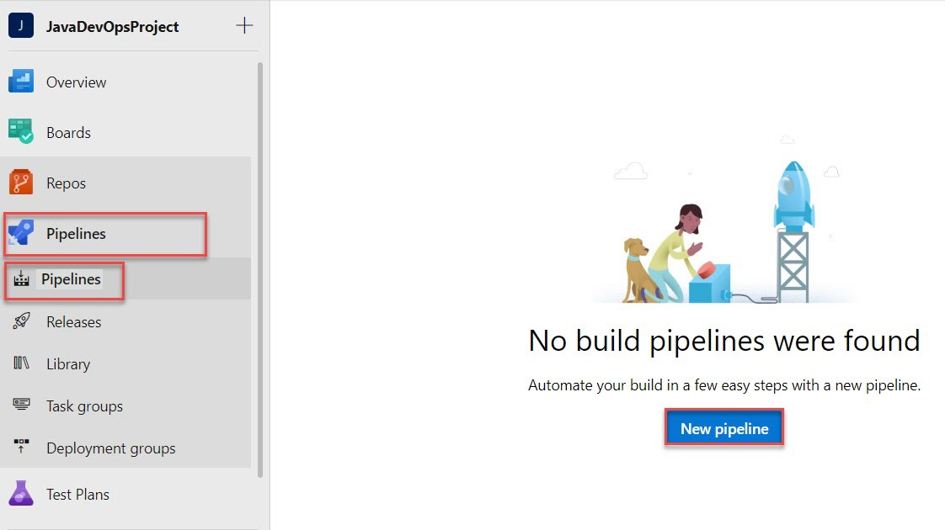

**Step 8:** Click on **Use the classic editor**

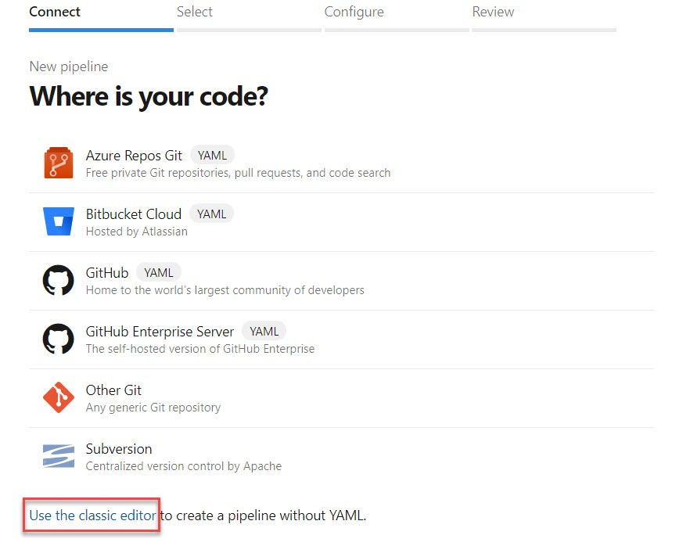

**Step 9:** Select **Azure Repos Git** and click on **Continue** button.

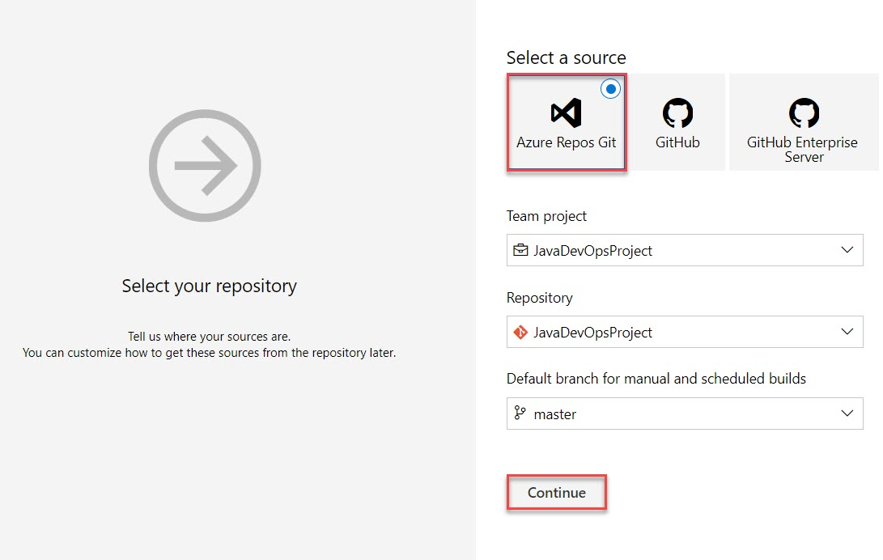

**Step 10:** Select **Maven** from list

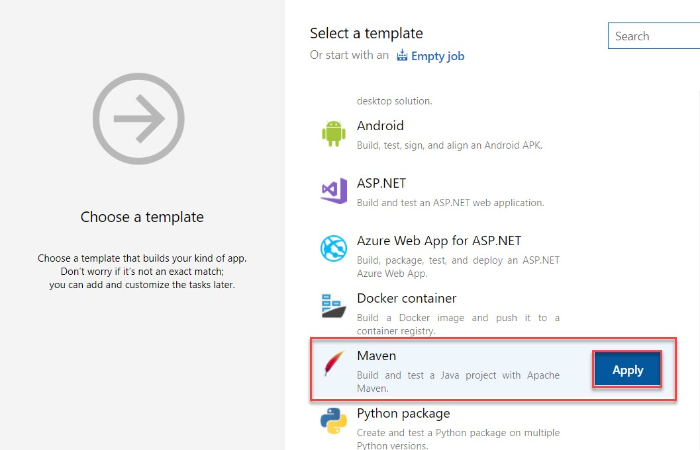

**Step 11:** Click on Pipeline

Agent Pool: **Azure Pipelines**

Agent Specification: **ubuntu-18.04**

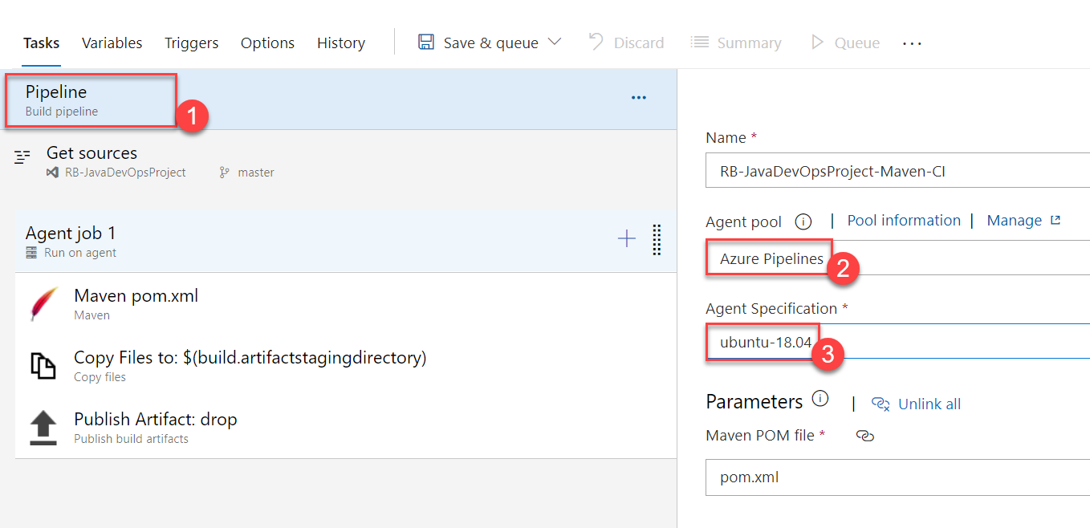

**Step 12:** Select **Copy Files to** and navigate to **Contents** option. Add .war

**\*\*/*.war**

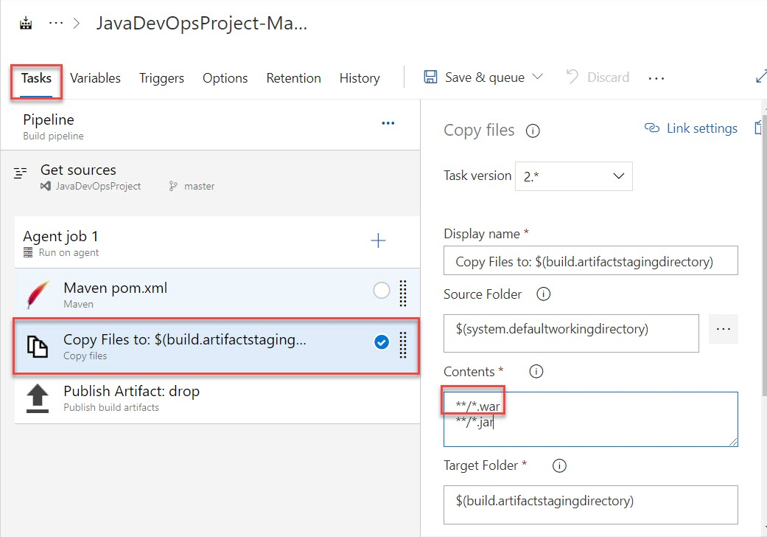

**Step 13:** Select **Triggers** tab.

**Enable Continue Integration** and click on **Save & queue -> Save & queue** option

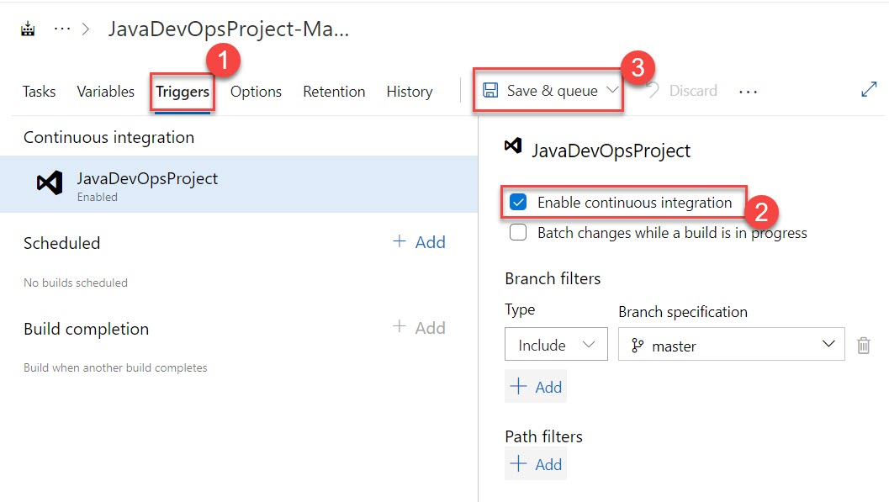

**Step 14:** Click on **Save and run** button.

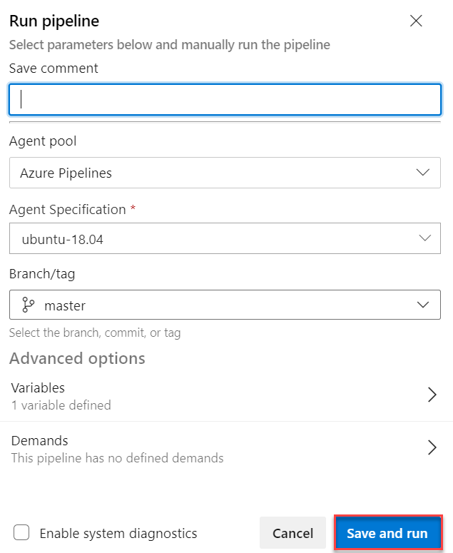

**Step 15:** Click on Agent job 1

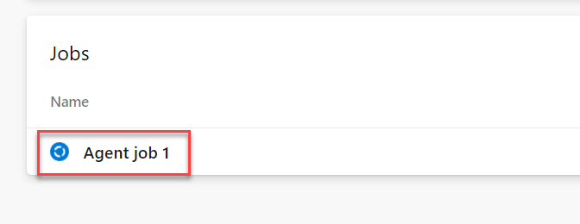

**Step 16:** Build pipeline is running. If completed click on **back arrow** button

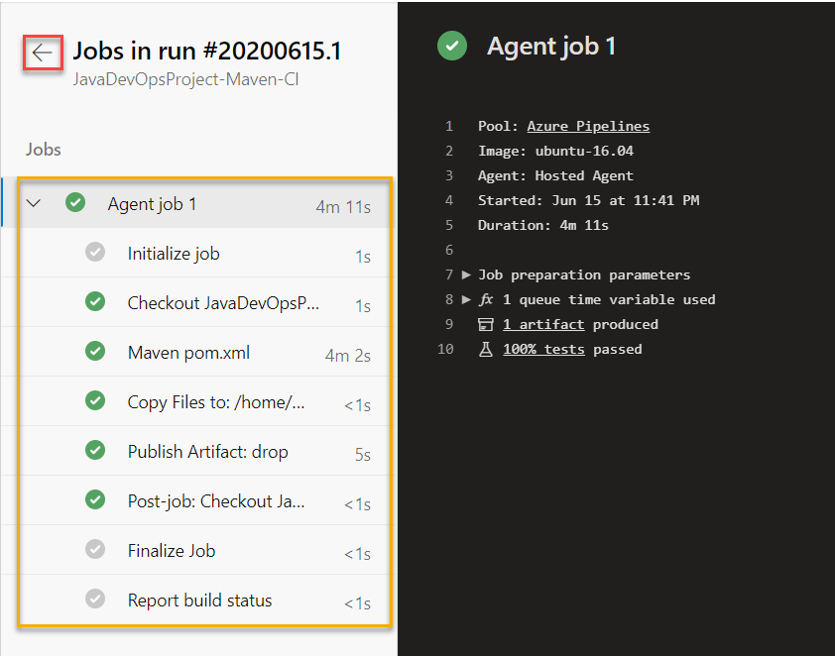

**Step 17:** Click on **1 published; 1 consumed** option

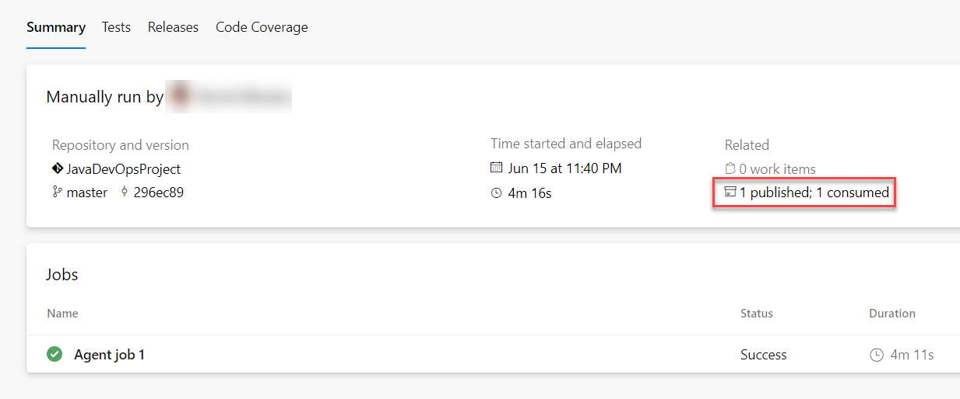

**Step 18:** navigate to war file.

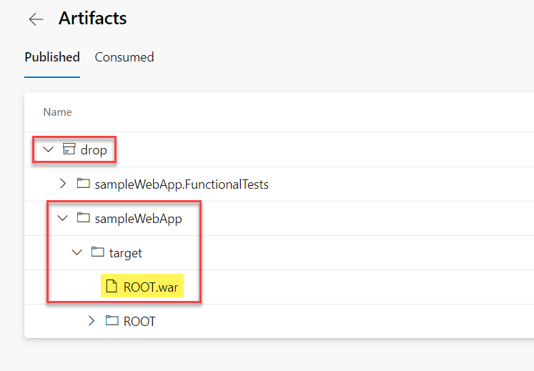

**Step 19:** Open **Microsoft Azure Portal**

[http://portal.azure.com](http://portal.azure.com/)

**+ Create a resource -> Get started -> Web App**

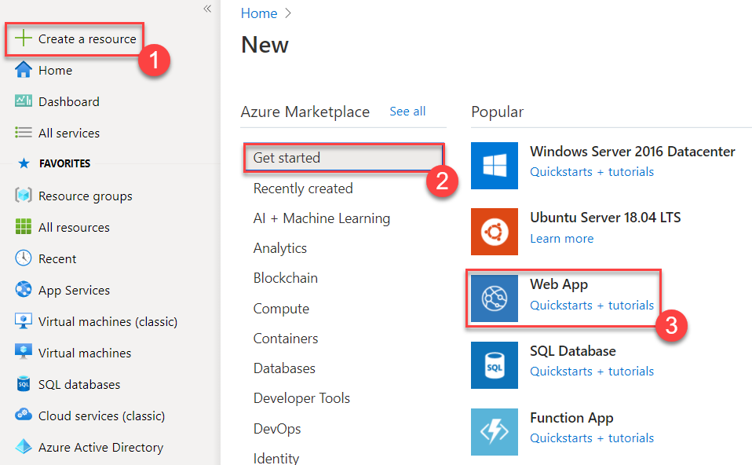

**Step 20:** Create Web App

Resource Group: **JavaDevOpsRG**

Name: **Enter unique name Ex javadevopsapp**

Publish : **Code**

Runtime stack : **Java 11**

Java web server stack : **Tomcat 9.0**

Operating System : **Windows**

Region: **Choose nearest region**

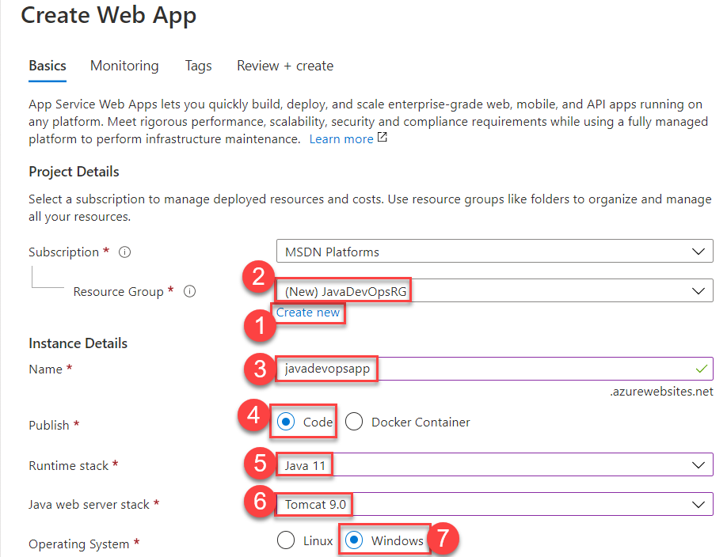



Plan: **Create New Plan** Ex. **javawebappPlan**

Click on **Next: Monitoring >** button

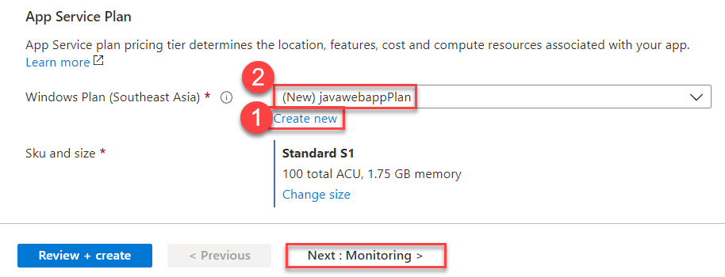

Application insights: **No**

Click on **Review + Create** button

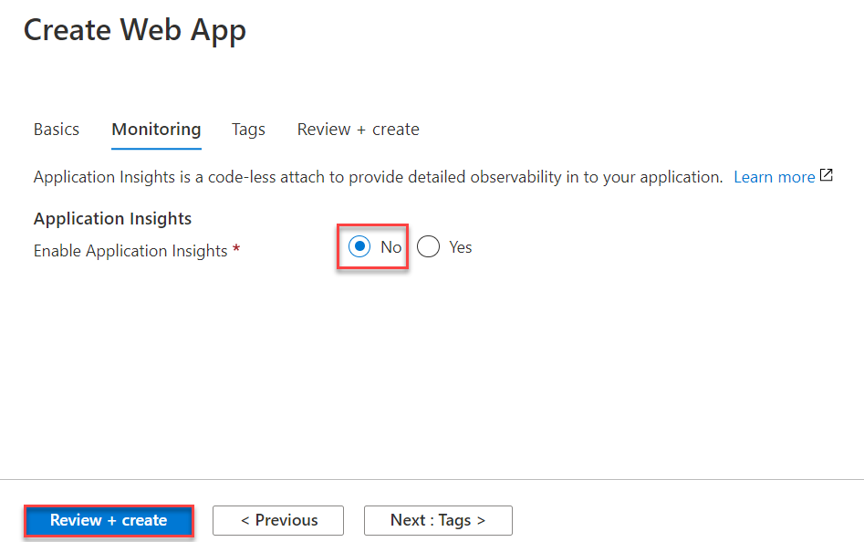

**Step 21:** Click on **Create** button.

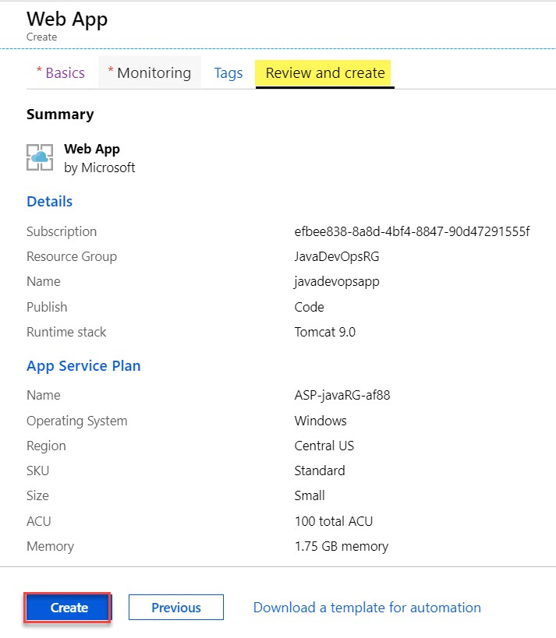

**Step 22:** wait for few seconds to deploy web app. Click on **Go to resource** button.

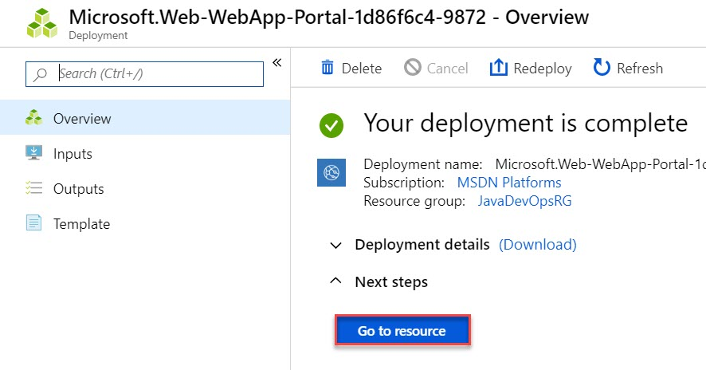

**Step 23:** Click on **Browse** to open web app

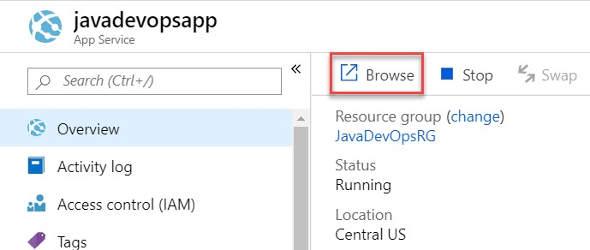

**Step 24:** Verify default page of Java App

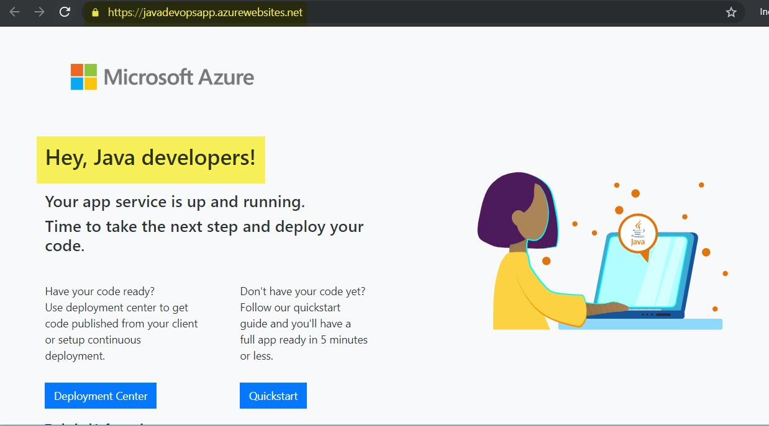

**Step 25:** Navigate to **Azure DevOps Portal.**

Create **Release** Pipeline

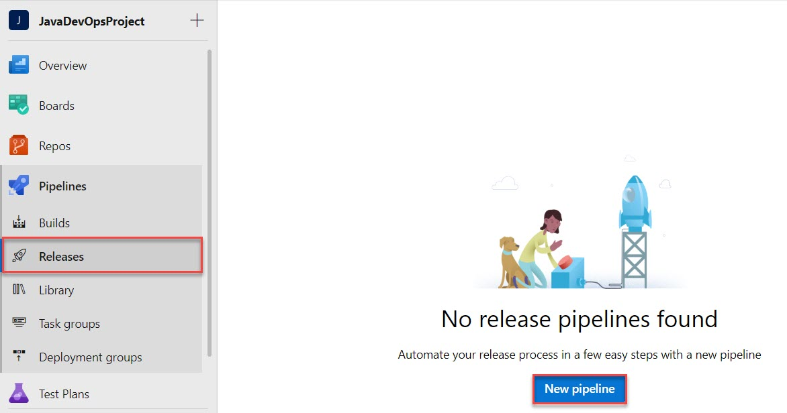

**Step 26:** We need to Deploy as Web App so select **Azure App Service Deployment**

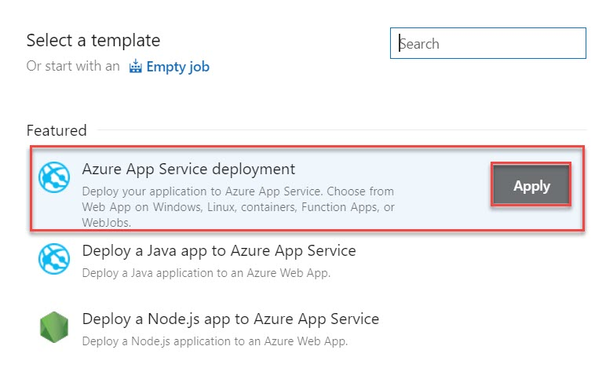

**Step 27:** Edit stage name: **Production** or **dev** or **test**

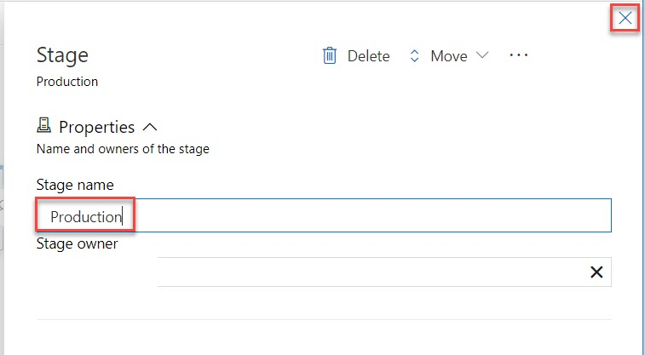

**Step 28:** Click on **+ Add an artifact** option

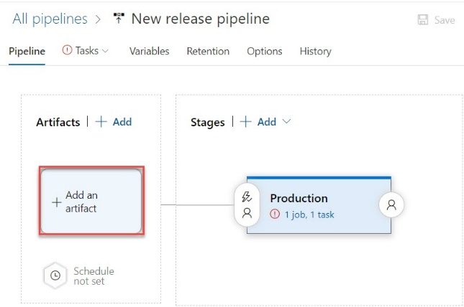

**Step 29:** Select Artifact

Source type: **Build**

Source (build pipeline): **Choose existing CI Ex. ProjectName-Maven-CI**

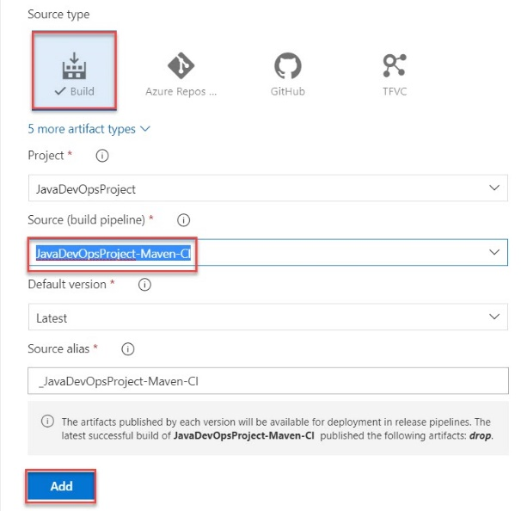

**Step 30:** **Enable Continuous Deployment** Trigger

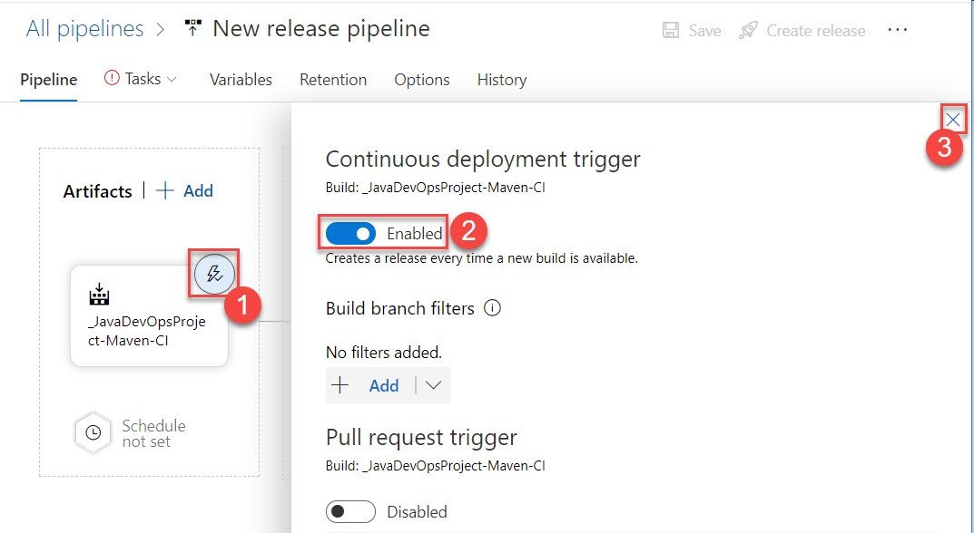

**Step 31:** Click on **Tasks -> Production**

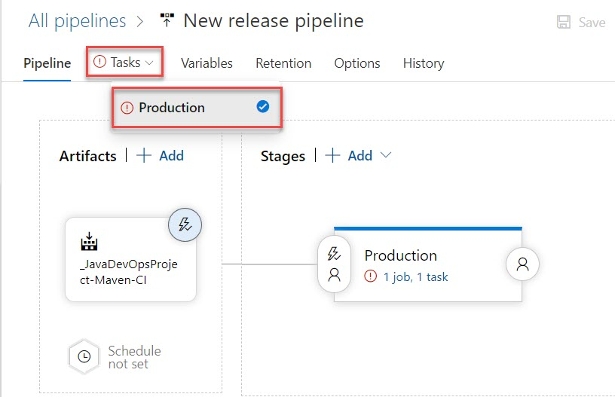

**Step 32:** Authorize with your Azure Subscription

Choose **Azure Subscription** and click on **Authorize** button

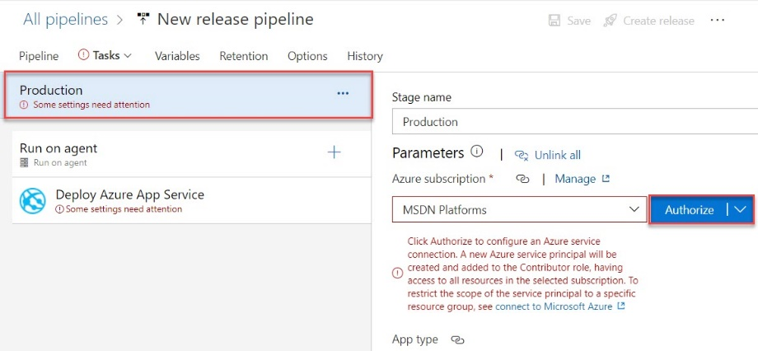

**Step 33:** Enter Microsoft Azure Credentials

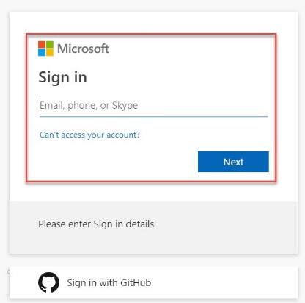

**Step 34:** App type: **Web App on Windows**

App Service name: **Choose Web App from existing list (created in Step No. 18)**

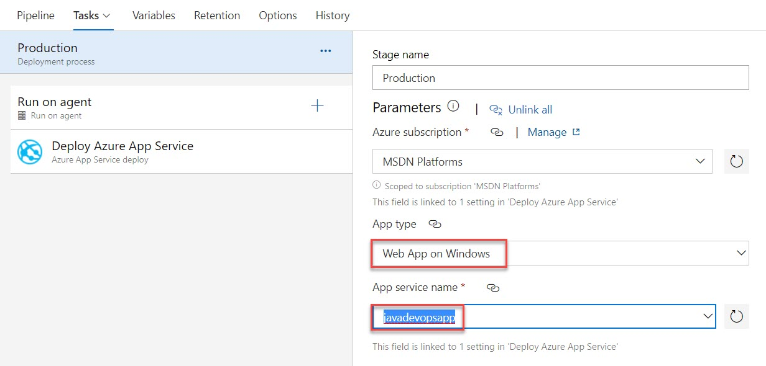

**Step 35:** Click on **Deploy Azure App Service** and select **Package or folder**

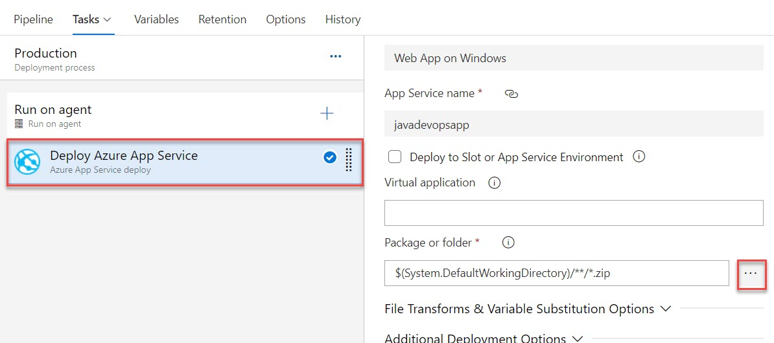

**Step 36:** Select **war** file

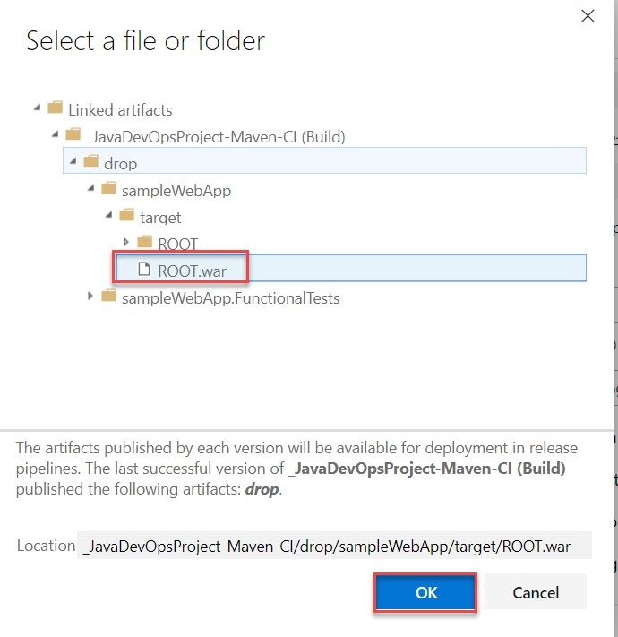

**Step 37:** Click on **Save**

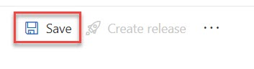

**Step 38:** Click on **OK** button

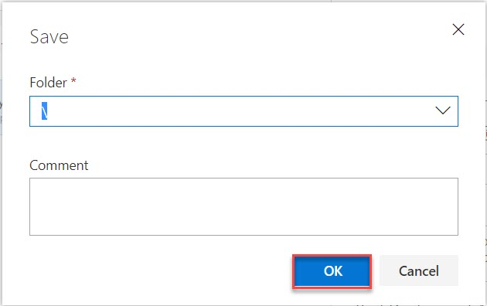

**Step 39:** Click on **Create release**



**Step 40:** Click on **Create** button.

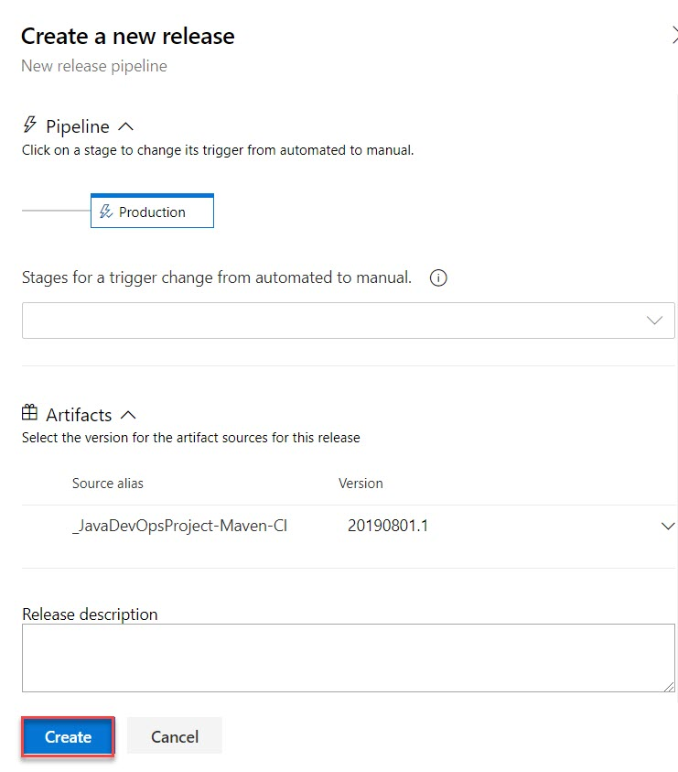

Click on **Release-1**

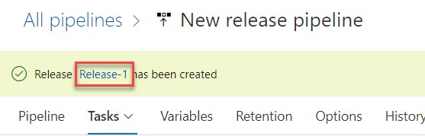

**Step 41:** Progress started

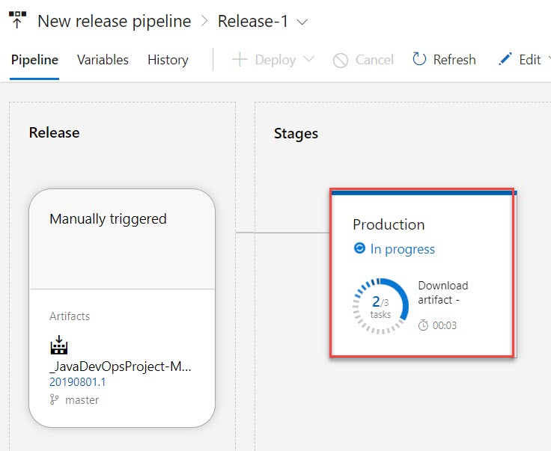

**Step 42:** Browse web app

